ATIC Accessibility
To support the accessible community in making informed travel decisions for their individual needs

This report prepared for:
Business name: | All Sea Charters
Address: | 5 Wirraway Place
Town: | Busselton
Contact for enquiries: | Paul Szczypior
Contact Number: | 0417794008
Contact Email: | allseacharters@gmail.com
Website: | www.whalewatchingcharters.com.au
Date: | 2026-10-25 22:39

ATIC Accessibility
The following pages provides travellers with information on the businesses facilities and amenities which aims to support the traveller to make an informed decision on whether the business is suitable for their individual needs.
OVERVIEW 4
Business Overview 4
Bookings 4
Emergency Management 4
Communications 5
GENERAL 6
Pre-arrival, arrival and reception 6
Cognitive Impairment Support 6
Car Park and Access amenities 6
Entry 6
Internal Spaces 7
Displays, exhibits, commentary and live performances 7
External Paths 7
Steps 8
Ramps 8
Public Toilets/Adult change facilities 8
TOUR OPERATORS 9
Tour/Transport Services 9
Route Planning 9
Guides 10
ADVENTURE ACTIVITIES 11
Adventure activities 11
Report Disclaimer 13

OVERVIEW

Business Overview

The business has the following products/services available
- Tour/Transport
- Adventure

Our business caters for the following disability types:
- Blind or low vision
- Deaf or low hearing
- Limited mobility
- Wheelchairs or mobility scooters
- Cognitive or people on the Autism Spectrum

Bookings

The business offers the following methods for bookings and enquiries:
- Phone
- Email
- Webportal
- Our website supports Screen Readers
- Our forms have high contract boxes and submit boxes

Emergency Management
- Emergency and evacuation procedures are explained on arrival
- There are Audible device/s to alert occupants to evacuate with instructions on how to evacuate.
- Exits and access to exists are greater than 900mm
- Exit doors are able to be opened by all occupants
- The evacuation point is clearly marked by a sign
The business identifies guests who need additional assistance should an emergency occur by: they are assessed by our person onshore and information relayed to crew
The procedure for assisting guests who need assisted rescue is: there carer will assist and staff will assist when available

Communications
- Our website meets WCAG 2.0 accessibility standards
The business provides the following services for services animals: we offer no services for service animals never had 1 on the vessel in 17 years

GENERAL

Pre-arrival, arrival and reception
The business has the following in place to support guests during pre-arrival, arrival and reception
- Booking information and websites are compatible with screen readers
- There is a reception/public entryway.
- A lower counter at reception/ticket office
- Picture Board at reception to aid in communication
we meet our passengers at a central meeting point
- Information and maps are available in written form
- A step free map/guide
- Advertising material, web sites and social media contain information relating to phone numbers available for non-voice communication e: Text, SMS, email and fax
no area on the boat is locked .
The following steps are in place to ensure that people with fatigue related to their disability are not disadvantaged by long wait times: na

Cognitive Impairment Support
- Documents are available in plain English for people with cognitive impairment (This may include instructions, guides, menus and general information)

Car Park and Access amenities
The business has the following Car Park and Access amenities
- A drop off zone
- Designated disabled parking bays
- Level or ramped access from the car park to the entrance
- The accessible entrance is clearly signed from the parking bay

Entry
The business has the following amenities/systems in place for entry
- A drop off point close to the entrance
- A path of access to the building is clear of obstruction
- The entry door is a minimum of 850mm wide
- There a clear space of at least 1500mm x 1500mm in front of all doors.
- In addition, the following further information can assist guests:
Non of the above questions really pertain to a Vessel operating a whale watching charter.

Internal Spaces
- Floor surfaces are hard or short pile carpet
The width of the smallest corridor is: NA
- In addition, the following further information can assist guests:
All questions above do not pertain to a whale watching vessel.
- In addition, the following further information can assist guests:
NA for a boat

Displays, exhibits, commentary and live performances
For displays, exhibits, commentary and live performances the following amenities are in place
- Seating
- Wheelchair accessible spaces/seating
- A written transcript where audio description is provided i.e. display commentary, tour commentary

External Paths
External paths of travel
- Surfaces are concrete, asphalt, smooth paving or hard packed fine gravel (max aggregate size 13mm)
- Pathways are wider than 900mm
- There 3 successive steps or less on any path or at any doorway
- Step free routes clearly signed

Steps
Steps
- There are steps.
- All steps or staircases have enclosed risers
- The underside of all staircases are enclosed or protected to a height of at least 2 metres
- Handrails fitted to all open sets of steps
- Handrails extend 300mm beyond the top and bottom step
- In addition, the following further information can assist guests:
To get from the lower deck to the upper deck stairs are present, but on the lower deck of both vessels these can be accessed via a loading ramp onto the boat with no steps and wheelchair friendly

Ramps
Ramps have the following amenities are in place
- There are ramps.
- All fixed ramps are 1:14 or less
- Hand rails are fitted
- In addition, the following further information can assist guests:
our ramp is a mobile ramp designed for loading wheel chairs on to the vessel less than 3 metres in length

Public Toilets/Adult change facilities
Public Toilets/Adult change facilities have the following amenities are in place
- There is an accessible toilet for public use
- The door is at least 850mm wide
- There is a minimum of 850mm beside the toilet
- Handrails are fitted
- The toilet seat of a contrasting colour to the floor
- The toilet seat is460mm above the floor
- In addition, the following further information can assist guests:
the vessel is fitted with a disabled toilet with handrails

TOUR OPERATORS

Tour/Transport Services
The tour/transport services have the following facilities/amenities in place
- Buses/Coaches
- 3 vehicles have wheelchair lifts or ramps
- 0 vehicles have low floors with ramped entry
The maximum wheelchair capacity available in the fleet is: 3
- Commentary is available in written format

Route Planning
- There is an accessible toilet on-board for public use
- The door is at least 850mm wide
- There is a minimum of 850mm beside the toilet
- Handrails are fitted
- The toilet seat of a contrasting colour to the floor
- The toilet seat is 460mm above the floor
  - Accessible Toilet Image(s)
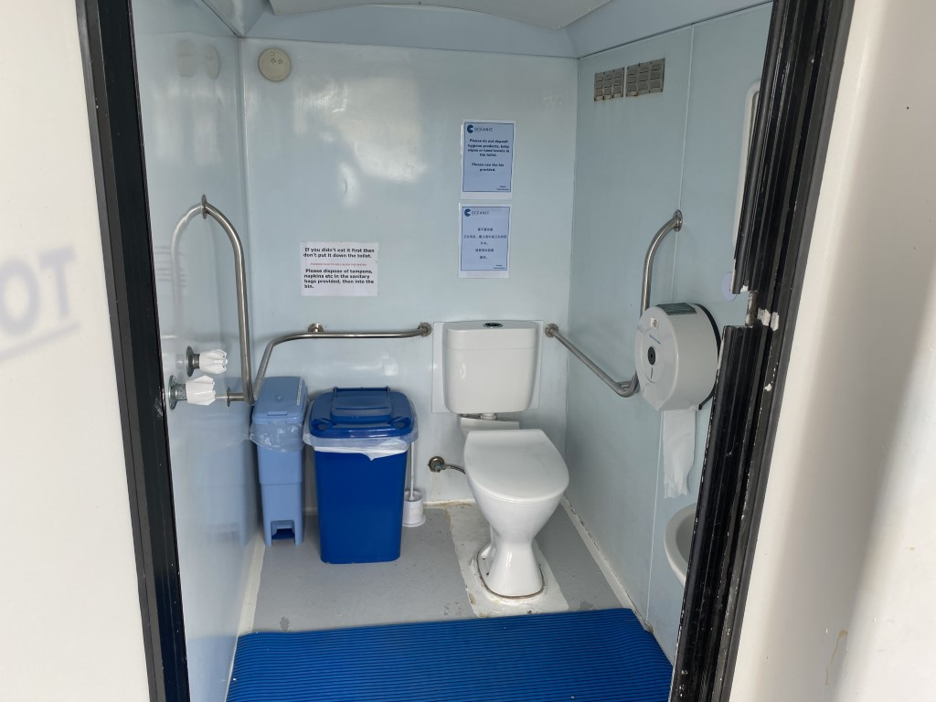
Lower Toilet (Medium)
- In addition, the following further information can assist guests:
nil

Guides
- Use of clear/simple English
- Correct pronunciation for lip readers
- There is a audio description of surroundings
- Marine
- Marine craft are wheelchair accessible
- Length (cm) 1000.
- Width (cm) 800mm.
- Height (cm) 900.
- Weight (kg) 200kg.
  - Image(s)
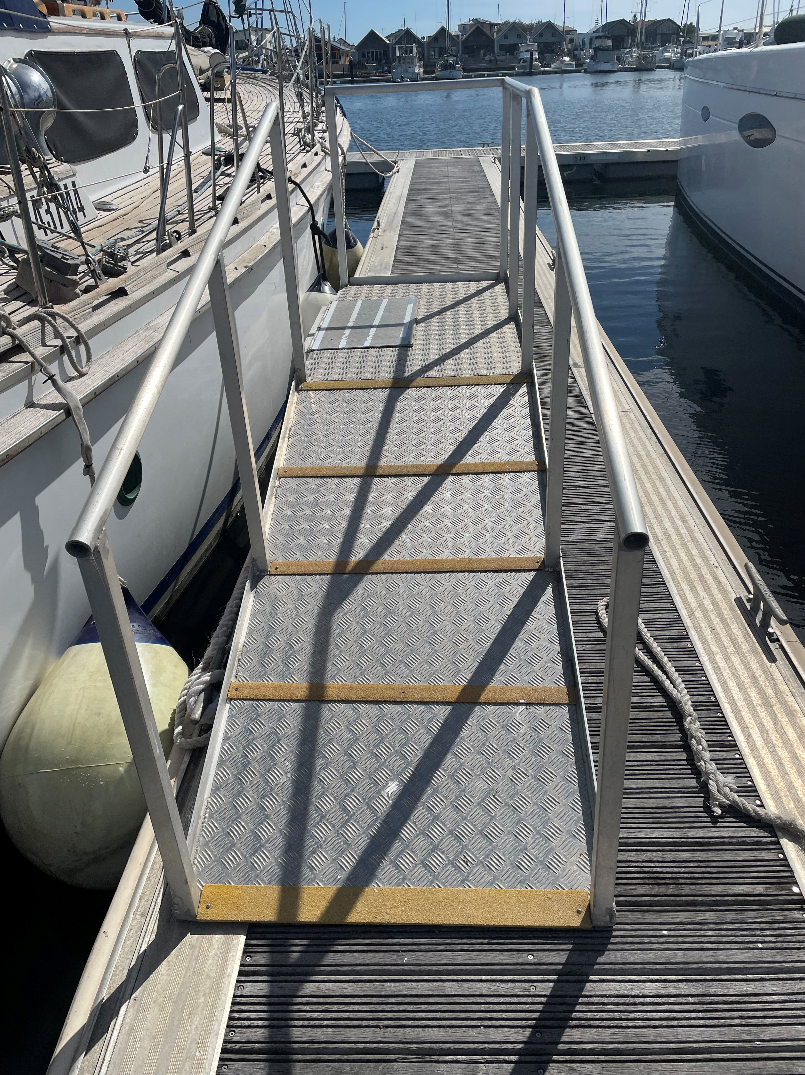
IMG_1436
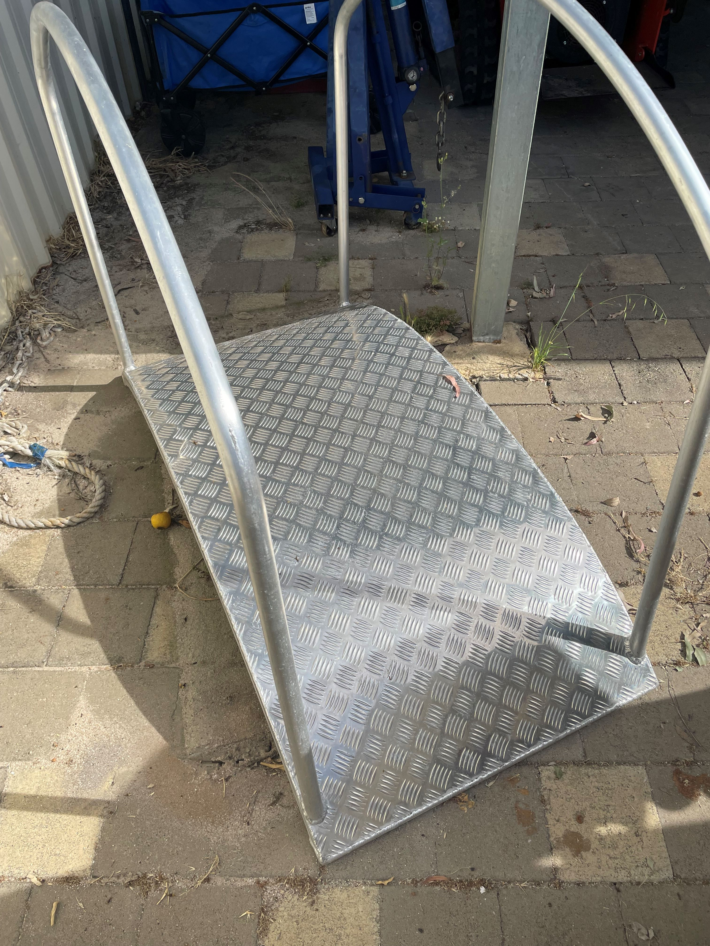
IMG_1446
- In addition, the following further information can assist guests:
wheelchair ramp can only be used for busselton tours , and we need to know prior to booking , n:b picture of ramp not against our boat

ADVENTURE ACTIVITIES

Adventure activities
The adventure activities have the following facilities/amenities in place
- Our adventure activities cater for people with a disability
The following activities are available to people with a disability: whale watching
The equipment utilised to make the activities available are: we have a acess ramp and disabled toilets
The following limitations apply to participation, including those activities that are not available to people with a disability: if in wheel chair access only to bottom deck
  - Adventure Activity Image(s)
IMG_1436
IMG_1446
- In addition, the following further information can assist guests:
we must know prior to tour of any mobility issue ,

Report Disclaimer
Please note that this business report, provided as a result of the use of the diagnostic assessment, is for information purposes only.
Australian Tourism Industry Council (ATIC) cannot guarantee the accuracy of respondent’s answers, or that they are fully representative of your business. Therefore, ATIC does not warrant or guarantee any particular outcome in respect of your businesses self-assessment.
This report is intended as guidance only for your business and should not be relied on for future marketing considerations. ATIC recommends that you seek your own independent advice as well as the results from the diagnostic.
Links to external web sites are inserted for convenience and do not constitute endorsement of material at those sites, or any associated organisation, product or service.
ATIC does not:
- Assume any legal liability for the accuracy, completeness, or usefulness of any information from this report or any links provided; or
- Accept responsibility for any loss associated directly or indirectly from the use of this report.

