ATIC Accessibility
To support the accessible community in making informed travel decisions for their individual needs

This report prepared for:
Business name: | Go Adventure Nagambie
Address: | 66 Loddings Lane
Town: | Nagambie
Contact for enquiries: | Lee Rowland
Contact Number: | 0449504398
Contact Email: | bookings@goadventurenagambie.com.au
Website: | https://www.goadventurenagambie.com.au/
Date: | 2026-10-28 18:06

ATIC Accessibility
The following pages provides travellers with information on the businesses facilities and amenities which aims to support the traveller to make an informed decision on whether the business is suitable for their individual needs.
OVERVIEW 4
Business Overview 4
Bookings 4
Emergency Management 4
Communications 5
Other Information 5
Guide Dog and Service Animals 6
GENERAL 7
Pre-arrival, arrival and reception 7
Cognitive Impairment Support 7
Car Park and Access amenities 8
Entry 8
Internal Spaces 9
Public areas 9
External Paths 9
Ramps 10
Public Toilets/Adult change facilities 10
TOUR OPERATORS 11
Tour/Transport Services 11
Route Planning 11
Guides 11
ADVENTURE ACTIVITIES 13
Adventure activities 13
Report Disclaimer 15

OVERVIEW

Business Overview

The business has the following products/services available
- Tour/Transport
- Adventure

Our business caters for the following disability types:
- Blind or low vision
- Deaf or low hearing
- Limited mobility
- Wheelchairs or mobility scooters
- Food allergies or intolerances
- Cognitive or people on the Autism Spectrum

Bookings

The business offers the following methods for bookings and enquiries:
- Phone
- Email
- Webportal
- Our website supports Screen Readers
- Staff have undergone disability awareness and training

Emergency Management
- The business has an emergency management and evacuation plan for guests with a disability
- Emergency and evacuation procedures are explained on arrival
We ensure exit access is free and clear at all times by: Entry and exit gates remain fully open during operating hours and kept clear of parked cars at all times
- There is an emergency refuge that has an intercommunication system linked and has sufficient fire resistance levels.
- Guests with disabilities are noted in the guest log book for emergency and evacuation purposes

Communications
- An accessibility guide is available on the website
https://accreditation.qualitytourismaustralia.com/report/AccessReportPublicHtml2/f84d8416-bc80-ec11-a972-00155d6431a8#
- Our business offers the following alternative communication methods
- Plain English
- Magnifiers
Google translate available on site
- There is easy to read signage and information (e.g. menus and emergency information)
- There is a Pictorial menu
- There are Picture boards
  - Picture Boards Image(s)
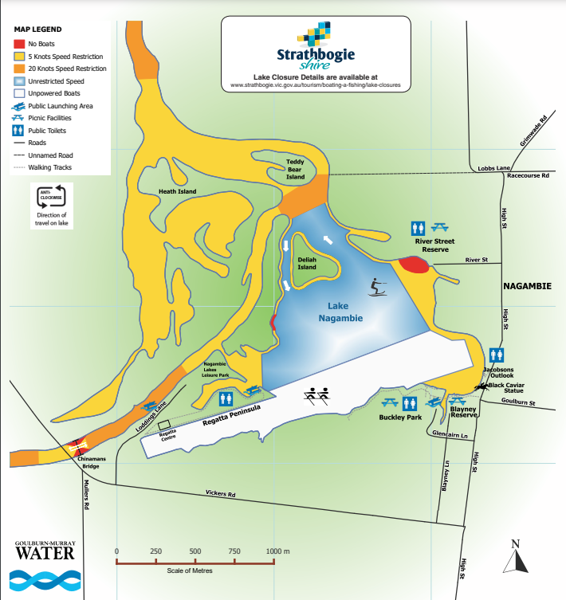
Nagambie Lakes Waterways Map
Introduction cards are used when necessary

Other Information
- The business accepts the companion card

Guide Dog and Service Animals
- The business provides a secure area with shade and water for service animals
- The business provides a toilet area for service animals
- Bowls, bedding, etc. are provided for service animals
The business provides the following services for services animals: Service animals have access across our entire operating site and are able to access all our equipment to support owners as necessary. Onsite food and water are available for service animals as are flotation devices and buoyancy vests to support on water activities.

GENERAL

Pre-arrival, arrival and reception
The business has the following in place to support guests during pre-arrival, arrival and reception
- Booking information and websites are compatible with screen readers
- There is a reception/public entryway.
- Seating available at reception
- A lower counter at reception/ticket office
- A clipboard to allow check-in/ticket purchase whilst seated
- A tablet with text to voice or pen and paper at reception to aid in communication
- Picture Board at reception to aid in communication
- Lighting in the reception area is even and glare free
- Large print information sheets and registration forms
- Information and maps are available in written form
- A familiarisation tour
- Advertising material, web sites and social media contain information relating to phone numbers available for non-voice communication e: Text, SMS, email and fax
- A key to any accessible facilities that are locked
The following steps are in place to ensure that people with fatigue related to their disability are not disadvantaged by long wait times: All customer bookings are time slotted and made within equipment and resourcing capabilities of the business to ensure that there are no long wait times for any customers regardless of disability or not. For walk ins without a booking, we communicate to customers availability and wait times if applicable and having seating and wait areas available to suit differing capabilities and disabilities if necessary.
- In addition, the following further information can assist guests:
Go Adventure Nagambie is an inclusive business and will always attempt to support all accessibility and inclusivity needs of our customers. To ensure we can accommodate specific needs we recommend contacting our friendly team to discuss your needs further.

Cognitive Impairment Support
- Documents are available in plain English for people with cognitive impairment (This may include instructions, guides, menus and general information)
- A "social script" guide to your premises or attraction describing the sights, sounds and smells to aid parents/carers prepare visitors in advance
- The 'social script' is available in word and other editable formats
- Quiet periods or early opening times for people on the Autism Spectrum
- A space for parents and children on the Autism Spectrum
- Access has alternative procedures and clear written instructions with universal access symbols

Car Park and Access amenities
The business has the following Car Park and Access amenities
- A drop off zone
- Designated disabled parking bays
- Level or ramped access from the car park to the entrance
- The accessible entrance is clearly signed from the parking bay
- The public transport services available are:
Full accessibility is available at the Nagambie Train/Bus Station - Nash Street Nagambie
- In addition, the following further information can assist guests:
Car parking is available immediately outside our site with clear unimpeded access to our site office for check in prior to activity.

Entry
The business has the following amenities/systems in place for entry
- A drop off point close to the entrance
- A path of access to the building is slip resistance and even
- A path of access to the building is clear of obstruction
- Self opening entry doors or fitted with a self closer
- Glass doors are fitted with a visual sighting strip
- Door jams/doors are of a contrasting colour to surrounding walls
- Door handles are of a contrasting colour to the door
- Signage is written in a contrasting colour
- Signage is written in a Sans Serif font and use upper and lower case letters
- The entry door is a minimum of 850mm wide
- The entry door has self opening or a light opening pressure (for manual operations)
- The entrance sill is less than 13mm
- There a clear space of at least 1500mm x 1500mm in front of all doors.
- The entrance door mats have a thickness less than 13mm and a width of 7500mm or greater
- In addition, the following further information can assist guests:
A 3 metre wide gate access gate at the front of our site ensures unimpeded access at all times.
- In addition, the following further information can assist guests:
No lifts on site

Internal Spaces
- Clear and unobstructed routes through and between buildings
- Interior walls are matte or low sheen
- Floors, walls, counters and furniture are of contrasting colours
- Floor surfaces are hard or short pile carpet
- Seating is available for guests unable to stand for long periods
- Accessible facilities are clearly signed and visible from all areas
- All corridors greater than 900mm
- There is a quiet space for parents and children on the Autism Spectrum
- In addition, the following further information can assist guests:
Our open-air site with ample space and much seating ensures accessibility support for our customers.

Public areas
The public areas have the following amenities in place
- Display units, Televisions, Video displays etc. are open captioned
- Even lighting
- Seating
- In addition, the following further information can assist guests:
Our open-air site with ample space and much seating ensures accessibility support for our customers.

External Paths
External paths of travel
- Surfaces are concrete, asphalt, smooth paving or hard packed fine gravel (max aggregate size 13mm)
- Pathways are wider than 900mm
No steps and where necessary access to equipment is assisted by temporary ramps
No steps and where necessary access to equipment is assisted by temporary ramps
- In addition, the following further information can assist guests:
A clear path of access is available across our entire site
- In addition, the following further information can assist guests:
No steps

Ramps
Ramps have the following amenities are in place
- Temporary ramps are in place for the duration of the guests stay

Public Toilets/Adult change facilities
Public Toilets/Adult change facilities have the following amenities are in place
- There is an accessible toilet for public use
- The door is at least 850mm wide
- There is a minimum of 850mm beside the toilet
- Handrails are fitted
- The toilet seat is 460mm above the floor
- There is 2500mm mm of clear space in front of the toilet
- The toilet seat of a contrasting colour to the floor
- The toilet seat is460mm above the floor
- There is a registered changing places facility
- There is a 'Changing Place' within 100 metres of our business
- In addition, the following further information can assist guests:
An all-access toilet block is available adjoining our operating site.

TOUR OPERATORS

Tour/Transport Services
The tour/transport services have the following facilities/amenities in place
- Buses/Coaches
- All vehicles have wheelchair lifts or ramps
- All vehicles have low floors with ramped entry
The maximum wheelchair capacity available in the fleet is: Two
- Commentary is available in written format
- Audio visual displays are sub titles

Route Planning
- Route Planning
- The tour route includes stops with accessible toilet facilities
- In addition, the following further information can assist guests:
All tours and routes can be customised to the specific needs of our customers and can be pre-arranged or arranged on the day (whenever possible)
- Lunch stop venues are accessible
- Sightseeing and photo opportunity stops are step free

Guides
- Use of clear/simple English
- Correct pronunciation for lip readers
- There is a audio description of surroundings
- Marine
- Marine craft are wheelchair accessible
- Length (cm) 100.
- Width (cm) 65.
- Height (cm) 100.
- Weight (kg) 25.
- This tour stops at attractions/accommodation/food and beverage/retail spaces that are not operated by this business. For information relating to these individual properties please follow the weblink provided
- In addition, the following further information can assist guests:
All tours and routes can be customised to the specific needs of our customers and additional access at other sites such as river side wineries can be pre-arranged to suit customer needs (whenever possible)

ADVENTURE ACTIVITIES

Adventure activities
The adventure activities have the following facilities/amenities in place
- Our adventure activities cater for people with a disability
The following activities are available to people with a disability: All activities at Go Adventure Nagambie are able to be modified to suit the vast majority of disability needs, with physical disability being the key factor in assessing customer accessibility for our activities. Disabled customers are able to enjoy our activities inclusive of - Canoe and Kayaking - Stand up paddle boarding - Pedal boating - Tinnie (motor boat) activities, and - Pontoon boat cruises - Cycling Pending the actual disability and level of disability, support persons or team members from Go Adventure Nagambie support disabled customers embarking and disembarking from our activities to ensure safe and fun enjoyment of our activities.
The equipment utilised to make the activities available are: Other than physical disability all other activities are able to be enjoyed by our customers. In the case of physical disability and the necessity of wheelchair use, we recommend appropriate wheelchairs for access to our customers, or alternatively we have on site an appropriately sized wheelchair and can access more of these at short notice when needed. Ramps are also used to assist with wheelchair access when needed as are floating docks to assist in positioning of equipment and ramps when and if necessary.
The following limitations apply to participation, including those activities that are not available to people with a disability: Our limitation to participation is physical disability, we always endeavor to alter activities or provide support for physical disabilities, however if physically disabled customers are unable to safety partake in activities, we do not risk their safety. Activities such as kayaking and canoeing, stand up paddle boarding and pedal boating are affected by limitations of physical disability. Where physical disability requires wheelchair access, activities are limited to our pontoon boat guided cruises. All ability customers are able to enjoy our pontoon boat cruises.
- In addition, the following further information can assist guests:
Go Adventure Nagambie is an inclusive business and will always attempt to support all accessibility and inclusivity needs of our customers. To ensure we can accommodate specific needs we recommend contacting our friendly team to discuss your needs further.

Report Disclaimer
Please note that this business report, provided as a result of the use of the diagnostic assessment, is for information purposes only.
Australian Tourism Industry Council (ATIC) cannot guarantee the accuracy of respondent’s answers, or that they are fully representative of your business. Therefore, ATIC does not warrant or guarantee any particular outcome in respect of your businesses self-assessment.
This report is intended as guidance only for your business and should not be relied on for future marketing considerations. ATIC recommends that you seek your own independent advice as well as the results from the diagnostic.
Links to external web sites are inserted for convenience and do not constitute endorsement of material at those sites, or any associated organisation, product or service.
ATIC does not:
- Assume any legal liability for the accuracy, completeness, or usefulness of any information from this report or any links provided; or
- Accept responsibility for any loss associated directly or indirectly from the use of this report.

