ATIC Accessibility
To support the accessible community in making informed travel decisions for their individual needs

This report prepared for:
Business name: | Off The Beaten Track WA
Address: | 114 Wattle Rd
Town: | Serpentine
Contact for enquiries: | Tracy Lindsey
Contact Number: | 0417 128 896
Contact Email: | tracy@offthebeatentrackwa.com.au
Website: | https://offthebeatentrackwa.com.au
Date: | 2026-10-20 19:54

ATIC Accessibility
The following pages provides travellers with information on the businesses facilities and amenities which aims to support the traveller to make an informed decision on whether the business is suitable for their individual needs.
OVERVIEW 4
Business Overview 4
Bookings 4
Emergency Management 4
Communications 5
Other Information 5
Guide Dog and Service Animals 5
GENERAL 6
Pre-arrival, arrival and reception 6
Cognitive Impairment Support 6
Car Park and Access amenities 6
External Paths 7
Ramps 7
Public Toilets/Adult change facilities 7
TOUR OPERATORS 8
Route Planning 8
Guides 8
FOOD AND DRINK 9
Dining Spaces 9
Report Disclaimer 11

OVERVIEW

Business Overview

The business has the following products/services available
- Tour/Transport

Our business caters for the following disability types:
- Blind or low vision
- Deaf or low hearing
- Limited mobility
- Wheelchairs or mobility scooters
- Food allergies or intolerances
- Cognitive or people on the Autism Spectrum

Bookings

The business offers the following methods for bookings and enquiries:
- Phone
- Email
- Webportal
- Our forms have high contract boxes and submit boxes
- Staff have undergone disability awareness and training

Emergency Management
- The business has an emergency management and evacuation plan for guests with a disability
- Emergency and evacuation procedures are explained on arrival
- Guests with disabilities are noted in the guest log book for emergency and evacuation purposes

Communications
- An accessibility guide is available on the website
chrome-extension://efaidnbmnnnibpcajpcglclefindmkaj/https://offthebeatentrackwa.com.au/wp-content/uploads/2023/06/ATICAccessibilityPublic.pdf
- Our website meets WCAG 2.0 accessibility standards
- Our business offers the following alternative communication methods
- Plain English
- Magnifiers
3.2 N/A | Alternative communication methods, Voice, text, face-to-face/video
- There is easy to read signage and information (e.g. menus and emergency information)
Picture Boards are used to demonstrate some interpretive content where the participant specifies this requirement in boking form/consult

Other Information
- The business accepts the companion card

Guide Dog and Service Animals
- The business provides a secure area with shade and water for service animals
- The business provides a toilet area for service animals
The business provides the following services for services animals: Service animals are permitted to join the experience if required. They must stay leashed though due to 1080 baiting.

GENERAL

Pre-arrival, arrival and reception
The business has the following in place to support guests during pre-arrival, arrival and reception
- Information and maps are available in written form
- A step free map/guide
- A familiarisation tour
We do not have lockable facilities
The following steps are in place to ensure that people with fatigue related to their disability are not disadvantaged by long wait times: All our experiences are tailored for people living with a disability. For any of our accommodation based tours, we provide all the Guests details to the venue and manage the check in on their behalf.

Cognitive Impairment Support
- Documents are available in plain English for people with cognitive impairment (This may include instructions, guides, menus and general information)
- A "social script" guide to your premises or attraction describing the sights, sounds and smells to aid parents/carers prepare visitors in advance
- The 'social script' is available in word and other editable formats
- Quiet periods or early opening times for people on the Autism Spectrum
- A space for parents and children on the Autism Spectrum

Car Park and Access amenities
The business has the following Car Park and Access amenities
- A drop off zone
- Designated disabled parking bays
- Level or ramped access from the car park to the entrance
- The accessible entrance is clearly signed from the parking bay
- The public transport services available are:
Information is provided on an as needs basis for our guests to ensure they can arrive at the Tour/Hike meeting point safely and with ease.
The width of the smallest corridor is: No corridors in nature

External Paths
External paths of travel
- Surfaces are concrete, asphalt, smooth paving or hard packed fine gravel (max aggregate size 13mm)
- Pathways are wider than 900mm
- There 3 successive steps or less on any path or at any doorway
- Any paths having steps are clearly identified as non-wheelchair accessible
- In addition, the following further information can assist guests:
We use nature trails with minimal signage/steps. The Guide verbalises and hazards and accompanies guests at all times. We generally adjust the route for the hike/tour if we have a guest with low vision/mobility to avoid steps and minimise risk.

Ramps
Ramps have the following amenities are in place
- Temporary ramps are in place for the duration of the guests stay

Public Toilets/Adult change facilities
Public Toilets/Adult change facilities have the following amenities are in place
- There is an accessible toilet for public use
- The door is at least 850mm wide
- There is a minimum of 850mm beside the toilet
- Handrails are fitted
- The toilet seat is 460mm above the floor
- There is Various, but minimum is 1400mm mm of clear space in front of the toilet
- The toilet seat of a contrasting colour to the floor
- The toilet seat is460mm above the floor
- In addition, the following further information can assist guests:
N/A

TOUR OPERATORS

Route Planning
- Route Planning
- The tour route includes stops with accessible toilet facilities
- In addition, the following further information can assist guests:
N/A
- Lunch stop venues are accessible
- Sightseeing and photo opportunity stops are step free
- Overnight Stops
The total number of wheelchair passengers that can be catered for at overnight stops are: 2
- Walking Tours
- Operated on a step free route
- Multi-paced to account for slower walkers

Guides

Guides have been trained in the following
- Use of clear/simple English
- Correct pronunciation for lip readers
- There is a audio description of surroundings
  - Image(s)
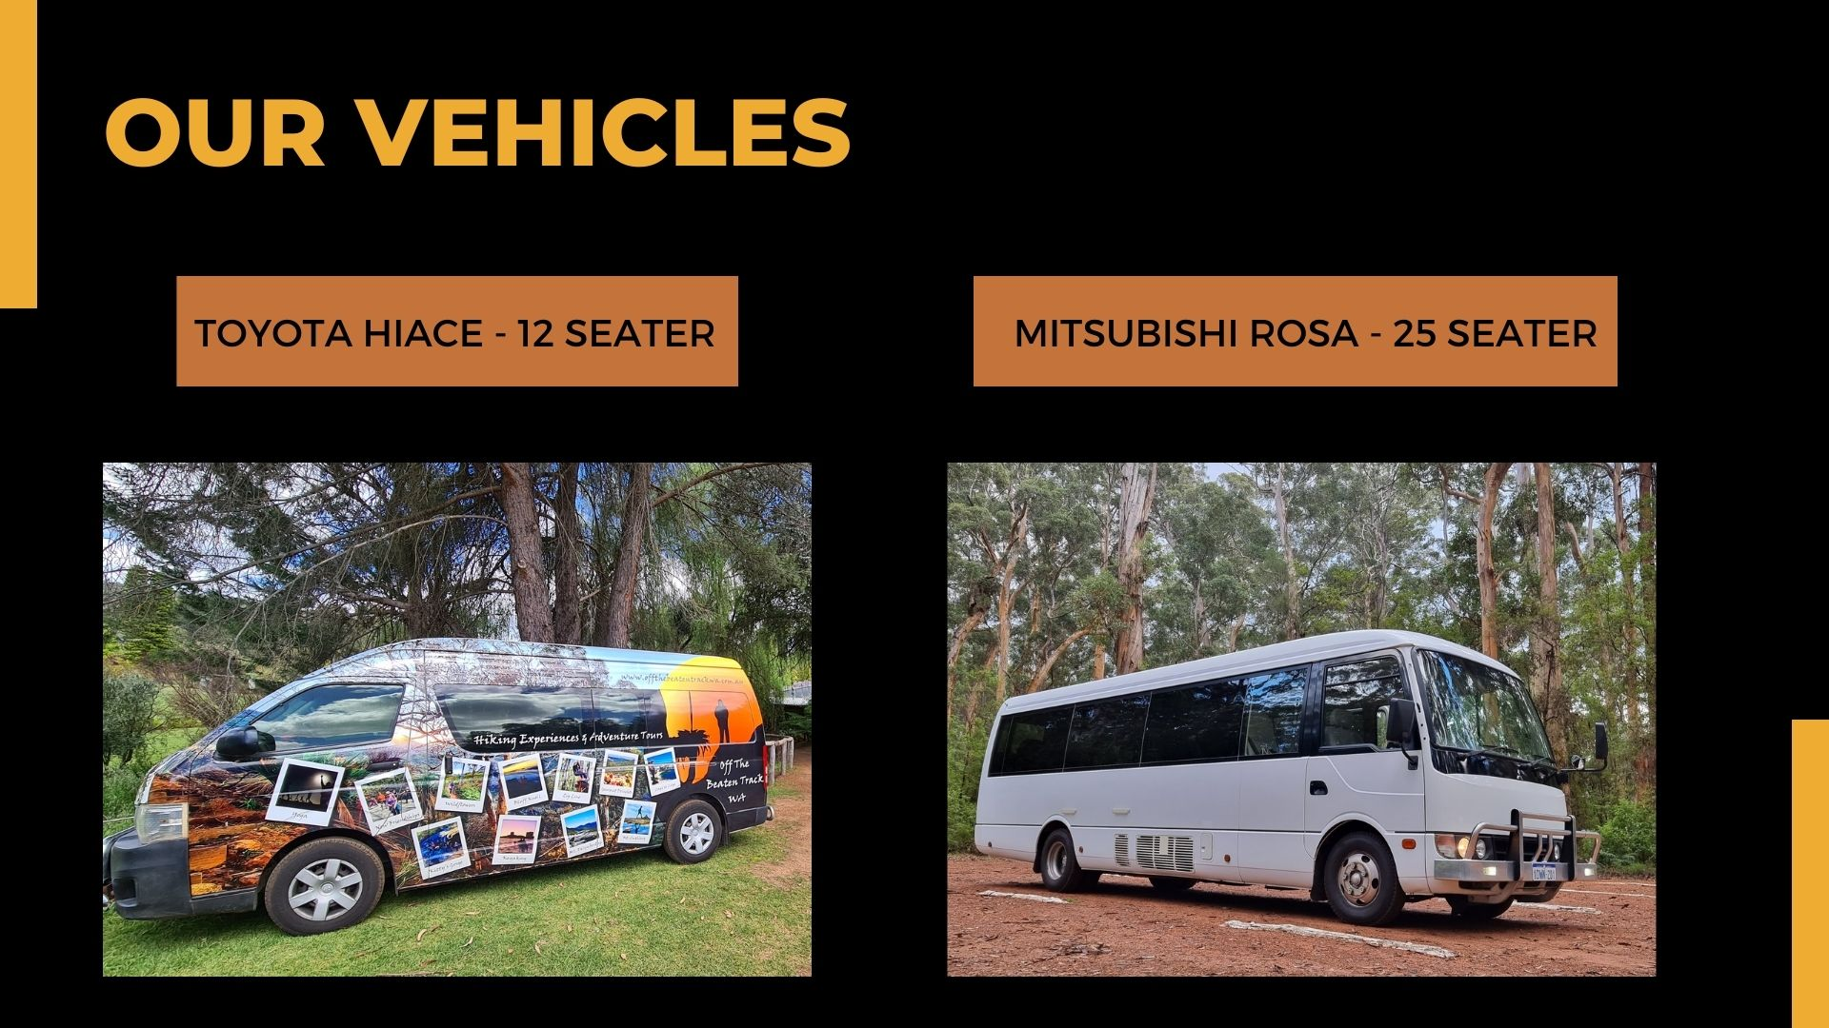
OTBT Vehicles
- This tour stops at attractions/accommodation/food and beverage/retail spaces that are not operated by this business. For information relating to these individual properties please follow the weblink provided

FOOD AND DRINK

Dining Spaces
The dining spaces have the following facilities/amenities in place
- The smallest doorway is NA wide
- There are areas of full lighting
- There is an accessible toilet

Our business caters for the following dietary requirements
- Sugar free (diabetic)
- Gluten free (celiac)
- Lactose free (dairy free)
- Low fat and fibre with no gastric content
- Low potassium
- Low sodium
- Nut free
- Additive free
- Organic
- Vegetarian
- Vegan
- Kosher
- Halal
- There are procedures in place to avoid cross-contamination of food products
- In addition, the following further information can assist guests:
NA above - as no entry/doors etc.

Report Disclaimer
Please note that this business report, provided as a result of the use of the diagnostic assessment, is for information purposes only.
Australian Tourism Industry Council (ATIC) cannot guarantee the accuracy of respondent’s answers, or that they are fully representative of your business. Therefore, ATIC does not warrant or guarantee any particular outcome in respect of your businesses self-assessment.
This report is intended as guidance only for your business and should not be relied on for future marketing considerations. ATIC recommends that you seek your own independent advice as well as the results from the diagnostic.
Links to external web sites are inserted for convenience and do not constitute endorsement of material at those sites, or any associated organisation, product or service.
ATIC does not:
- Assume any legal liability for the accuracy, completeness, or usefulness of any information from this report or any links provided; or
- Accept responsibility for any loss associated directly or indirectly from the use of this report.

