ATIC Accessibility
To support the accessible community in making informed travel decisions for their individual needs

This report prepared for:
Business name: | Coral Bay Ecotours
Address: | Shop 4, Peoples Park SHopping Village
Town: | Coral Bay
Contact for enquiries: | Kylie Merritt
Contact Number: | 0899425885
Contact Email: | enquiries@coralbayecotours.com.au
Website: | www.coralbayecotours.com.au
Date: | 2026-11-09 01:24

ATIC Accessibility
The following pages provides travellers with information on the businesses facilities and amenities which aims to support the traveller to make an informed decision on whether the business is suitable for their individual needs.
OVERVIEW 4
Business Overview 4
Bookings 4
Emergency Management 4
Communications 5
Other Information 5
Guide Dog and Service Animals 5
GENERAL 6
Pre-arrival, arrival and reception 6
Cognitive Impairment Support 6
Car Park and Access amenities 6
Entry 6
Internal Spaces 7
Public areas 7
Displays, exhibits, commentary and live performances 7
External Paths 7
Steps 8
Ramps 8
TOUR OPERATORS 9
Tour/Transport Services 9
Route Planning 9
Guides 10
Report Disclaimer 13

OVERVIEW

Business Overview

The business has the following products/services available
- Tour/Transport

Our business caters for the following disability types:
- Blind or low vision
- Limited mobility
- Wheelchairs or mobility scooters
- Food allergies or intolerances

Bookings

The business offers the following methods for bookings and enquiries:
- Phone
- Email
- Webportal

Emergency Management
- Emergency and evacuation procedures are explained on arrival
- There are Audible device/s to alert occupants to evacuate with instructions on how to evacuate.
- Exit signs are clear and easy to see
- Exit access is free and clear at all times
We ensure exit access is free and clear at all times by: On our boats, there are several areas that can be used for exits, but main exits are areas where equipment is kept away from and passengers are told to keep clear of
- Exits and access to exists are greater than 900mm
- Exit doors are able to be opened by all occupants
- Exits to the emergency evacuation point does not include stairways
- The evacuation point is clearly marked by a sign
The business identifies guests who need additional assistance should an emergency occur by: Indemnity forms that are completed prior to the tour
The procedure for assisting guests who need assisted rescue is: In water: the same as all guests. First aid and water safety rescue, whistles, clear communication
- Guests with disabilities are noted in the guest log book for emergency and evacuation purposes

Communications

Other Information
- The business accepts the companion card

Guide Dog and Service Animals
- The business provides a secure area with shade and water for service animals
The business provides the following services for services animals: Our tour boats allow service animals to join the tours. The most accessible tour boat for service animals is our Glass Bottom Boat. This boat runs short tours which allow guests to take service animals, with minimal chances of animals suffering seasickness due to being in sheltered waters and not too far from shore. For longer tours, service animals are considers on case-by-case basis, and can absolutely be accommodated if the guest feels that it would be suitable.

GENERAL

Pre-arrival, arrival and reception
The business has the following in place to support guests during pre-arrival, arrival and reception
- There is a reception/public entryway.
- Seating available at reception
- A lower counter at reception/ticket office
- A clipboard to allow check-in/ticket purchase whilst seated
- A tablet with text to voice or pen and paper at reception to aid in communication
- Information and maps are available in written form
- A familiarisation tour
- Advertising material, web sites and social media contain information relating to phone numbers available for non-voice communication e: Text, SMS, email and fax
No facilities are locked
The following steps are in place to ensure that people with fatigue related to their disability are not disadvantaged by long wait times: If guests are waiting to be served/seen to at our office, there is seating available if required

Cognitive Impairment Support
- Documents are available in plain English for people with cognitive impairment (This may include instructions, guides, menus and general information)

Car Park and Access amenities
The business has the following Car Park and Access amenities
- A drop off zone
- Level or ramped access from the car park to the entrance
- The accessible entrance is clearly signed from the parking bay

Entry
The business has the following amenities/systems in place for entry
- A drop off point close to the entrance
- A path of access to the building is slip resistance and even
- A path of access to the building is clear of obstruction
- Glass doors are fitted with a visual sighting strip
- Door jams/doors are of a contrasting colour to surrounding walls
- Door handles are of a contrasting colour to the door
- The entry door is a minimum of 850mm wide
- The entrance sill is less than 13mm

Internal Spaces
- Clear and unobstructed routes through and between buildings
- Any protruding or overhanging obstructions are at least 2meters above the floor or are protected
- Seating is available for guests unable to stand for long periods
- All corridors greater than 900mm

Public areas
The public areas have the following amenities in place
- Even lighting
- Seating

Displays, exhibits, commentary and live performances
For displays, exhibits, commentary and live performances the following amenities are in place
- Seating
- Wheelchair accessible spaces/seating
- A written transcript where audio description is provided i.e. display commentary, tour commentary

External Paths
External paths of travel
- Surfaces are concrete, asphalt, smooth paving or hard packed fine gravel (max aggregate size 13mm)
- Pathways are wider than 900mm
- There 3 successive steps or less on any path or at any doorway

Steps
Steps
- There are steps.
- Handrails fitted to all open sets of steps
- Handrails extend 300mm beyond the top and bottom step
- In addition, the following further information can assist guests:
2 of our vessels have upper decks which are accessible on via steps/ladders. All other areas are accessible without steps, or with 3 steps or less. For people who cannot use these ladders/steps, they have ample comfortable space on the lower decks of the vessels.

Ramps
Ramps have the following amenities are in place
- There are ramps.
- Hand rails are fitted
- Long ramps (more than 10m) are 1:20 or less
- There is n/a mm beside the toilet
- In addition, the following further information can assist guests:
There is a public toilet within the park facility where our office is located, but it is not operated by our business. All of our vessels have toilet facilities, but they are confined spaces and there would be a number of circumstances where people with accessibility issues would require assistance utilising the toilet facilities onboard.

TOUR OPERATORS

Tour/Transport Services
The tour/transport services have the following facilities/amenities in place
- Buses/Coaches
- 1 vehicles have wheelchair lifts or ramps
- 0 vehicles have low floors with ramped entry
The maximum wheelchair capacity available in the fleet is: 1 wheelchair per vessel
- Commentary is available in written format

Route Planning
- There is an accessible toilet on-board for public use
- The door is 800mm wide
- There is less than 700mm mm beside the toilet
- The toilet seat of a contrasting colour to the floor
- The toilet seat is 460mm above the floor
  - Accessible Toilet Image(s)
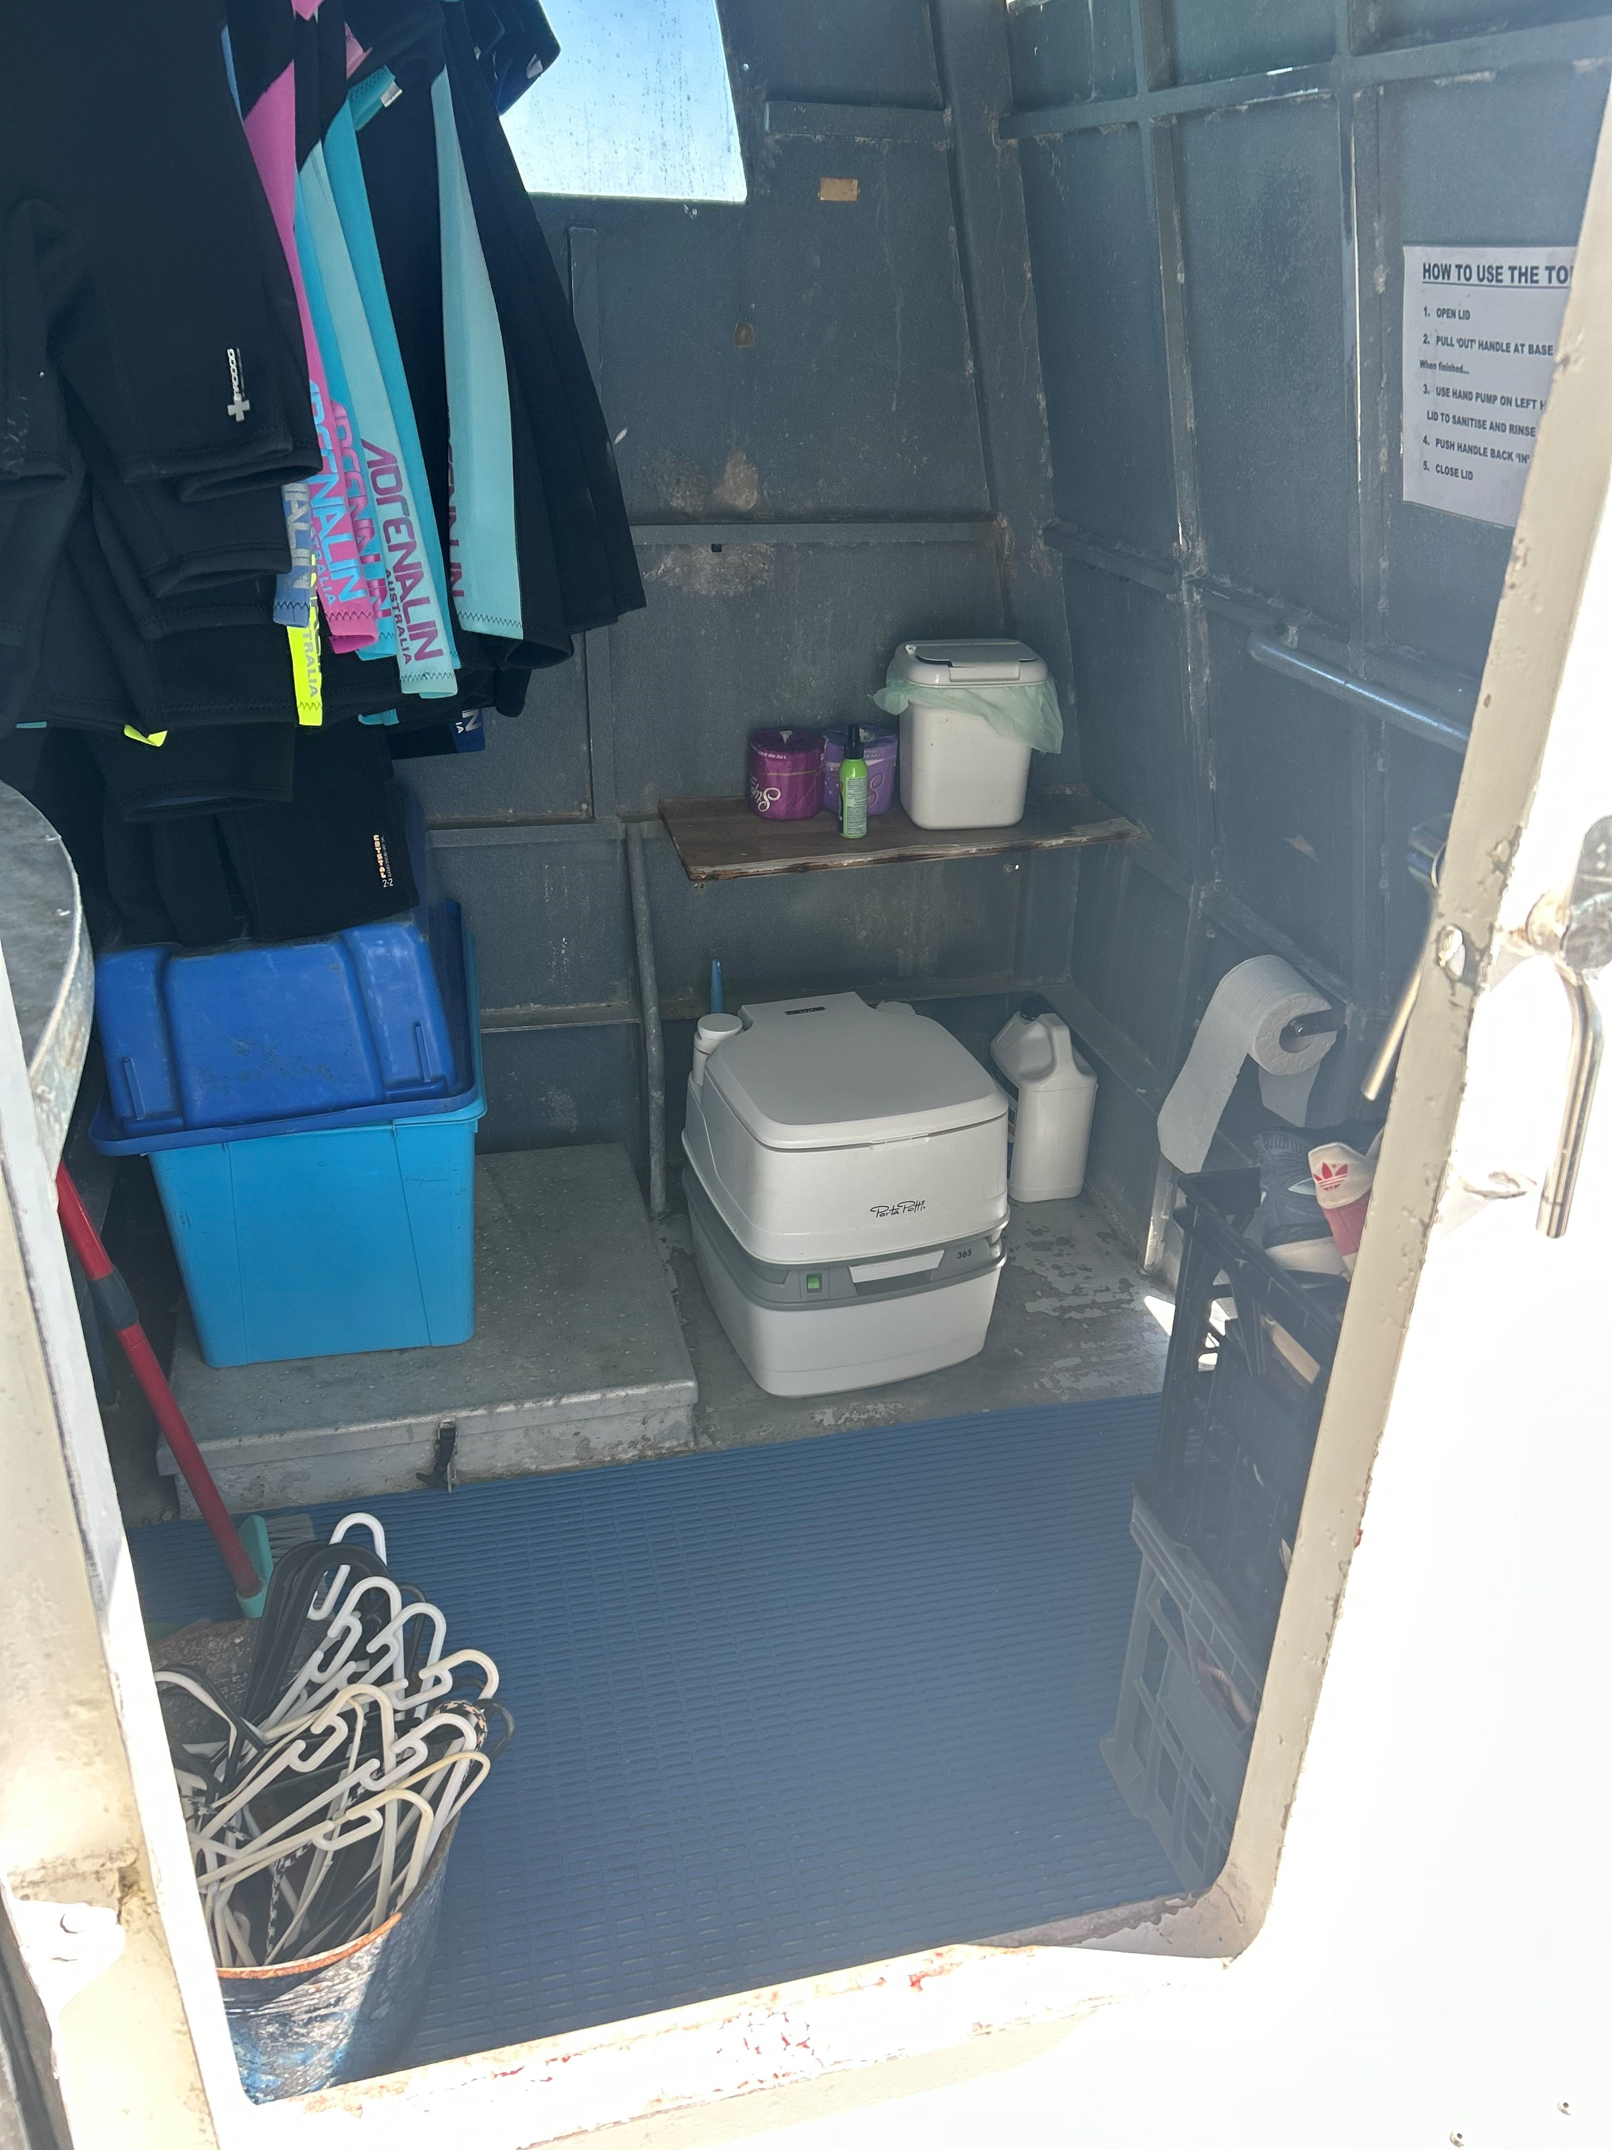
Toilet Kurni-ku
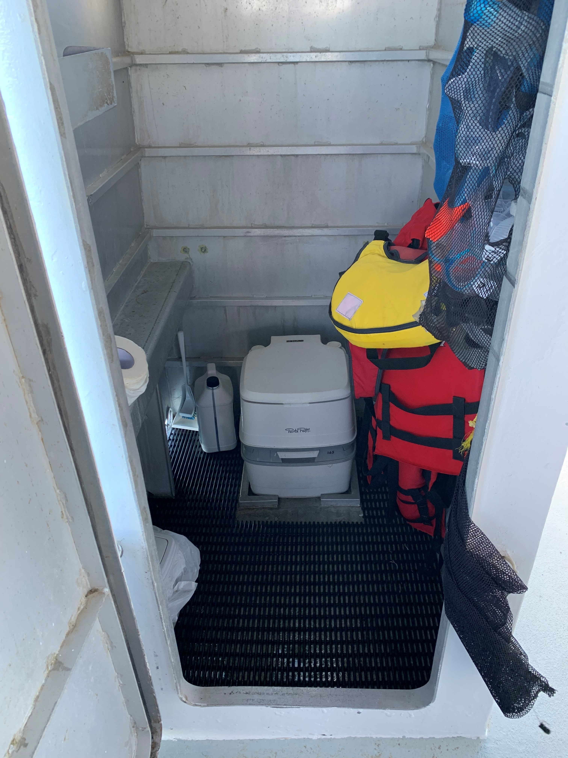
Toilet Nhanya-ku
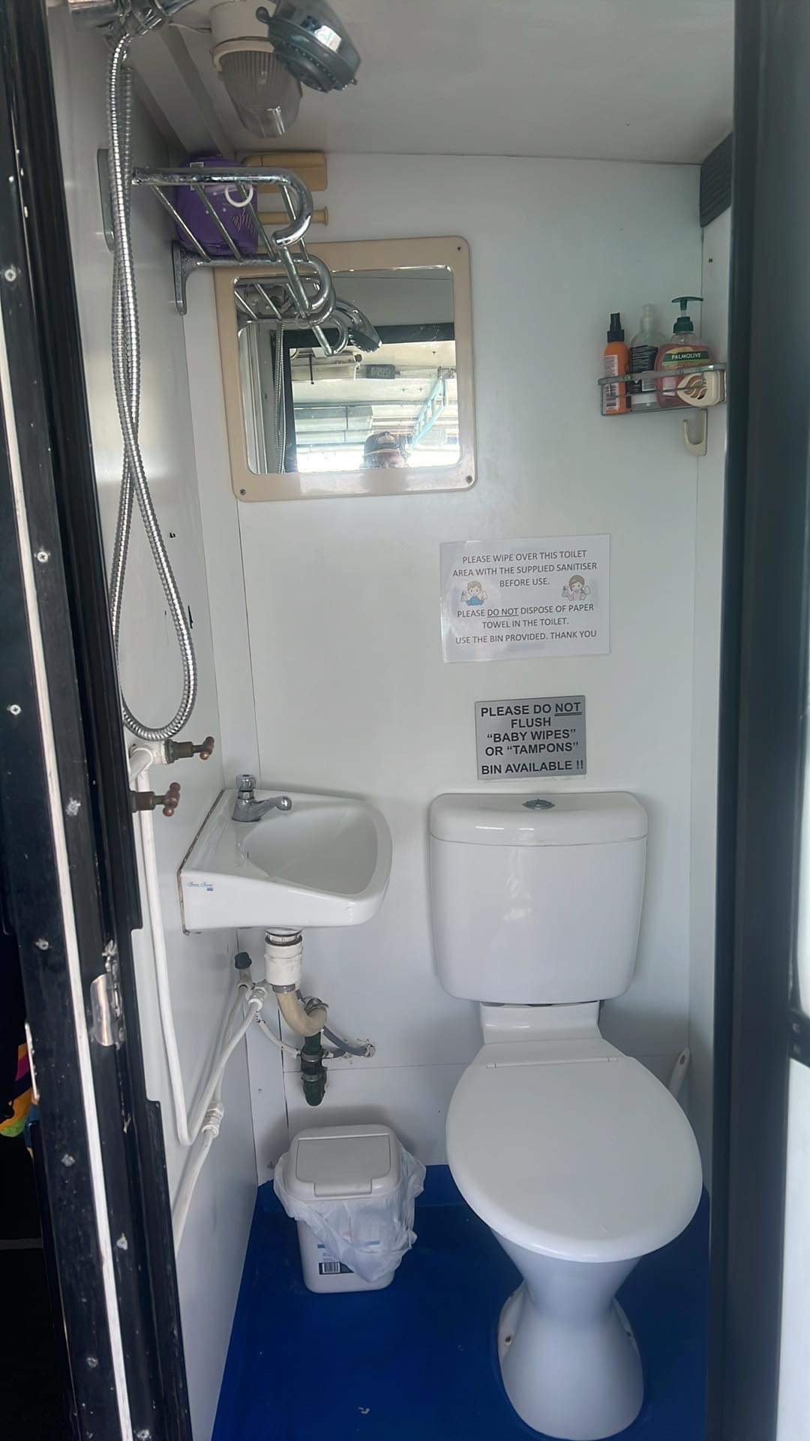
Toilet Thunder

Guides
- Use of clear/simple English
- Correct pronunciation for lip readers
- Marine
- Marine craft are wheelchair accessible
- Length (cm) 100.
- Width (cm) 110.
- Height (cm) 60.
- Weight (kg) 30.
- Accessibility is tide dependent
  - Image(s)
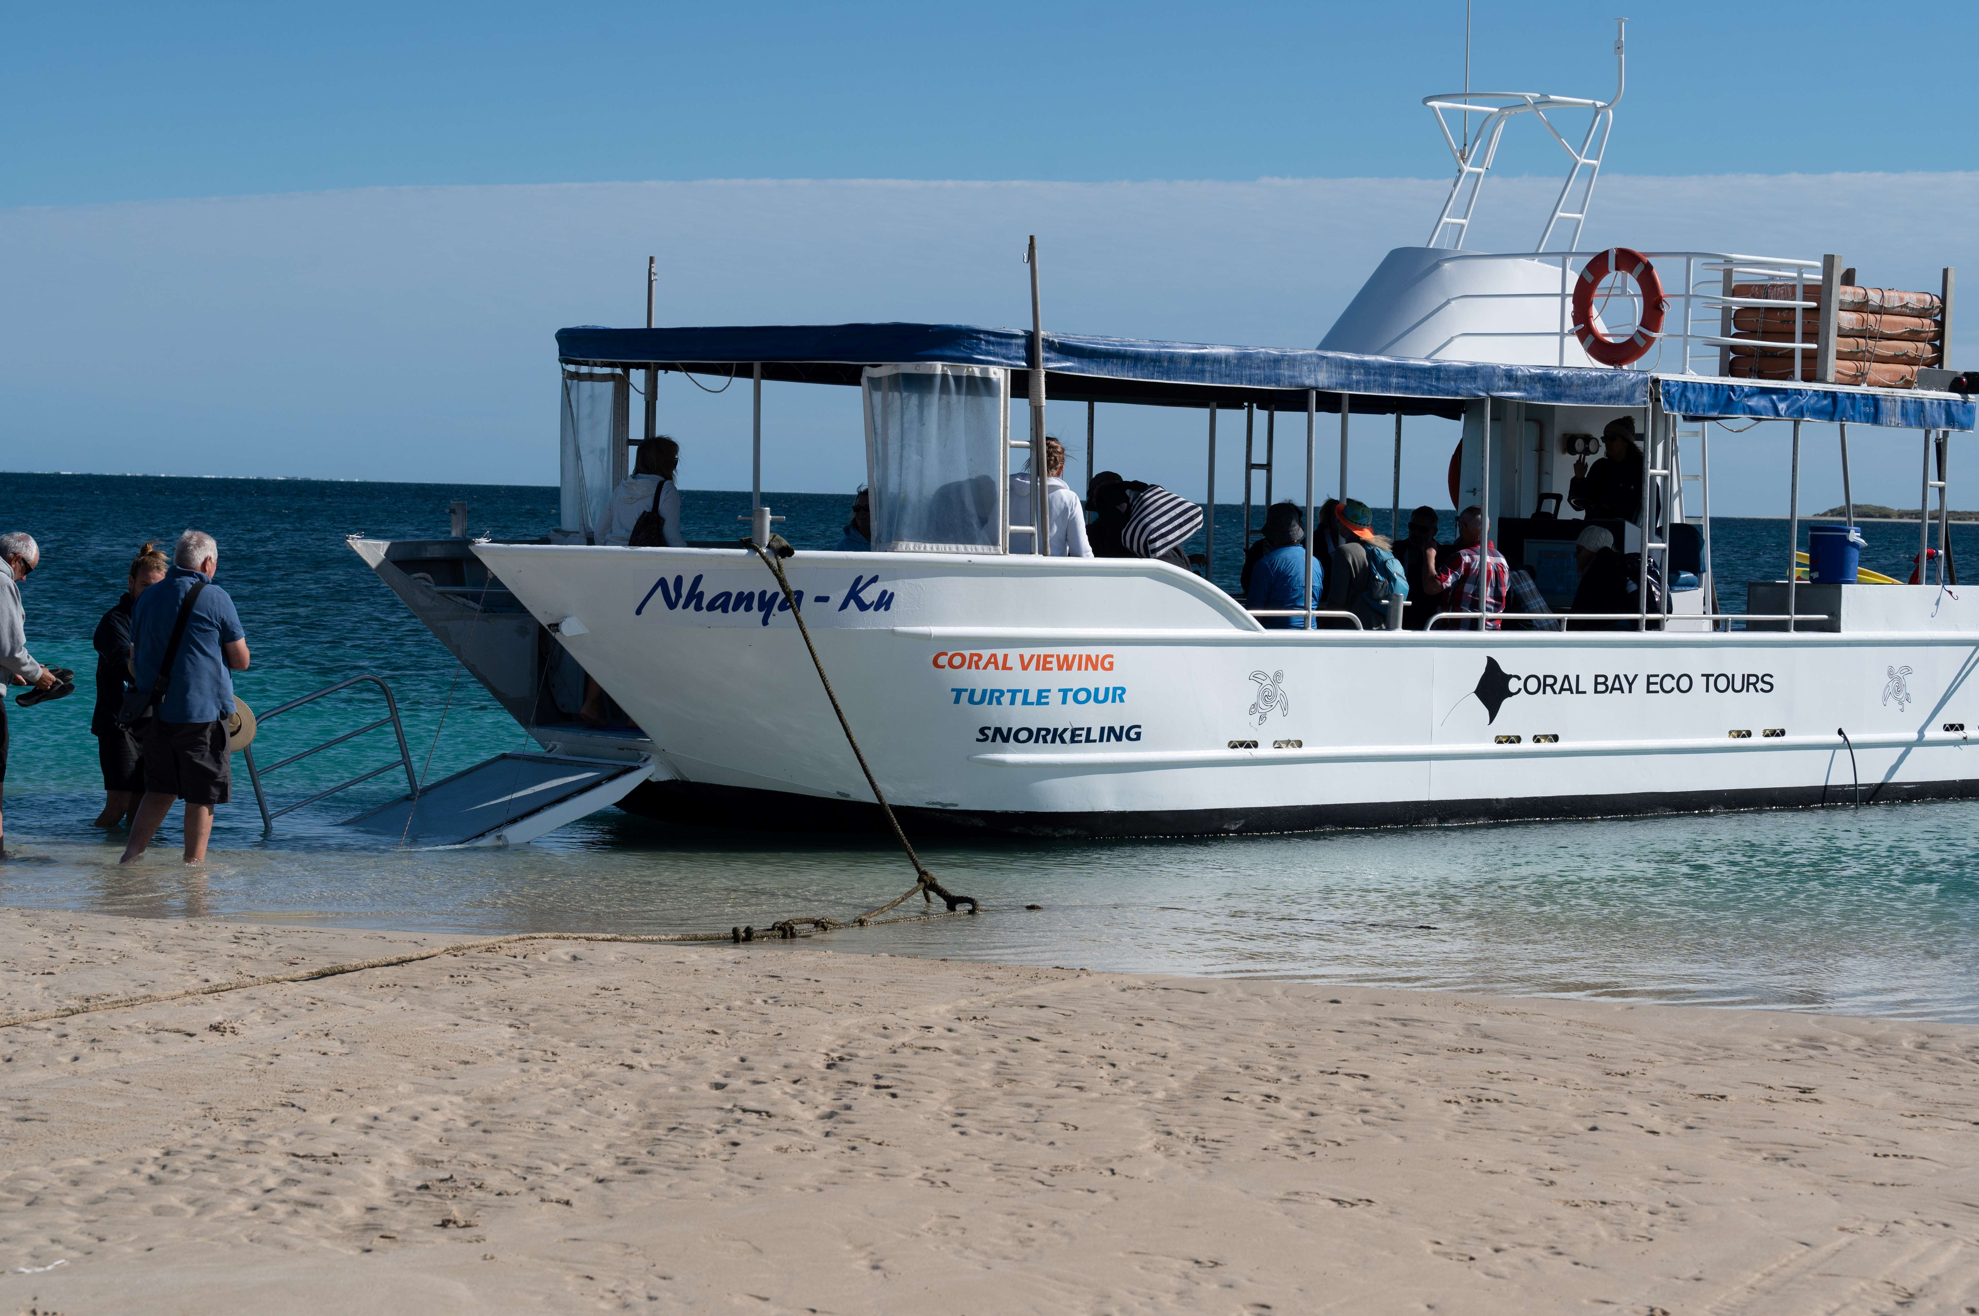
Ramp - wheelchair access Nhanya-ku1

Report Disclaimer
Please note that this business report, provided as a result of the use of the diagnostic assessment, is for information purposes only.
Australian Tourism Industry Council (ATIC) cannot guarantee the accuracy of respondent’s answers, or that they are fully representative of your business. Therefore, ATIC does not warrant or guarantee any particular outcome in respect of your businesses self-assessment.
This report is intended as guidance only for your business and should not be relied on for future marketing considerations. ATIC recommends that you seek your own independent advice as well as the results from the diagnostic.
Links to external web sites are inserted for convenience and do not constitute endorsement of material at those sites, or any associated organisation, product or service.
ATIC does not:
- Assume any legal liability for the accuracy, completeness, or usefulness of any information from this report or any links provided; or
- Accept responsibility for any loss associated directly or indirectly from the use of this report.

