ATIC Accessibility
To support the accessible community in making informed travel decisions for their individual needs

This report prepared for:
Business name: | Cygnet Bay Pearls
Address: | Cygnet Bay Pearl Farm
Town: | Dampier Peninsula
Contact for enquiries: | Jessie Hornblow
Contact Number: | 08 9192 4283
Contact Email: | reception@cygnetbay.com.au
Website: | www.cygnetbaypearlfarm.com.au
Date: | 2026-10-25 03:45

ATIC Accessibility
The following pages provides travellers with information on the businesses facilities and amenities which aims to support the traveller to make an informed decision on whether the business is suitable for their individual needs.
OVERVIEW 4
Business Overview 4
Bookings 4
Emergency Management 4
Communications 5
GENERAL 6
Pre-arrival, arrival and reception 6
Cognitive Impairment Support 6
Car Park and Access amenities 6
Entry 6
Internal Spaces 7
Public areas 7
Displays, exhibits, commentary and live performances 7
External Paths 7
Steps 8
Ramps 8
Public Toilets/Adult change facilities 8
TOUR OPERATORS 9
Tour/Transport Services 9
Route Planning 9
Guides 9
ACCOMMODATION 12
Bedrooms 12
Room Amenities 12
Bathrooms 13
COMMON AREAS 15
Play Spaces 15
Swimming pools, spas and waterparks 17
FOOD AND DRINK 23
Dining Spaces 23
ADVENTURE ACTIVITIES 27
Report Disclaimer 31

OVERVIEW

Business Overview

The business has the following products/services available
- Tour/Transport
- Accommodation
- Food and Drink
- Adventure

Our business caters for the following disability types:
- Limited mobility
- Wheelchairs or mobility scooters
- Food allergies or intolerances
- Cognitive or people on the Autism Spectrum

Bookings

The business offers the following methods for bookings and enquiries:
- Phone
- Email
- Webportal

Emergency Management
- Exit signs are clear and easy to see
- Exit access is free and clear at all times
We ensure exit access is free and clear at all times by: Wide open spaces, safari tents so not part of a building structure with passages.
- Exits and access to exists are greater than 900mm
- Exit doors are able to be opened by all occupants
- Exits to the emergency evacuation point does not include stairways
- The evacuation point is clearly marked by a sign
The business identifies guests who need additional assistance should an emergency occur by: It is noted on the In House Report from RMS and the duty manager is notified if we have guests who require extra assistance.
The procedure for assisting guests who need assisted rescue is: Duty Manager would meet the guests in a buggy to ensure they could be transported to the safe area.
- Guests with disabilities are noted in the guest log book for emergency and evacuation purposes

Communications

GENERAL

Pre-arrival, arrival and reception
The business has the following in place to support guests during pre-arrival, arrival and reception
- There is a reception/public entryway.
- Seating available at reception
- A clipboard to allow check-in/ticket purchase whilst seated
- Picture Board at reception to aid in communication
- Lighting in the reception area is even and glare free
- Advertising material, web sites and social media contain information relating to phone numbers available for non-voice communication e: Text, SMS, email and fax
- Luggage assistance
The following steps are in place to ensure that people with fatigue related to their disability are not disadvantaged by long wait times: The parking area for checking in is closest to reception and the parking area next to the disabled safari tents is adjacent to the tents. We have minimized the wait time as much as possible, there is a shaded area at reception if the guests are fatigued. Our reception staff will come out from behind the desk to assist the guest with the check in process.

Cognitive Impairment Support
- Documents are available in plain English for people with cognitive impairment (This may include instructions, guides, menus and general information)

Car Park and Access amenities
The business has the following Car Park and Access amenities
- A drop off zone
- Designated disabled parking bays
- Level or ramped access from the car park to the entrance

Entry
The business has the following amenities/systems in place for entry
- A drop off point close to the entrance
- A path of access to the building is slip resistance and even
- A path of access to the building is clear of obstruction
- Door jams/doors are of a contrasting colour to surrounding walls
- The entry door is a minimum of 850mm wide
- There a clear space of at least 1500mm x 1500mm in front of all doors.

Internal Spaces
- Clear and unobstructed routes through and between buildings
- Interior walls are matte or low sheen
- Tableware/glassware contrast with the table surface or table cloth
- Floor surfaces are hard or short pile carpet
- Seating is available for guests unable to stand for long periods
- All corridors greater than 900mm

Public areas
The public areas have the following amenities in place
- Seating

Displays, exhibits, commentary and live performances
For displays, exhibits, commentary and live performances the following amenities are in place
- Seating
- Wheelchair accessible spaces/seating

External Paths
External paths of travel
- Surfaces are concrete, asphalt, smooth paving or hard packed fine gravel (max aggregate size 13mm)
- Pathways are wider than 900mm
- There 3 successive steps or less on any path or at any doorway

Steps
Steps
- There are steps.
- Handrails extend 300mm beyond the top and bottom step
- Where steps are present are there three steps or less

Ramps
Ramps have the following amenities are in place
- There are ramps.
- All fixed ramps are 1:14 or less
- Long ramps (more than 10m) are 1:20 or less

Public Toilets/Adult change facilities
Public Toilets/Adult change facilities have the following amenities are in place
- There is an accessible toilet for public use
- The door is at least 850mm wide
- There is a minimum of 850mm beside the toilet
- Handrails are fitted
- The toilet seat is 460mm above the floor
- There is 1650mm mm of clear space in front of the toilet
- The toilet seat of a contrasting colour to the floor
- The toilet seat is460mm above the floor
- There is a registered changing places facility

TOUR OPERATORS

Tour/Transport Services
The tour/transport services have the following facilities/amenities in place
- Buses/Coaches
- 0 vehicles have wheelchair lifts or ramps
- 0 vehicles have low floors with ramped entry
The maximum wheelchair capacity available in the fleet is: 0

Route Planning
- In addition, the following further information can assist guests:
no toilet on our vessels - bus is only used to transport guests to & from airstrip, vessel launch from Shenton Bluff.
- Overnight Stops
- For overnight stays, wheelchair accessible rooms are available
The total number of wheelchair passengers that can be catered for at overnight stops are: 2 Disabled Tents with beds that can be split so we could accommodate 4 pax.

Guides
- Use of clear/simple English
- Marine
  - Image(s)
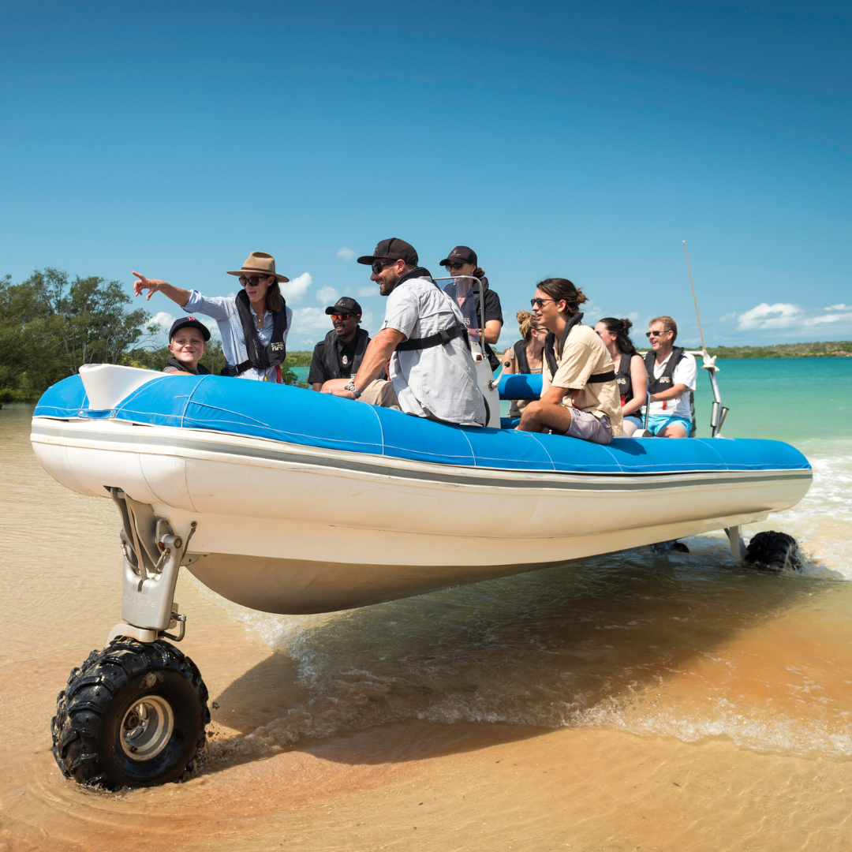
Insta Post (9)

ACCOMMODATION

Bedrooms
The bedrooms have the following facilities/amenities in place
- There are 2 rooms available to guests who use a wheelchair
- Bedroom furniture can be re-arranged on request

The following bed types are available in wheelchair accessible rooms
- One double/queen bed/king bed
- Two single beds
  - Layout of room Image(s)
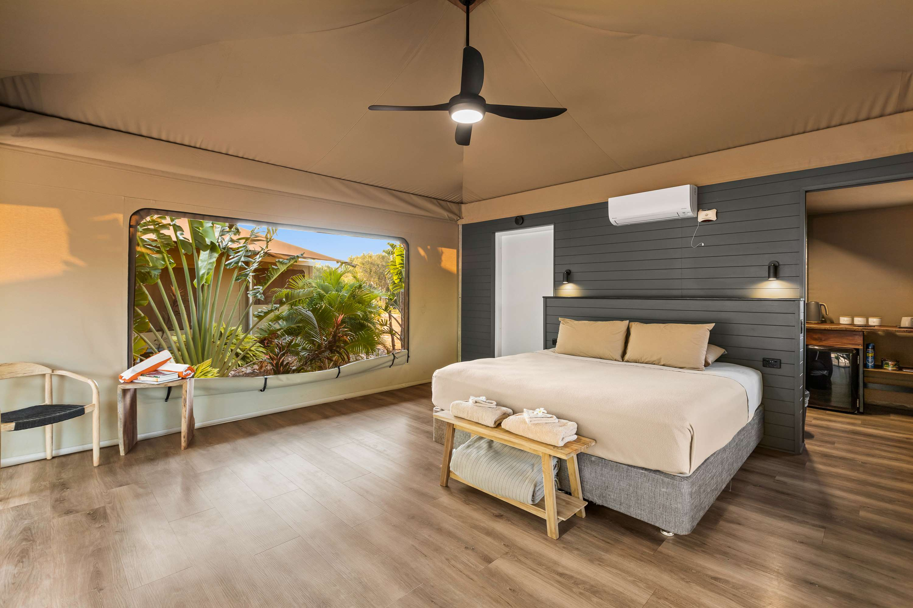
CBPF Village Safari Tent 18

Room Amenities
no wardrobe
For guests with a hearing impairment, the following emergency evacuation procedures apply to ensure safe evacuation: Duty Manager is given the in-house guest list, which is generated via our PMS, any guest with a disability is highlighted on the list so that they are aware to offer assistance in the event of an emergency.
- There is contrast between the walls, skirtings, floor and furniture
- There is a clear path through the room
- The edges of all furniture and fixtures are rounded
- Wardrobe handles are a contrasting colour to the doors and draws
- Housekeeping procedures instruct staff not to reposition furniture that has been moved
- Doors open fully against the adjoining wall
- There is a clear opening at least 850mm wide
- There at least one chair with rigid arms
- Wardrobe and drawer handles are easy to grip
- The bedside lamp switch is easy to reach from the bed
- There is at least 850mm clear space beside the bed
- The bed height is no higher than 680mm from the floor

Bathrooms
The bathrooms have the following facilities/amenities in place
- All heating appliances and hot water pipes are protected or insulated
- All shower, bath and basin taps are clearly differentiated between hot and cold
- Fixtures and fittings have rounded edges
- The hot water is thermostatically controlled to 41 degrees
- The door is at least 850mm wide
- There is a minimum of 850mm beside the toilet
- Handrails are fitted
- There is a minimum of 1400mm of clear space in front of the toilet
- The toilet seat is a contrasting colour to the floor
- The toilet seat is 460mm above the floor
- There is a portable shower head on flexible hose
  - Bathroom Image(s)
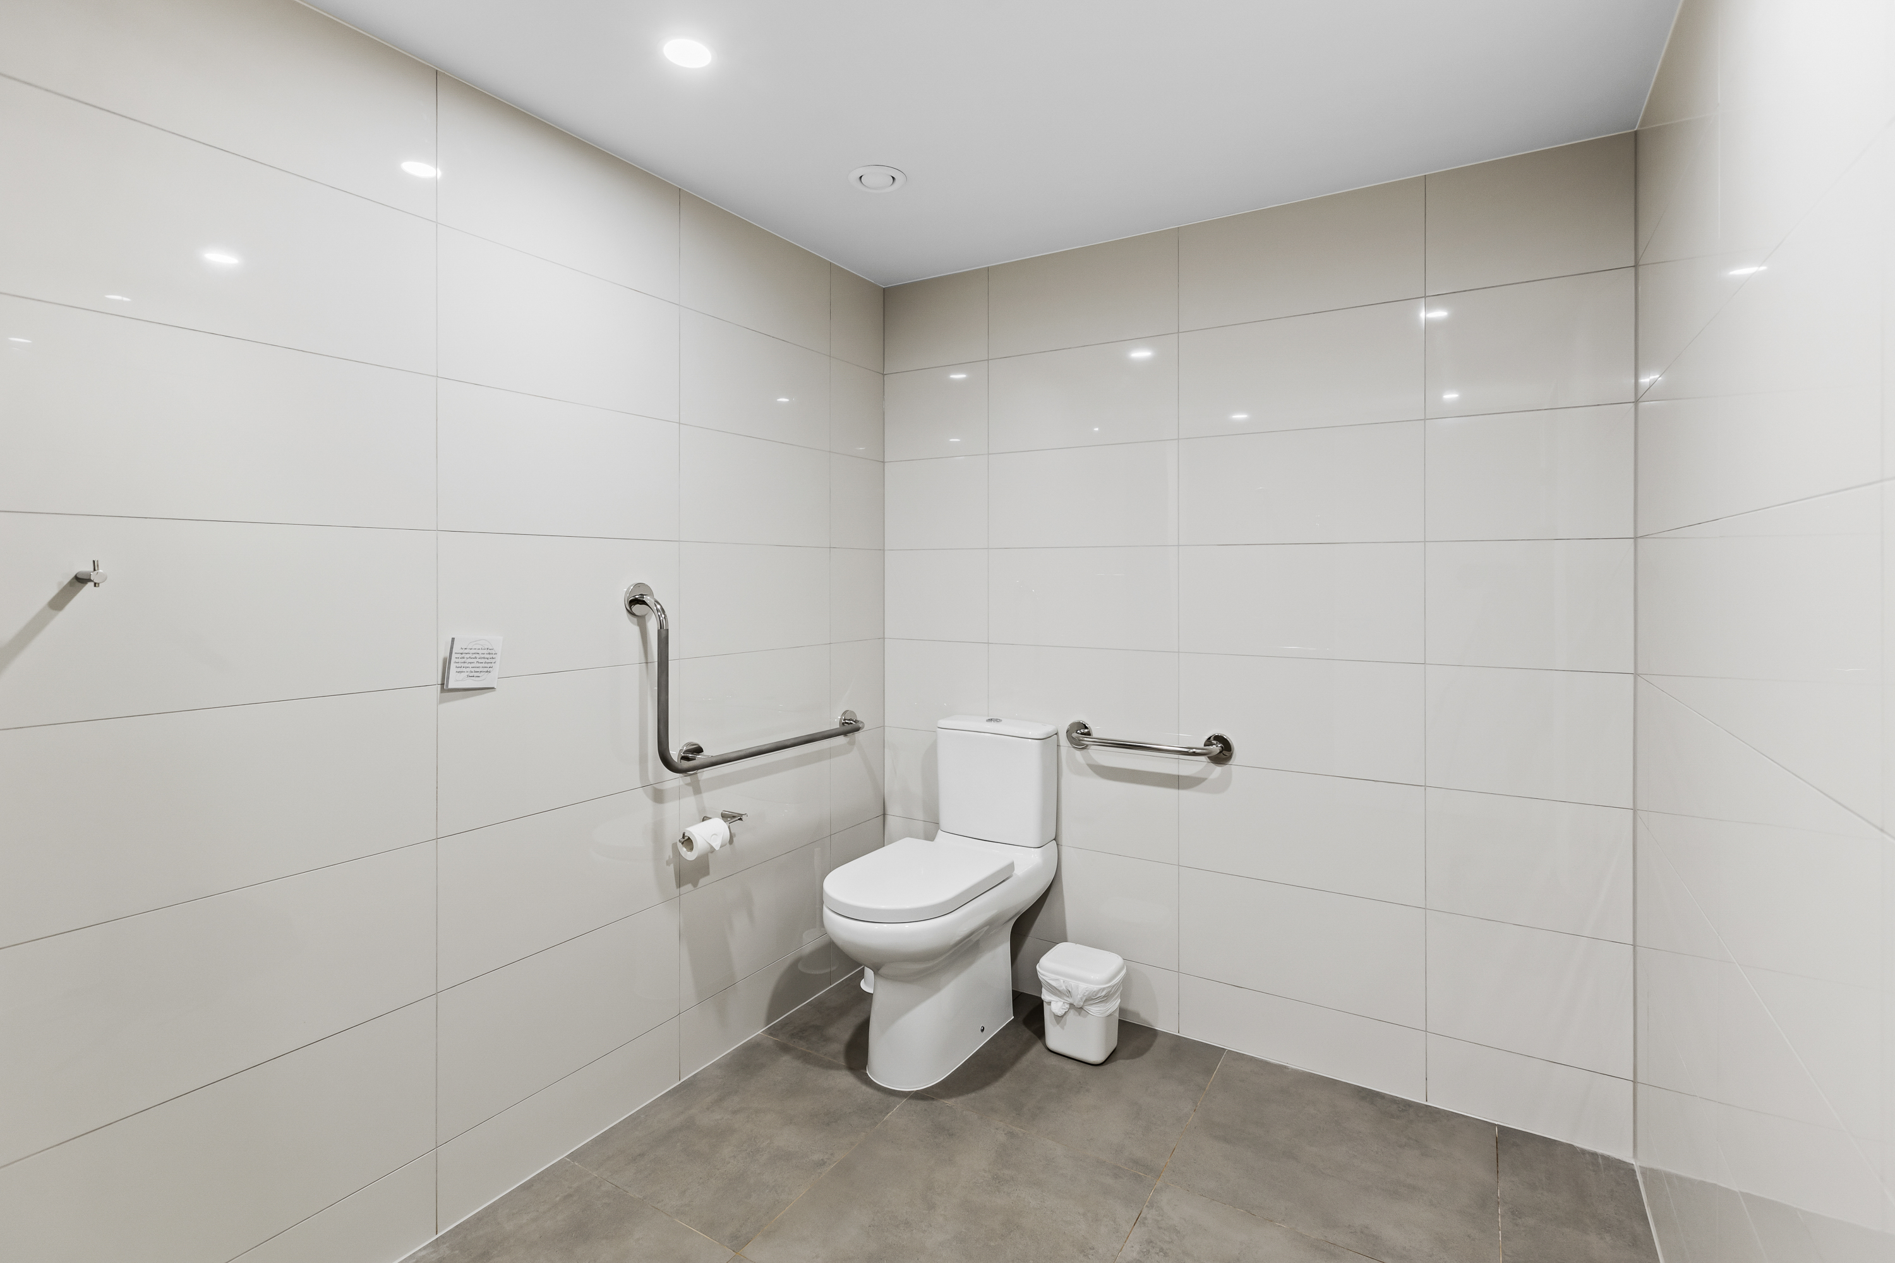
CBPF Village Safari Tent 16
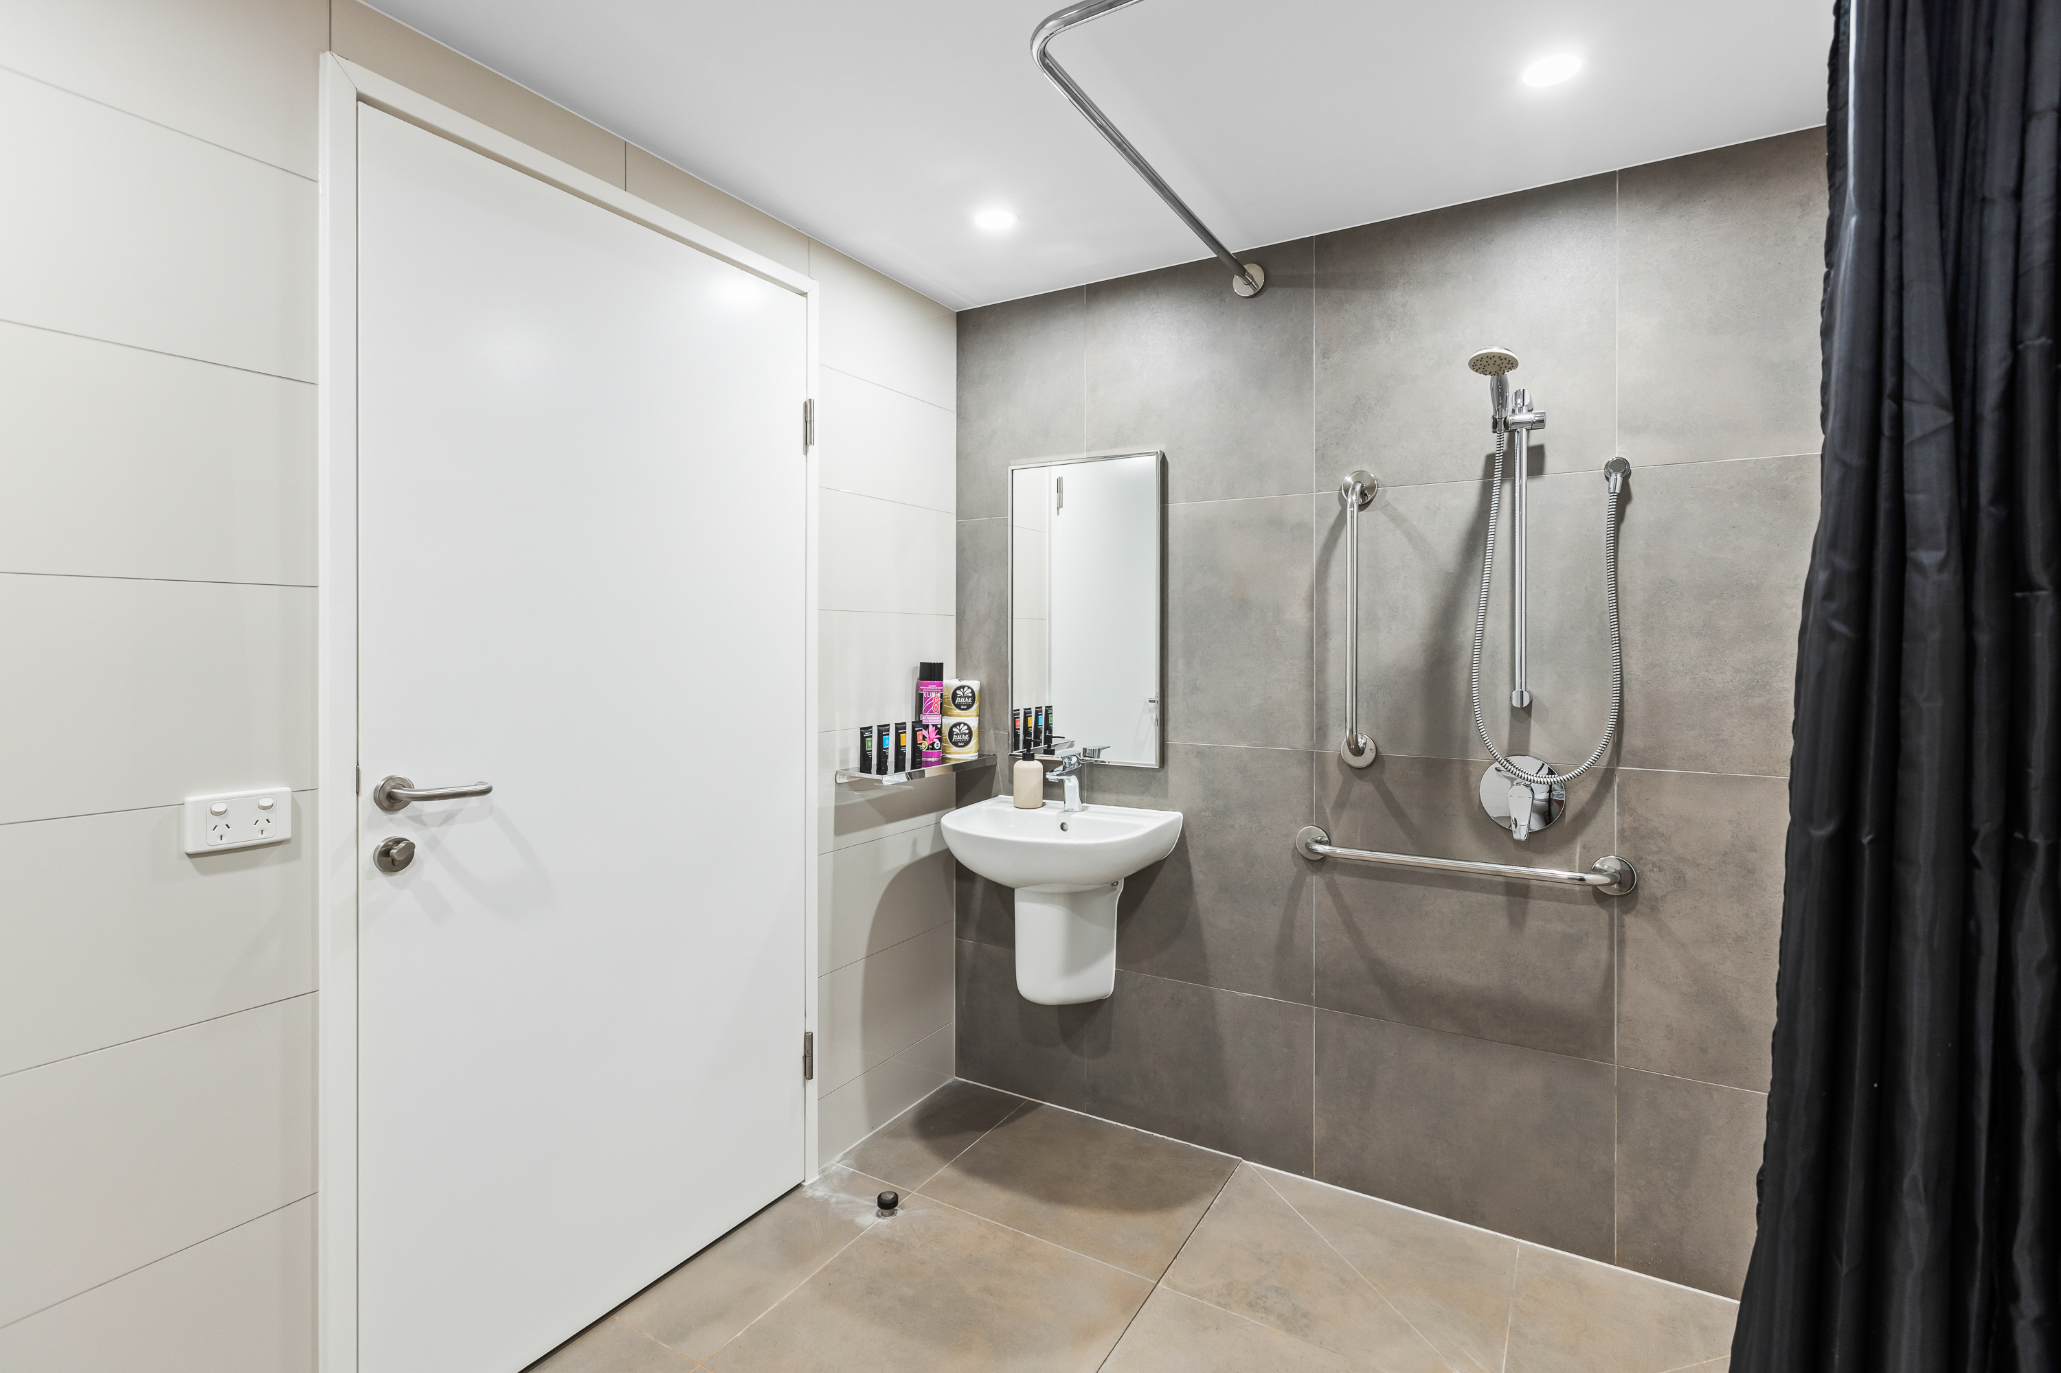
CBPF Village Safari Tent 17

COMMON AREAS

Play Spaces
- The space contain colour contrasting elements
- Seating is provided in or around the play space
  - Image(s)
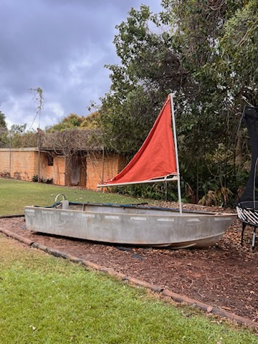
Boat in play area
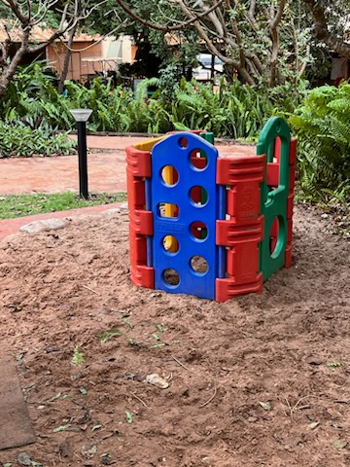
Playhouse
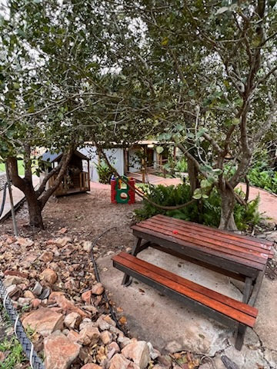
Seating close to childrens area
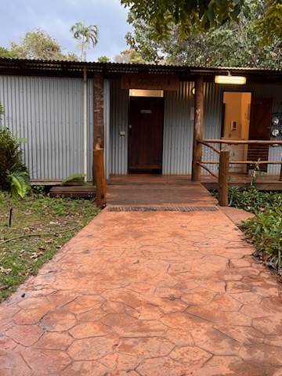
toilets
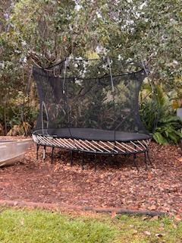
Trampoline
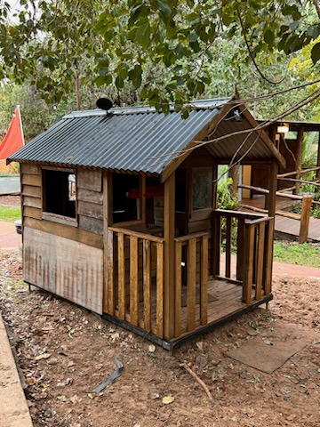
Wendy House
- In addition, the following further information can assist guests:
The play area is in our grass tennis court section, children have a wide open area to run & not have to worry about the farm vehicles or getting in people's space.

Swimming pools, spas and waterparks
- The following swimming pools, spas and waterparks amenities are available
- Unisex change facilities with an accessible toilet
  - Pool Access Image(s)
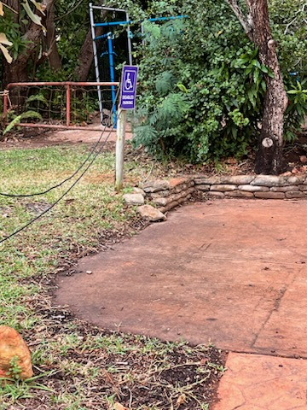
Disable Parking in General Car Park Area
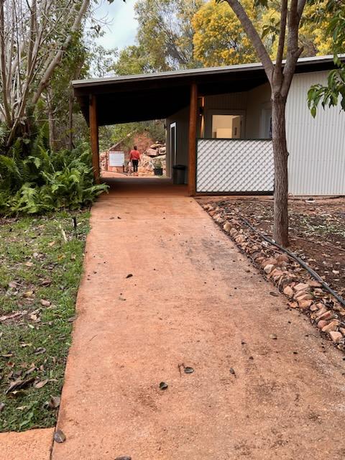
Full Access Path to Resturant & Upstairs Toilet Area
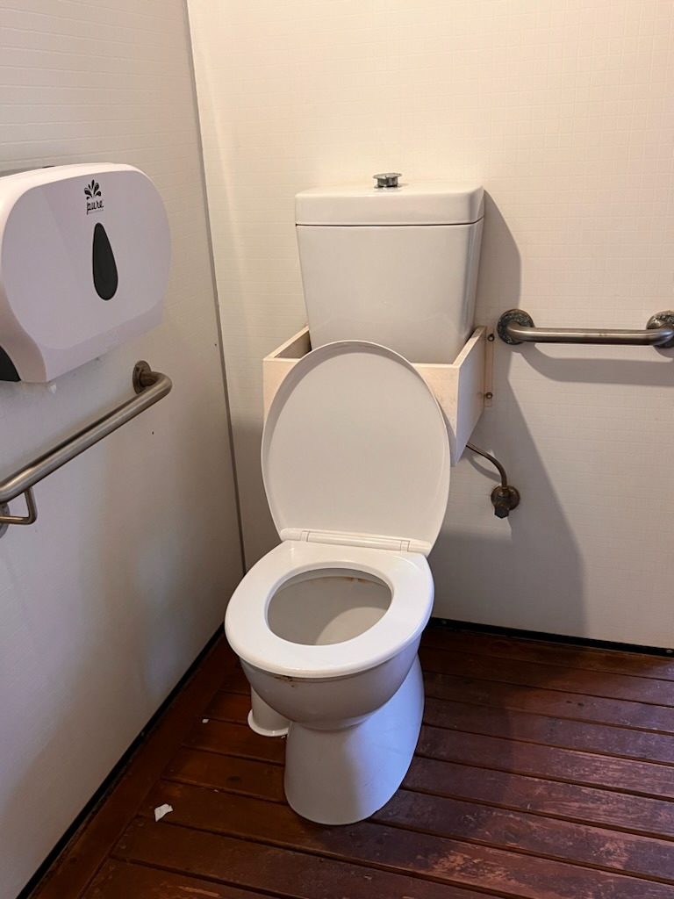
Interior ~ Reception Area Disabled Toilet
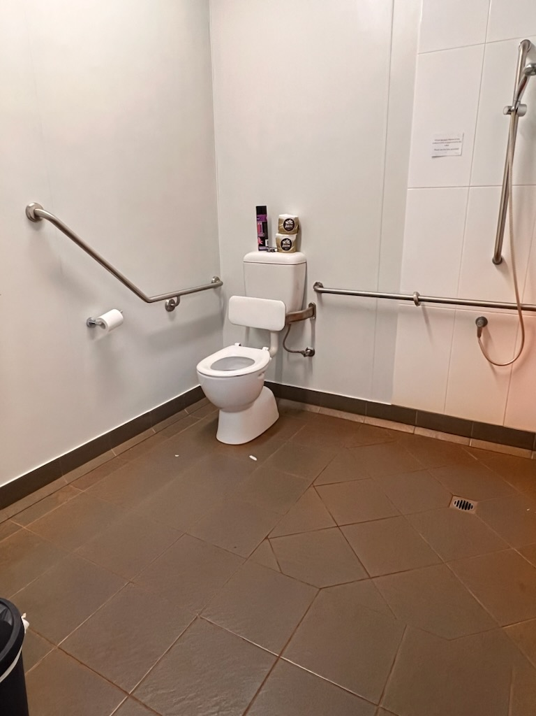
Interior ~ Resturant Disabled Facility incl Shower pg
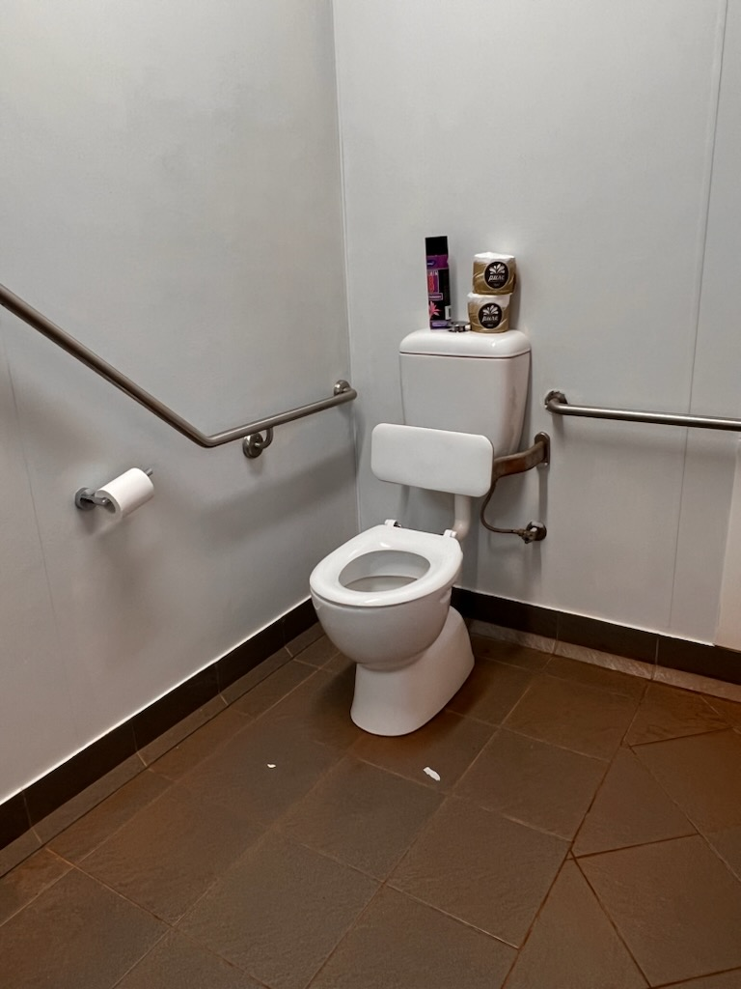
Interior ~ Resturant Disabled Facility
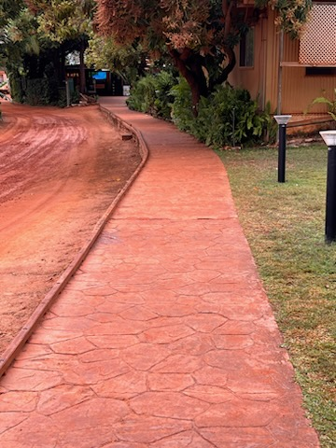
Looking down towards reception
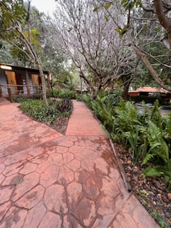
path from toilets to the reception & car park
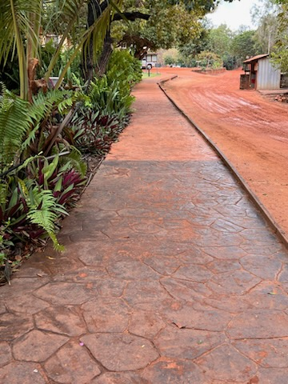
Path to car public car park
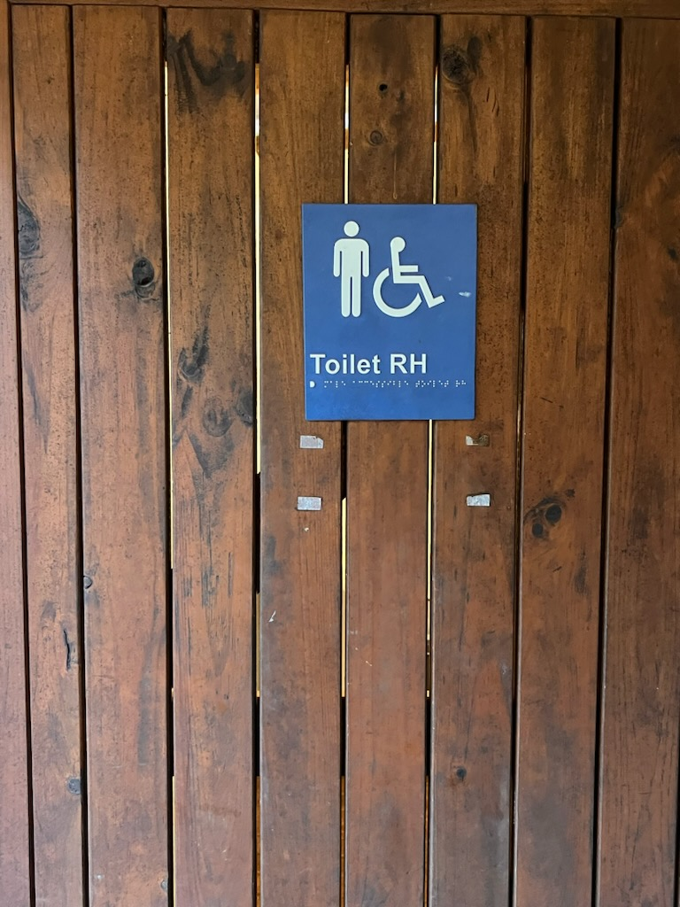
Reception Area Disabled Toilet
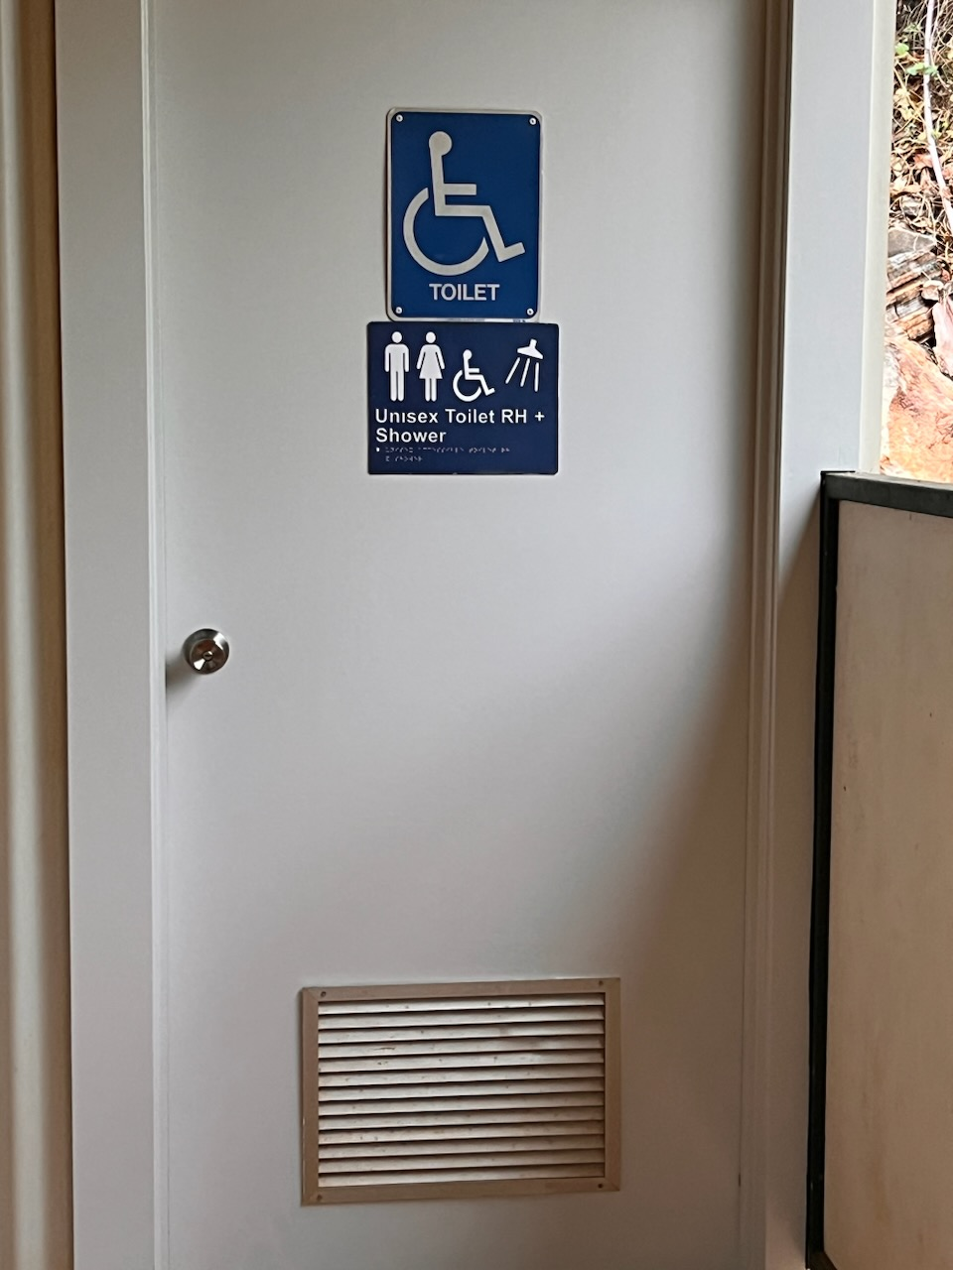
Restaurant Toilet Block
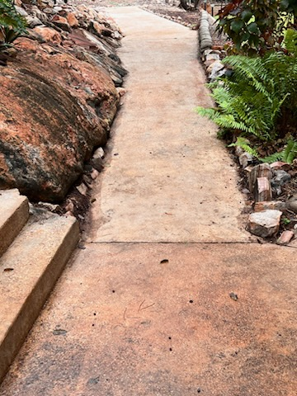
Showing section of the path for guests with disability
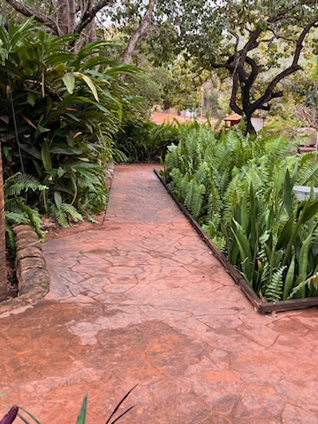
Toilet area down to reception & carpark
toilets

FOOD AND DRINK

Dining Spaces
The dining spaces have the following facilities/amenities in place
- The entrance has level access
- The doorway is at least 850mm wide
- There is level access through the dining area
- Chairs are moveable to allow for wheelchairs to be seated at the tables
- There are areas of full lighting
- There are Plain English menus
- There is an accessible toilet

Our business caters for the following dietary requirements
- Sugar free (diabetic)
- Gluten free (celiac)
- Lactose free (dairy free)
- Low fat and fibre with no gastric content
- Low potassium
- Low sodium
- Additive free
- Vegetarian
- Vegan
- Halal
- There are procedures in place to avoid cross-contamination of food products
- There is a sample menu available online
Sample menu is available here - https://www.cygnetbaypearlfarm.com.au
  - Food and Beverage Image(s)
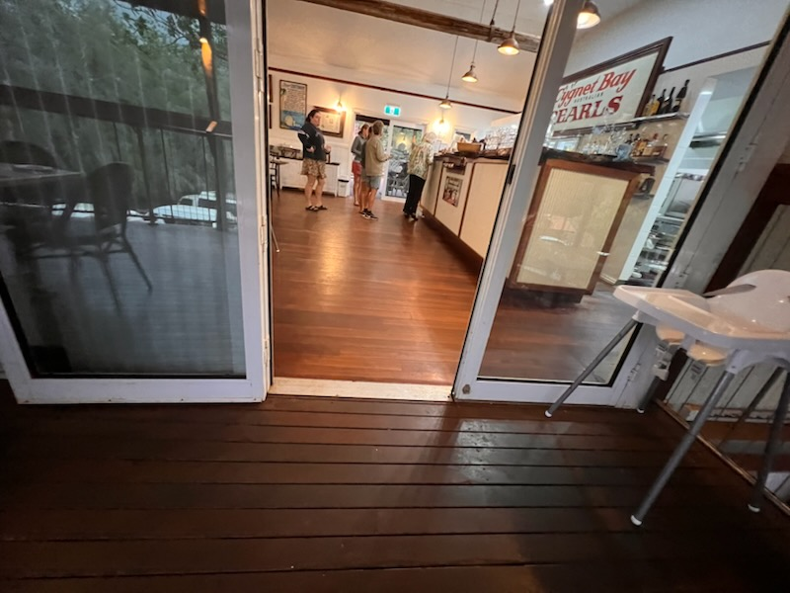
Entrance from another Door into Restaurant
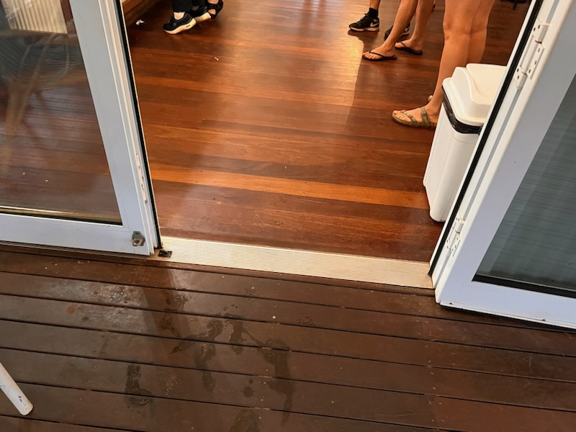
Entrance to Restaurant
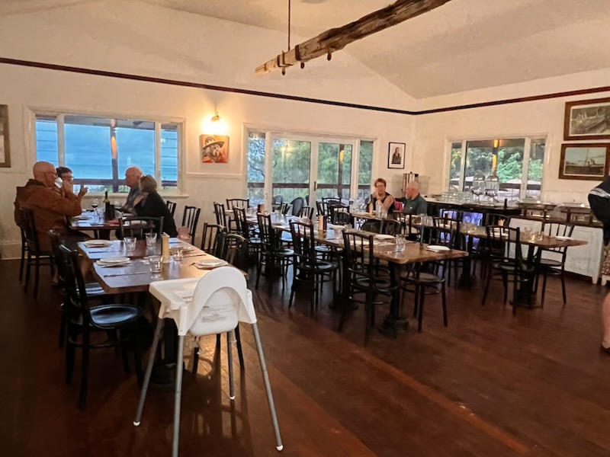
Inside Restaurant ~ Not typical set up.
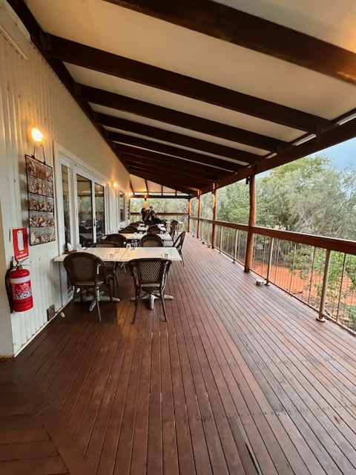
Middle section of Balcony - Copy
Middle section of Balcony
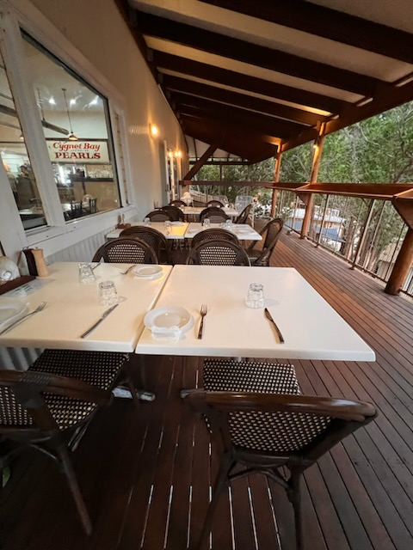
Outer Area of Balcony - Copy
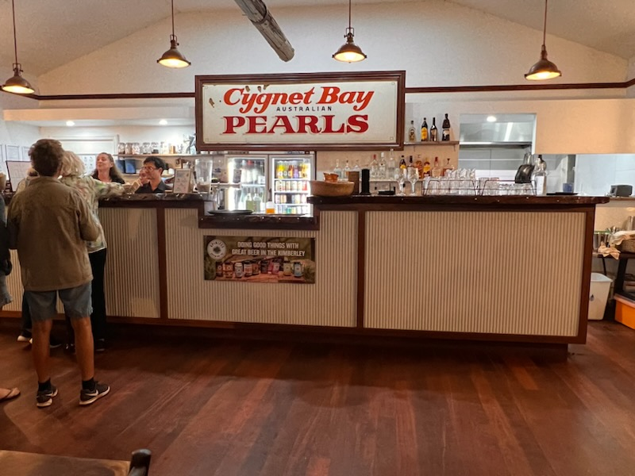
Service Counter
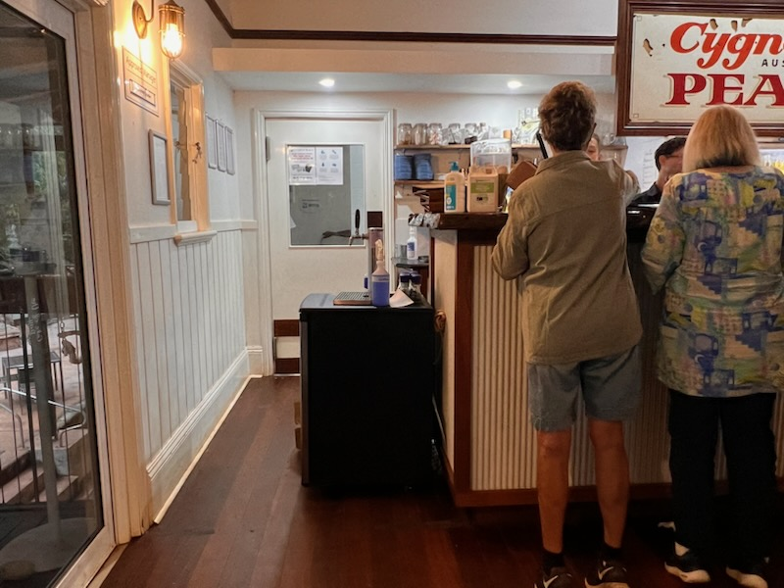
Side where guests with disability can speak to staff - Copy
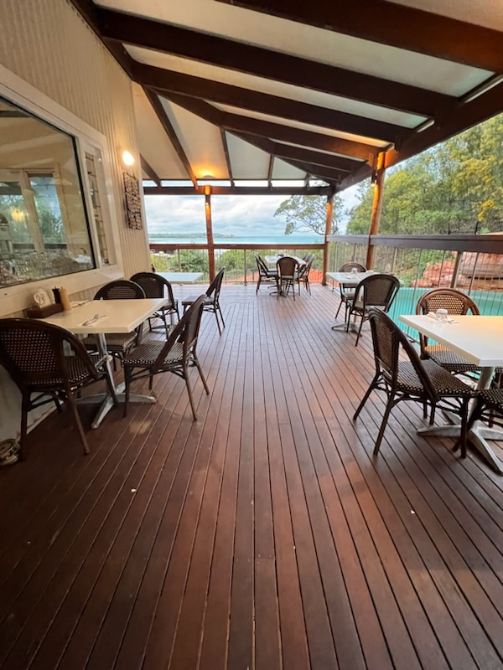
View towards balcony from top of restaurant
- In addition, the following further information can assist guests:
During lunch it is counter service, but staff are always at hand to assist all guests. Dinner is table service.

ADVENTURE ACTIVITIES
  - Adventure Activity Image(s)
Insta Post (9)
- In addition, the following further information can assist guests:
N/A

Report Disclaimer
Please note that this business report, provided as a result of the use of the diagnostic assessment, is for information purposes only.
Australian Tourism Industry Council (ATIC) cannot guarantee the accuracy of respondent’s answers, or that they are fully representative of your business. Therefore, ATIC does not warrant or guarantee any particular outcome in respect of your businesses self-assessment.
This report is intended as guidance only for your business and should not be relied on for future marketing considerations. ATIC recommends that you seek your own independent advice as well as the results from the diagnostic.
Links to external web sites are inserted for convenience and do not constitute endorsement of material at those sites, or any associated organisation, product or service.
ATIC does not:
- Assume any legal liability for the accuracy, completeness, or usefulness of any information from this report or any links provided; or
- Accept responsibility for any loss associated directly or indirectly from the use of this report.

