ATIC Accessibility
To support the accessible community in making informed travel decisions for their individual needs

This report prepared for:
Business name: | Dwellingup Adventures
Address: | 4 Marinup St
Town: | Dwellingup
Contact for enquiries: | Alicia Caruso
Contact Number: | 08 95381127
Contact Email: | info@dwellingupadventures.com.au
Website: | www.dwellingupadventures.com.au
Date: | 2026-09-24 06:30

ATIC Accessibility
The following pages provides travellers with information on the businesses facilities and amenities which aims to support the traveller to make an informed decision on whether the business is suitable for their individual needs.
OVERVIEW 4
Business Overview 4
Bookings 4
Emergency Management 4
Communications 5
Other Information 6
Guide Dog and Service Animals 6
GENERAL 7
Pre-arrival, arrival and reception 7
Cognitive Impairment Support 7
Car Park and Access amenities 7
Entry 8
Internal Spaces 8
Public areas 9
External Paths 9
Public Toilets/Adult change facilities 9
TOUR OPERATORS 10
Tour/Transport Services 10
Guides 10
COMMON AREAS 11
ADVENTURE ACTIVITIES 12
Adventure activities 12
Report Disclaimer 15

OVERVIEW

Business Overview

The business has the following products/services available
- Tour/Transport
- Adventure

Our business caters for the following disability types:
- Blind or low vision
- Deaf or low hearing
- Limited mobility
- Wheelchairs or mobility scooters
- Food allergies or intolerances
- Cognitive or people on the Autism Spectrum

Bookings

The business offers the following methods for bookings and enquiries:
- Phone
- Email
- Webportal
- Our website supports Screen Readers
- Our forms have high contract boxes and submit boxes
- Staff have undergone disability awareness and training

Emergency Management
- The business has an emergency management and evacuation plan for guests with a disability
- Emergency and evacuation procedures are explained on arrival
We ensure exit access is free and clear at all times by: Staff monitor area is clear as it is a legal requirement.
- Guests with disabilities are noted in the guest log book for emergency and evacuation purposes

Communications
- An accessibility guide is available on the website
https://dwellingupadventures.com.au/about-accessibility-guide/
- Our business offers the following alternative communication methods
- Plain English
- Magnifiers
- There is easy to read signage and information (e.g. menus and emergency information)
- There is a Pictorial menu
  - Pictorial Menu Image(s)
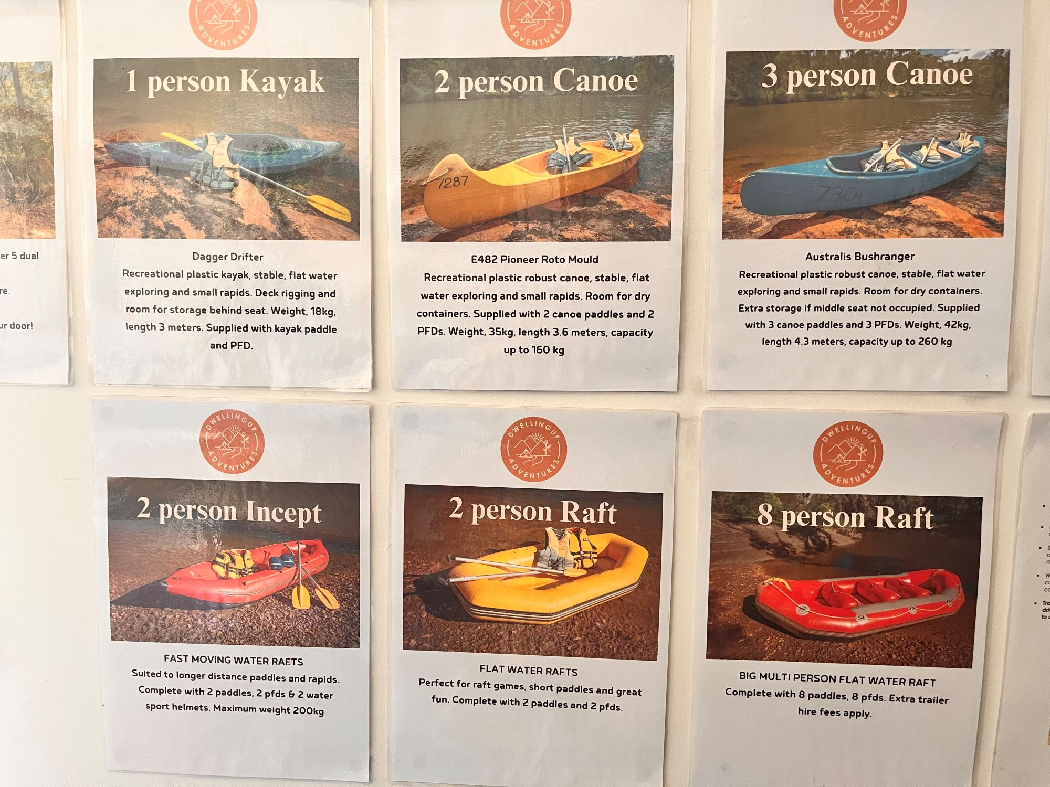
Picture Menu 2
- There are Picture boards
  - Picture Boards Image(s)
Picture Menu 2
pen and paper, ipad application on 'read aloud'

Other Information
- For bookings made onsite, the ticket booth/counter/box office is accessible for people using a wheelchair
- The business accepts the companion card

Guide Dog and Service Animals
- The business provides a secure area with shade and water for service animals
- The business provides a toilet area for service animals
- Bowls, bedding, etc. are provided for service animals
The business provides the following services for services animals: water bowls and water refill station, shaded area where dogs can be tied up.

GENERAL

Pre-arrival, arrival and reception
The business has the following in place to support guests during pre-arrival, arrival and reception
- Booking information and websites are compatible with screen readers
- There is a reception/public entryway.
- Seating available at reception
- A lower counter at reception/ticket office
- A clipboard to allow check-in/ticket purchase whilst seated
- A tablet with text to voice or pen and paper at reception to aid in communication
- Picture Board at reception to aid in communication
- Lighting in the reception area is even and glare free
- Large print information sheets and registration forms
No sound system is used at all. No commentary. Face-to-face, one-on-one communication takes place.
- Information and maps are available in written form
- A familiarisation tour
no accessible facilities are locked.
The following steps are in place to ensure that people with fatigue related to their disability are not disadvantaged by long wait times: We have tables and chairs for people to sit at if they need to wait.

Cognitive Impairment Support
- Documents are available in plain English for people with cognitive impairment (This may include instructions, guides, menus and general information)
- A "social script" guide to your premises or attraction describing the sights, sounds and smells to aid parents/carers prepare visitors in advance
- The 'social script' is available in word and other editable formats
- Quiet periods or early opening times for people on the Autism Spectrum
- A space for parents and children on the Autism Spectrum

Car Park and Access amenities
The business has the following Car Park and Access amenities
- A drop off zone
- Designated disabled parking bays
- Level or ramped access from the car park to the entrance
- The accessible entrance is clearly signed from the parking bay
- The public transport services available are:
This needs to be NA. The closest public transport is 45km away making it irrelevant.
- Kerb ramps are in place where a pavement or walkway needs to be crossed

Entry
The business has the following amenities/systems in place for entry
- A drop off point close to the entrance
- A path of access to the building is slip resistance and even
- A path of access to the building is clear of obstruction
- Self opening entry doors or fitted with a self closer
- Glass doors are fitted with a visual sighting strip
- Door jams/doors are of a contrasting colour to surrounding walls
- Door handles are of a contrasting colour to the door
- Signage is written in a contrasting colour
- Signage is written in a Sans Serif font and use upper and lower case letters
- The entry door is a minimum of 850mm wide
- The entry door has self opening or a light opening pressure (for manual operations)
- The entrance sill is less than 13mm
- There a clear space of at least 1500mm x 1500mm in front of all doors.
- In addition, the following further information can assist guests:
No entrance door mats at wheelchair access (main) entrance.
- In addition, the following further information can assist guests:
Not applicable. It is a single storey building with no stairs.

Internal Spaces
- Clear and unobstructed routes through and between buildings
- Interior walls are matte or low sheen
- Floors, walls, counters and furniture are of contrasting colours
- Floor surfaces are hard or short pile carpet
- Seating is available for guests unable to stand for long periods
- Accessible facilities are clearly signed and visible from all areas
- All corridors greater than 900mm
- There is a quiet space for parents and children on the Autism Spectrum

Public areas
The public areas have the following amenities in place
- Even lighting
- Seating

External Paths
External paths of travel
- Surfaces are concrete, asphalt, smooth paving or hard packed fine gravel (max aggregate size 13mm)
- Paths or slopes longer than 15 metres have resting places or seats
- Pathways are wider than 900mm
No steps.
There are no steps
- Step free routes clearly signed

Public Toilets/Adult change facilities
Public Toilets/Adult change facilities have the following amenities are in place
- There is an accessible toilet for public use
- The door is at least 850mm wide
- There is a minimum of 850mm beside the toilet
- Handrails are fitted
- The toilet seat is 460mm above the floor
- There is The toilet sits 6ft from sink in front of it and the room is 8ft wide. mm of clear space in front of the toilet
- The toilet seat of a contrasting colour to the floor
- The toilet seat is460mm above the floor

TOUR OPERATORS

Tour/Transport Services
The tour/transport services have the following facilities/amenities in place
- Buses/Coaches
- none vehicles have wheelchair lifts or ramps
- none vehicles have low floors with ramped entry
The maximum wheelchair capacity available in the fleet is: 0
- Commentary is available in written format
- Audio visual displays are sub titles

Guides
- Use of clear/simple English
- Correct pronunciation for lip readers
- There is a audio description of surroundings
  - Image(s)
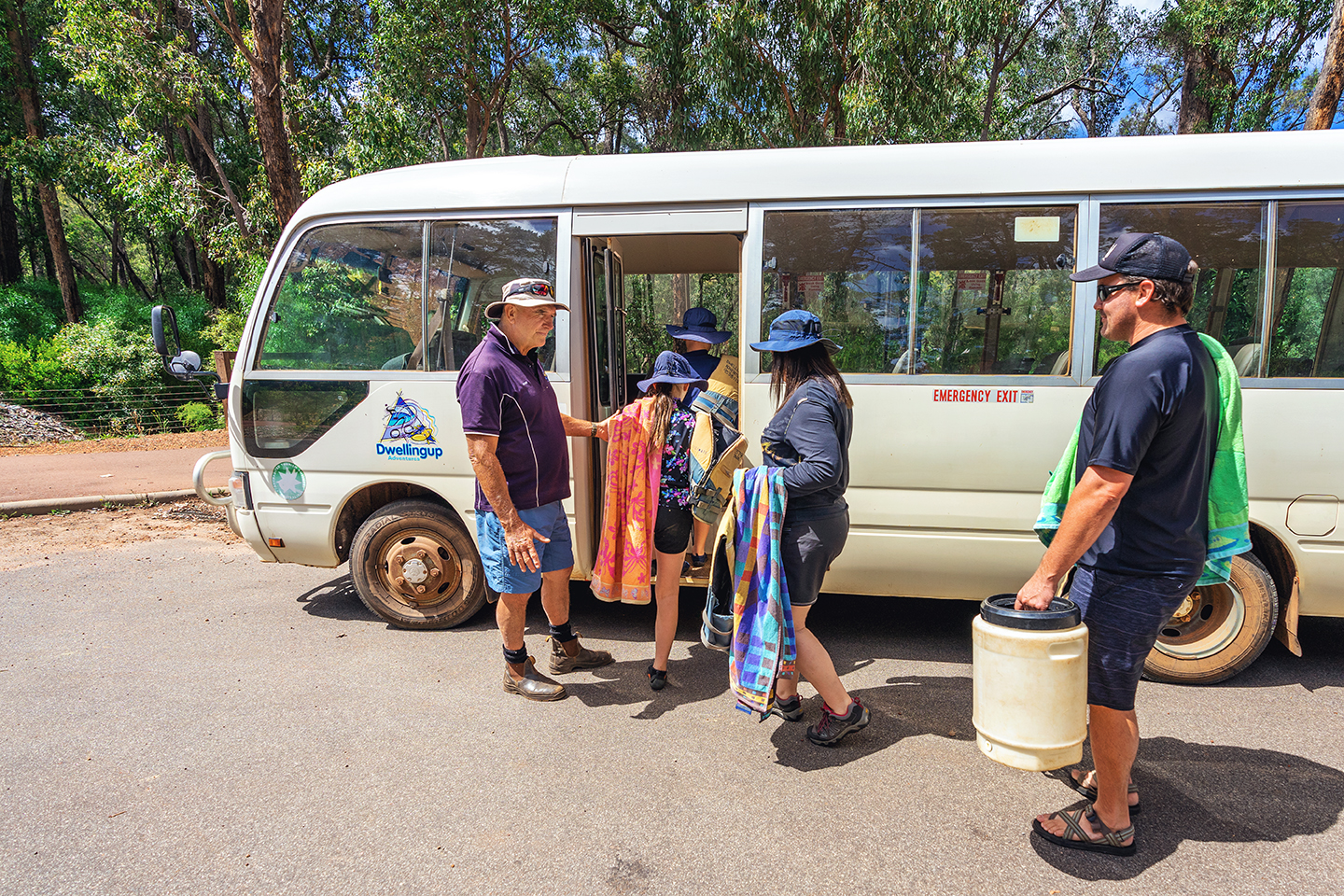
Bus Transfer-web

COMMON AREAS

ADVENTURE ACTIVITIES

Adventure activities
The adventure activities have the following facilities/amenities in place
- Our adventure activities cater for people with a disability
The following activities are available to people with a disability: Depending on the persons disability we have a range of canoes, bikes, rafts and camping gear for hire. Most of our tours are self-guided so again it would depend on the persons disability. For instance if they have low hearing they would likely still be able to partake in most our the activities we offer. If someone has low vision they may not be able to ride a bike, but could paddle a canoe with a friend or companion assisting. Someone with low mobility could sit in a raft and paddle. Rafts are more stable and forgiving than a canoe.
The equipment utilised to make the activities available are: We do not have any specialised equipment, rather we recommend a product that is more suitable such as the raft example above.
The following limitations apply to participation, including those activities that are not available to people with a disability: We currently do not have any activities suitable for someone using a wheelchair.
  - Adventure Activity Image(s)
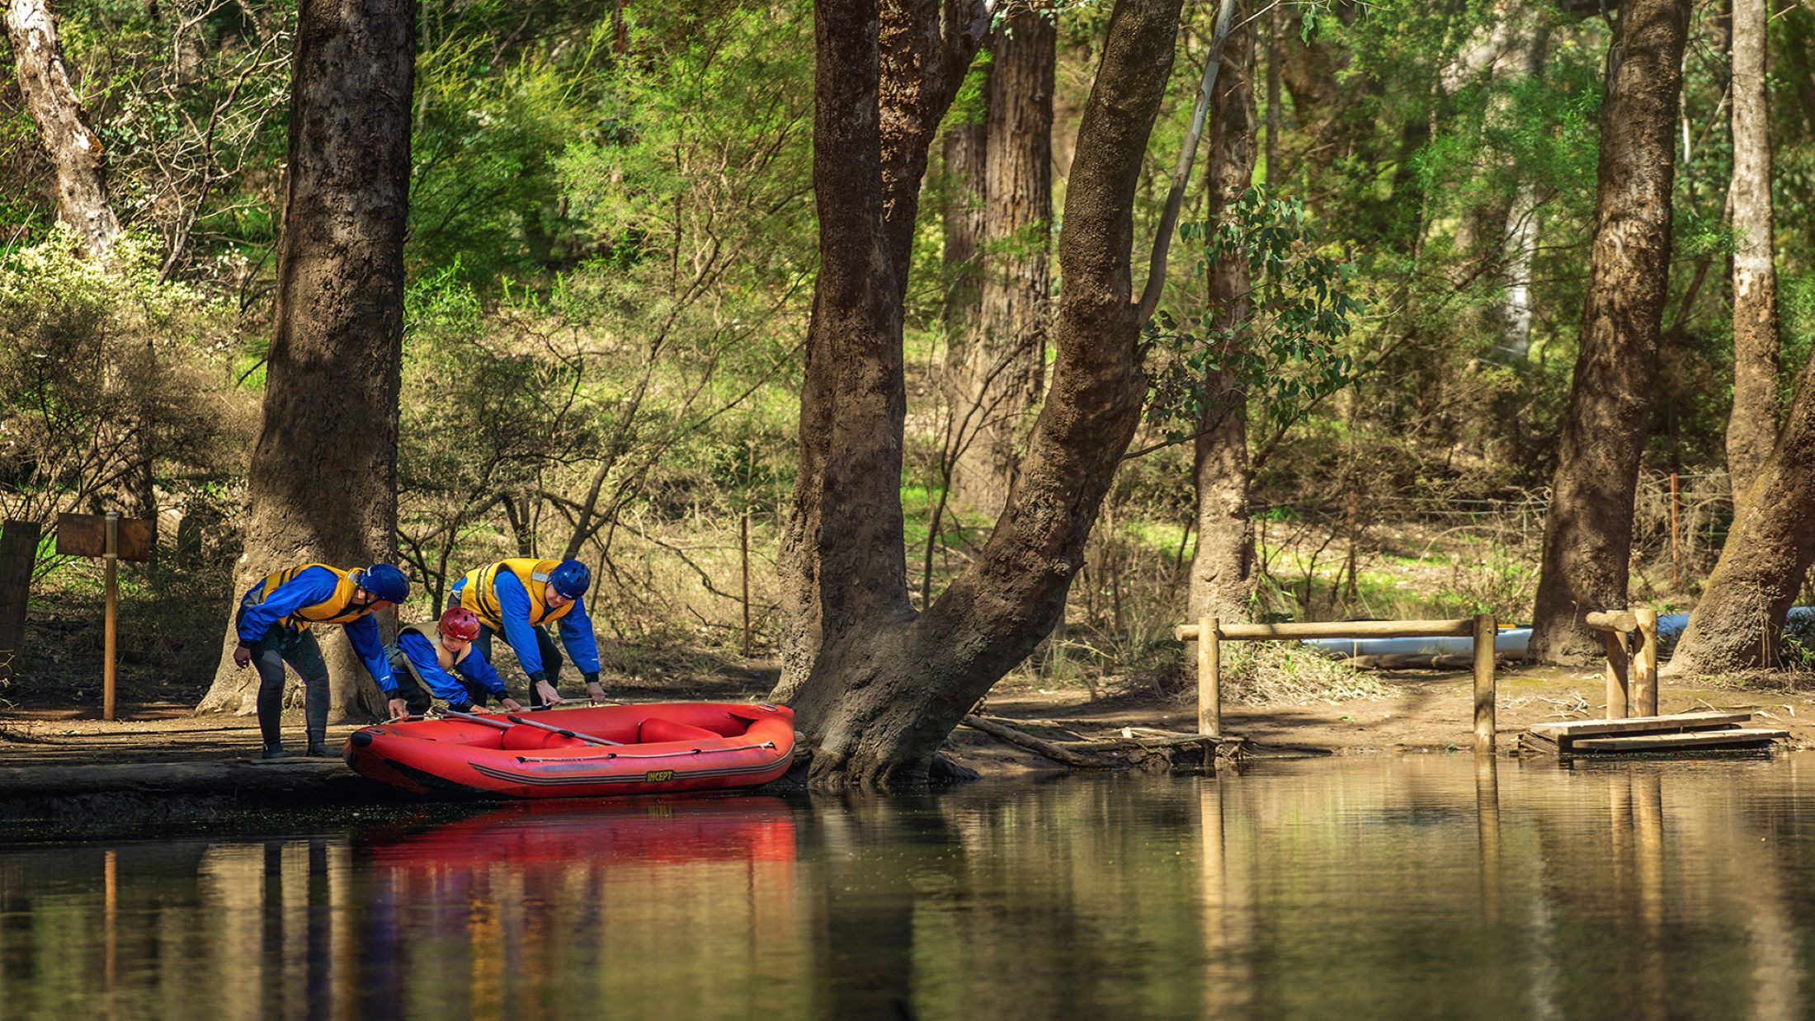
Fast water rafting-02 (1) ATDW
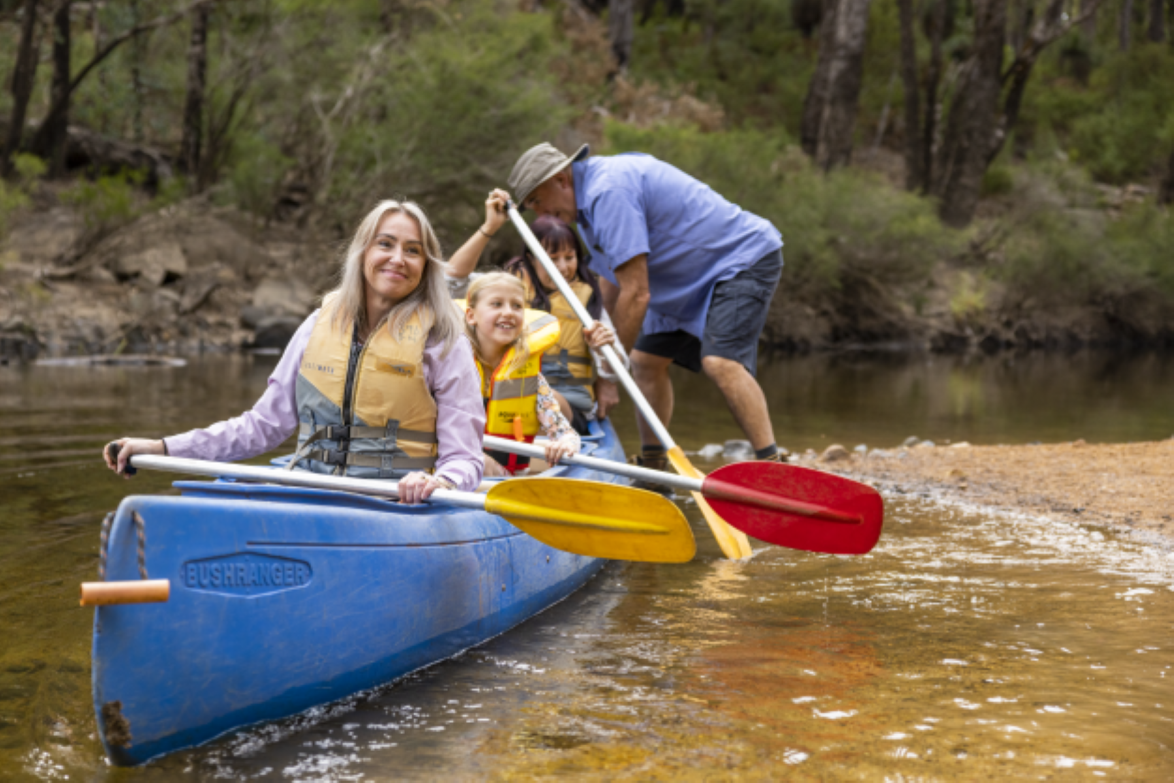
P&P Launch with Pete ATDW

Report Disclaimer
Please note that this business report, provided as a result of the use of the diagnostic assessment, is for information purposes only.
Australian Tourism Industry Council (ATIC) cannot guarantee the accuracy of respondent’s answers, or that they are fully representative of your business. Therefore, ATIC does not warrant or guarantee any particular outcome in respect of your businesses self-assessment.
This report is intended as guidance only for your business and should not be relied on for future marketing considerations. ATIC recommends that you seek your own independent advice as well as the results from the diagnostic.
Links to external web sites are inserted for convenience and do not constitute endorsement of material at those sites, or any associated organisation, product or service.
ATIC does not:
- Assume any legal liability for the accuracy, completeness, or usefulness of any information from this report or any links provided; or
- Accept responsibility for any loss associated directly or indirectly from the use of this report.

