ATIC Accessibility
To support the accessible community in making informed travel decisions for their individual needs

This report prepared for:
Business name: | Gorge Scenic Chairlift
Address: | 69 Basin Road
Town: | West Launceston
Contact for enquiries: | Joanne Larter
Contact Number: | 03 6331 5915
Contact Email: | Jolarter@gorgechairlift.com.au
Website: | https://www.gorgechairlift.com.au
Date: | 2026-10-22 10:29

ATIC Accessibility
The following pages provides travellers with information on the businesses facilities and amenities which aims to support the traveller to make an informed decision on whether the business is suitable for their individual needs.
OVERVIEW 4
Business Overview 4
Bookings 4
Emergency Management 4
Communications 5
Other Information 5
Guide Dog and Service Animals 5
GENERAL 6
Pre-arrival, arrival and reception 6
Cognitive Impairment Support 6
Car Park and Access amenities 6
Entry 7
Internal Spaces 7
Public areas 8
External Paths 8
Steps 8
Public Toilets/Adult change facilities 9
ATTRACTIONS 10
Attractions Basics 10
Gondolas, cableways, observation wheels 10
COMMON AREAS 12
Play Spaces 12
Swimming pools, spas and waterparks 12
Parks and gardens 13
Report Disclaimer 16

OVERVIEW

Business Overview

The business has the following products/services available
- Attraction

Our business caters for the following disability types:
- Blind or low vision
- Deaf or low hearing
- Limited mobility
- Wheelchairs or mobility scooters
- Food allergies or intolerances
- Cognitive or people on the Autism Spectrum

Bookings

The business offers the following methods for bookings and enquiries:
- Phone
- Email
- Webportal
- Our website supports Screen Readers
- Our forms have high contract boxes and submit boxes
- Staff have undergone disability awareness and training

Emergency Management
- Emergency and evacuation procedures are explained on arrival
We ensure exit access is free and clear at all times by: one exit only. the space between the chairs allows plenty of time for previous travelers to exit the area before next travelers arrive
- Guests with disabilities are noted in the guest log book for emergency and evacuation purposes

Communications
- An accessibility guide is available on the website
https://www.gorgechairlift.com.au/chairlift
- Our website meets WCAG 2.0 accessibility standards
- Our business offers the following alternative communication methods
- Plain English
hand signals
- There is easy to read signage and information (e.g. menus and emergency information)

Other Information
- For bookings made onsite, the ticket booth/counter/box office is accessible for people using a wheelchair
- The business accepts the companion card

Guide Dog and Service Animals
- The business provides a secure area with shade and water for service animals
The business provides the following services for services animals: as our ride is approximately 20 mins, most travelers with service animals will have someone that can sit with the animal while riding the chairlift. If not, the carpark is only 500m away so many people choose to leave their animals in the vehicle.

GENERAL

Pre-arrival, arrival and reception
The business has the following in place to support guests during pre-arrival, arrival and reception
- Booking information and websites are compatible with screen readers
- There is a reception/public entryway.
- Seating available at reception
- Lighting in the reception area is even and glare free
Our office is currently located at the main entrance to the Gorge on the main throughfare/road hence no office facilities are available to us. We welcome all our travelers to approach us to discuss any special needs as every traveler is different and the team are here to do everything we can to make travel happen.
- Information and maps are available in written form
- A step free map/guide
- A familiarisation tour
accessible facilities are open 24 hours a day within the reserve
The following steps are in place to ensure that people with fatigue related to their disability are not disadvantaged by long wait times: When guests are purchasing tickets any special requirements are always discussed with traveller and where possible we will always accommodate as we do have a waiting area available if required.

Cognitive Impairment Support
- Documents are available in plain English for people with cognitive impairment (This may include instructions, guides, menus and general information)
- A "social script" guide to your premises or attraction describing the sights, sounds and smells to aid parents/carers prepare visitors in advance
- The 'social script' is available in word and other editable formats
- Quiet periods or early opening times for people on the Autism Spectrum
- A space for parents and children on the Autism Spectrum

Car Park and Access amenities
The business has the following Car Park and Access amenities
- A drop off zone
- Designated disabled parking bays
- Level or ramped access from the car park to the entrance
- The accessible entrance is clearly signed from the parking bay
- The public transport services available are:
if required the staff are trained to be able to provide directions
- Kerb ramps are in place where a pavement or walkway needs to be crossed
- In addition, the following further information can assist guests:
The Chairlift is located just inside the main gates to the reserve. Reserve facilities are the responsibility of the Launceston City Council. Re-train facilities - there are no trains in Launceston - but happy to direct travelers to bus services and walking tracks depending on their ability

Entry
The business has the following amenities/systems in place for entry
- A drop off point close to the entrance
- A path of access to the building is slip resistance and even
- A path of access to the building is clear of obstruction
- Self opening entry doors or fitted with a self closer
- Glass doors are fitted with a visual sighting strip
- Signage is written in a contrasting colour
- Signage is written in a Sans Serif font and use upper and lower case letters
- The entry door is a minimum of 850mm wide
- The entry door has self opening or a light opening pressure (for manual operations)
- The entrance sill is less than 13mm
- There a clear space of at least 1500mm x 1500mm in front of all doors.
- In addition, the following further information can assist guests:
Entrance to the chairlift for travelers that need assistance is flat with special wide gates to accommodate all sizes of mobility aides. The surfaces inside the Chairlift perimeter are also 100% flat with no steps or different levels for travelers to traverse
- In addition, the following further information can assist guests:
The Chairlift has only one level on both the Main entrance and Cliff Grounds stations, so nil lifts required

Internal Spaces
- Clear and unobstructed routes through and between buildings
- Interior walls are matte or low sheen
- Floors, walls, counters and furniture are of contrasting colours
- Floor surfaces are hard or short pile carpet
- Seating is available for guests unable to stand for long periods
- Accessible facilities are clearly signed and visible from all areas
- All corridors greater than 900mm
- There is a quiet space for parents and children on the Autism Spectrum
- In addition, the following further information can assist guests:
The Chairlift is an A frame building with no walls or corridors to traverse. The surfaces are all concrete and flat. Wait times during most of the year are only a couple of minutes, but if travellers do need somewhere to wait away from crowds we do have an area to the left of the building.

Public areas
The public areas have the following amenities in place
- Even lighting
- Seating
- In addition, the following further information can assist guests:
We are a very visual operation - most people in line can clearly see requirements for getting on and off the Chairlift. But the team show every person what to do each time and if required we can stop the chair to assist.

External Paths
External paths of travel
- Surfaces are concrete, asphalt, smooth paving or hard packed fine gravel (max aggregate size 13mm)
- Pathways are wider than 900mm
- There 3 successive steps or less on any path or at any doorway
- Any paths having steps are clearly identified as non-wheelchair accessible
- Step free routes clearly signed
- In addition, the following further information can assist guests:
Only one entrance has 3 steps - Staff when purchasing tickets will always discuss best options to enter the facitlity as there is access if required with no steps.

Steps
Steps
- There are steps.
- Top and bottom steps are easily distinguished through colour contrast or the use of TGSIs (Tactile Ground Surface Indicators)
- All steps or staircases have enclosed risers
- The underside of all staircases are enclosed or protected to a height of at least 2 metres
- Handrails fitted to all open sets of steps
- Handrails extend 300mm beyond the top and bottom step
- Where steps are present are there three steps or less
- In addition, the following further information can assist guests:
The stepped areas that are described above are all part of the reserve that is managed by the Launceston City Council.

Public Toilets/Adult change facilities
Public Toilets/Adult change facilities have the following amenities are in place
- There is an accessible toilet for public use
- The door is at least 850mm wide
- There is a minimum of 850mm beside the toilet
- Handrails are fitted
- The toilet seat is 460mm above the floor
- There is 2 metres mm of clear space in front of the toilet
- The toilet seat of a contrasting colour to the floor
- The toilet seat is460mm above the floor
- There is a registered changing places facility
- There is a 'Changing Place' within The changing facilities are part of the accessible facilities that are managed by the Launceston City Council of our business
- In addition, the following further information can assist guests:
All public facilities in the Gorge Reserve are managed by the Launceston City Council

ATTRACTIONS

Attractions Basics
- A park map is available here:
https://www.gorgescenicchairlift.com.au/find-us

Gondolas, cableways, observation wheels
The clear opening of the gondola doors is: 1350mm
- The gondola has level access from the loading platform
- In addition, the following further information can assist guests:
Our Chairlift is one of a few in the world that can stop to assit with the loading and unloading for travellers requiring assistance
  - Image(s)
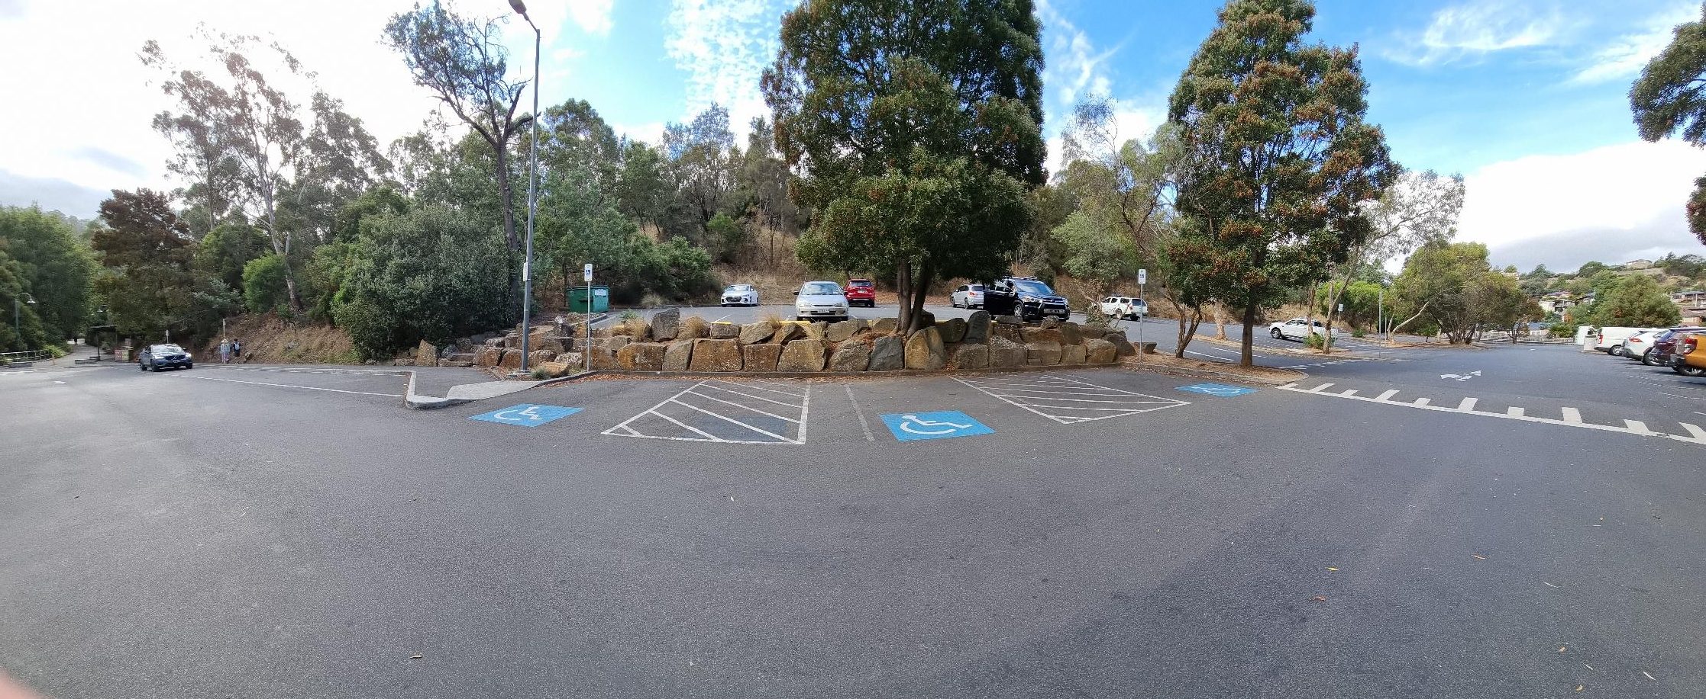
Carpark
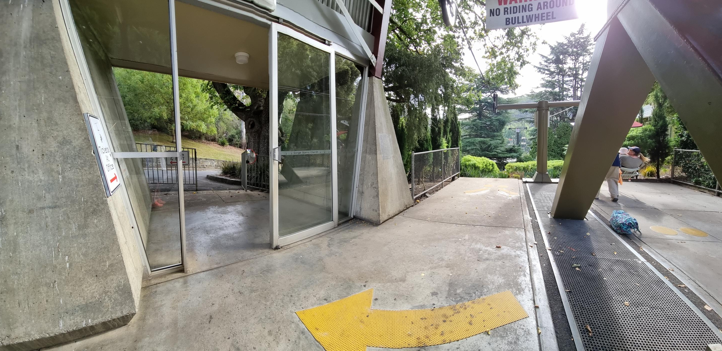
Chairlift pad
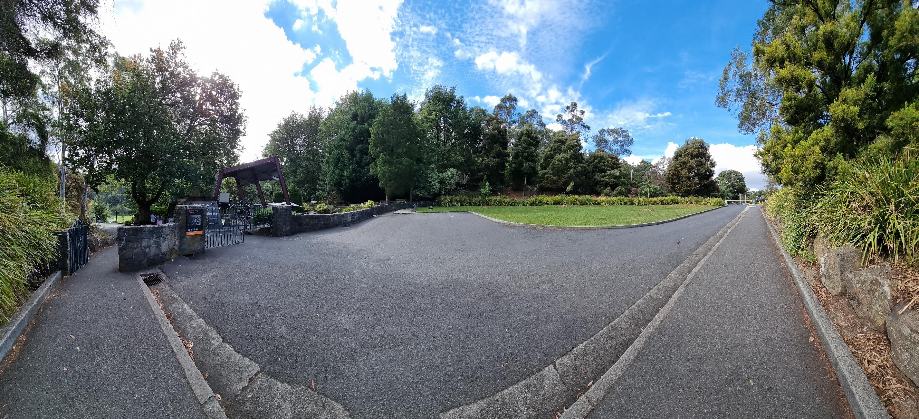
Gorge front gates and Chairlift
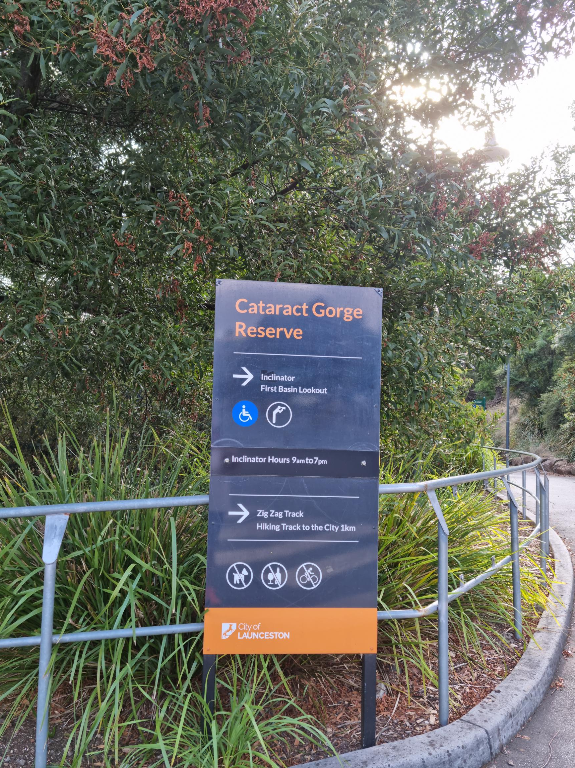
Inclinator
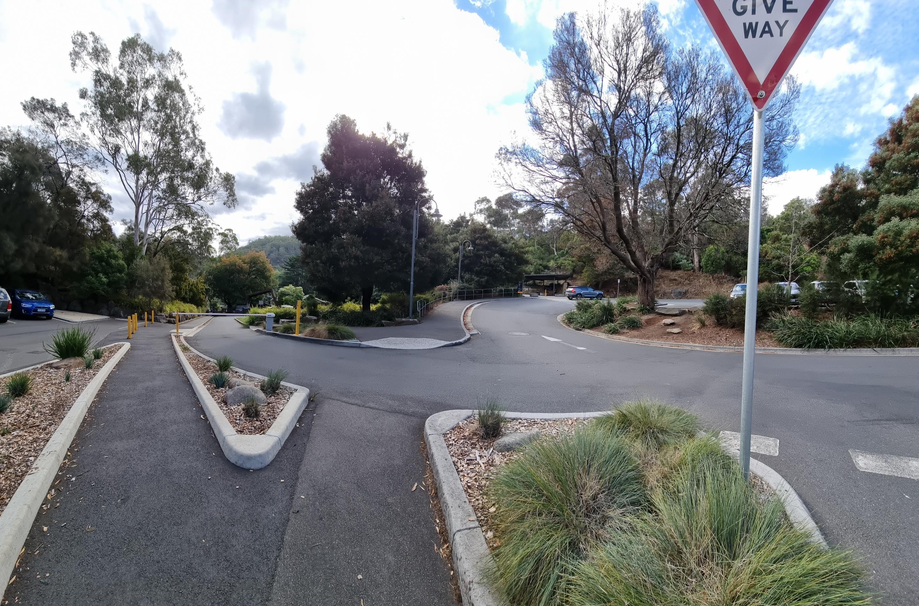
Walk down to chairlift

COMMON AREAS

Play Spaces
- Level access is provided to play spaces
- Ramps provided are at least 25% of elevated sections of the play space
- The surface of the play space is of a composite or rubberized material
- There wheelchair accessible activities
- The play space contains cognitive play panels
- The play space contains tactile play panels or activities
- The space contain colour contrasting elements
- Seating is provided in or around the play space
- The space contains a wheelchair swing
  - Image(s)
Carpark
Gorge front gates and Chairlift
- In addition, the following further information can assist guests:
All these spaces are part of the Cataract Gorge Reserve that is managed by the Launceston City Council

Swimming pools, spas and waterparks
- The following swimming pools, spas and waterparks amenities are available
- Unisex change facilities with an accessible toilet

The following accessible entry methods are available to the pools and spas:
- Sloped/level entry
- Transfer stairs
- Accessible pool stairs (hand rails both sides)
  - Pool Access Image(s)
Carpark
- In addition, the following further information can assist guests:
All these spaces are part of the Cataract Gorge Reserve that is managed by the Launceston City Council

Parks and gardens
- The following parks and gardens amenities are available
- Accessible toilets
- Accessible toilets are signed at regular intervals
- There is a step free map
- Seats are provided at regular intervals
- Direction signage contains distances
- Accessible picnic tables
- Accessible drinking fountains
- Accessible BBQs
- The park contains an observation deck or tower
- The observation deck or tower has level or ramped access
- The observation deck provides a clear view through the safety railing
  - Parks and Gardens Access/Entry Image(s)
Carpark
Inclinator
Walk down to chairlift

Report Disclaimer
Please note that this business report, provided as a result of the use of the diagnostic assessment, is for information purposes only.
Australian Tourism Industry Council (ATIC) cannot guarantee the accuracy of respondent’s answers, or that they are fully representative of your business. Therefore, ATIC does not warrant or guarantee any particular outcome in respect of your businesses self-assessment.
This report is intended as guidance only for your business and should not be relied on for future marketing considerations. ATIC recommends that you seek your own independent advice as well as the results from the diagnostic.
Links to external web sites are inserted for convenience and do not constitute endorsement of material at those sites, or any associated organisation, product or service.
ATIC does not:
- Assume any legal liability for the accuracy, completeness, or usefulness of any information from this report or any links provided; or
- Accept responsibility for any loss associated directly or indirectly from the use of this report.

