ATIC Accessibility
To support the accessible community in making informed travel decisions for their individual needs

This report prepared for:
Business name: | Naturaliste Charters
Address: | 25-27 Dunn Bay Rd
Town: | Dunsborough
Contact for enquiries: | Nakita Field
Contact Number: | 08 9750 5500
Contact Email: | info@whales-australia.com.au
Website: | www.naturalistecharters.com.au
Date: | 2026-11-08 01:49

ATIC Accessibility
The following pages provides travellers with information on the businesses facilities and amenities which aims to support the traveller to make an informed decision on whether the business is suitable for their individual needs.
OVERVIEW 4
Business Overview 4
Bookings 4
Emergency Management 4
Communications 5
Other Information 5
Guide Dog and Service Animals 5
GENERAL 6
Pre-arrival, arrival and reception 6
Car Park and Access amenities 6
Entry 6
Internal Spaces 7
Public areas 7
Displays, exhibits, commentary and live performances 7
External Paths 7
Steps 8
Public Toilets/Adult change facilities 8
TOUR OPERATORS 9
Tour/Transport Services 9
Route Planning 9
Guides 9
Report Disclaimer 35

OVERVIEW

Business Overview

The business has the following products/services available
- Tour/Transport

Our business caters for the following disability types:
- Blind or low vision
- Deaf or low hearing
- Limited mobility
- Wheelchairs or mobility scooters
- Food allergies or intolerances
- Cognitive or people on the Autism Spectrum

Bookings

The business offers the following methods for bookings and enquiries:
- Phone
- Email
- Webportal
- Our forms have high contract boxes and submit boxes

Emergency Management
- Emergency and evacuation procedures are explained on arrival
- There are visual device/s to alert occupants to evacuate.
- Exit signs are clear and easy to see
- Exit access is free and clear at all times
We ensure exit access is free and clear at all times by: Nothing is ever stored there
- Exits and access to exists are greater than 900mm
- Exit doors are able to be opened by all occupants
- Exits to the emergency evacuation point does not include stairways
The business identifies guests who need additional assistance should an emergency occur by: At the time of booking, guests are prompted to advise us of any medical conditions, mobility issues, or special assistance requirements. This information is noted in our booking system and communicated to the crew prior to each tour. Upon check-in, our team further engages with guests to confirm any assistance needs, ensuring those who may require extra support during an emergency are identified. Crew members are trained to observe and discreetly assess guests during boarding, and any individuals requiring additional assistance are prioritised during safety briefings and mustering procedures.
The procedure for assisting guests who need assisted rescue is: Guests identified as needing additional support are discreetly prioritised, and trained crew members are assigned to assist them. In the event of an emergency, a crew member will conduct a primary assessment and determine the safest way to assist the guest, using appropriate safety equipment such as life jackets if required. These guests are calmly escorted to the muster point or evacuation area, with clear communication and reassurance provided throughout the process.
- Guests with disabilities are noted in the guest log book for emergency and evacuation purposes

Communications
- Our business offers the following alternative communication methods
- Plain English
- There is easy to read signage and information (e.g. menus and emergency information)

Other Information
- The business accepts the companion card

Guide Dog and Service Animals
- The business provides a secure area with shade and water for service animals
The business provides the following services for services animals: We allow service dogs on board our vessel with their companions, we explain the risks and conditions and let the companion decide if they think our trips would be suitable for the service animal.

GENERAL

Pre-arrival, arrival and reception
The business has the following in place to support guests during pre-arrival, arrival and reception
- There is a reception/public entryway.
- Seating available at reception
- A lower counter at reception/ticket office
- A tablet with text to voice or pen and paper at reception to aid in communication
Our reception/check in areas are all different, we have one interior office, then 3 check in locations which are all outdoors.
- Information and maps are available in written form
- A familiarisation tour
The following steps are in place to ensure that people with fatigue related to their disability are not disadvantaged by long wait times: We allow them to board first or last dependent on their preference. If we notice anyone struggling in a queue we will go down and chat with them before addressing the others.

Car Park and Access amenities
The business has the following Car Park and Access amenities
- Designated disabled parking bays
- Level or ramped access from the car park to the entrance

Entry
The business has the following amenities/systems in place for entry
- A drop off point close to the entrance
- A path of access to the building is slip resistance and even
- A path of access to the building is clear of obstruction
- Glass doors are fitted with a visual sighting strip
- Door jams/doors are of a contrasting colour to surrounding walls
- Door handles are of a contrasting colour to the door
- Signage is written in a contrasting colour
- Signage is written in a Sans Serif font and use upper and lower case letters
- The entry door is a minimum of 850mm wide
- The entrance sill is less than 13mm
- There a clear space of at least 1500mm x 1500mm in front of all doors.
- The entrance door mats have a thickness less than 13mm and a width of 7500mm or greater

Internal Spaces
- Clear and unobstructed routes through and between buildings
- Interior walls are matte or low sheen
- Floors, walls, counters and furniture are of contrasting colours
- Floor surfaces are hard or short pile carpet
- Seating is available for guests unable to stand for long periods
- All corridors greater than 900mm

Public areas
The public areas have the following amenities in place
- Display units, Televisions, Video displays etc. are open captioned
- Even lighting
- Seating

Displays, exhibits, commentary and live performances
For displays, exhibits, commentary and live performances the following amenities are in place
- Seating
- Wheelchair accessible spaces/seating

External Paths
External paths of travel
- Surfaces are concrete, asphalt, smooth paving or hard packed fine gravel (max aggregate size 13mm)
- Pathways are wider than 900mm
- There 3 successive steps or less on any path or at any doorway
- Any paths having steps are clearly identified as non-wheelchair accessible
- Step free routes clearly signed

Steps
Steps
- There are steps.
- Top and bottom steps are easily distinguished through colour contrast or the use of TGSIs (Tactile Ground Surface Indicators)
- All steps or staircases have enclosed risers
- The underside of all staircases are enclosed or protected to a height of at least 2 metres
- Handrails fitted to all open sets of steps
- Handrails extend 300mm beyond the top and bottom step

Public Toilets/Adult change facilities
Public Toilets/Adult change facilities have the following amenities are in place
- There is an accessible toilet for public use
- The door is at least 850mm wide
- There is 300MM at a guess from to the wall from the toilet mm beside the toilet
- Handrails are fitted
- The toilet seat of a contrasting colour to the floor
- The toilet seat is460mm above the floor

TOUR OPERATORS

Tour/Transport Services
The tour/transport services have the following facilities/amenities in place
- Buses/Coaches
- 0 vehicles have wheelchair lifts or ramps
- 1 vehicles have low floors with ramped entry
The maximum wheelchair capacity available in the fleet is: 2
- Commentary is available in written format
- Audio visual displays are sub titles

Route Planning
- There is an accessible toilet on-board for public use
- The door is at least 850mm wide
- There is 300mm at a guess, the complete width of the toilet cubicle is 890mm mm beside the toilet
- Handrails are fitted
- The toilet seat of a contrasting colour to the floor
- The toilet seat is 460mm above the floor
  - Accessible Toilet Image(s)
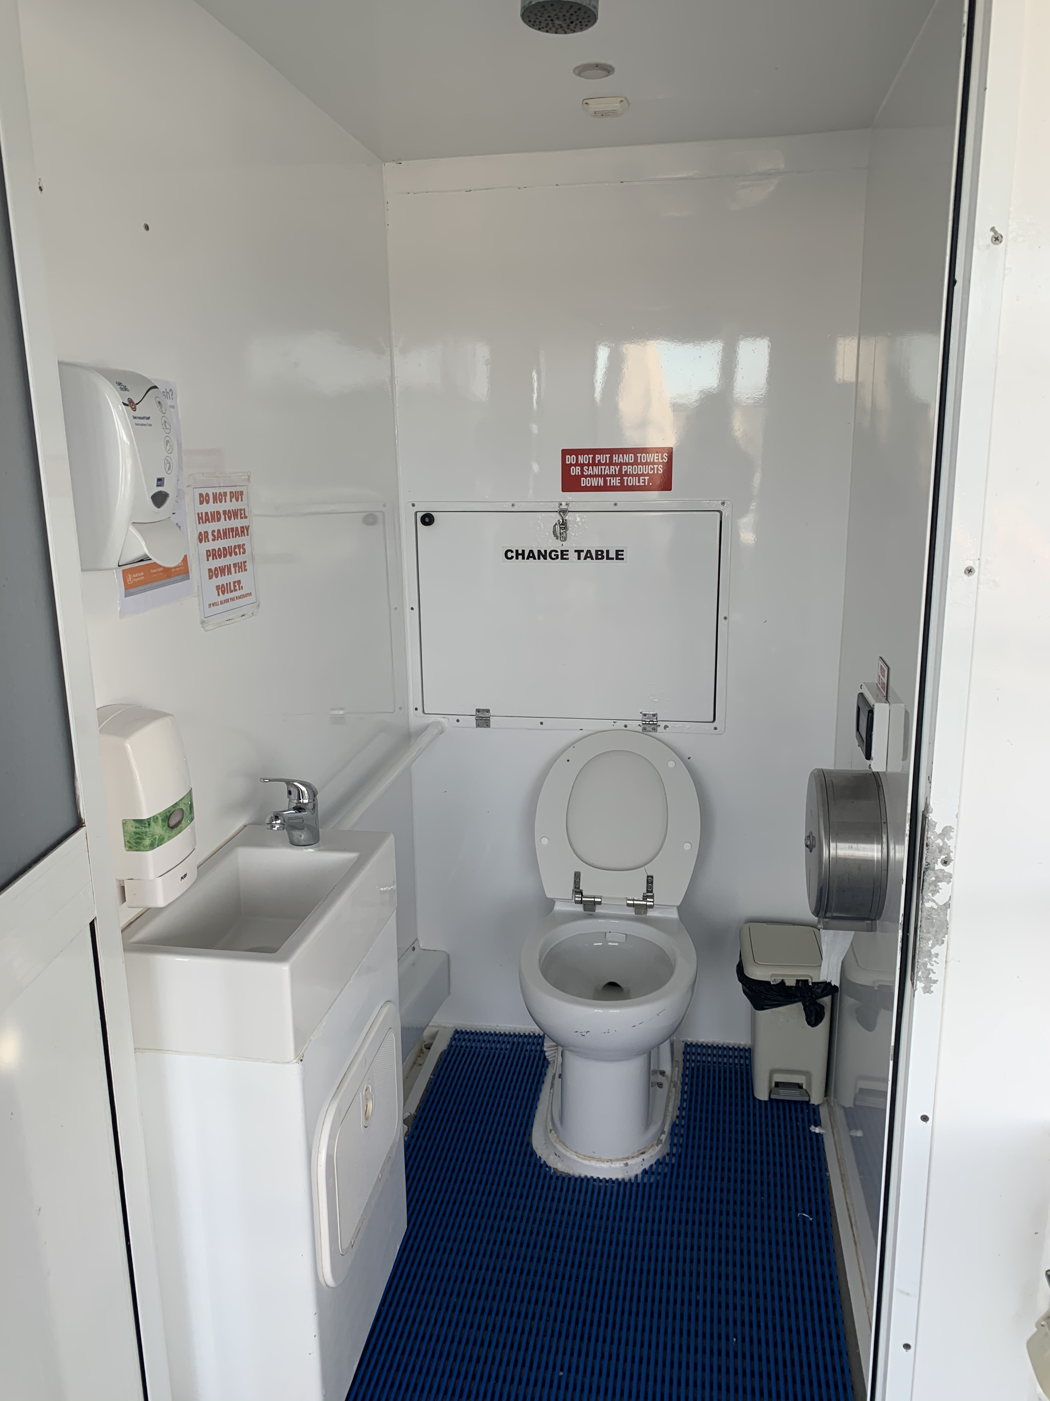
1D14C6B9-54E9-45A9-AAA2-39761F8BFDD8

Guides
- Use of clear/simple English
- Marine
- Marine craft are wheelchair accessible
- Length (cm) Varies.
- Width (cm) Varies.
- Height (cm) Varies.
- Weight (kg) Varies.
- Accessibility is tide dependent
  - Image(s)
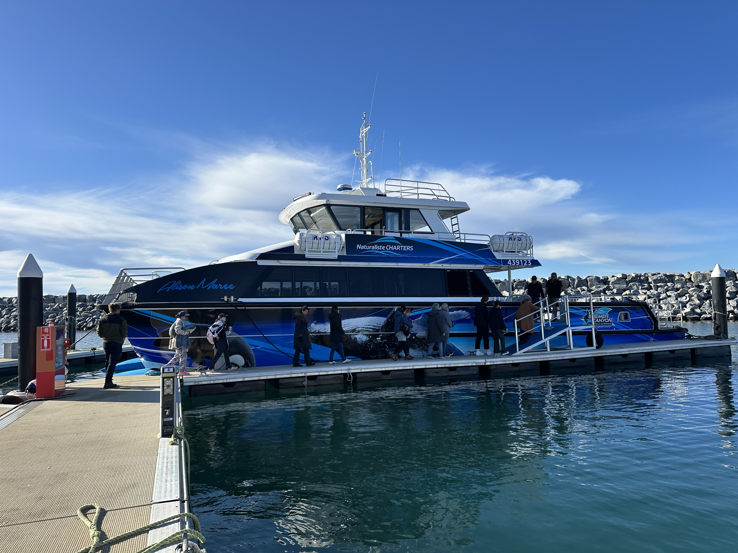
IMG_1832
- In addition, the following further information can assist guests:
Wheelchair Accessibility Information
At Naturaliste Charters, we strive to accommodate all guests wherever possible. However, due to the unique boarding environments at each of our departure locations, wheelchair accessibility varies.

Dunsborough Whale Watching Tours
Unfortunately, our Dunsborough tours are not wheelchair accessible. These tours require a beach launch using a tender vessel, which involves boarding from the sand and is not suitable for wheelchairs or guests with limited mobility.

Augusta & Bremer Bay Whale Watching Tours
We welcome guests who use wheelchairs to join us on our Augusta and Bremer Bay tours; however, please note that access is limited and dependent on individual circumstances.

Wheel-on access is not guaranteed as it is tide dependent and boarding ramps vary in size.

The most feasible option is when the guest is:

Able to take a few assisted steps, or

Able to be carried by a carer or companion onto the vessel.

Our trained crew are happy to assist by lifting and securing the wheelchair on board, provided the chair is:

*Under 30kg

*Manual (non-electric) if possible

We strongly recommend contacting our team prior to booking so we can discuss individual needs and ensure the best possible experience.

Report Disclaimer
Please note that this business report, provided as a result of the use of the diagnostic assessment, is for information purposes only.
Australian Tourism Industry Council (ATIC) cannot guarantee the accuracy of respondent’s answers, or that they are fully representative of your business. Therefore, ATIC does not warrant or guarantee any particular outcome in respect of your businesses self-assessment.
This report is intended as guidance only for your business and should not be relied on for future marketing considerations. ATIC recommends that you seek your own independent advice as well as the results from the diagnostic.
Links to external web sites are inserted for convenience and do not constitute endorsement of material at those sites, or any associated organisation, product or service.
ATIC does not:
- Assume any legal liability for the accuracy, completeness, or usefulness of any information from this report or any links provided; or
- Accept responsibility for any loss associated directly or indirectly from the use of this report.

