ATIC Accessibility
To support the accessible community in making informed travel decisions for their individual needs

This report prepared for:
Business name: | Beachcomber Holiday Units
Address: | 603 Esplanade
Town: | Lakes Entrance
Contact for enquiries: | Rebecca Hayes
Contact Number: | 0413294061
Contact Email: | info@beachcomberholidayunits.com.au
Website: | https://www.beachcomberholidayunits.com.au/
Date: | 2026-10-26 09:48

ATIC Accessibility
The following pages provides travellers with information on the businesses facilities and amenities which aims to support the traveller to make an informed decision on whether the business is suitable for their individual needs.
OVERVIEW 4
Business Overview 4
Bookings 4
Emergency Management 4
Communications 5
GENERAL 6
Pre-arrival, arrival and reception 6
Cognitive Impairment Support 6
Car Park and Access amenities 6
Entry 6
Internal Spaces 7
Public areas 7
External Paths 7
Steps 8
ACCOMMODATION 9
Bedrooms 9
Room Amenities 11
Bathrooms 12
COMMON AREAS 15
Report Disclaimer 17

OVERVIEW

Business Overview

The business has the following products/services available
- Accommodation

Our business caters for the following disability types:
- Blind or low vision
- Deaf or low hearing
- Limited mobility
- Food allergies or intolerances
- Cognitive or people on the Autism Spectrum

Bookings

The business offers the following methods for bookings and enquiries:
- Phone
- Email
- Webportal
- Our website supports Screen Readers
- Our forms have high contract boxes and submit boxes

Emergency Management
- Exit signs are clear and easy to see
- Exit access is free and clear at all times
We ensure exit access is free and clear at all times by: We conduct regular inspections of all areas throughout the day to ensure that exit access remains unobstructed at all times. Our small property allows us to maintain a high level of oversight and promptly address any potential hazards.
- Exits and access to exists are greater than 900mm
- Exit doors are able to be opened by all occupants
- Exits to the emergency evacuation point does not include stairways
- The evacuation point is clearly marked by a sign
The business identifies guests who need additional assistance should an emergency occur by: During check-in, we personally speak with each guest to identify those who may require additional assistance in the event of an emergency. As we live on-site, we can provide immediate support and ensure the safety and well-being of all our guests.
The procedure for assisting guests who need assisted rescue is: In the event of an emergency, our procedure involves: Identifying guests who require assistance based on the information gathered during check-in. Assigning a staff member to assist each identified guest, ensuring they receive the necessary support to evacuate safely. Coordinating with emergency services to facilitate the rescue of guests who need additional assistance. Maintaining communication with the guests throughout the evacuation process to provide reassurance and guidance.
- Guests with disabilities are noted in the guest log book for emergency and evacuation purposes

Communications
- An accessibility guide is available on the website
https://www.beachcomberholidayunits.com.au/accessibility-1
- Our business offers the following alternative communication methods
- Plain English
The business provides the following services for services animals: We welcome guests with service animals and allow them to stay in our holiday units. Service animals are permitted in all areas of the property, provided they are accompanied by their owner and the owner ensures proper cleanliness. While we do not offer specific amenities such as bowls or bedding, we strive to accommodate any additional needs of our guests and their service animals upon request.

GENERAL

Pre-arrival, arrival and reception
The business has the following in place to support guests during pre-arrival, arrival and reception
- Booking information and websites are compatible with screen readers
- Information and maps are available in written form
- A familiarisation tour
- Keys are available for each guest
- Luggage assistance
The following steps are in place to ensure that people with fatigue related to their disability are not disadvantaged by long wait times: We check in guests at their unit. So they can sit down, go to the bathroom, lay down, unpack immediately.

Cognitive Impairment Support
- Documents are available in plain English for people with cognitive impairment (This may include instructions, guides, menus and general information)
- Quiet periods or early opening times for people on the Autism Spectrum
- A space for parents and children on the Autism Spectrum

Car Park and Access amenities
The business has the following Car Park and Access amenities
- A drop off zone
- Level or ramped access from the car park to the entrance
- The accessible entrance is clearly signed from the parking bay
- The public transport services available are:
We do have public transport access on our website, booking platform and in confirmation emails.

Entry
The business has the following amenities/systems in place for entry
- A drop off point close to the entrance
- A path of access to the building is slip resistance and even
- A path of access to the building is clear of obstruction
- Glass doors are fitted with a visual sighting strip
- Door jams/doors are of a contrasting colour to surrounding walls
- Door handles are of a contrasting colour to the door
- Signage is written in a contrasting colour
- The entry door has self opening or a light opening pressure (for manual operations)
- The entrance sill is less than 13mm
- There a clear space of at least 1500mm x 1500mm in front of all doors.
- The entrance door mats have a thickness less than 13mm and a width of 7500mm or greater

Internal Spaces
- Clear and unobstructed routes through and between buildings
- Interior walls are matte or low sheen
- Floors, walls, counters and furniture are of contrasting colours
- Any protruding or overhanging obstructions are at least 2meters above the floor or are protected
- Tableware/glassware contrast with the table surface or table cloth
- Floor surfaces are hard or short pile carpet
- Seating is available for guests unable to stand for long periods
- Accessible facilities are clearly signed and visible from all areas
- All corridors greater than 900mm
- There is a quiet space for parents and children on the Autism Spectrum

Public areas
The public areas have the following amenities in place
- Display units, Televisions, Video displays etc. are open captioned
- Even lighting
- Seating

External Paths
External paths of travel
- Surfaces are concrete, asphalt, smooth paving or hard packed fine gravel (max aggregate size 13mm)
- Paths or slopes longer than 15 metres have resting places or seats
- Pathways are wider than 900mm
- There 3 successive steps or less on any path or at any doorway
- Step free routes clearly signed

Steps
Steps
- There are steps.
- Top and bottom steps are easily distinguished through colour contrast or the use of TGSIs (Tactile Ground Surface Indicators)
- All steps or staircases have enclosed risers
- The underside of all staircases are enclosed or protected to a height of at least 2 metres
- Where steps are present are there three steps or less

ACCOMMODATION

Bedrooms
The bedrooms have the following facilities/amenities in place
- There are We have two self-contained holiday units that are step free for wheelchair users these are not suitable for all wheelchair users though rooms available to guests who use a wheelchair
- Bedroom furniture can be re-arranged on request

The following bed types are available in wheelchair accessible rooms
- One double/queen bed/king bed
  - Layout of room Image(s)
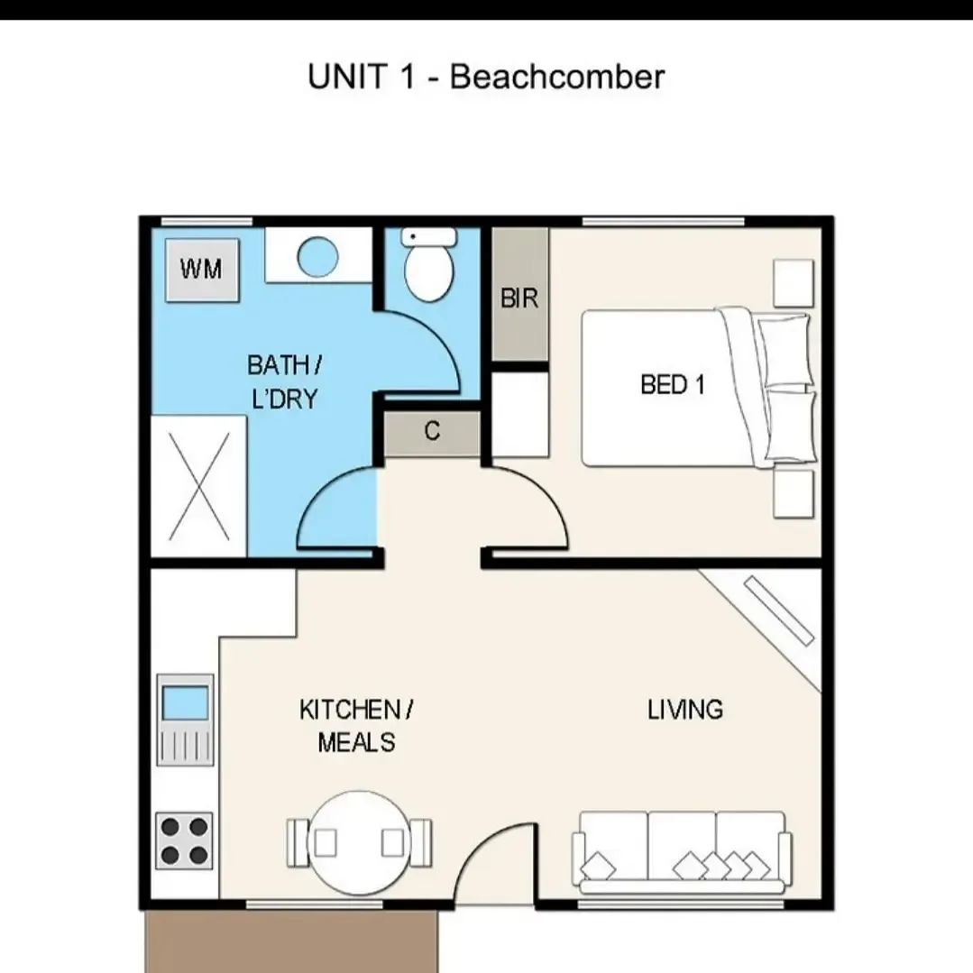
Unit 1 9
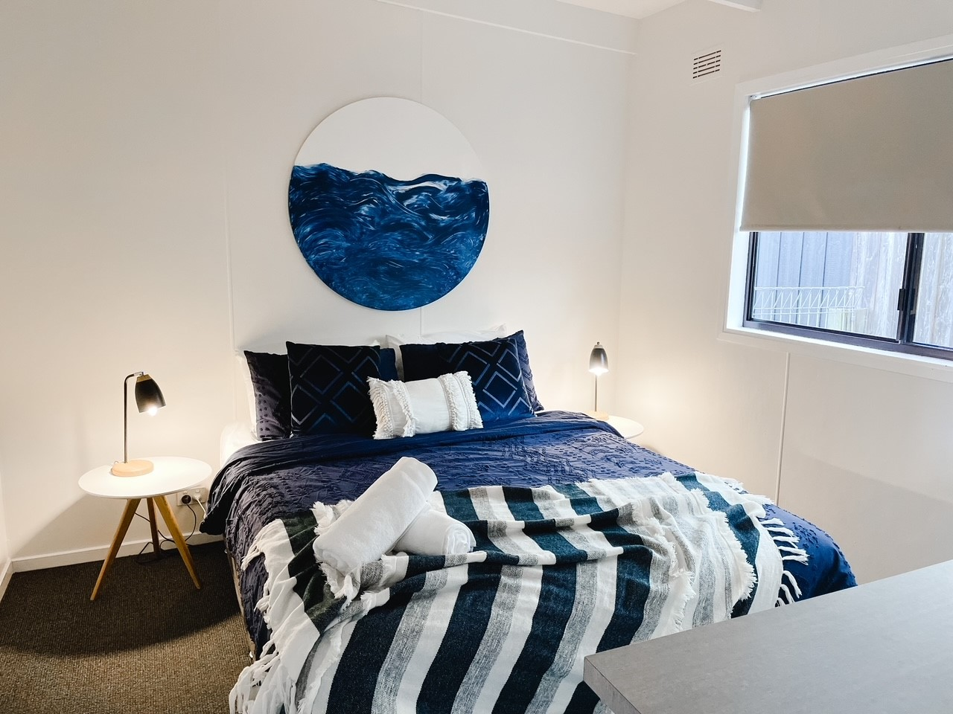
Unit 2 bedroom

Room Amenities
- Lower hanging rails are in wardrobes
For guests with a hearing impairment, the following emergency evacuation procedures apply to ensure safe evacuation: During check-in at Beachcomber Holiday Units, we personally engage with each guest to identify those who may have hearing impairments and require additional assistance in an emergency. As we live on-site, we are readily available to provide immediate support. In the event of an emergency, our procedure includes: Directly notifying guests with hearing impairments through face-to-face communication or written notes. Assigning a staff member to assist these guests and ensure they are aware of the situation. Guiding them to the nearest exit and assisting them to the evacuation point. Ensuring their safety and well-being throughout the evacuation process by maintaining clear and supportive communication.
- Televisions are equipped with closed captioning capability
- There is contrast between the walls, skirtings, floor and furniture
- There is a clear path through the room
- Housekeeping procedures instruct staff not to reposition furniture that has been moved
- Doors open fully against the adjoining wall
- Openings are a minimum of Our smallest opening is 790mm wide
- There at least one chair with rigid arms
- Wardrobe and drawer handles are easy to grip
- The bedside lamp switch is easy to reach from the bed
- There is at least 850mm clear space beside the bed
- The bed height is no higher than 680mm from the floor
- Blocks are available to put under the bed legs
- In addition, the following further information can assist guests:
Beds are able to be moved to make more space to the side on request

Bathrooms
The bathrooms have the following facilities/amenities in place
- All heating appliances and hot water pipes are protected or insulated
- All shower, bath and basin taps are clearly differentiated between hot and cold
- Fixtures and fittings have rounded edges
- The hot water is thermostatically controlled to 41 degrees
- The width of the door is 690mm.
- The width beside the toilet is 310mm.
- There is 860mm mm of clear space in front of the toilet
- The toilet seat is a contrasting colour to the floor
- The actual height of the toilet seat is 410mm.
- There is a roll-in shower with fold down fixed seat or a shower chair
- There is a portable shower head on flexible hose
  - Bathroom Image(s)
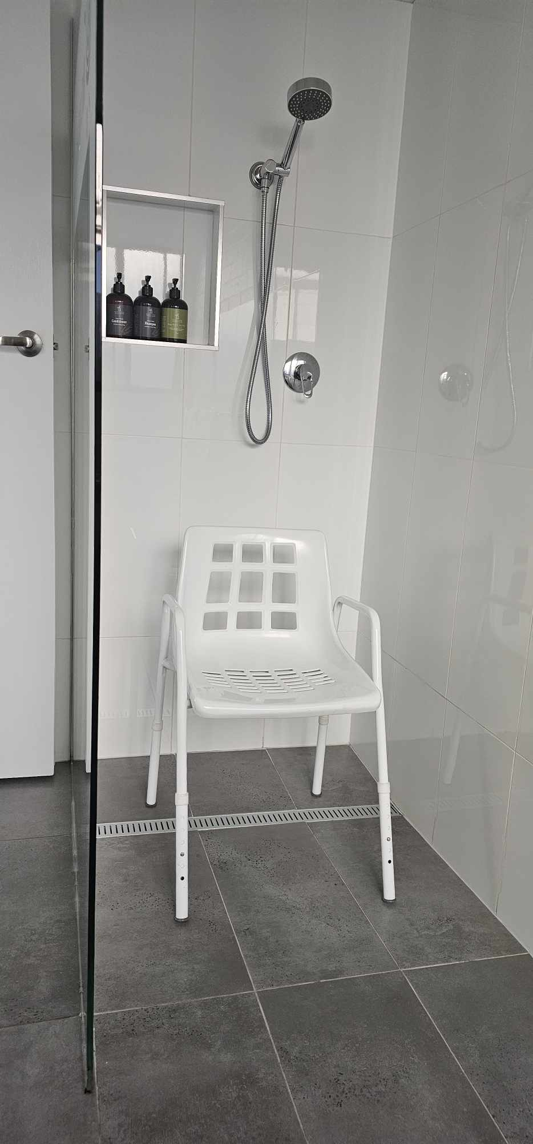
Unit 1 Shower with Shower Chair
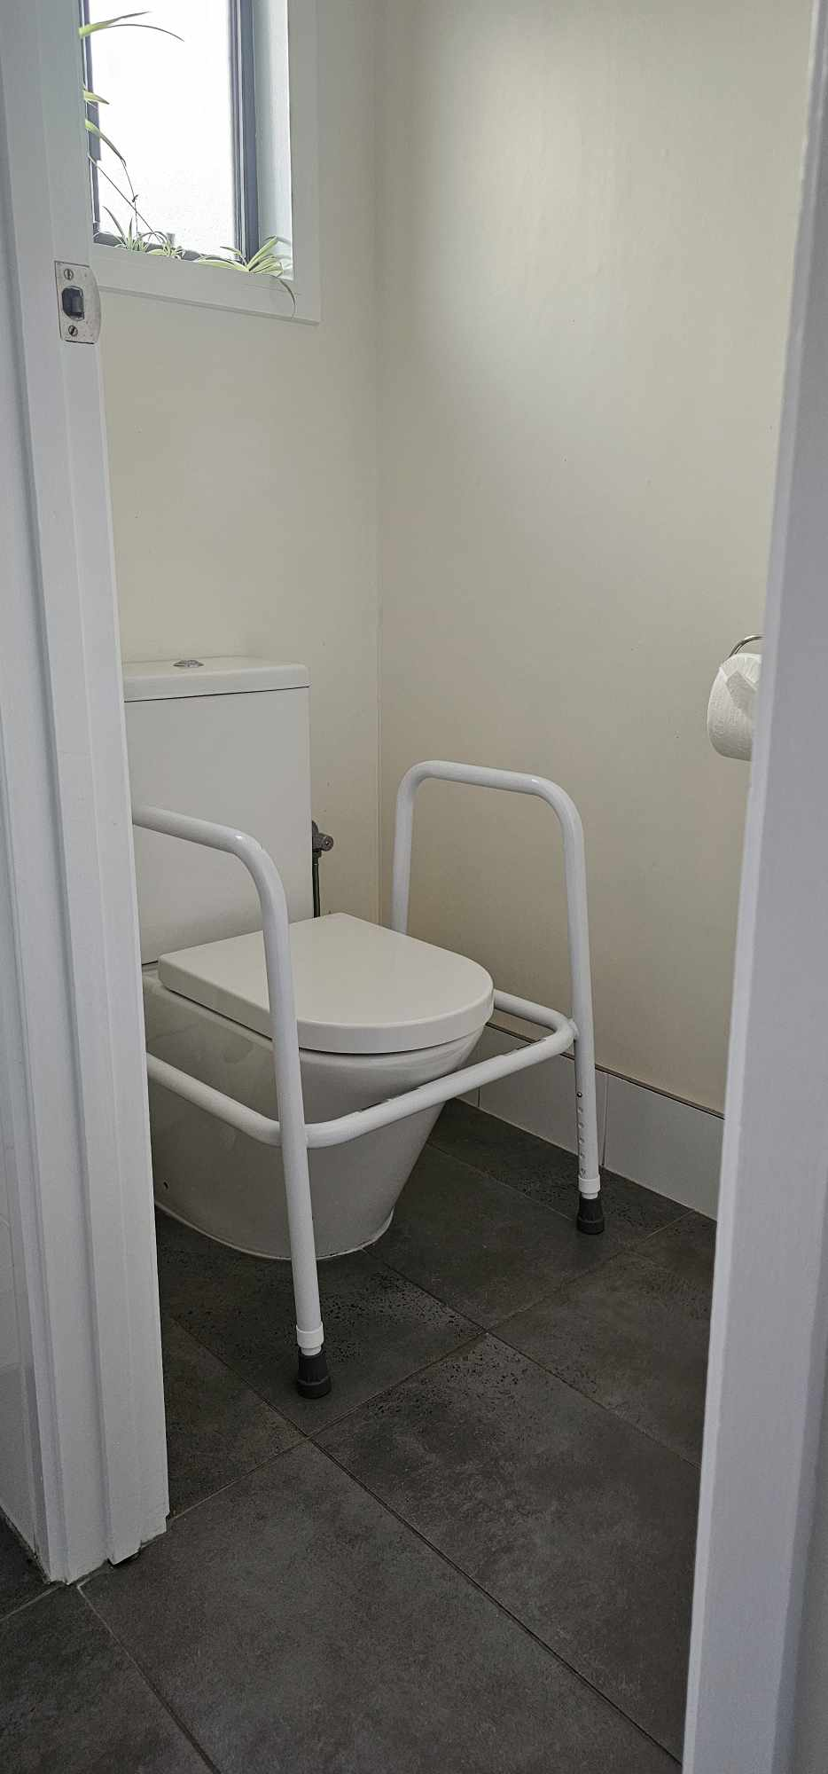
Unit 1 Toilet with surround
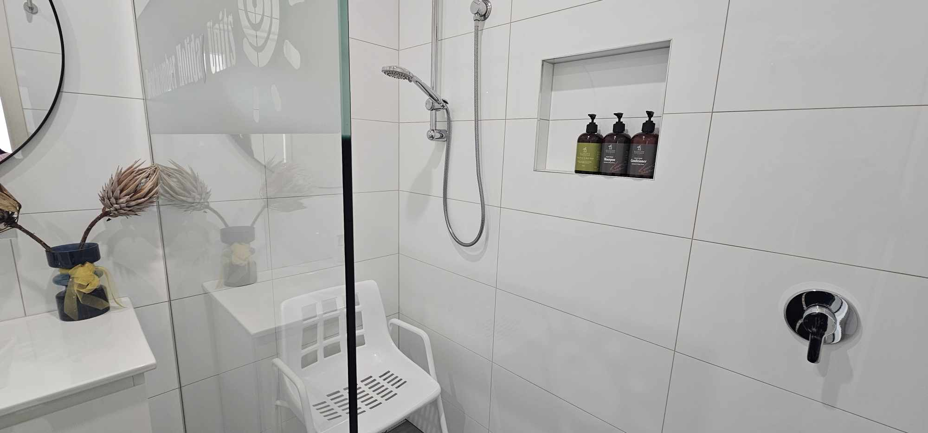
Unit 4 Bathroom with shower chair 2
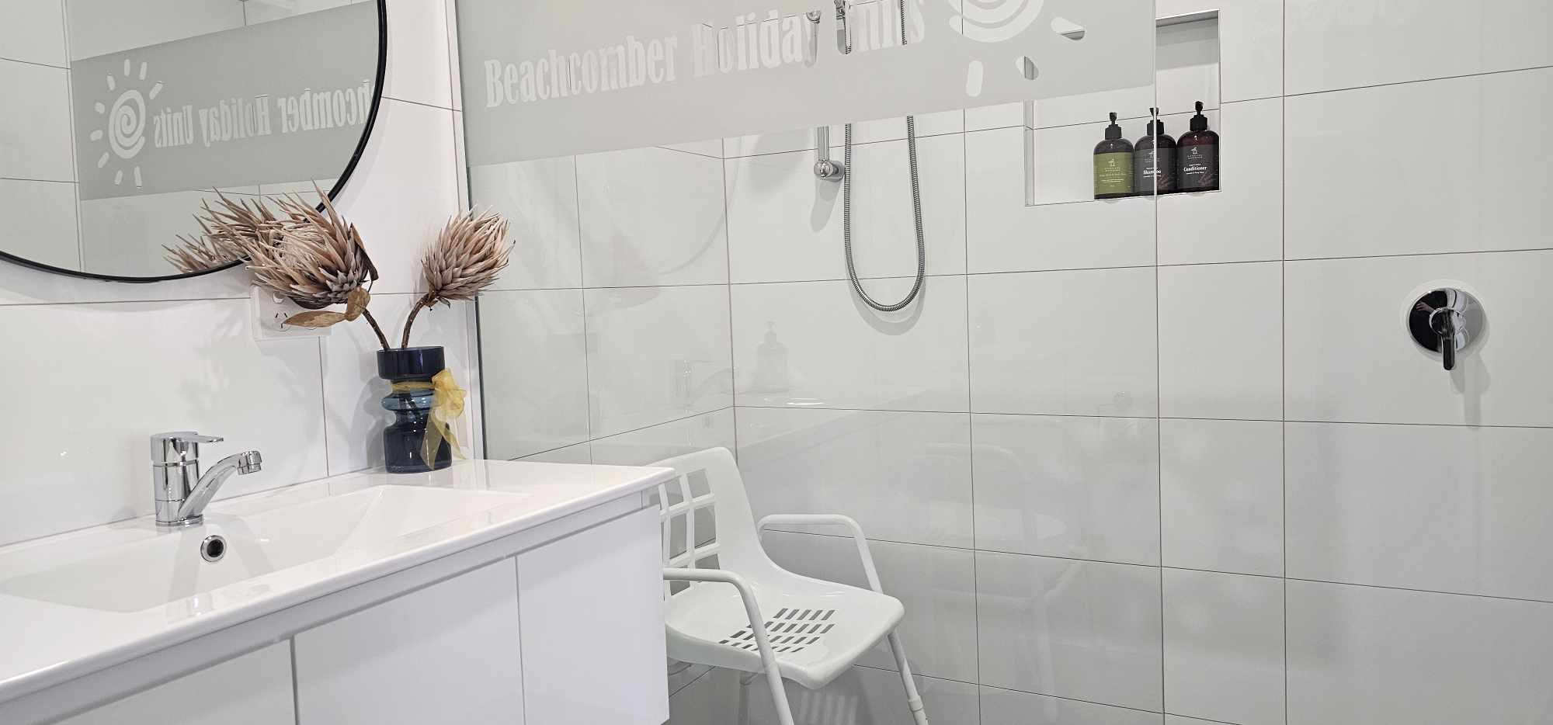
Unit 4 Bathroom with shower chair
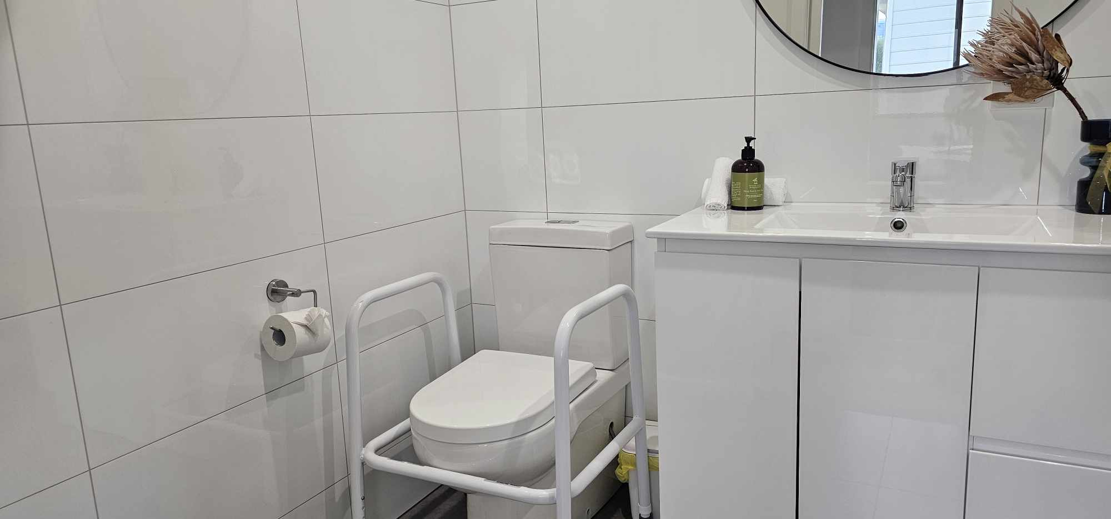
Unit 4 Bathroom with toilet surround 2
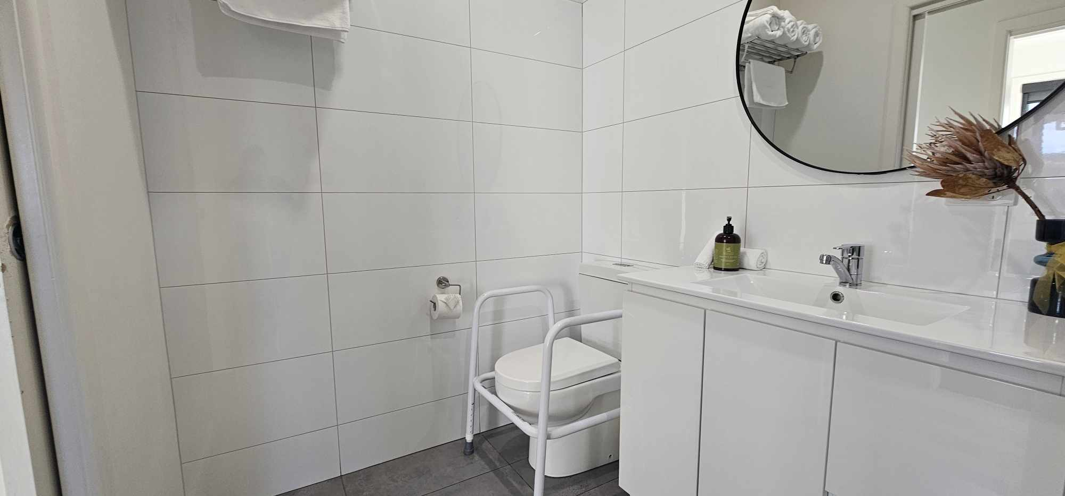
Unit 4 Bathroom with toilet surround
- In addition, the following further information can assist guests:
Beachcomber Holiday Units has 3 different size units, one bedroom, two bedroom and three bedroom. All of these sizes have different size and style bathrooms. They all have step free showers and we can provide a shower chair and toilet surround support to a weight value of 250kg on request.

COMMON AREAS

Report Disclaimer
Please note that this business report, provided as a result of the use of the diagnostic assessment, is for information purposes only.
Australian Tourism Industry Council (ATIC) cannot guarantee the accuracy of respondent’s answers, or that they are fully representative of your business. Therefore, ATIC does not warrant or guarantee any particular outcome in respect of your businesses self-assessment.
This report is intended as guidance only for your business and should not be relied on for future marketing considerations. ATIC recommends that you seek your own independent advice as well as the results from the diagnostic.
Links to external web sites are inserted for convenience and do not constitute endorsement of material at those sites, or any associated organisation, product or service.
ATIC does not:
- Assume any legal liability for the accuracy, completeness, or usefulness of any information from this report or any links provided; or
- Accept responsibility for any loss associated directly or indirectly from the use of this report.

