ATIC Accessibility
To support the accessible community in making informed travel decisions for their individual needs

This report prepared for:
Business name: | Sin Gin Distillery
Address: | 124 Lennard Street
Town: | Herne Hill
Contact for enquiries: | Tess Crake
Contact Number: | 0438998300
Contact Email: | kate@singindistillery.com.au
Website: | https://singindistillery.com.au
Date: | 2026-11-07 05:24

ATIC Accessibility
The following pages provides travellers with information on the businesses facilities and amenities which aims to support the traveller to make an informed decision on whether the business is suitable for their individual needs.
OVERVIEW 4
Business Overview 4
Bookings 4
Emergency Management 4
Communications 5
Other Information 5
Guide Dog and Service Animals 5
GENERAL 6
Pre-arrival, arrival and reception 6
Cognitive Impairment Support 6
Car Park and Access amenities 6
Entry 7
Internal Spaces 7
Public areas 7
External Paths 8
Public Toilets/Adult change facilities 8
FOOD AND DRINK 9
Dining Spaces 9
Report Disclaimer 12

OVERVIEW

Business Overview

The business has the following products/services available
- Food and Drink

Our business caters for the following disability types:
- Blind or low vision
- Deaf or low hearing
- Limited mobility
- Wheelchairs or mobility scooters
- Food allergies or intolerances
- Cognitive or people on the Autism Spectrum

Bookings

The business offers the following methods for bookings and enquiries:
- Phone
- Email
- Webportal
- Our forms have high contract boxes and submit boxes

Emergency Management
- Exit signs are clear and easy to see
- Exit access is free and clear at all times
We ensure exit access is free and clear at all times by: We ensure all doorways are always kept clear.
- Exits and access to exists are greater than 900mm
- Exit doors are able to be opened by all occupants
- Exits to the emergency evacuation point does not include stairways
- The evacuation point is clearly marked by a sign
The business identifies guests who need additional assistance should an emergency occur by: At time of booking guests can advise if persons in their group has a disability or requires assistance.
The procedure for assisting guests who need assisted rescue is: When assisting any person with a disability to leave the building, or to the nearest fire safe area 1. Ask what assistance the person requires (such as clearing the path before them, walking alongside or behind). Try to avoid offering advice or pre-empting what the person needs. 2. Reassure the person by talking calmly to them. Tell them that you will stay with them and communicate clearly. 4. Assist the person quickly and calmly to the designated assembly area for our building or as advised by a Warden or Fire and Emergency Services person.
- Guests with disabilities are noted in the guest log book for emergency and evacuation purposes

Communications
- Our business offers the following alternative communication methods
- Plain English
- There is easy to read signage and information (e.g. menus and emergency information)

Other Information
- For bookings made onsite, the ticket booth/counter/box office is accessible for people using a wheelchair

Guide Dog and Service Animals
- The business provides a secure area with shade and water for service animals
- The business provides a toilet area for service animals
The business provides the following services for services animals: Outdoor facilities available. All service animals are accepted

GENERAL

Pre-arrival, arrival and reception
The business has the following in place to support guests during pre-arrival, arrival and reception
- Booking information and websites are compatible with screen readers
- There is a reception/public entryway.
- Seating available at reception
- A tablet with text to voice or pen and paper at reception to aid in communication
- Lighting in the reception area is even and glare free
- Large print information sheets and registration forms
- Information and maps are available in written form
- A familiarisation tour
The following steps are in place to ensure that people with fatigue related to their disability are not disadvantaged by long wait times: Seating is available for those waiting. However long wait times are a rare occurrence.
- In addition, the following further information can assist guests:
N/A

Cognitive Impairment Support
- Documents are available in plain English for people with cognitive impairment (This may include instructions, guides, menus and general information)

Car Park and Access amenities
The business has the following Car Park and Access amenities
- A drop off zone
- Designated disabled parking bays
- Level or ramped access from the car park to the entrance
- The accessible entrance is clearly signed from the parking bay
- Kerb ramps are in place where a pavement or walkway needs to be crossed
- In addition, the following further information can assist guests:
Fully level car park.

Entry
The business has the following amenities/systems in place for entry
- A drop off point close to the entrance
- A path of access to the building is slip resistance and even
- A path of access to the building is clear of obstruction
- Door jams/doors are of a contrasting colour to surrounding walls
- Door handles are of a contrasting colour to the door
- Signage is written in a contrasting colour
- Signage is written in a Sans Serif font and use upper and lower case letters
- The entry door is a minimum of 850mm wide
- The entry door has self opening or a light opening pressure (for manual operations)
- The entrance sill is less than 13mm
- There a clear space of at least 1500mm x 1500mm in front of all doors.
- The entrance door mats have a thickness less than 13mm and a width of 7500mm or greater
- In addition, the following further information can assist guests:
N/A
- In addition, the following further information can assist guests:
Single storey building

Internal Spaces
- Clear and unobstructed routes through and between buildings
- Interior walls are matte or low sheen
- Floors, walls, counters and furniture are of contrasting colours
- Any protruding or overhanging obstructions are at least 2meters above the floor or are protected
- Tableware/glassware contrast with the table surface or table cloth
- Seating is available for guests unable to stand for long periods
- Accessible facilities are clearly signed and visible from all areas
- All corridors greater than 900mm
- In addition, the following further information can assist guests:
Our space can be very noisy at times, particularly between the hours of 11am - 4pm on Weekends. Our space is very quiet Monday to Friday

Public areas
The public areas have the following amenities in place
- Even lighting
- Seating
- In addition, the following further information can assist guests:
N/A

External Paths
External paths of travel
- Surfaces are concrete, asphalt, smooth paving or hard packed fine gravel (max aggregate size 13mm)
- Pathways are wider than 900mm
- There 3 successive steps or less on any path or at any doorway
There are no internal or external steps at our building
- In addition, the following further information can assist guests:
N/A
- In addition, the following further information can assist guests:
N/A

Public Toilets/Adult change facilities
Public Toilets/Adult change facilities have the following amenities are in place
- There is an accessible toilet for public use
- The door is at least 850mm wide
- There is a minimum of 850mm beside the toilet
- Handrails are fitted
- The toilet seat is 460mm above the floor
- There is 1554mm mm of clear space in front of the toilet
- The toilet seat of a contrasting colour to the floor
- The toilet seat is460mm above the floor
- There is a 'Changing Place' within 1400mm of our business
- In addition, the following further information can assist guests:
N/A

FOOD AND DRINK

Dining Spaces
The dining spaces have the following facilities/amenities in place
- The entrance has level access
- The doorway is at least 850mm wide
- There is level access through the dining area
- Chairs are moveable to allow for wheelchairs to be seated at the tables
- All glass doors and full height windows have contrast markings
- There are areas of full lighting
- There is an accessible toilet

Our business caters for the following dietary requirements
- Sugar free (diabetic)
- Gluten free (celiac)
- Lactose free (dairy free)
- Low fat and fibre with no gastric content
- Low potassium
- Low sodium
- Nut free
- Additive free
- Organic
- Vegetarian
- Vegan
- There are procedures in place to avoid cross-contamination of food products
  - Food and Beverage Image(s)
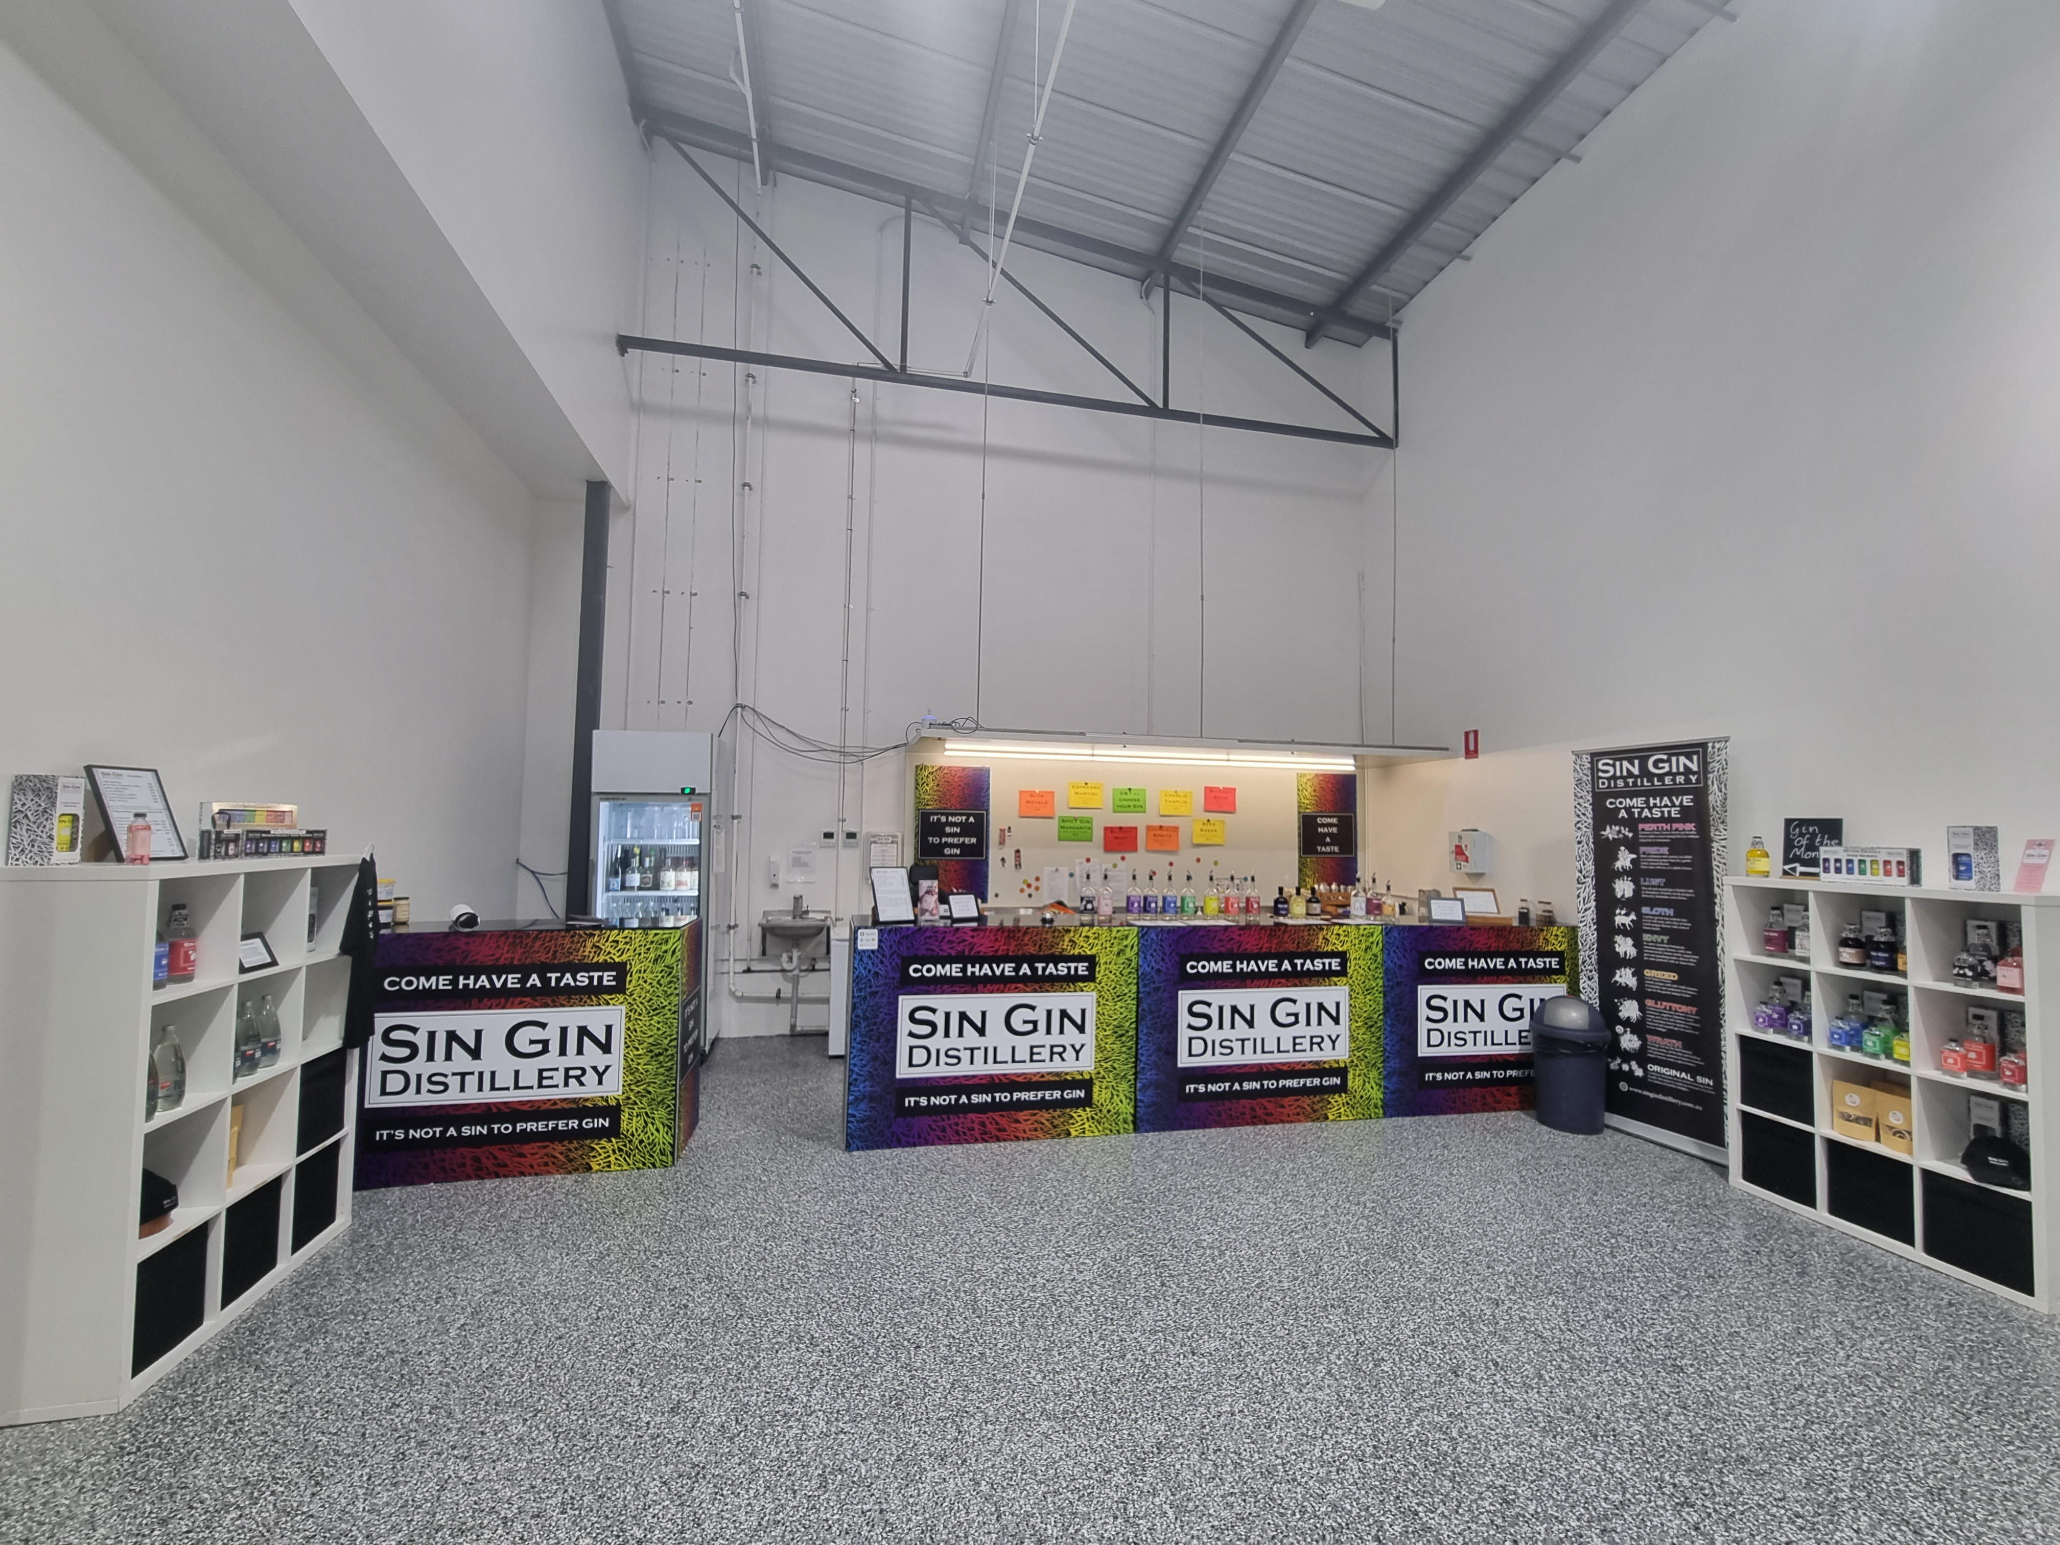
20240531_144618
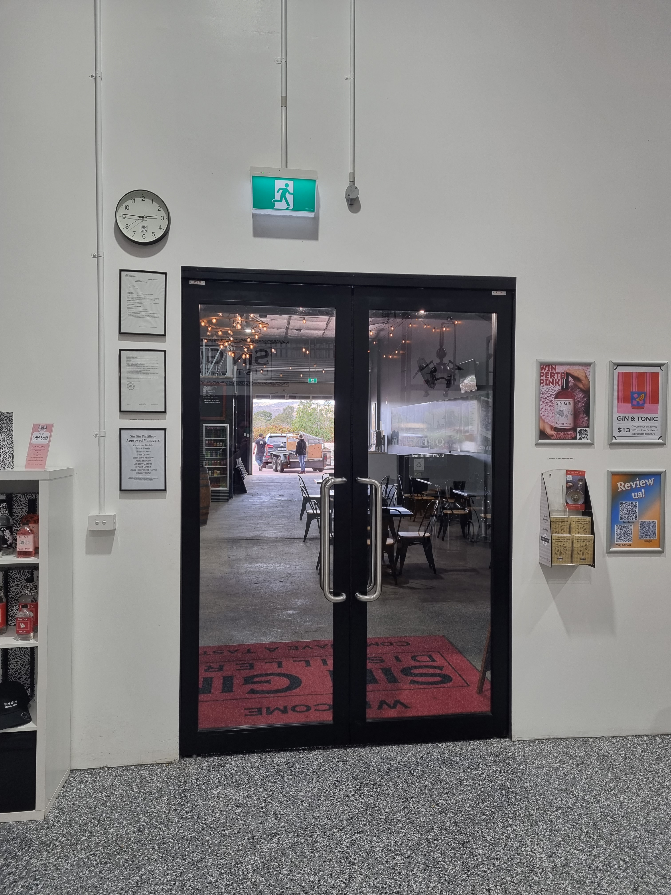
20240531_144625
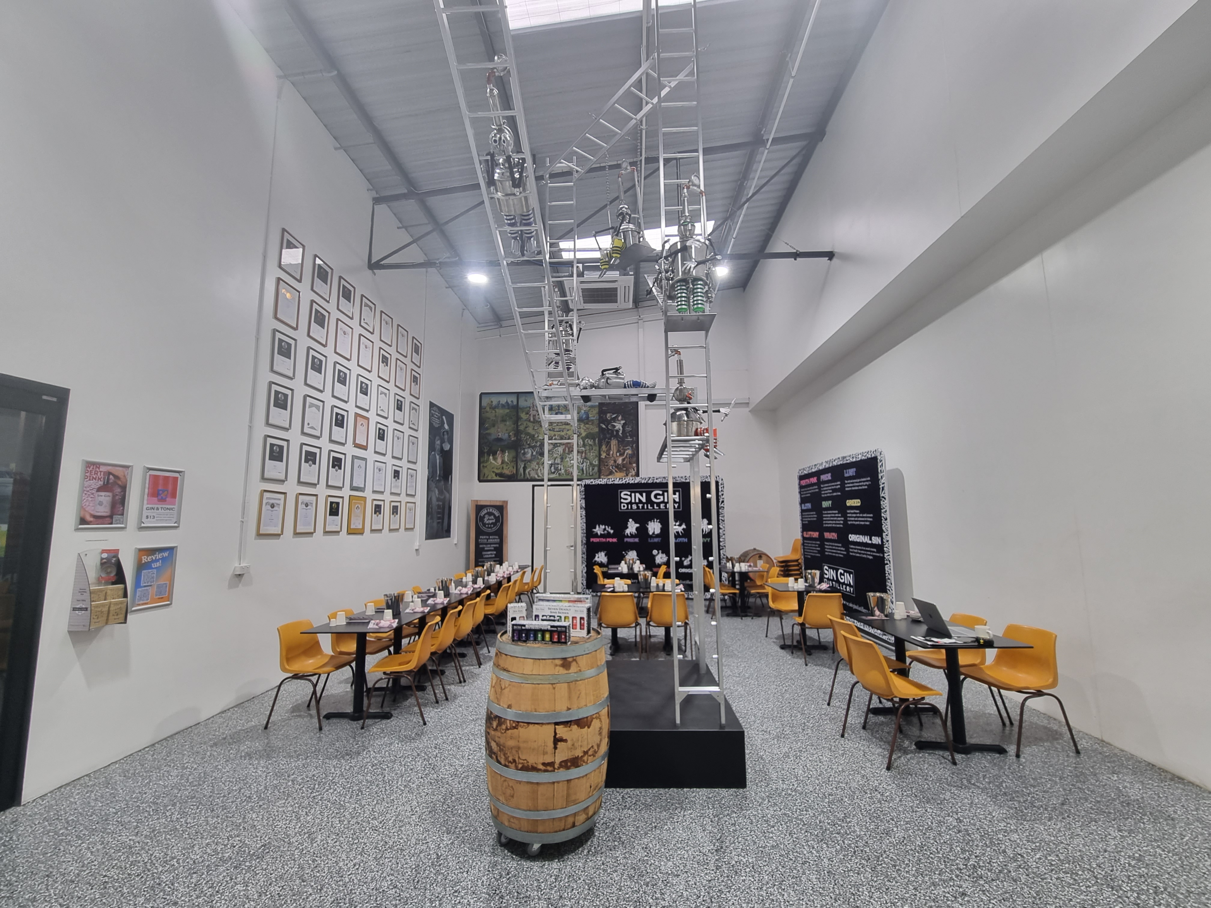
20240531_144637
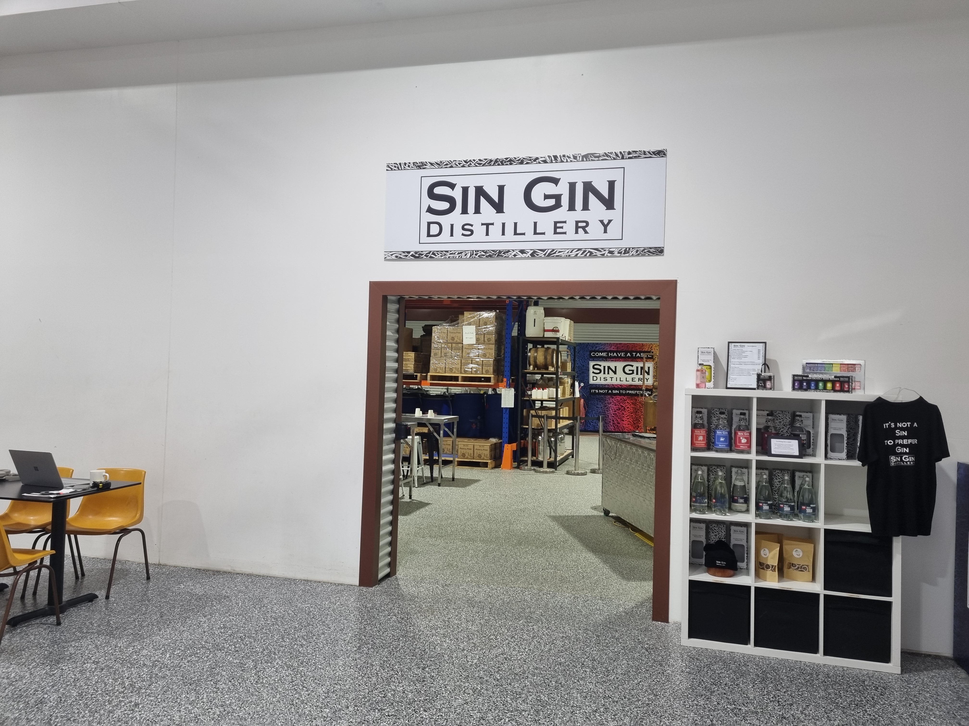
20240531_144644
- In addition, the following further information can assist guests:
We are a distillery producing low risk, high quality spirits, gin & liqueurs.

Report Disclaimer
Please note that this business report, provided as a result of the use of the diagnostic assessment, is for information purposes only.
Australian Tourism Industry Council (ATIC) cannot guarantee the accuracy of respondent’s answers, or that they are fully representative of your business. Therefore, ATIC does not warrant or guarantee any particular outcome in respect of your businesses self-assessment.
This report is intended as guidance only for your business and should not be relied on for future marketing considerations. ATIC recommends that you seek your own independent advice as well as the results from the diagnostic.
Links to external web sites are inserted for convenience and do not constitute endorsement of material at those sites, or any associated organisation, product or service.
ATIC does not:
- Assume any legal liability for the accuracy, completeness, or usefulness of any information from this report or any links provided; or
- Accept responsibility for any loss associated directly or indirectly from the use of this report.

