ATIC Accessibility
To support the accessible community in making informed travel decisions for their individual needs

This report prepared for:
Business name: | QT Perth
Address: | 133 Murray St
Town: | Perth
Contact for enquiries: | Emilie Churchill
Contact Number: | 08 9225 8000
Contact Email: | sales_qtperth@evt.com
Website: | www.qtperth.com
Date: | 2026-10-20 13:43

ATIC Accessibility
The following pages provides travellers with information on the businesses facilities and amenities which aims to support the traveller to make an informed decision on whether the business is suitable for their individual needs.
OVERVIEW 4
Business Overview 4
Bookings 4
Emergency Management 4
Communications 5
Guide Dog and Service Animals 5
GENERAL 6
Pre-arrival, arrival and reception 6
Car Park and Access amenities 6
Entry 7
Lifts 7
Internal Spaces 7
Public areas 8
External Paths 8
Steps 8
Public Toilets/Adult change facilities 9
ACCOMMODATION 10
Bedrooms 10
Room Amenities 10
Bathrooms 11
COMMON AREAS 12
Report Disclaimer 14

OVERVIEW

Business Overview

The business has the following products/services available
- Accommodation

Our business caters for the following disability types:
- Blind or low vision
- Deaf or low hearing
- Limited mobility
- Wheelchairs or mobility scooters
- Food allergies or intolerances
- Cognitive or people on the Autism Spectrum

Bookings

The business offers the following methods for bookings and enquiries:
- Phone
- Email
- Webportal
- Our forms have high contract boxes and submit boxes

Emergency Management
- Emergency and evacuation procedures are explained on arrival
- There are Audible device/s to alert occupants to evacuate with instructions on how to evacuate.
- There are visual device/s to alert occupants to evacuate.
- Exit signs are clear and easy to see
- Exit signs have raised lettering or braille
- Exit access is free and clear at all times
We ensure exit access is free and clear at all times by: daily checks
- Exits and access to exists are greater than 900mm
- Exit doors are able to be opened by all occupants
- Exits to the emergency evacuation point does not include stairways
- There is an emergency refuge that has an intercommunication system linked and has sufficient fire resistance levels.
- The evacuation point is clearly marked by a sign
- The evacuation point is clearly marked by a sign with raised letters or braille
The business identifies guests who need additional assistance should an emergency occur by: chief warden will allocate a warden to find and secure guests with disabilities
The procedure for assisting guests who need assisted rescue is: for emergencies attend with fire and emergency team
- Guests with disabilities are noted in the guest log book for emergency and evacuation purposes

Communications
- An accessibility guide is available on the website
https://www.qthotels.com/perth/features-and-amenities/
- Our website meets WCAG 2.0 accessibility standards
- Our business offers the following alternative communication methods
- Plain English
- There is easy to read signage and information (e.g. menus and emergency information)

Guide Dog and Service Animals
- The business provides a secure area with shade and water for service animals
- The business provides a toilet area for service animals
- Bowls, bedding, etc. are provided for service animals
The business provides the following services for services animals: https://www.qthotels.com/perth/offers/hotel/pup-yeah/

GENERAL

Pre-arrival, arrival and reception
The business has the following in place to support guests during pre-arrival, arrival and reception
- Booking information and websites are compatible with screen readers
- There is a reception/public entryway.
- Seating available at reception
- A tablet with text to voice or pen and paper at reception to aid in communication
- Picture Board at reception to aid in communication
- Hearing loop fitted to the reception area
- Lighting in the reception area is even and glare free
- Large print information sheets and registration forms
team can seat with guest in sitting area to check in
- Information and maps are available in written form
- A step free map/guide
- A familiarisation tour
- Keys are available for each guest
- Luggage assistance
The following steps are in place to ensure that people with fatigue related to their disability are not disadvantaged by long wait times: seating areas in proximity of the reception

Car Park and Access amenities
The business has the following Car Park and Access amenities
- A drop off zone
- Designated disabled parking bays
- Level or ramped access from the car park to the entrance
- The accessible entrance is clearly signed from the parking bay
- The public transport services available are:
bus stop approx 20mt from hotel entrance, train stop approx 100mt from hotel entrance,
- An intercom system is available at the entrance of car park

Entry
The business has the following amenities/systems in place for entry
- A drop off point close to the entrance
- A path of access to the building is slip resistance and even
- A path of access to the building is clear of obstruction
- Self opening entry doors or fitted with a self closer
- Glass doors are fitted with a visual sighting strip
- Door jams/doors are of a contrasting colour to surrounding walls
- Door handles are of a contrasting colour to the door
- Signage is written in a contrasting colour
- The entry door is a minimum of 850mm wide
- The entry door has self opening or a light opening pressure (for manual operations)
- The entrance sill is less than 13mm
- There a clear space of at least 1500mm x 1500mm in front of all doors.

Lifts
- Premises has lifts
  - Lift Location: ground floor
- This lift is available to all public floors
- The lift contains a visual method of identifying the floor level
- There is a breakdown procedure for lifts containing guests with a hearing impairment
- The emergency procedures within the lift have an SMS contact number
- The lift call buttons contrast with the surrounding wall finishes
- The lift floor buttons have large print numbers
- The lift buttons have braille floor numbers
- The lift has audio floor announcements
- The lift has an easily identifiable/tactile emergency button
- There is an external tactile or braille floor indicator near the lift call button
- The doors open to a clear span of 880mm
- The minimum size of the lift 1100mm wide by 1400mm deep
- The control button heights are between 900mm and 1200mm
- There is a handrail of a minimum length of 600mm

Internal Spaces
- Clear and unobstructed routes through and between buildings
- Interior walls are matte or low sheen
- Floors, walls, counters and furniture are of contrasting colours
- Menus are available in large print or Braille
- Tableware/glassware contrast with the table surface or table cloth
- Floor surfaces are hard or short pile carpet
- Seating is available for guests unable to stand for long periods
- Accessible facilities are clearly signed and visible from all areas
- All corridors greater than 900mm
- In addition, the following further information can assist guests:
Are menus available in large print or Braille? - YES, can be printed in large print upon request

Public areas
The public areas have the following amenities in place
- Display units, Televisions, Video displays etc. are open captioned
- Hearing loops
- Hearing loop symbols are displayed
- Even lighting
- Seating

External Paths
External paths of travel
- Surfaces are concrete, asphalt, smooth paving or hard packed fine gravel (max aggregate size 13mm)
- Pathways are wider than 900mm
- There 3 successive steps or less on any path or at any doorway

Steps
Steps
- There are steps.
- Top and bottom steps are easily distinguished through colour contrast or the use of TGSIs (Tactile Ground Surface Indicators)
- All steps or staircases have enclosed risers
- The underside of all staircases are enclosed or protected to a height of at least 2 metres
- Handrails fitted to all open sets of steps
- Handrails extend 300mm beyond the top and bottom step
- In addition, the following further information can assist guests:
lift is present to all floors.

Public Toilets/Adult change facilities
Public Toilets/Adult change facilities have the following amenities are in place
- There is an accessible toilet for public use
- The door is at least 850mm wide
- There is a minimum of 850mm beside the toilet
- Handrails are fitted
- The toilet seat is 460mm above the floor
- There is 1800mm mm of clear space in front of the toilet
- The toilet seat of a contrasting colour to the floor
- The toilet seat is460mm above the floor
- A facility with an adult change table

ACCOMMODATION

Bedrooms
The bedrooms have the following facilities/amenities in place
- There are 10 rooms available to guests who use a wheelchair
- Bedroom furniture can be re-arranged on request

The following bed types are available in wheelchair accessible rooms
- One double/queen bed/king bed
  - Layout of room Image(s)
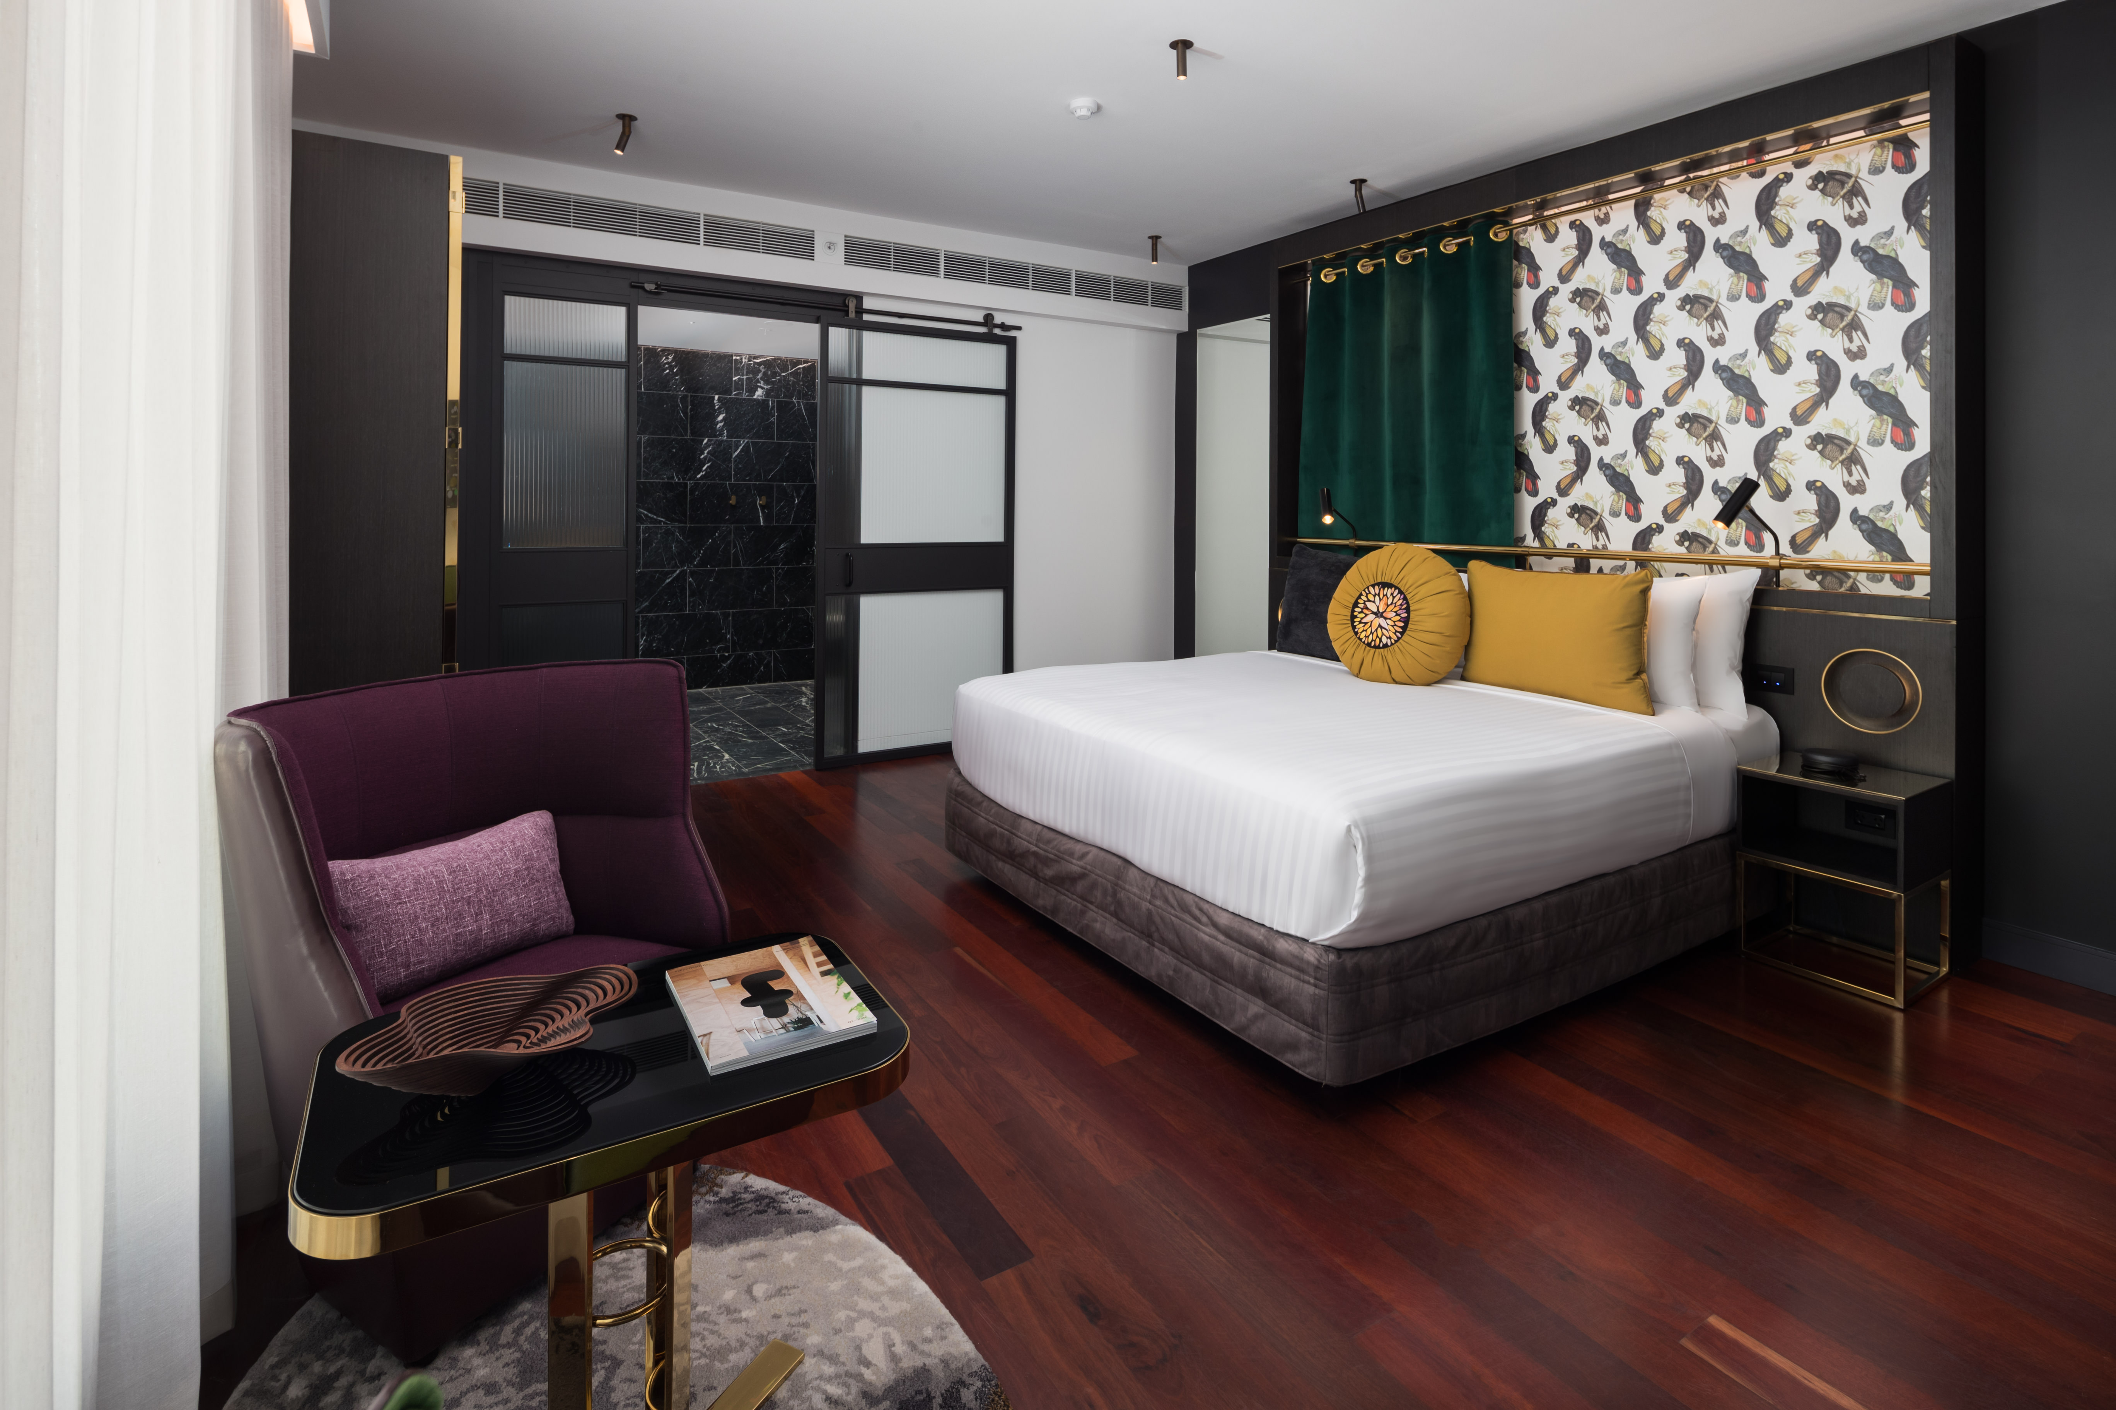
0163-QT-Perth-20190527

Room Amenities
- Lower hanging rails are in wardrobes
- Visual alarm is fitted to the room
- Televisions are equipped with closed captioning capability
- Room phones have volume control
- Room phones have a visual ringing indicator
- There is contrast between the walls, skirtings, floor and furniture
- There is a clear path through the room
- Wardrobe handles are a contrasting colour to the doors and draws
- Housekeeping procedures instruct staff not to reposition furniture that has been moved
- Doors open fully against the adjoining wall
- There is a clear opening at least 850mm wide
- There at least one chair with rigid arms
- Wardrobe and drawer handles are easy to grip
- The bedside lamp switch is easy to reach from the bed
- There is at least 850mm clear space beside the bed
- The bed height is no higher than 680mm from the floor
- There is at least 130mm clearance under the bed
- The business offers a range of non-allergenic bedding
- Non-allergenic cleaning products are used

Bathrooms
The bathrooms have the following facilities/amenities in place
- All heating appliances and hot water pipes are protected or insulated
- All shower, bath and basin taps are clearly differentiated between hot and cold
- The hot water is thermostatically controlled to 41 degrees
- The door is at least 850mm wide
- There is a minimum of 850mm beside the toilet
- Handrails are fitted
- There is a minimum of 1400mm of clear space in front of the toilet
- The toilet seat is a contrasting colour to the floor
- The toilet seat is 460mm above the floor
- There is a roll-in shower with fold down fixed seat or a shower chair
- There is a portable shower head on flexible hose
  - Bathroom Image(s)
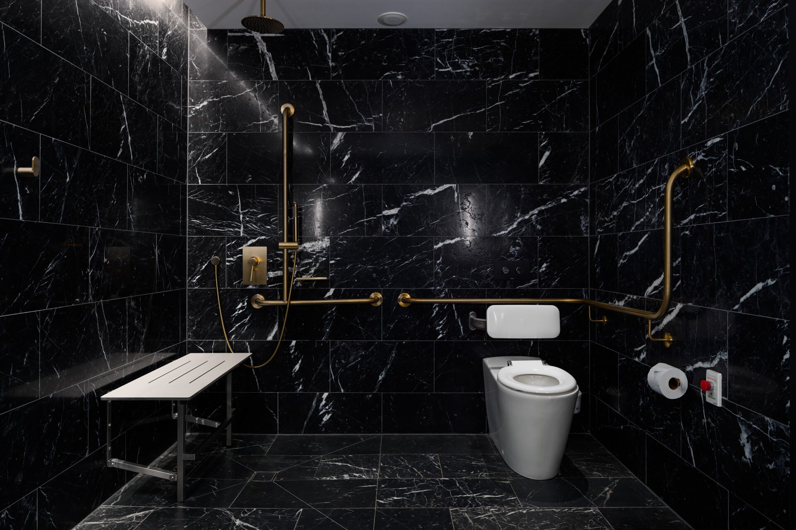
Accessible Room 2

COMMON AREAS

Report Disclaimer
Please note that this business report, provided as a result of the use of the diagnostic assessment, is for information purposes only.
Australian Tourism Industry Council (ATIC) cannot guarantee the accuracy of respondent’s answers, or that they are fully representative of your business. Therefore, ATIC does not warrant or guarantee any particular outcome in respect of your businesses self-assessment.
This report is intended as guidance only for your business and should not be relied on for future marketing considerations. ATIC recommends that you seek your own independent advice as well as the results from the diagnostic.
Links to external web sites are inserted for convenience and do not constitute endorsement of material at those sites, or any associated organisation, product or service.
ATIC does not:
- Assume any legal liability for the accuracy, completeness, or usefulness of any information from this report or any links provided; or
- Accept responsibility for any loss associated directly or indirectly from the use of this report.

