ATIC Accessibility
To support the accessible community in making informed travel decisions for their individual needs

This report prepared for:
Business name: | Emu Ridge Eucalyptus
Address: | 703 Willsons Road
Town: | MacGillivray
Contact for enquiries: | Bev Turner
Contact Number: | 08 8553 8228
Contact Email: | info@emuridge.com.au
Website: | www.emuridge.com.au
Date: | 2026-09-22 00:59

ATIC Accessibility
The following pages provides travellers with information on the businesses facilities and amenities which aims to support the traveller to make an informed decision on whether the business is suitable for their individual needs.
OVERVIEW 4
Business Overview 4
Bookings 4
Emergency Management 4
Communications 5
Other Information 5
Guide Dog and Service Animals 5
GENERAL 7
Pre-arrival, arrival and reception 7
Cognitive Impairment Support 7
Car Park and Access amenities 8
Entry 8
Internal Spaces 8
Public areas 9
Displays, exhibits, commentary and live performances 9
External Paths 9
Ramps 9
Public Toilets/Adult change facilities 10
TOUR OPERATORS 11
Route Planning 11
Guides 11
ATTRACTIONS 12
Attractions Basics 12
COMMON AREAS 19
Play Spaces 19
FOOD AND DRINK 22
Dining Spaces 22
EVENTS 23
Events 23
Report Disclaimer 25

OVERVIEW

Business Overview

The business has the following products/services available
- Tour/Transport
- Attraction
- Food and Drink
- Event

Our business caters for the following disability types:
- Blind or low vision
- Deaf or low hearing
- Limited mobility
- Wheelchairs or mobility scooters
- Food allergies or intolerances
- Cognitive or people on the Autism Spectrum

Bookings

The business offers the following methods for bookings and enquiries:
- Phone
- Email
- Webportal
- Our forms have high contract boxes and submit boxes
- Staff have undergone disability awareness and training

Emergency Management
- The business has an emergency management and evacuation plan for guests with a disability
- Emergency and evacuation procedures are explained on arrival
- Guests with disabilities are noted in the guest log book for emergency and evacuation purposes

Communications
- Our business offers the following alternative communication methods
- Plain English
- Magnifiers
videos in 9 different languages and brochures translated in 12 languages
- There is easy to read signage and information (e.g. menus and emergency information)
- There are Picture boards
  - Picture Boards Image(s)
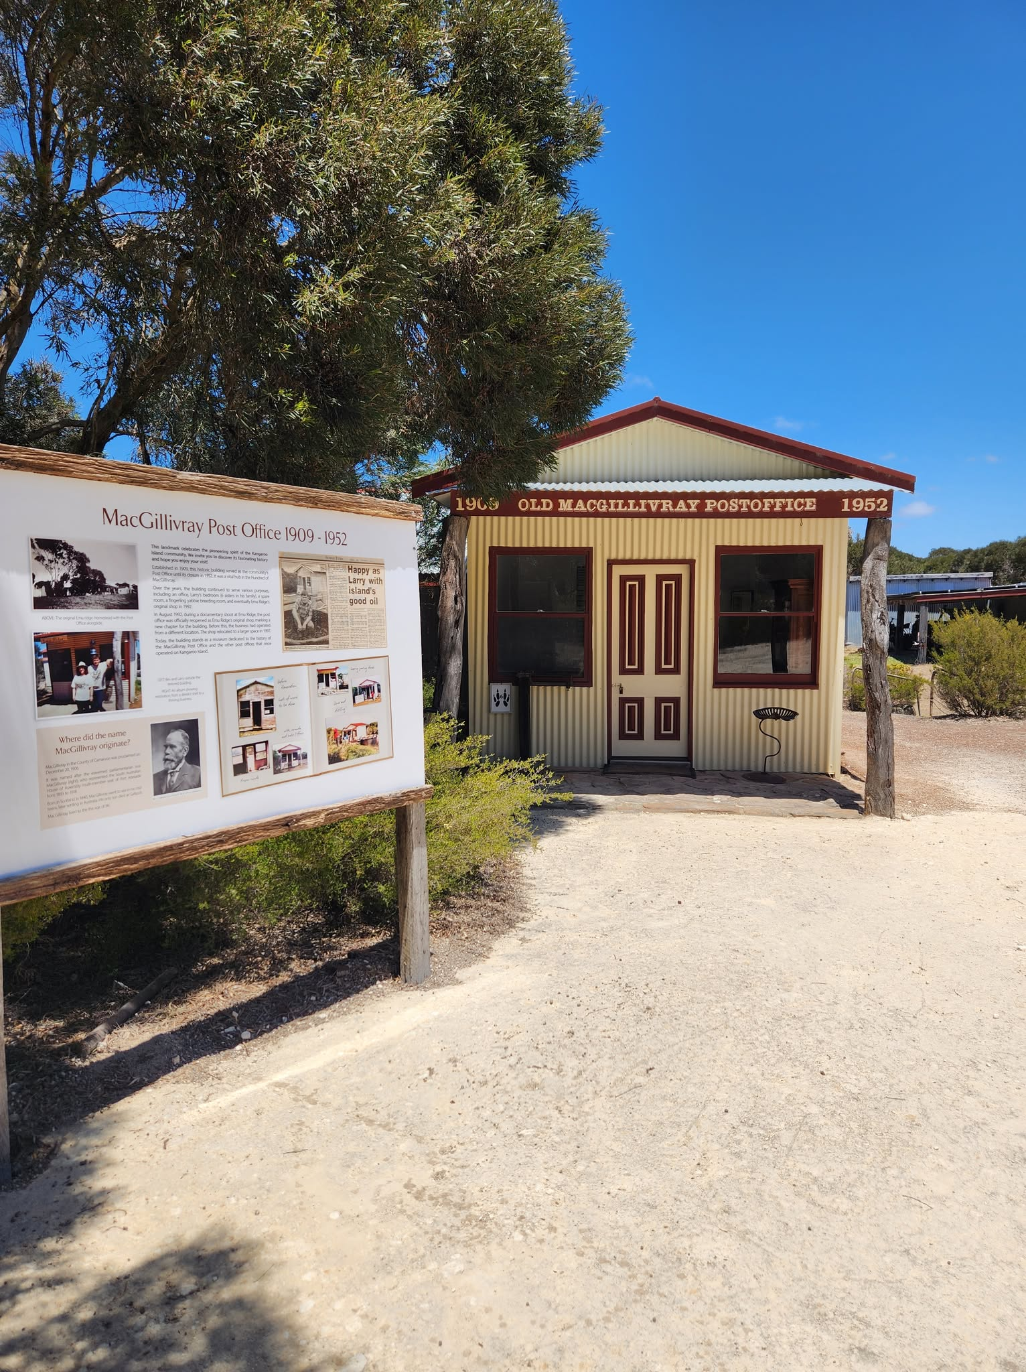
Post Office
We have introduction brochures in 12 languages. Our video presentation is in different languages

Other Information
- For bookings made onsite, the ticket booth/counter/box office is accessible for people using a wheelchair
- The business accepts the companion card

Guide Dog and Service Animals
- The business provides a secure area with shade and water for service animals
- The business provides a toilet area for service animals
- Bowls, bedding, etc. are provided for service animals
The business provides the following services for services animals: We have a fenced Animal area including trees, water and places to lay down. We are dog friendly in all parts of the business

GENERAL

Pre-arrival, arrival and reception
The business has the following in place to support guests during pre-arrival, arrival and reception
- Booking information and websites are compatible with screen readers
- There is a reception/public entryway.
- Seating available at reception
- A lower counter at reception/ticket office
- A clipboard to allow check-in/ticket purchase whilst seated
- A tablet with text to voice or pen and paper at reception to aid in communication
- Picture Board at reception to aid in communication
- Lighting in the reception area is even and glare free
- Large print information sheets and registration forms
- Information and maps are available in written form
- A step free map/guide
- A familiarisation tour
The following steps are in place to ensure that people with fatigue related to their disability are not disadvantaged by long wait times: We have seating available all through the premises and around the site for anyone who needs to rest. If a guest has fatigue or any special needs, we’re happy to offer support or adjust our service to help make their visit easier. Our staff are always here to help
- In addition, the following further information can assist guests:
We are not a accommodation facility so we don't have rooms etc for customers. They don't bring luggage etc here.

Cognitive Impairment Support
- Documents are available in plain English for people with cognitive impairment (This may include instructions, guides, menus and general information)
- A "social script" guide to your premises or attraction describing the sights, sounds and smells to aid parents/carers prepare visitors in advance
- The 'social script' is available in word and other editable formats
- Quiet periods or early opening times for people on the Autism Spectrum
- A space for parents and children on the Autism Spectrum

Car Park and Access amenities
The business has the following Car Park and Access amenities
- A drop off zone
- Designated disabled parking bays
- Level or ramped access from the car park to the entrance
- The accessible entrance is clearly signed from the parking bay
- Kerb ramps are in place where a pavement or walkway needs to be crossed
- In addition, the following further information can assist guests:
We dont have public transport on Kangaroo Island

Entry
The business has the following amenities/systems in place for entry
- A drop off point close to the entrance
- A path of access to the building is slip resistance and even
- A path of access to the building is clear of obstruction
- Self opening entry doors or fitted with a self closer
- Glass doors are fitted with a visual sighting strip
- Door jams/doors are of a contrasting colour to surrounding walls
- Door handles are of a contrasting colour to the door
- Signage is written in a contrasting colour
- Signage is written in a Sans Serif font and use upper and lower case letters
- The entry door is a minimum of 850mm wide
- The entry door has self opening or a light opening pressure (for manual operations)
- The entrance sill is less than 13mm
- There a clear space of at least 1500mm x 1500mm in front of all doors.
- The entrance door mats have a thickness less than 13mm and a width of 7500mm or greater
- In addition, the following further information can assist guests:
No where needed for lifts

Internal Spaces
- Clear and unobstructed routes through and between buildings
- Interior walls are matte or low sheen
- Floors, walls, counters and furniture are of contrasting colours
- Any protruding or overhanging obstructions are at least 2meters above the floor or are protected
- Menus are available in large print or Braille
- Tableware/glassware contrast with the table surface or table cloth
- Floor surfaces are hard or short pile carpet
- Seating is available for guests unable to stand for long periods
- Accessible facilities are clearly signed and visible from all areas
- All corridors greater than 900mm
- There is a quiet space for parents and children on the Autism Spectrum

Public areas
The public areas have the following amenities in place
- Display units, Televisions, Video displays etc. are open captioned
- Even lighting
- Seating

Displays, exhibits, commentary and live performances
For displays, exhibits, commentary and live performances the following amenities are in place
- Seating
- Wheelchair accessible spaces/seating
- A written transcript where audio description is provided i.e. display commentary, tour commentary

External Paths
External paths of travel
- Surfaces are concrete, asphalt, smooth paving or hard packed fine gravel (max aggregate size 13mm)
- Paths or slopes longer than 15 metres have resting places or seats
- Pathways are wider than 900mm
- There 3 successive steps or less on any path or at any doorway
- Any paths having steps are clearly identified as non-wheelchair accessible
- Step free routes clearly signed

Ramps
Ramps have the following amenities are in place
- There are ramps.
- All fixed ramps are 1:14 or less
- Hand rails are fitted
- Long ramps (more than 10m) are 1:20 or less
- Ramps have a raised edge of at least 100mm

Public Toilets/Adult change facilities
Public Toilets/Adult change facilities have the following amenities are in place
- There is an accessible toilet for public use
- The door is at least 850mm wide
- There is a minimum of 850mm beside the toilet
- Handrails are fitted
- The toilet seat is 460mm above the floor
- There is 190cm x 220cm mm of clear space in front of the toilet
- The toilet seat of a contrasting colour to the floor
- The toilet seat is460mm above the floor
- There is a registered changing places facility

TOUR OPERATORS

Route Planning
- In addition, the following further information can assist guests:
this is not applicable to our business they don't go on tour on a bus
- Walking Tours
- Operated on a step free route
- Multi-paced to account for slower walkers
- Hearing aid compatible

Guides

Guides have been trained in the following
- Use of clear/simple English
- Correct pronunciation for lip readers
- There is a audio description of surroundings
- In addition, the following further information can assist guests:
None of the above is applicable to us

ATTRACTIONS

Attractions Basics
- A park map is available here:
https://www.emuridge.com.au/tours
  - Image(s)
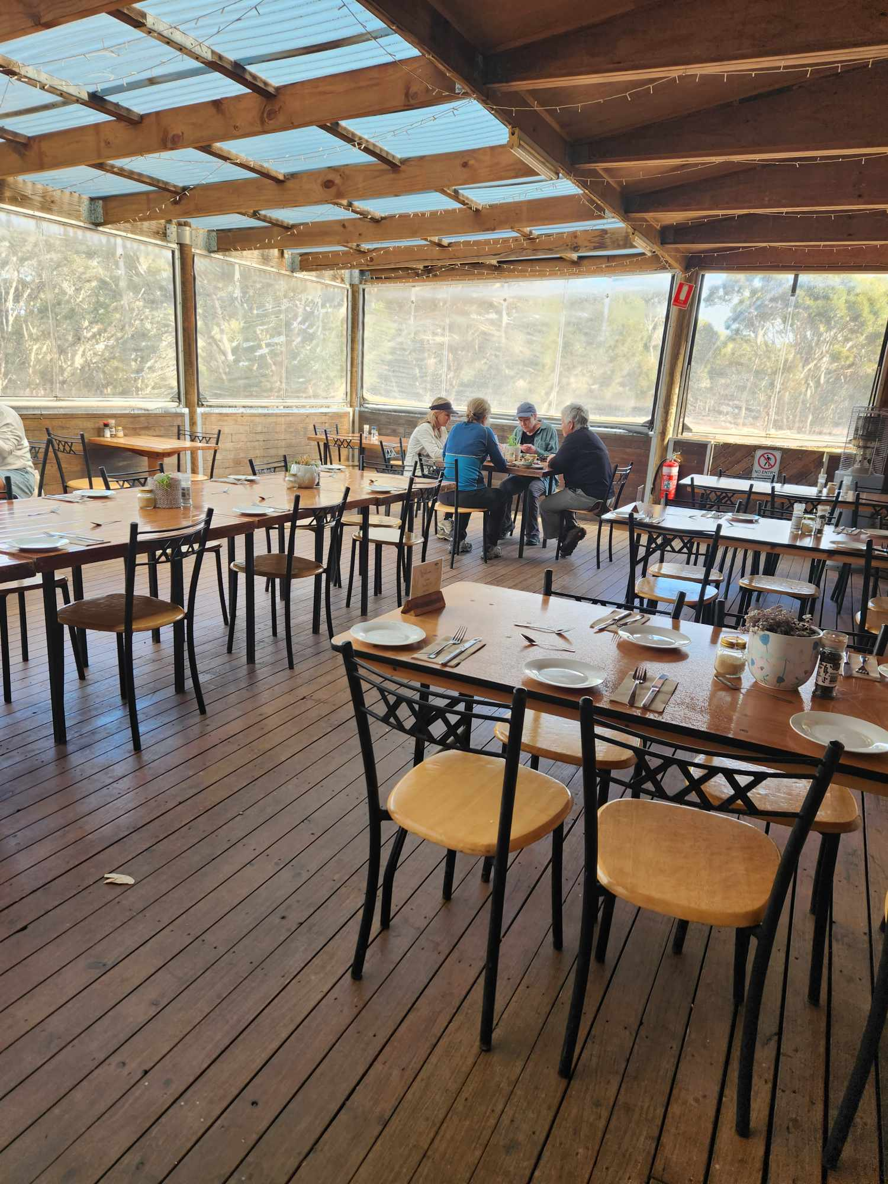
490769278_692931809867078_262505822472088408_n
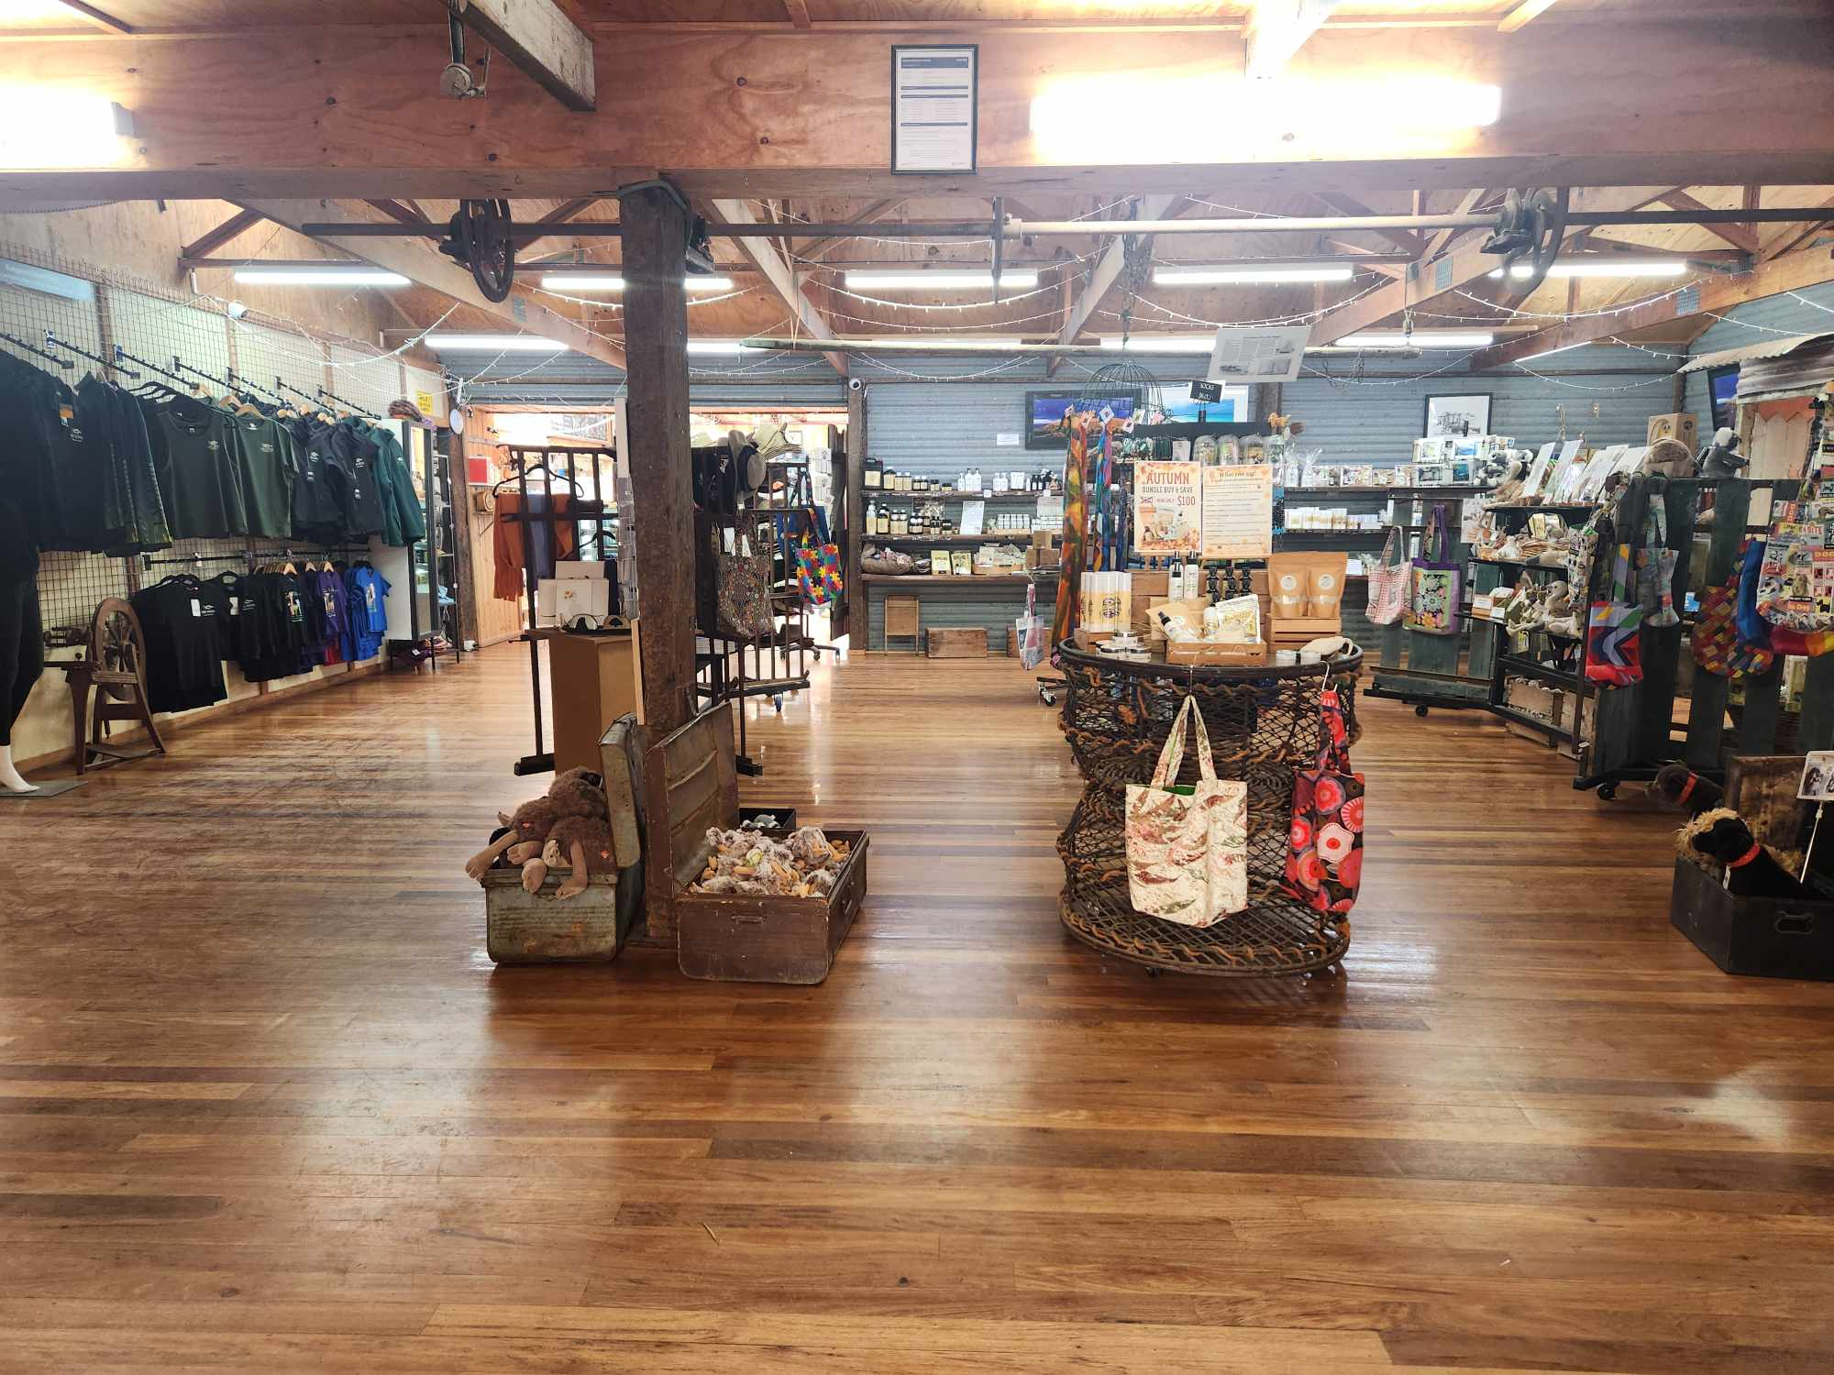
490997225_3970040733234798_4236631757749459113_n
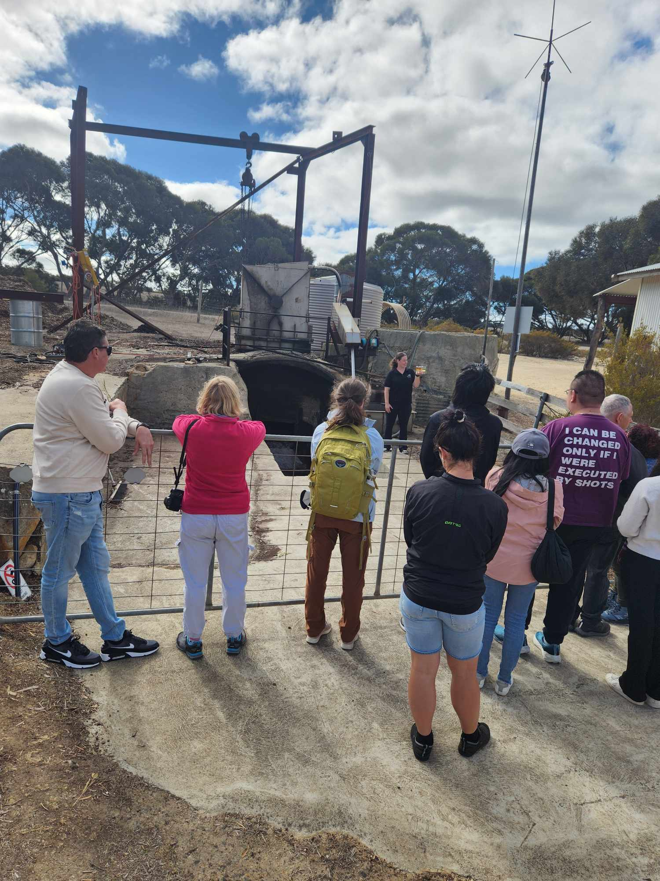
490997329_1012321961004693_6359961740236825937_n
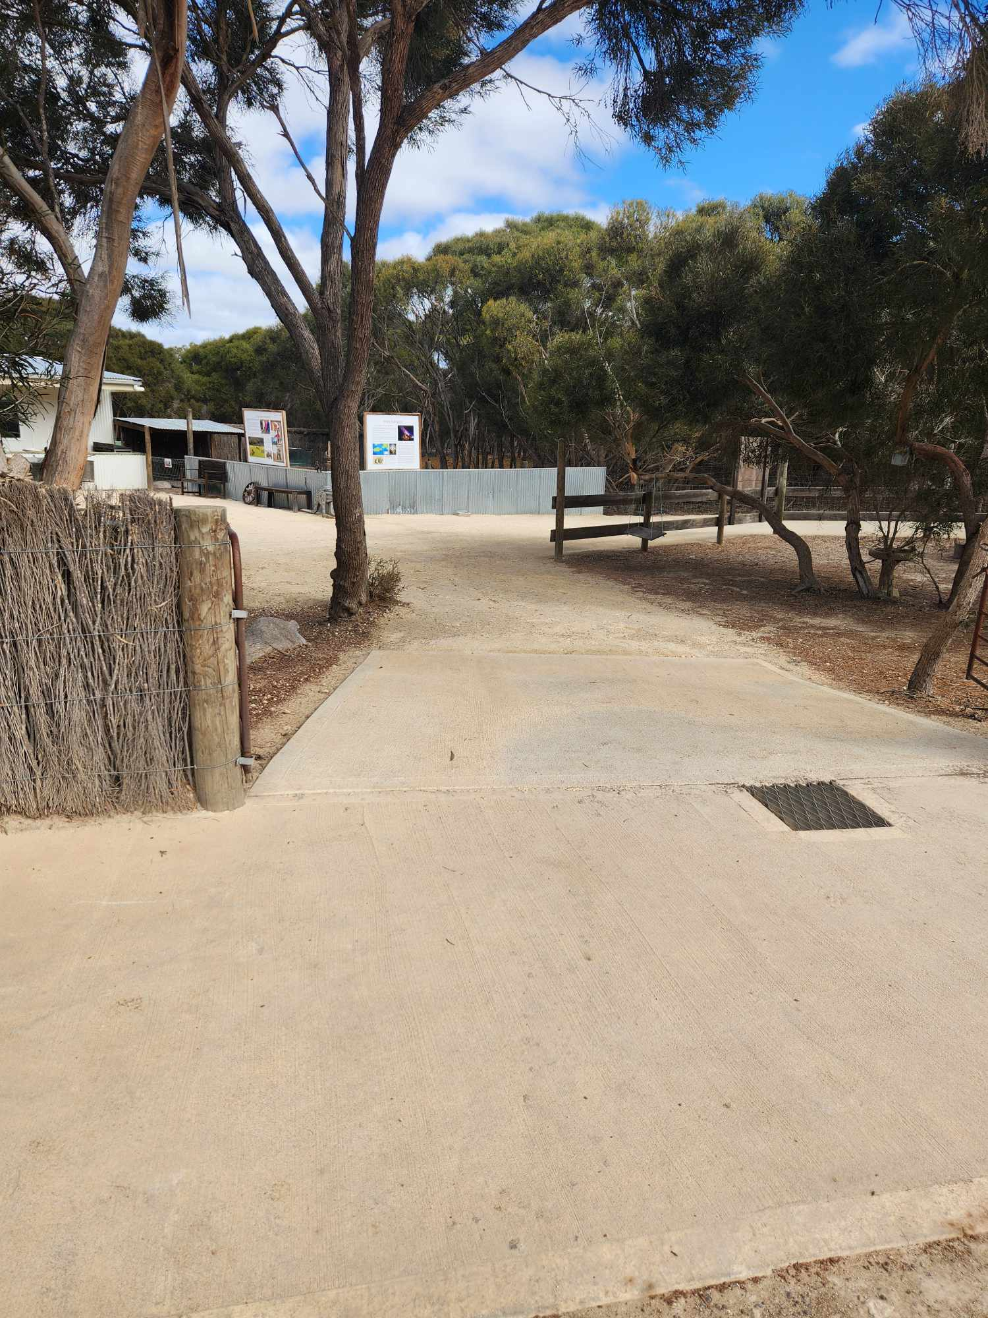
491001704_1299634431099747_622670646927956449_n
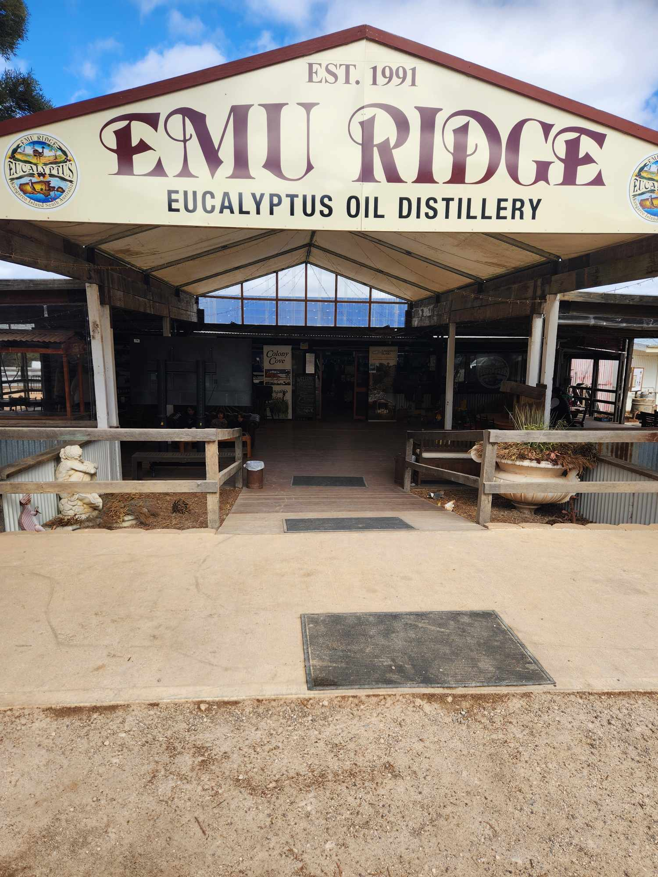
491001762_685561987300749_6375417226514376486_n
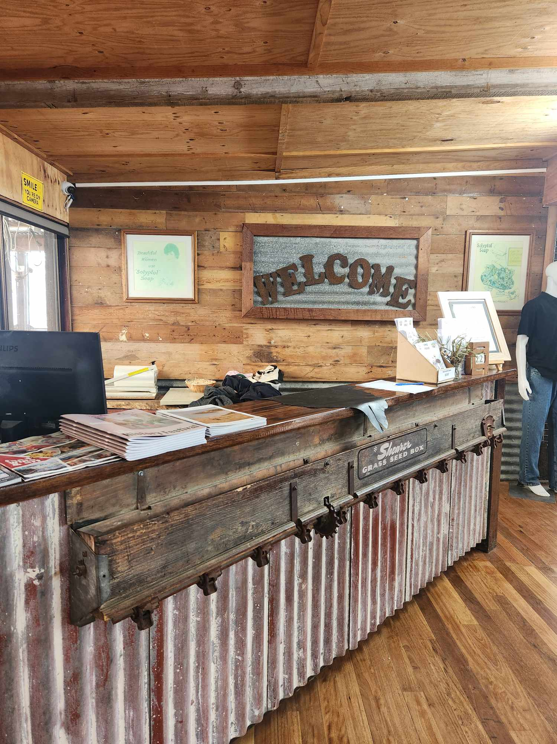
491003919_658240736991427_5698369807343634321_n
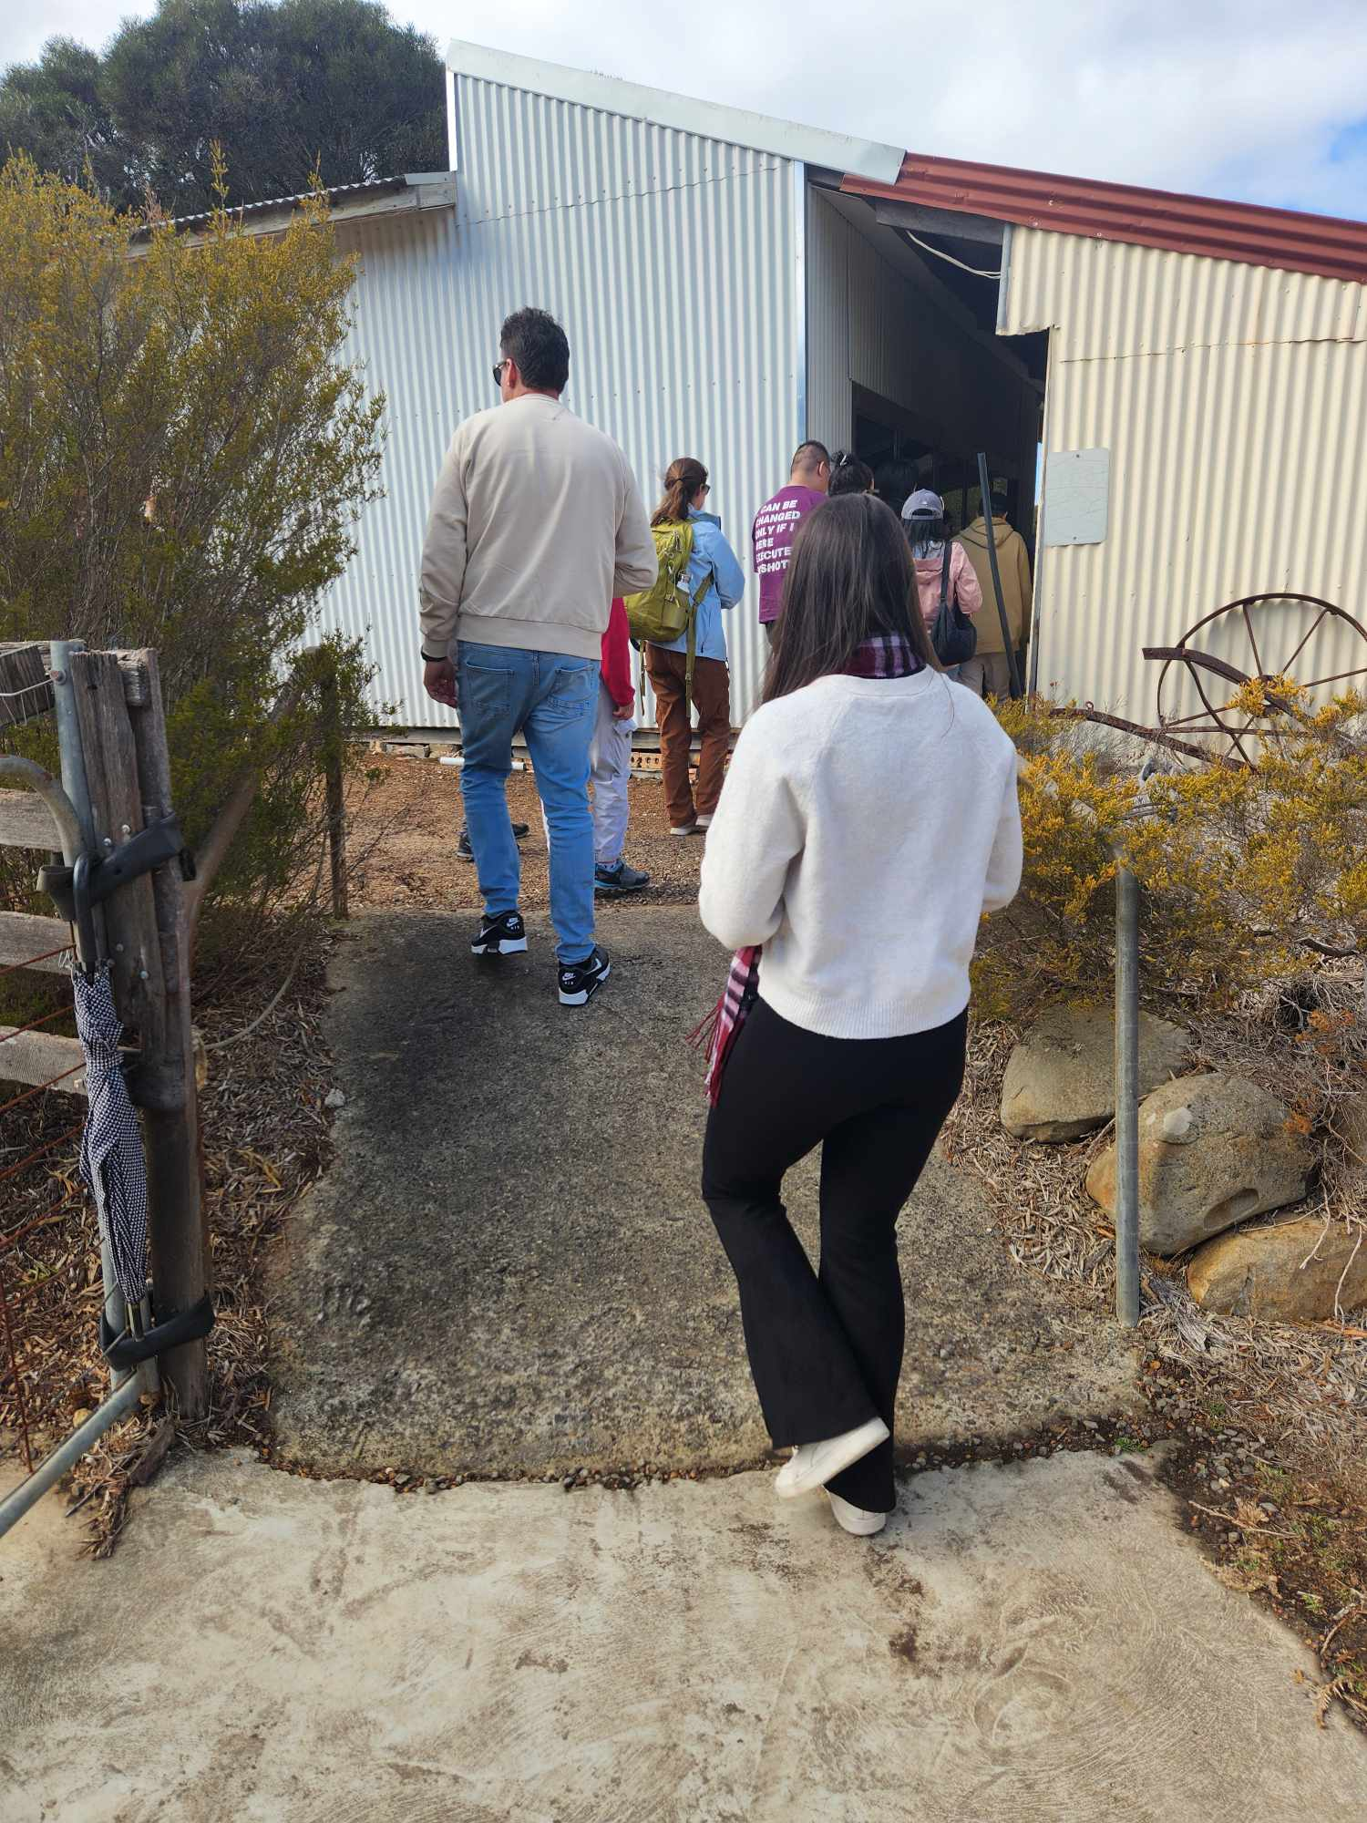
491006937_1291249295696567_2965292888380065508_n
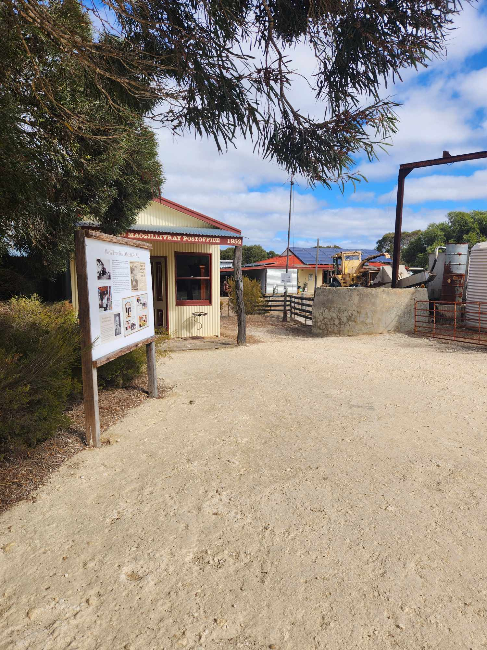
491023928_1114787090459797_6013715770846760094_n
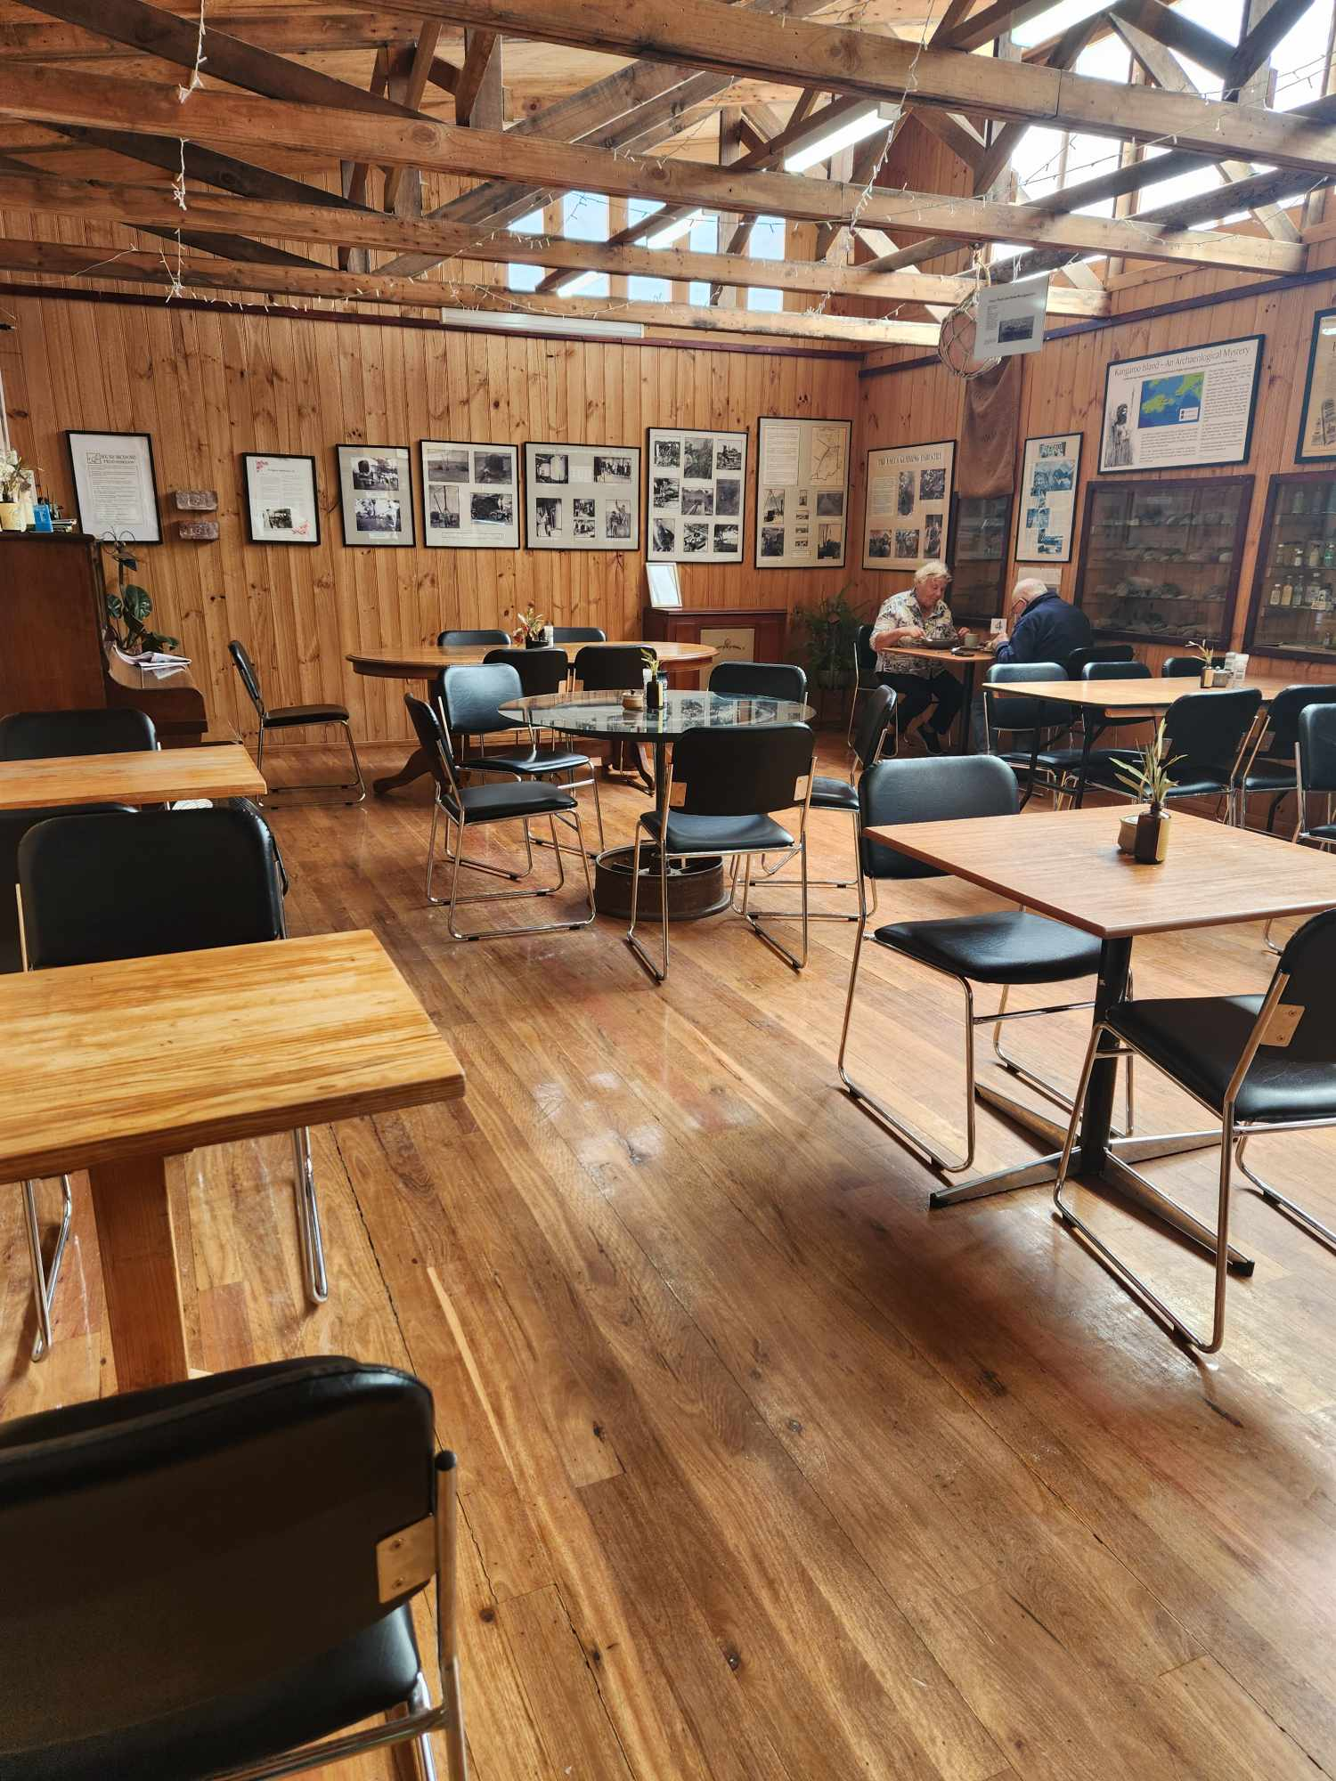
491024923_1877033193070650_5546371900135307745_n
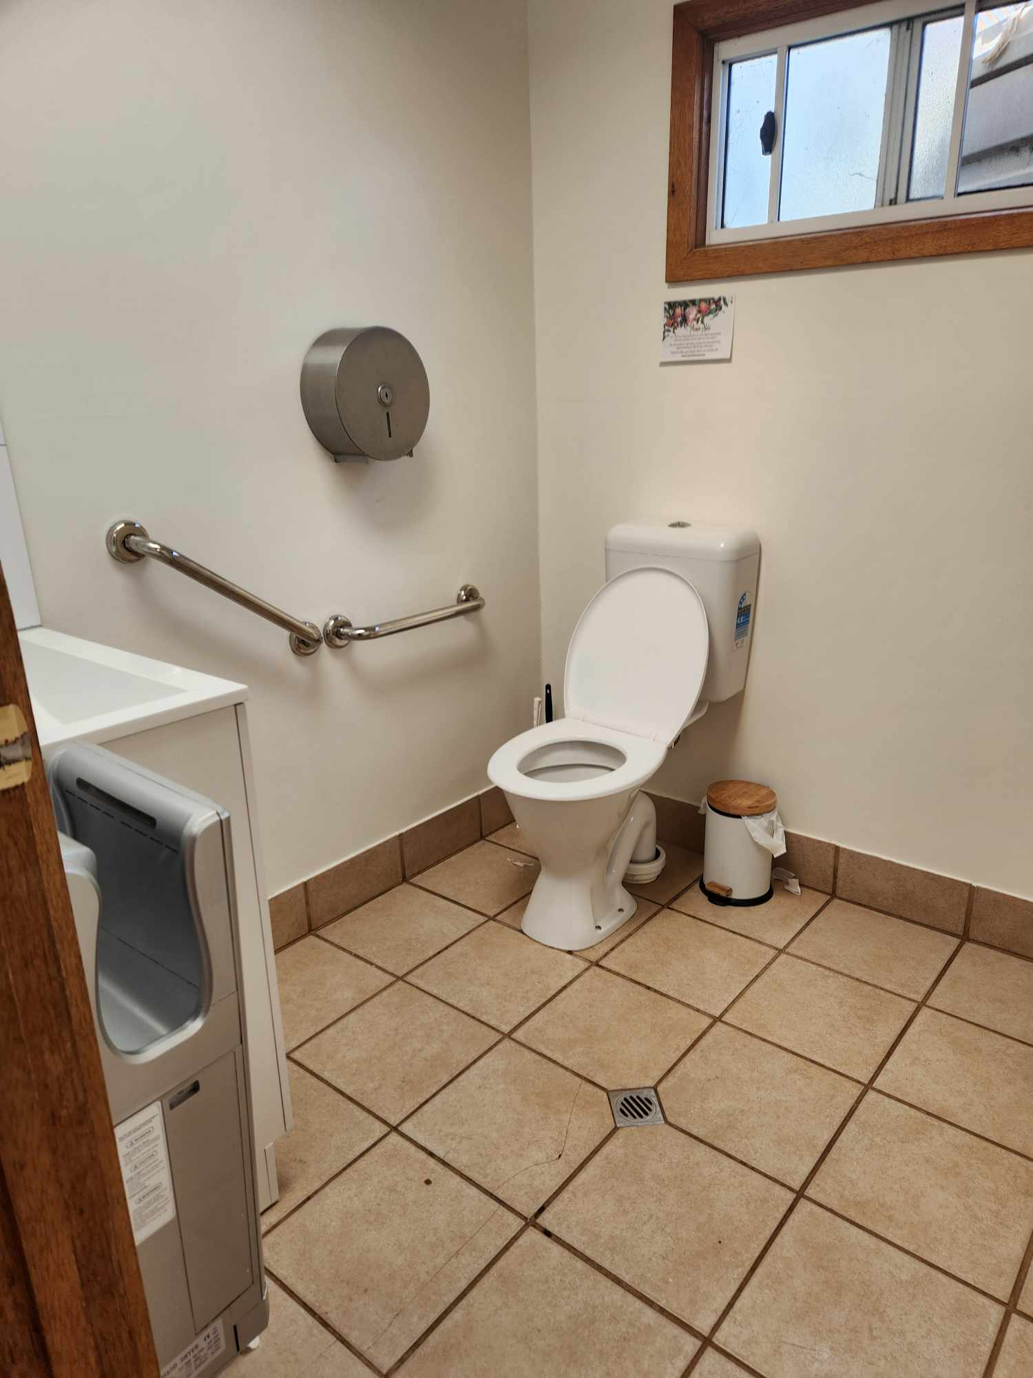
491025287_584700370618496_5405153318229844931_n
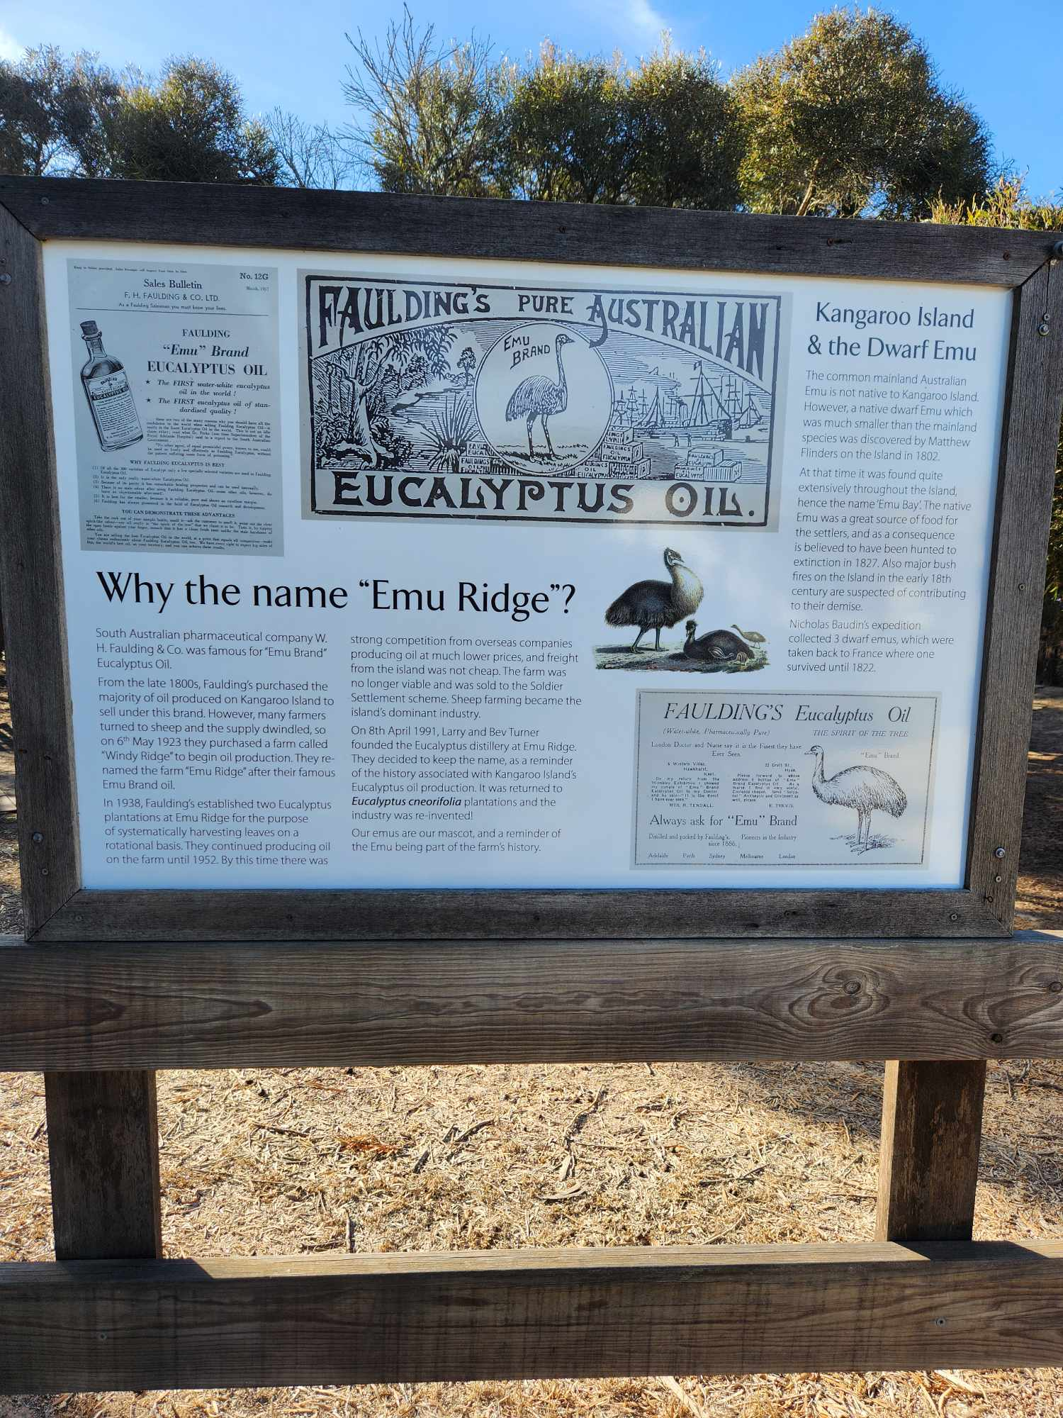
491026895_1194167942345663_3188811266019844154_n
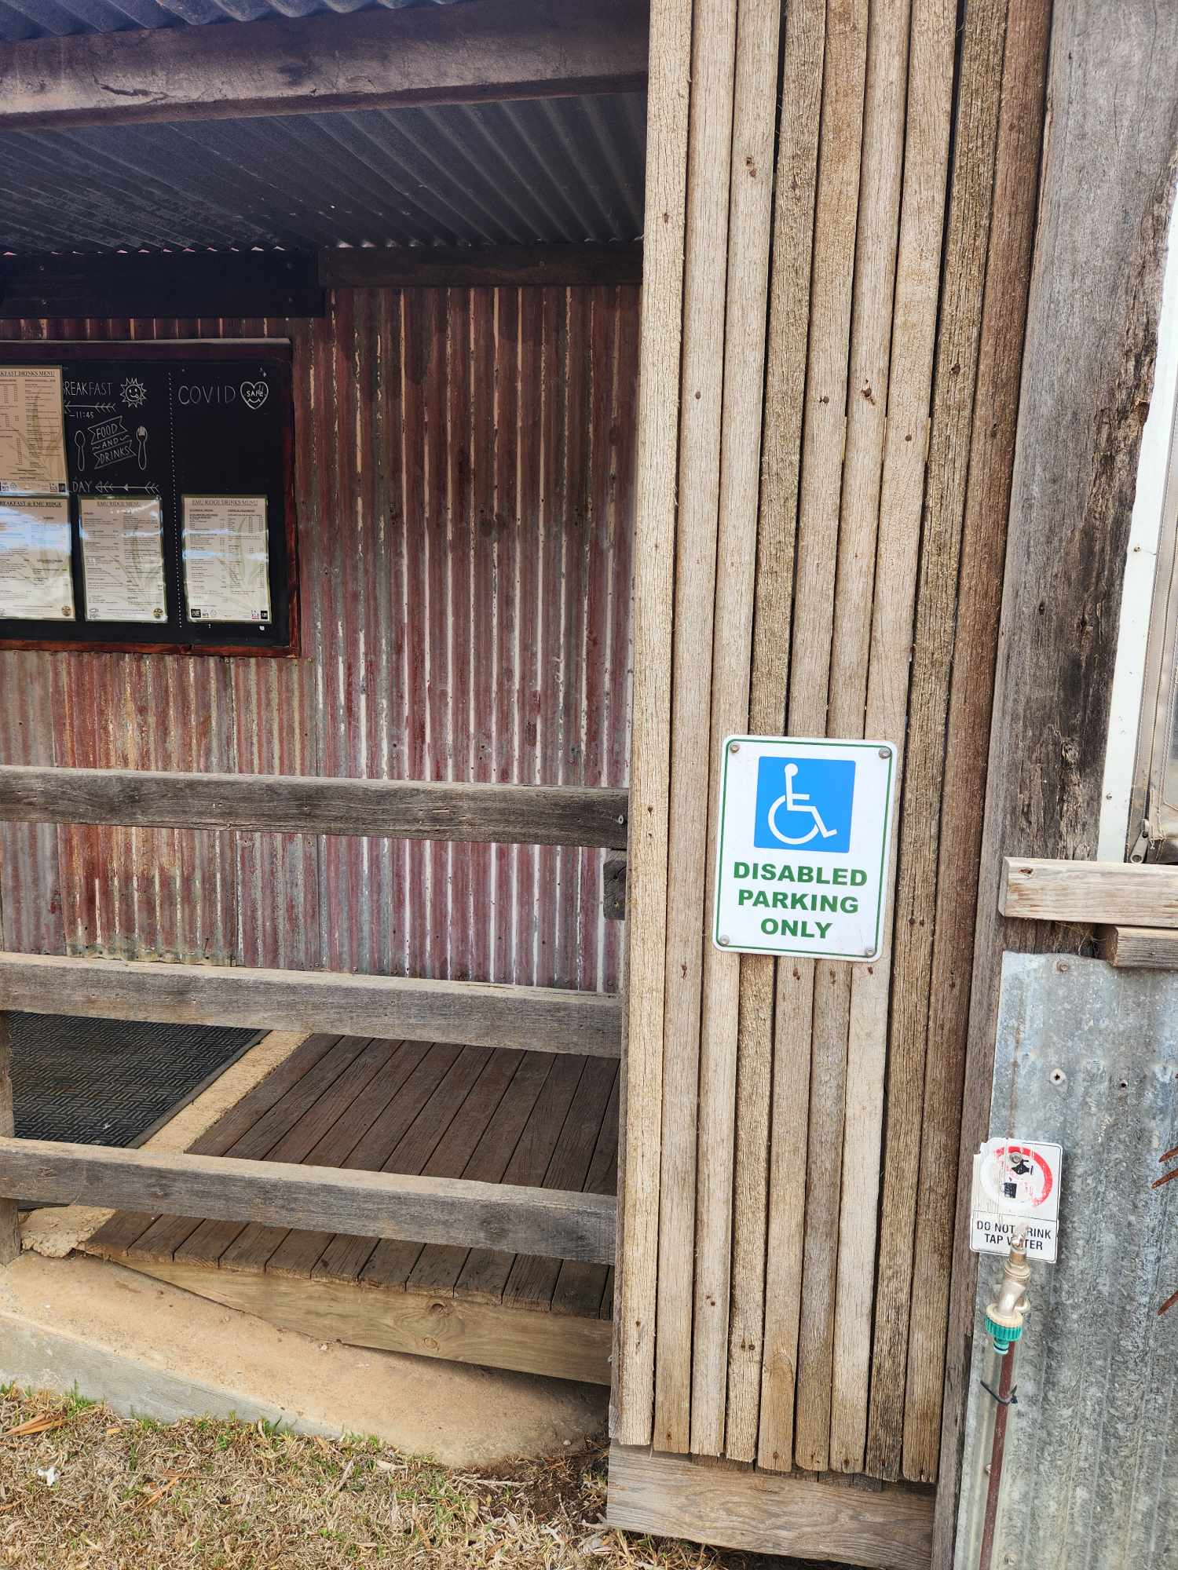
491069692_1253582262766923_6153923842842307930_n
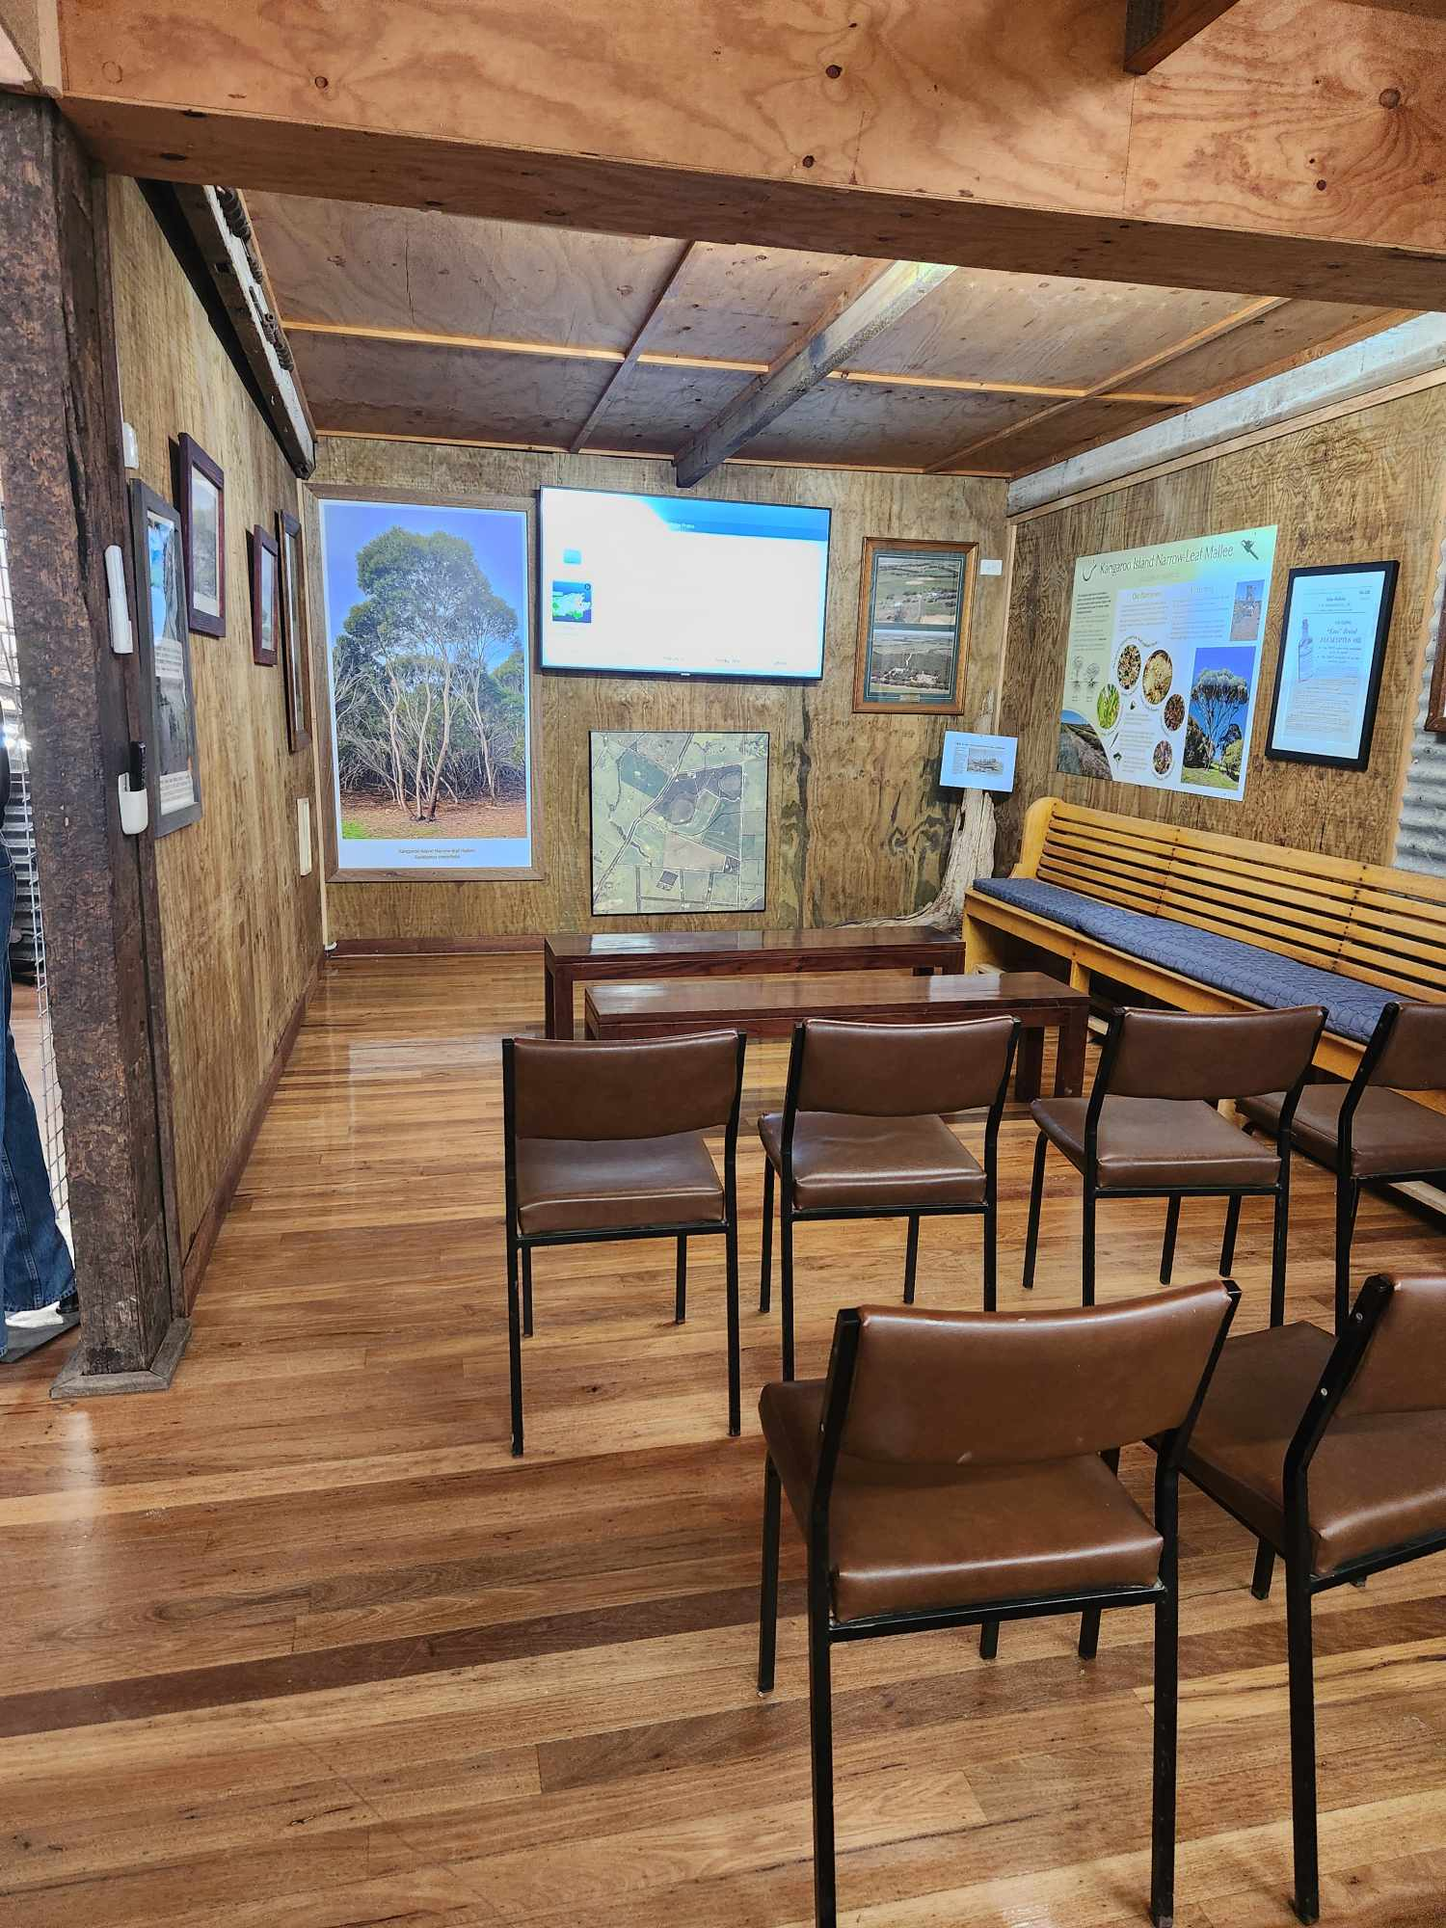
491281114_1167403651798704_3278546202314263423_n
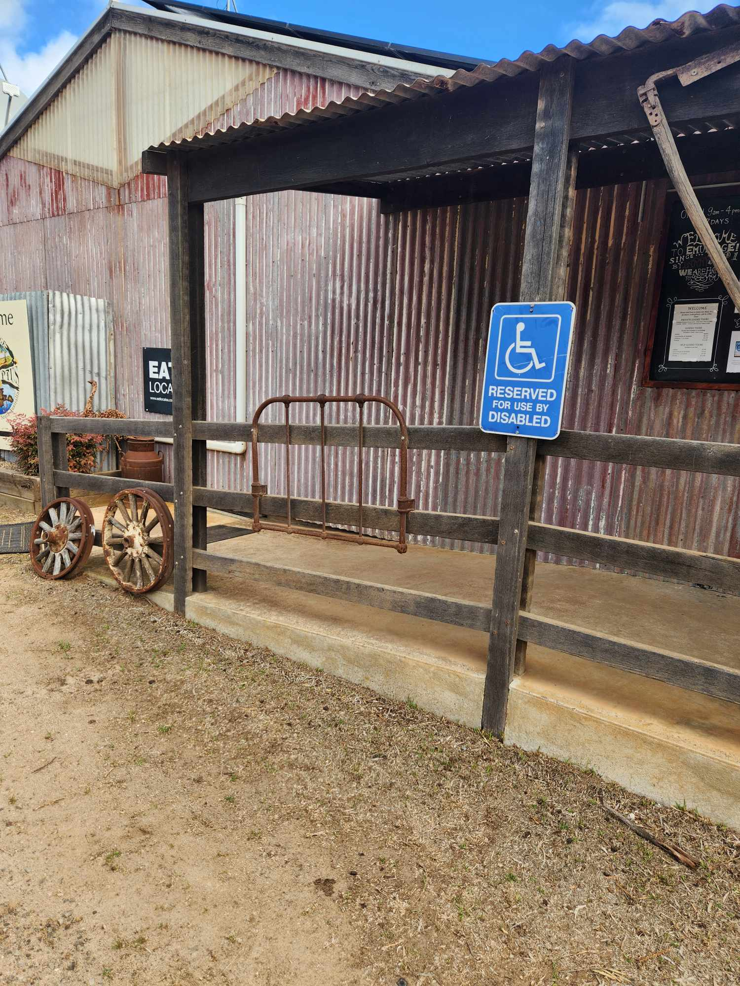
491354784_2516461412020055_4876764682581081113_n
491524301_670394492607186_4954798145888133196_n

COMMON AREAS

Play Spaces
- Level access is provided to play spaces
- There wheelchair accessible activities
- The play space contains cognitive play panels
- The play space contains tactile play panels or activities
- The space contain colour contrasting elements
- Seating is provided in or around the play space
  - Image(s)
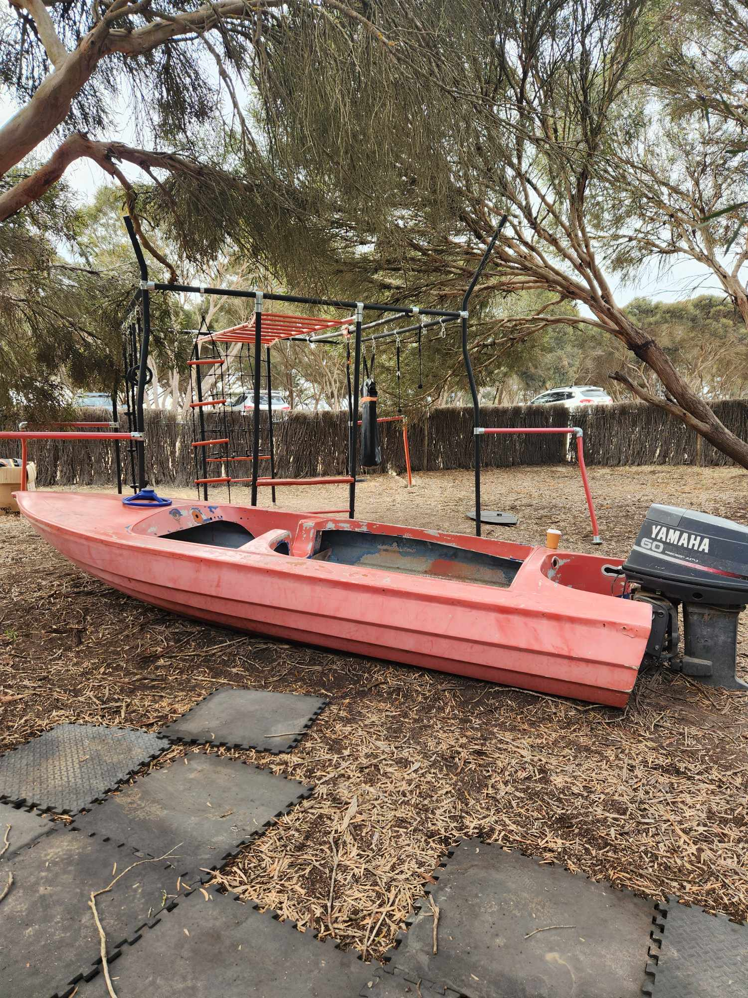
490768412_1741041243498321_2395243438062163950_n
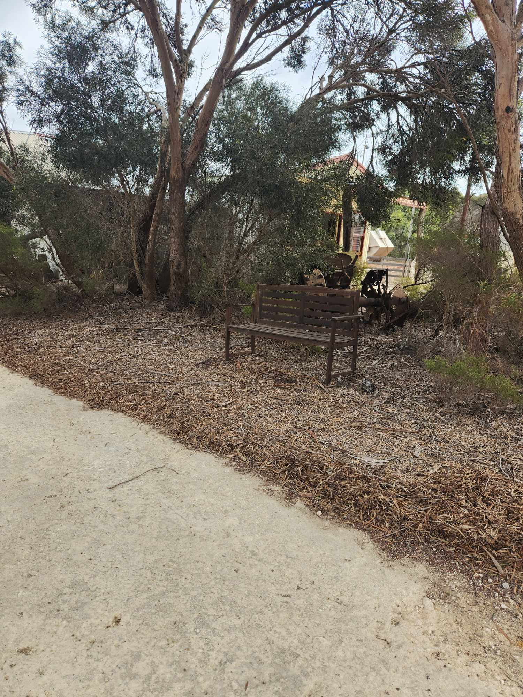
491005397_526582683665963_4375162140270798101_n
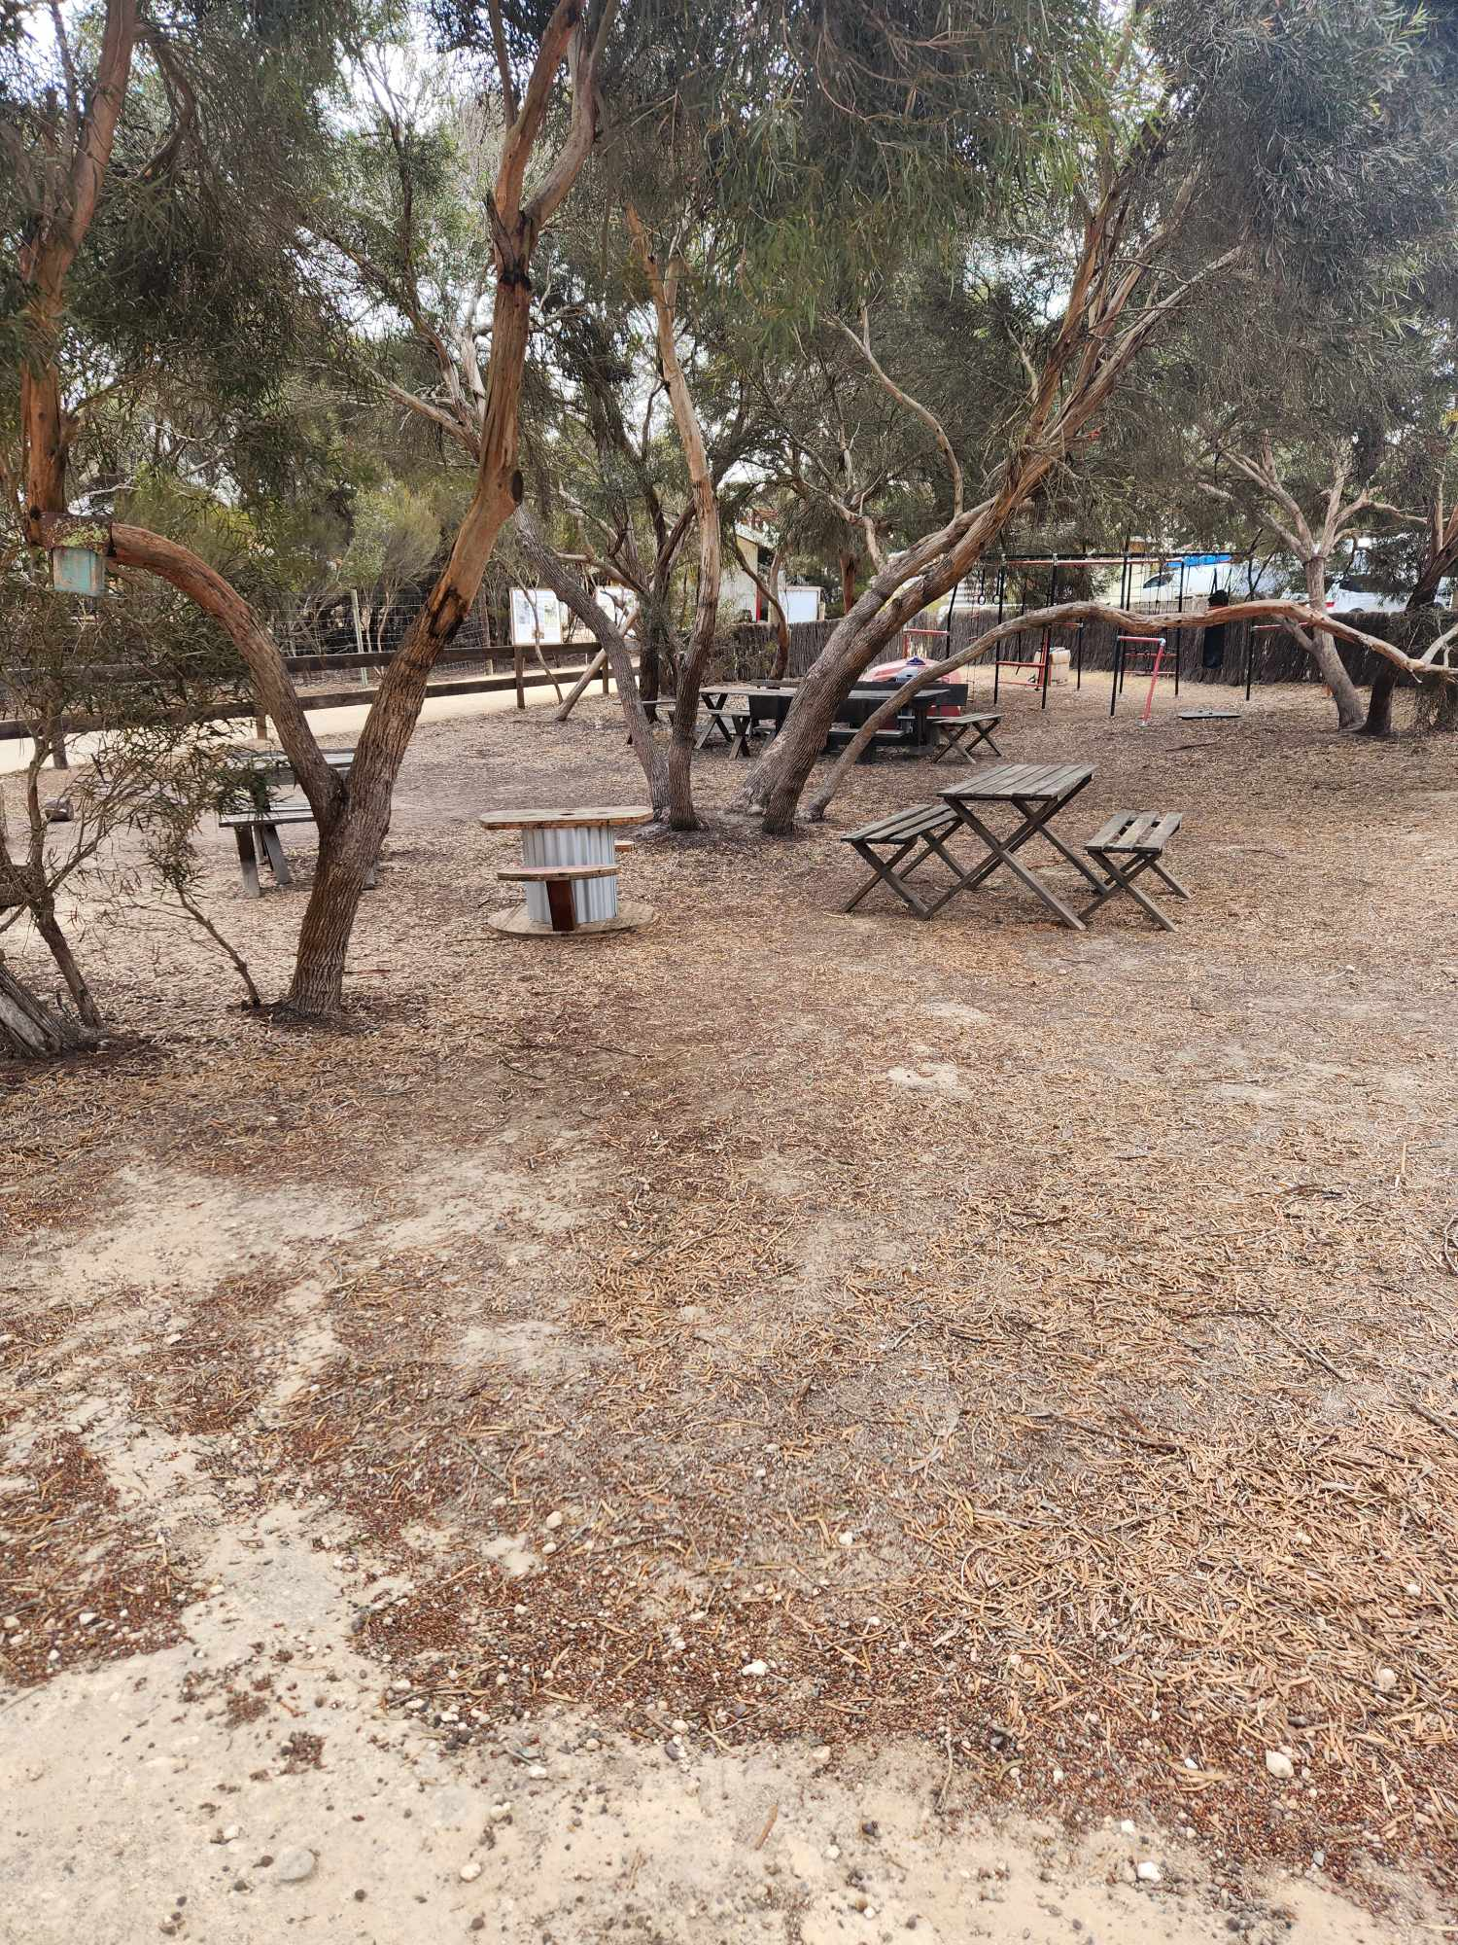
491021843_1044639627536904_6572978465797980800_n
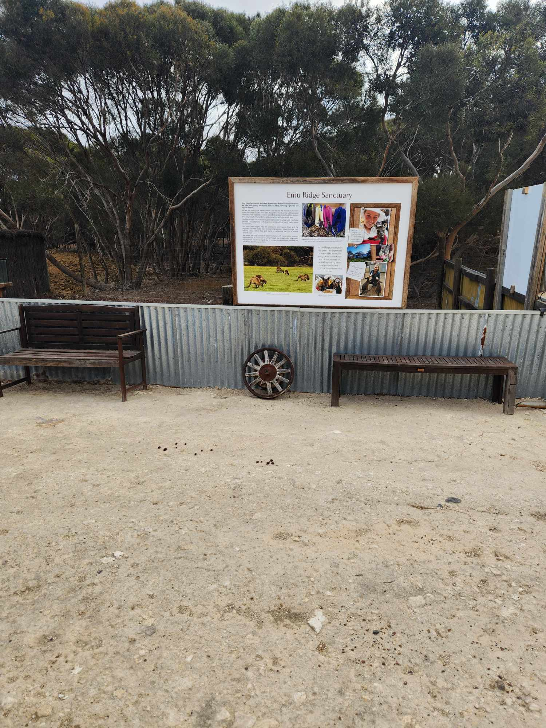
491024463_2153312828448391_9099654812154272718_n
491025287_584700370618496_5405153318229844931_n

FOOD AND DRINK

Dining Spaces
The dining spaces have the following facilities/amenities in place
- The entrance has level access
- The doorway is at least 850mm wide
- There is level access through the dining area
- Chairs are moveable to allow for wheelchairs to be seated at the tables
- All glass doors and full height windows have contrast markings
- There are areas of full lighting
- There are large print menus
- There are Plain English menus
- There is an accessible toilet

Our business caters for the following dietary requirements
- Sugar free (diabetic)
- Gluten free (celiac)
- Lactose free (dairy free)
- Low fat and fibre with no gastric content
- Low potassium
- Low sodium
- Nut free
- Additive free
- Organic
- Vegetarian
- Vegan
- Kosher
- Halal
- There are procedures in place to avoid cross-contamination of food products
- There is a sample menu available online
Sample menu is available here - https://www.emuridge.com.au/cafe

EVENTS

Events
Events have the following facilities/amenities in place
- There is step free access throughout the venue
- All ancillary areas are step free e.g. breakout rooms, dining areas, outside areas and exhibition spaces
- All stage areas including speaker platforms are accessible
- Accessible toilets are available at the venue
- There is clear signage throughout the venue including accessible routes and accessible facilities
- Wheelchair designated seating is provided
- We cater for varying group sizes
- Our event can be booked from the main web site
- All presentations are captioned
- There is good circulation space with the number of people expected to allow people with a disability to move around freely
- Food and water is available for guide and service animals
- The event is outdoors
- Portable accessible toilets are available
- Seating is at regular intervals
- Accessible car parking is available
- There are designated drop-off points
- Quiet rooms, marquees or spaces are available
- In addition, the following further information can assist guests:
We don't often have events and if it is its hired out by different organisations.

Report Disclaimer
Please note that this business report, provided as a result of the use of the diagnostic assessment, is for information purposes only.
Australian Tourism Industry Council (ATIC) cannot guarantee the accuracy of respondent’s answers, or that they are fully representative of your business. Therefore, ATIC does not warrant or guarantee any particular outcome in respect of your businesses self-assessment.
This report is intended as guidance only for your business and should not be relied on for future marketing considerations. ATIC recommends that you seek your own independent advice as well as the results from the diagnostic.
Links to external web sites are inserted for convenience and do not constitute endorsement of material at those sites, or any associated organisation, product or service.
ATIC does not:
- Assume any legal liability for the accuracy, completeness, or usefulness of any information from this report or any links provided; or
- Accept responsibility for any loss associated directly or indirectly from the use of this report.

