ATIC Accessibility
To support the accessible community in making informed travel decisions for their individual needs

This report prepared for:
Business name: | The Truffle Farm
Address: | 844 Mole Creek Road
Town: | DELORAINE
Contact for enquiries: | Anna Terry
Contact Number: | 0437849283
Contact Email: | hello@thetrufflefarmtasmania.com.au
Website: | https://www.thetrufflefarmtasmania.com.au/
Date: | 2026-10-24 04:03

ATIC Accessibility
The following pages provides travellers with information on the businesses facilities and amenities which aims to support the traveller to make an informed decision on whether the business is suitable for their individual needs.
OVERVIEW 4
Business Overview 4
Bookings 4
Emergency Management 4
Communications 5
Other Information 5
Guide Dog and Service Animals 5
GENERAL 6
Pre-arrival, arrival and reception 6
Cognitive Impairment Support 6
Car Park and Access amenities 6
Entry 6
Internal Spaces 7
Public areas 7
Displays, exhibits, commentary and live performances 7
External Paths 8
Ramps 8
Public Toilets/Adult change facilities 8
TOUR OPERATORS 9
Route Planning 9
Guides 9
COMMON AREAS 10
Parks and gardens 10
FOOD AND DRINK 11
Dining Spaces 11
Report Disclaimer 13

OVERVIEW

Business Overview

The business has the following products/services available
- Tour/Transport
- Food and Drink

Our business caters for the following disability types:
- Limited mobility
- Wheelchairs or mobility scooters
- Food allergies or intolerances
- Cognitive or people on the Autism Spectrum

Bookings

The business offers the following methods for bookings and enquiries:
- Phone
- Email
- Webportal
- Our website supports Screen Readers
- Our forms have high contract boxes and submit boxes
- Staff have undergone disability awareness and training

Emergency Management
- Exit access is free and clear at all times
We ensure exit access is free and clear at all times by: All tour experiences are located outdoors.
- Exits and access to exists are greater than 900mm
- Exits to the emergency evacuation point does not include stairways
- The evacuation point is clearly marked by a sign
The business identifies guests who need additional assistance should an emergency occur by: Guests requiring additional assistance in the event of an emergency will be identified by staff prior to tour experiences commencing.
The procedure for assisting guests who need assisted rescue is: Guests requiring additional assistance in the event of an emergency will be identified by staff prior to tour experiences commencing and supported one-to-one.
- Guests with disabilities are noted in the guest log book for emergency and evacuation purposes

Communications
- An accessibility guide is available on the website
https://accreditation.qualitytourismaustralia.com/report/AccessReportPublicHtml2/aaf6ac01-56f5-ee11-b426-6045bd3f338d
- Our website meets WCAG 2.0 accessibility standards
- Our business offers the following alternative communication methods
- Plain English
- There is easy to read signage and information (e.g. menus and emergency information)

Other Information
- For bookings made onsite, the ticket booth/counter/box office is accessible for people using a wheelchair
- The business accepts the companion card

Guide Dog and Service Animals
- The business provides a secure area with shade and water for service animals
- The business provides a toilet area for service animals
- Bowls, bedding, etc. are provided for service animals
The business provides the following services for services animals: Service dogs are welcome. Designated sheltered areas are provided for them along with water bowl and toilet area.

GENERAL

Pre-arrival, arrival and reception
The business has the following in place to support guests during pre-arrival, arrival and reception
- Booking information and websites are compatible with screen readers
- There is a reception/public entryway.
- Seating available at reception
- A lower counter at reception/ticket office
Staff provide assistance for bookings when required/requested.
The following steps are in place to ensure that people with fatigue related to their disability are not disadvantaged by long wait times: Seats are available near reception. Guests with mobility limitations are prioritised on truffle hunts to allow for minimal standing/walking and then seated comfortably while other guests complete their turn.

Cognitive Impairment Support
- Documents are available in plain English for people with cognitive impairment (This may include instructions, guides, menus and general information)

Car Park and Access amenities
The business has the following Car Park and Access amenities
- A drop off zone
- Designated disabled parking bays
- Level or ramped access from the car park to the entrance
- The accessible entrance is clearly signed from the parking bay
- In addition, the following further information can assist guests:
The Truffle Farm is not accessible by public transport (except taxi/uber).

Entry
The business has the following amenities/systems in place for entry
- A drop off point close to the entrance
- A path of access to the building is slip resistance and even
- A path of access to the building is clear of obstruction
- Door jams/doors are of a contrasting colour to surrounding walls
- Door handles are of a contrasting colour to the door
- Signage is written in a contrasting colour
- The entry door is a minimum of 850mm wide
- The entrance sill is less than 13mm
- There a clear space of at least 1500mm x 1500mm in front of all doors.
- In addition, the following further information can assist guests:
There are no glass doors at The Truffle Farm.

Internal Spaces
- Clear and unobstructed routes through and between buildings
- Interior walls are matte or low sheen
- Floors, walls, counters and furniture are of contrasting colours
- Tableware/glassware contrast with the table surface or table cloth
- Floor surfaces are hard or short pile carpet
- Seating is available for guests unable to stand for long periods
- Accessible facilities are clearly signed and visible from all areas
The width of the smallest corridor is: There are no corridors at The Truffle Farm.
- In addition, the following further information can assist guests:
Breakaway areas adjacent to our purpose-built tour shed can be arranged.

Public areas
The public areas have the following amenities in place
- Seating
- In addition, the following further information can assist guests:
Seating is provided in our garden area at the Farmgate shop.

Displays, exhibits, commentary and live performances
For displays, exhibits, commentary and live performances the following amenities are in place
- Seating
- Wheelchair accessible spaces/seating

External Paths
External paths of travel
- Surfaces are concrete, asphalt, smooth paving or hard packed fine gravel (max aggregate size 13mm)
- Paths or slopes longer than 15 metres have resting places or seats
- Pathways are wider than 900mm
There are no steps at The Truffle Farm.
There are no steps at The Truffle Farm.
- In addition, the following further information can assist guests:
The farmgate shop is all-accessible with level (gravel) surfaces from the carpark to shop entry (around 35m), and the entry door has a very low doorframe to gain access to the shop.

The Truffle Farm have previously customised tours for guests with accessibility requirements. Wheelchairs and mobility aids can be accommodated.

Ramps
Ramps have the following amenities are in place
- There are ramps.
- All fixed ramps are 1:14 or less
- Long ramps (more than 10m) are 1:20 or less
- Ramps have a raised edge of at least 100mm

Public Toilets/Adult change facilities
Public Toilets/Adult change facilities have the following amenities are in place
- There is an accessible toilet for public use
- The door is at least 850mm wide
- There is a minimum of 850mm beside the toilet
- The toilet seat is 460mm above the floor
- There is 1700mm mm of clear space in front of the toilet
- The toilet seat is460mm above the floor

TOUR OPERATORS

Route Planning
- In addition, the following further information can assist guests:
Transport services are not provided by this business. The Truffle farm is located 45mins from Launceston and can accessed by private vehicle or private transportation service.
- Walking Tours
- Operated on a step free route
- Multi-paced to account for slower walkers

Guides

Guides have been trained in the following
- Use of clear/simple English
- Correct pronunciation for lip readers
  - Image(s)
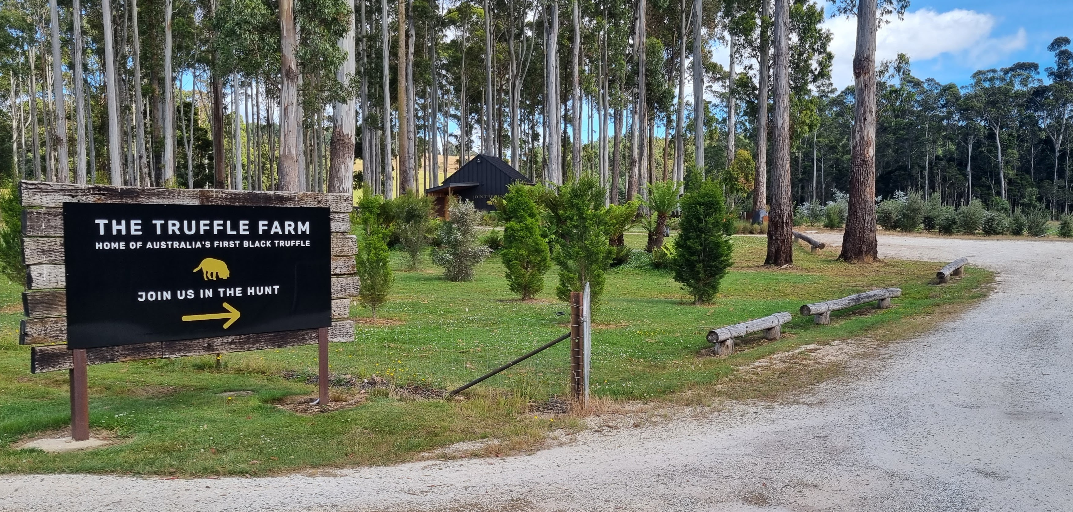
Large carpark signage with directional arrow_Compacted gravel surface
- In addition, the following further information can assist guests:
Two staff are currently enrolled in and participating in Auslan courses.

COMMON AREAS
  - Image(s)
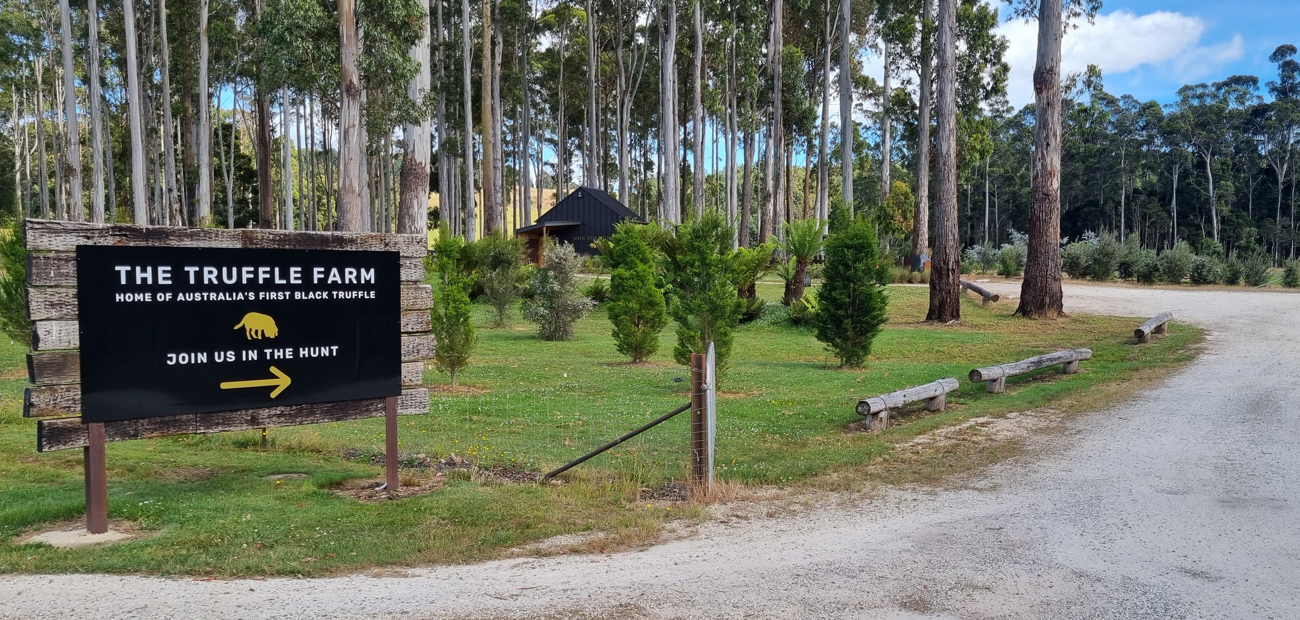
THE TRUFFLE FARM_CARPARK SIGN
- In addition, the following further information can assist guests:
The Truffle Farm does not have a designated play space, however the farmgate shop boasts a a large grassed and garden area for relaxing, playing and resting. An outdoor 'find-the-dogs' game is available for children.

Parks and gardens
- Seats are provided at regular intervals
  - Parks and Gardens Access/Entry Image(s)
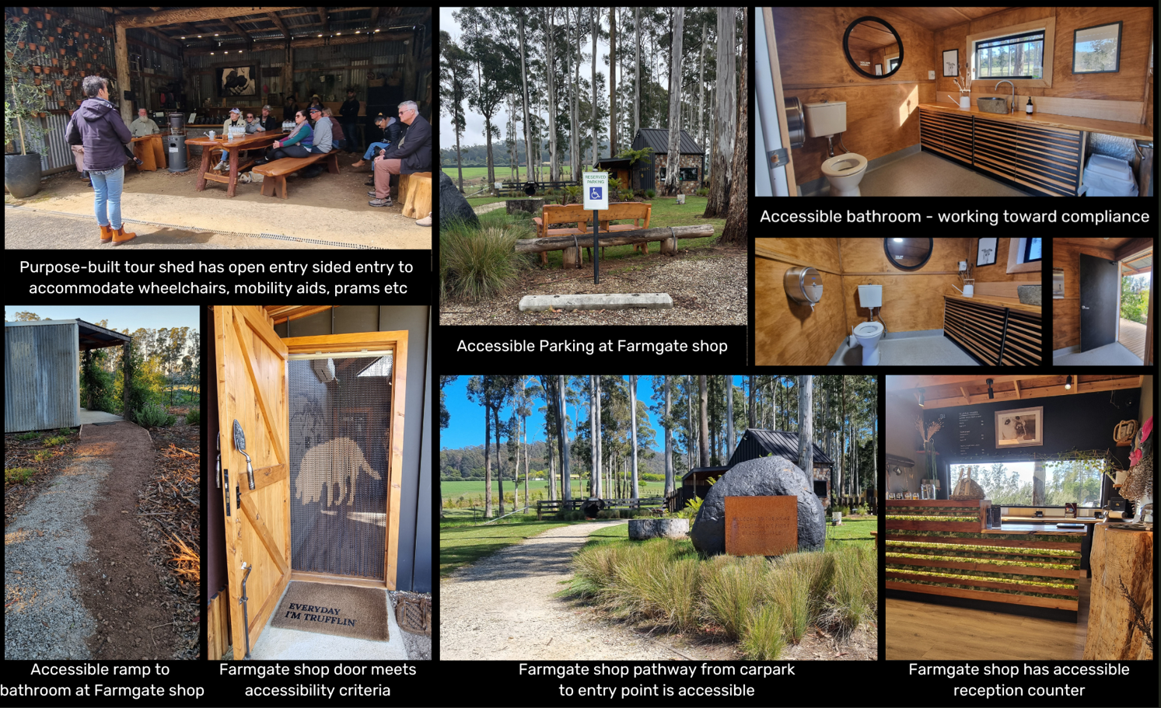
Accessibility Options at The Truffle Farm

FOOD AND DRINK

Dining Spaces
The dining spaces have the following facilities/amenities in place
- The entrance has level access
- The smallest doorway is All tour experiences are conducted outdoors and door width is not applicable. wide
- There is level access through the dining area
- Chairs are moveable to allow for wheelchairs to be seated at the tables
- There are areas of full lighting
- There is an accessible toilet

Our business caters for the following dietary requirements
- Gluten free (celiac)
- Lactose free (dairy free)
- Nut free
- Vegetarian
- Vegan
- There are procedures in place to avoid cross-contamination of food products
- There is a sample menu available online
Sample menu is available here - https://www.thetrufflefarmtasmania.com.au/home/#unique-lunch
  - Food and Beverage Image(s)
Accessibility Options at The Truffle Farm

Report Disclaimer
Please note that this business report, provided as a result of the use of the diagnostic assessment, is for information purposes only.
Australian Tourism Industry Council (ATIC) cannot guarantee the accuracy of respondent’s answers, or that they are fully representative of your business. Therefore, ATIC does not warrant or guarantee any particular outcome in respect of your businesses self-assessment.
This report is intended as guidance only for your business and should not be relied on for future marketing considerations. ATIC recommends that you seek your own independent advice as well as the results from the diagnostic.
Links to external web sites are inserted for convenience and do not constitute endorsement of material at those sites, or any associated organisation, product or service.
ATIC does not:
- Assume any legal liability for the accuracy, completeness, or usefulness of any information from this report or any links provided; or
- Accept responsibility for any loss associated directly or indirectly from the use of this report.

