ATIC Accessibility
To support the accessible community in making informed travel decisions for their individual needs

This report prepared for:
Business name: | Esk Caravan Park
Address: | 16 Hassall Street
Town: | Esk
Contact for enquiries: | Emily Willoughby
Contact Number: | 54241466
Contact Email: | info@eskcaravanpark.com.au
Website: | www.eskcaravanpark.com.au
Date: | 2026-10-21 10:24

ATIC Accessibility
The following pages provides travellers with information on the businesses facilities and amenities which aims to support the traveller to make an informed decision on whether the business is suitable for their individual needs.
OVERVIEW 4
Business Overview 4
Bookings 4
Emergency Management 4
Communications 5
Other Information 5
Guide Dog and Service Animals 5
GENERAL 6
Pre-arrival, arrival and reception 6
Cognitive Impairment Support 6
Car Park and Access amenities 6
Entry 7
Internal Spaces 7
Public areas 7
External Paths 7
Steps 8
Ramps 8
Public Toilets/Adult change facilities 9
ACCOMMODATION 10
Bedrooms 10
Room Amenities 11
Bathrooms 12
COMMON AREAS 23
Swimming pools, spas and waterparks 23
Parks and gardens 25
Report Disclaimer 29

OVERVIEW

Business Overview

The business has the following products/services available
- Accommodation

Our business caters for the following disability types:
- Limited mobility
- Wheelchairs or mobility scooters
- Cognitive or people on the Autism Spectrum

Bookings

The business offers the following methods for bookings and enquiries:
- Phone
- Email
- Webportal
- Our forms have high contract boxes and submit boxes
- Staff have undergone disability awareness and training

Emergency Management
- Exit signs are clear and easy to see
- Exit access is free and clear at all times
We ensure exit access is free and clear at all times by: Regularly inspect exit routes for obstructions and ensure that all materials and equipment are stored in designated areas away from exits.
- Exits and access to exists are greater than 900mm
- Exit doors are able to be opened by all occupants
- Exits to the emergency evacuation point does not include stairways
- The evacuation point is clearly marked by a sign
The business identifies guests who need additional assistance should an emergency occur by: Guests with a disability are noted in the guest log and will notify us at the time of booking by phone or web portal via a required field.
The procedure for assisting guests who need assisted rescue is: Provide advice and assistance as required.
- Guests with disabilities are noted in the guest log book for emergency and evacuation purposes

Communications
- An accessibility guide is available on the website
https://static1.squarespace.com/static/5f98b695dfd8f63fa77e1b70/t/6a28ab84c6350f72da668f03/1781050244750/Accessibility+Goals+2026.pdf

Other Information
- For bookings made onsite, the ticket booth/counter/box office is accessible for people using a wheelchair

Guide Dog and Service Animals
- The business provides a secure area with shade and water for service animals
- The business provides a toilet area for service animals
- Bowls, bedding, etc. are provided for service animals
The business provides the following services for services animals: Dedicated pet-friendly accessible BBQ area including DDA compliant BBQs and seating, hitching areas and water bowls. Multiple grassed and shaded areas for service animals through the park grounds with water bowls provided..

GENERAL

Pre-arrival, arrival and reception
The business has the following in place to support guests during pre-arrival, arrival and reception
- There is a reception/public entryway.
- A clipboard to allow check-in/ticket purchase whilst seated
- A tablet with text to voice or pen and paper at reception to aid in communication
- Lighting in the reception area is even and glare free
- Large print information sheets and registration forms
- Information and maps are available in written form
- A familiarisation tour
- Keys are available for each guest
- Luggage assistance
The following steps are in place to ensure that people with fatigue related to their disability are not disadvantaged by long wait times: Priority check-in for guests with disabilities

Cognitive Impairment Support
- Documents are available in plain English for people with cognitive impairment (This may include instructions, guides, menus and general information)
- Quiet periods or early opening times for people on the Autism Spectrum

Car Park and Access amenities
The business has the following Car Park and Access amenities
- A drop off zone
- Designated disabled parking bays
- Level or ramped access from the car park to the entrance
- The accessible entrance is clearly signed from the parking bay
- Kerb ramps are in place where a pavement or walkway needs to be crossed
- In addition, the following further information can assist guests:
We have added an accessible ensuite to one of our existing astroturf sites

Entry
The business has the following amenities/systems in place for entry
- A drop off point close to the entrance
- A path of access to the building is slip resistance and even
- A path of access to the building is clear of obstruction
- Glass doors are fitted with a visual sighting strip
- Door jams/doors are of a contrasting colour to surrounding walls
- Door handles are of a contrasting colour to the door
- Signage is written in a contrasting colour
- The entry door is a minimum of 850mm wide
- The entrance sill is less than 13mm
- The entrance door mats have a thickness less than 13mm and a width of 7500mm or greater
- In addition, the following further information can assist guests:
Not required as all buildings, facilities and amenities are on ground level.

Internal Spaces
- Clear and unobstructed routes through and between buildings
- Interior walls are matte or low sheen
- Floors, walls, counters and furniture are of contrasting colours
- Floor surfaces are hard or short pile carpet
- Seating is available for guests unable to stand for long periods
- Accessible facilities are clearly signed and visible from all areas
- All corridors greater than 900mm

Public areas
The public areas have the following amenities in place
- Display units, Televisions, Video displays etc. are open captioned
- Even lighting
- Seating

External Paths
External paths of travel
- Surfaces are concrete, asphalt, smooth paving or hard packed fine gravel (max aggregate size 13mm)
- Pathways are wider than 900mm
- There 3 successive steps or less on any path or at any doorway
No paths within the park grounds have stairs - all paths are accessible
- Step free routes clearly signed

Steps
Steps
- There are steps.
- Top and bottom steps are easily distinguished through colour contrast or the use of TGSIs (Tactile Ground Surface Indicators)
- The underside of all staircases are enclosed or protected to a height of at least 2 metres
- Handrails fitted to all open sets of steps
- Where steps are present are there three steps or less
- In addition, the following further information can assist guests:
Steps are only present on our non-accessible cabin and facilities
There are no steps to access our disability assist motel room

Our new accessible cabin and accessible ensuite are both ramped

Ramps
Ramps have the following amenities are in place
- There are ramps.
- All fixed ramps are 1:14 or less
- Hand rails are fitted
- Long ramps (more than 10m) are 1:20 or less
- Ramps have a raised edge of at least 100mm
- In addition, the following further information can assist guests:
Ramps are in place to access our new accessible tourist cabin and new accessible ensuite caravan site - all other communal surfaces within the park are flat/ground level.

Public Toilets/Adult change facilities
Public Toilets/Adult change facilities have the following amenities are in place
- There is an accessible toilet for public use
- The door is at least 850mm wide
- There is a minimum of 850mm beside the toilet
- Handrails are fitted
- The toilet seat is 460mm above the floor
- There is 2000mm mm of clear space in front of the toilet
- The toilet seat of a contrasting colour to the floor
- The toilet seat is460mm above the floor
- In addition, the following further information can assist guests:
Accessible bathroom and change facilities attached to the main amenities block are for in-house guests. Bathroom is also fitted with a wall-mounted baby change table.

ACCOMMODATION

Bedrooms
The bedrooms have the following facilities/amenities in place
- There are 1 rooms available to guests who use a wheelchair
- Bedroom furniture can be re-arranged on request

The following bed types are available in wheelchair accessible rooms
- One double/queen bed/king bed
  - Layout of room Image(s)
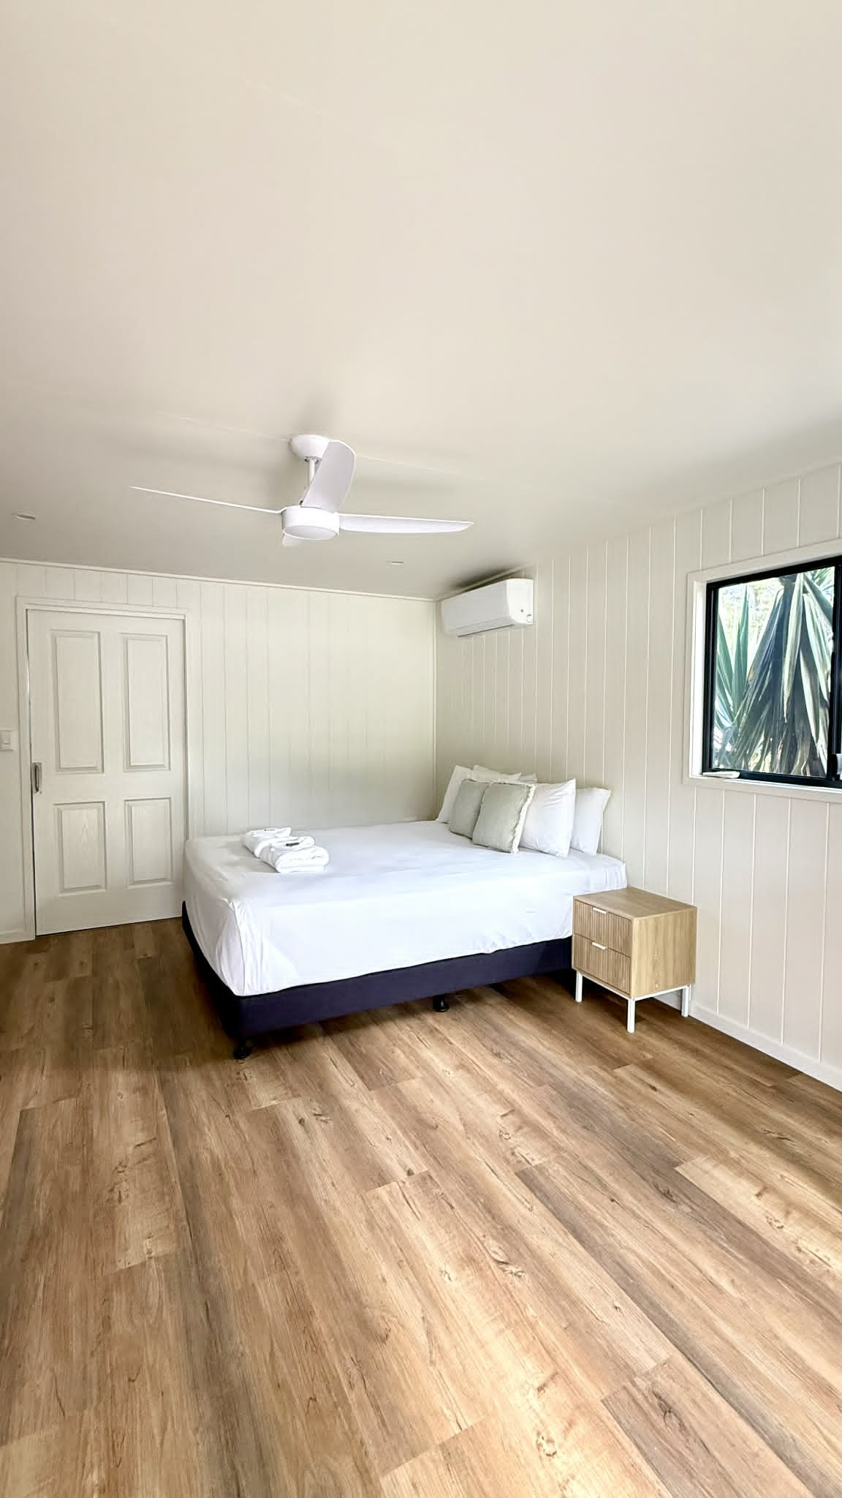
Bed and clearance
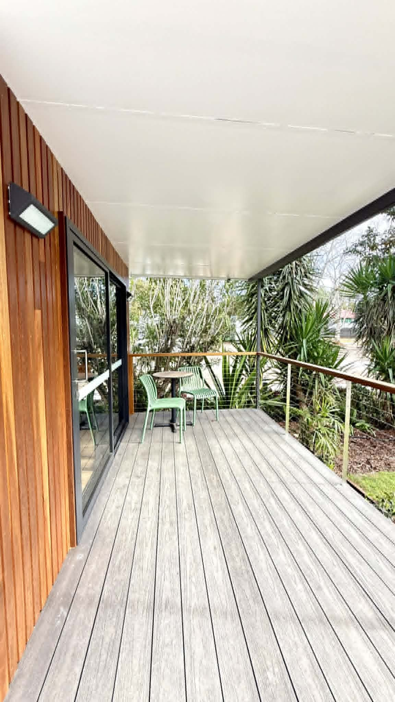
Front Deck
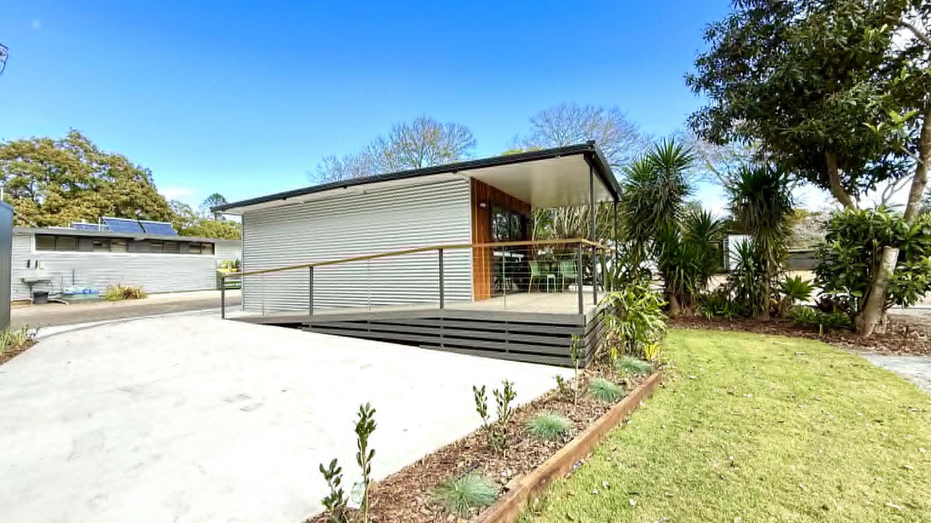
Parking Bay
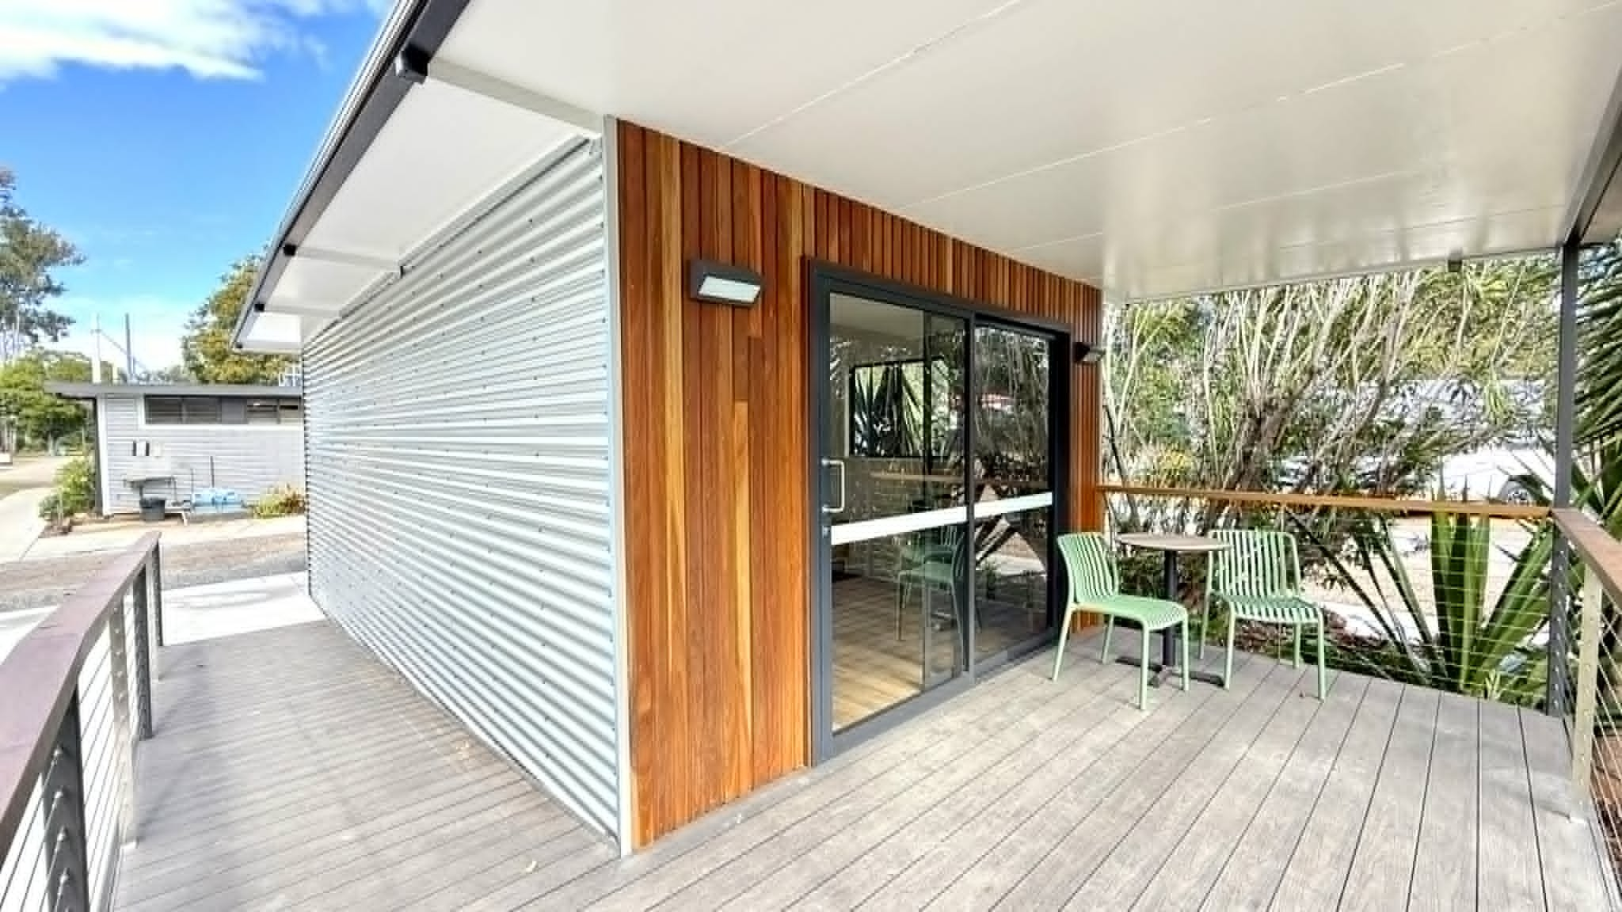
Ramped Entry

Room Amenities
- Lower hanging rails are in wardrobes
For guests with a hearing impairment, the following emergency evacuation procedures apply to ensure safe evacuation: An SMS would be sent to alert the guest and staff would also conduct a welfare check to ensure the guest is evacuated to the emergency evacuation point safely. Staff members would also conduct a welfare check and ensure the guest is aware of evacuation.
- Televisions are equipped with closed captioning capability
- There is contrast between the walls, skirtings, floor and furniture
- There is a clear path through the room
- The edges of all furniture and fixtures are rounded
- Wardrobe handles are a contrasting colour to the doors and draws
- Housekeeping procedures instruct staff not to reposition furniture that has been moved
- Doors open fully against the adjoining wall
- There is a clear opening at least 850mm wide
- There luggage racks for at least two suitcases
- There at least one chair with rigid arms
- Wardrobe and drawer handles are easy to grip
- The bedside lamp switch is easy to reach from the bed
- There is at least 850mm clear space beside the bed
- The bed height is no higher than 680mm from the floor
- There is at least 130mm clearance under the bed
- In addition, the following further information can assist guests:
Queen-size Platinum Supreme Mattress
Total bed height 650mm / 150mm clearance under bed
1:14 ramp access, width 1155mm
Front deck depth / turning area 2165mm x 3000mm
Sliding door entry 985mm
Compliant bench heights and clearances under kitchen sink
Microwave at 800mm high
European Light switches at 900mm
Parking Bay with 1:40 (2.5%) gradient
USB and Lightning Charger

Bathrooms
The bathrooms have the following facilities/amenities in place
- All heating appliances and hot water pipes are protected or insulated
- All shower, bath and basin taps are clearly differentiated between hot and cold
- Fixtures and fittings have rounded edges
- The hot water is thermostatically controlled to 41 degrees
- The door is at least 850mm wide
- There is a minimum of 850mm beside the toilet
- Handrails are fitted
- There is 1300mm mm of clear space in front of the toilet
- The toilet seat is a contrasting colour to the floor
- The toilet seat is 460mm above the floor
- There is a roll-in shower with fold down fixed seat or a shower chair
- There is a portable shower head on flexible hose
  - Bathroom Image(s)
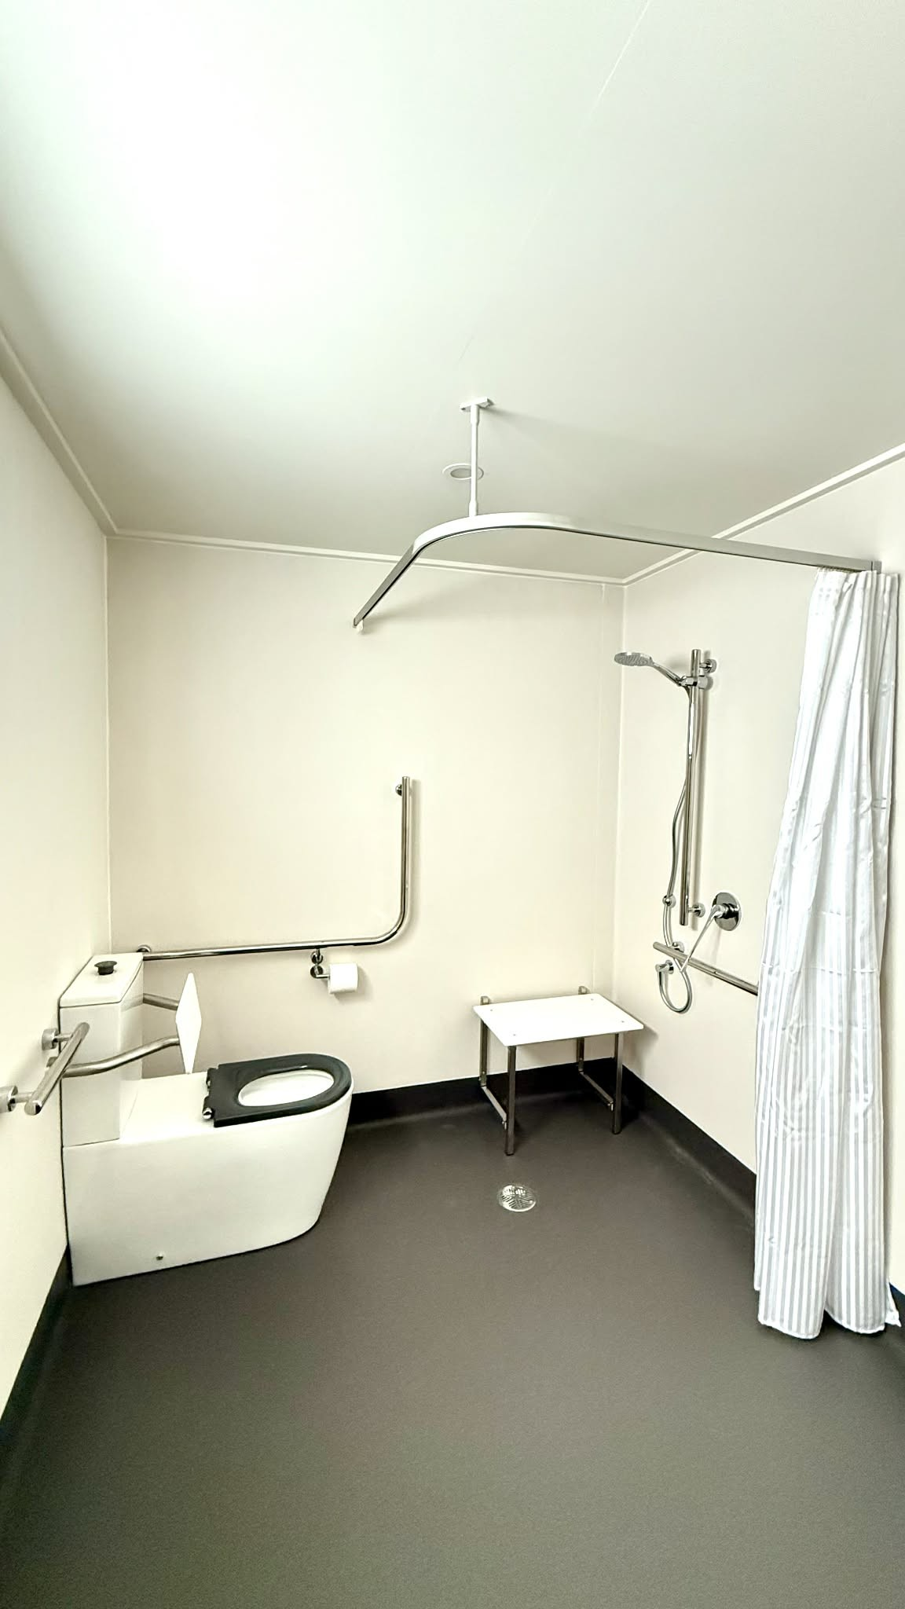
Bathroom 1
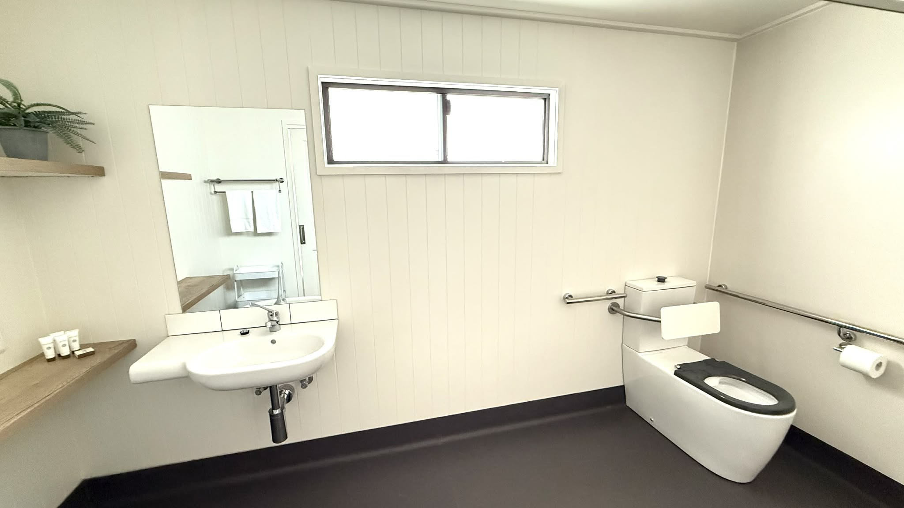
Bathroom 2
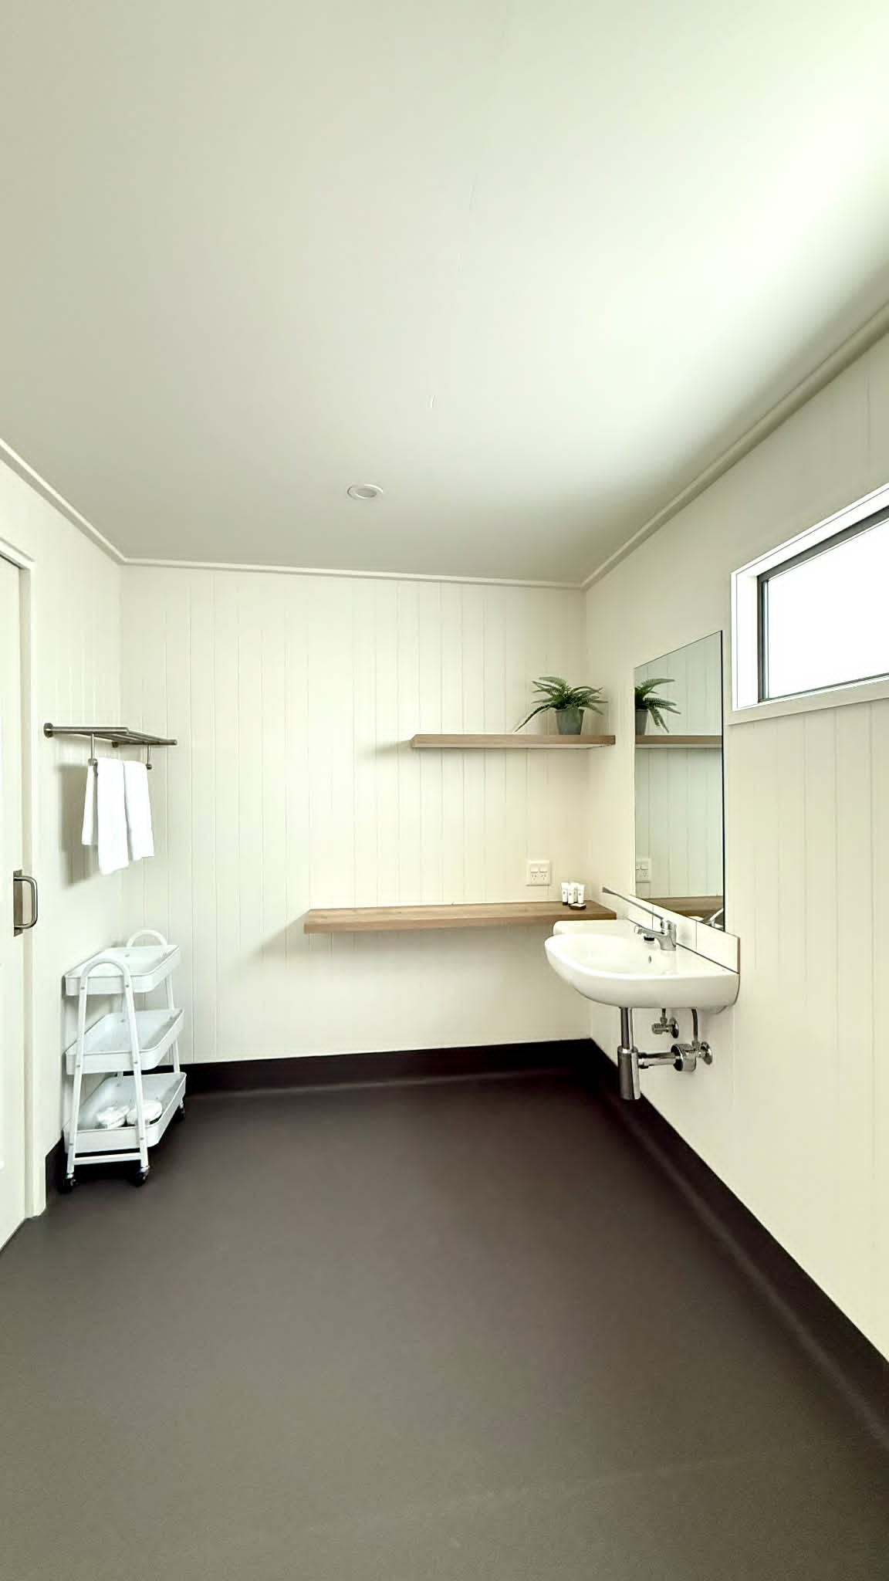
Bathroom 3
- In addition, the following further information can assist guests:
Bathroom fitted with:

Sliding bathroom door clearance 860mm
Wolfen 800 Back to Wall Rimless Toilet with Single Flap Seat and Backrest
Wolfen Ambulant Folding Shower Seat 600mm
Linear Grab Rail Shower with hose restrictor
Barrier-free wash basin and bench space
Shower curtain track with weighted shower curtain
Accessible tapware/levers
Mirror 600 x 900 - bottom edge set at 900mm AFFL

COMMON AREAS

Swimming pools, spas and waterparks
- The following swimming pools, spas and waterparks amenities are available
- Unisex change facilities with an accessible toilet

The following accessible entry methods are available to the pools and spas:
- Pool lift
  - Pool Access Image(s)
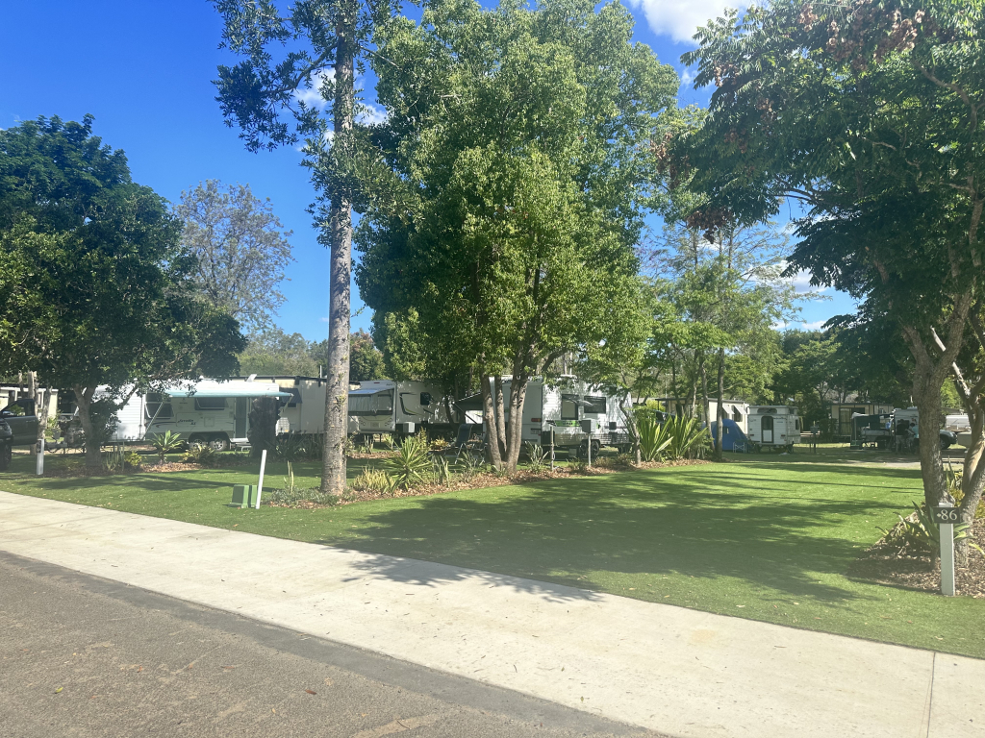
Accessible Astroturf Site and Path
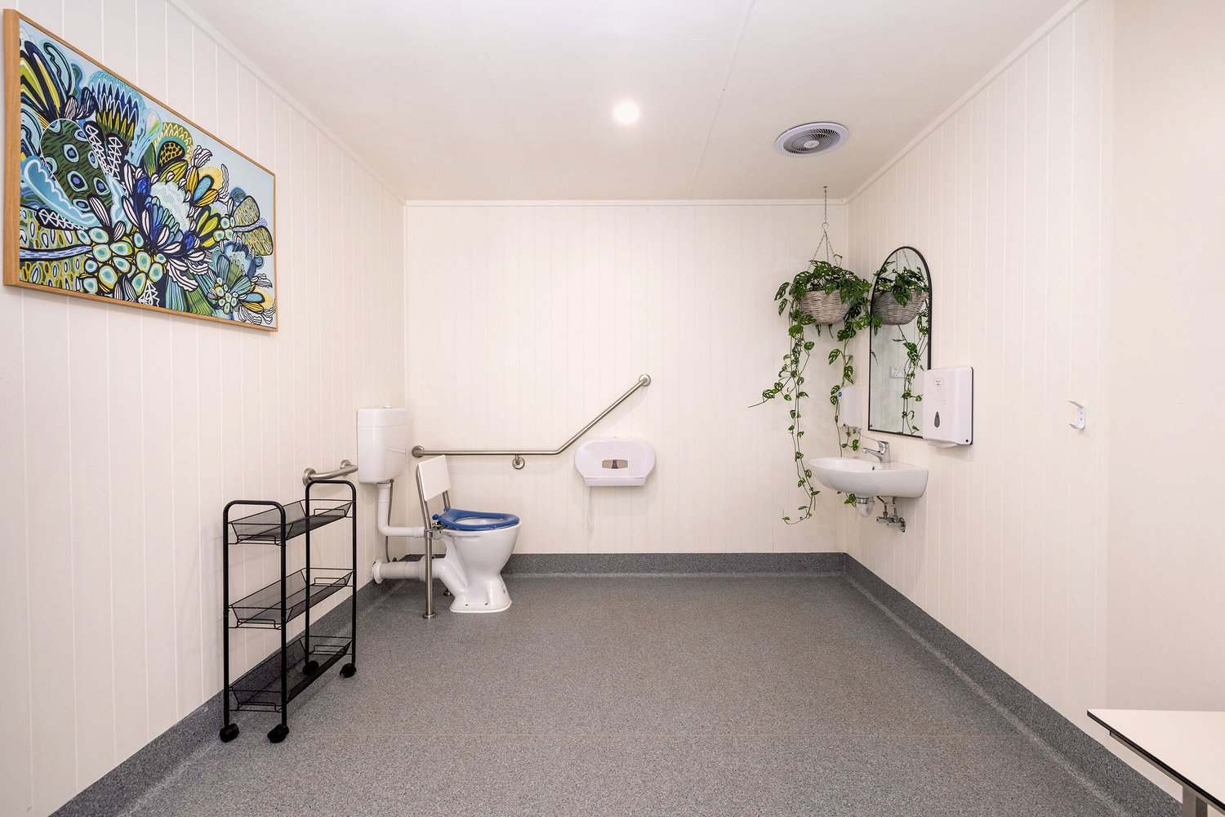
Accessible Bathroom
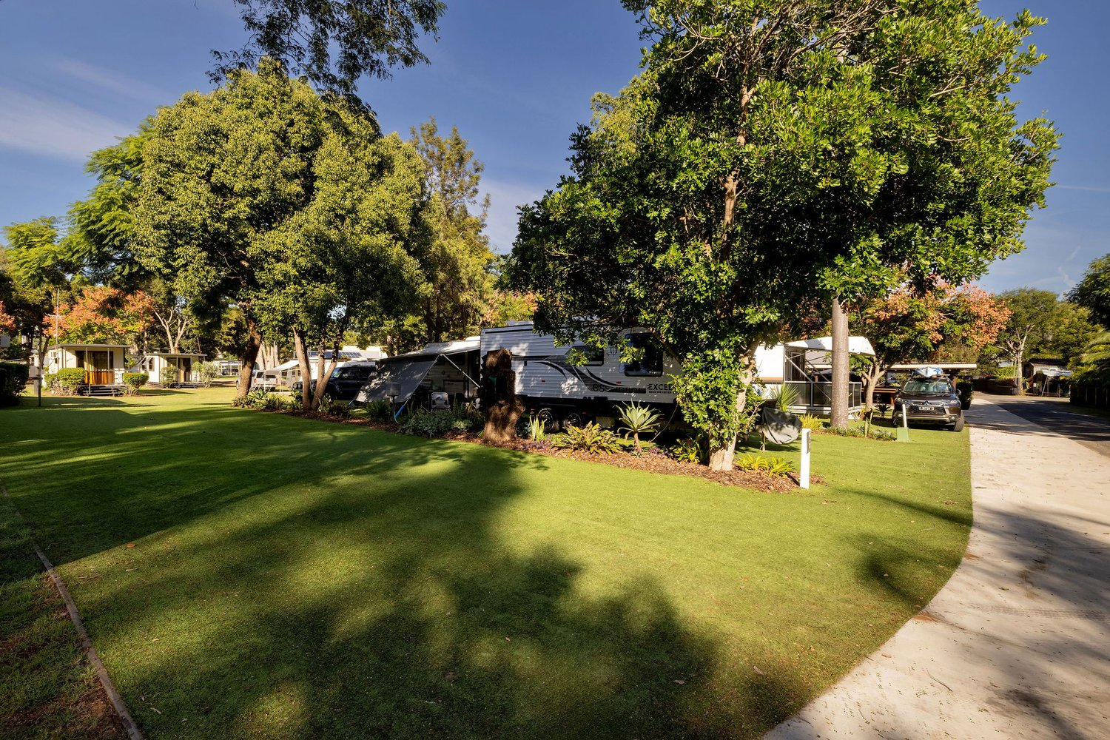
Accessible sites with path link to camp kitchen and pools
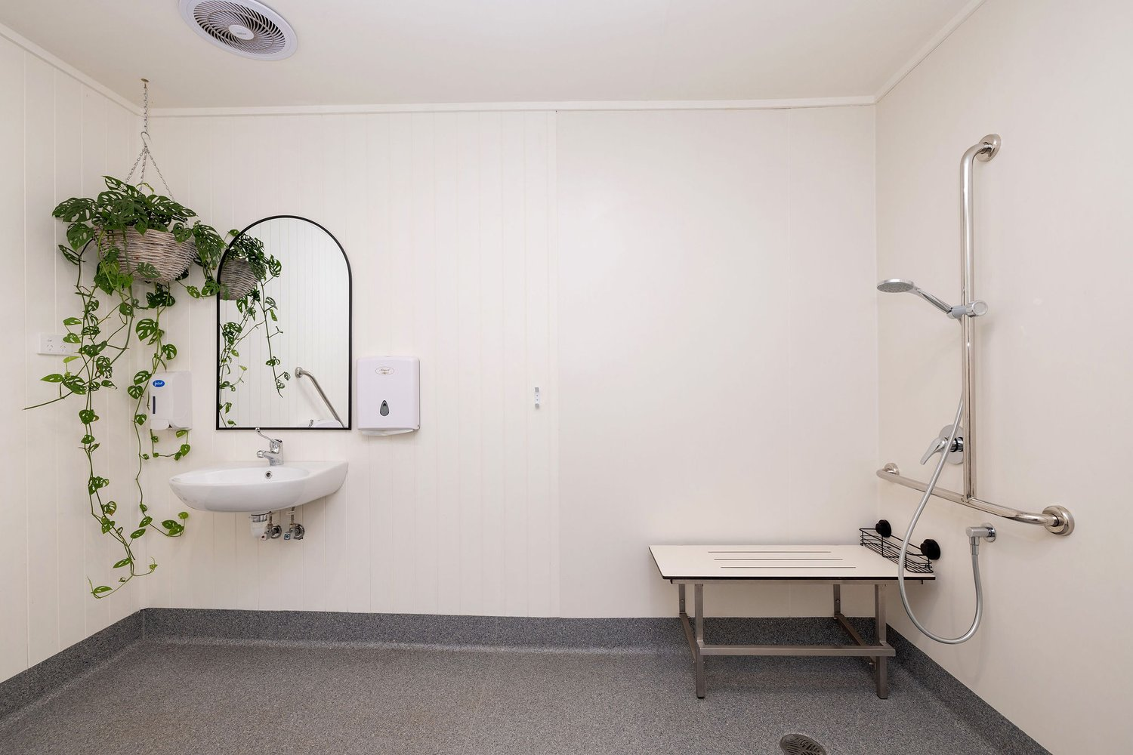
Accessible+Bathroom
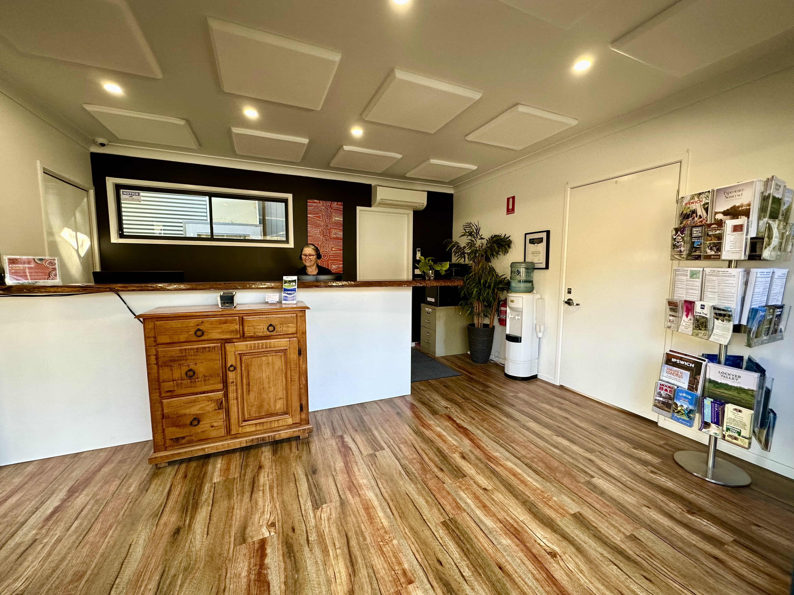
Office Interior
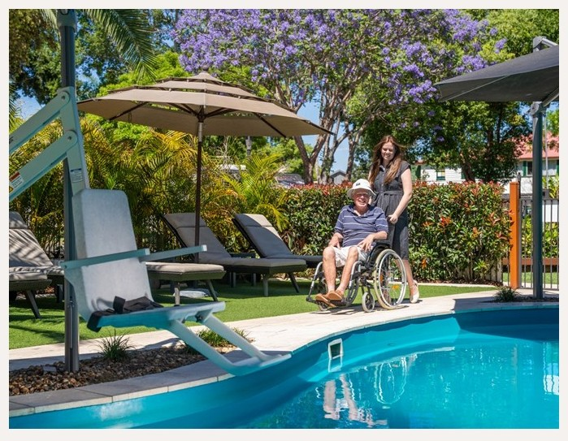
Pool Hoist Adult Pool 1
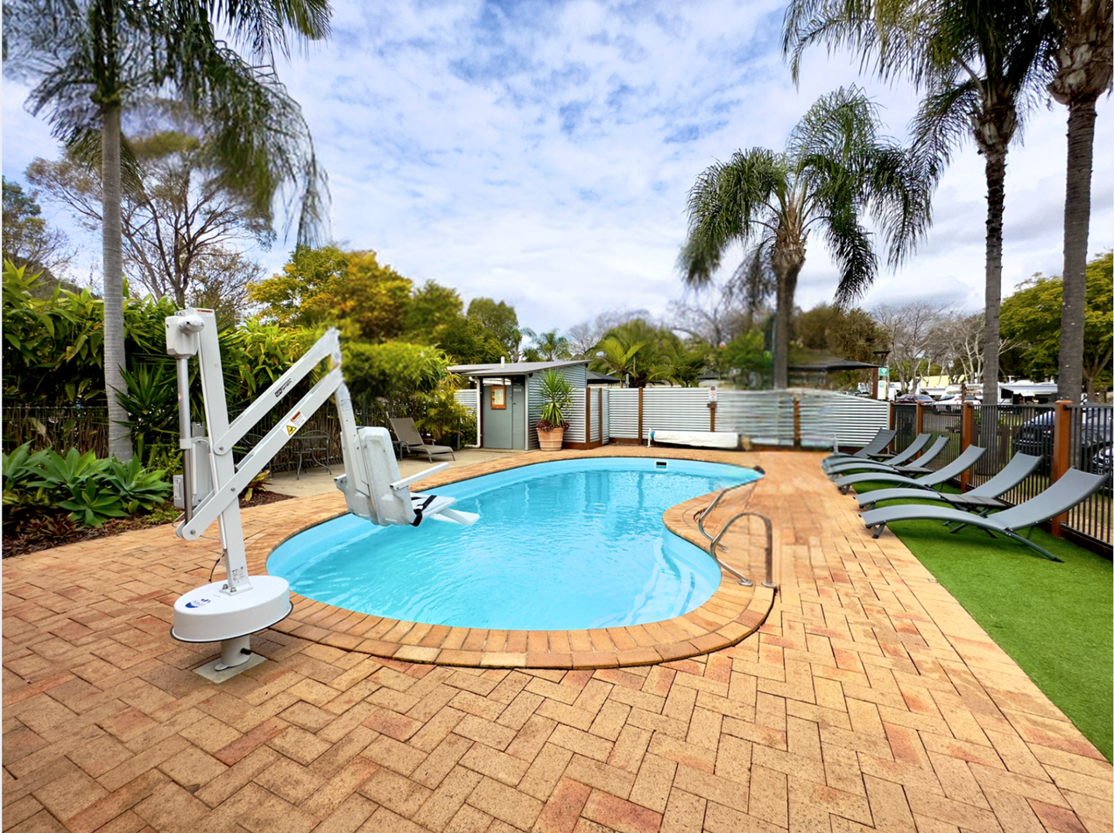
Pool Hoist Family Pool
- In addition, the following further information can assist guests:
Both pools are serviced by a pool hoist, available on request

Parks and gardens
- The following parks and gardens amenities are available
- Accessible toilets
- Accessible toilets are signed at regular intervals
- There is a step free map
- This map is available online
https://www.eskcaravanpark.com.au/maps
- Accessible picnic tables
- Accessible drinking fountains
- Accessible BBQs
  - Parks and Gardens Access/Entry Image(s)
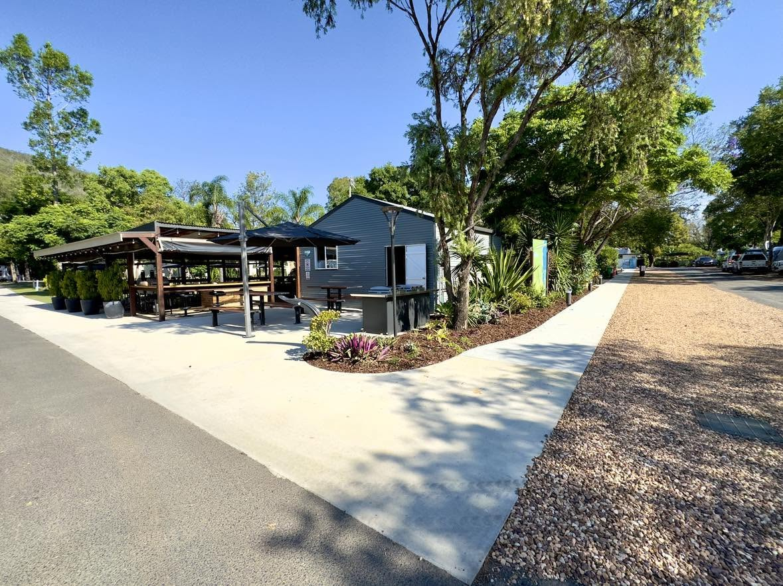
Accessible path linking camp kitchen to main amenities and accessible bathroom
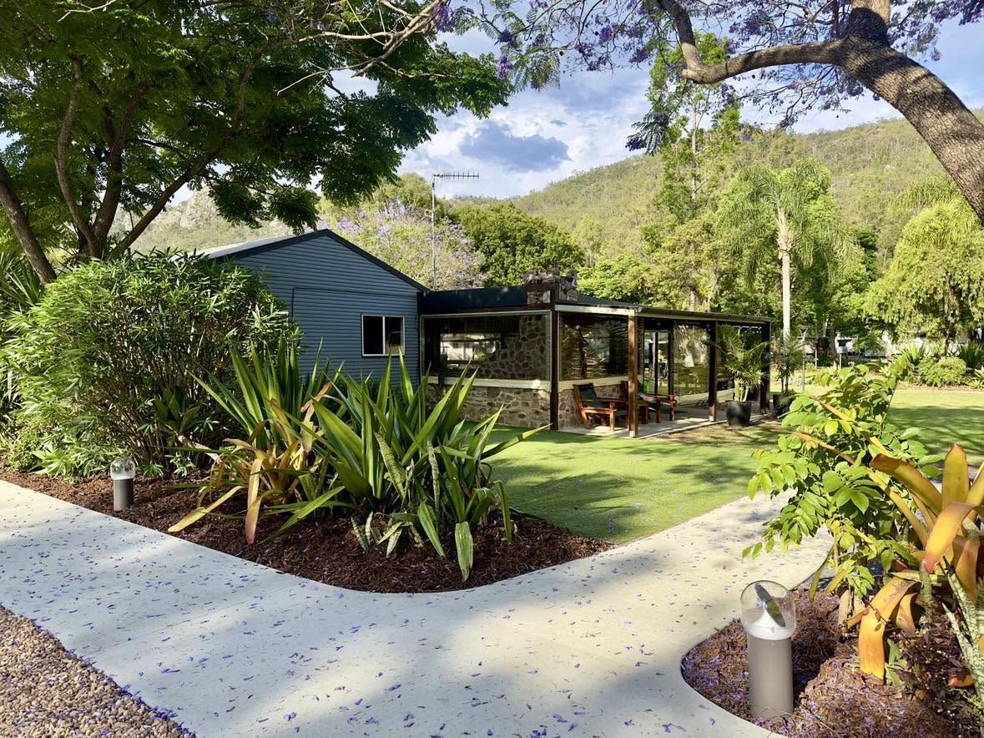
Accessible pathway linked to accessible astroturf camp-caravan site
Accessible sites with path link to camp kitchen and pools
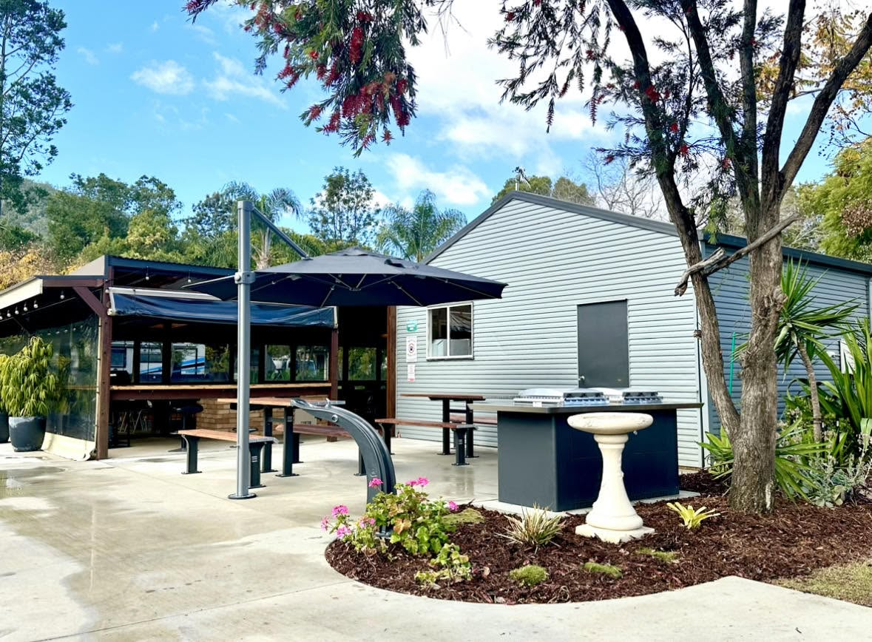
DDA Compliant BBQ Seating and Drink Fountain Area 1
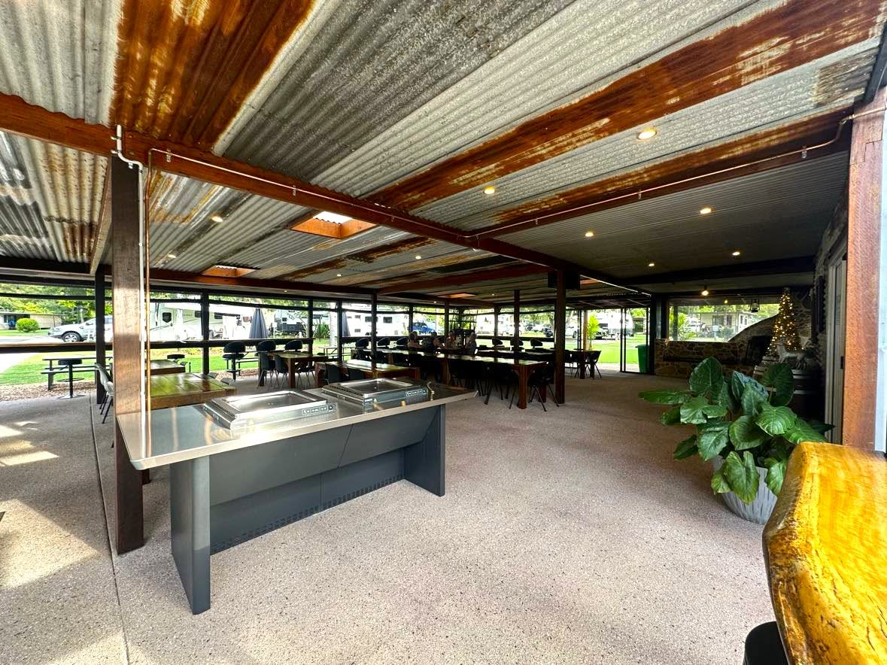
Undercover Accessible BBQ

Report Disclaimer
Please note that this business report, provided as a result of the use of the diagnostic assessment, is for information purposes only.
Australian Tourism Industry Council (ATIC) cannot guarantee the accuracy of respondent’s answers, or that they are fully representative of your business. Therefore, ATIC does not warrant or guarantee any particular outcome in respect of your businesses self-assessment.
This report is intended as guidance only for your business and should not be relied on for future marketing considerations. ATIC recommends that you seek your own independent advice as well as the results from the diagnostic.
Links to external web sites are inserted for convenience and do not constitute endorsement of material at those sites, or any associated organisation, product or service.
ATIC does not:
- Assume any legal liability for the accuracy, completeness, or usefulness of any information from this report or any links provided; or
- Accept responsibility for any loss associated directly or indirectly from the use of this report.

