ATIC Accessibility
To support the accessible community in making informed travel decisions for their individual needs

This report prepared for:
Business name: | Harvest Tours
Address: | 16 Copse way
Town: | Cowaramup
Contact for enquiries: | Stephen Hayman
Contact Number: | 0429 728 687
Contact Email: | indulge@harvesttours.com.au
Website: | https://www.harvesttours.com.au/
Date: | 2026-11-02 22:23

ATIC Accessibility
The following pages provides travellers with information on the businesses facilities and amenities which aims to support the traveller to make an informed decision on whether the business is suitable for their individual needs.
OVERVIEW 4
Business Overview 4
Bookings 4
Emergency Management 4
Communications 5
Other Information 5
Guide Dog and Service Animals 5
GENERAL 6
Pre-arrival, arrival and reception 6
Cognitive Impairment Support 6
Car Park and Access amenities 6
Entry 7
Internal Spaces 7
Public areas 8
Displays, exhibits, commentary and live performances 8
External Paths 8
Steps 9
Public Toilets/Adult change facilities 9
TOUR OPERATORS 10
Tour/Transport Services 10
Route Planning 10
Guides 10
ACCOMMODATION 12
Bedrooms 12
Room Amenities 12
Bathrooms 13
ATTRACTIONS 15
Zoos and Wildlife Parks 15
COMMON AREAS 16
Play Spaces 16
Parks and gardens 16
FOOD AND DRINK 17
Dining Spaces 17
ADVENTURE ACTIVITIES 18
Adventure activities 18
Report Disclaimer 20

OVERVIEW

Business Overview

The business has the following products/services available
- Tour/Transport
- Accommodation
- Attraction
- Food and Drink
- Adventure

Our business caters for the following disability types:
- Blind or low vision
- Deaf or low hearing
- Limited mobility
- Wheelchairs or mobility scooters
- Food allergies or intolerances
- Cognitive or people on the Autism Spectrum

Bookings

The business offers the following methods for bookings and enquiries:
- Phone
- Email
- Webportal
- Our website supports Screen Readers
- Our forms have high contract boxes and submit boxes
- Staff have undergone disability awareness and training

Emergency Management
- The business has an emergency management and evacuation plan for guests with a disability
- Emergency and evacuation procedures are explained on arrival
We ensure exit access is free and clear at all times by: All unnecessary luggage is stowed on transport trailer ensuring exit access, checked by driver/guide prior to moving.
- Guests with disabilities are noted in the guest log book for emergency and evacuation purposes

Communications
- An accessibility guide is available on the website
www.harvesttours.com.au
- Our website meets WCAG 2.0 accessibility standards
- Our business offers the following alternative communication methods
- Plain English
website is also in Chinese
- There is easy to read signage and information (e.g. menus and emergency information)
Note pads are made available to assist with communication

Other Information
- The business accepts the companion card

Guide Dog and Service Animals
- The business provides a secure area with shade and water for service animals
- The business provides a toilet area for service animals
The business provides the following services for services animals: Additional space is provided to ensure both the traveller, and their service animal can remain comfortable while staying connected with other guests. Dog areas are clearly signposted, allowing service animals to take breaks, have a drink, and rest during stops. We kindly ask owners to bring bedding and food bowls for their dogs or service animals, as these items support the comfort of the animals and contribute to a welcoming environment for all guests. Our focus is on making each stay accessible and enjoyable, with thoughtful accommodations for every need.

GENERAL

Pre-arrival, arrival and reception
The business has the following in place to support guests during pre-arrival, arrival and reception
- Booking information and websites are compatible with screen readers
- Information and maps are available in written form
- A facility map and information is available in Braille
- A step free map/guide
- A familiarisation tour
- Keys are available for each guest
- Luggage assistance
The following steps are in place to ensure that people with fatigue related to their disability are not disadvantaged by long wait times: Booked accommodation by Harvest tours provide detail to all providers and on arrival the driver/guide will assist the guest to their room and ensure they are comfortable, both day and night staff within the the complex are made aware and assist when requested
- In addition, the following further information can assist guests:
They are given a Harvest Tours contact card should they require any assistance

Cognitive Impairment Support
- Documents are available in plain English for people with cognitive impairment (This may include instructions, guides, menus and general information)
- A "social script" guide to your premises or attraction describing the sights, sounds and smells to aid parents/carers prepare visitors in advance
- The 'social script' is available in word and other editable formats
- Quiet periods or early opening times for people on the Autism Spectrum
- A space for parents and children on the Autism Spectrum
- Access has alternative procedures and clear written instructions with universal access symbols

Car Park and Access amenities
The business has the following Car Park and Access amenities
- A drop off zone
- Designated disabled parking bays
- Level or ramped access from the car park to the entrance
- The accessible entrance is clearly signed from the parking bay
- The public transport services available are:
These are pointed out to all travellers along with time tables
- Kerb ramps are in place where a pavement or walkway needs to be crossed
- In addition, the following further information can assist guests:
They are given a Harvest Tours contact card should they require any assistance

Entry
The business has the following amenities/systems in place for entry
- A drop off point close to the entrance
- A path of access to the building is slip resistance and even
- A path of access to the building is clear of obstruction
- Self opening entry doors or fitted with a self closer
- Glass doors are fitted with a visual sighting strip
- Door jams/doors are of a contrasting colour to surrounding walls
- Door handles are of a contrasting colour to the door
- Signage is written in a contrasting colour
- Signage is written in a Sans Serif font and use upper and lower case letters
- The entry door is a minimum of 850mm wide
- The entrance sill is less than 13mm
- There a clear space of at least 1500mm x 1500mm in front of all doors.
- The entrance door mats have a thickness less than 13mm and a width of 7500mm or greater
- In addition, the following further information can assist guests:
Guest are made aware of whether conditions that may effect their stay
- In addition, the following further information can assist guests:
All required information for guests is conveyed at the time of booking and reinforced on collection prior to tour commencing.

Internal Spaces
- Clear and unobstructed routes through and between buildings
- Interior walls are matte or low sheen
- Floors, walls, counters and furniture are of contrasting colours
- Any protruding or overhanging obstructions are at least 2meters above the floor or are protected
- Floor surfaces are hard or short pile carpet
- Seating is available for guests unable to stand for long periods
- Accessible facilities are clearly signed and visible from all areas
- All corridors greater than 900mm
- There is a quiet space for parents and children on the Autism Spectrum
- In addition, the following further information can assist guests:
All guests are advised on building conditions prior to entry, and spaces that can be used for parents and children on the Autism Spectrum.

Public areas
The public areas have the following amenities in place
- Display units, Televisions, Video displays etc. are open captioned
- Even lighting
- Seating
- In addition, the following further information can assist guests:
Harvest Tours driver/guide will assist as required

Displays, exhibits, commentary and live performances
For displays, exhibits, commentary and live performances the following amenities are in place
- Seating
- Wheelchair accessible spaces/seating
- A written transcript where audio description is provided i.e. display commentary, tour commentary
- In addition, the following further information can assist guests:
Harvest Tours driver/guide will assist as required

External Paths
External paths of travel
- Surfaces are concrete, asphalt, smooth paving or hard packed fine gravel (max aggregate size 13mm)
- Paths or slopes longer than 15 metres have resting places or seats
- Pathways are wider than 900mm
- There 3 successive steps or less on any path or at any doorway
- Any paths having steps are clearly identified as non-wheelchair accessible
- Step free routes clearly signed
- In addition, the following further information can assist guests:
Harvest Tours driver/guide will assist as required

Steps
Steps
- There are steps.
- Top and bottom steps are easily distinguished through colour contrast or the use of TGSIs (Tactile Ground Surface Indicators)
- All steps or staircases have enclosed risers
- The underside of all staircases are enclosed or protected to a height of at least 2 metres
- Handrails fitted to all open sets of steps
- Handrails extend 300mm beyond the top and bottom step
- Where steps are present are there three steps or less
- In addition, the following further information can assist guests:
Harvest Tours driver/guide will assist as required

Public Toilets/Adult change facilities
Public Toilets/Adult change facilities have the following amenities are in place
- There is an accessible toilet for public use
- The door is at least 850mm wide
- There is a minimum of 850mm beside the toilet
- Handrails are fitted
- The toilet seat is 460mm above the floor
- There is N/A mm of clear space in front of the toilet
- The toilet seat of a contrasting colour to the floor
- The toilet seat is460mm above the floor
- There is a registered changing places facility
- In addition, the following further information can assist guests:
Assistance is offered by Harvest Tours and the premieres visited

TOUR OPERATORS

Tour/Transport Services
The tour/transport services have the following facilities/amenities in place
- Buses/Coaches
- Buses/Coaches: 4 Vehicles 1 x High Roof Accessible bus- seats 9 and 2 wheelchairs, (lift capacity 300kg – loading platform 82.55cm x 121.55cm) 2 x High Roof buses with extended step and support rails (luggage trailers) 1 x 7 seater executive wagon (capacity 4 pax) • Commentary is available in written format on request. vehicles have wheelchair lifts or ramps
- none vehicles have low floors with ramped entry
The maximum wheelchair capacity available in the fleet is: High Roof Accessible bus- seats 9 and 2 wheelchairs
- Commentary is available in written format

Route Planning
- Route Planning
- The tour route includes stops with accessible toilet facilities
- In addition, the following further information can assist guests:
Harvest Tours driver/guide points out toilet locations at each venue visited
- Lunch stop venues are accessible
- Sightseeing and photo opportunity stops are step free
- Overnight Stops
- For overnight stays, wheelchair accessible rooms are available
The total number of wheelchair passengers that can be catered for at overnight stops are: 2
- Walking Tours
- Operated on a step free route
- Multi-paced to account for slower walkers
- Electronic voice augmentation
- Hearing aid compatible

Guides

Guides have been trained in the following
- Use of clear/simple English
- Correct pronunciation for lip readers
- There is a audio description of surroundings
- Marine
- Marine craft are wheelchair accessible
- Length (cm) Standard hired chair.
- Width (cm) Standard hired chair.
- Height (cm) Standard hired chair.
- Weight (kg) Standard hired chair.
  - Image(s)
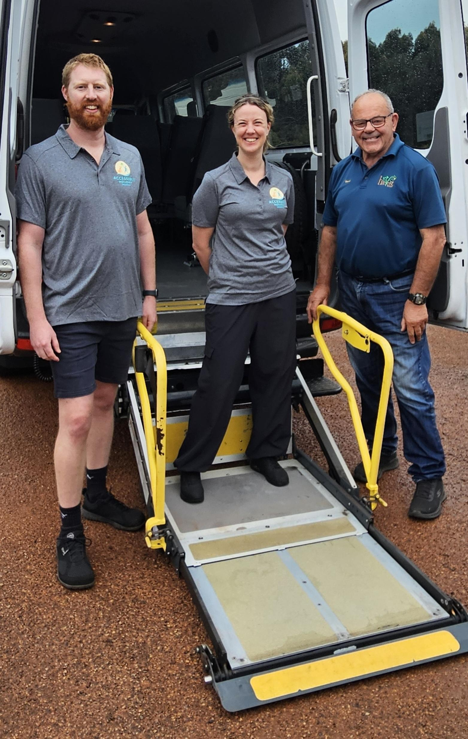
AHH photo 2
- This tour stops at attractions/accommodation/food and beverage/retail spaces that are not operated by this business. For information relating to these individual properties please follow the weblink provided
- In addition, the following further information can assist guests:
Contact Harvest Tours foe assistance or request via our website contact page

ACCOMMODATION

Bedrooms
The bedrooms have the following facilities/amenities in place
- There are Dependant on the suppler - request made by Harvest Tours rooms available to guests who use a wheelchair
- Bedroom furniture can be re-arranged on request

The following bed types are available in wheelchair accessible rooms
- One double/queen bed/king bed
- One single bed
- Two single beds
- Two double/queen
- One double/queen and one single
  - Layout of room Image(s)
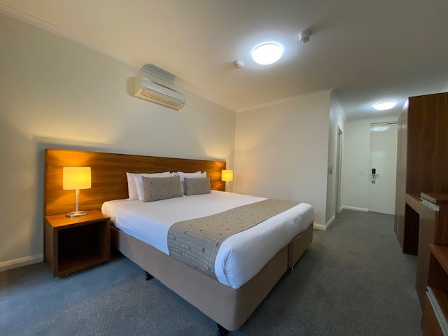
MIT bed room

Room Amenities
Accommodation provider is advised of any room amenities requirments
- Visual alarm is fitted to the room
- Televisions are equipped with closed captioning capability
- Vibrating alarm clocks
- Room phones have volume control
- Room phones have a visual ringing indicator
- Room phones are capable of sending and receiving an SMS
- There is contrast between the walls, skirtings, floor and furniture
- There is a clear path through the room
- The edges of all furniture and fixtures are rounded
- Wardrobe handles are a contrasting colour to the doors and draws
- Housekeeping procedures instruct staff not to reposition furniture that has been moved
- Doors open fully against the adjoining wall
- There is a clear opening at least 850mm wide
- There luggage racks for at least two suitcases
- There at least one chair with rigid arms
- Wardrobe and drawer handles are easy to grip
- The bedside lamp switch is easy to reach from the bed
- There is at least 850mm clear space beside the bed
- The bed height is no higher than 680mm from the floor
- There is at least 130mm clearance under the bed
- The business offers a range of non-allergenic bedding
- Non-allergenic cleaning products are used
- In addition, the following further information can assist guests:
Accommodation provider is advised of any room amenities requirments

Bathrooms
The bathrooms have the following facilities/amenities in place
- All heating appliances and hot water pipes are protected or insulated
- All shower, bath and basin taps are clearly differentiated between hot and cold
- Fixtures and fittings have rounded edges
- The hot water is thermostatically controlled to 41 degrees
- The door is at least 850mm wide
- There is a minimum of 850mm beside the toilet
- Handrails are fitted
- There is a minimum of 1400mm of clear space in front of the toilet
- The toilet seat is a contrasting colour to the floor
- The toilet seat is 460mm above the floor
- A range of non-allergenic toiletries are available
- There is a roll-in shower with fold down fixed seat or a shower chair
- There is a portable shower head on flexible hose
- A door is fitted to the shower
- A door is fitted to the showers with an outward swing at minimum width of 900 mm
  - Bathroom Image(s)
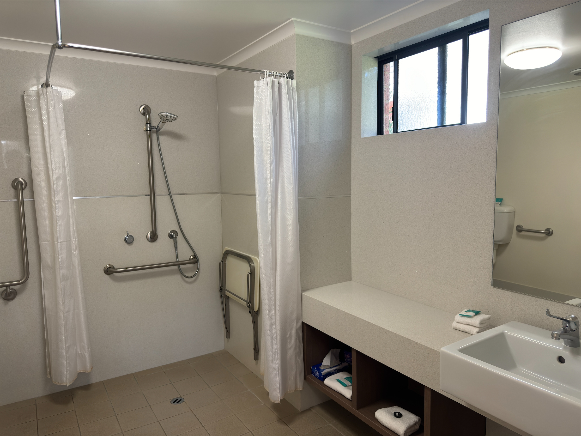
MITbathroom-
- In addition, the following further information can assist guests:
All requirements are to be given to Harvest tours at the time of booking

ATTRACTIONS

Zoos and Wildlife Parks
- Guide and service dogs are welcome
Guide and service animals should observe the following rules: Permission is sort from the Packs DCBA to enter national parks
- A secure area with shade and water for service dogs is available
- A guide for patrons who are blind or vision impaired are available
- Displays have glass or mesh viewing panels for children or people seated in wheelchairs
- Signage is positioned between 800mm and 1200mm above the ground
- Signage is in a font larger than 18 point
- Signage and information provide pictorial information
The following alternative information sources are available: Audio
- Seating is provided at regular intervals
- Aviaries and other enclosures provide level access
- Airlocks provide sufficient room for a wheelchair
- Tour vehicles are available
- Tour vehicles have a wheelchair lift or ramp
- In addition, the following further information can assist guests:
Flat covered in shoes recommended

COMMON AREAS

Play Spaces
- Level access is provided to play spaces
- Ramps provided are at least 25% of elevated sections of the play space
- The surface of the play space is of a composite or rubberized material
- There wheelchair accessible activities
- The play space contains cognitive play panels
- The play space contains tactile play panels or activities
- The space contain colour contrasting elements
- Seating is provided in or around the play space
- In addition, the following further information can assist guests:
All requirements are to be given to Harvest tours at the time of booking

Parks and gardens
- The following parks and gardens amenities are available
- Accessible toilets
- Accessible toilets are signed at regular intervals
- There is a step free map
- Seats are provided at regular intervals
- Direction signage contains distances
- The park or garden contains sensory experiences
- Accessible picnic tables
- Accessible BBQs
- The park contains an observation deck or tower
- The observation deck or tower has level or ramped access
- The observation deck provides a clear view through the safety railing
- Edge protection is provided
- Edge protection is a contrasting colour to the deck

FOOD AND DRINK

Dining Spaces
The dining spaces have the following facilities/amenities in place
- The entrance has level access
- The doorway is at least 850mm wide
- There is level access through the dining area
- Chairs are moveable to allow for wheelchairs to be seated at the tables
- All glass doors and full height windows have contrast markings
- There are areas of full lighting
- There are large print menus
- There are Plain English menus
- There is an accessible toilet

Our business caters for the following dietary requirements
- Sugar free (diabetic)
- Gluten free (celiac)
- Lactose free (dairy free)
- Low fat and fibre with no gastric content
- Low potassium
- Low sodium
- Nut free
- Additive free
- Organic
- Vegetarian
- Vegan
- Kosher
- Halal
- There are procedures in place to avoid cross-contamination of food products
- In addition, the following further information can assist guests:
Please advise any requirements at the time of booking

ADVENTURE ACTIVITIES

Adventure activities
The adventure activities have the following facilities/amenities in place
- Our adventure activities cater for people with a disability
The following activities are available to people with a disability: Train rides, water adventures, coastal attractions, accessible paths
The equipment utilised to make the activities available are: Assistance given by Harvest driver/guide
The following limitations apply to participation, including those activities that are not available to people with a disability: Rocky out crops and climbing
  - Adventure Activity Image(s)
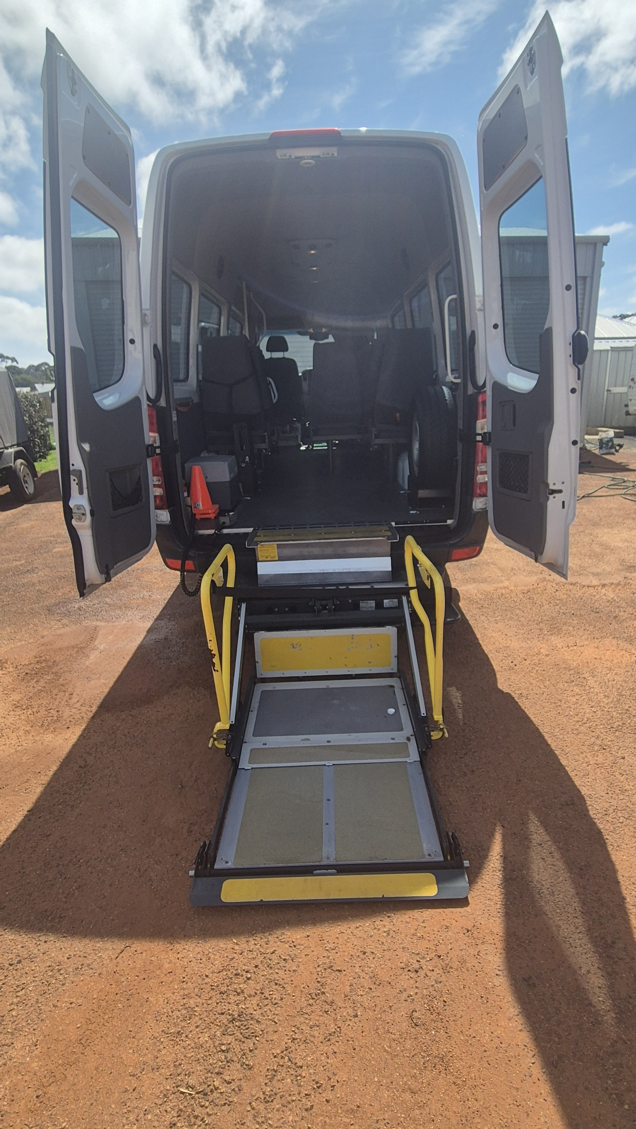
Bus 3

Report Disclaimer
Please note that this business report, provided as a result of the use of the diagnostic assessment, is for information purposes only.
Australian Tourism Industry Council (ATIC) cannot guarantee the accuracy of respondent’s answers, or that they are fully representative of your business. Therefore, ATIC does not warrant or guarantee any particular outcome in respect of your businesses self-assessment.
This report is intended as guidance only for your business and should not be relied on for future marketing considerations. ATIC recommends that you seek your own independent advice as well as the results from the diagnostic.
Links to external web sites are inserted for convenience and do not constitute endorsement of material at those sites, or any associated organisation, product or service.
ATIC does not:
- Assume any legal liability for the accuracy, completeness, or usefulness of any information from this report or any links provided; or
- Accept responsibility for any loss associated directly or indirectly from the use of this report.

