ATIC Accessibility
To support the accessible community in making informed travel decisions for their individual needs

This report prepared for:
Business name: | Esplanade Hotel Fremantle by Rydges
Address: | 46-54, Marine Terrace
Town: | Fremantle
Contact for enquiries: | Jaaidev Vidyadharan
Contact Number: | (08) 9432 4000
Contact Email: | reservations_esplanadefremantle@evt.com
Website: | https://www.rydges.com/accommodation/perth-wa/esplanade-hotel-fremantle-by-rydges/
Date: | 2026-10-28 08:37

ATIC Accessibility
The following pages provides travellers with information on the businesses facilities and amenities which aims to support the traveller to make an informed decision on whether the business is suitable for their individual needs.
OVERVIEW 4
Business Overview 4
Bookings 4
Emergency Management 4
Communications 5
Other Information 5
Guide Dog and Service Animals 5
GENERAL 6
Pre-arrival, arrival and reception 6
Cognitive Impairment Support 6
Car Park and Access amenities 6
Entry 7
Lifts 7
Internal Spaces 8
Public areas 8
Displays, exhibits, commentary and live performances 9
External Paths 9
Steps 9
Ramps 9
Public Toilets/Adult change facilities 10
TOUR OPERATORS 11
ACCOMMODATION 12
Bedrooms 12
Room Amenities 13
Bathrooms 13
ATTRACTIONS 16
COMMON AREAS 19
Swimming pools, spas and waterparks 19
FOOD AND DRINK 22
Dining Spaces 22
EVENTS 24
Events 24
Report Disclaimer 26

OVERVIEW

Business Overview

The business has the following products/services available
- Tour/Transport
- Accommodation
- Attraction
- Food and Drink
- Event

Our business caters for the following disability types:
- Blind or low vision
- Deaf or low hearing
- Limited mobility
- Wheelchairs or mobility scooters
- Food allergies or intolerances
- Cognitive or people on the Autism Spectrum

Bookings

The business offers the following methods for bookings and enquiries:
- Phone
- Email
- Webportal
- Our forms have high contract boxes and submit boxes

Emergency Management
- Exit signs are clear and easy to see
- Exit access is free and clear at all times
We ensure exit access is free and clear at all times by: Staff walkthroughs daily to ensure no exit is blocked.
- Exits and access to exists are greater than 900mm
- Exit doors are able to be opened by all occupants
- Exits to the emergency evacuation point does not include stairways
- There is an emergency refuge that has an intercommunication system linked and has sufficient fire resistance levels.
- The evacuation point is clearly marked by a sign
The business identifies guests who need additional assistance should an emergency occur by: PMS system
The procedure for assisting guests who need assisted rescue is: Sending a fire warden to check on guest
- Guests with disabilities are noted in the guest log book for emergency and evacuation purposes

Communications
- Our business offers the following alternative communication methods
- Plain English
- There is easy to read signage and information (e.g. menus and emergency information)

Other Information
- For bookings made onsite, the ticket booth/counter/box office is accessible for people using a wheelchair

Guide Dog and Service Animals
- The business provides a secure area with shade and water for service animals
- Bowls, bedding, etc. are provided for service animals

GENERAL

Pre-arrival, arrival and reception
The business has the following in place to support guests during pre-arrival, arrival and reception
- Booking information and websites are compatible with screen readers
- There is a reception/public entryway.
- Seating available at reception
- A clipboard to allow check-in/ticket purchase whilst seated
- A tablet with text to voice or pen and paper at reception to aid in communication
- Lighting in the reception area is even and glare free
- Large print information sheets and registration forms
- Information and maps are available in written form
- A familiarisation tour
- Keys are available for each guest
- Luggage assistance
The following steps are in place to ensure that people with fatigue related to their disability are not disadvantaged by long wait times: Personalized check in is offered for guests with a disability - guest is invited to sit down whilst a Duty Manager assists with the check in process. Concierge will assist with the luggage and assisting the guest to their rooms.

Cognitive Impairment Support
- Documents are available in plain English for people with cognitive impairment (This may include instructions, guides, menus and general information)
- Quiet periods or early opening times for people on the Autism Spectrum
- A space for parents and children on the Autism Spectrum

Car Park and Access amenities
The business has the following Car Park and Access amenities
- A drop off zone
- Designated disabled parking bays
- Level or ramped access from the car park to the entrance
- The public transport services available are:
Map is available
- Kerb ramps are in place where a pavement or walkway needs to be crossed
- An intercom system is available at the entrance of car park
- Instructions on how to use the system are in Plan English and accompanied by Universal design standard pictures
- In addition, the following further information can assist guests:
Carpark is available for hotel guests with the carpark located just across the street from the hotel.

Entry
The business has the following amenities/systems in place for entry
- A drop off point close to the entrance
- A path of access to the building is slip resistance and even
- A path of access to the building is clear of obstruction
- Self opening entry doors or fitted with a self closer
- Glass doors are fitted with a visual sighting strip
- Door jams/doors are of a contrasting colour to surrounding walls
- Door handles are of a contrasting colour to the door
- Signage is written in a contrasting colour
- Signage is written in a Sans Serif font and use upper and lower case letters
- The entry door is a minimum of 850mm wide
- The entry door has self opening or a light opening pressure (for manual operations)
- The entrance sill is less than 13mm
- There a clear space of at least 1500mm x 1500mm in front of all doors.
- The entrance door mats have a thickness less than 13mm and a width of 7500mm or greater

Lifts
- Premises has lifts
  - Lift Location: Main Lobby
- This lift is available to all public floors
- The lift contains a visual method of identifying the floor level
- There is a breakdown procedure for lifts containing guests with a hearing impairment
- The emergency procedures within the lift have an SMS contact number
- The lift doors contrast with the surrounding wall finishes
- The lift call buttons contrast with the surrounding wall finishes
- The lift floor buttons have large print numbers
- The lift buttons have braille floor numbers
- The lift has an easily identifiable/tactile emergency button
- The doors open to a clear span of 880mm
- The minimum size of the lift 1100mm wide by 1400mm deep
- The control button heights are between 900mm and 1200mm
- There is a handrail of a minimum length of 600mm
  - Lift Location: Southern Cross Wing Lift
- This lift is available to all public floors
- The lift contains a visual method of identifying the floor level
- There is a breakdown procedure for lifts containing guests with a hearing impairment
- The emergency procedures within the lift have an SMS contact number
- The lift doors contrast with the surrounding wall finishes
- The lift call buttons contrast with the surrounding wall finishes
- The lift floor buttons have large print numbers
- The lift buttons have braille floor numbers
- The lift has an easily identifiable/tactile emergency button
- There is an external tactile or braille floor indicator near the lift call button
- The doors open to a clear span of 880mm
- The minimum size of the lift 1100mm wide by 1400mm deep
- The control button heights are between 900mm and 1200mm
- There is a handrail of a minimum length of 600mm

Internal Spaces
- Clear and unobstructed routes through and between buildings
- Interior walls are matte or low sheen
- Floors, walls, counters and furniture are of contrasting colours
- Any protruding or overhanging obstructions are at least 2meters above the floor or are protected
- Tableware/glassware contrast with the table surface or table cloth
- Floor surfaces are hard or short pile carpet
- Seating is available for guests unable to stand for long periods
- All corridors greater than 900mm
- There is a quiet space for parents and children on the Autism Spectrum

Public areas
The public areas have the following amenities in place
- Even lighting
- Seating

Displays, exhibits, commentary and live performances
For displays, exhibits, commentary and live performances the following amenities are in place
- Seating
- Wheelchair accessible spaces/seating

External Paths
External paths of travel
- Surfaces are concrete, asphalt, smooth paving or hard packed fine gravel (max aggregate size 13mm)
- Pathways are wider than 900mm
- There 3 successive steps or less on any path or at any doorway

Steps
Steps
- There are steps.
- Top and bottom steps are easily distinguished through colour contrast or the use of TGSIs (Tactile Ground Surface Indicators)
- All steps or staircases have enclosed risers
- The underside of all staircases are enclosed or protected to a height of at least 2 metres
- Handrails fitted to all open sets of steps
- Handrails extend 300mm beyond the top and bottom step
- Where steps are present are there three steps or less

Ramps
Ramps have the following amenities are in place
- There are ramps.
- All fixed ramps are 1:14 or less
- Hand rails are fitted
- Long ramps (more than 10m) are 1:20 or less
- Ramps have a raised edge of at least 100mm

Public Toilets/Adult change facilities
Public Toilets/Adult change facilities have the following amenities are in place
- There is an accessible toilet for public use
- The door is at least 850mm wide
- There is a minimum of 850mm beside the toilet
- Handrails are fitted
- The toilet seat is 460mm above the floor
- There is 1.2m mm of clear space in front of the toilet
- The toilet seat of a contrasting colour to the floor
- The toilet seat is460mm above the floor

TOUR OPERATORS
  - Image(s)
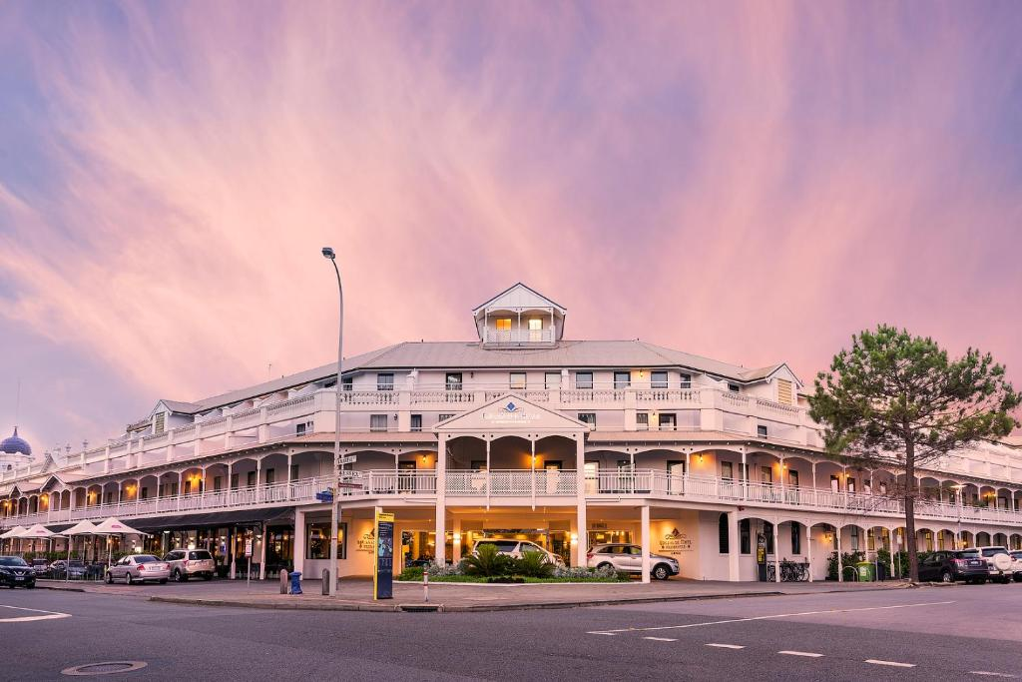
Esplanade Exterior

ACCOMMODATION

Bedrooms
The bedrooms have the following facilities/amenities in place
- There are 11 rooms available to guests who use a wheelchair
- Bedroom furniture can be re-arranged on request

The following bed types are available in wheelchair accessible rooms
- One double/queen bed/king bed
- One double/queen and one single
  - Layout of room Image(s)
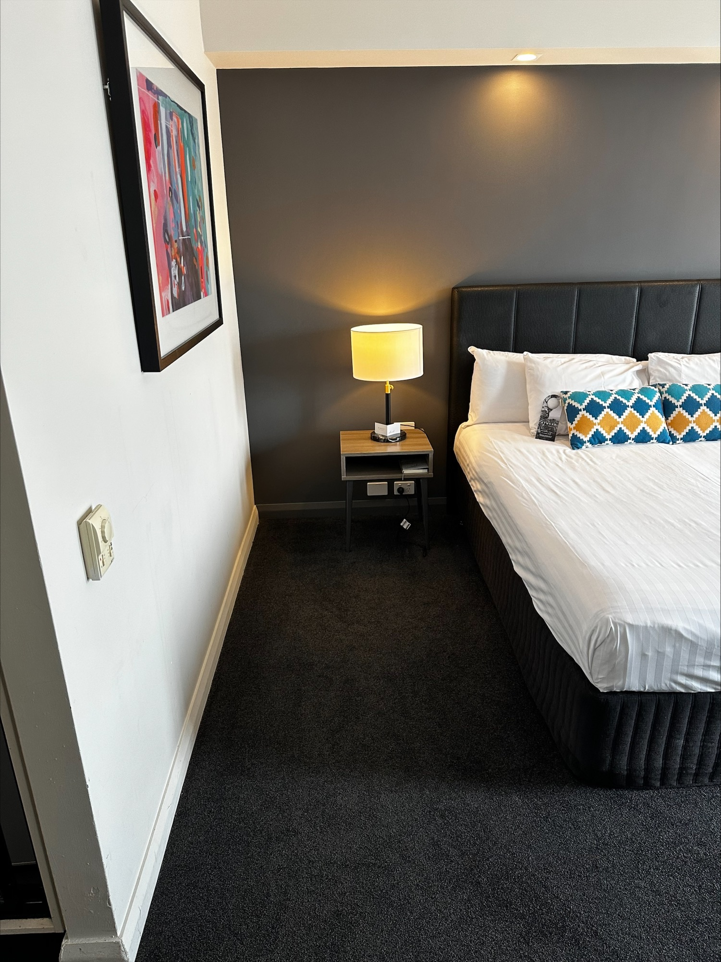
Space Between Walls and Bed 1
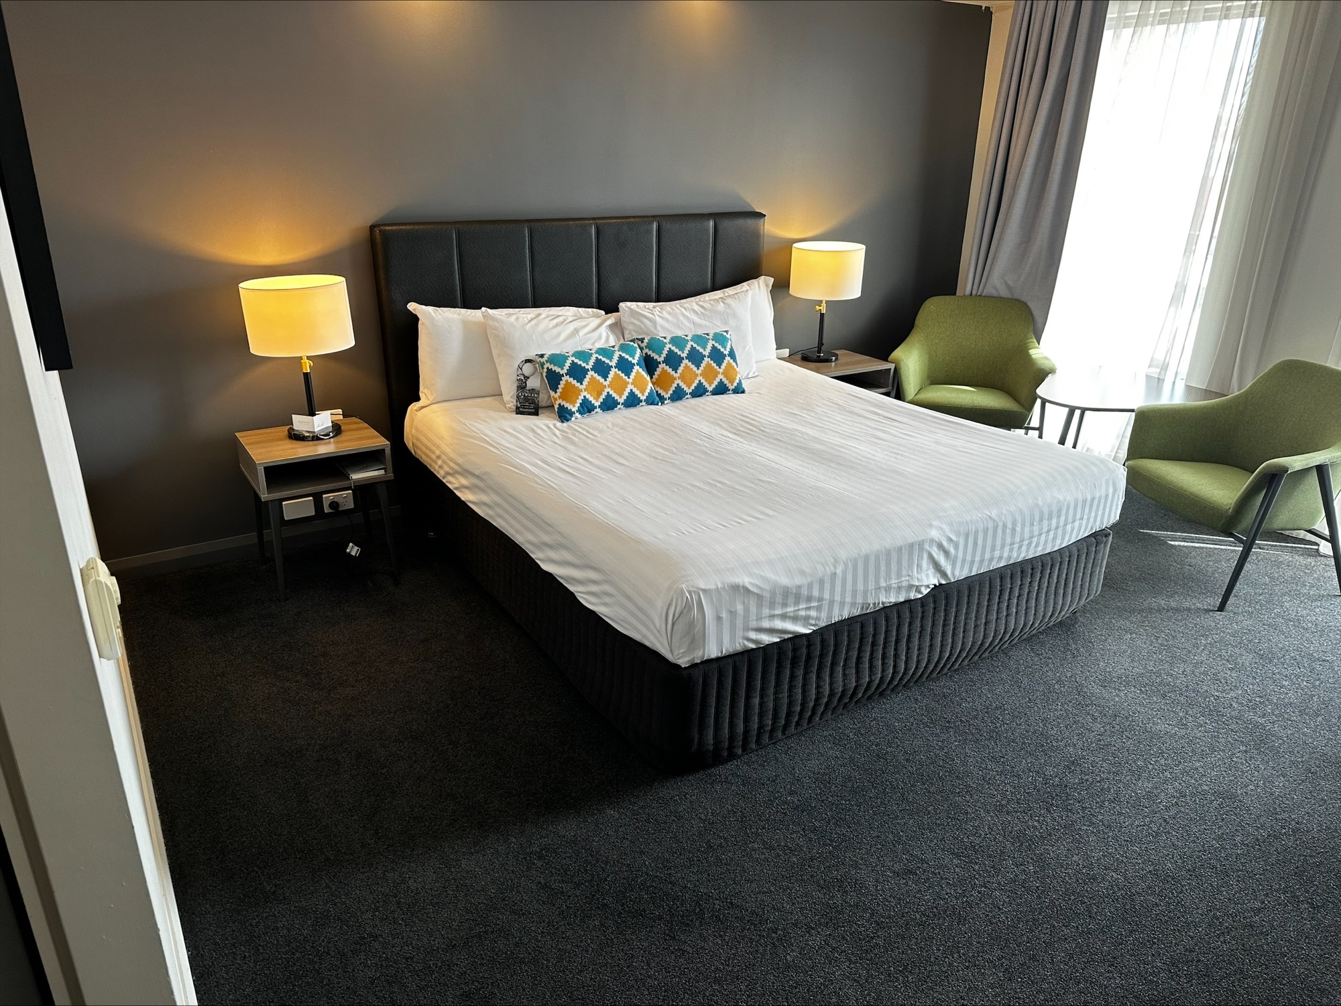
Space Between Walls and Bed 2

Room Amenities
- Lower hanging rails are in wardrobes
- Visual alarm is fitted to the room
- Televisions are equipped with closed captioning capability
- Vibrating alarm clocks
- Room phones have volume control
- There is contrast between the walls, skirtings, floor and furniture
- There is a clear path through the room
- The edges of all furniture and fixtures are rounded
- Wardrobe handles are a contrasting colour to the doors and draws
- Housekeeping procedures instruct staff not to reposition furniture that has been moved
- Doors open fully against the adjoining wall
- There is a clear opening at least 850mm wide
- There luggage racks for at least two suitcases
- There at least one chair with rigid arms
- Wardrobe and drawer handles are easy to grip
- The bedside lamp switch is easy to reach from the bed
- There is at least 850mm clear space beside the bed
- The bed height is no higher than 680mm from the floor
- Blocks are available to put under the bed legs
- The business offers a range of non-allergenic bedding
- Non-allergenic cleaning products are used

Bathrooms
The bathrooms have the following facilities/amenities in place
- All heating appliances and hot water pipes are protected or insulated
- All shower, bath and basin taps are clearly differentiated between hot and cold
- Fixtures and fittings have rounded edges
- The door is at least 850mm wide
- There is a minimum of 850mm beside the toilet
- Handrails are fitted
- There is a minimum of 1400mm of clear space in front of the toilet
- The toilet seat is a contrasting colour to the floor
- The toilet seat is 460mm above the floor
- A range of non-allergenic toiletries are available
- There is a roll-in shower with fold down fixed seat or a shower chair
- There is a portable shower head on flexible hose
- A door is fitted to the shower
- A door is fitted to the showers with an outward swing at minimum width of 900 mm
  - Bathroom Image(s)
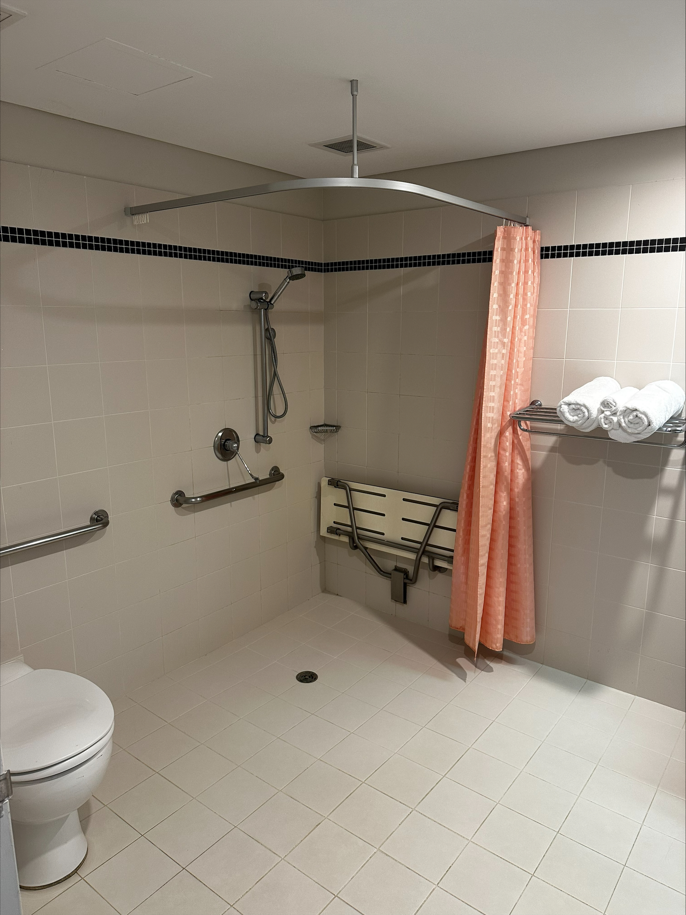
Accessible Toilet in Room 1
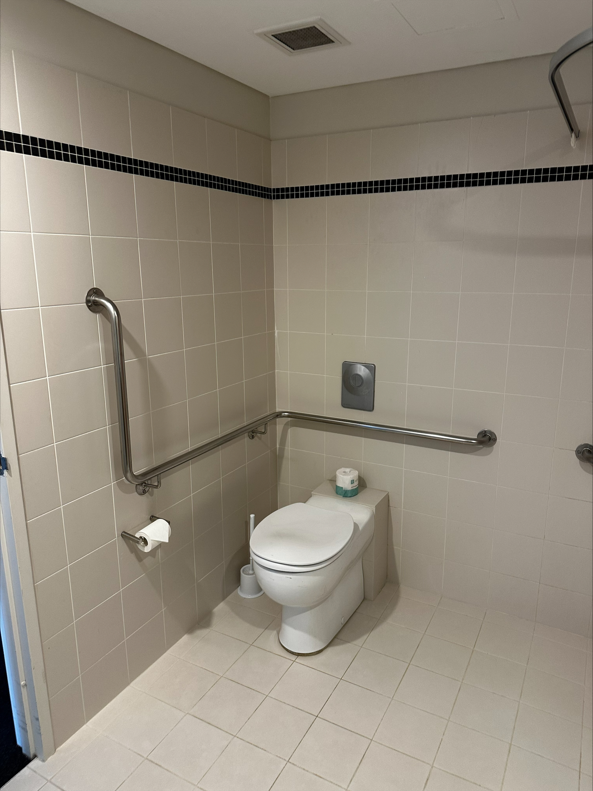
Accessible Toilet in Room 2
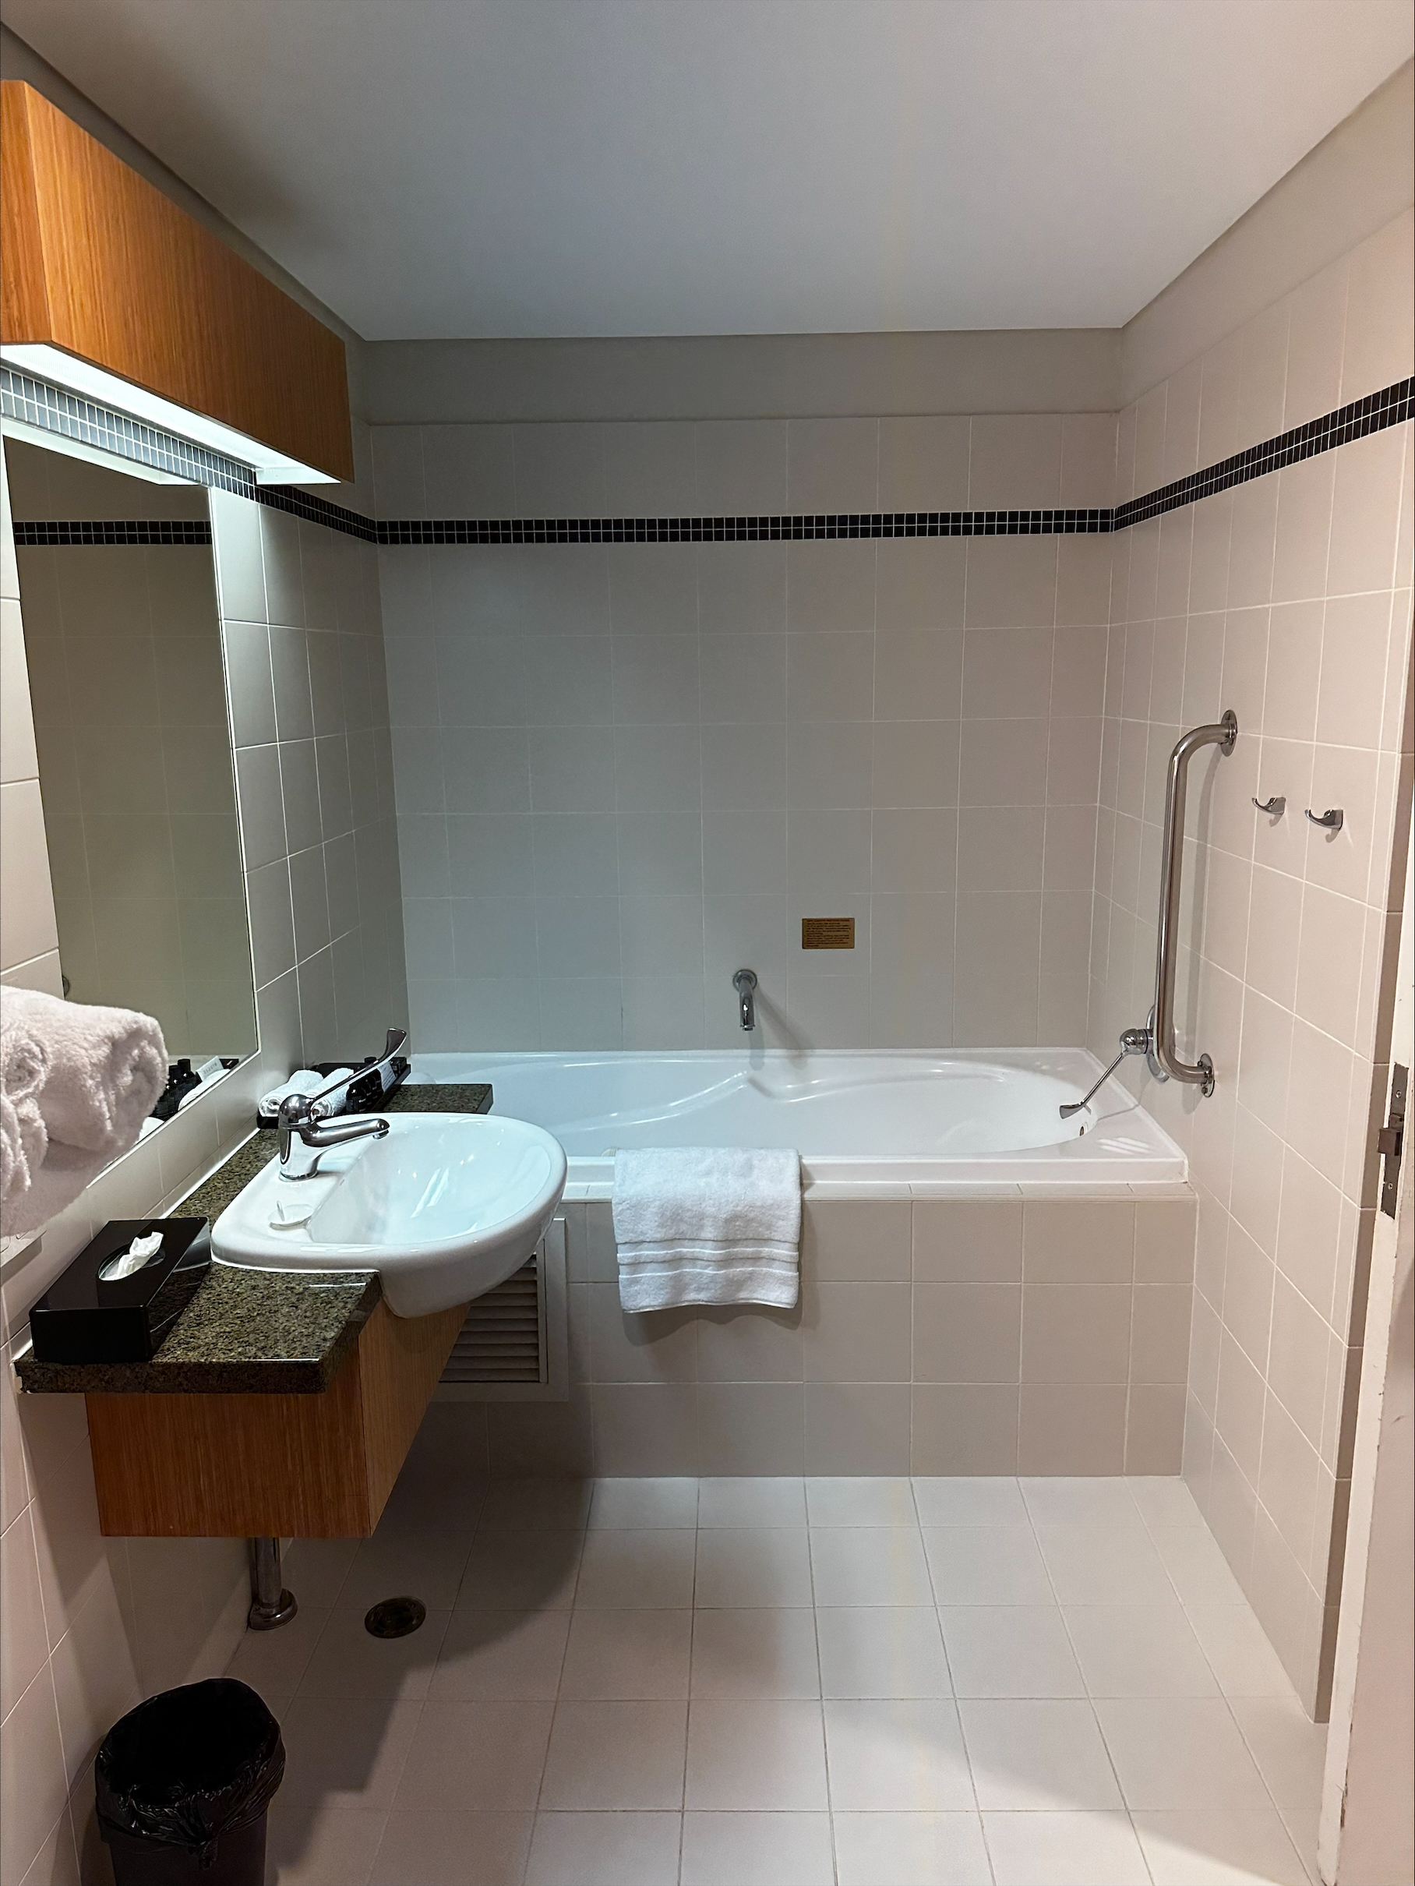
Accessible Toilet in Room 3
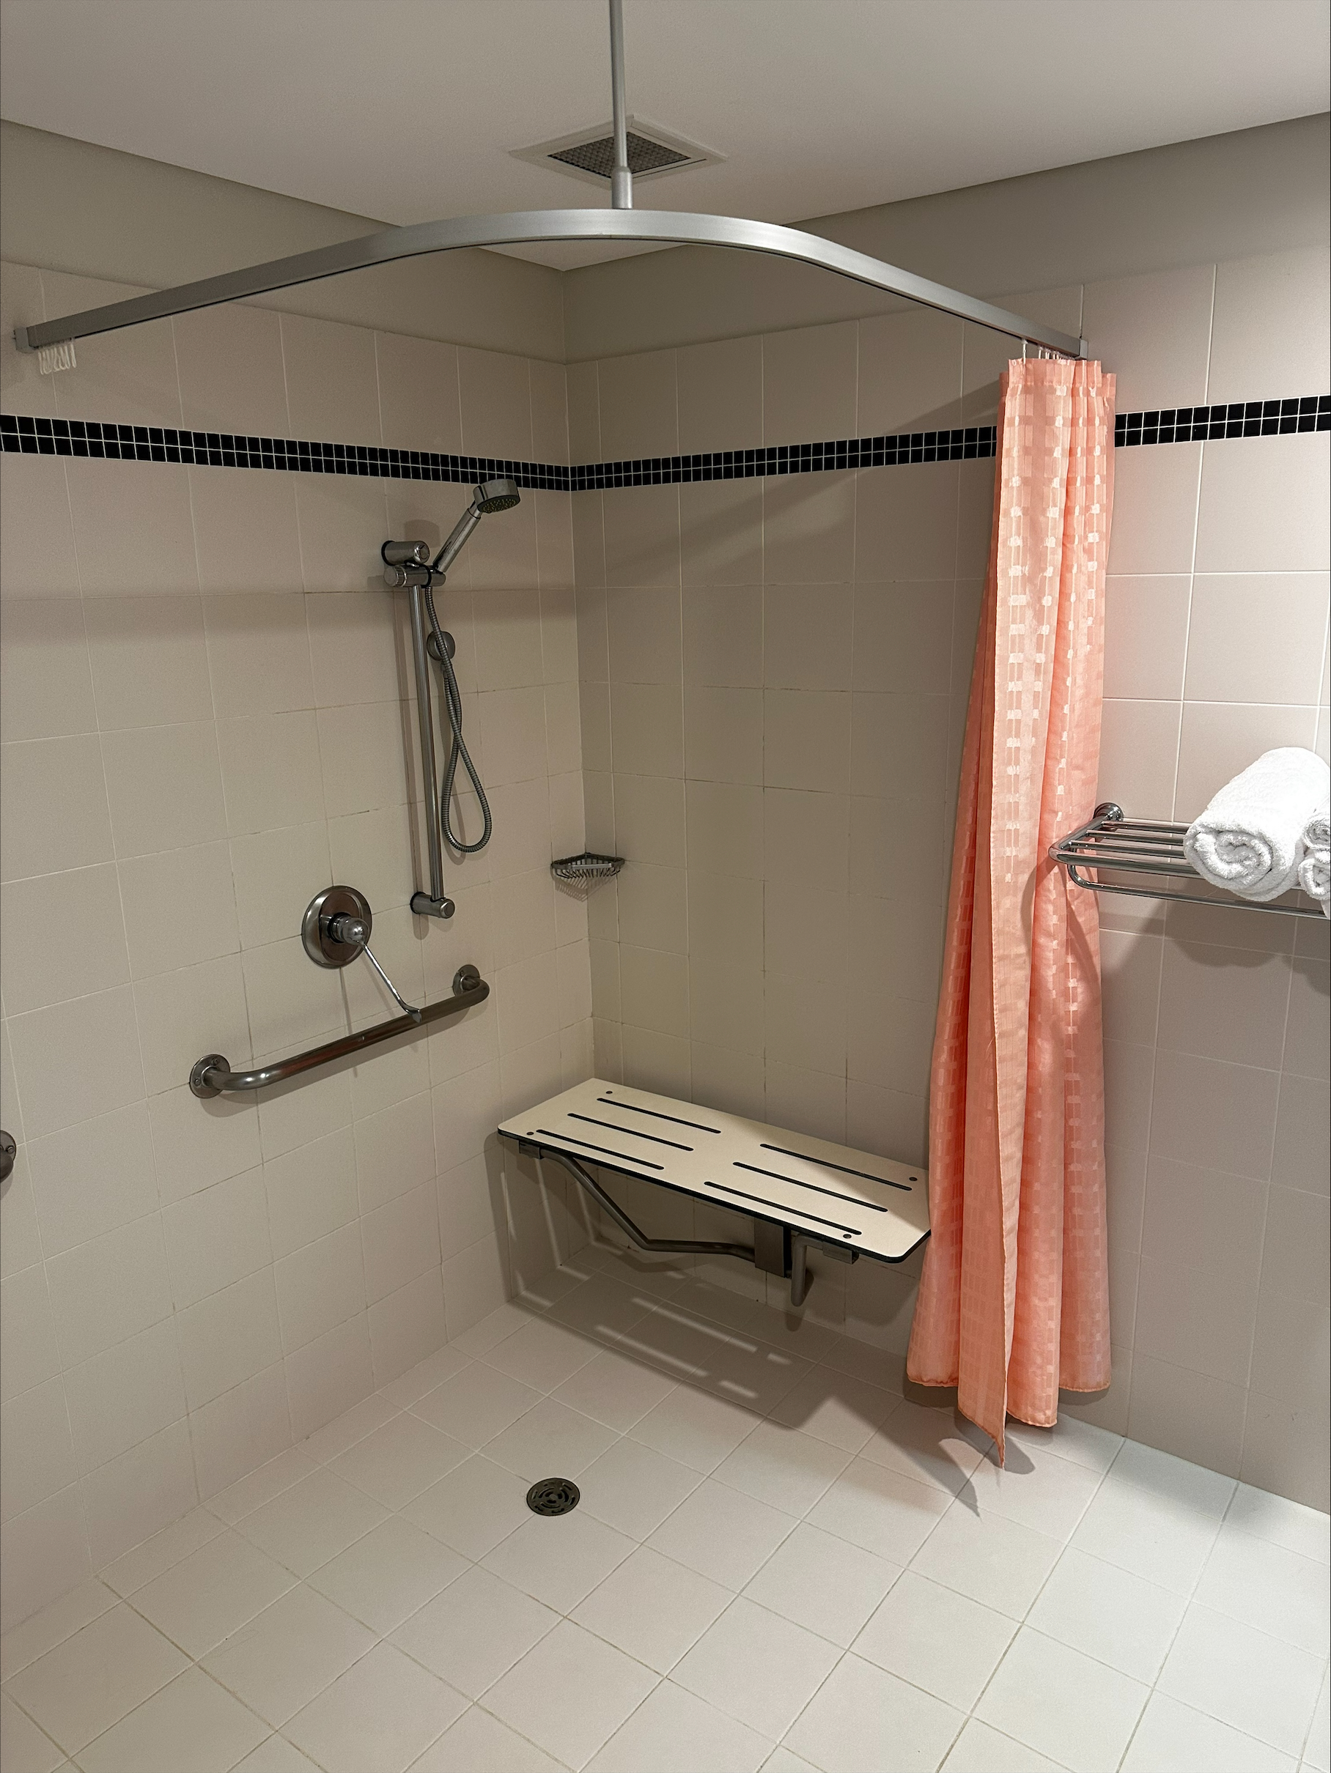
Accessible Toilet in Room 4

ATTRACTIONS
  - Image(s)
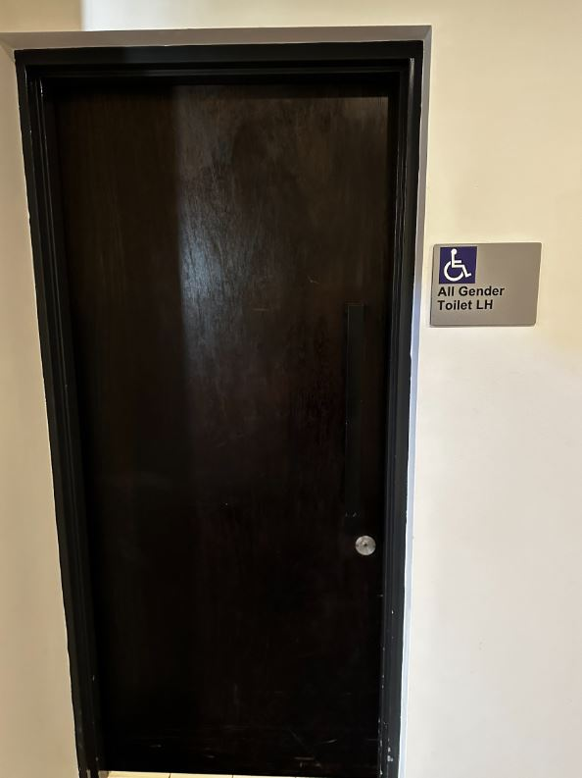
Accessible Public Toilet 2
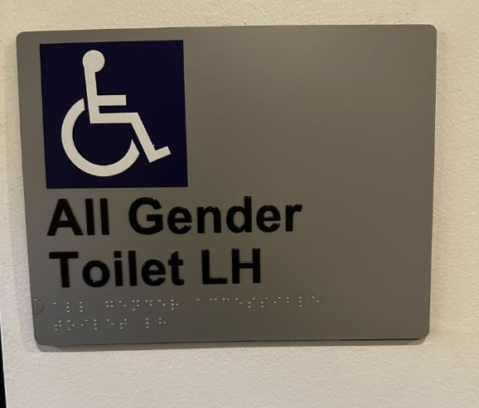
Accessible Public Toilet 3
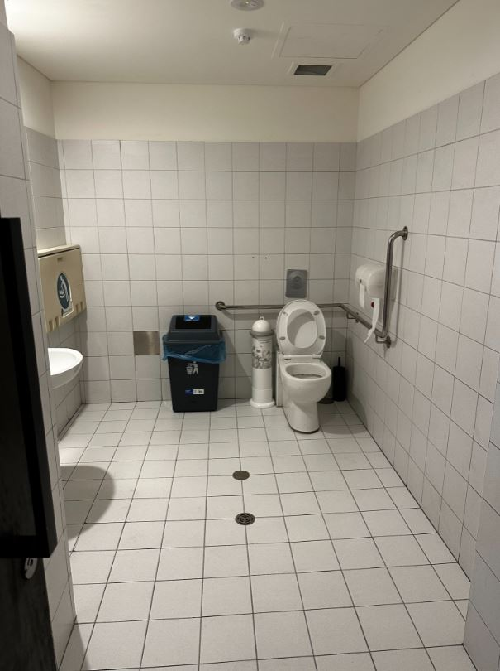
Accessible Public Toilet
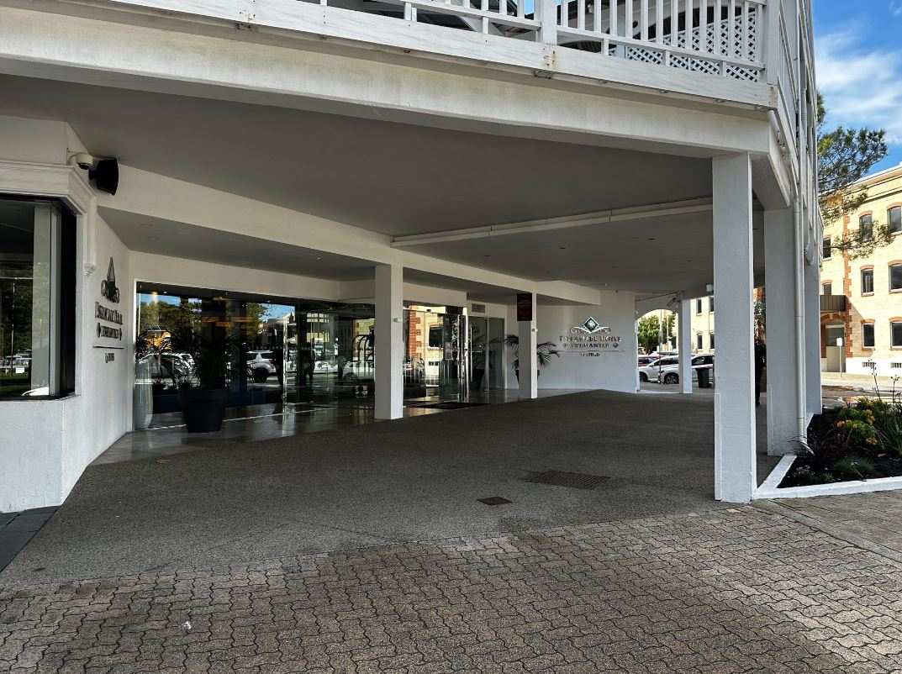
Main Entrance Exterior 1
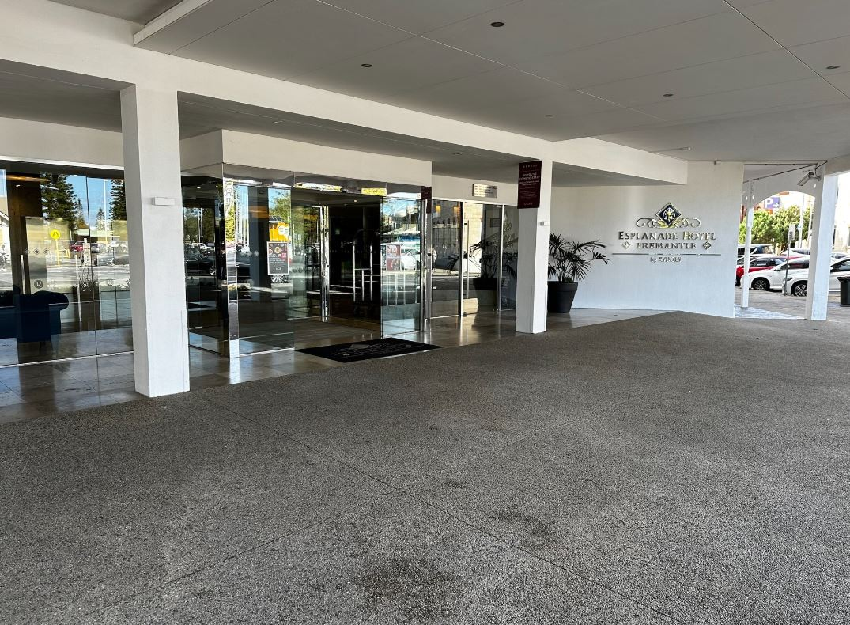
Main Entrance Exterior 2
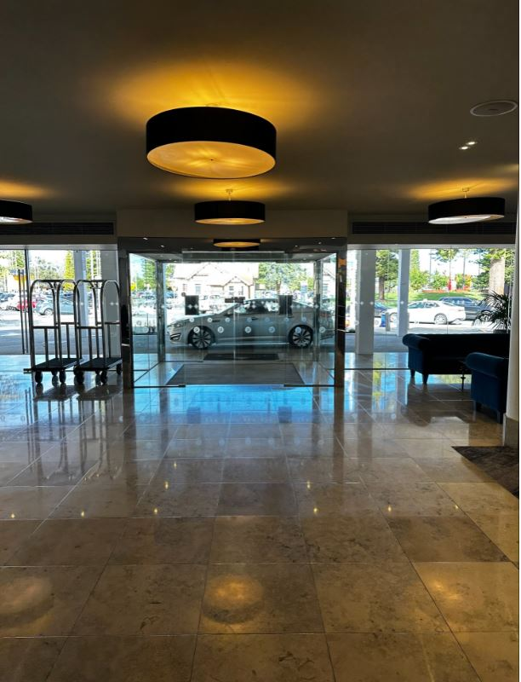
Main Entrance Interior

COMMON AREAS

Swimming pools, spas and waterparks
- The following swimming pools, spas and waterparks amenities are available
- Beach or pool wheelchairs
- Unisex change facilities with an accessible toilet

The following accessible entry methods are available to the pools and spas:
- Sloped/level entry
- Transfer stairs
- Accessible pool stairs (hand rails both sides)
  - Pool Access Image(s)
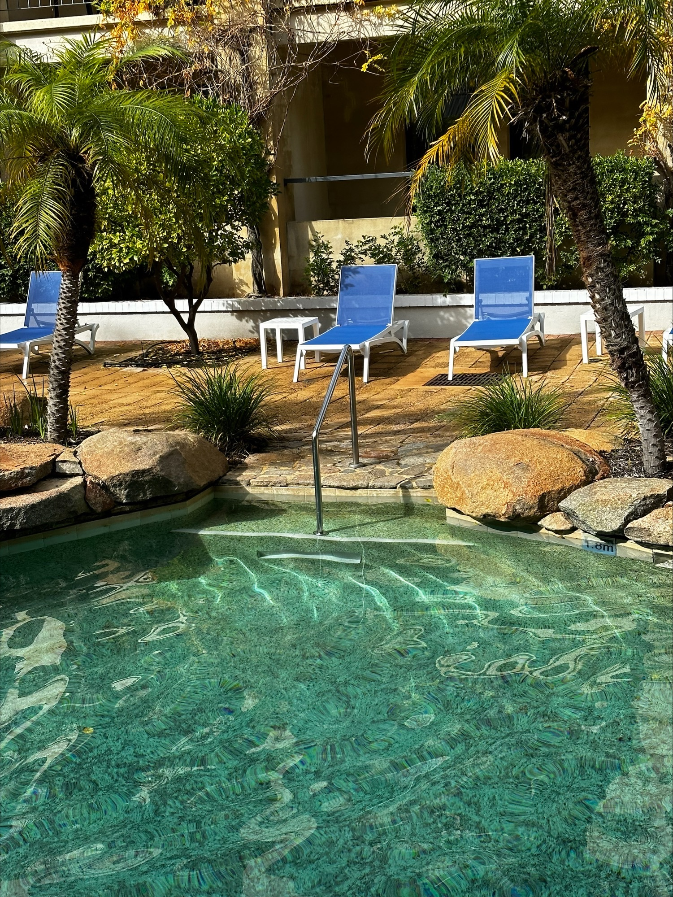
Swimming Pool Area 1
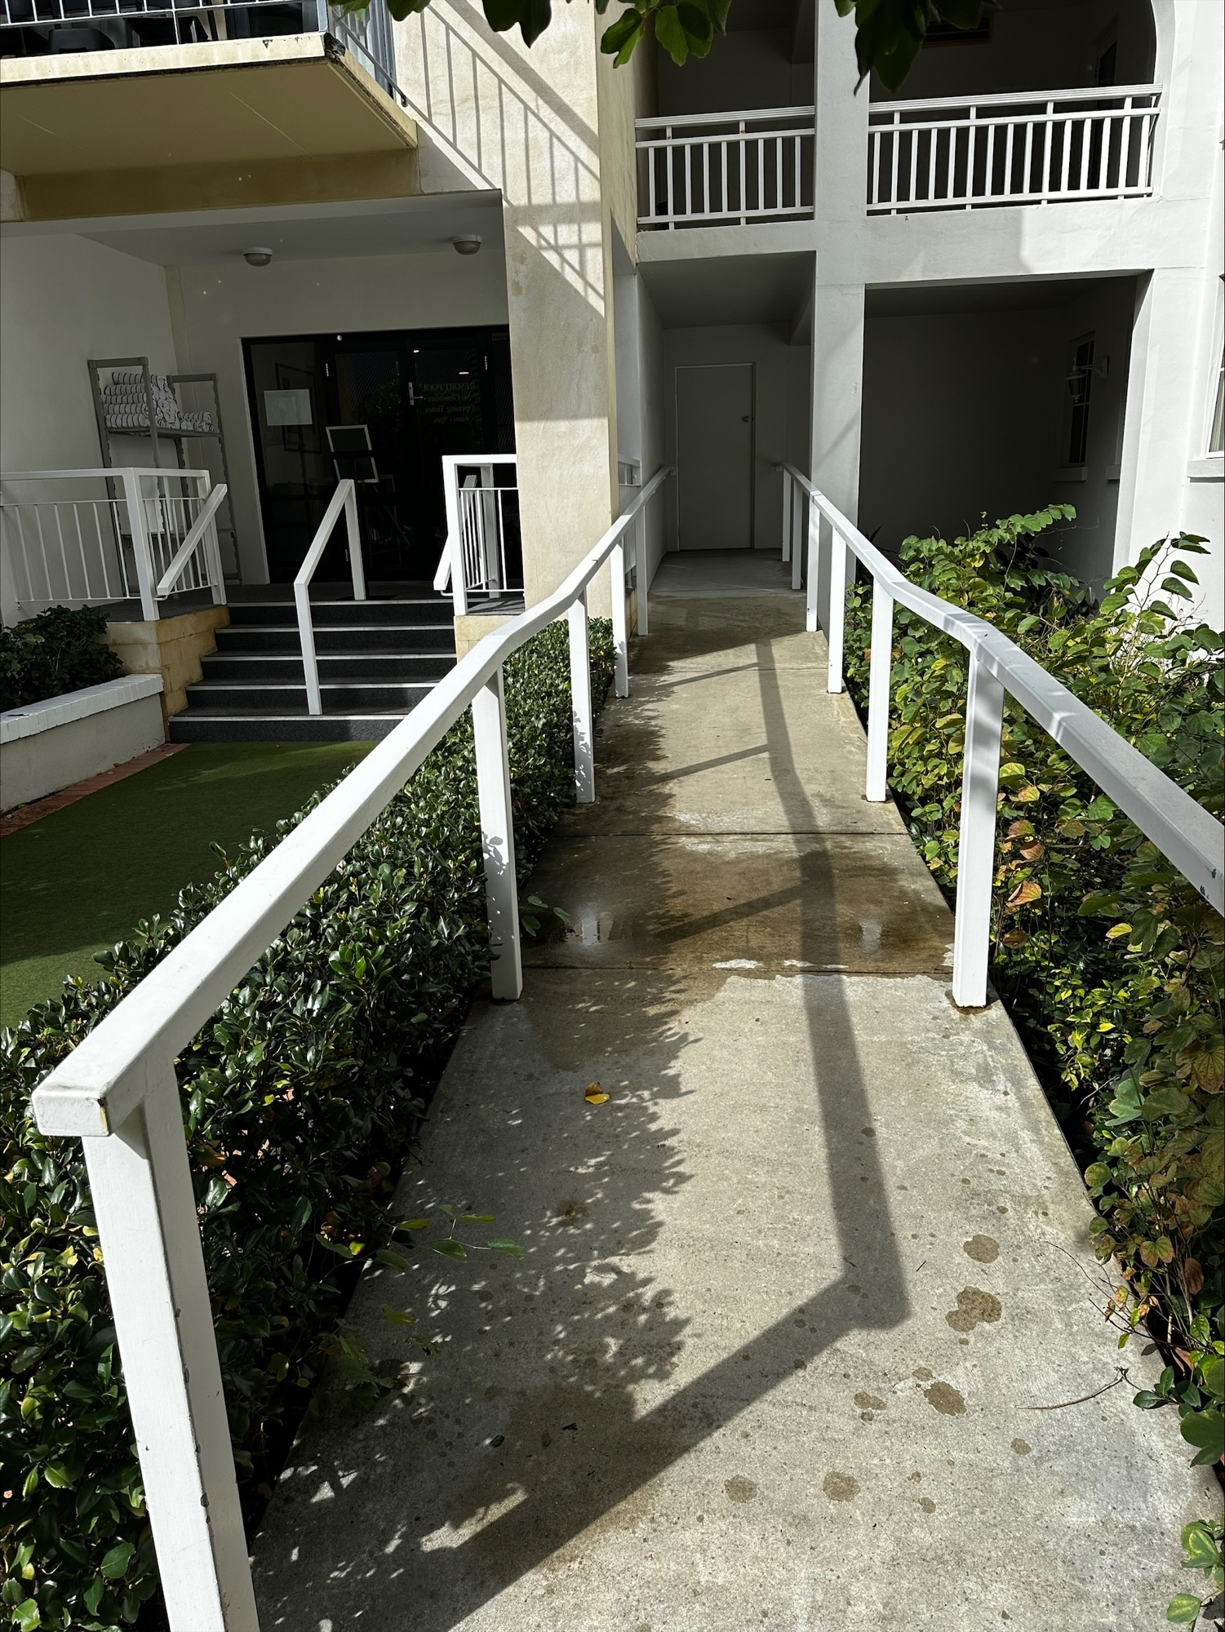
Swimming Pool Area 2
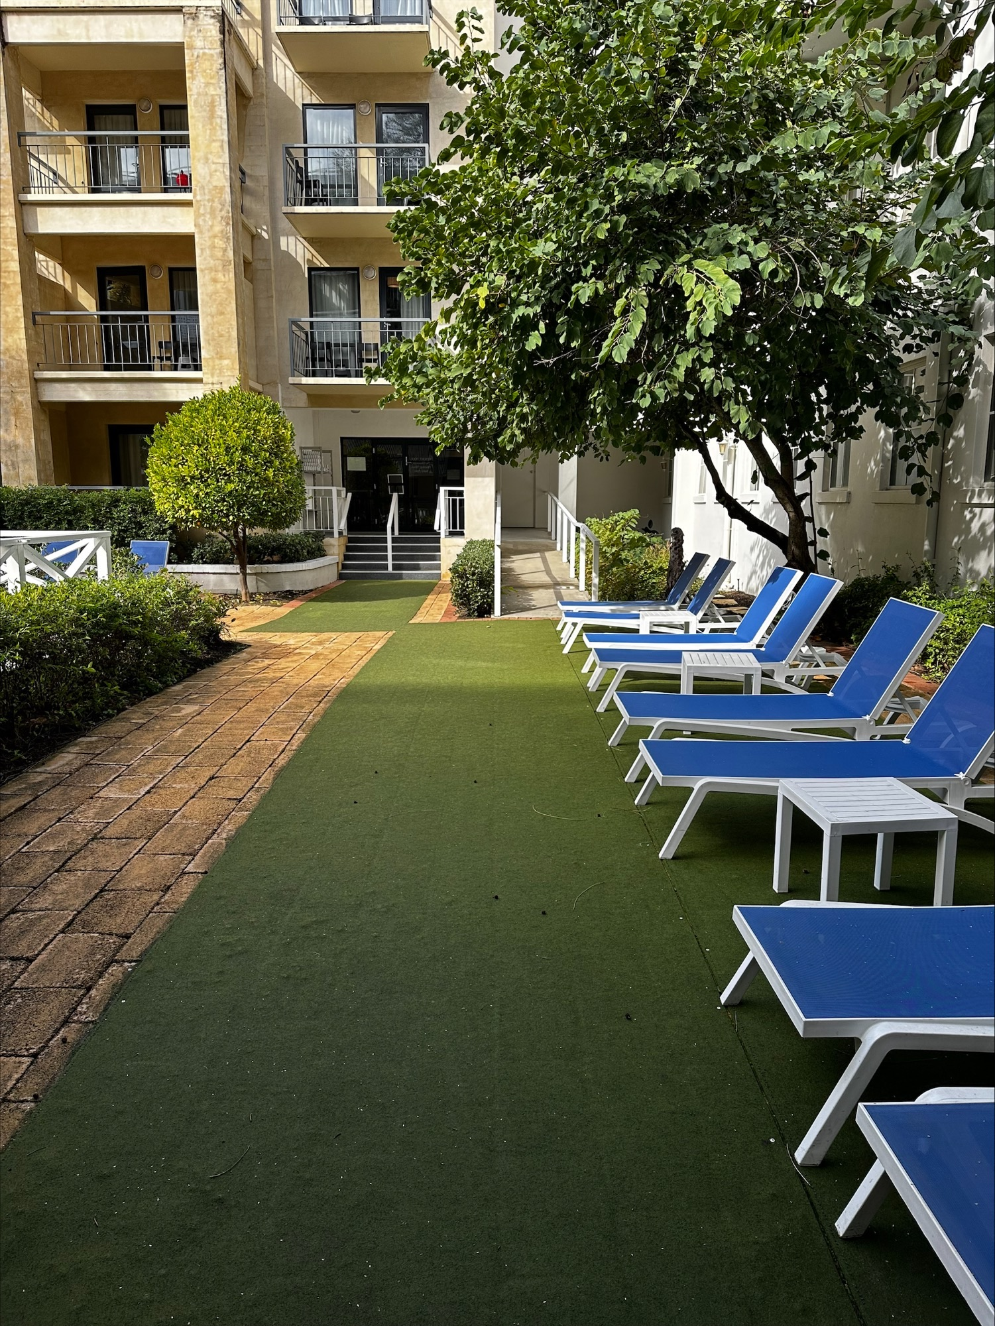
Swimming Pool Area 3
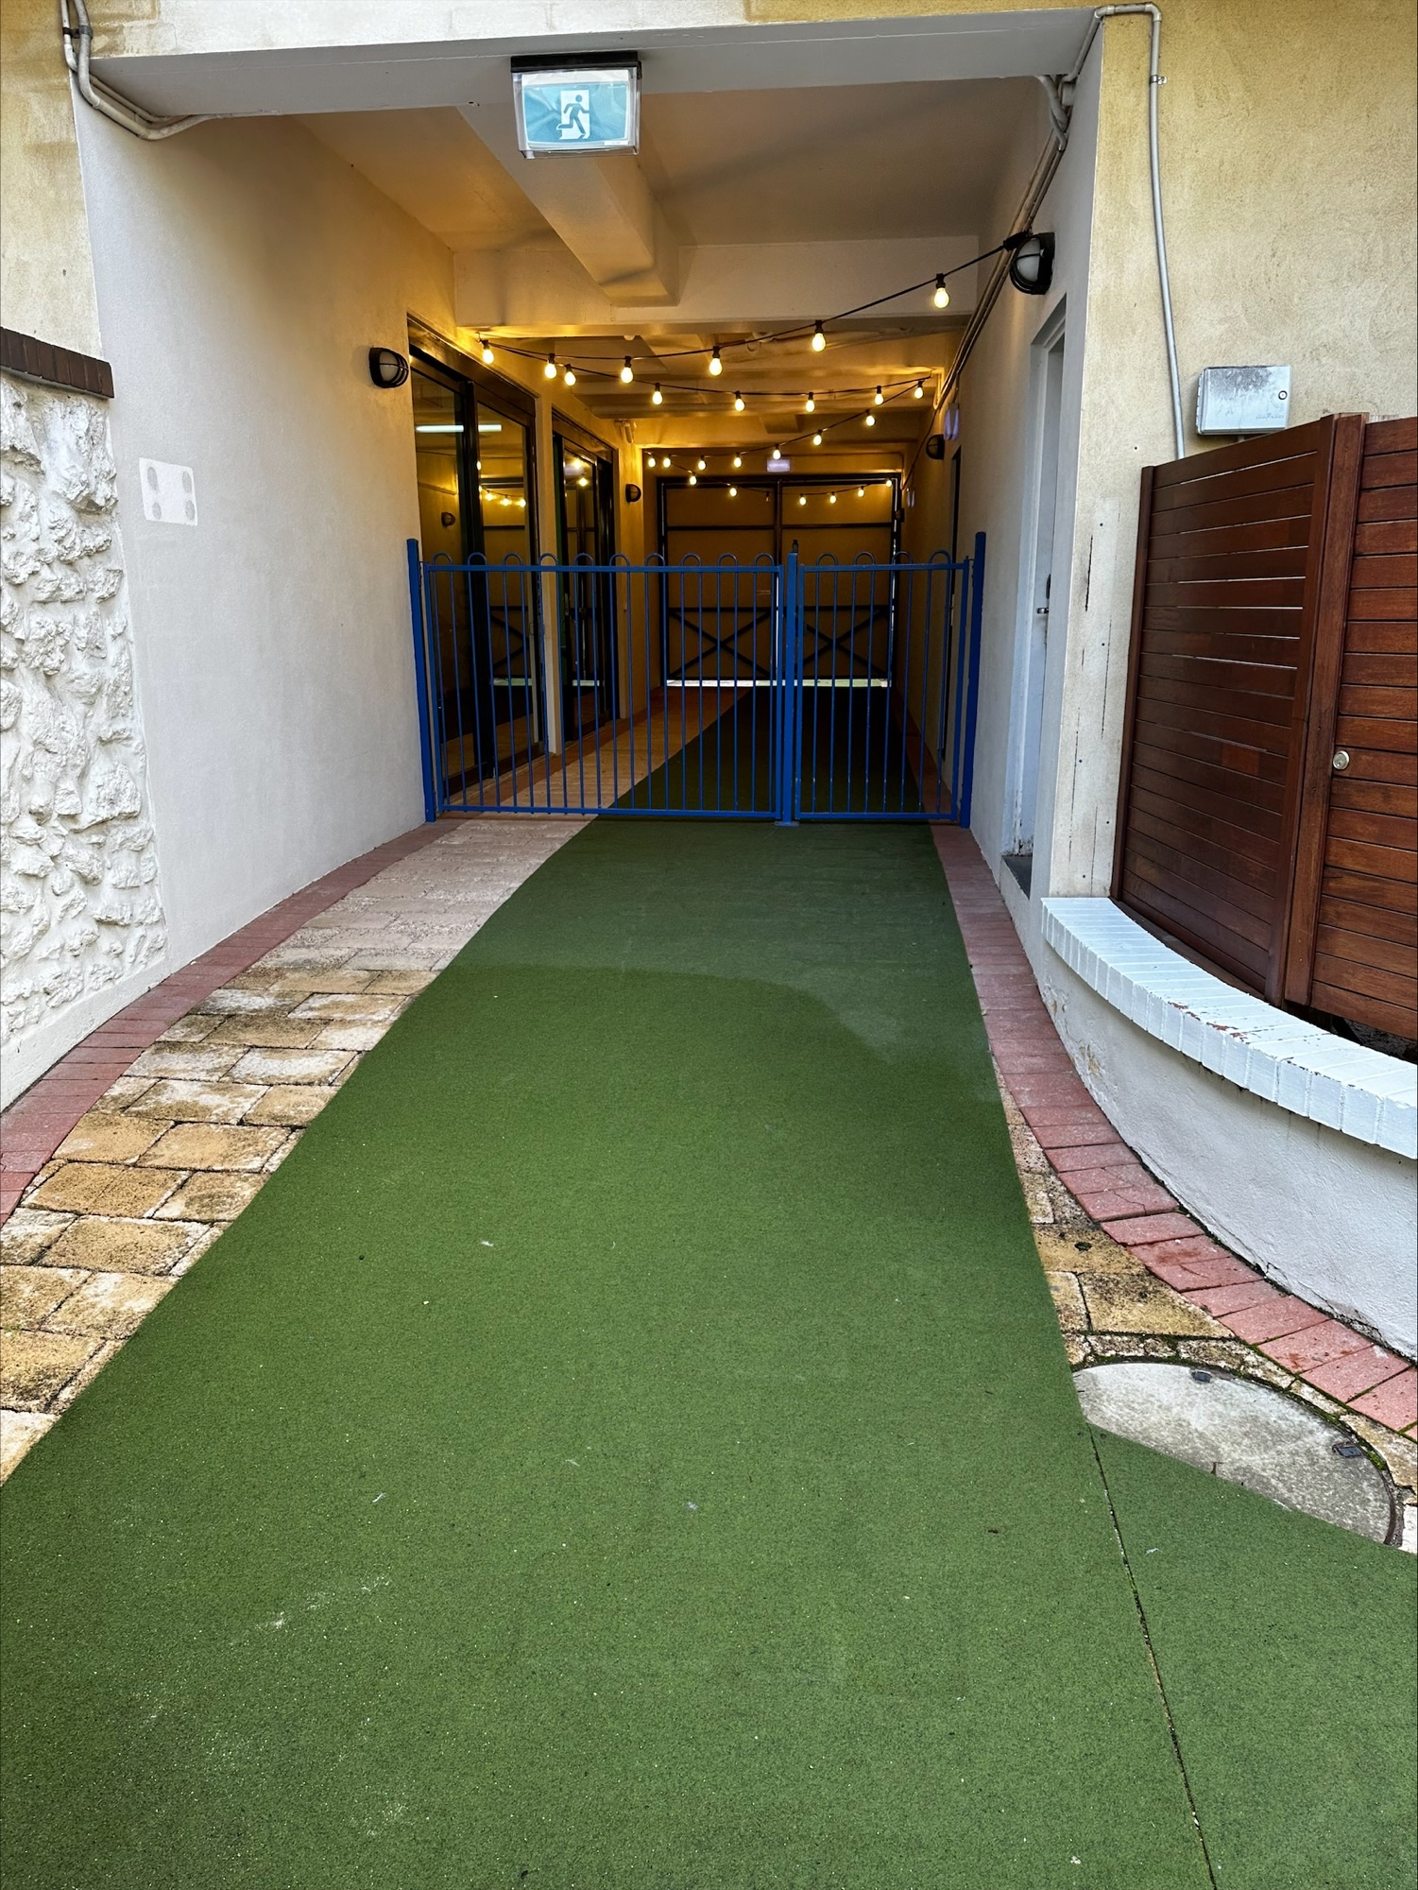
Swimming Pool Area 4
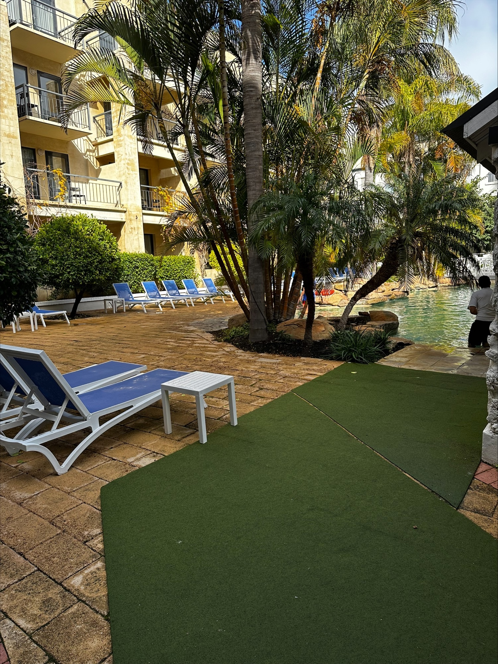
Swimming Pool Area 5

FOOD AND DRINK

Dining Spaces
The dining spaces have the following facilities/amenities in place
- The entrance has level access
- The doorway is at least 850mm wide
- There is level access through the dining area
- Chairs are moveable to allow for wheelchairs to be seated at the tables
- All glass doors and full height windows have contrast markings
- There are areas of full lighting
- There are large print menus
- There are Plain English menus
- There is an accessible toilet

Our business caters for the following dietary requirements
- Sugar free (diabetic)
- Gluten free (celiac)
- Lactose free (dairy free)
- Low fat and fibre with no gastric content
- Low potassium
- Low sodium
- Nut free
- Additive free
- Vegetarian
- Vegan
- Halal
- There are procedures in place to avoid cross-contamination of food products
- There is a sample menu available online
Sample menu is available here - https://cdn.rydges.com/wp-content/uploads/sites/25/2015/10/23155225/MLB-Menu-A-la-Carte-Online-.pdf?_gl=1*1abqnsn*_gcl_aw*R0NMLjE2ODg4OTkzMzcuQ2owS0NRand0YW1sQmhEM0FSSXNBQVJvYUV6ZTVQTFVjMlNPV0ZIQ2FIRFludVBOUE95QlVXQkxCeGdwd2FpN29KcVh0SHJaZWktX1RFNGFBb0xGRUFMd193Y0I.*_gcl_au*MTkxMDEzNDI2MC4xNjg2NTMzMzg2
  - Food and Beverage Image(s)
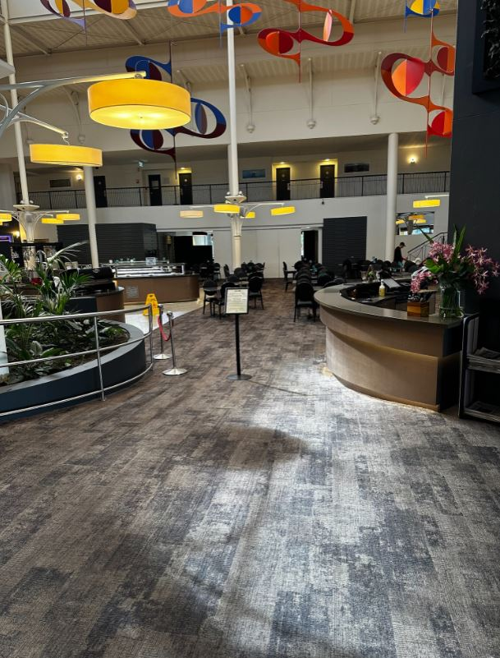
DiningSpaces1
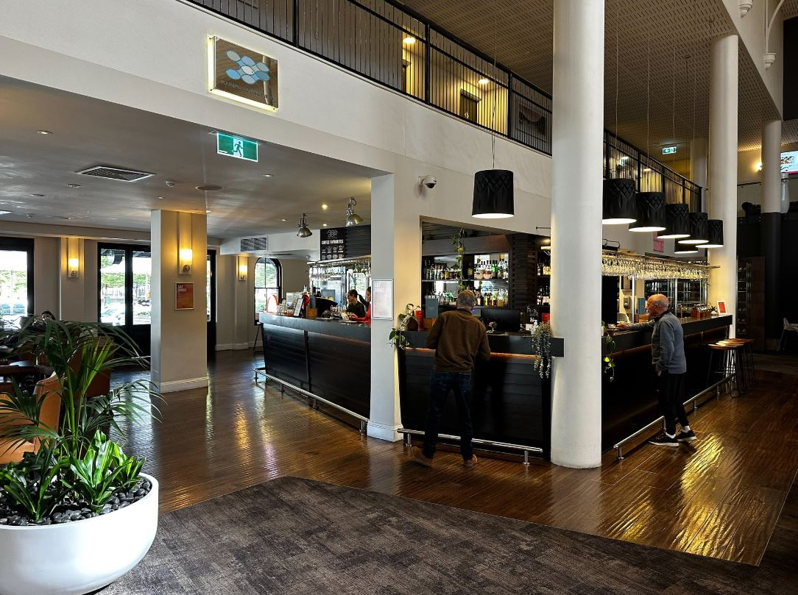
OrderingArea1
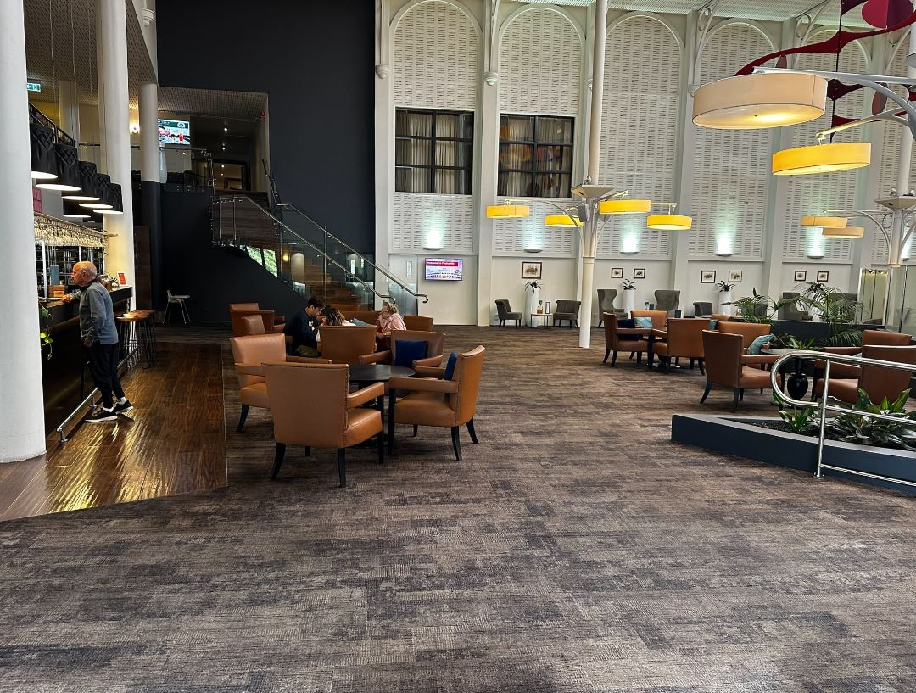
SeatingAreas1

EVENTS

Events
Events have the following facilities/amenities in place
- There is step free access throughout the venue
- All ancillary areas are step free e.g. breakout rooms, dining areas, outside areas and exhibition spaces
- All stage areas including speaker platforms are accessible
- Accessible toilets are available at the venue
- Wheelchair designated seating is provided
- We cater for a range of seating and viewing options
- We cater for varying group sizes
- Audio description is available
- There is good circulation space with the number of people expected to allow people with a disability to move around freely
- Accessible car parking is available
- There are designated drop-off points
- There is accessible public transport to the venue
- The event includes the use of loud noises, fireworks or strobe lighting
- Quiet rooms, marquees or spaces are available

Report Disclaimer
Please note that this business report, provided as a result of the use of the diagnostic assessment, is for information purposes only.
Australian Tourism Industry Council (ATIC) cannot guarantee the accuracy of respondent’s answers, or that they are fully representative of your business. Therefore, ATIC does not warrant or guarantee any particular outcome in respect of your businesses self-assessment.
This report is intended as guidance only for your business and should not be relied on for future marketing considerations. ATIC recommends that you seek your own independent advice as well as the results from the diagnostic.
Links to external web sites are inserted for convenience and do not constitute endorsement of material at those sites, or any associated organisation, product or service.
ATIC does not:
- Assume any legal liability for the accuracy, completeness, or usefulness of any information from this report or any links provided; or
- Accept responsibility for any loss associated directly or indirectly from the use of this report.

