ATIC Accessibility
To support the accessible community in making informed travel decisions for their individual needs

This report prepared for:
Business name: | Scenic Helicopters
Address: | Margaret River Airport
Town: | Margaret River
Contact for enquiries: | Jackson Mcleod
Contact Number: | 0499723642
Contact Email: | bookings@scenichelicopters.com.au
Website: | www.scenichelicopters.com.au
Date: | 2026-10-29 02:55

ATIC Accessibility
The following pages provides travellers with information on the businesses facilities and amenities which aims to support the traveller to make an informed decision on whether the business is suitable for their individual needs.
OVERVIEW 4
Business Overview 4
Bookings 4
Emergency Management 4
Communications 5
Other Information 5
Guide Dog and Service Animals 5
GENERAL 6
Pre-arrival, arrival and reception 6
Cognitive Impairment Support 6
Car Park and Access amenities 6
Displays, exhibits, commentary and live performances 6
External Paths 7
TOUR OPERATORS 8
Guides 8
Report Disclaimer 10

OVERVIEW

Business Overview

The business has the following products/services available
- Tour/Transport

Our business caters for the following disability types:
- Blind or low vision
- Deaf or low hearing
- Limited mobility
- Wheelchairs or mobility scooters
- Food allergies or intolerances
- Cognitive or people on the Autism Spectrum

Bookings

The business offers the following methods for bookings and enquiries:
- Phone
- Email
- Webportal
- Our forms have high contract boxes and submit boxes

Emergency Management
- Emergency and evacuation procedures are explained on arrival
- There are visual device/s to alert occupants to evacuate.
- Exit signs are clear and easy to see
- Exits and access to exists are greater than 900mm
- Exit doors are able to be opened by all occupants
- Exits to the emergency evacuation point does not include stairways
- There is an emergency refuge that has an intercommunication system linked and has sufficient fire resistance levels.
- The evacuation point is clearly marked by a sign
The business identifies guests who need additional assistance should an emergency occur by: This is establshed at time of booking confirmation
The procedure for assisting guests who need assisted rescue is: Guests who need require assistance will be escorted by a carer.
- Guests with disabilities are noted in the guest log book for emergency and evacuation purposes

Communications
- Our business offers the following alternative communication methods
- Plain English
Staff available to assist
- There is easy to read signage and information (e.g. menus and emergency information)

Other Information
- For bookings made onsite, the ticket booth/counter/box office is accessible for people using a wheelchair
- The business accepts the companion card

Guide Dog and Service Animals
- The business provides a secure area with shade and water for service animals
- The business provides a toilet area for service animals
- Bowls, bedding, etc. are provided for service animals
The business provides the following services for services animals: any specific requirements for service animals will be discussed and arranged with guests at time of booking

GENERAL

Pre-arrival, arrival and reception
The business has the following in place to support guests during pre-arrival, arrival and reception
- Booking information and websites are compatible with screen readers
- Information and maps are available in written form
The following steps are in place to ensure that people with fatigue related to their disability are not disadvantaged by long wait times: we have airconditioned seating and refreshments available, and ensure there will be no long wait times or if so, that the guests are advised in advance.

Cognitive Impairment Support
- Documents are available in plain English for people with cognitive impairment (This may include instructions, guides, menus and general information)
- A "social script" guide to your premises or attraction describing the sights, sounds and smells to aid parents/carers prepare visitors in advance
- The 'social script' is available in word and other editable formats
- Quiet periods or early opening times for people on the Autism Spectrum
- A space for parents and children on the Autism Spectrum

Car Park and Access amenities
The business has the following Car Park and Access amenities
- A drop off zone
- Designated disabled parking bays
- Level or ramped access from the car park to the entrance
- The accessible entrance is clearly signed from the parking bay
- Kerb ramps are in place where a pavement or walkway needs to be crossed

Displays, exhibits, commentary and live performances
For displays, exhibits, commentary and live performances the following amenities are in place
- Seating
- Wheelchair accessible spaces/seating

External Paths
External paths of travel
- Surfaces are concrete, asphalt, smooth paving or hard packed fine gravel (max aggregate size 13mm)
- Paths or slopes longer than 15 metres have resting places or seats
- Pathways are wider than 900mm
- There 3 successive steps or less on any path or at any doorway
- Any paths having steps are clearly identified as non-wheelchair accessible
- Step free routes clearly signed

TOUR OPERATORS

Guides
- Use of clear/simple English
- Correct pronunciation for lip readers
- There is a audio description of surroundings
  - Image(s)
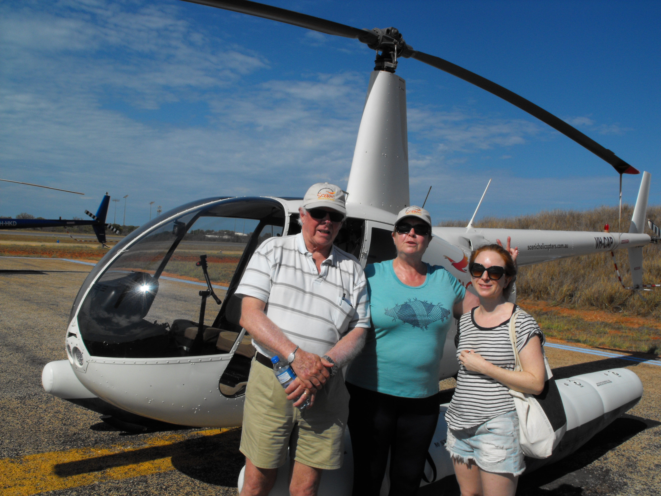
DSCF1011
- In addition, the following further information can assist guests:
We can assist carers if requested to transition guests from wheelchairs into their seat in the helicopter. We will always discuss any queries in relation to this in advance of booking confirmation.

Report Disclaimer
Please note that this business report, provided as a result of the use of the diagnostic assessment, is for information purposes only.
Australian Tourism Industry Council (ATIC) cannot guarantee the accuracy of respondent’s answers, or that they are fully representative of your business. Therefore, ATIC does not warrant or guarantee any particular outcome in respect of your businesses self-assessment.
This report is intended as guidance only for your business and should not be relied on for future marketing considerations. ATIC recommends that you seek your own independent advice as well as the results from the diagnostic.
Links to external web sites are inserted for convenience and do not constitute endorsement of material at those sites, or any associated organisation, product or service.
ATIC does not:
- Assume any legal liability for the accuracy, completeness, or usefulness of any information from this report or any links provided; or
- Accept responsibility for any loss associated directly or indirectly from the use of this report.

