ATIC Accessibility
To support the accessible community in making informed travel decisions for their individual needs

This report prepared for:
Business name: | Mindful in Nature
Address: | ..
Town: | Busselton
Contact for enquiries: | Belinda McCawley
Contact Number: | 0439908249
Contact Email: | belinda@mindfulinnature.com.au
Website: | www.minfulforestbathing.com.au
Date: | 2026-10-11 11:59

ATIC Accessibility
The following pages provides travellers with information on the businesses facilities and amenities which aims to support the traveller to make an informed decision on whether the business is suitable for their individual needs.
OVERVIEW 4
Business Overview 4
Bookings 4
Emergency Management 4
Communications 5
Other Information 5
Guide Dog and Service Animals 5
GENERAL 7
Pre-arrival, arrival and reception 7
Cognitive Impairment Support 7
Car Park and Access amenities 7
External Paths 7
Public Toilets/Adult change facilities 8
TOUR OPERATORS 16
Route Planning 16
Guides 16
Report Disclaimer 19

OVERVIEW

Business Overview

The business has the following products/services available
- Tour/Transport

Our business caters for the following disability types:
- Blind or low vision
- Deaf or low hearing
- Limited mobility
- Wheelchairs or mobility scooters
- Food allergies or intolerances
- Cognitive or people on the Autism Spectrum

Bookings

The business offers the following methods for bookings and enquiries:
- Phone
- Email
- Webportal
- Staff have undergone disability awareness and training

Emergency Management
- The business has an emergency management and evacuation plan for guests with a disability
- Emergency and evacuation procedures are explained on arrival
- Guests with disabilities are noted in the guest log book for emergency and evacuation purposes

Communications
- An accessibility guide is available on the website
https://mindfulforestbathing.com.au/wp-content/uploads/Accessibility-PDF-1.pdf
- Our business offers the following alternative communication methods
- Plain English
- Magnifiers
- There are Picture boards
  - Picture Boards Image(s)
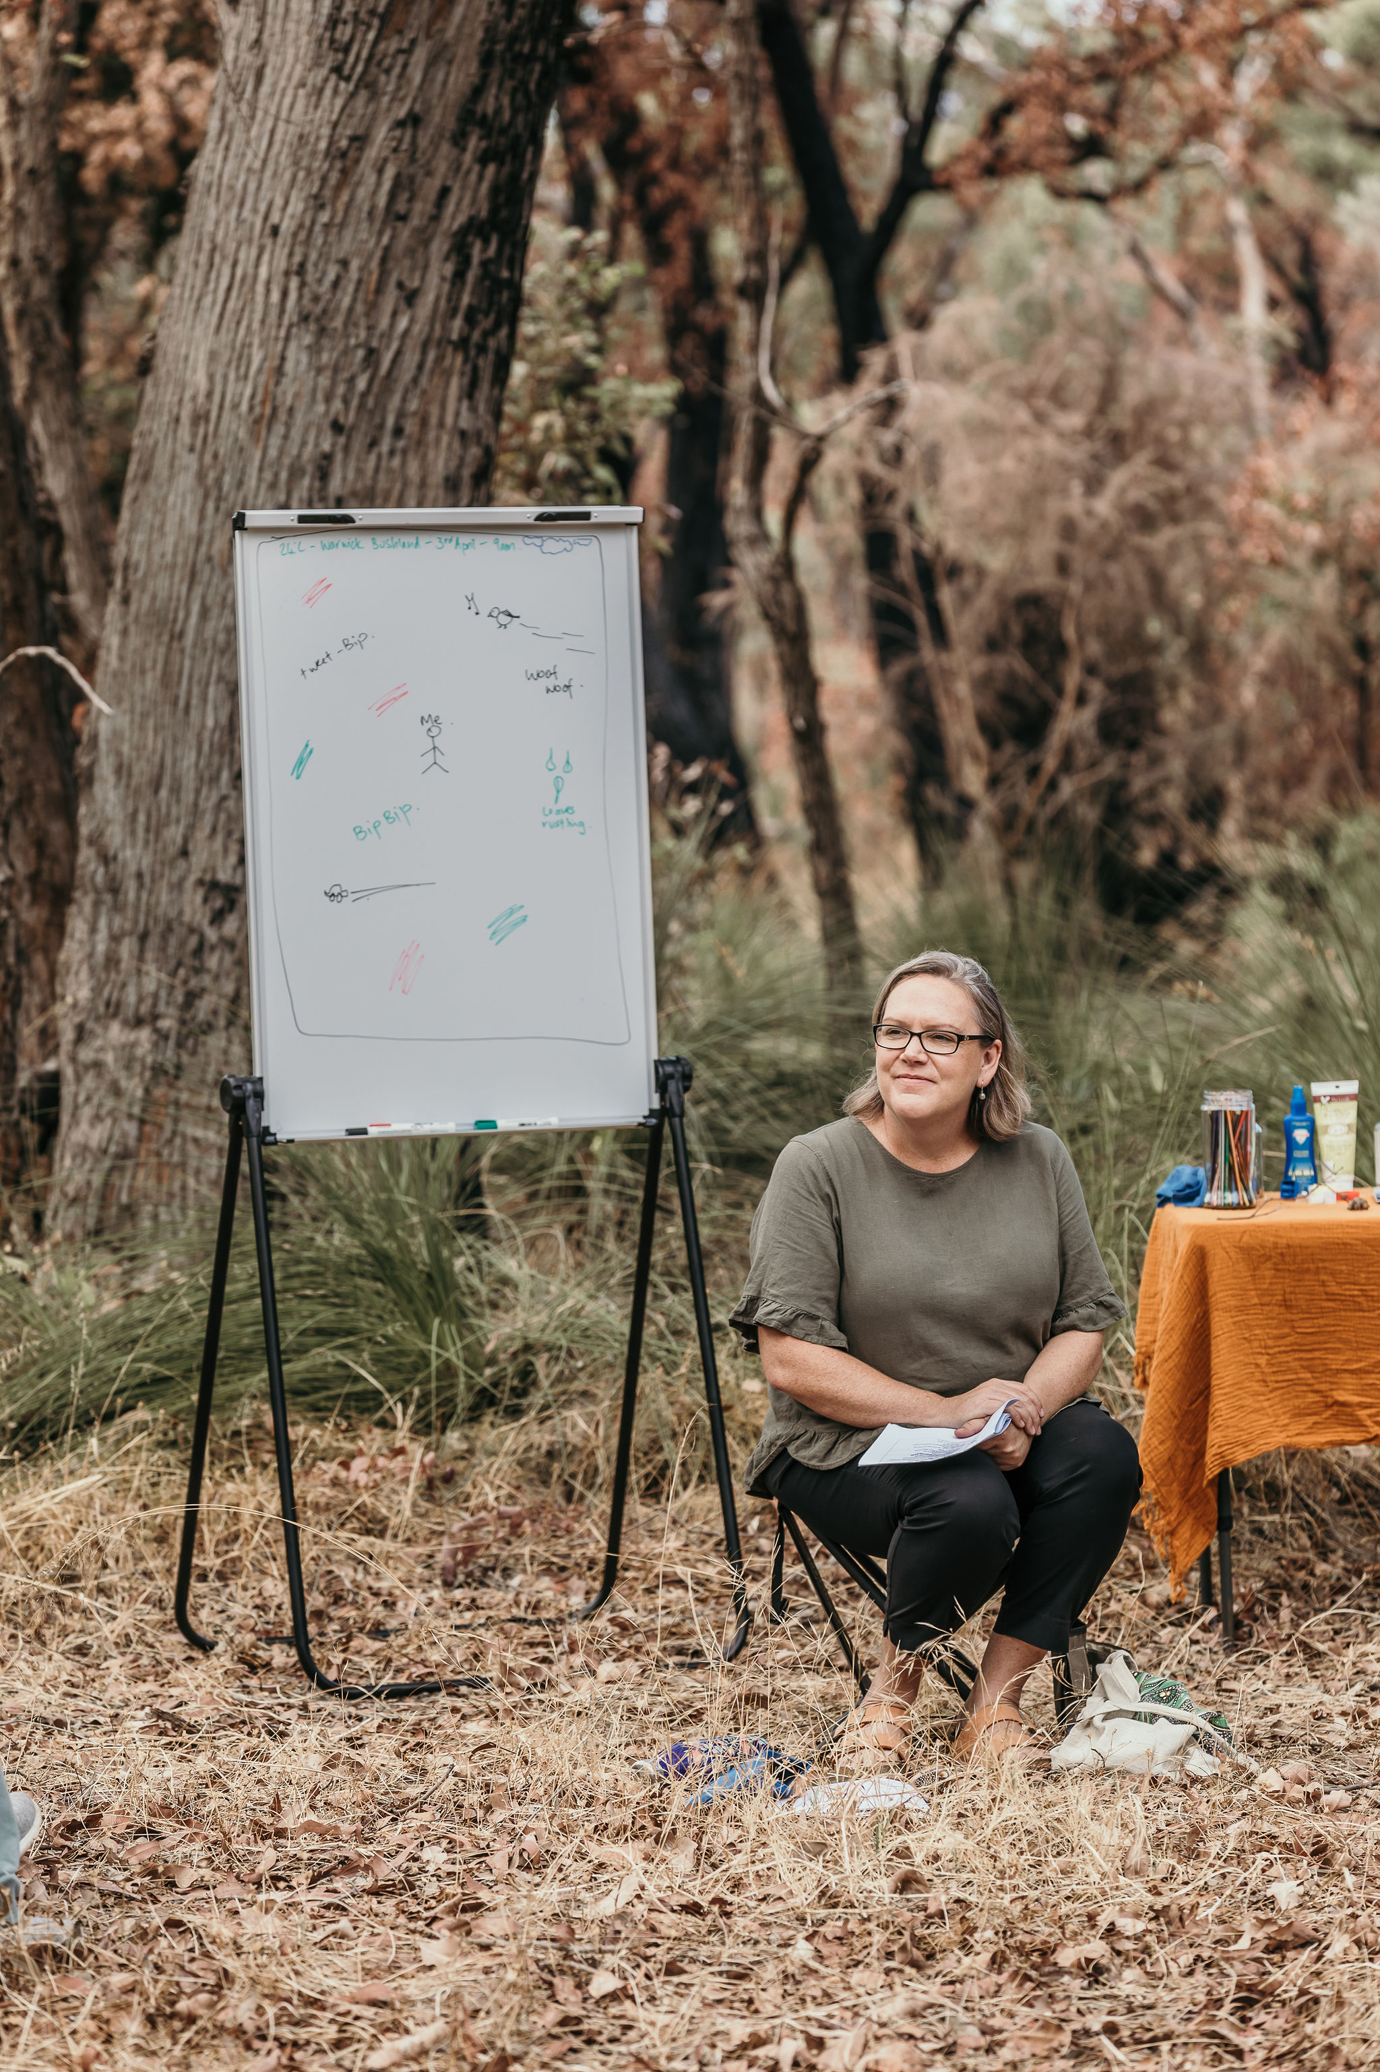
Picture Boards and Alternative Communication
Yes, we use visual communication tools - Ie a whiteboard, nature journals, natural objects, sensory communication. that provide alternative ways of Commnication i.e. pictures, words or numbers.

Other Information
- The business accepts the companion card

Guide Dog and Service Animals
- The business provides a secure area with shade and water for service animals
- The business provides a toilet area for service animals
The business provides the following services for services animals: Mindful in Nature strives to offer a welcoming environment for service animals by ensuring our nature-based workshops and tours are accessible and accommodating. We provide wide paths and rest areas where service animals can comfortably accompany their handlers. Our staff are trained to interact respectfully with service animals, allowing them to participate fully in our activities without disruption. We have clear policies in place to ensure the safety and comfort of service animals throughout their visit, and we welcome feedback to continuously improve our services for all participants, including those with service animals. Please be aware that in some National Parks and natural areas dog baits are present.

GENERAL

Pre-arrival, arrival and reception
The business has the following in place to support guests during pre-arrival, arrival and reception
- Information and maps are available in written form
The following steps are in place to ensure that people with fatigue related to their disability are not disadvantaged by long wait times: Places to sit
- In addition, the following further information can assist guests:
To accommodate individuals with fatigue-related disabilities, we provide quiet seating areas for rest while waiting. Although we don’t anticipate long wait times since experiences are scheduled to start at specific times, these spaces ensure comfort and ease for all participants.

Cognitive Impairment Support
- Documents are available in plain English for people with cognitive impairment (This may include instructions, guides, menus and general information)
- Quiet periods or early opening times for people on the Autism Spectrum
- A space for parents and children on the Autism Spectrum

Car Park and Access amenities
The business has the following Car Park and Access amenities
- A drop off zone
- Designated disabled parking bays
- Level or ramped access from the car park to the entrance
- The accessible entrance is clearly signed from the parking bay
- In addition, the following further information can assist guests:
Accessibility amenities for disabled car bays vary depending on the location. At the Kings Park location, disabled parking bays are available to ensure easy access for all participants.

External Paths
External paths of travel
- Surfaces are concrete, asphalt, smooth paving or hard packed fine gravel (max aggregate size 13mm)
The width of the smallest pathway is: Varies depending on the trail
outdoor paths
- In addition, the following further information can assist guests:
Our paths we use are a combination of sealed and earthen / lawn surfaces. Information on the paths and the suitability of the paths for wheelchairs is provided for each experience.

Public Toilets/Adult change facilities
Public Toilets/Adult change facilities have the following amenities are in place
- There is an accessible toilet for public use
- The door is at least 850mm wide
- There is a minimum of 850mm beside the toilet
- Handrails are fitted
- The toilet seat is 460mm above the floor
- There is 1400mm mm of clear space in front of the toilet
- The toilet seat of a contrasting colour to the floor
- The toilet seat is460mm above the floor
- In addition, the following further information can assist guests:
At Mindful in Nature, we endeavor to create experiences where accessible bathroom facilities are available, ensuring comfort and inclusivity for all participants.

TOUR OPERATORS

Route Planning
- Walking Tours
- Operated on a step free route
- Multi-paced to account for slower walkers
- Hearing aid compatible

Guides

Guides have been trained in the following
- Use of clear/simple English
- Correct pronunciation for lip readers
  - Image(s)
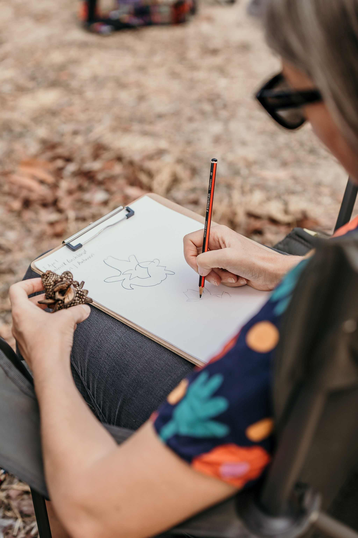
Alternative Communication
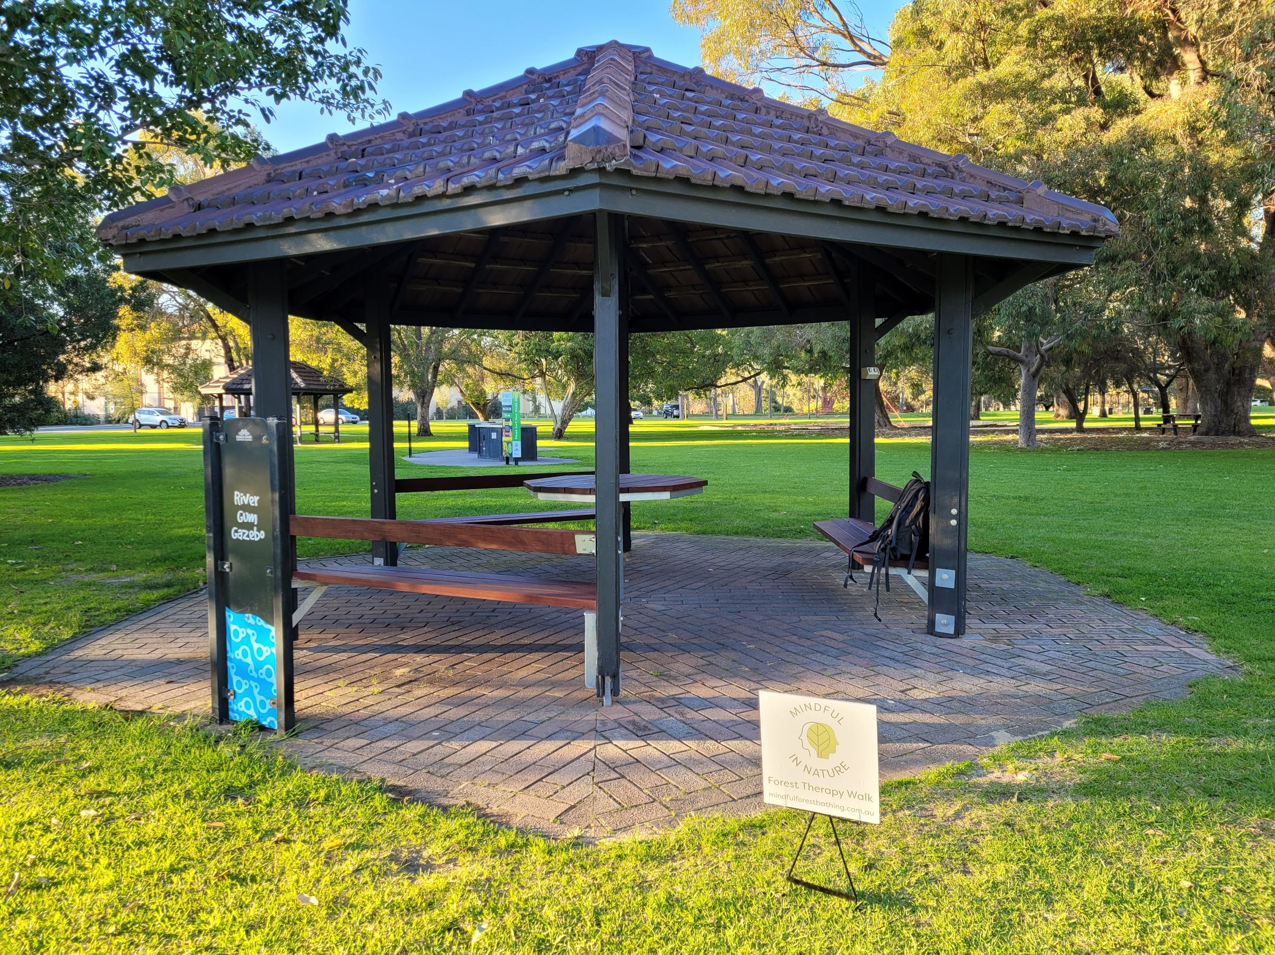
Meeting Point
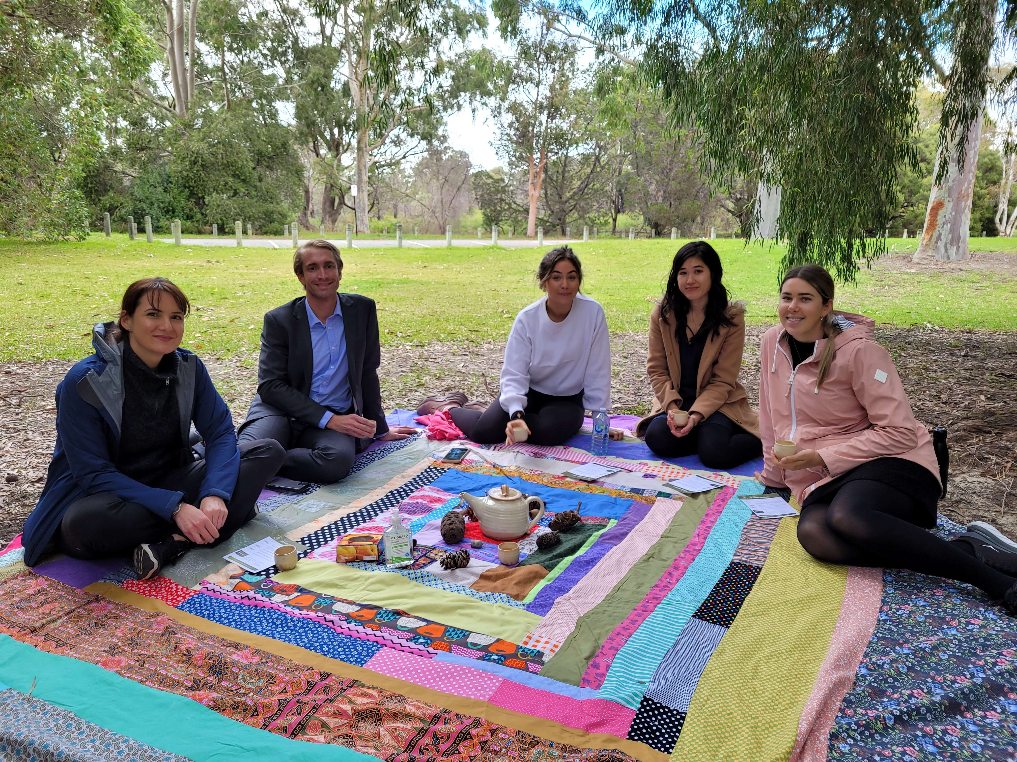
Resting Areas
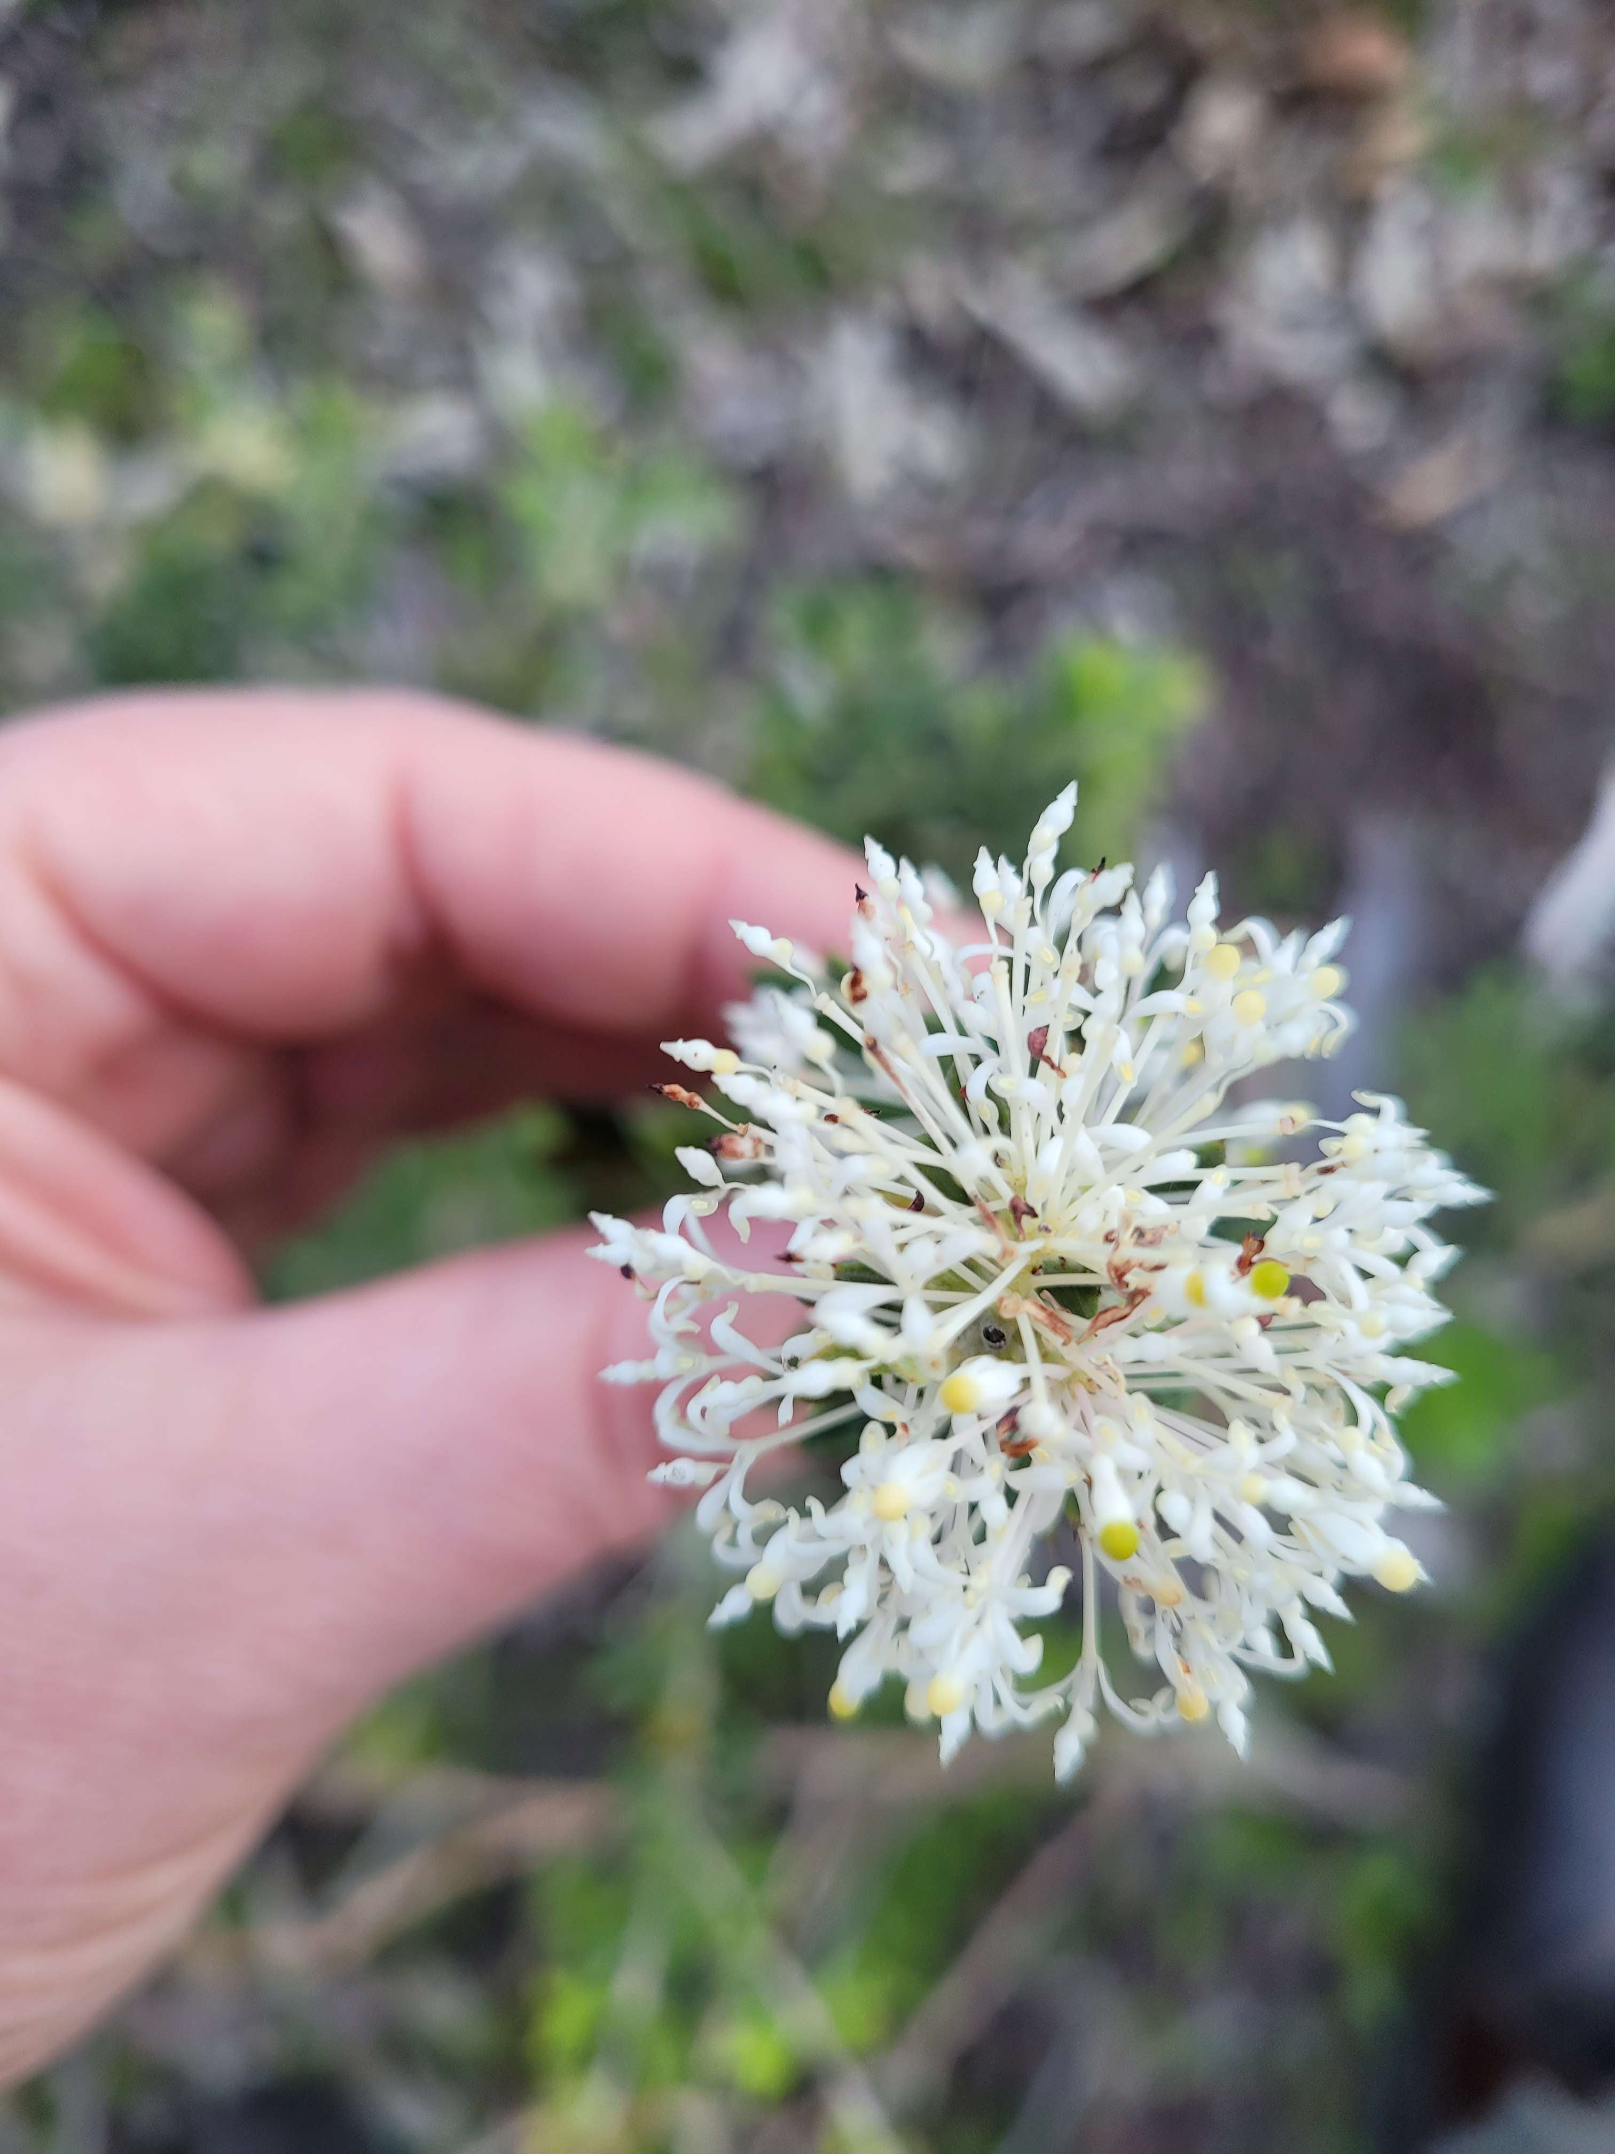
Sensory Activities

Report Disclaimer
Please note that this business report, provided as a result of the use of the diagnostic assessment, is for information purposes only.
Australian Tourism Industry Council (ATIC) cannot guarantee the accuracy of respondent’s answers, or that they are fully representative of your business. Therefore, ATIC does not warrant or guarantee any particular outcome in respect of your businesses self-assessment.
This report is intended as guidance only for your business and should not be relied on for future marketing considerations. ATIC recommends that you seek your own independent advice as well as the results from the diagnostic.
Links to external web sites are inserted for convenience and do not constitute endorsement of material at those sites, or any associated organisation, product or service.
ATIC does not:
- Assume any legal liability for the accuracy, completeness, or usefulness of any information from this report or any links provided; or
- Accept responsibility for any loss associated directly or indirectly from the use of this report.

