ATIC Accessibility
To support the accessible community in making informed travel decisions for their individual needs

This report prepared for:
Business name: | Royal Flying Doctor Service Darwin Tourist Facility
Address: | 45 Stokes Hill Road
Town: | Darwin
Contact for enquiries: | Emmalee Tranebo
Contact Number: | 0889535702
Contact Email: | RFDSDarwin@flyingdoctor.net
Website: | https://www.rfdsdarwin.com.au/
Date: | 2026-09-21 19:57

ATIC Accessibility
The following pages provides travellers with information on the businesses facilities and amenities which aims to support the traveller to make an informed decision on whether the business is suitable for their individual needs.
OVERVIEW 4
Business Overview 4
Bookings 4
Emergency Management 4
Communications 4
Other Information 5
Guide Dog and Service Animals 5
GENERAL 6
Pre-arrival, arrival and reception 6
Car Park and Access amenities 6
Entry 6
Internal Spaces 7
Public areas 7
Displays, exhibits, commentary and live performances 7
External Paths 7
Ramps 8
Public Toilets/Adult change facilities 8
ATTRACTIONS 9
COMMON AREAS 17
Report Disclaimer 19

OVERVIEW

Business Overview

The business has the following products/services available
- Attraction

Our business caters for the following disability types:
- Limited mobility
- Wheelchairs or mobility scooters

Bookings

The business offers the following methods for bookings and enquiries:
- Phone
- Email
- Webportal
- Staff have undergone disability awareness and training

Emergency Management
- The business has an emergency management and evacuation plan for guests with a disability
- Emergency and evacuation procedures are explained on arrival
We ensure exit access is free and clear at all times by: adhering to WHS requirements and staff training. Our attraction is planned to keep the areas free and clear at all times.
- Guests with disabilities are noted in the guest log book for emergency and evacuation purposes

Communications
- An accessibility guide is available on the website
https://www.rfdsdarwin.com.au/

Other Information
- For bookings made onsite, the ticket booth/counter/box office is accessible for people using a wheelchair
- The business accepts the companion card

Guide Dog and Service Animals
- The business provides a secure area with shade and water for service animals
The business provides the following services for services animals: No extra services other than airconditioned facility, water can be provided if requested

GENERAL

Pre-arrival, arrival and reception
The business has the following in place to support guests during pre-arrival, arrival and reception
- There is a reception/public entryway.
- Seating available at reception
- A lower counter at reception/ticket office
- A clipboard to allow check-in/ticket purchase whilst seated
- Lighting in the reception area is even and glare free
- Information and maps are available in written form
- A familiarisation tour
accessible toilet is not locked
The following steps are in place to ensure that people with fatigue related to their disability are not disadvantaged by long wait times: There are seats in the reception area to rest and is requested the RFDS team member can call the person to the front desk when it is their place in the queue. We also have a wheelchair available for customers that may tire easily.

Car Park and Access amenities
The business has the following Car Park and Access amenities
- A drop off zone
- Designated disabled parking bays
- Level or ramped access from the car park to the entrance
- The accessible entrance is clearly signed from the parking bay

Entry
The business has the following amenities/systems in place for entry
- A drop off point close to the entrance
- A path of access to the building is slip resistance and even
- A path of access to the building is clear of obstruction
- Self opening entry doors or fitted with a self closer
- Glass doors are fitted with a visual sighting strip
- Door jams/doors are of a contrasting colour to surrounding walls
- Door handles are of a contrasting colour to the door
- Signage is written in a contrasting colour
- Signage is written in a Sans Serif font and use upper and lower case letters
- The entry door is a minimum of 850mm wide
- The entry door has self opening or a light opening pressure (for manual operations)
- The entrance sill is less than 13mm
- There a clear space of at least 1500mm x 1500mm in front of all doors.
- The entrance door mats have a thickness less than 13mm and a width of 7500mm or greater

Internal Spaces
- Clear and unobstructed routes through and between buildings
- Interior walls are matte or low sheen
- Floors, walls, counters and furniture are of contrasting colours
- Any protruding or overhanging obstructions are at least 2meters above the floor or are protected
- Floor surfaces are hard or short pile carpet
- Seating is available for guests unable to stand for long periods
- Accessible facilities are clearly signed and visible from all areas
- All corridors greater than 900mm

Public areas
The public areas have the following amenities in place
- Even lighting
- Seating

Displays, exhibits, commentary and live performances
For displays, exhibits, commentary and live performances the following amenities are in place
- Seating
- Wheelchair accessible spaces/seating

External Paths
External paths of travel
- Surfaces are concrete, asphalt, smooth paving or hard packed fine gravel (max aggregate size 13mm)
- Pathways are wider than 900mm
- There 3 successive steps or less on any path or at any doorway
- Any paths having steps are clearly identified as non-wheelchair accessible
- Step free routes clearly signed

Ramps
Ramps have the following amenities are in place
- There are ramps.
- All fixed ramps are 1:14 or less
- Hand rails are fitted
- Long ramps (more than 10m) are 1:20 or less
- Ramps have a raised edge of at least 100mm

Public Toilets/Adult change facilities
Public Toilets/Adult change facilities have the following amenities are in place
- There is an accessible toilet for public use
- The door is at least 850mm wide
- There is a minimum of 850mm beside the toilet
- Handrails are fitted
- The toilet seat is 460mm above the floor
- There is 1450mm mm of clear space in front of the toilet
- The toilet seat of a contrasting colour to the floor
- The toilet seat is460mm above the floor

ATTRACTIONS
  - Image(s)
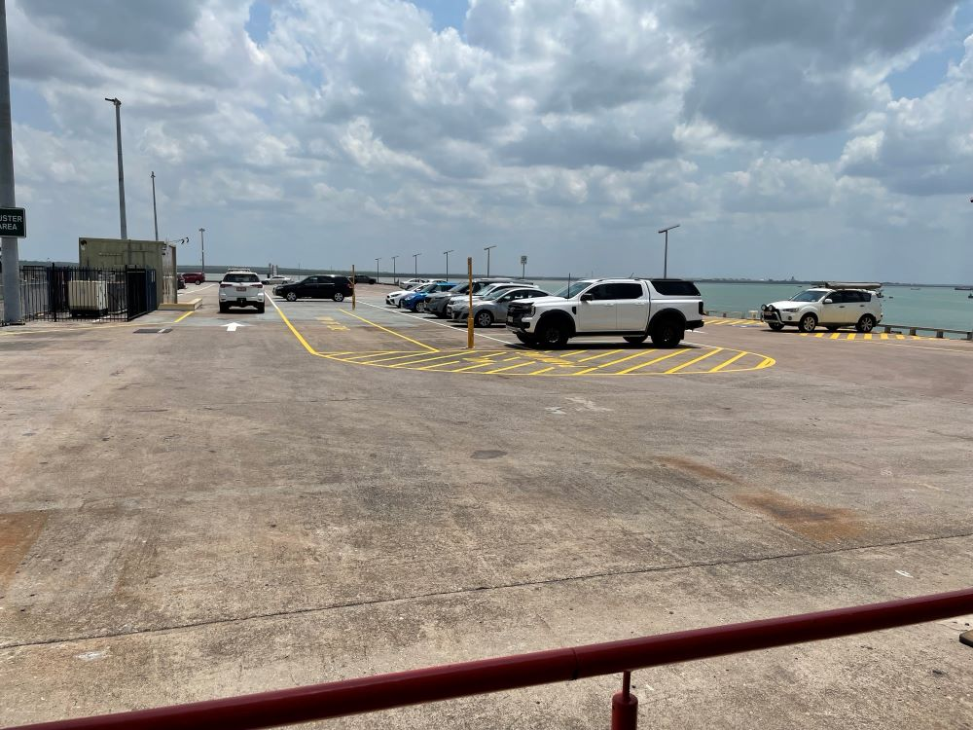
Carpark view from RFDS entry
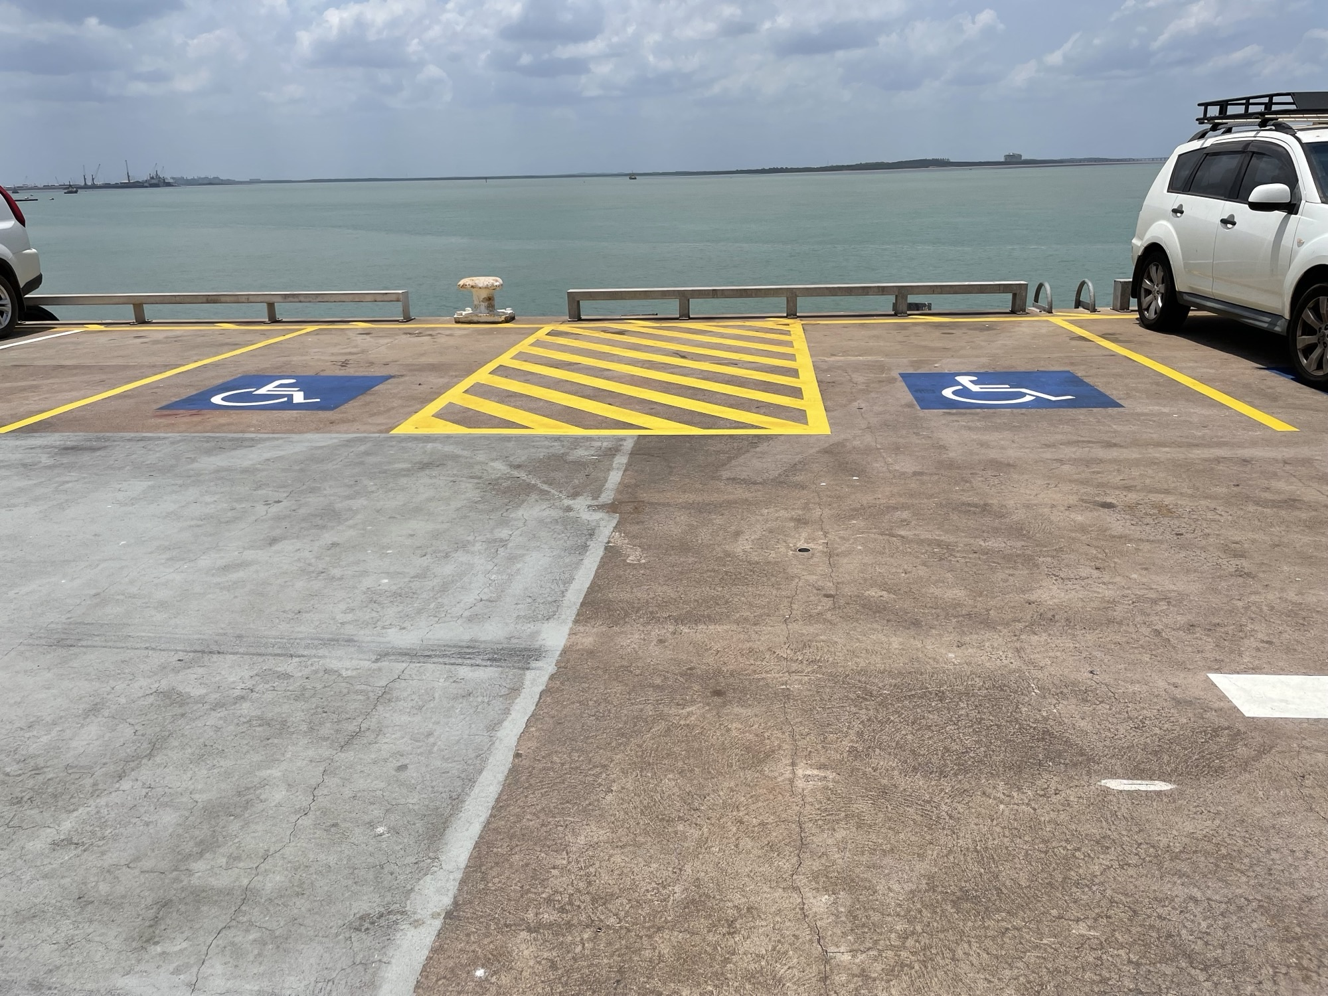
RFDS 3 accessible carparks
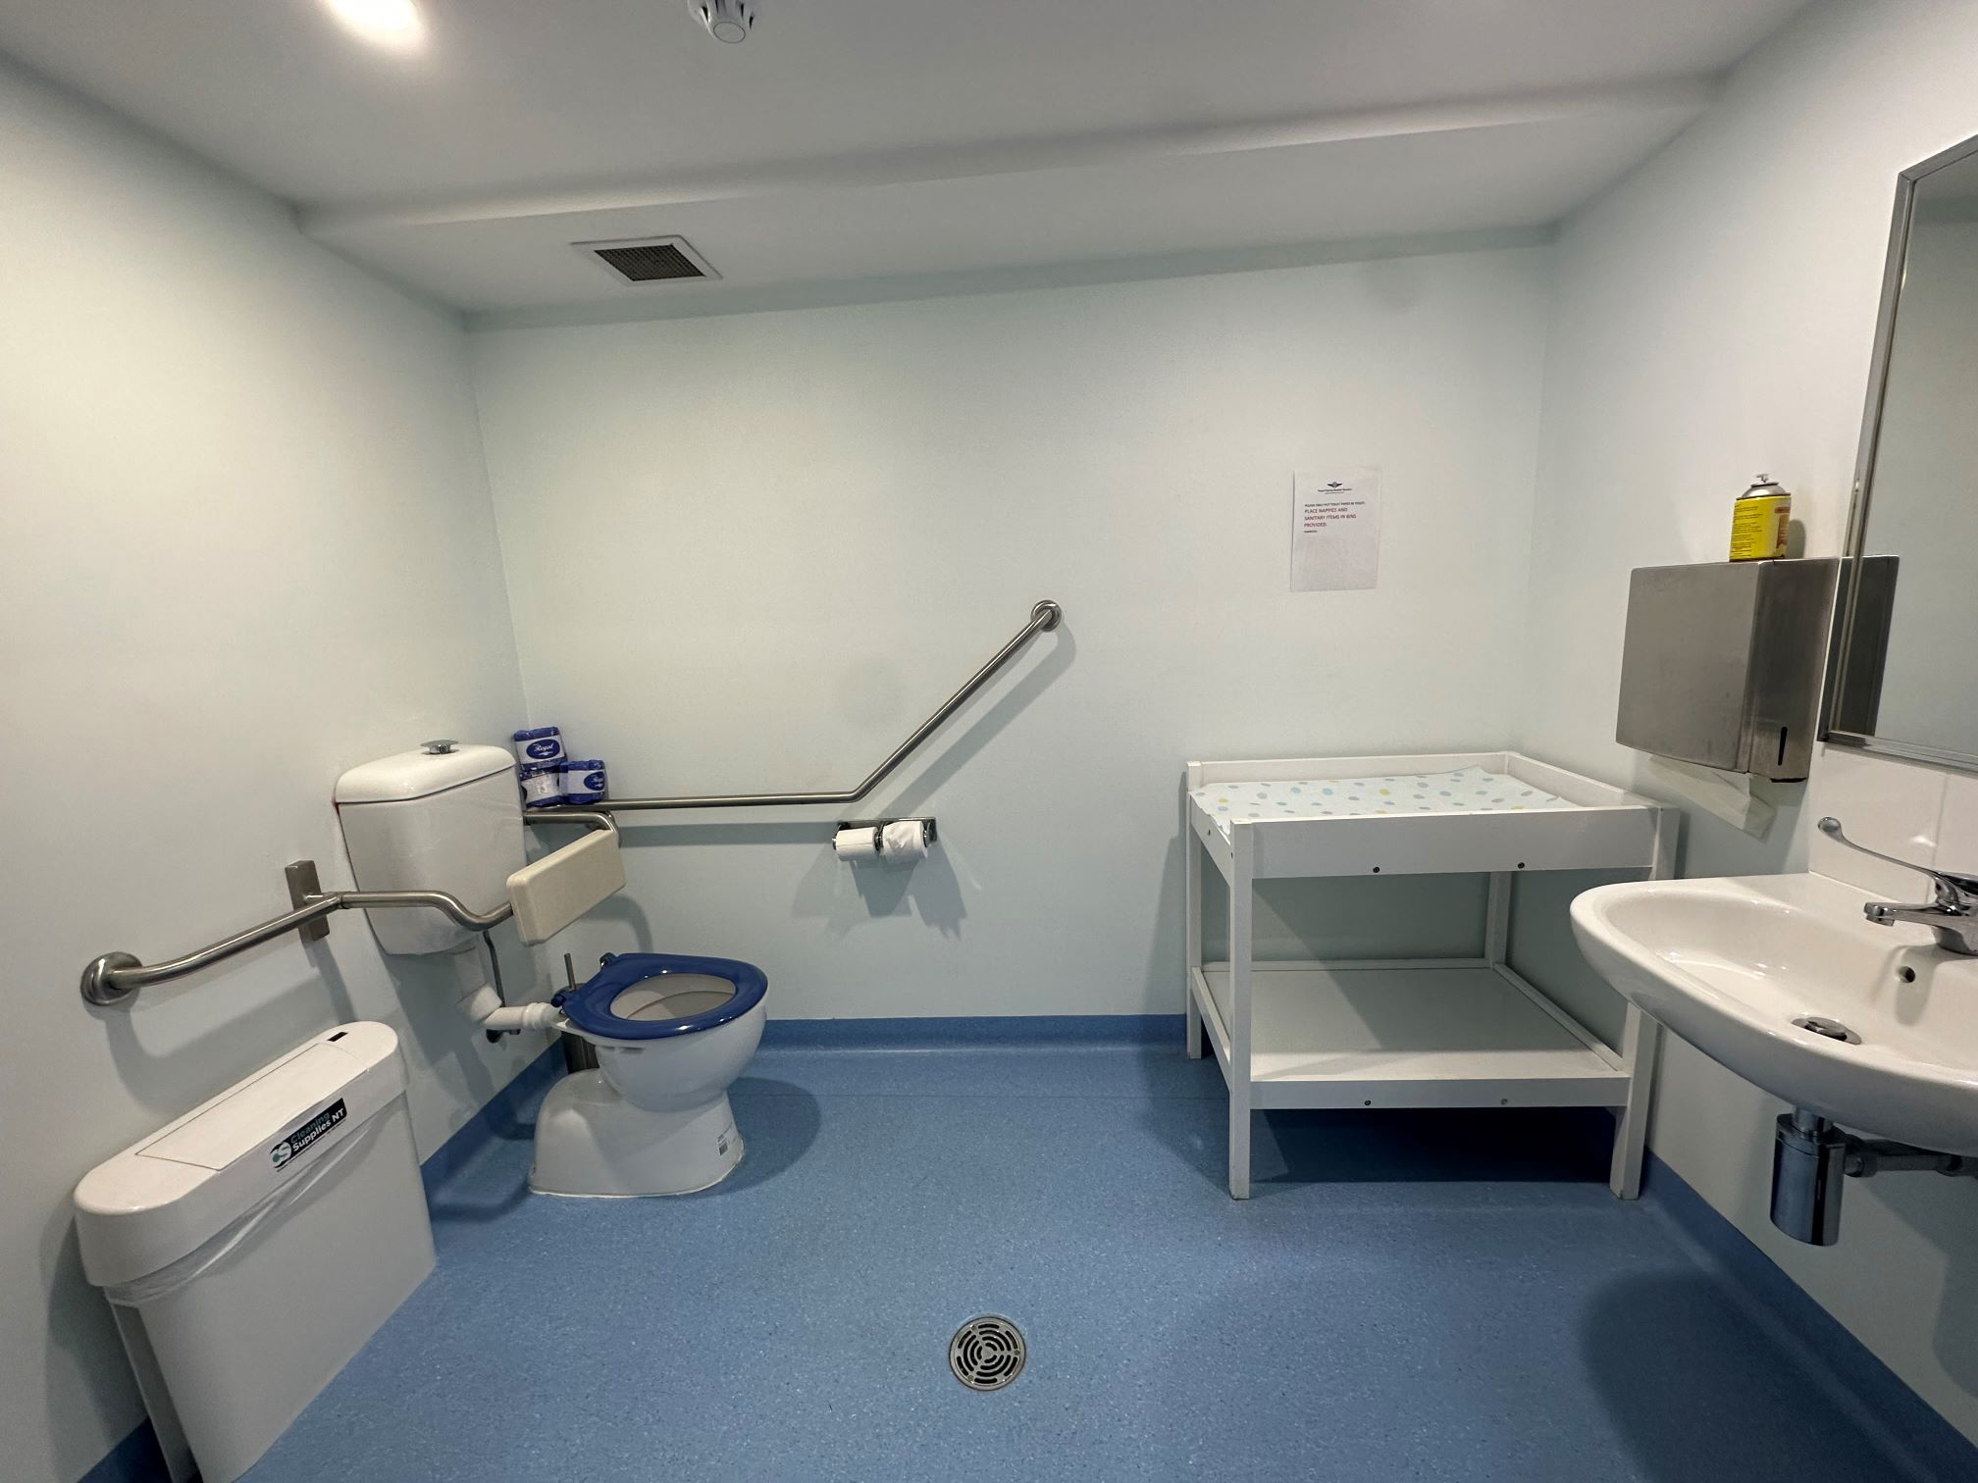
RFDS Accessible bathroom
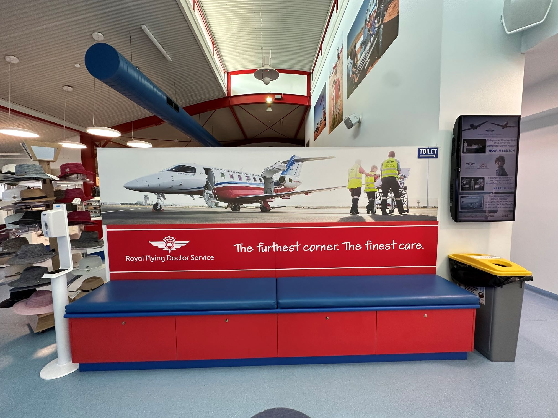
RFDS bench
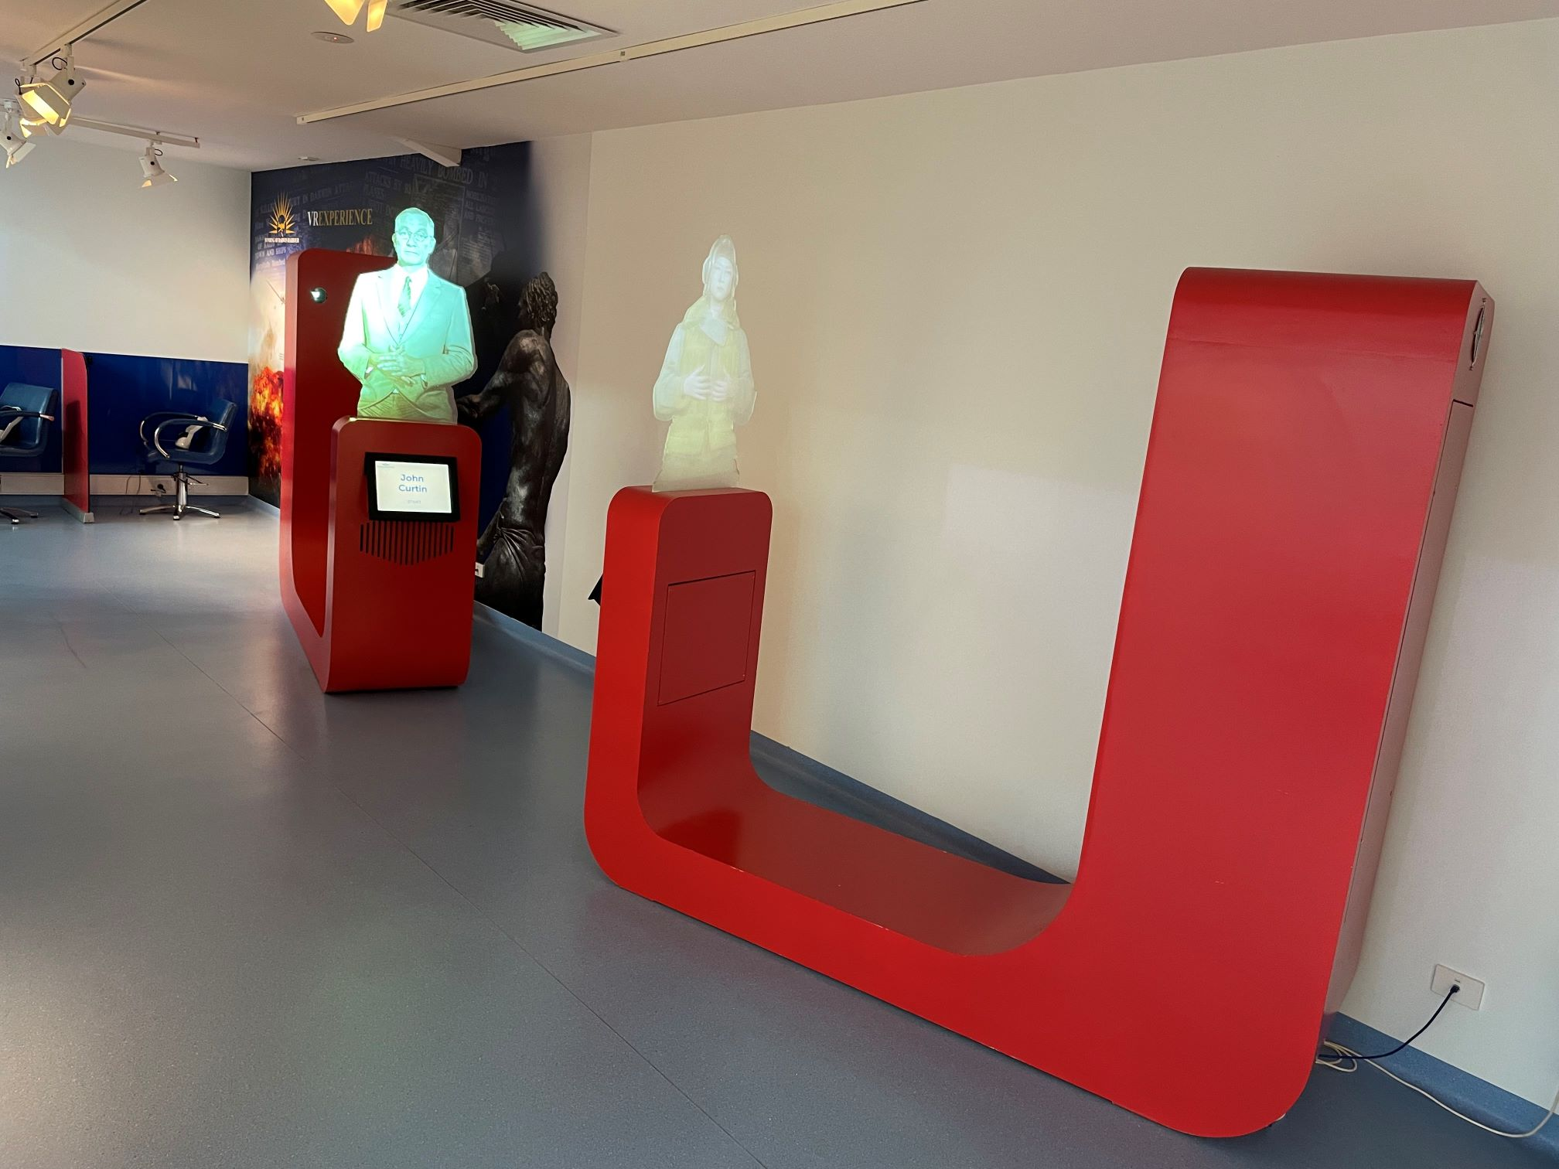
RFDS BOD holograms
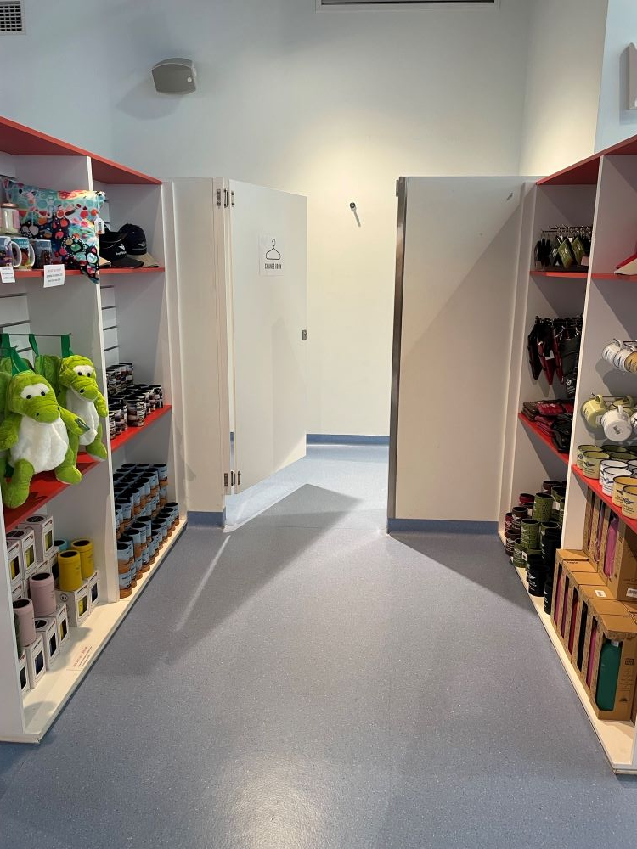
RFDS change room
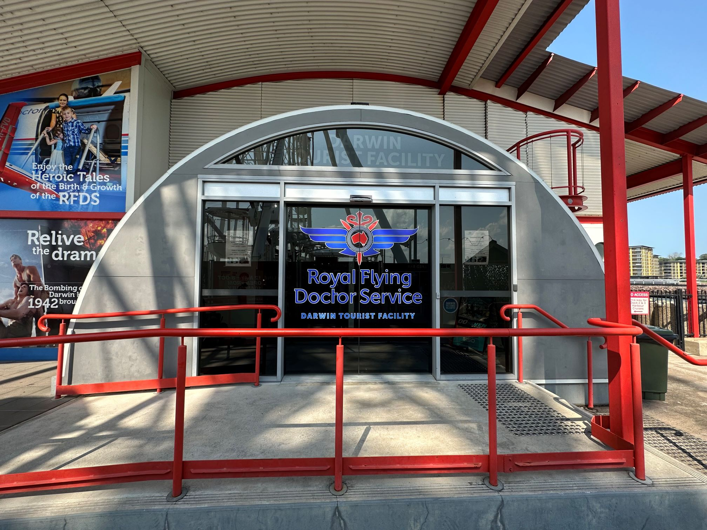
RFDS entry doors
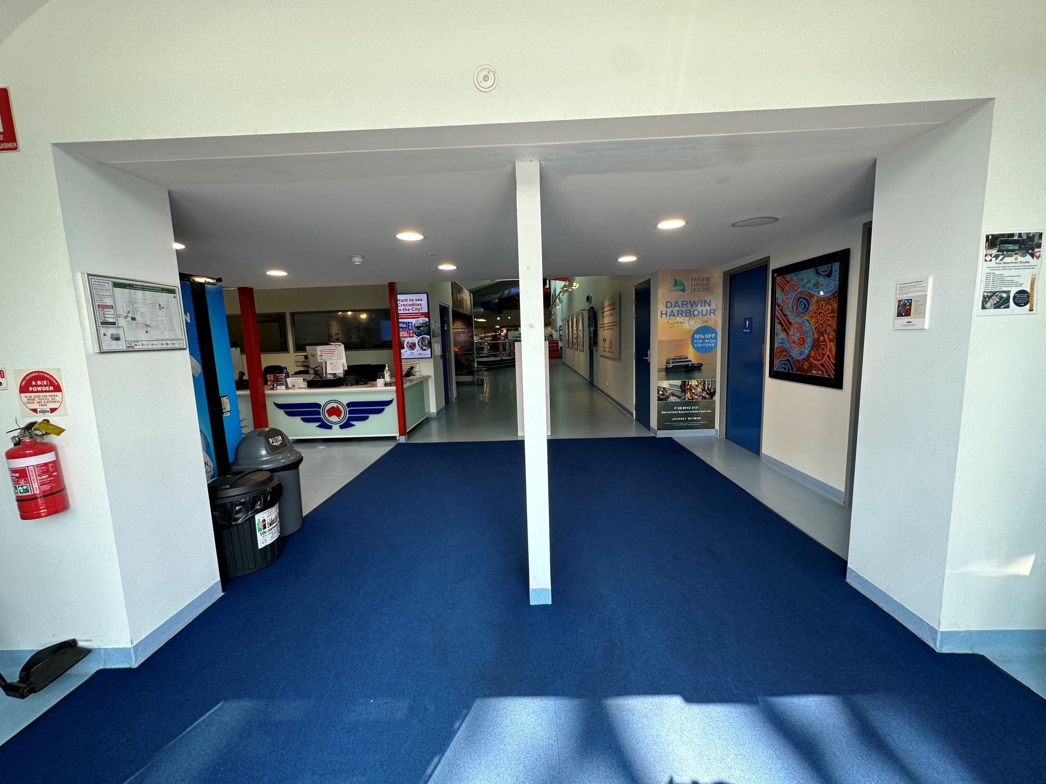
RFDS entry
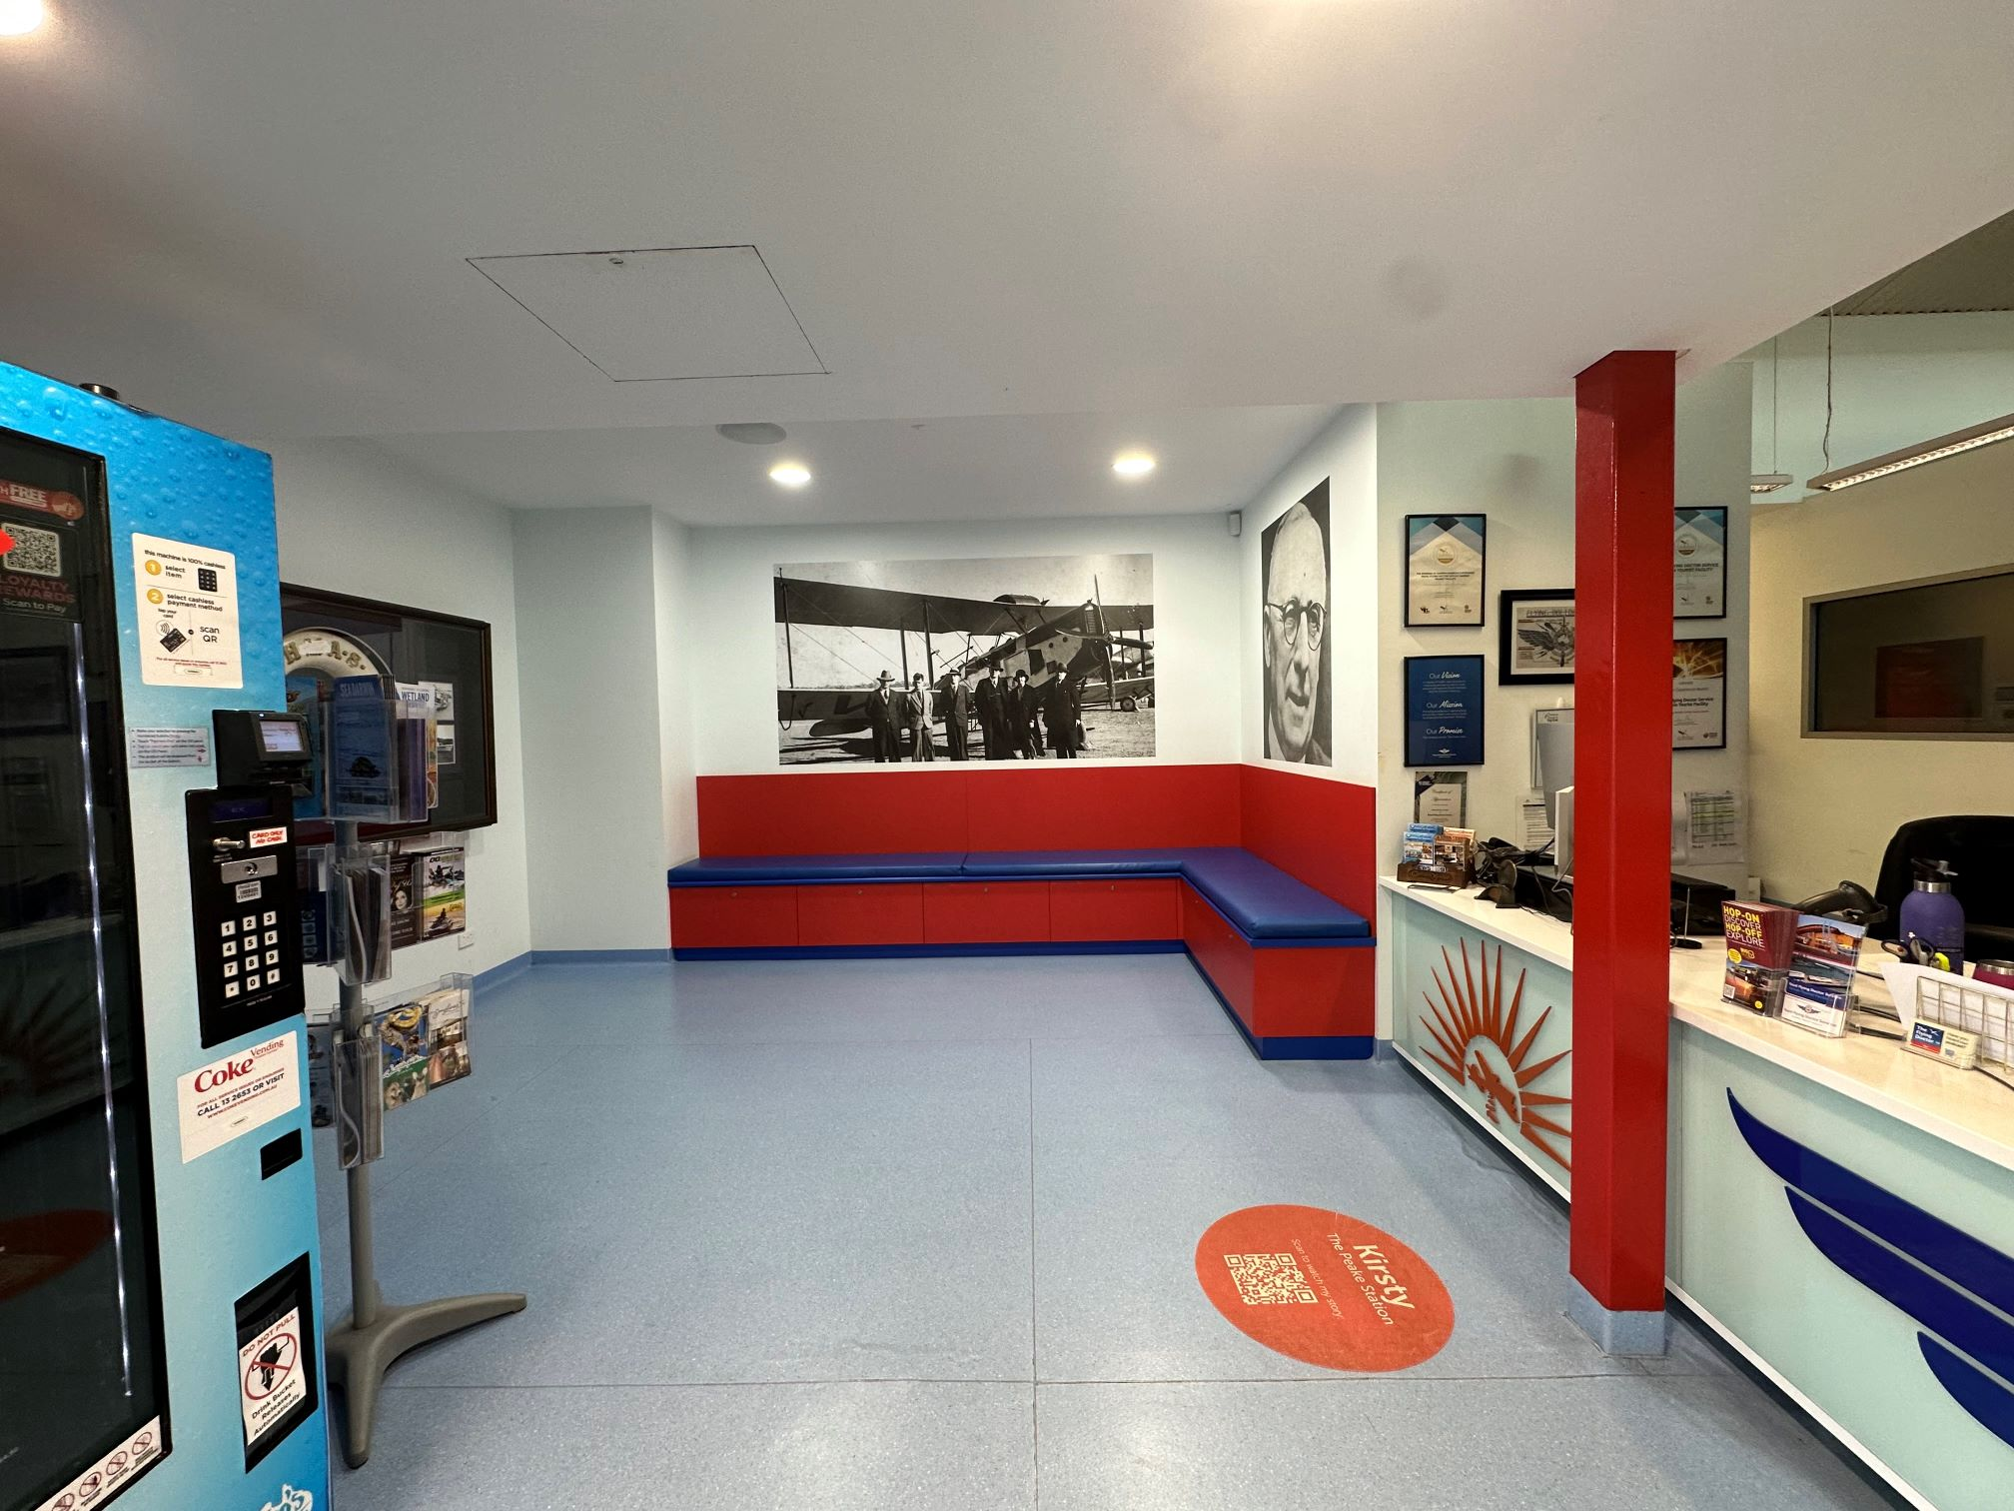
RFDS Foyer
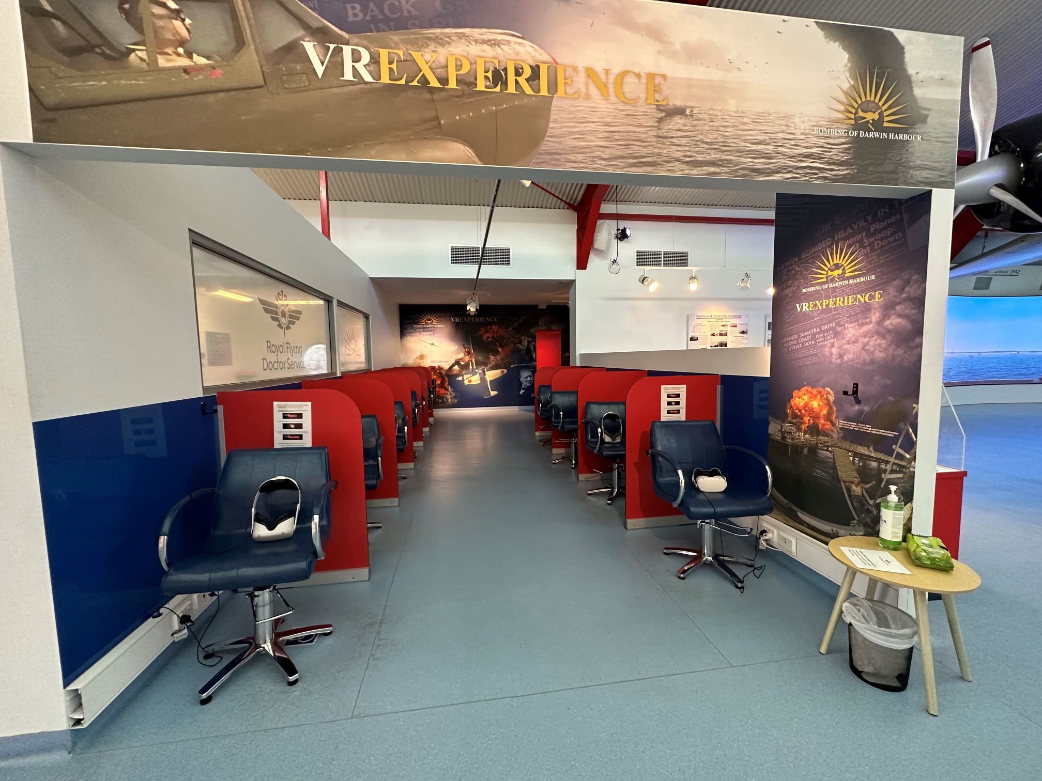
RFDS inside attraction VR BOD
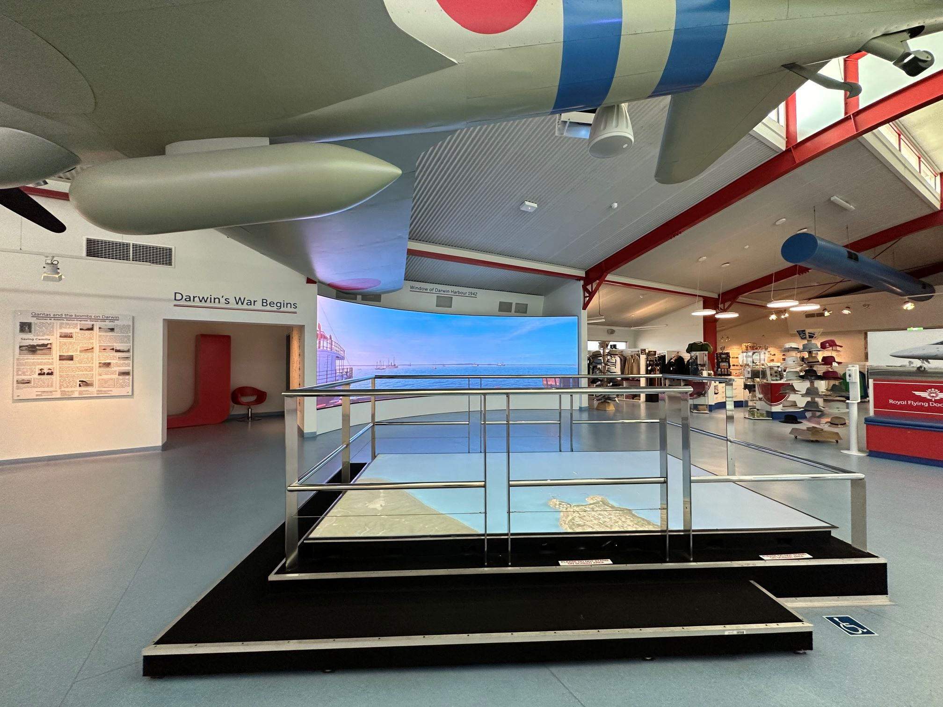
RFDS Platform middle of building
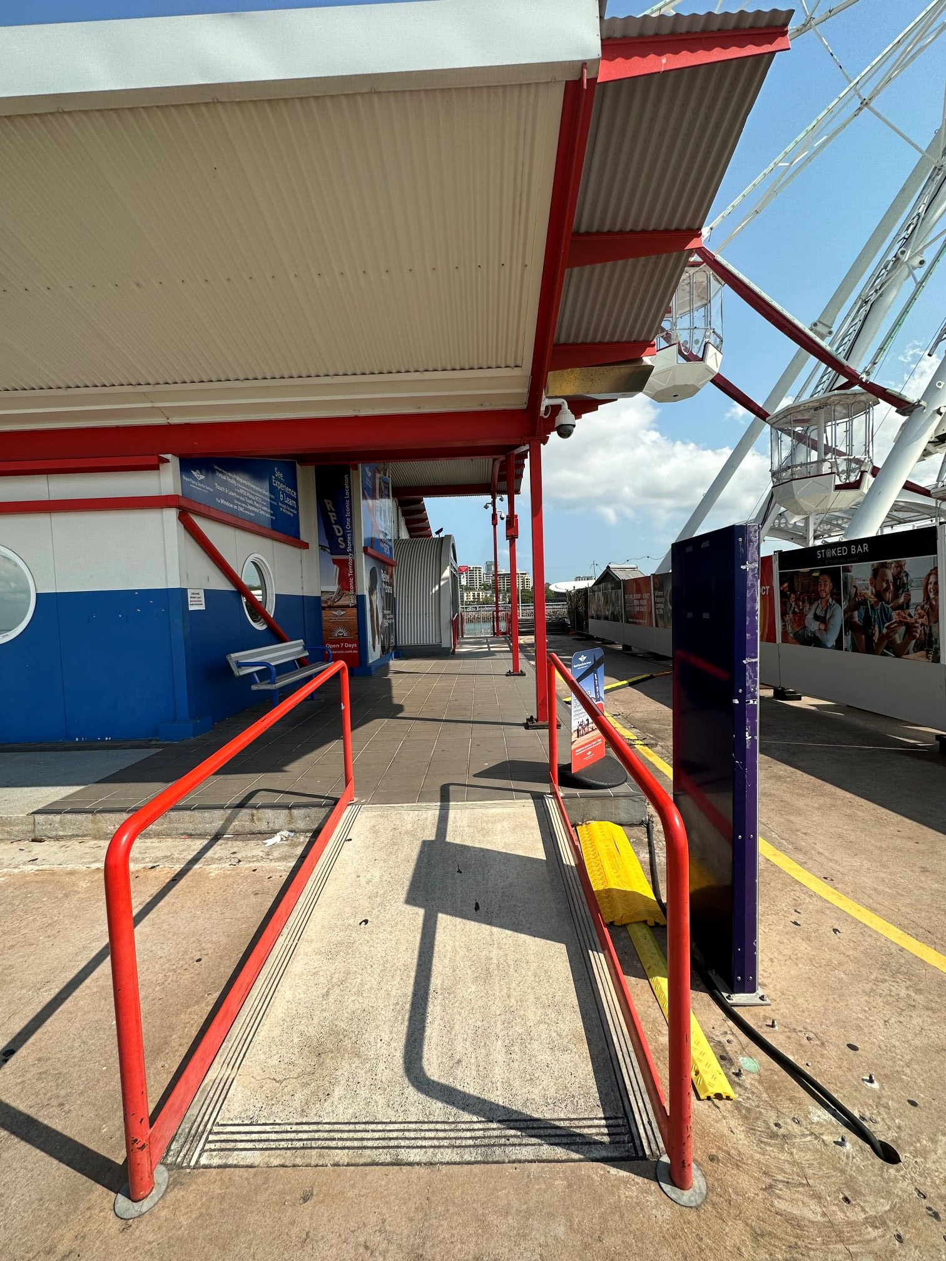
RFDS ramp outside
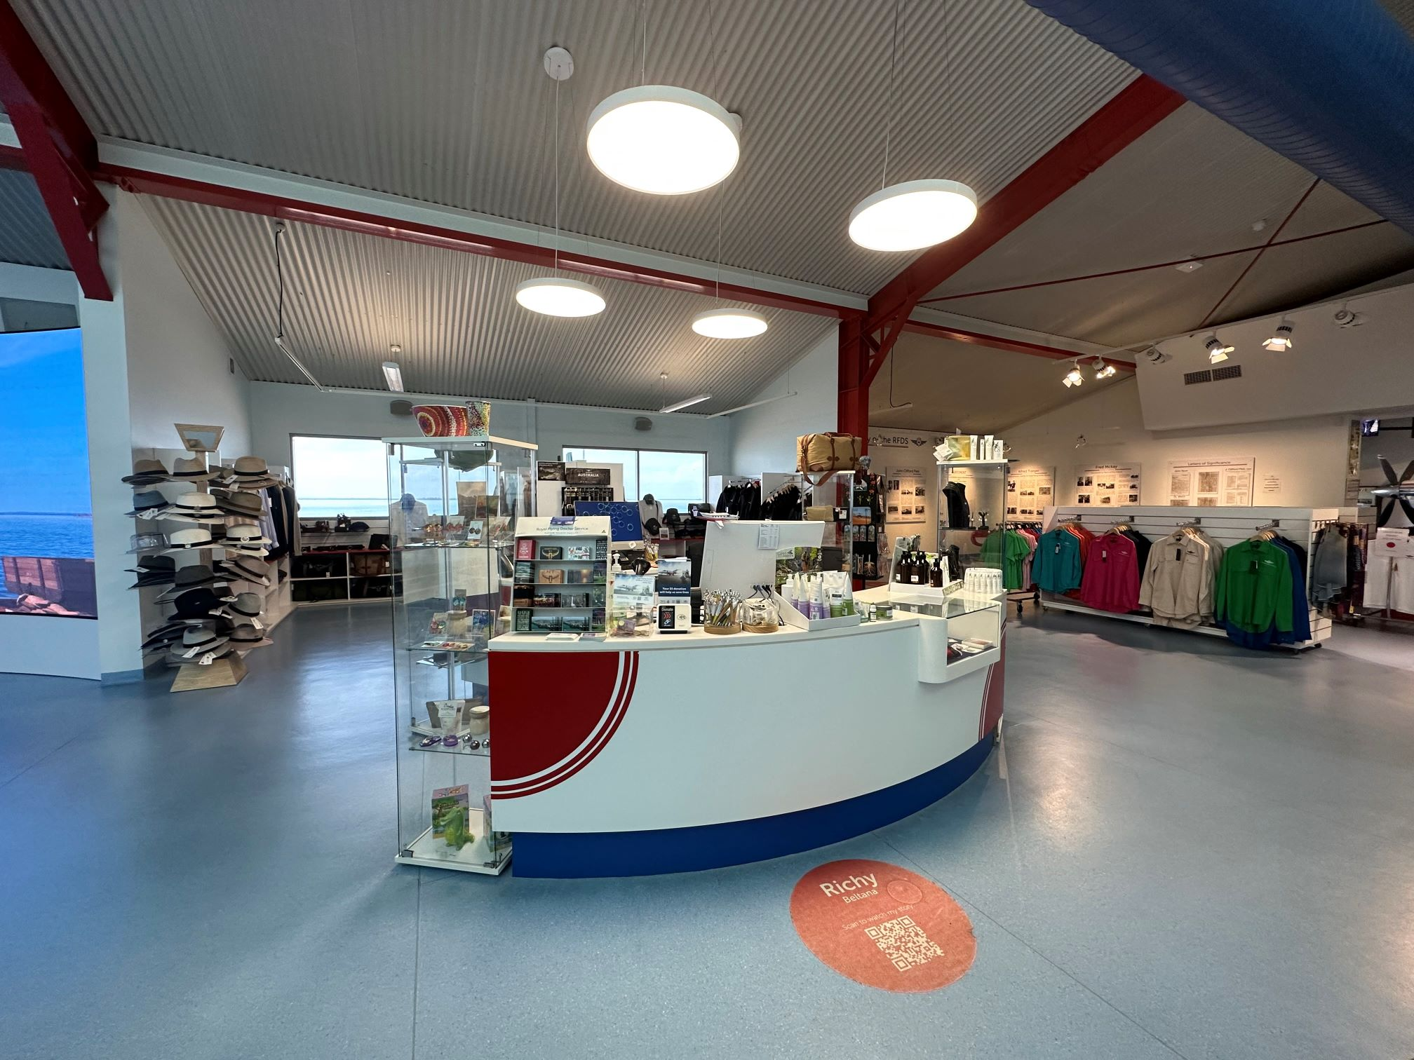
RFDS Retail Counter
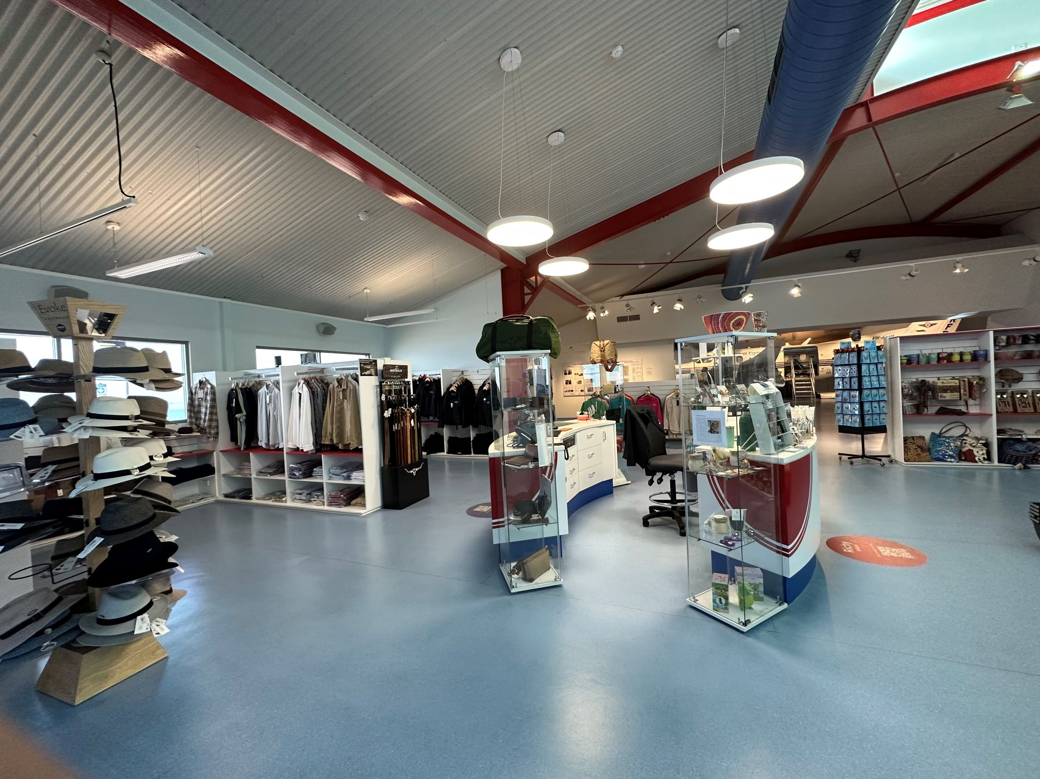
RFDS Retail section 1
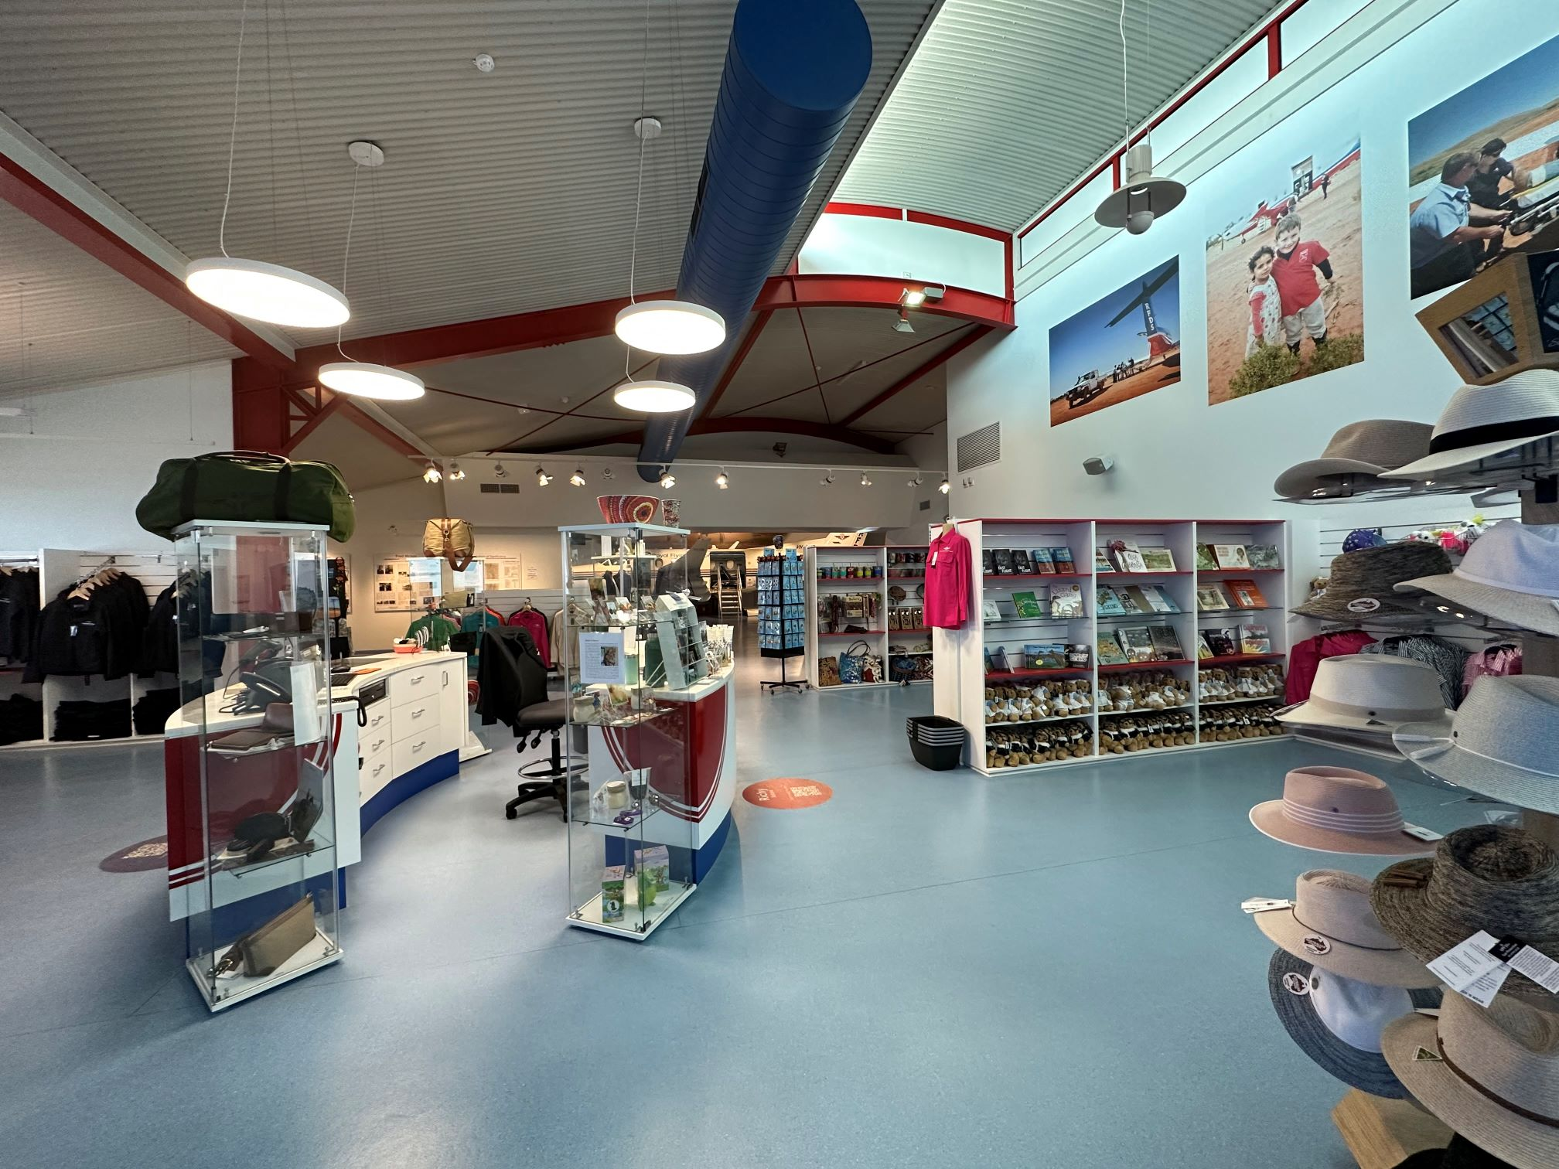
RFDS Retail section 2
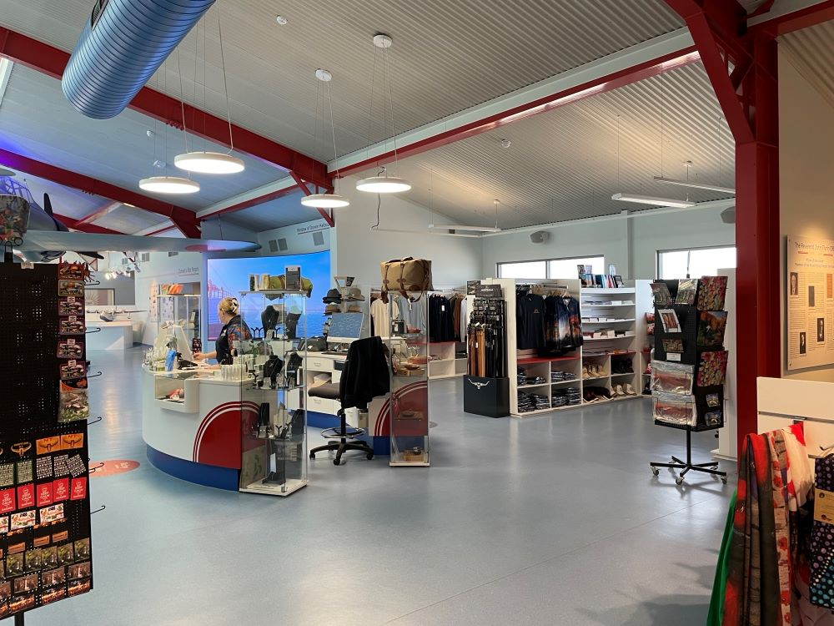
RFDS Retail section3
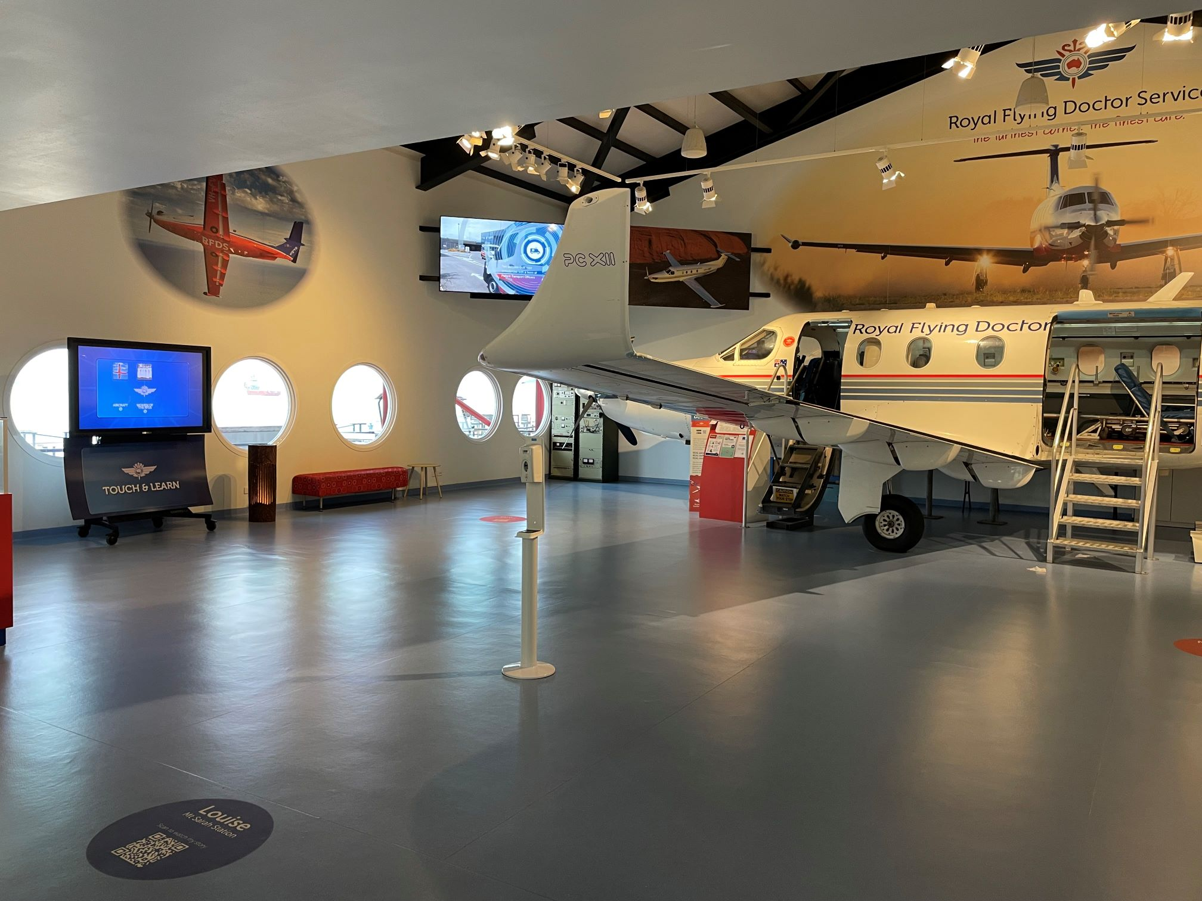
RFDS section 2
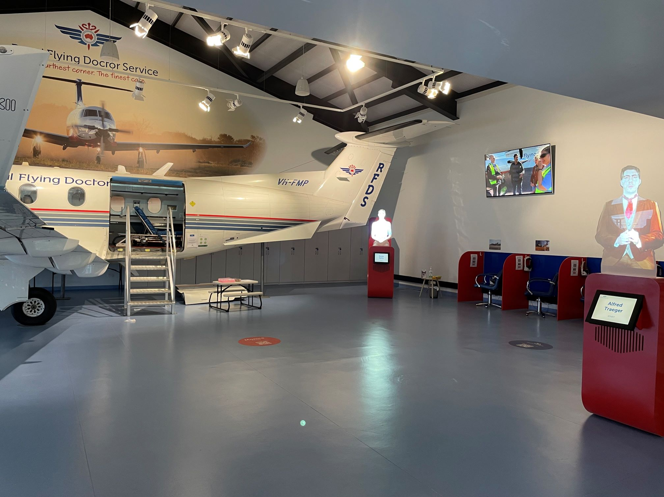
RFDS section1
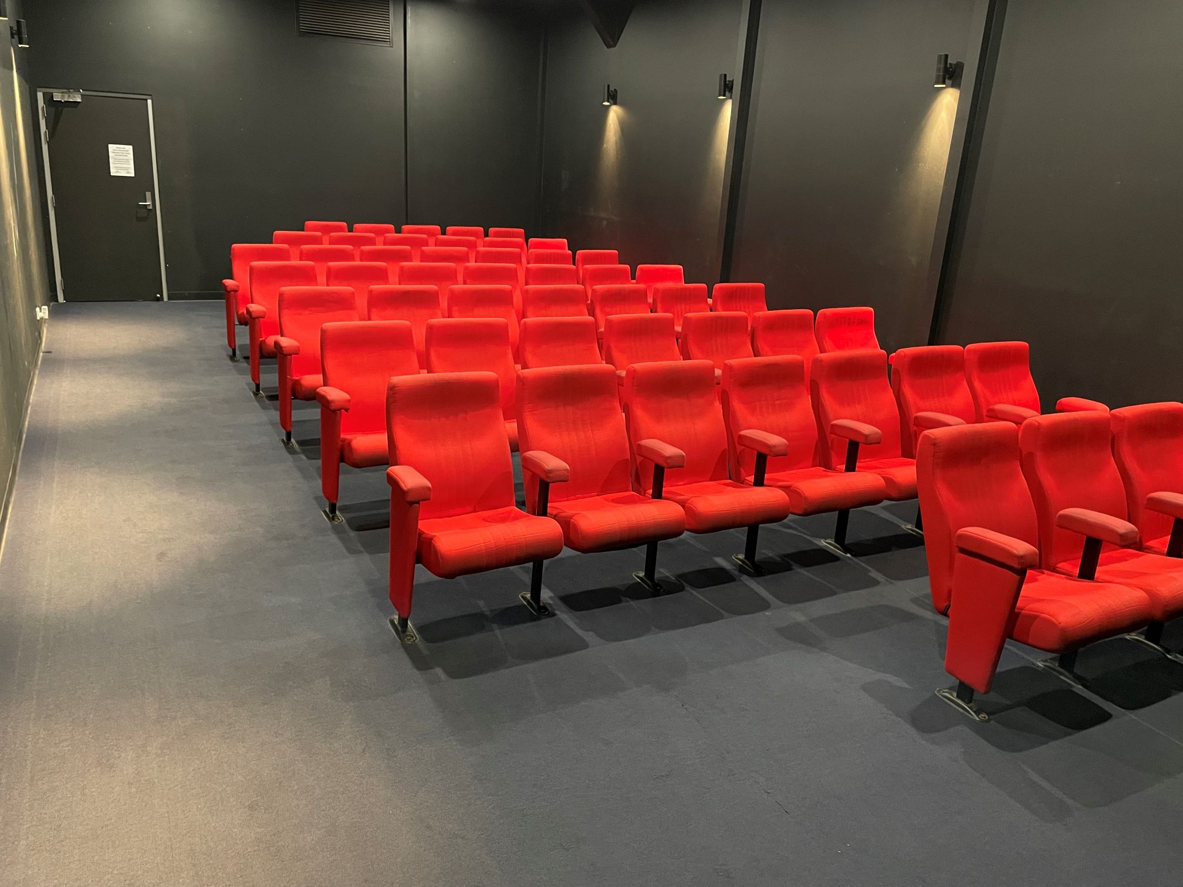
RFDS theatre
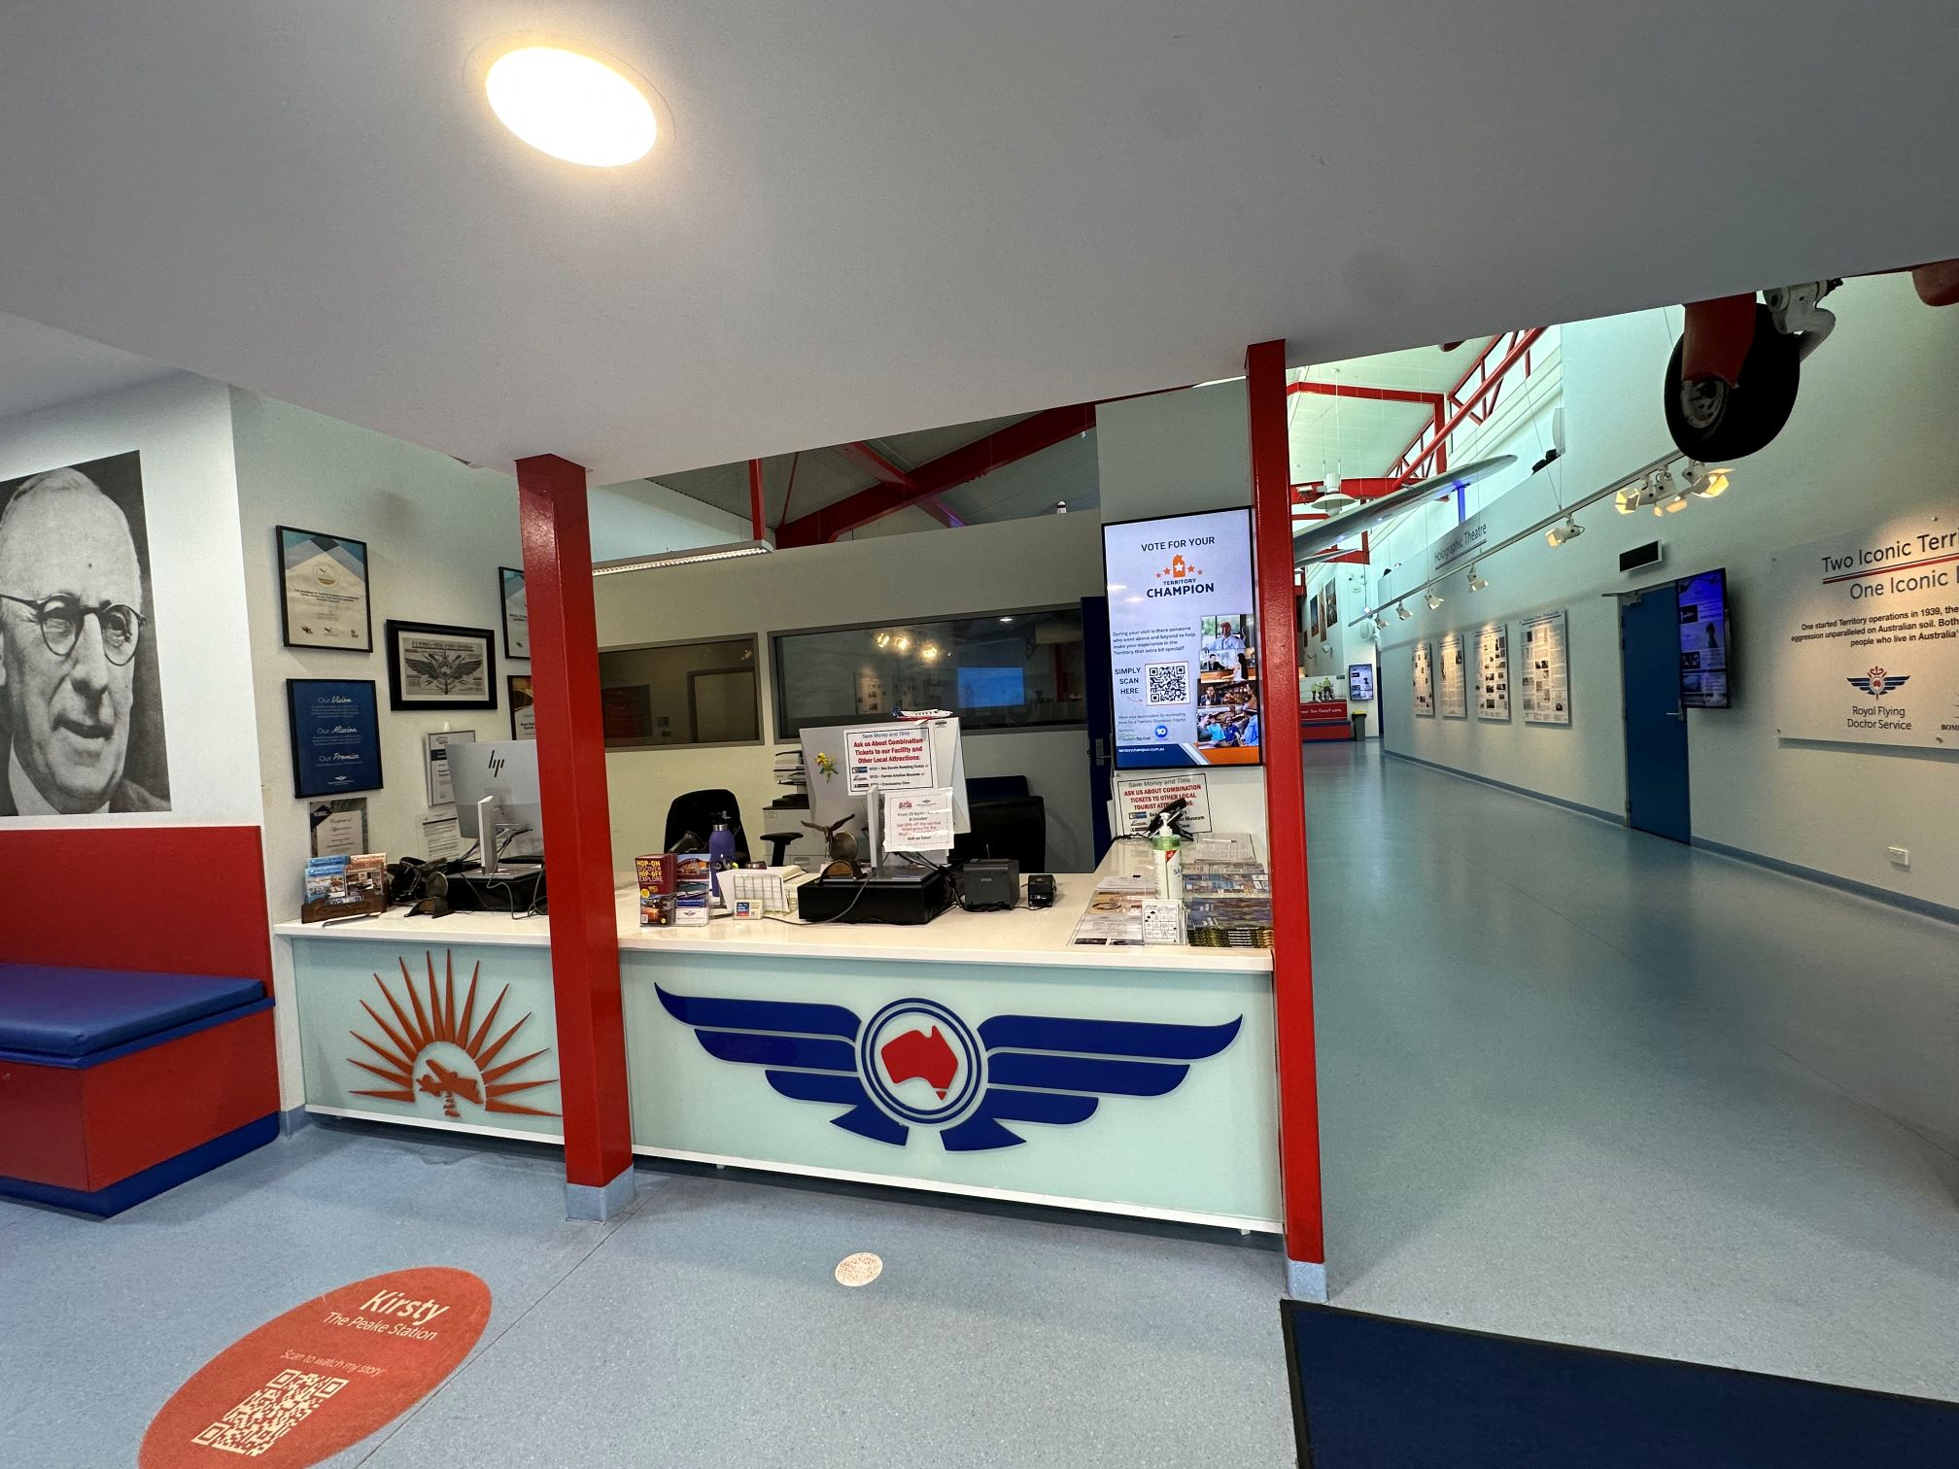
RFDS Ticket Desk
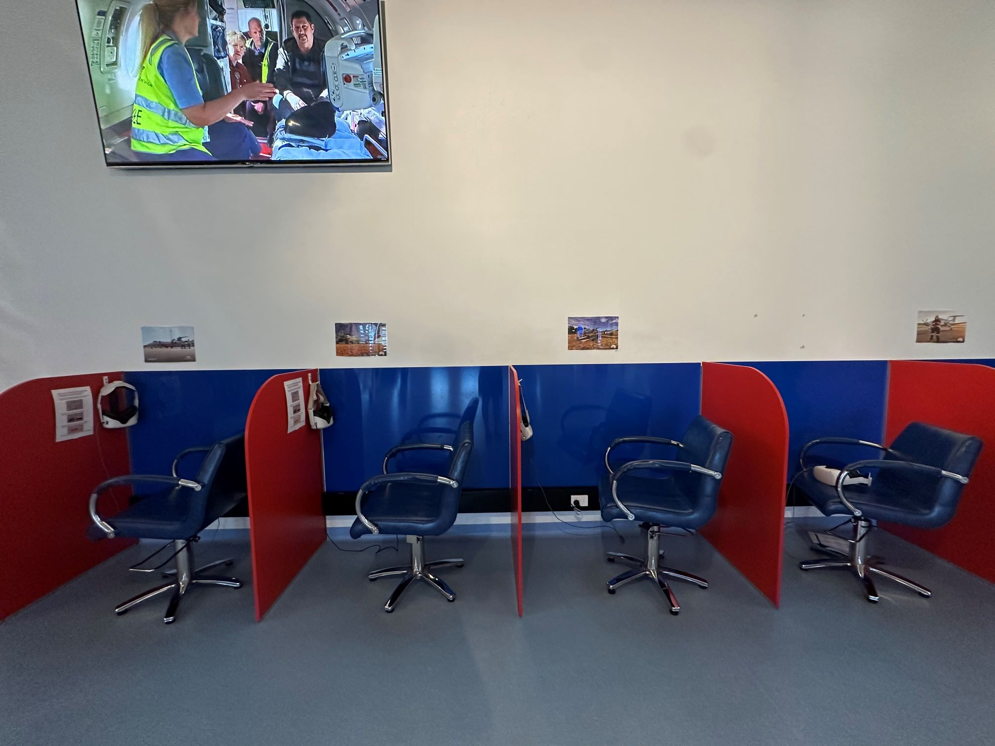
RFDS VR chairs
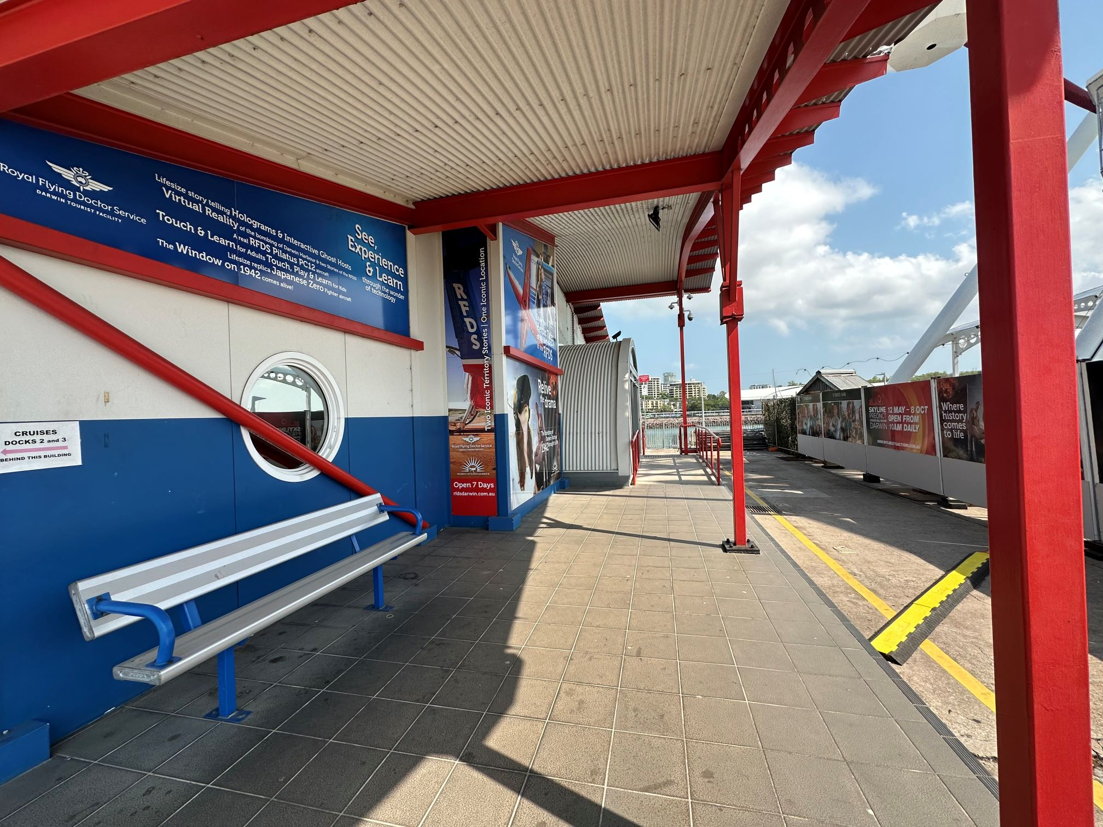
RFDS walkway to entrance
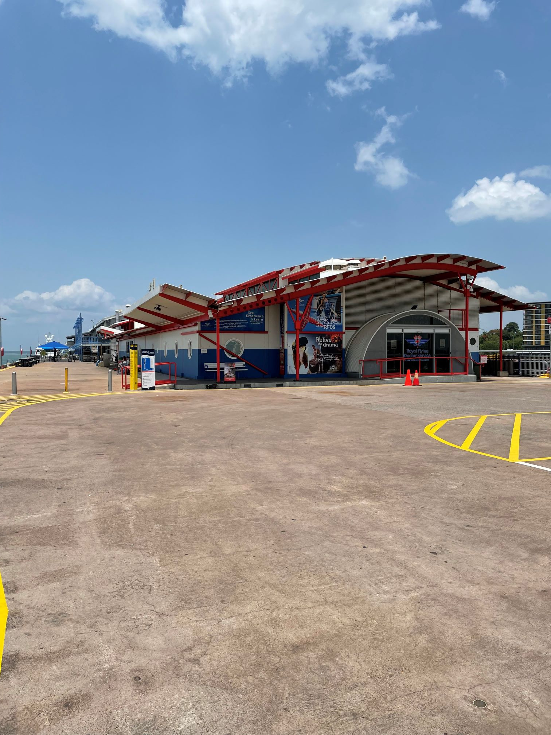
View to RFDS facility from carpark

COMMON AREAS

Report Disclaimer
Please note that this business report, provided as a result of the use of the diagnostic assessment, is for information purposes only.
Australian Tourism Industry Council (ATIC) cannot guarantee the accuracy of respondent’s answers, or that they are fully representative of your business. Therefore, ATIC does not warrant or guarantee any particular outcome in respect of your businesses self-assessment.
This report is intended as guidance only for your business and should not be relied on for future marketing considerations. ATIC recommends that you seek your own independent advice as well as the results from the diagnostic.
Links to external web sites are inserted for convenience and do not constitute endorsement of material at those sites, or any associated organisation, product or service.
ATIC does not:
- Assume any legal liability for the accuracy, completeness, or usefulness of any information from this report or any links provided; or
- Accept responsibility for any loss associated directly or indirectly from the use of this report.

