ATIC Accessibility
To support the accessible community in making informed travel decisions for their individual needs

This report prepared for:
Business name: | South West Eco Discoveries
Address: | 1/9 Yale Close
Town: | Busselton
Contact for enquiries: | Ryan White
Contact Number: | 0477049722
Contact Email: | info@southwestecodiscoveries.com.au
Website: | www.southwestecodiscoveries.com.au
Date: | 2026-11-07 05:25

ATIC Accessibility
The following pages provides travellers with information on the businesses facilities and amenities which aims to support the traveller to make an informed decision on whether the business is suitable for their individual needs.
OVERVIEW 4
Business Overview 4
Bookings 4
Emergency Management 4
Communications 5
GENERAL 6
Pre-arrival, arrival and reception 6
Cognitive Impairment Support 6
Displays, exhibits, commentary and live performances 6
External Paths 7
Steps 7
TOUR OPERATORS 8
Tour/Transport Services 8
Route Planning 8
Guides 8
Report Disclaimer 11

OVERVIEW

Business Overview

The business has the following products/services available
- Tour/Transport

Our business caters for the following disability types:
- Blind or low vision
- Deaf or low hearing
- Limited mobility
- Food allergies or intolerances
- Cognitive or people on the Autism Spectrum

Bookings

The business offers the following methods for bookings and enquiries:
- Phone
- Email
- Webportal
- Our website supports Screen Readers

Emergency Management
- Emergency and evacuation procedures are explained on arrival
- Exit signs are clear and easy to see
- Exit access is free and clear at all times
We ensure exit access is free and clear at all times by: Tour vehicle - doorway always kept clear
- Exits and access to exists are greater than 900mm
- Exit doors are able to be opened by all occupants
- Exits including stairwells, have bright edges used on the steps.
The business identifies guests who need additional assistance should an emergency occur by: We usually know in advance, when people book whether there are any additional assistance requirements.
The procedure for assisting guests who need assisted rescue is: Guide calmly assists guest with exiting the vehicle, with the help of carers if present.
- Guests with disabilities are noted in the guest log book for emergency and evacuation purposes

Communications
- Our business offers the following alternative communication methods
- Plain English
- There is easy to read signage and information (e.g. menus and emergency information)
The business provides the following services for services animals: Service animals have access to the vehicle

GENERAL

Pre-arrival, arrival and reception
The business has the following in place to support guests during pre-arrival, arrival and reception
- Booking information and websites are compatible with screen readers
- Information and maps are available in written form
The following steps are in place to ensure that people with fatigue related to their disability are not disadvantaged by long wait times: Guests are picked up from their accommodation at a specific time, access straight on to the tour vehicle.
- In addition, the following further information can assist guests:
Guests are given a specific pick up time for their accommodation to reduce wait times.

Cognitive Impairment Support
- Documents are available in plain English for people with cognitive impairment (This may include instructions, guides, menus and general information)
- In addition, the following further information can assist guests:
We do not have a bricks and mortar establishment, therefore do not offer car parking facilities. Guests will be picked up from their accommodation

Displays, exhibits, commentary and live performances
For displays, exhibits, commentary and live performances the following amenities are in place
- Seating
- A written transcript where audio description is provided i.e. display commentary, tour commentary
- In addition, the following further information can assist guests:
During the tour, we can provide a written transcript of the main commentary if required, and requested in advance.

External Paths
External paths of travel
The width of the smallest pathway is: 450mm
- There 3 successive steps or less on any path or at any doorway
- Any paths having steps are clearly identified as non-wheelchair accessible
- Step free routes clearly signed
- In addition, the following further information can assist guests:
Tours take place in National Parks, on tracks of different surfaces and terrains.

Steps
Steps
- There are steps.
- Top and bottom steps are easily distinguished through colour contrast or the use of TGSIs (Tactile Ground Surface Indicators)
- The underside of all staircases are enclosed or protected to a height of at least 2 metres
- Handrails fitted to all open sets of steps
- In addition, the following further information can assist guests:
There are 2 steps to enter the tour vehicle
- In addition, the following further information can assist guests:
We do not have bricks and mortar facilities. We operate in public spaces including National Parks. There are limited toilet facilities during the tour. There may be accessible toilets that can be used depending on the specific locations visited during the tour.

TOUR OPERATORS

Tour/Transport Services
The tour/transport services have the following facilities/amenities in place
- Buses/Coaches
- 0 vehicles have wheelchair lifts or ramps
- 0 vehicles have low floors with ramped entry
The maximum wheelchair capacity available in the fleet is: 0
- Commentary is available in written format
- Audio visual displays are sub titles

Route Planning
- Route Planning
- The tour route includes stops with accessible toilet facilities
- In addition, the following further information can assist guests:
Some of our tours have more access to accessible toilet facilities than others. Tours that operate mainly in National Parks have limited facilities.
- Lunch stop venues are accessible
- Walking Tours
- Multi-paced to account for slower walkers
- Electronic voice augmentation
- Hearing aid compatible

Guides

Guides have been trained in the following
- Use of clear/simple English
- Correct pronunciation for lip readers
  - Image(s)
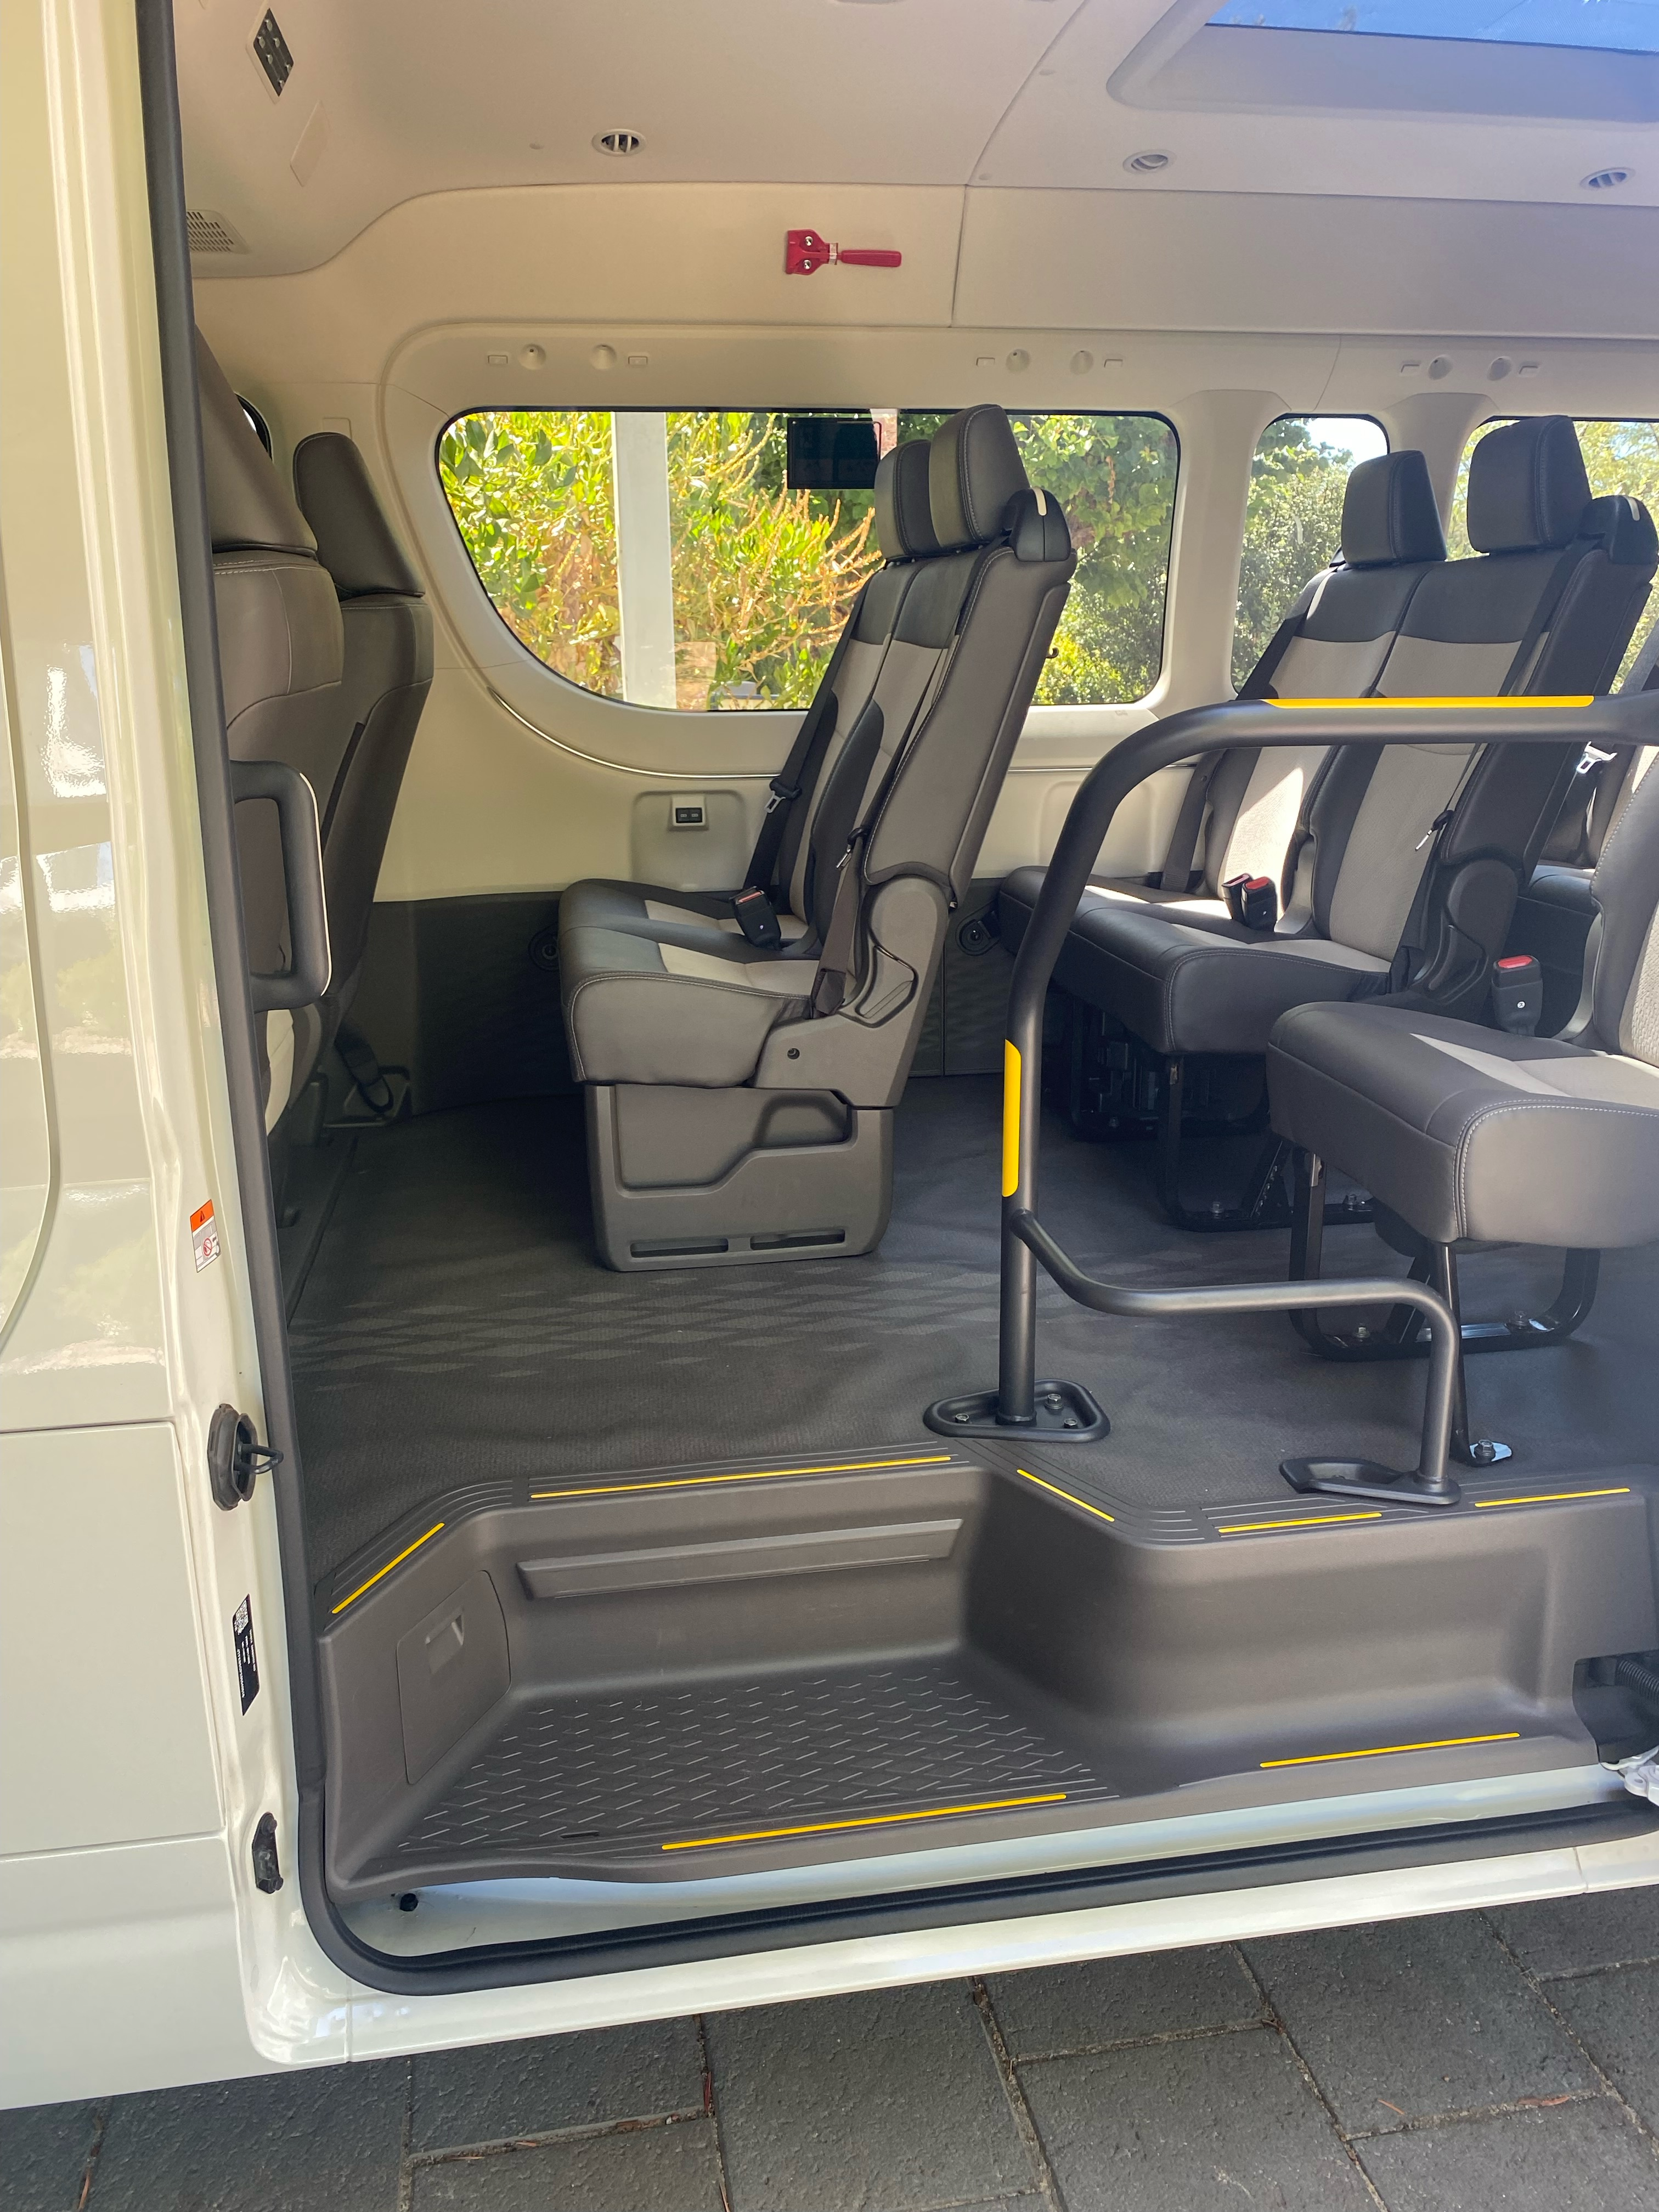
Bus entry with steps and rails
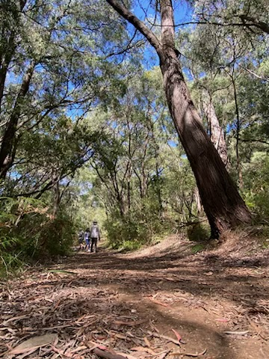
Walk trail example
- This tour stops at attractions/accommodation/food and beverage/retail spaces that are not operated by this business. For information relating to these individual properties please follow the weblink provided
- In addition, the following further information can assist guests:
Our Wine & Sights Discovery Tour visits establishments not operated by us.

Report Disclaimer
Please note that this business report, provided as a result of the use of the diagnostic assessment, is for information purposes only.
Australian Tourism Industry Council (ATIC) cannot guarantee the accuracy of respondent’s answers, or that they are fully representative of your business. Therefore, ATIC does not warrant or guarantee any particular outcome in respect of your businesses self-assessment.
This report is intended as guidance only for your business and should not be relied on for future marketing considerations. ATIC recommends that you seek your own independent advice as well as the results from the diagnostic.
Links to external web sites are inserted for convenience and do not constitute endorsement of material at those sites, or any associated organisation, product or service.
ATIC does not:
- Assume any legal liability for the accuracy, completeness, or usefulness of any information from this report or any links provided; or
- Accept responsibility for any loss associated directly or indirectly from the use of this report.

