ATIC Accessibility
To support the accessible community in making informed travel decisions for their individual needs

This report prepared for:
Business name: | Kalbarri Rock Lobster Tours & Charter
Address: | 15 Mariner Cresent
Town: | Kalbarri
Contact for enquiries: | Vaughn Ralph
Contact Number: | 0400149049
Contact Email: | kalbarrirocklobstertours@hotmail.com
Website: | www.kalbarrirocklobstertoursandcharters.com
Date: | 2026-11-01 21:51

ATIC Accessibility
The following pages provides travellers with information on the businesses facilities and amenities which aims to support the traveller to make an informed decision on whether the business is suitable for their individual needs.
OVERVIEW 4
Business Overview 4
Bookings 4
Emergency Management 4
Communications 5
Other Information 5
Guide Dog and Service Animals 5
GENERAL 6
Pre-arrival, arrival and reception 6
Cognitive Impairment Support 6
Car Park and Access amenities 6
Displays, exhibits, commentary and live performances 6
External Paths 6
Steps 7
Public Toilets/Adult change facilities 7
TOUR OPERATORS 8
Tour/Transport Services 8
Route Planning 8
Guides 8
Report Disclaimer 11

OVERVIEW

Business Overview

The business has the following products/services available
- Tour/Transport

Our business caters for the following disability types:
- Blind or low vision
- Deaf or low hearing
- Limited mobility
- Wheelchairs or mobility scooters
- Cognitive or people on the Autism Spectrum

Bookings

The business offers the following methods for bookings and enquiries:
- Phone
- Email
- Webportal

Emergency Management
- Emergency and evacuation procedures are explained on arrival
- Exit access is free and clear at all times
We ensure exit access is free and clear at all times by: it just is
- Exits and access to exists are greater than 900mm
- Exit doors are able to be opened by all occupants
- Exits to the emergency evacuation point does not include stairways
- The evacuation point is clearly marked by a sign
The business identifies guests who need additional assistance should an emergency occur by: we ask them on arrival
The procedure for assisting guests who need assisted rescue is: crew will assist them

Communications
- Our website meets WCAG 2.0 accessibility standards

Other Information
- For bookings made onsite, the ticket booth/counter/box office is accessible for people using a wheelchair
- The business accepts the companion card

Guide Dog and Service Animals
- The business provides a secure area with shade and water for service animals
The business provides the following services for services animals: lay down area

GENERAL

Pre-arrival, arrival and reception
The business has the following in place to support guests during pre-arrival, arrival and reception
- Information and maps are available in written form
- A familiarisation tour
The following steps are in place to ensure that people with fatigue related to their disability are not disadvantaged by long wait times: access to vessel and setting first

Cognitive Impairment Support
- Documents are available in plain English for people with cognitive impairment (This may include instructions, guides, menus and general information)

Car Park and Access amenities
The business has the following Car Park and Access amenities
- A drop off zone
- Level or ramped access from the car park to the entrance
- The accessible entrance is clearly signed from the parking bay
- Kerb ramps are in place where a pavement or walkway needs to be crossed

Displays, exhibits, commentary and live performances
For displays, exhibits, commentary and live performances the following amenities are in place
- Seating
- Wheelchair accessible spaces/seating

External Paths
External paths of travel
- Surfaces are concrete, asphalt, smooth paving or hard packed fine gravel (max aggregate size 13mm)
- Pathways are wider than 900mm
- There 3 successive steps or less on any path or at any doorway

Steps
Steps
- There are steps.
- Top and bottom steps are easily distinguished through colour contrast or the use of TGSIs (Tactile Ground Surface Indicators)
- All steps or staircases have enclosed risers
- Handrails fitted to all open sets of steps
- Handrails extend 300mm beyond the top and bottom step
- Where steps are present are there three steps or less

Public Toilets/Adult change facilities
Public Toilets/Adult change facilities have the following amenities are in place
- There is an accessible toilet for public use
- The door is at least 850mm wide
- There is a minimum of 850mm beside the toilet
- The toilet seat of a contrasting colour to the floor
- The toilet seat is460mm above the floor

TOUR OPERATORS

Tour/Transport Services
The tour/transport services have the following facilities/amenities in place
- Buses/Coaches
- None vehicles have wheelchair lifts or ramps
- None vehicles have low floors with ramped entry
The maximum wheelchair capacity available in the fleet is: 3

Route Planning
- There is an accessible toilet on-board for public use
- The door is at least 850mm wide
- There is a minimum of 850mm beside the toilet
- The toilet seat of a contrasting colour to the floor
- The toilet seat is 460mm above the floor
  - Accessible Toilet Image(s)
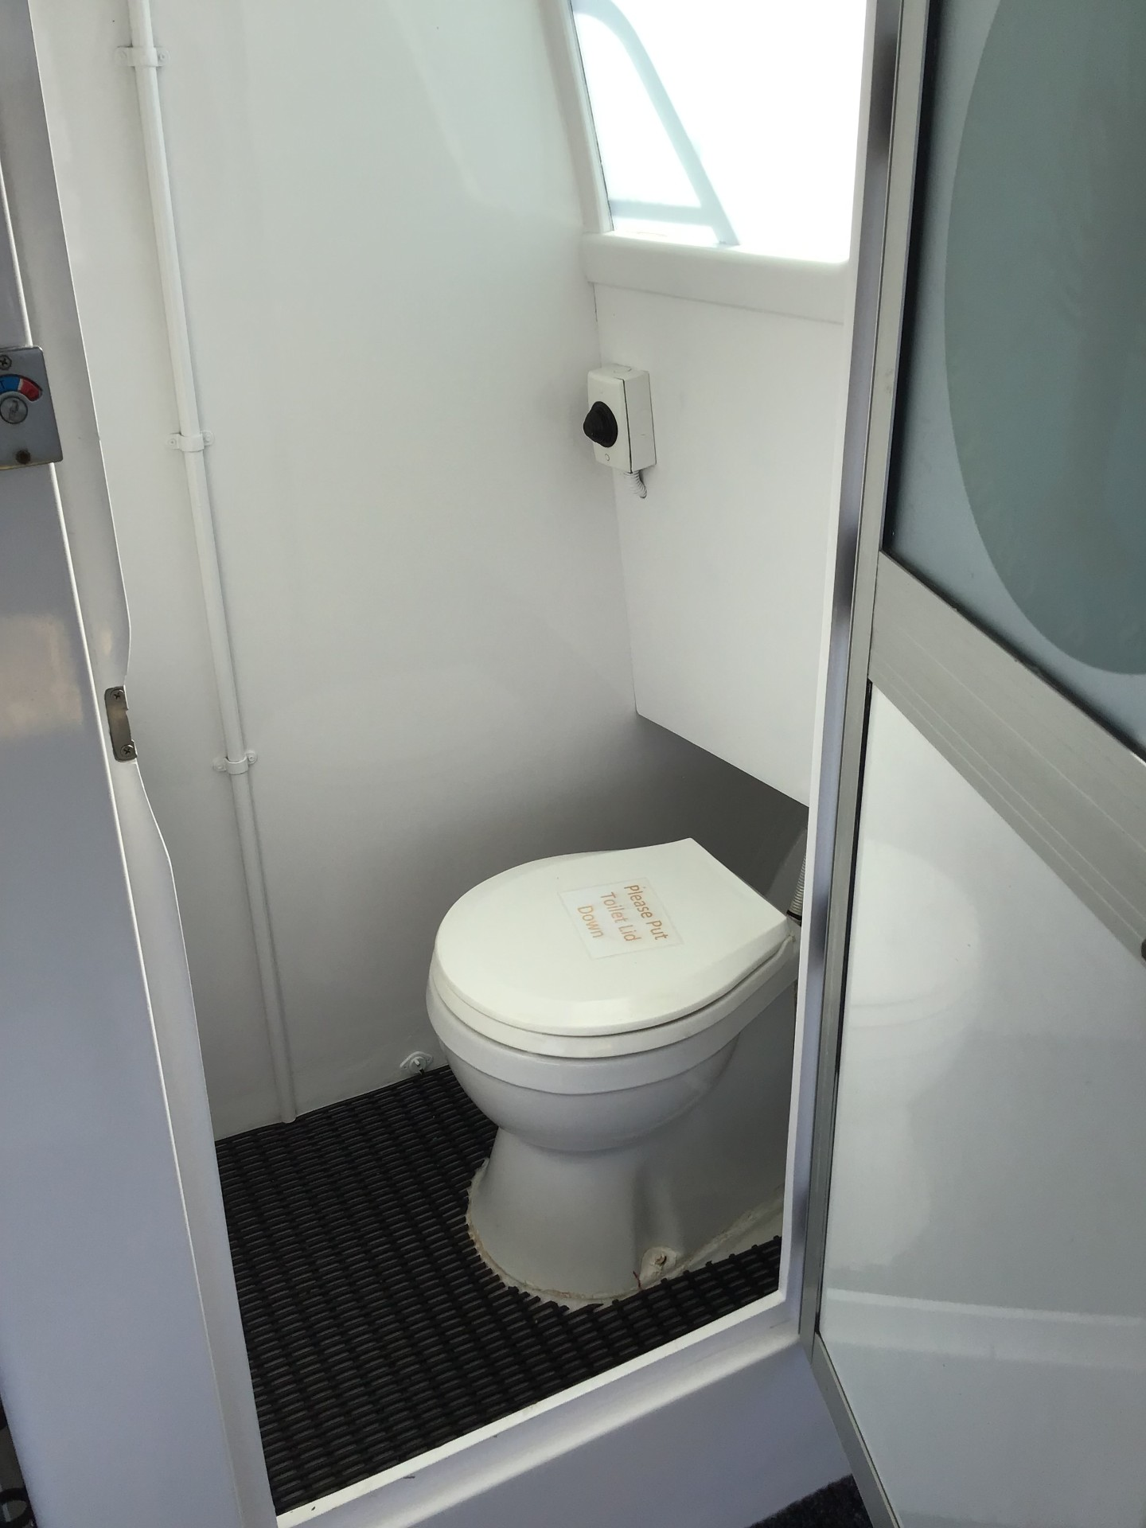
thumbnail_IMG_1980

Guides
- Use of clear/simple English
- Correct pronunciation for lip readers
- Marine
- Marine craft are wheelchair accessible
- Length (cm) 80.
- Width (cm) 80.
- Height (cm) 120.
- Weight (kg) 40.
  - Image(s)
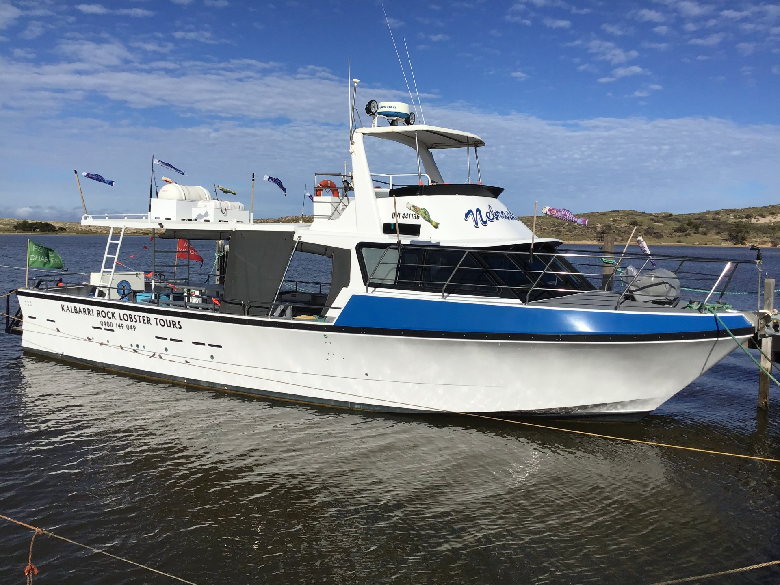
thumbnail_IMG_1978
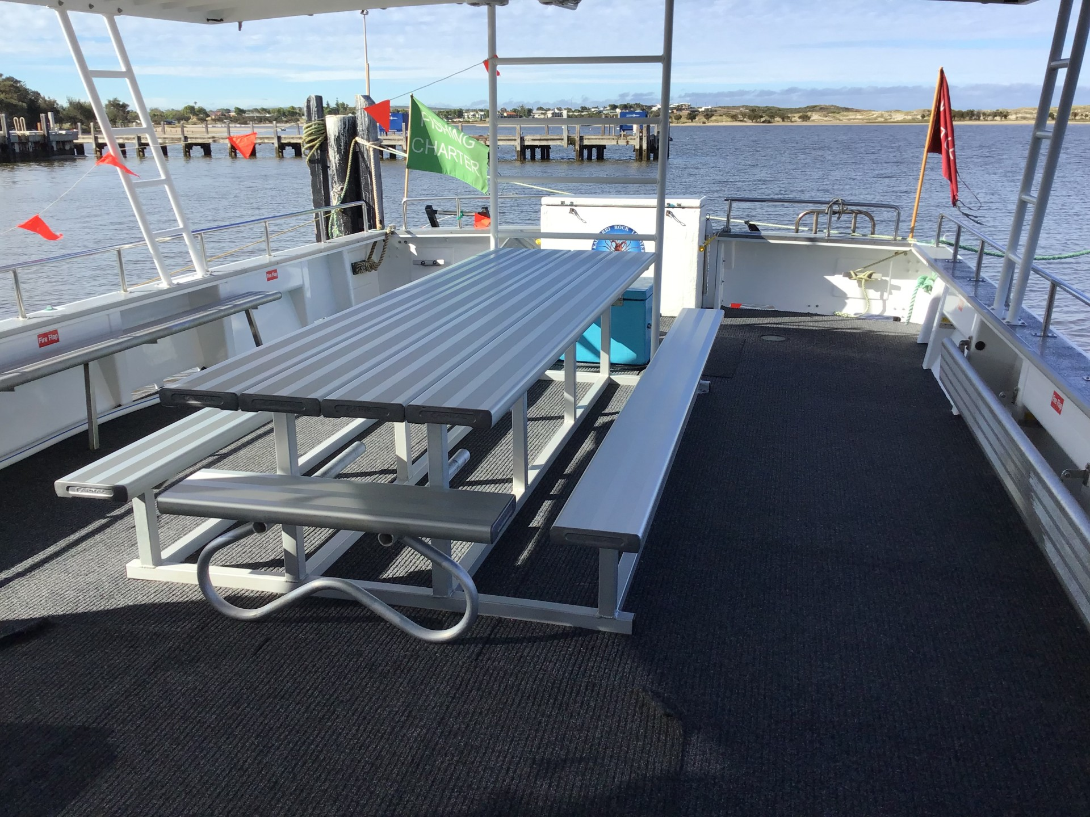
thumbnail_IMG_1981

Report Disclaimer
Please note that this business report, provided as a result of the use of the diagnostic assessment, is for information purposes only.
Australian Tourism Industry Council (ATIC) cannot guarantee the accuracy of respondent’s answers, or that they are fully representative of your business. Therefore, ATIC does not warrant or guarantee any particular outcome in respect of your businesses self-assessment.
This report is intended as guidance only for your business and should not be relied on for future marketing considerations. ATIC recommends that you seek your own independent advice as well as the results from the diagnostic.
Links to external web sites are inserted for convenience and do not constitute endorsement of material at those sites, or any associated organisation, product or service.
ATIC does not:
- Assume any legal liability for the accuracy, completeness, or usefulness of any information from this report or any links provided; or
- Accept responsibility for any loss associated directly or indirectly from the use of this report.

