ATIC Accessibility
To support the accessible community in making informed travel decisions for their individual needs

This report prepared for:
Business name: | Fun Over 50 Holidays - Immersive Tours and Adventures
Address: | 316 Ford Road
Town: | Burbank
Contact for enquiries: | Cassie Fitton
Contact Number: | 1300554505
Contact Email: | info@funover50holidays.com.au
Website: | https://www.funover50holidays.com.au/
Date: | 2026-05-23 21:19

ATIC Accessibility
The following pages provides travellers with information on the businesses facilities and amenities which aims to support the traveller to make an informed decision on whether the business is suitable for their individual needs.
OVERVIEW 4
Business Overview 4
Bookings 4
Emergency Management 4
Communications 5
Guide Dog and Service Animals 5
GENERAL 6
Pre-arrival, arrival and reception 6
Cognitive Impairment Support 6
Car Park and Access amenities 6
Displays, exhibits, commentary and live performances 6
Steps 7
TOUR OPERATORS 8
Tour/Transport Services 8
Route Planning 8
Guides 8
ACCOMMODATION 10
FOOD AND DRINK 11
Dining Spaces 11
Report Disclaimer 13

OVERVIEW

Business Overview

The business has the following products/services available
- Tour/Transport

Our business caters for the following disability types:
- Blind or low vision
- Deaf or low hearing
- Limited mobility
- Food allergies or intolerances
- Cognitive or people on the Autism Spectrum

Bookings

The business offers the following methods for bookings and enquiries:
- Phone
- Email
- Webportal
- Our website supports Screen Readers
- Our forms have high contract boxes and submit boxes
- Staff have undergone disability awareness and training

Emergency Management
- The business has an emergency management and evacuation plan for guests with a disability
- Emergency and evacuation procedures are explained on arrival
- There is an emergency refuge that has an intercommunication system linked and has sufficient fire resistance levels.
- Guests with disabilities are noted in the guest log book for emergency and evacuation purposes

Communications
- An accessibility guide is available on the website
https://www.funoverfifty.com.au/tour-information/fitness-ratings
- Our website meets WCAG 2.0 accessibility standards
- Our business offers the following alternative communication methods
- Plain English
- There is easy to read signage and information (e.g. menus and emergency information)
Signage onboard coaches and in guest itineraries, tour guiding system (hearing device with transmitter and receiver), fits hearing aids also. Legally deaf guests, we provide daily written itinerary.

Guide Dog and Service Animals
- The business provides a secure area with shade and water for service animals
- The business provides a toilet area for service animals
The business provides the following services for services animals: We accept service animals when touring, we stop every 2 hours for toilet break for the animals, work closely with accommodation providers to comply with accessibility requests.

GENERAL

Pre-arrival, arrival and reception
The business has the following in place to support guests during pre-arrival, arrival and reception
- Booking information and websites are compatible with screen readers
The following steps are in place to ensure that people with fatigue related to their disability are not disadvantaged by long wait times: We have a swift, pre-arranged check in process with no guest wait times. The host and office staff manage prior to arrival. Tour Host and Coach Captain assist guests where required.

Cognitive Impairment Support
- Documents are available in plain English for people with cognitive impairment (This may include instructions, guides, menus and general information)
- Quiet periods or early opening times for people on the Autism Spectrum

Car Park and Access amenities
The business has the following Car Park and Access amenities
- A drop off zone
- In addition, the following further information can assist guests:
We are a tour operator and all the above information is not related to our services.

Displays, exhibits, commentary and live performances
For displays, exhibits, commentary and live performances the following amenities are in place
- Seating
- A written transcript where audio description is provided i.e. display commentary, tour commentary
- Hearting loops for live shows and presentations
- In addition, the following further information can assist guests:
We provide a tour guide system that has transmitter and receivers that guests wear to improve hearing. we provide a daily script of commentary for legally deaf guests. Our onboard safety messaging on the coaches is closed captions.
The width of the smallest pathway is: We do not have pathways on our coaches.
We do not have pathways on our coaches.

Steps
Steps
- There are steps.
- Top and bottom steps are easily distinguished through colour contrast or the use of TGSIs (Tactile Ground Surface Indicators)
- All steps or staircases have enclosed risers
- The underside of all staircases are enclosed or protected to a height of at least 2 metres
- Handrails fitted to all open sets of steps
- Handrails extend 300mm beyond the top and bottom step
- In addition, the following further information can assist guests:
Our coaches have the capacity to kneel to the curbside, they have handrails and safety strips on the treads.
- In addition, the following further information can assist guests:
This section is not applicable to us an extended coach tour operator.

TOUR OPERATORS

Tour/Transport Services
The tour/transport services have the following facilities/amenities in place
- Buses/Coaches
- 0 vehicles have wheelchair lifts or ramps
- 0 vehicles have low floors with ramped entry
The maximum wheelchair capacity available in the fleet is: 0
- There are hearing loops
- Commentary is available in written format
- Audio visual displays are sub titles

Route Planning
- Route Planning
- The tour route includes stops with accessible toilet facilities
- In addition, the following further information can assist guests:
We are not a public transport company. Our tours do not suit those in a wheelchair however those with other mobility impairment such as wheeler walker and walking sticks, can travel on our lower fitness graded tours. Our coach has a kneel facility to lower to the curb for ease of boarding and handrails.
- Lunch stop venues are accessible
- Overnight Stops
- For overnight stays, wheelchair accessible rooms are available
The total number of wheelchair passengers that can be catered for at overnight stops are: 0
- Walking Tours
- Multi-paced to account for slower walkers

Guides

Guides have been trained in the following
- Use of clear/simple English
- Correct pronunciation for lip readers
- There is a audio description of surroundings
  - Image(s)
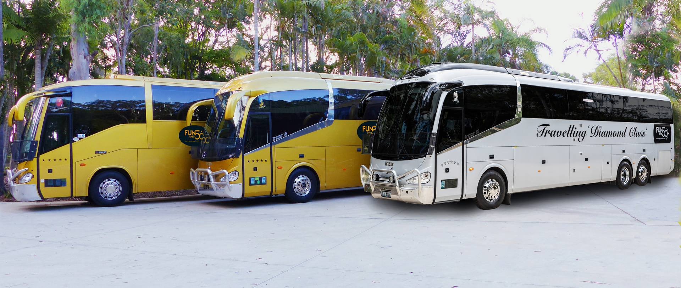
3-coaches_diamond--gold-ext
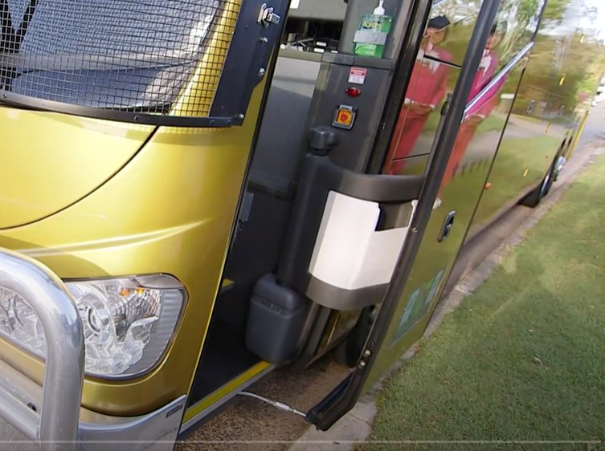
Bus Lowers to Curb
- This tour stops at attractions/accommodation/food and beverage/retail spaces that are not operated by this business. For information relating to these individual properties please follow the weblink provided

ACCOMMODATION
The accommodation section does not apply to our business as we use 100's of accommodation suppliers. We do not have specific details on every venue.
- In addition, the following further information can assist guests:
The accommodation section does not apply to our business as we use 100's of accommodation suppliers. We do not have specific details on every venue.
- There is The accommodation section does not apply to our business as we use 100's of accommodation suppliers. We do not have specific details on every venue. mm of clear space in front of the toilet
  - Bathroom Image(s)
3-coaches_diamond--gold-ext
- In addition, the following further information can assist guests:
The accommodation section does not apply to our business as we use 100's of accommodation suppliers. We do not have specific details on every venue.

FOOD AND DRINK

Dining Spaces
The dining spaces have the following facilities/amenities in place
- The smallest doorway is The accommodation section does not apply to our business as we use 100's of accommodation suppliers. We do not have specific details on every venue. wide

Our business caters for the following dietary requirements
- Sugar free (diabetic)
- Gluten free (celiac)
- Lactose free (dairy free)
- Low fat and fibre with no gastric content
- Low potassium
- Low sodium
- Nut free
- Additive free
- Organic
- Vegetarian
- Vegan
- Kosher
- Halal
- There are procedures in place to avoid cross-contamination of food products
  - Food and Beverage Image(s)
3-coaches_diamond--gold-ext
- In addition, the following further information can assist guests:
The dining section does not apply to our business as we use 100's of meal suppliers. We do not have specific details on every venue.

Report Disclaimer
Please note that this business report, provided as a result of the use of the diagnostic assessment, is for information purposes only.
Australian Tourism Industry Council (ATIC) cannot guarantee the accuracy of respondent’s answers, or that they are fully representative of your business. Therefore, ATIC does not warrant or guarantee any particular outcome in respect of your businesses self-assessment.
This report is intended as guidance only for your business and should not be relied on for future marketing considerations. ATIC recommends that you seek your own independent advice as well as the results from the diagnostic.
Links to external web sites are inserted for convenience and do not constitute endorsement of material at those sites, or any associated organisation, product or service.
ATIC does not:
- Assume any legal liability for the accuracy, completeness, or usefulness of any information from this report or any links provided; or
- Accept responsibility for any loss associated directly or indirectly from the use of this report.

