ATIC Accessibility
To support the accessible community in making informed travel decisions for their individual needs

This report prepared for:
Business name: | Mandalay Holiday Resort
Address: | 652 Geographe Bay Rd
Town: | Broadwater
Contact for enquiries: | Rhys Johnson
Contact Number: | 0897521328
Contact Email: | info@mandalayresort.com.au
Website: | https://mandalayresort.com.au/
Date: | 2026-10-24 00:37

ATIC Accessibility
The following pages provides travellers with information on the businesses facilities and amenities which aims to support the traveller to make an informed decision on whether the business is suitable for their individual needs.
OVERVIEW 4
Business Overview 4
Bookings 4
Emergency Management 4
Communications 5
Other Information 5
GENERAL 6
Pre-arrival, arrival and reception 6
Cognitive Impairment Support 6
Car Park and Access amenities 6
Entry 7
Internal Spaces 7
Public areas 7
External Paths 8
Steps 8
Ramps 8
Public Toilets/Adult change facilities 8
ACCOMMODATION 10
Bedrooms 10
Room Amenities 10
Bathrooms 11
COMMON AREAS 13
Play Spaces 13
Swimming pools, spas and waterparks 13
Report Disclaimer 16

OVERVIEW

Business Overview

The business has the following products/services available
- Accommodation

Our business caters for the following disability types:
- Blind or low vision
- Deaf or low hearing
- Limited mobility
- Wheelchairs or mobility scooters
- Food allergies or intolerances
- Cognitive or people on the Autism Spectrum

Bookings

The business offers the following methods for bookings and enquiries:
- Phone
- Email
- Webportal
- Our forms have high contract boxes and submit boxes

Emergency Management
- Emergency and evacuation procedures are explained on arrival
- There are Audible device/s to alert occupants to evacuate with instructions on how to evacuate.
- There are visual device/s to alert occupants to evacuate.
- Exit signs are clear and easy to see
- Exit access is free and clear at all times
We ensure exit access is free and clear at all times by: Multiple paths for exit. All roads and pathways are open and accessible for wheelchairs.
- Exits and access to exists are greater than 900mm
- Exit doors are able to be opened by all occupants
- Exits to the emergency evacuation point does not include stairways
- The evacuation point is clearly marked by a sign
The business identifies guests who need additional assistance should an emergency occur by: All guests are registered on arrival.
The procedure for assisting guests who need assisted rescue is: The chief warden will arrange actions as necessary, every assisted rescue is unique.

Communications
- An accessibility guide is available on the website
https://mandalayresort.com.au/accommodation/accessible-accommodation/

Other Information
- For bookings made onsite, the ticket booth/counter/box office is accessible for people using a wheelchair
- The business accepts the companion card
The business provides the following services for services animals: Service animals are allowed throughout our resort.

GENERAL

Pre-arrival, arrival and reception
The business has the following in place to support guests during pre-arrival, arrival and reception
- Booking information and websites are compatible with screen readers
- There is a reception/public entryway.
- Seating available at reception
- A lower counter at reception/ticket office
- A clipboard to allow check-in/ticket purchase whilst seated
- Lighting in the reception area is even and glare free
- Information and maps are available in written form
- A familiarisation tour
- Advertising material, web sites and social media contain information relating to phone numbers available for non-voice communication e: Text, SMS, email and fax
- A key to any accessible facilities that are locked
- Keys are available for each guest
- Luggage assistance
The following steps are in place to ensure that people with fatigue related to their disability are not disadvantaged by long wait times: Accessible bathroom in reception. We very rarely have long wait times, with many reception and ground staff on hand to accommodate guest needs at all times.

Cognitive Impairment Support
- A "social script" guide to your premises or attraction describing the sights, sounds and smells to aid parents/carers prepare visitors in advance
- The 'social script' is available in word and other editable formats
- A space for parents and children on the Autism Spectrum

Car Park and Access amenities
The business has the following Car Park and Access amenities
- A drop off zone
- Designated disabled parking bays
- Level or ramped access from the car park to the entrance
- The accessible entrance is clearly signed from the parking bay
- Kerb ramps are in place where a pavement or walkway needs to be crossed

Entry
The business has the following amenities/systems in place for entry
- A drop off point close to the entrance
- A path of access to the building is slip resistance and even
- A path of access to the building is clear of obstruction
- Self opening entry doors or fitted with a self closer
- Glass doors are fitted with a visual sighting strip
- Door jams/doors are of a contrasting colour to surrounding walls
- Door handles are of a contrasting colour to the door
- Signage is written in a contrasting colour
- The entry door is a minimum of 850mm wide
- The entry door has self opening or a light opening pressure (for manual operations)
- The entrance sill is less than 13mm
- The entrance door mats have a thickness less than 13mm and a width of 7500mm or greater

Internal Spaces
- Clear and unobstructed routes through and between buildings
- Interior walls are matte or low sheen
- Floors, walls, counters and furniture are of contrasting colours
- Any protruding or overhanging obstructions are at least 2meters above the floor or are protected
- Floor surfaces are hard or short pile carpet
- Seating is available for guests unable to stand for long periods
- Accessible facilities are clearly signed and visible from all areas
- All corridors greater than 900mm
- There is a quiet space for parents and children on the Autism Spectrum

Public areas
The public areas have the following amenities in place
- Display units, Televisions, Video displays etc. are open captioned
- Even lighting
- Seating

External Paths
External paths of travel
- Surfaces are concrete, asphalt, smooth paving or hard packed fine gravel (max aggregate size 13mm)
- Pathways are wider than 900mm
- There 3 successive steps or less on any path or at any doorway
All paths are wheelchair accessible.

Steps
Steps
- There are steps.
- Top and bottom steps are easily distinguished through colour contrast or the use of TGSIs (Tactile Ground Surface Indicators)
- All steps or staircases have enclosed risers
- The underside of all staircases are enclosed or protected to a height of at least 2 metres
- Handrails fitted to all open sets of steps
- Handrails extend 300mm beyond the top and bottom step
- Where steps are present are there three steps or less

Ramps
Ramps have the following amenities are in place
- There are ramps.
- All fixed ramps are 1:14 or less
- Long ramps (more than 10m) are 1:20 or less

Public Toilets/Adult change facilities
Public Toilets/Adult change facilities have the following amenities are in place
- There is an accessible toilet for public use
- The door is at least 850mm wide
- There is a minimum of 850mm beside the toilet
- Handrails are fitted
- The toilet seat is 460mm above the floor
- There is 1400mm mm of clear space in front of the toilet
- The toilet seat of a contrasting colour to the floor
- The toilet seat is460mm above the floor

ACCOMMODATION

Bedrooms
The bedrooms have the following facilities/amenities in place
- There are 2 rooms available to guests who use a wheelchair
- Bedroom furniture can be re-arranged on request

The following bed types are available in wheelchair accessible rooms
- One double/queen bed/king bed
- Two single beds
  - Layout of room Image(s)
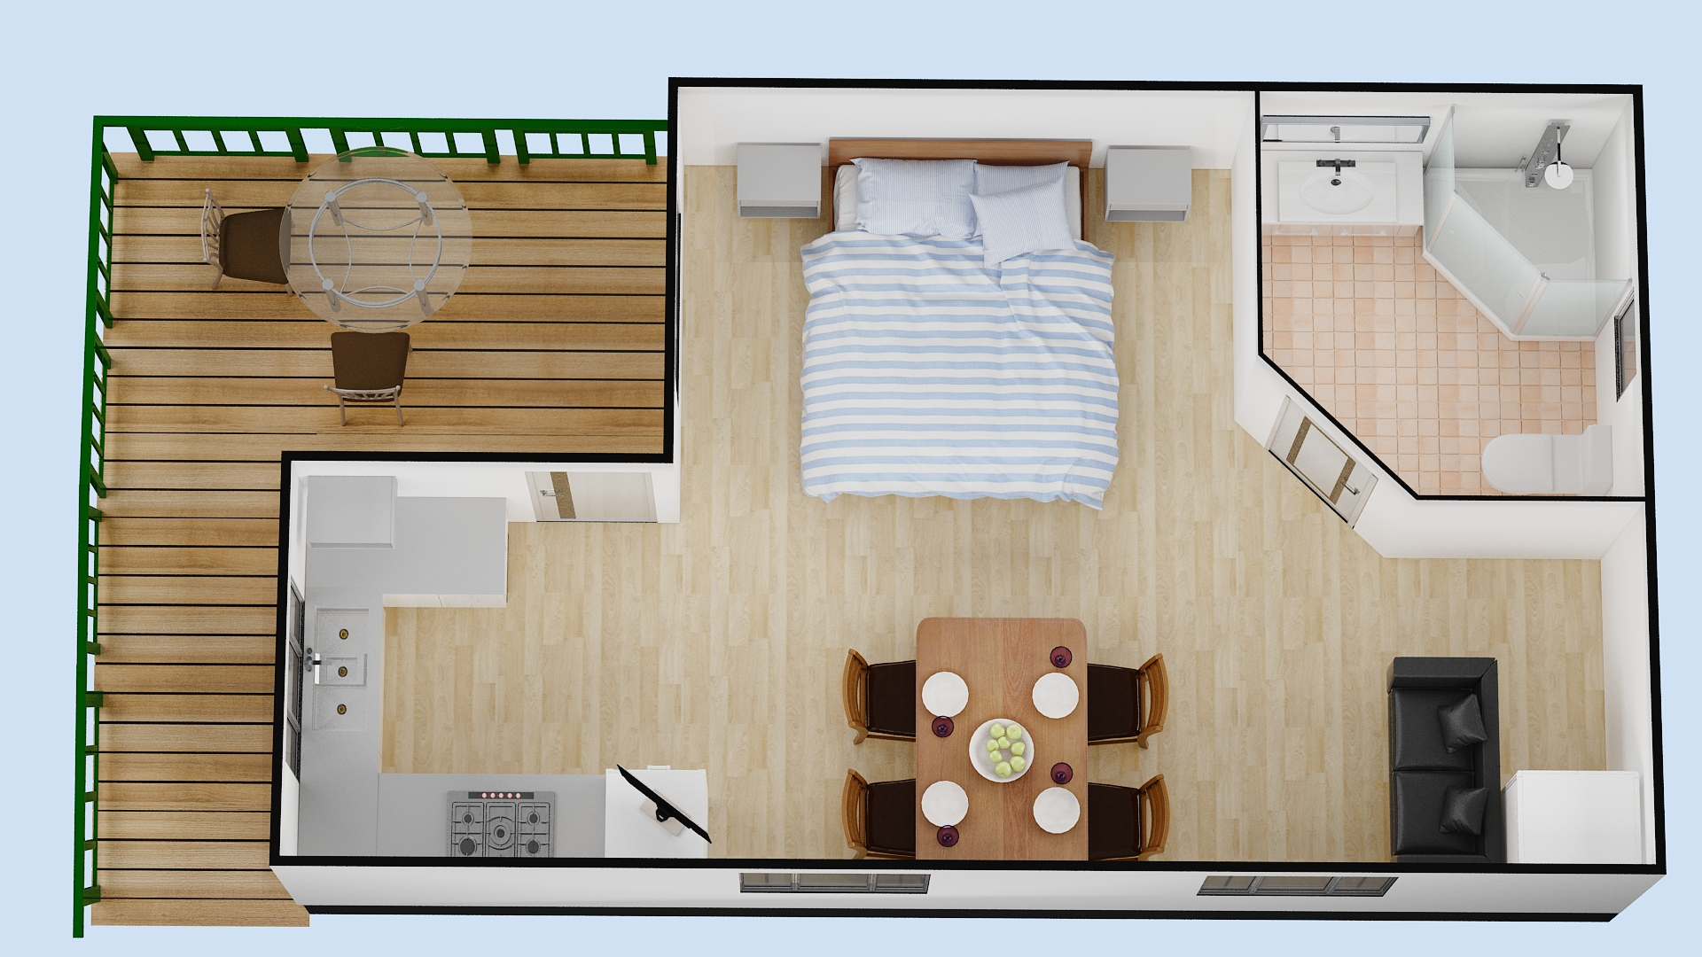
Accessible cabin

Room Amenities
- Lower hanging rails are in wardrobes
For guests with a hearing impairment, the following emergency evacuation procedures apply to ensure safe evacuation: All guests are registered on arrival and will be accounted for by the chief warden if an evacuation occurs.
- Televisions are equipped with closed captioning capability
- There is contrast between the walls, skirtings, floor and furniture
- There is a clear path through the room
- The edges of all furniture and fixtures are rounded
- Wardrobe handles are a contrasting colour to the doors and draws
- Doors open fully against the adjoining wall
- There is a clear opening at least 850mm wide
- There at least one chair with rigid arms
- Wardrobe and drawer handles are easy to grip
- The bedside lamp switch is easy to reach from the bed
- There is at least 850mm clear space beside the bed
- The bed height is no higher than 680mm from the floor
- Blocks are available to put under the bed legs
- Non-allergenic cleaning products are used

Bathrooms
The bathrooms have the following facilities/amenities in place
- All heating appliances and hot water pipes are protected or insulated
- All shower, bath and basin taps are clearly differentiated between hot and cold
- Fixtures and fittings have rounded edges
- The hot water is thermostatically controlled to 41 degrees
- The door is at least 850mm wide
- There is a minimum of 850mm beside the toilet
- Handrails are fitted
- There is a minimum of 1400mm of clear space in front of the toilet
- The toilet seat is a contrasting colour to the floor
- The toilet seat is 460mm above the floor
- A range of non-allergenic toiletries are available
- There is a roll-in shower with fold down fixed seat or a shower chair
- There is a portable shower head on flexible hose
- A door is fitted to the shower
- A door is fitted to the showers with an outward swing at minimum width of 900 mm
  - Bathroom Image(s)
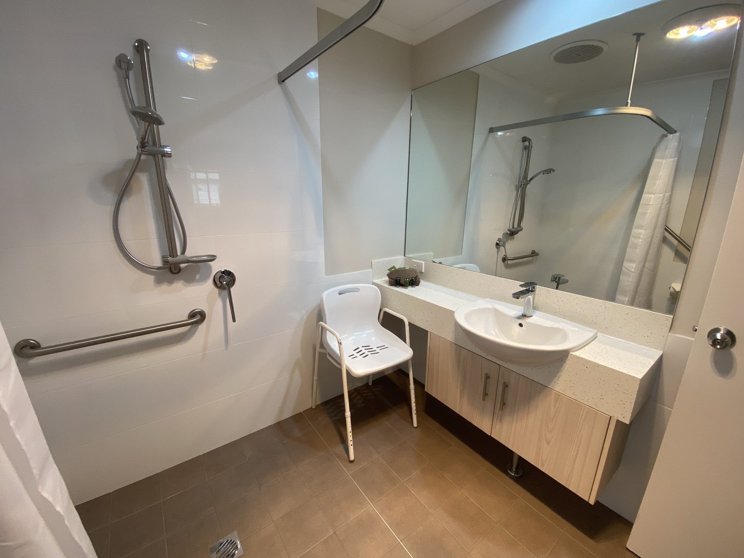
Accessible Sink
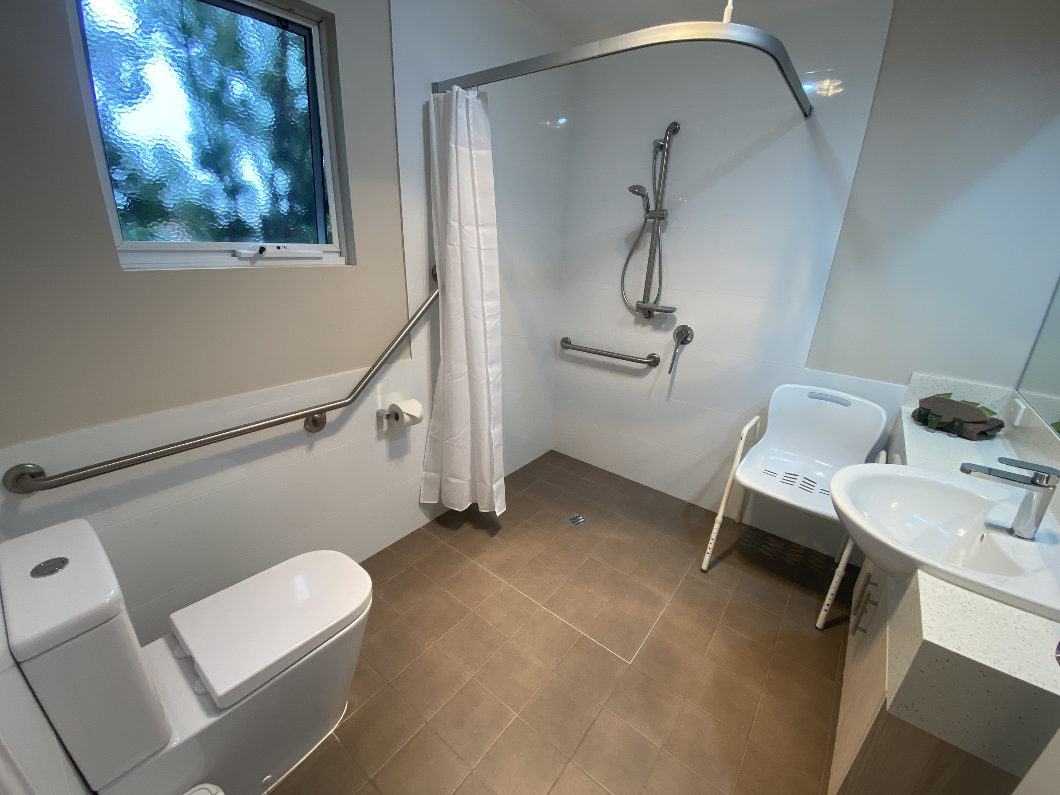
Bathroom 1-1
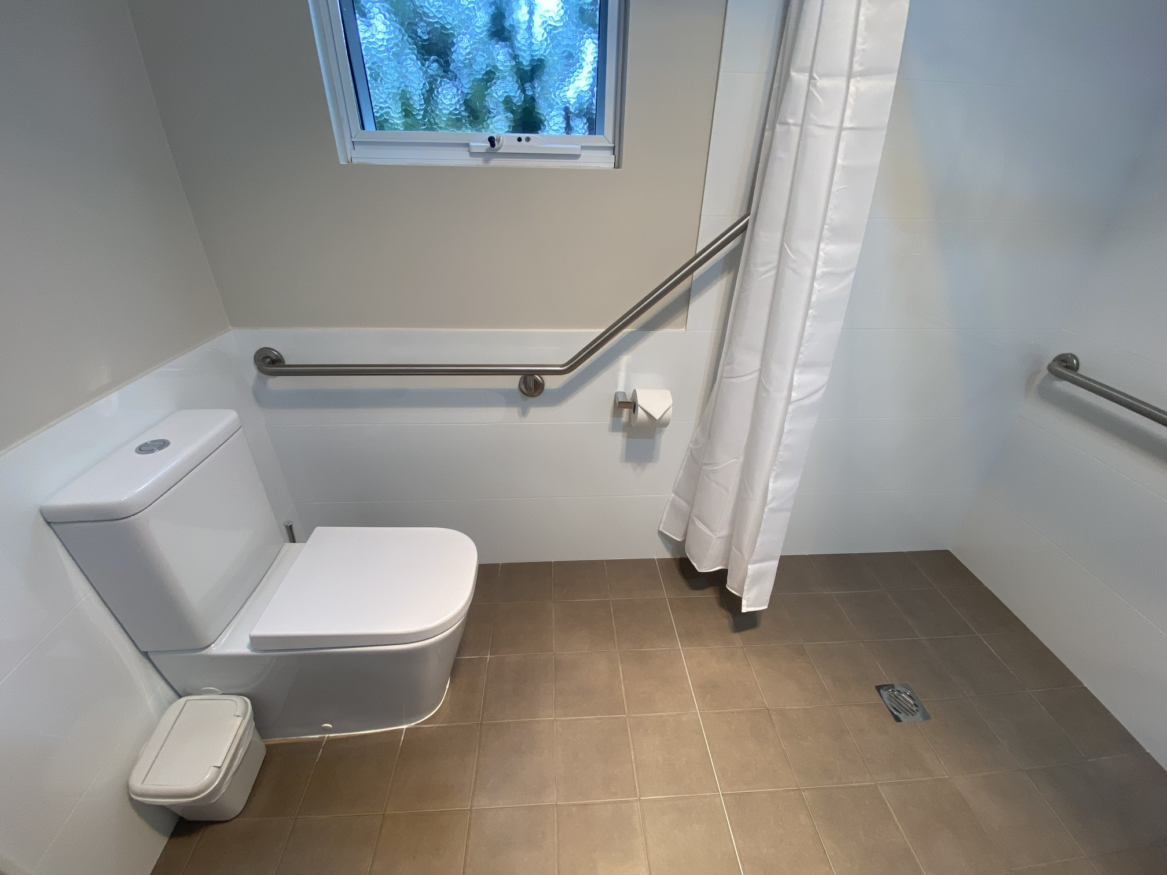
Toilet

COMMON AREAS

Play Spaces
- Level access is provided to play spaces
- Ramps provided are at least 25% of elevated sections of the play space
- The surface of the play space is of a composite or rubberized material
- There wheelchair accessible activities
- The play space contains tactile play panels or activities
- The space contain colour contrasting elements
- Seating is provided in or around the play space
  - Image(s)
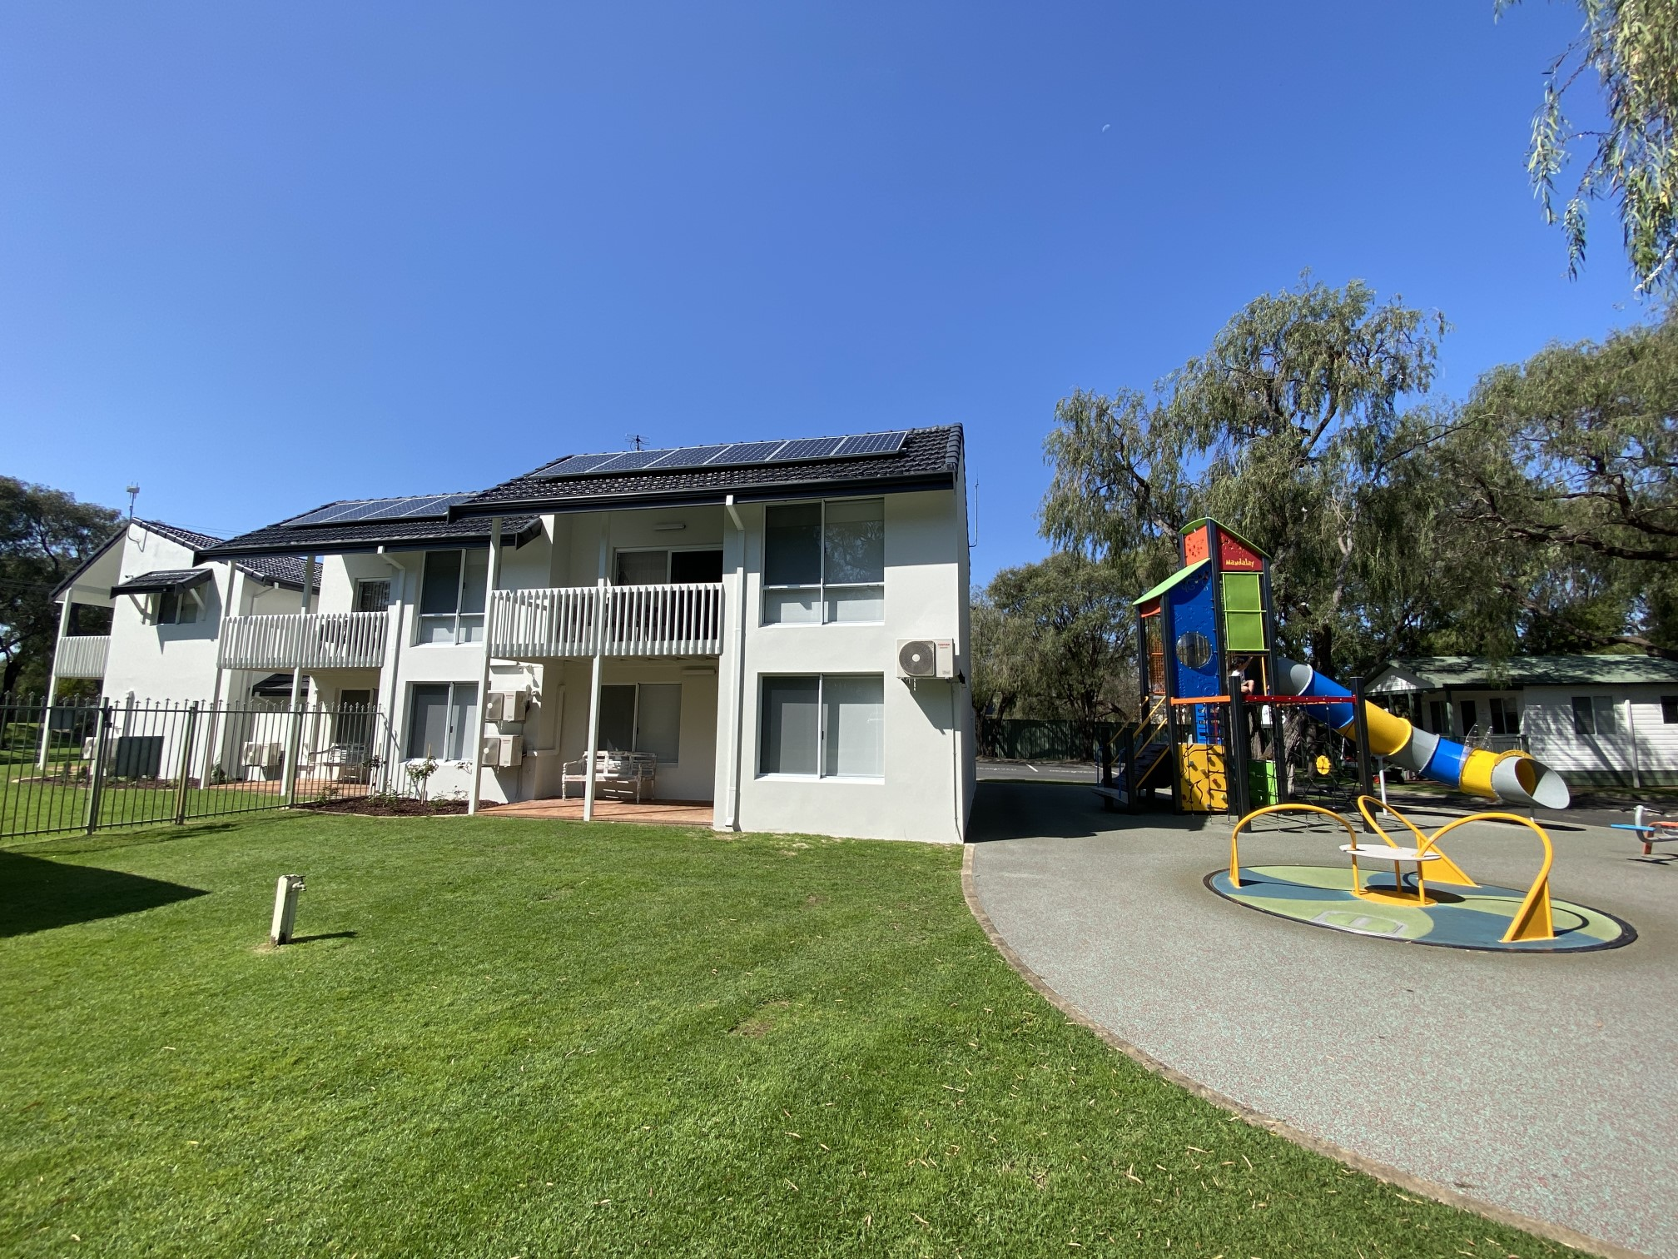
Villa Exterior with playground

Swimming pools, spas and waterparks
- The following swimming pools, spas and waterparks amenities are available
- Beach or pool wheelchairs
- Unisex change facilities with an accessible toilet

The following accessible entry methods are available to the pools and spas:
- Sloped/level entry
- Transfer wall
- Transfer stairs
- Accessible pool stairs (hand rails both sides)
  - Pool Access Image(s)
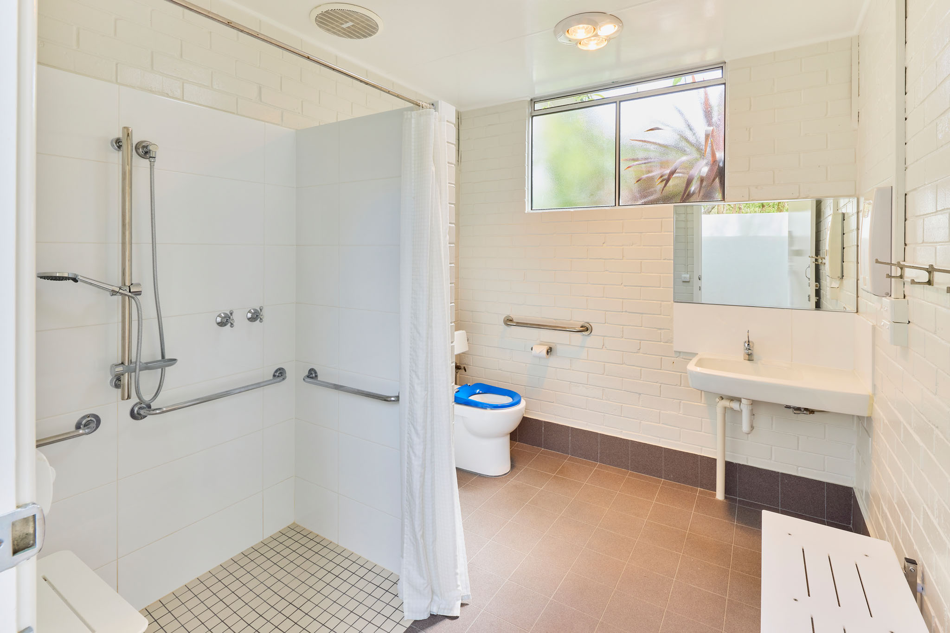
Mandalay-October-2021-078
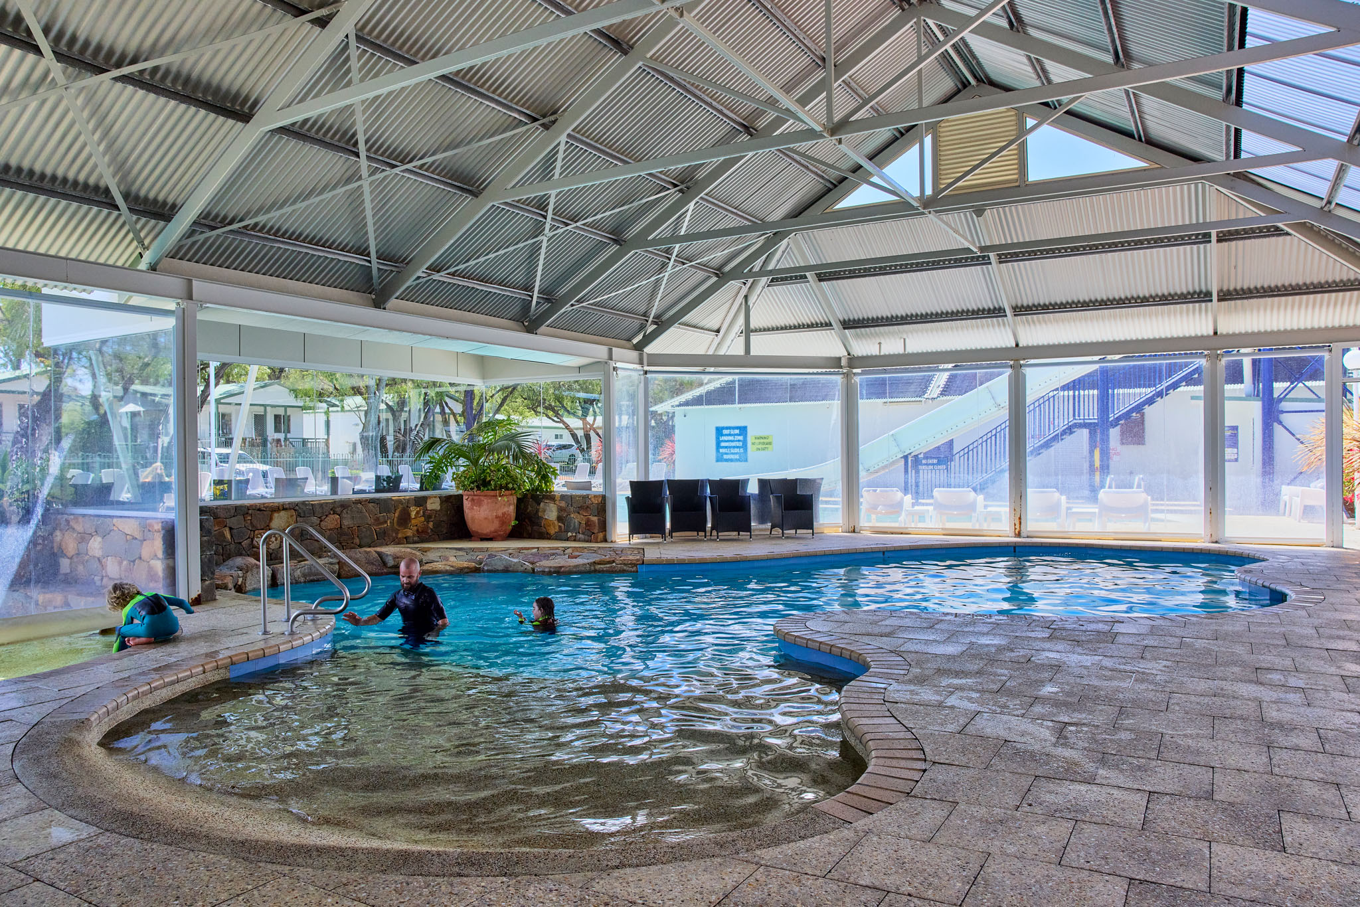
Mandalay-October-2021-197

Report Disclaimer
Please note that this business report, provided as a result of the use of the diagnostic assessment, is for information purposes only.
Australian Tourism Industry Council (ATIC) cannot guarantee the accuracy of respondent’s answers, or that they are fully representative of your business. Therefore, ATIC does not warrant or guarantee any particular outcome in respect of your businesses self-assessment.
This report is intended as guidance only for your business and should not be relied on for future marketing considerations. ATIC recommends that you seek your own independent advice as well as the results from the diagnostic.
Links to external web sites are inserted for convenience and do not constitute endorsement of material at those sites, or any associated organisation, product or service.
ATIC does not:
- Assume any legal liability for the accuracy, completeness, or usefulness of any information from this report or any links provided; or
- Accept responsibility for any loss associated directly or indirectly from the use of this report.

