ATIC Accessibility
To support the accessible community in making informed travel decisions for their individual needs

This report prepared for:
Business name: | Creative Tours
Address: | 71 Valetta Street
Town: | Manly
Contact for enquiries: | Jamie Marshall
Contact Number: | 0438823377
Contact Email: | hello@creativetours.com.au
Website: | www.creativetours.com.au
Date: | 2026-10-24 19:03

ATIC Accessibility
The following pages provides travellers with information on the businesses facilities and amenities which aims to support the traveller to make an informed decision on whether the business is suitable for their individual needs.
OVERVIEW 4
Business Overview 4
Bookings 4
Emergency Management 4
Communications 5
Other Information 5
Guide Dog and Service Animals 5
GENERAL 6
Pre-arrival, arrival and reception 6
Cognitive Impairment Support 6
Entry 6
Internal Spaces 6
Public areas 6
Displays, exhibits, commentary and live performances 7
External Paths 7
TOUR OPERATORS 8
Tour/Transport Services 8
Route Planning 8
Guides 8
FOOD AND DRINK 9
Dining Spaces 9
Report Disclaimer 13

OVERVIEW

Business Overview

The business has the following products/services available
- Tour/Transport
- Food and Drink

Our business caters for the following disability types:
- Blind or low vision
- Deaf or low hearing
- Limited mobility
- Food allergies or intolerances
- Cognitive or people on the Autism Spectrum

Bookings

The business offers the following methods for bookings and enquiries:
- Phone
- Email
- Webportal
- Our forms have high contract boxes and submit boxes

Emergency Management
- Emergency and evacuation procedures are explained on arrival
- Exit doors are able to be opened by all occupants
- The evacuation point is clearly marked by a sign
The business identifies guests who need additional assistance should an emergency occur by: Through prior communication
The procedure for assisting guests who need assisted rescue is: Procedures noted through prior communication
- Guests with disabilities are noted in the guest log book for emergency and evacuation purposes

Communications

Other Information
- The business accepts the companion card

Guide Dog and Service Animals
- The business provides a secure area with shade and water for service animals
The business provides the following services for services animals: N/a

GENERAL

Pre-arrival, arrival and reception
The business has the following in place to support guests during pre-arrival, arrival and reception
- A step free map/guide
- A familiarisation tour
The following steps are in place to ensure that people with fatigue related to their disability are not disadvantaged by long wait times: Small group tours. Short drives between venues.

Cognitive Impairment Support
- Documents are available in plain English for people with cognitive impairment (This may include instructions, guides, menus and general information)
- A "social script" guide to your premises or attraction describing the sights, sounds and smells to aid parents/carers prepare visitors in advance

Entry
The business has the following amenities/systems in place for entry
- A drop off point close to the entrance
- A path of access to the building is clear of obstruction

Internal Spaces
- Clear and unobstructed routes through and between buildings
- Seating is available for guests unable to stand for long periods
The width of the smallest corridor is: N/A

Public areas
The public areas have the following amenities in place
- Even lighting
- Seating

Displays, exhibits, commentary and live performances
For displays, exhibits, commentary and live performances the following amenities are in place
- Seating
- Wheelchair accessible spaces/seating

External Paths
External paths of travel
The width of the smallest pathway is: N/A
- There 3 successive steps or less on any path or at any doorway

TOUR OPERATORS

Tour/Transport Services
The tour/transport services have the following facilities/amenities in place
- Buses/Coaches
- 0 vehicles have wheelchair lifts or ramps
- 0 vehicles have low floors with ramped entry
The maximum wheelchair capacity available in the fleet is: 2 x folded

Route Planning
- Route Planning
- The tour route includes stops with accessible toilet facilities
- Lunch stop venues are accessible
- Sightseeing and photo opportunity stops are step free

Guides
- Use of clear/simple English
- Correct pronunciation for lip readers
- There is a audio description of surroundings
  - Image(s)
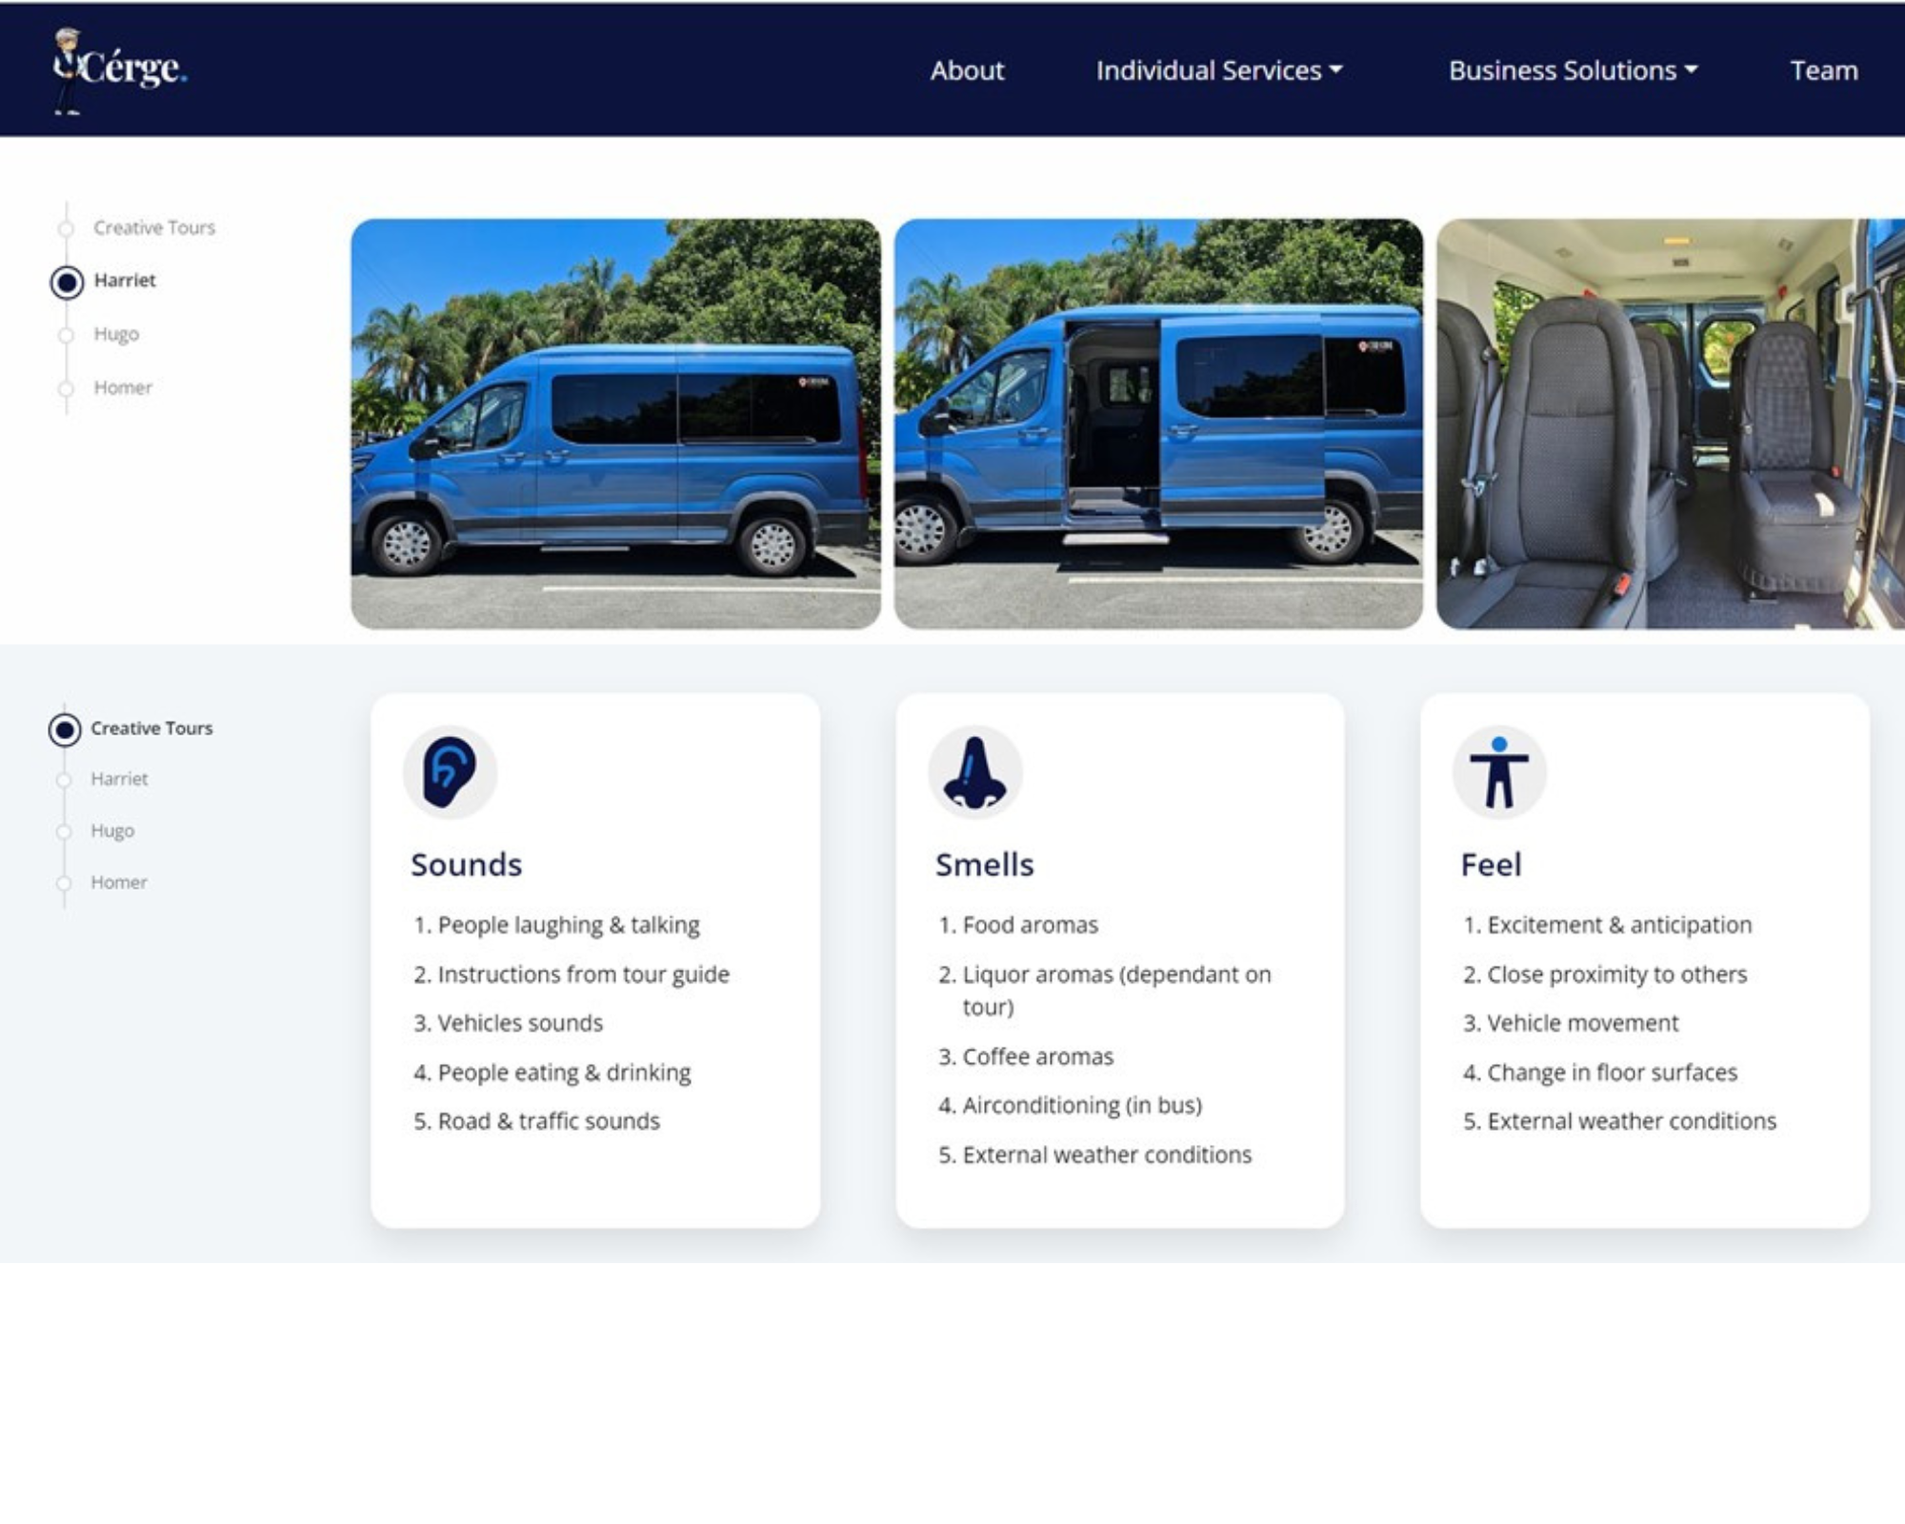
Cerge website
- This tour stops at attractions/accommodation/food and beverage/retail spaces that are not operated by this business. For information relating to these individual properties please follow the weblink provided

FOOD AND DRINK

Dining Spaces
The dining spaces have the following facilities/amenities in place
- The smallest doorway is N/A wide
- There is level access through the dining area
- Chairs are moveable to allow for wheelchairs to be seated at the tables
- There are areas of full lighting
- There are Plain English menus
- There is an accessible toilet

Our business caters for the following dietary requirements
- Sugar free (diabetic)
- Gluten free (celiac)
- Lactose free (dairy free)
- Low fat and fibre with no gastric content
- Low potassium
- Low sodium
- Nut free
- Additive free
- Organic
- Vegetarian
- Vegan
- There are procedures in place to avoid cross-contamination of food products
  - Food and Beverage Image(s)

Creative_Tours_Logo_Pink_Primary_Reverse

Report Disclaimer
Please note that this business report, provided as a result of the use of the diagnostic assessment, is for information purposes only.
Australian Tourism Industry Council (ATIC) cannot guarantee the accuracy of respondent’s answers, or that they are fully representative of your business. Therefore, ATIC does not warrant or guarantee any particular outcome in respect of your businesses self-assessment.
This report is intended as guidance only for your business and should not be relied on for future marketing considerations. ATIC recommends that you seek your own independent advice as well as the results from the diagnostic.
Links to external web sites are inserted for convenience and do not constitute endorsement of material at those sites, or any associated organisation, product or service.
ATIC does not:
- Assume any legal liability for the accuracy, completeness, or usefulness of any information from this report or any links provided; or
- Accept responsibility for any loss associated directly or indirectly from the use of this report.

