ATIC Accessibility
To support the accessible community in making informed travel decisions for their individual needs

This report prepared for:
Business name: | Heyscape
Address: | Level 6/ 191 St Georges Terrace
Town: | Perth
Contact for enquiries: | Louisa Choi
Contact Number: | 08 6255 5718
Contact Email: | hello@heyscape.com.au
Website: | heyscape.com.au
Date: | 2026-09-19 18:48

ATIC Accessibility
The following pages provides travellers with information on the businesses facilities and amenities which aims to support the traveller to make an informed decision on whether the business is suitable for their individual needs.
OVERVIEW 4
Business Overview 4
Bookings 4
Emergency Management 4
Communications 5
Guide Dog and Service Animals 5
GENERAL 6
Pre-arrival, arrival and reception 6
Cognitive Impairment Support 6
Car Park and Access amenities 6
Entry 6
Internal Spaces 7
Public areas 7
External Paths 7
Ramps 7
Public Toilets/Adult change facilities 8
ACCOMMODATION 9
Bedrooms 9
Room Amenities 9
Bathrooms 10
COMMON AREAS 12
Report Disclaimer 14

OVERVIEW

Business Overview

The business has the following products/services available
- Accommodation

Our business caters for the following disability types:
- Limited mobility
- Wheelchairs or mobility scooters
- Food allergies or intolerances
- Cognitive or people on the Autism Spectrum

Bookings

The business offers the following methods for bookings and enquiries:
- Email
- Webportal

Emergency Management
- Emergency and evacuation procedures are explained on arrival
- Exit signs are clear and easy to see
- Exits and access to exists are greater than 900mm
- Exit doors are able to be opened by all occupants
- Exits to the emergency evacuation point does not include stairways
The business identifies guests who need additional assistance should an emergency occur by: We encourage guests to always stay with an able bodied person
The procedure for assisting guests who need assisted rescue is: Call out 24/7 guest line or call 000 . These instructions are communicated in the Essential Handbook in the cabin

Communications

Guide Dog and Service Animals
- The business provides a secure area with shade and water for service animals
- Bowls, bedding, etc. are provided for service animals
The business provides the following services for services animals: bowls and bedding

GENERAL

Pre-arrival, arrival and reception
The business has the following in place to support guests during pre-arrival, arrival and reception
- Information and maps are available in written form
- A familiarisation tour
The following steps are in place to ensure that people with fatigue related to their disability are not disadvantaged by long wait times: It is self check in

Cognitive Impairment Support
- Documents are available in plain English for people with cognitive impairment (This may include instructions, guides, menus and general information)
- Quiet periods or early opening times for people on the Autism Spectrum
- A space for parents and children on the Autism Spectrum

Car Park and Access amenities
The business has the following Car Park and Access amenities
- A drop off zone
- Designated disabled parking bays
- Level or ramped access from the car park to the entrance
- The accessible entrance is clearly signed from the parking bay

Entry
The business has the following amenities/systems in place for entry
- A drop off point close to the entrance
- A path of access to the building is slip resistance and even
- A path of access to the building is clear of obstruction
- The entry door is a minimum of 850mm wide
- The entrance sill is less than 13mm
- There a clear space of at least 1500mm x 1500mm in front of all doors.
- The entrance door mats have a thickness less than 13mm and a width of 7500mm or greater

Internal Spaces
- Clear and unobstructed routes through and between buildings
- Interior walls are matte or low sheen
- Any protruding or overhanging obstructions are at least 2meters above the floor or are protected
- Seating is available for guests unable to stand for long periods
- Accessible facilities are clearly signed and visible from all areas
- All corridors greater than 900mm
- There is a quiet space for parents and children on the Autism Spectrum

Public areas
The public areas have the following amenities in place
- Even lighting
- Seating

External Paths
External paths of travel
- Surfaces are concrete, asphalt, smooth paving or hard packed fine gravel (max aggregate size 13mm)
- Pathways are wider than 900mm
No steps
one entrance

Ramps
Ramps have the following amenities are in place
- There are ramps.
- All fixed ramps are 1:14 or less
- Hand rails are fitted
- Long ramps (more than 10m) are 1:20 or less
- Ramps have a raised edge of at least 100mm

Public Toilets/Adult change facilities
Public Toilets/Adult change facilities have the following amenities are in place
- There is an accessible toilet for public use
- The door is at least 850mm wide
- There is a minimum of 850mm beside the toilet
- Handrails are fitted
- The toilet seat is460mm above the floor
- A facility with an adult change table

ACCOMMODATION

Bedrooms
The bedrooms have the following facilities/amenities in place
- There are 1 rooms available to guests who use a wheelchair

The following bed types are available in wheelchair accessible rooms
- One double/queen bed/king bed
  - Layout of room Image(s)
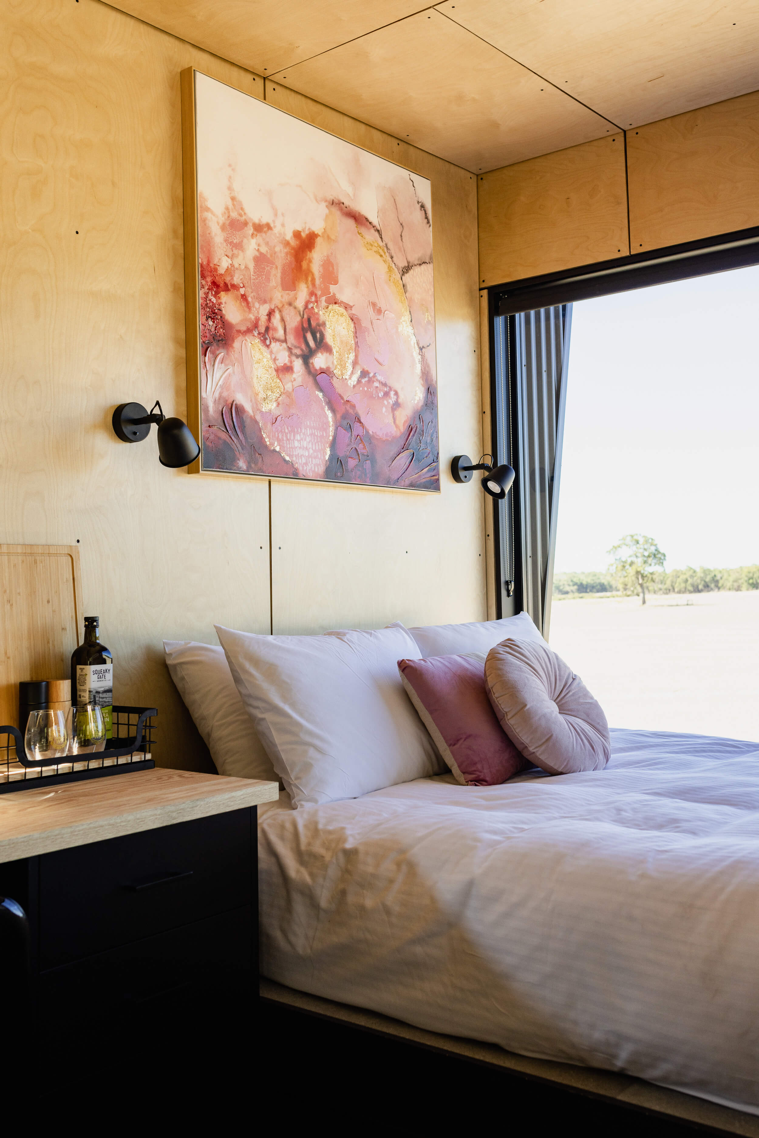
Alisa-Heyscape-MCP-36

Room Amenities
no wardrobe available
For guests with a hearing impairment, the following emergency evacuation procedures apply to ensure safe evacuation: No as we encourage guests to stay with some company that can assist
- Doors open fully against the adjoining wall
- There is a clear opening at least 850mm wide
- The bedside lamp switch is easy to reach from the bed
- The bed height is no higher than 680mm from the floor
- The business offers a range of non-allergenic bedding

Bathrooms
The bathrooms have the following facilities/amenities in place
- All heating appliances and hot water pipes are protected or insulated
- The door is at least 850mm wide
- There is a minimum of 850mm beside the toilet
- Handrails are fitted
- There is a minimum of 1400mm of clear space in front of the toilet
- The toilet seat is 460mm above the floor
- There is a roll-in shower with fold down fixed seat or a shower chair
- There is a portable shower head on flexible hose
  - Bathroom Image(s)
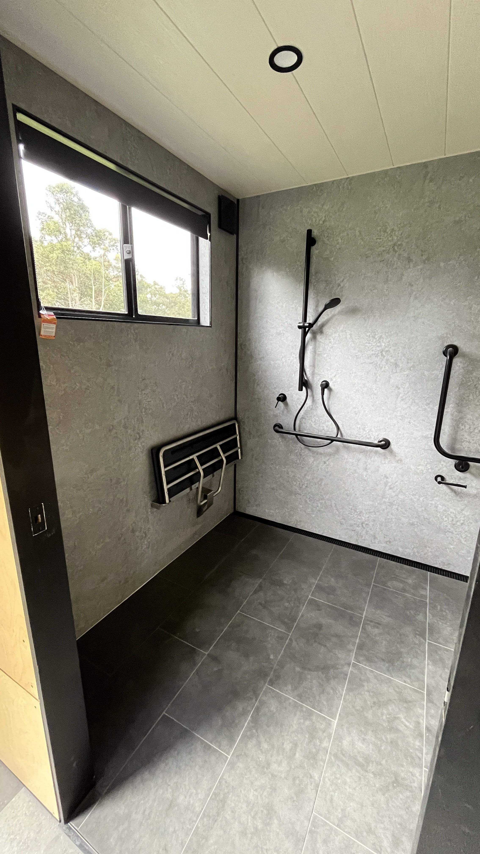
IMG_8012-min
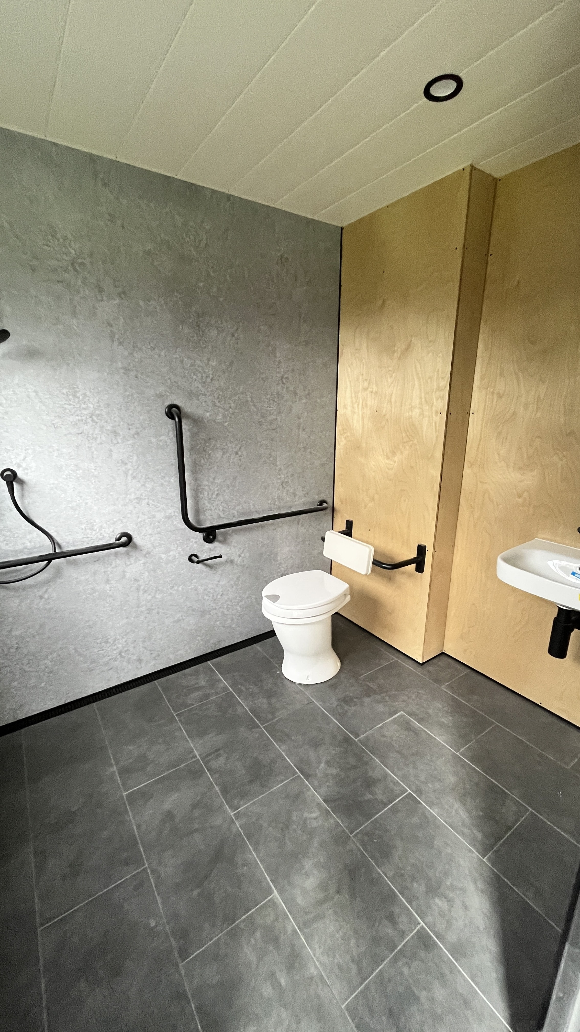
IMG_8013-min

COMMON AREAS

Report Disclaimer
Please note that this business report, provided as a result of the use of the diagnostic assessment, is for information purposes only.
Australian Tourism Industry Council (ATIC) cannot guarantee the accuracy of respondent’s answers, or that they are fully representative of your business. Therefore, ATIC does not warrant or guarantee any particular outcome in respect of your businesses self-assessment.
This report is intended as guidance only for your business and should not be relied on for future marketing considerations. ATIC recommends that you seek your own independent advice as well as the results from the diagnostic.
Links to external web sites are inserted for convenience and do not constitute endorsement of material at those sites, or any associated organisation, product or service.
ATIC does not:
- Assume any legal liability for the accuracy, completeness, or usefulness of any information from this report or any links provided; or
- Accept responsibility for any loss associated directly or indirectly from the use of this report.

