ATIC Accessibility
To support the accessible community in making informed travel decisions for their individual needs

This report prepared for:
Business name: | Central Wheatbelt Visitor Centre
Address: | 45 Barrack Street
Town: | Merredin
Contact for enquiries: | Carina Macdonald
Contact Number: | (08) 9041 1666
Contact Email: | visitor@merredin.wa.gov.au
Website: | www.wheatbelttourism.com
Date: | 2026-11-08 03:13

ATIC Accessibility
The following pages provides travellers with information on the businesses facilities and amenities which aims to support the traveller to make an informed decision on whether the business is suitable for their individual needs.
OVERVIEW 4
Business Overview 4
Bookings 4
Emergency Management 4
Communications 4
Other Information 5
Guide Dog and Service Animals 5
GENERAL 6
Pre-arrival, arrival and reception 6
Cognitive Impairment Support 6
Car Park and Access amenities 6
Entry 7
Internal Spaces 7
Public areas 7
External Paths 8
Public Toilets/Adult change facilities 8
COMMON AREAS 9
Parks and gardens 9
Report Disclaimer 12

OVERVIEW

Business Overview

The business has the following products/services available

Our business caters for the following disability types:
- Limited mobility
- Wheelchairs or mobility scooters

Bookings

The business offers the following methods for bookings and enquiries:
- Phone
- Email
- Webportal

Emergency Management
- Exit signs are clear and easy to see
- Exit doors are able to be opened by all occupants
- Exits to the emergency evacuation point does not include stairways
The business identifies guests who need additional assistance should an emergency occur by: first instance would be guests in wheelchair, frail seniors or using a mobility scooter
The procedure for assisting guests who need assisted rescue is: Emergency services/Unsure

Communications

Other Information
- For bookings made onsite, the ticket booth/counter/box office is accessible for people using a wheelchair
- The business accepts the companion card

Guide Dog and Service Animals
- The business provides a secure area with shade and water for service animals
The business provides the following services for services animals: water, and access to the building

GENERAL

Pre-arrival, arrival and reception
The business has the following in place to support guests during pre-arrival, arrival and reception
- There is a reception/public entryway.
- Seating available at reception
- A lower counter at reception/ticket office
- A clipboard to allow check-in/ticket purchase whilst seated
- Lighting in the reception area is even and glare free
- Information and maps are available in written form
The following steps are in place to ensure that people with fatigue related to their disability are not disadvantaged by long wait times: multiple counters and available staff to service more than one customer at a time
- In addition, the following further information can assist guests:
Visitor space with comfortable seating, where staff can provide information to the guest in this space if required.

Cognitive Impairment Support
- Documents are available in plain English for people with cognitive impairment (This may include instructions, guides, menus and general information)

Car Park and Access amenities
The business has the following Car Park and Access amenities
- A drop off zone
- Designated disabled parking bays
- Level or ramped access from the car park to the entrance
- The accessible entrance is clearly signed from the parking bay
- The public transport services available are:
Signage
- In addition, the following further information can assist guests:
Any method that would improve accessibility would be considered in the new location

Entry
The business has the following amenities/systems in place for entry
- A drop off point close to the entrance
- A path of access to the building is slip resistance and even
- A path of access to the building is clear of obstruction
- Self opening entry doors or fitted with a self closer
- Glass doors are fitted with a visual sighting strip
- The entry door is a minimum of 850mm wide
- There a clear space of at least 1500mm x 1500mm in front of all doors.
- The entrance door mats have a thickness less than 13mm and a width of 7500mm or greater
- In addition, the following further information can assist guests:
As the electronic door entrance is still yet to be installed, I envisage that there would be a sign on the door to alert visitors to the doors being automatic.
- In addition, the following further information can assist guests:
single story

Internal Spaces
- Clear and unobstructed routes through and between buildings
- Interior walls are matte or low sheen
- Floors, walls, counters and furniture are of contrasting colours
- Floor surfaces are hard or short pile carpet
- Seating is available for guests unable to stand for long periods
- All corridors greater than 900mm
- In addition, the following further information can assist guests:
Once the building is ready for relocation, consideration for accessible width between display furniture will be a priority.

Public areas
The public areas have the following amenities in place
- Even lighting
- Seating
- In addition, the following further information can assist guests:
Any video display on a TV monitor will be installed at a later date and Open Caption will be a consideration.

External Paths
External paths of travel
- Surfaces are concrete, asphalt, smooth paving or hard packed fine gravel (max aggregate size 13mm)
- Pathways are wider than 900mm
There are no steps on paths or entry
- In addition, the following further information can assist guests:
The existing building's surrounding paths will be modified to provide accessibility if required.

Public Toilets/Adult change facilities
Public Toilets/Adult change facilities have the following amenities are in place
- There is an accessible toilet for public use
- The door is at least 850mm wide
- There is a minimum of 850mm beside the toilet
- Handrails are fitted
- The toilet seat is 460mm above the floor
- There is The transportable toilet block is disability assessable however it will be installed before the existing public toilets are demolished in preparation for the CBD redevelopment mm of clear space in front of the toilet
- The toilet seat of a contrasting colour to the floor
- The toilet seat is460mm above the floor

COMMON AREAS

Parks and gardens
- The following parks and gardens amenities are available
- The park or garden contains sensory experiences
- Accessible picnic tables
- Accessible drinking fountains
- Edge protection is provided
  - Parks and Gardens Access/Entry Image(s)
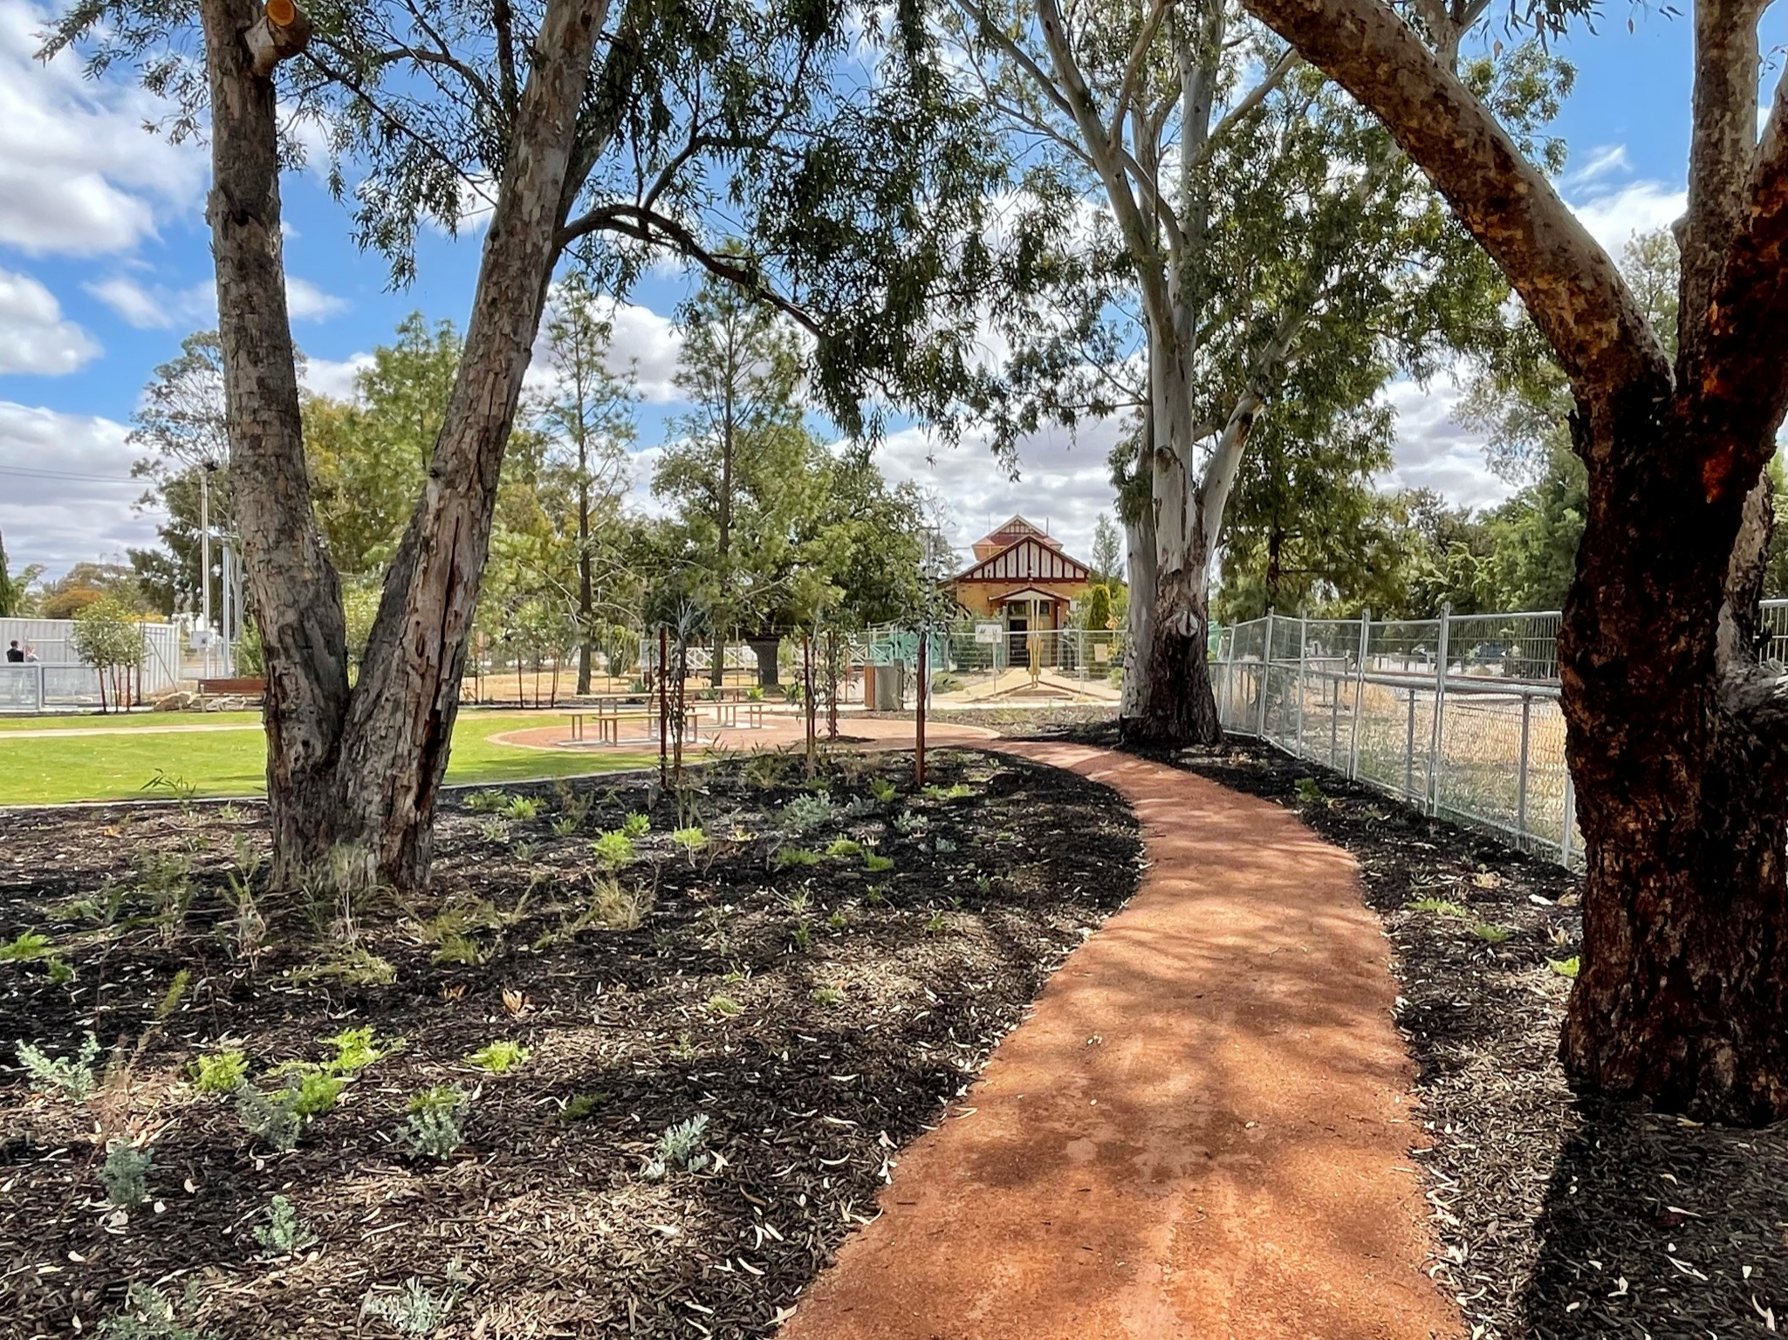
2
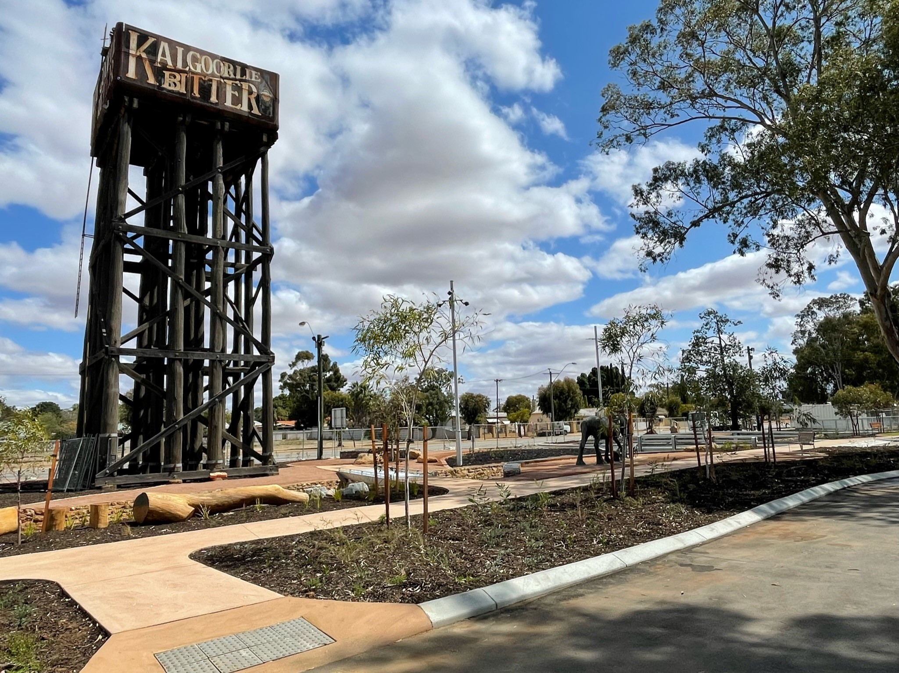
3
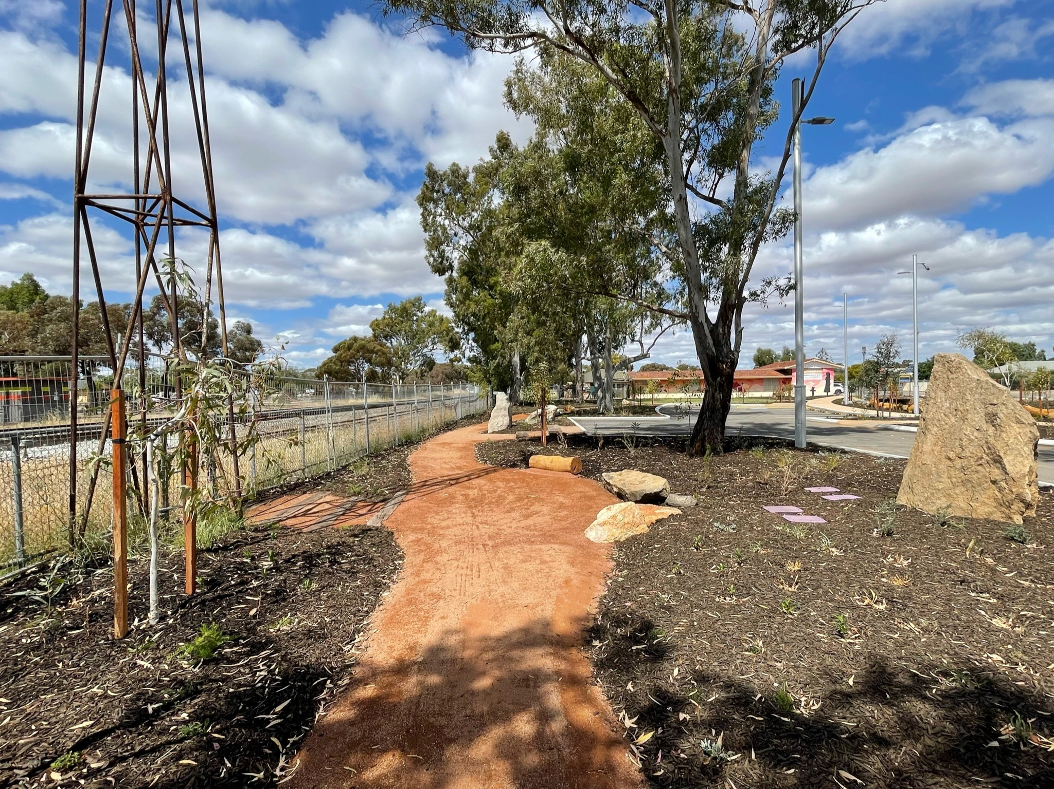
4
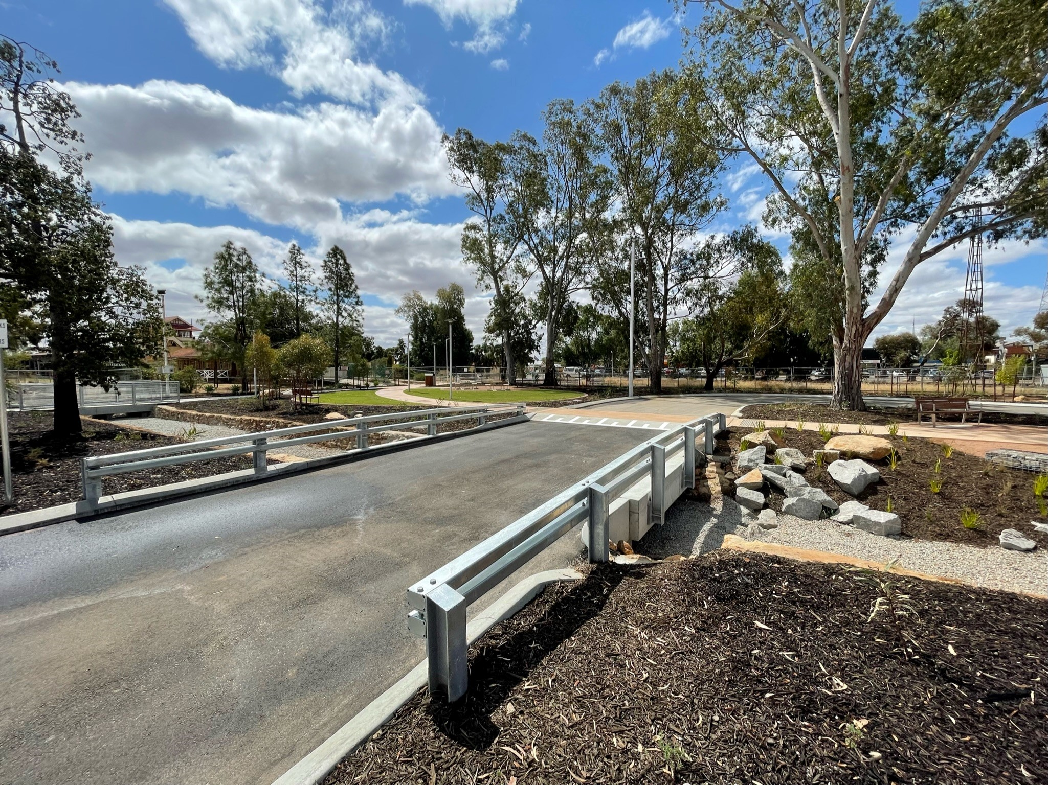
Pioneer Park Car Park

Report Disclaimer
Please note that this business report, provided as a result of the use of the diagnostic assessment, is for information purposes only.
Australian Tourism Industry Council (ATIC) cannot guarantee the accuracy of respondent’s answers, or that they are fully representative of your business. Therefore, ATIC does not warrant or guarantee any particular outcome in respect of your businesses self-assessment.
This report is intended as guidance only for your business and should not be relied on for future marketing considerations. ATIC recommends that you seek your own independent advice as well as the results from the diagnostic.
Links to external web sites are inserted for convenience and do not constitute endorsement of material at those sites, or any associated organisation, product or service.
ATIC does not:
- Assume any legal liability for the accuracy, completeness, or usefulness of any information from this report or any links provided; or
- Accept responsibility for any loss associated directly or indirectly from the use of this report.

