ATIC Accessibility
To support the accessible community in making informed travel decisions for their individual needs

This report prepared for:
Business name: | Swan River Seaplanes
Address: | Queen Street Jetty
Town: | South Perth
Contact for enquiries: | Kristy Bailey
Contact Number: | 0894178005
Contact Email: | bookings@swanriverseaplanes.com.au
Website: | http://swanriverseaplanes.com.au/
Date: | 2026-07-26 20:17

ATIC Accessibility
The following pages provides travellers with information on the businesses facilities and amenities which aims to support the traveller to make an informed decision on whether the business is suitable for their individual needs.
OVERVIEW 4
Business Overview 4
Bookings 4
Emergency Management 4
Communications 5
Other Information 5
Guide Dog and Service Animals 5
GENERAL 6
Pre-arrival, arrival and reception 6
Cognitive Impairment Support 6
Car Park and Access amenities 6
Entry 6
Internal Spaces 7
Public areas 7
External Paths 7
Steps 7
Ramps 8
Public Toilets/Adult change facilities 8
TOUR OPERATORS 9
Route Planning 9
Guides 9
Report Disclaimer 11

OVERVIEW

Business Overview

The business has the following products/services available
- Tour/Transport

Our business caters for the following disability types:
- Blind or low vision
- Deaf or low hearing
- Limited mobility
- Food allergies or intolerances
- Cognitive or people on the Autism Spectrum

Bookings

The business offers the following methods for bookings and enquiries:
- Phone
- Email
- Webportal
- Our website supports Screen Readers
- Our forms have high contract boxes and submit boxes
- Staff have undergone disability awareness and training

Emergency Management
- Emergency and evacuation procedures are explained on arrival
We ensure exit access is free and clear at all times by: Aviation requirement/plane configuration
- Guests with disabilities are noted in the guest log book for emergency and evacuation purposes

Communications
- An accessibility guide is available on the website
https://swanriverseaplanes.com.au/accessibility/
- Our website meets WCAG 2.0 accessibility standards
- Our business offers the following alternative communication methods
- Plain English
- Magnifiers
- There is easy to read signage and information (e.g. menus and emergency information)

Other Information
- For bookings made onsite, the ticket booth/counter/box office is accessible for people using a wheelchair
- The business accepts the companion card

Guide Dog and Service Animals
- The business provides a secure area with shade and water for service animals
- The business provides a toilet area for service animals
- Bowls, bedding, etc. are provided for service animals
The business provides the following services for services animals: Service animals are welcomed on aircraft, outdoor shaded areas for service animals available prior to departure.

GENERAL

Pre-arrival, arrival and reception
The business has the following in place to support guests during pre-arrival, arrival and reception
- Booking information and websites are compatible with screen readers
- Information and maps are available in written form
- A familiarisation tour
We don't have any locked facilities - nearby facilities are public and open
The following steps are in place to ensure that people with fatigue related to their disability are not disadvantaged by long wait times: We have very short wait times for all departures as timings are scheduled. A seating area is available for any unforeseen waits.

Cognitive Impairment Support
- Documents are available in plain English for people with cognitive impairment (This may include instructions, guides, menus and general information)
- Quiet periods or early opening times for people on the Autism Spectrum
- A space for parents and children on the Autism Spectrum

Car Park and Access amenities
The business has the following Car Park and Access amenities
- A drop off zone
- The public transport services available are:
On request
- Kerb ramps are in place where a pavement or walkway needs to be crossed

Entry
The business has the following amenities/systems in place for entry
- A drop off point close to the entrance
- A path of access to the building is slip resistance and even
- A path of access to the building is clear of obstruction
- Signage is written in a contrasting colour
- Signage is written in a Sans Serif font and use upper and lower case letters
- The entry door is a minimum of 850mm wide
- There a clear space of at least 1500mm x 1500mm in front of all doors.

Internal Spaces
- Floor surfaces are hard or short pile carpet
- Seating is available for guests unable to stand for long periods
- Accessible facilities are clearly signed and visible from all areas
- All corridors greater than 900mm
- There is a quiet space for parents and children on the Autism Spectrum

Public areas
The public areas have the following amenities in place
- Seating

External Paths
External paths of travel
- Surfaces are concrete, asphalt, smooth paving or hard packed fine gravel (max aggregate size 13mm)
- Paths or slopes longer than 15 metres have resting places or seats
- Pathways are wider than 900mm
- There 3 successive steps or less on any path or at any doorway
All paths are wheelchair accessible

Steps
Steps
- There are steps.
- Top and bottom steps are easily distinguished through colour contrast or the use of TGSIs (Tactile Ground Surface Indicators)
- In addition, the following further information can assist guests:
We have steps into the aircraft.

Ramps
Ramps have the following amenities are in place
- There are ramps.
- All fixed ramps are 1:14 or less
- Hand rails are fitted
- Long ramps (more than 10m) are 1:20 or less
- Temporary ramps are available
- Temporary ramps are in place for the duration of the guests stay
- Ramps have a raised edge of at least 100mm

Public Toilets/Adult change facilities
Public Toilets/Adult change facilities have the following amenities are in place
- There is an accessible toilet for public use
- The door is at least 850mm wide
- There is a minimum of 850mm beside the toilet
- Handrails are fitted
- The toilet seat is 460mm above the floor
- There is Accessible public toilet facilities available at Mends Street mm of clear space in front of the toilet
- The toilet seat of a contrasting colour to the floor
- The toilet seat is460mm above the floor

TOUR OPERATORS

Route Planning
- Route Planning
- In addition, the following further information can assist guests:
Accessible toilets are available prior to departure, at public facilities nearby.
- Lunch stop venues are accessible
- Sightseeing and photo opportunity stops are step free

Guides
- Use of clear/simple English
- Correct pronunciation for lip readers
  - Image(s)
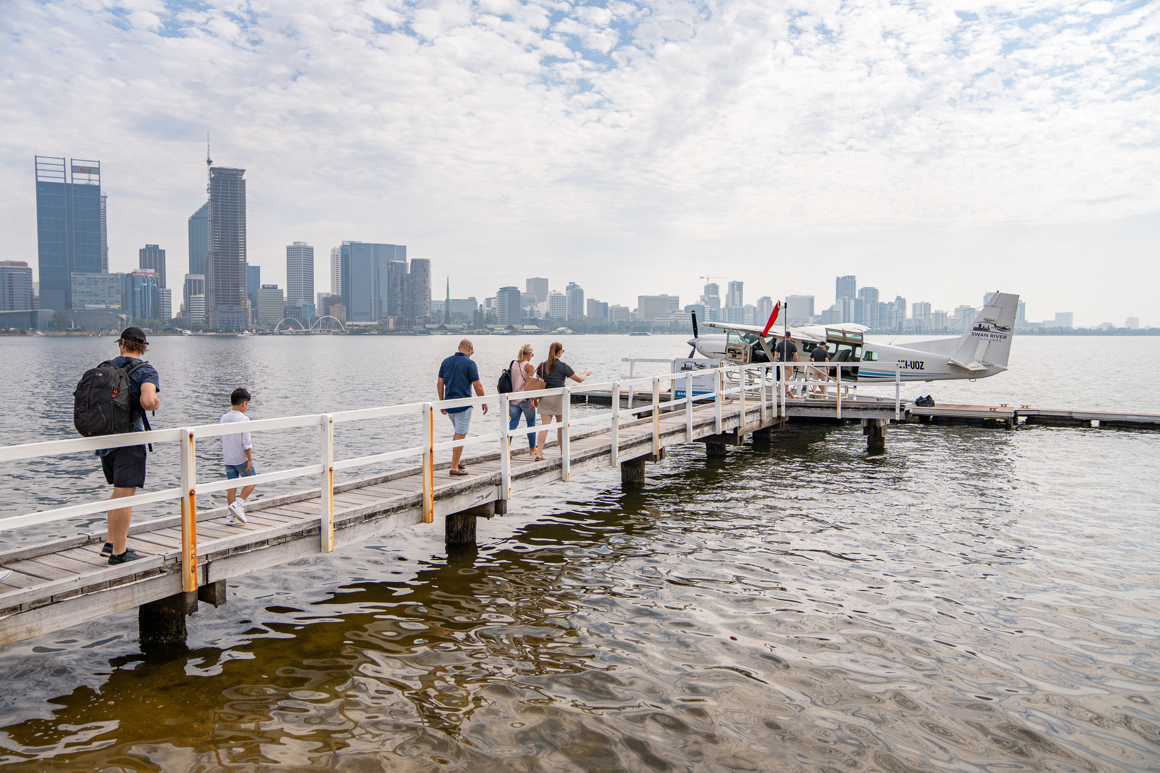
0003-SWANRIVERSEAPLANES-BASEIMAGERY
- This tour stops at attractions/accommodation/food and beverage/retail spaces that are not operated by this business. For information relating to these individual properties please follow the weblink provided
- In addition, the following further information can assist guests:
Swan River Seaplanes staff are available for assistance at all times, although currently, access to the aircraft is only possible via stairs. We are actively collaborating to develop innovative equipment that will eliminate accessibility barriers. We kindly ask for your patience as we work towards creating the necessary equipment to ensure equal participation.

Report Disclaimer
Please note that this business report, provided as a result of the use of the diagnostic assessment, is for information purposes only.
Australian Tourism Industry Council (ATIC) cannot guarantee the accuracy of respondent’s answers, or that they are fully representative of your business. Therefore, ATIC does not warrant or guarantee any particular outcome in respect of your businesses self-assessment.
This report is intended as guidance only for your business and should not be relied on for future marketing considerations. ATIC recommends that you seek your own independent advice as well as the results from the diagnostic.
Links to external web sites are inserted for convenience and do not constitute endorsement of material at those sites, or any associated organisation, product or service.
ATIC does not:
- Assume any legal liability for the accuracy, completeness, or usefulness of any information from this report or any links provided; or
- Accept responsibility for any loss associated directly or indirectly from the use of this report.

