ATIC Accessibility
To support the accessible community in making informed travel decisions for their individual needs

This report prepared for:
Business name: | Gravity Discovery Centre and Observatory
Address: | 1098 Military Road
Town: | Yeal
Contact for enquiries: | Majella Heaton
Contact Number: | 0895757577
Contact Email: | bookings@gravitycentre.com.au
Website: | www.gravitycentre.com.au
Date: | 2026-10-23 07:24

ATIC Accessibility
The following pages provides travellers with information on the businesses facilities and amenities which aims to support the traveller to make an informed decision on whether the business is suitable for their individual needs.
OVERVIEW 4
Business Overview 4
Bookings 4
Emergency Management 4
Communications 5
Other Information 5
Guide Dog and Service Animals 5
GENERAL 6
Pre-arrival, arrival and reception 6
Cognitive Impairment Support 6
Car Park and Access amenities 6
Entry 6
Lifts 7
Internal Spaces 7
Public areas 8
Displays, exhibits, commentary and live performances 8
External Paths 8
Steps 8
Ramps 9
Public Toilets/Adult change facilities 9
ATTRACTIONS 10
Attractions Basics 10
COMMON AREAS 13
Play Spaces 13
Parks and gardens 13
Report Disclaimer 16

OVERVIEW

Business Overview

The business has the following products/services available
- Attraction

Our business caters for the following disability types:
- Limited mobility
- Wheelchairs or mobility scooters
- Food allergies or intolerances
- Cognitive or people on the Autism Spectrum

Bookings

The business offers the following methods for bookings and enquiries:
- Phone
- Email
- Webportal
- Our forms have high contract boxes and submit boxes

Emergency Management
- Exit signs are clear and easy to see
- Exit access is free and clear at all times
We ensure exit access is free and clear at all times by: Regular Checks. Staff responsibility
- Exits and access to exists are greater than 900mm
- Exit doors are able to be opened by all occupants
- Exits to the emergency evacuation point does not include stairways
- There is an emergency refuge that has an intercommunication system linked and has sufficient fire resistance levels.
- The evacuation point is clearly marked by a sign
The business identifies guests who need additional assistance should an emergency occur by: Visual and booking requests
The procedure for assisting guests who need assisted rescue is: Staff responsibility

Communications

Other Information
- For bookings made onsite, the ticket booth/counter/box office is accessible for people using a wheelchair
- The business accepts the companion card

Guide Dog and Service Animals
- The business provides a secure area with shade and water for service animals
The business provides the following services for services animals: We provide what is needed on an as come basis. We have two service dogs visit in the last 9 years.

GENERAL

Pre-arrival, arrival and reception
The business has the following in place to support guests during pre-arrival, arrival and reception
- Booking information and websites are compatible with screen readers
- There is a reception/public entryway.
- Seating available at reception
- A tablet with text to voice or pen and paper at reception to aid in communication
- Lighting in the reception area is even and glare free
- Information and maps are available in written form
- A step free map/guide
- A familiarisation tour
The following steps are in place to ensure that people with fatigue related to their disability are not disadvantaged by long wait times: Reception is manned at all times and there are no long wait times for visitors.

Cognitive Impairment Support
- Documents are available in plain English for people with cognitive impairment (This may include instructions, guides, menus and general information)
- Quiet periods or early opening times for people on the Autism Spectrum
- A space for parents and children on the Autism Spectrum

Car Park and Access amenities
The business has the following Car Park and Access amenities
- A drop off zone
- Level or ramped access from the car park to the entrance
- The accessible entrance is clearly signed from the parking bay
- Kerb ramps are in place where a pavement or walkway needs to be crossed

Entry
The business has the following amenities/systems in place for entry
- A drop off point close to the entrance
- A path of access to the building is slip resistance and even
- A path of access to the building is clear of obstruction
- Self opening entry doors or fitted with a self closer
- Glass doors are fitted with a visual sighting strip
- Door jams/doors are of a contrasting colour to surrounding walls
- Door handles are of a contrasting colour to the door
- Signage is written in a contrasting colour
- Signage is written in a Sans Serif font and use upper and lower case letters
- The entry door is a minimum of 850mm wide
- The entry door has self opening or a light opening pressure (for manual operations)
- The entrance sill is less than 13mm
- There a clear space of at least 1500mm x 1500mm in front of all doors.
- The entrance door mats have a thickness less than 13mm and a width of 7500mm or greater

Lifts
- Premises has lifts
  - Lift Location: Main area
- This lift is available to all public floors
- The lift contains a visual method of identifying the floor level
- There is a breakdown procedure for lifts containing guests with a hearing impairment
- The emergency procedures within the lift have an SMS contact number
- The lift doors contrast with the surrounding wall finishes
- The lift call buttons contrast with the surrounding wall finishes
- The lift floor buttons have large print numbers
- The lift has an easily identifiable/tactile emergency button
- The doors open to a clear span of 880mm
- The minimum size of the lift 1100mm wide by 1400mm deep
- The control button heights are between 900mm and 1200mm
- There is a handrail of a minimum length of 600mm

Internal Spaces
- Clear and unobstructed routes through and between buildings
- Interior walls are matte or low sheen
- Floors, walls, counters and furniture are of contrasting colours
- Floor surfaces are hard or short pile carpet
- Seating is available for guests unable to stand for long periods
- Accessible facilities are clearly signed and visible from all areas
- All corridors greater than 900mm
- There is a quiet space for parents and children on the Autism Spectrum

Public areas
The public areas have the following amenities in place
- Display units, Televisions, Video displays etc. are open captioned
- Even lighting
- Seating

Displays, exhibits, commentary and live performances
For displays, exhibits, commentary and live performances the following amenities are in place
- Seating
- Wheelchair accessible spaces/seating

External Paths
External paths of travel
- Surfaces are concrete, asphalt, smooth paving or hard packed fine gravel (max aggregate size 13mm)
- Paths or slopes longer than 15 metres have resting places or seats
- Pathways are wider than 900mm
- There 3 successive steps or less on any path or at any doorway
- Any paths having steps are clearly identified as non-wheelchair accessible
- Step free routes clearly signed

Steps
Steps
- There are steps.
- Top and bottom steps are easily distinguished through colour contrast or the use of TGSIs (Tactile Ground Surface Indicators)
- The underside of all staircases are enclosed or protected to a height of at least 2 metres
- Handrails fitted to all open sets of steps
- Handrails extend 300mm beyond the top and bottom step

Ramps
Ramps have the following amenities are in place
- There are ramps.
- All fixed ramps are 1:14 or less
- Hand rails are fitted
- Long ramps (more than 10m) are 1:20 or less

Public Toilets/Adult change facilities
Public Toilets/Adult change facilities have the following amenities are in place
- There is an accessible toilet for public use
- The door is at least 850mm wide
- There is a minimum of 850mm beside the toilet
- Handrails are fitted
- The toilet seat is 460mm above the floor
- There is 2.5 metres mm of clear space in front of the toilet
- The toilet seat of a contrasting colour to the floor
- The toilet seat is460mm above the floor
- There is a registered changing places facility

ATTRACTIONS

Attractions Basics
- A park map is available here:
www.gravitycentre.com.au
  - Image(s)
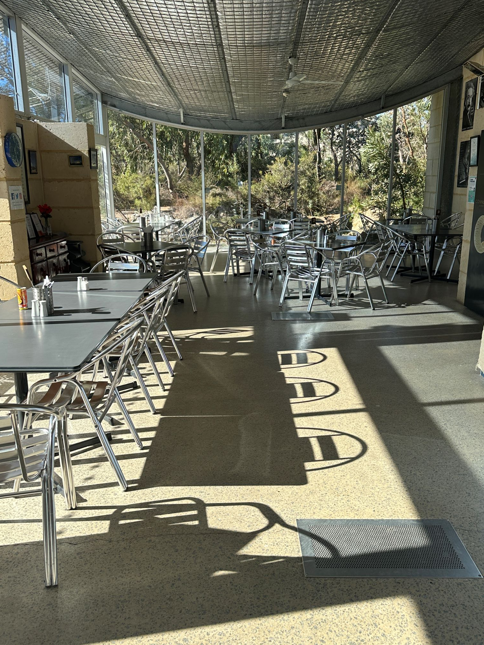
Cafe
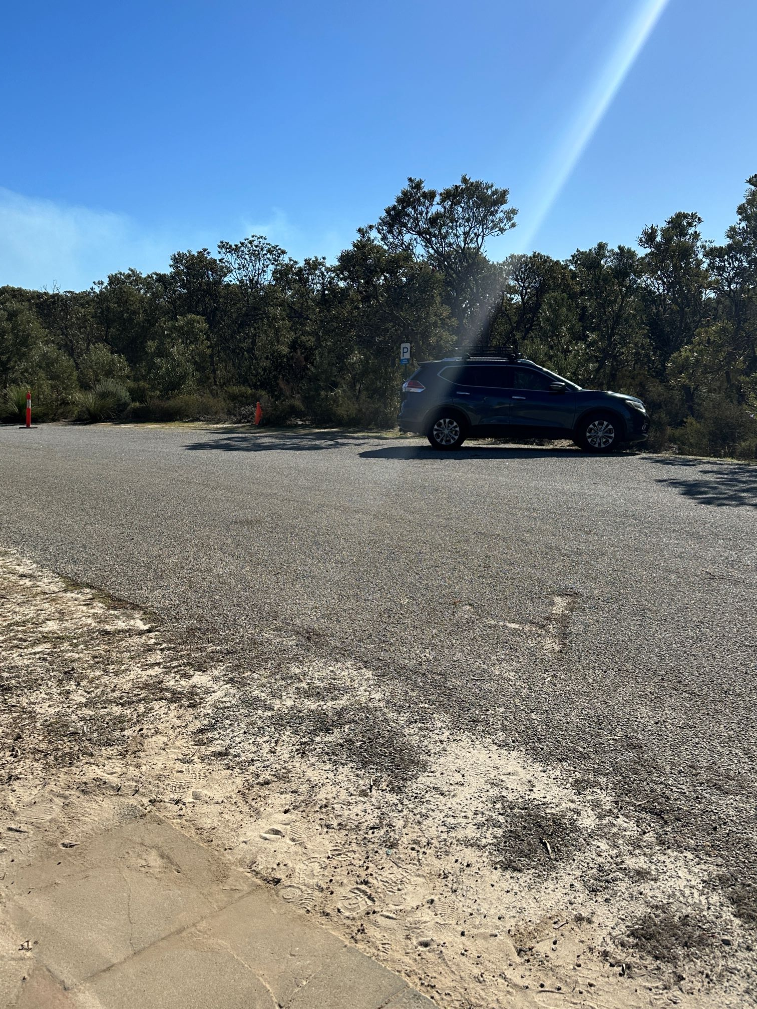
Carpark
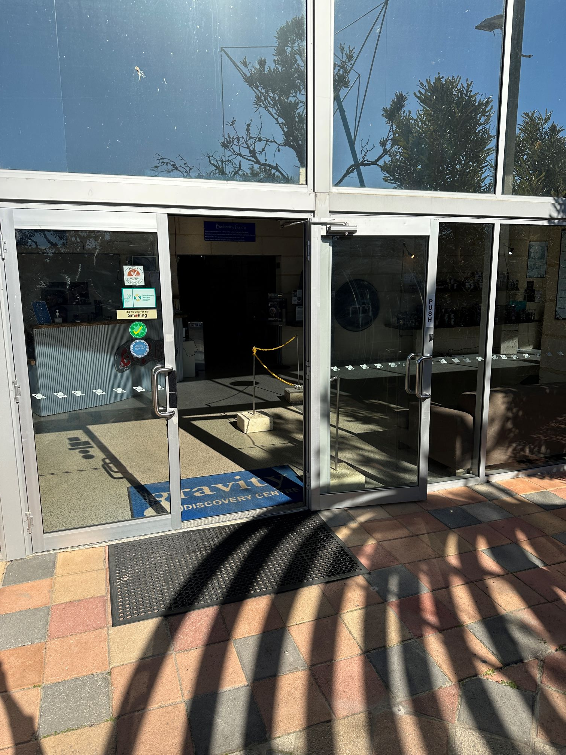
front door
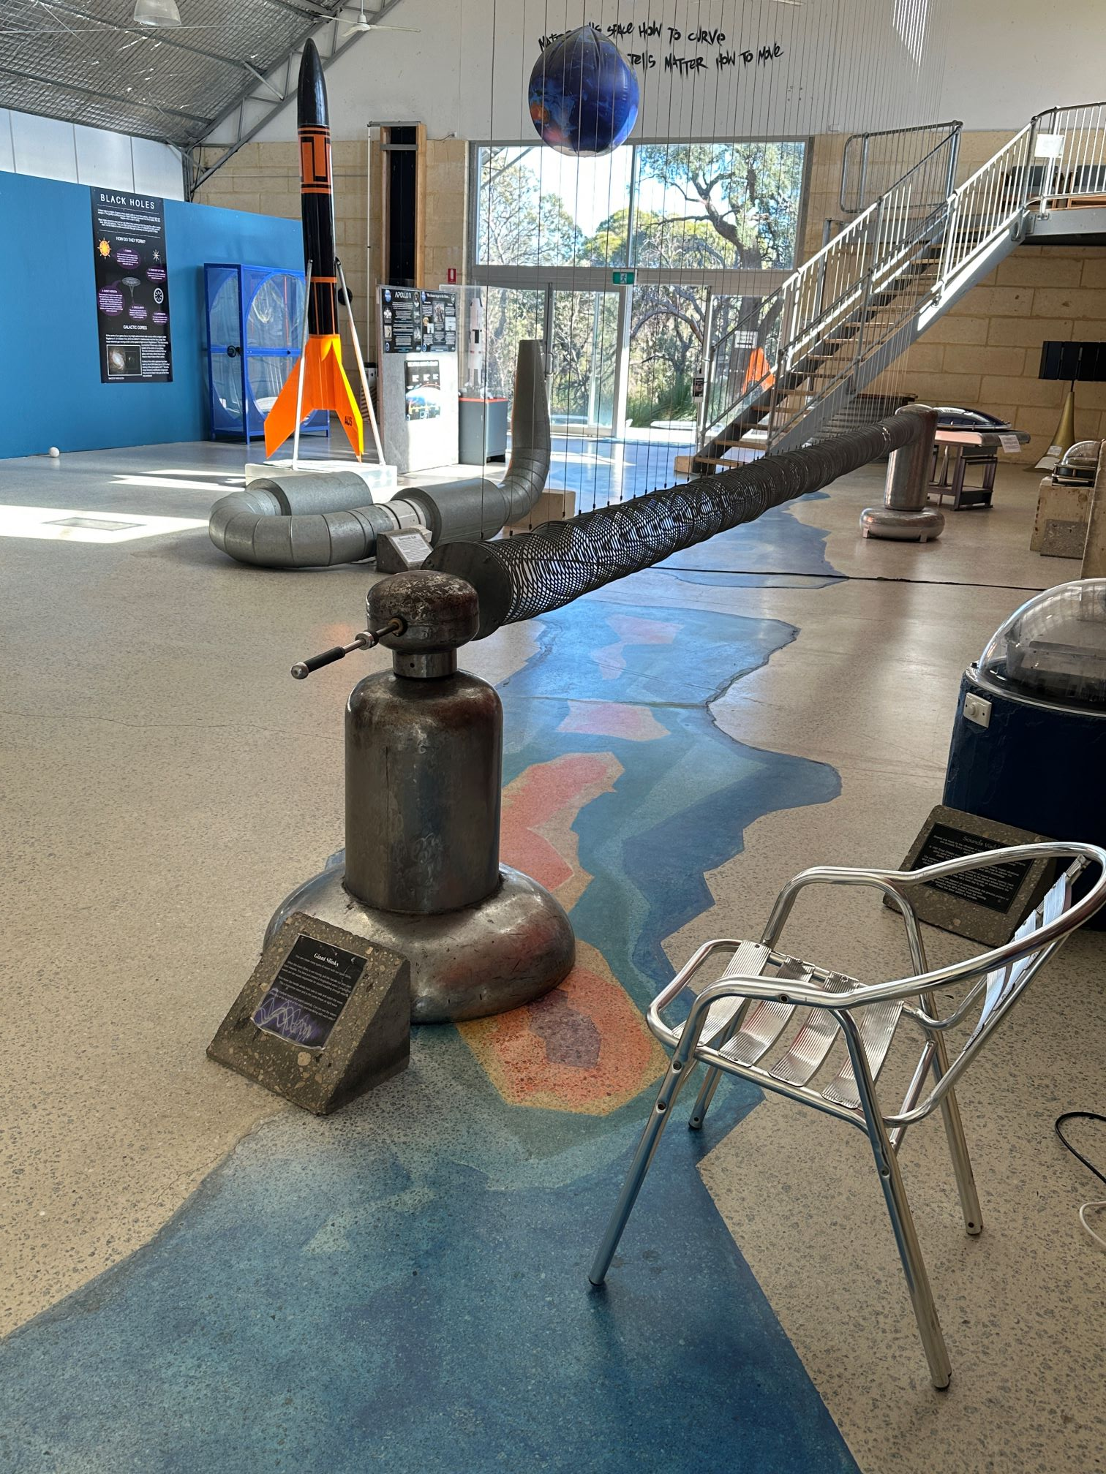
Main Gallery
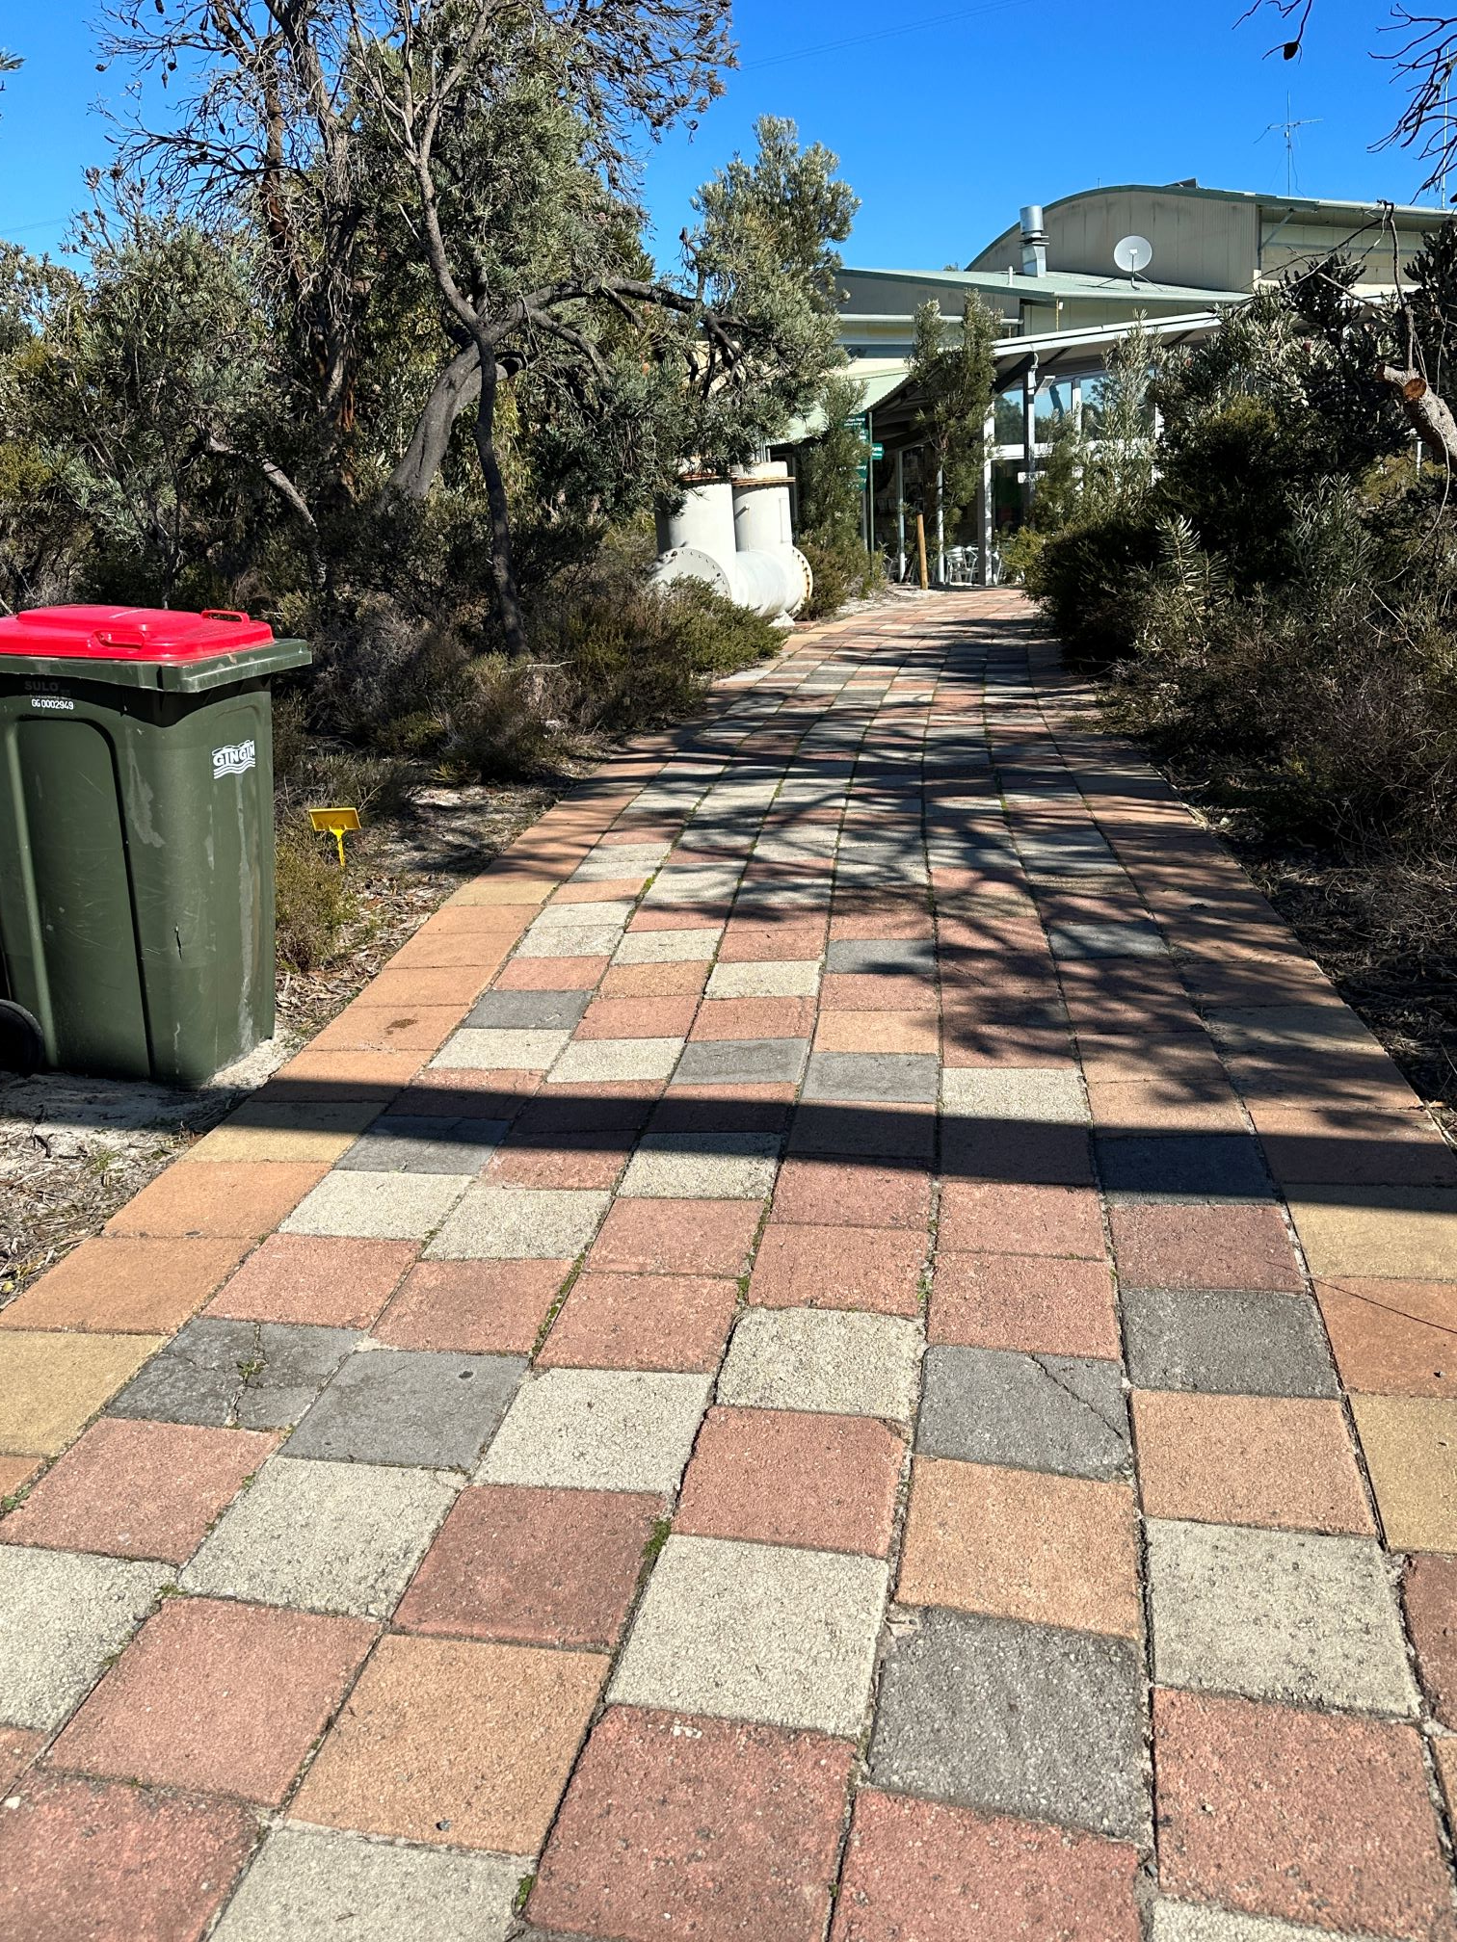
Pathway
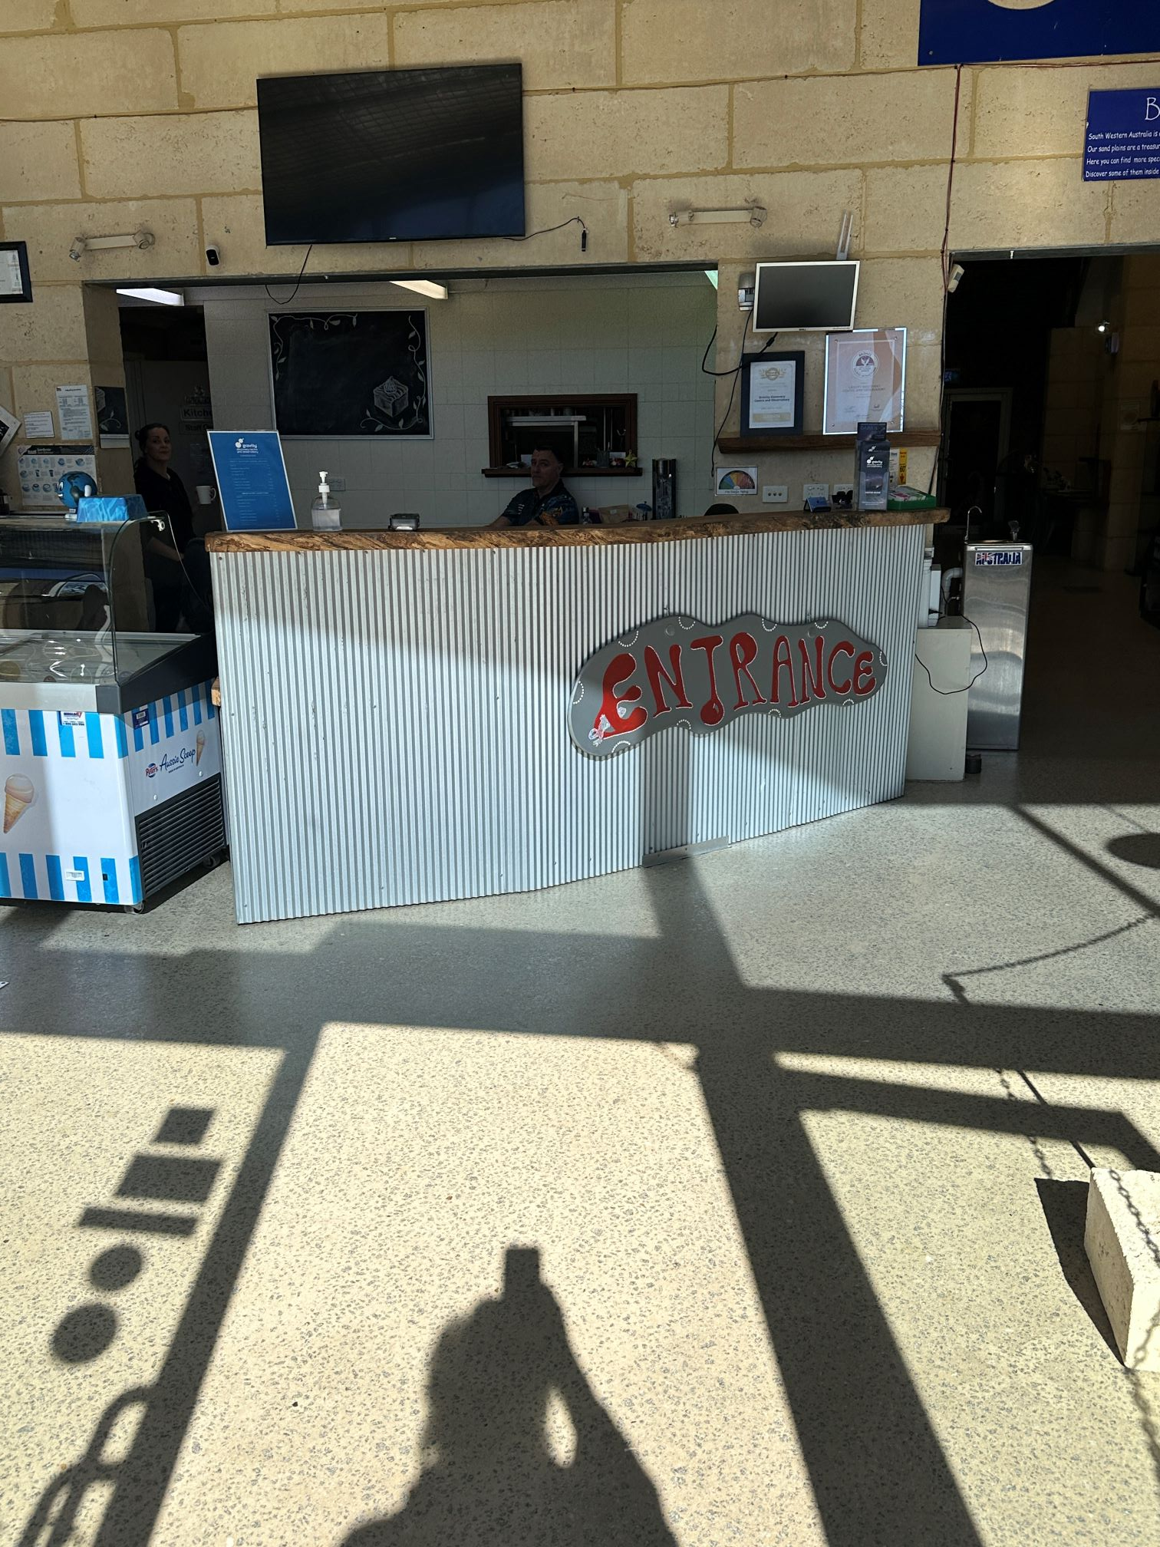
Reception
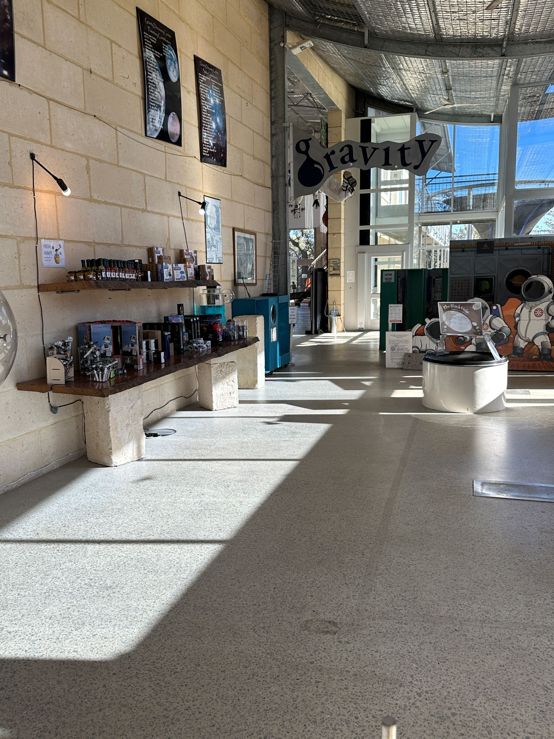
Shop
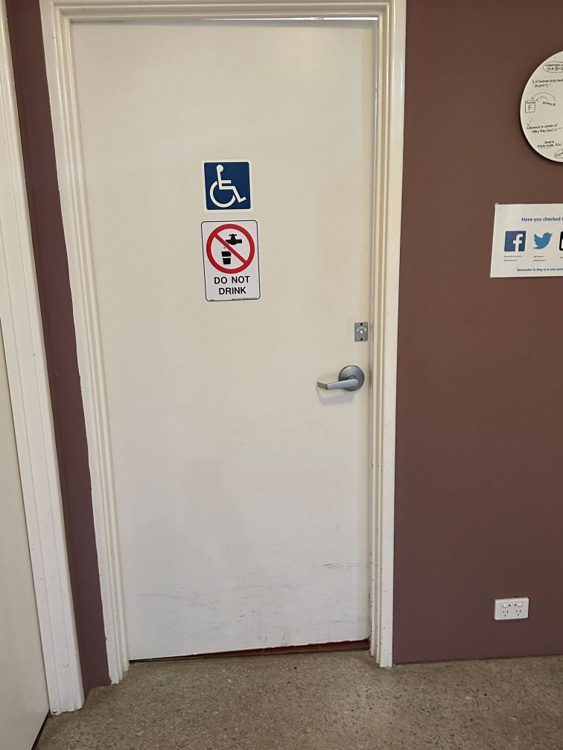
Toilet Door
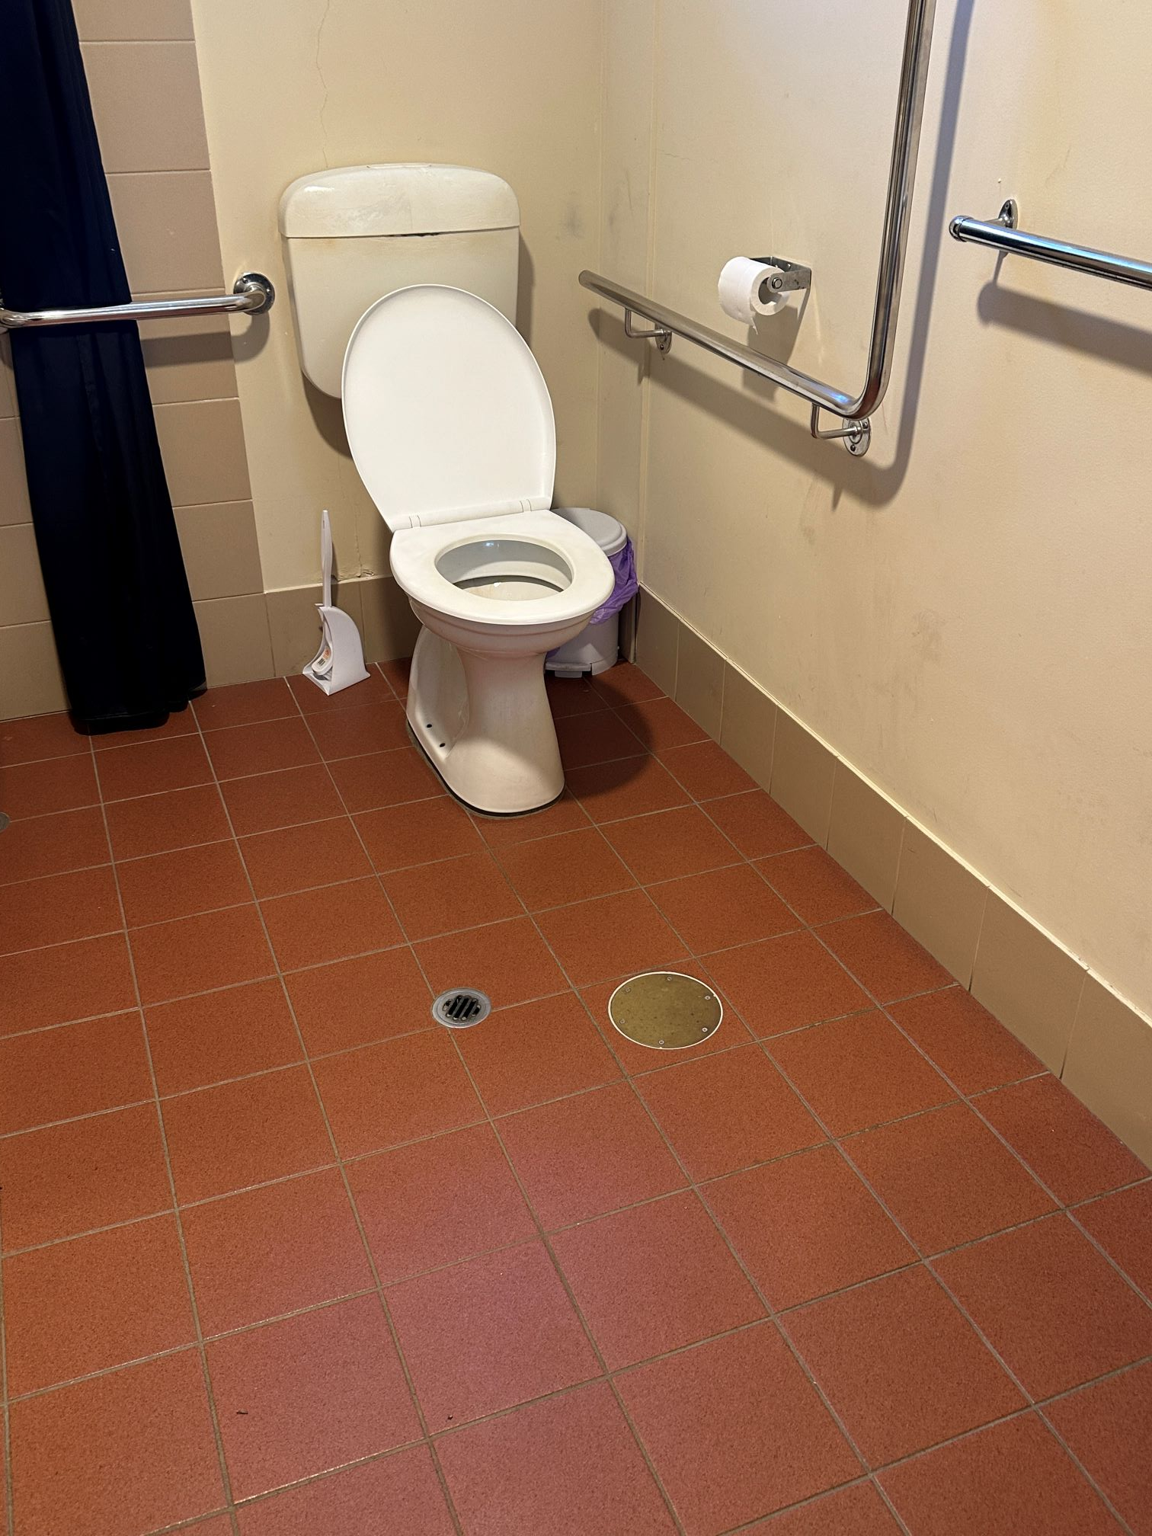
Toilet

COMMON AREAS

Play Spaces
- Ramps provided are at least 25% of elevated sections of the play space
- The surface of the play space is of a composite or rubberized material
- There wheelchair accessible activities
- The play space contains cognitive play panels
- The play space contains tactile play panels or activities
- The space contain colour contrasting elements
- Seating is provided in or around the play space
  - Image(s)
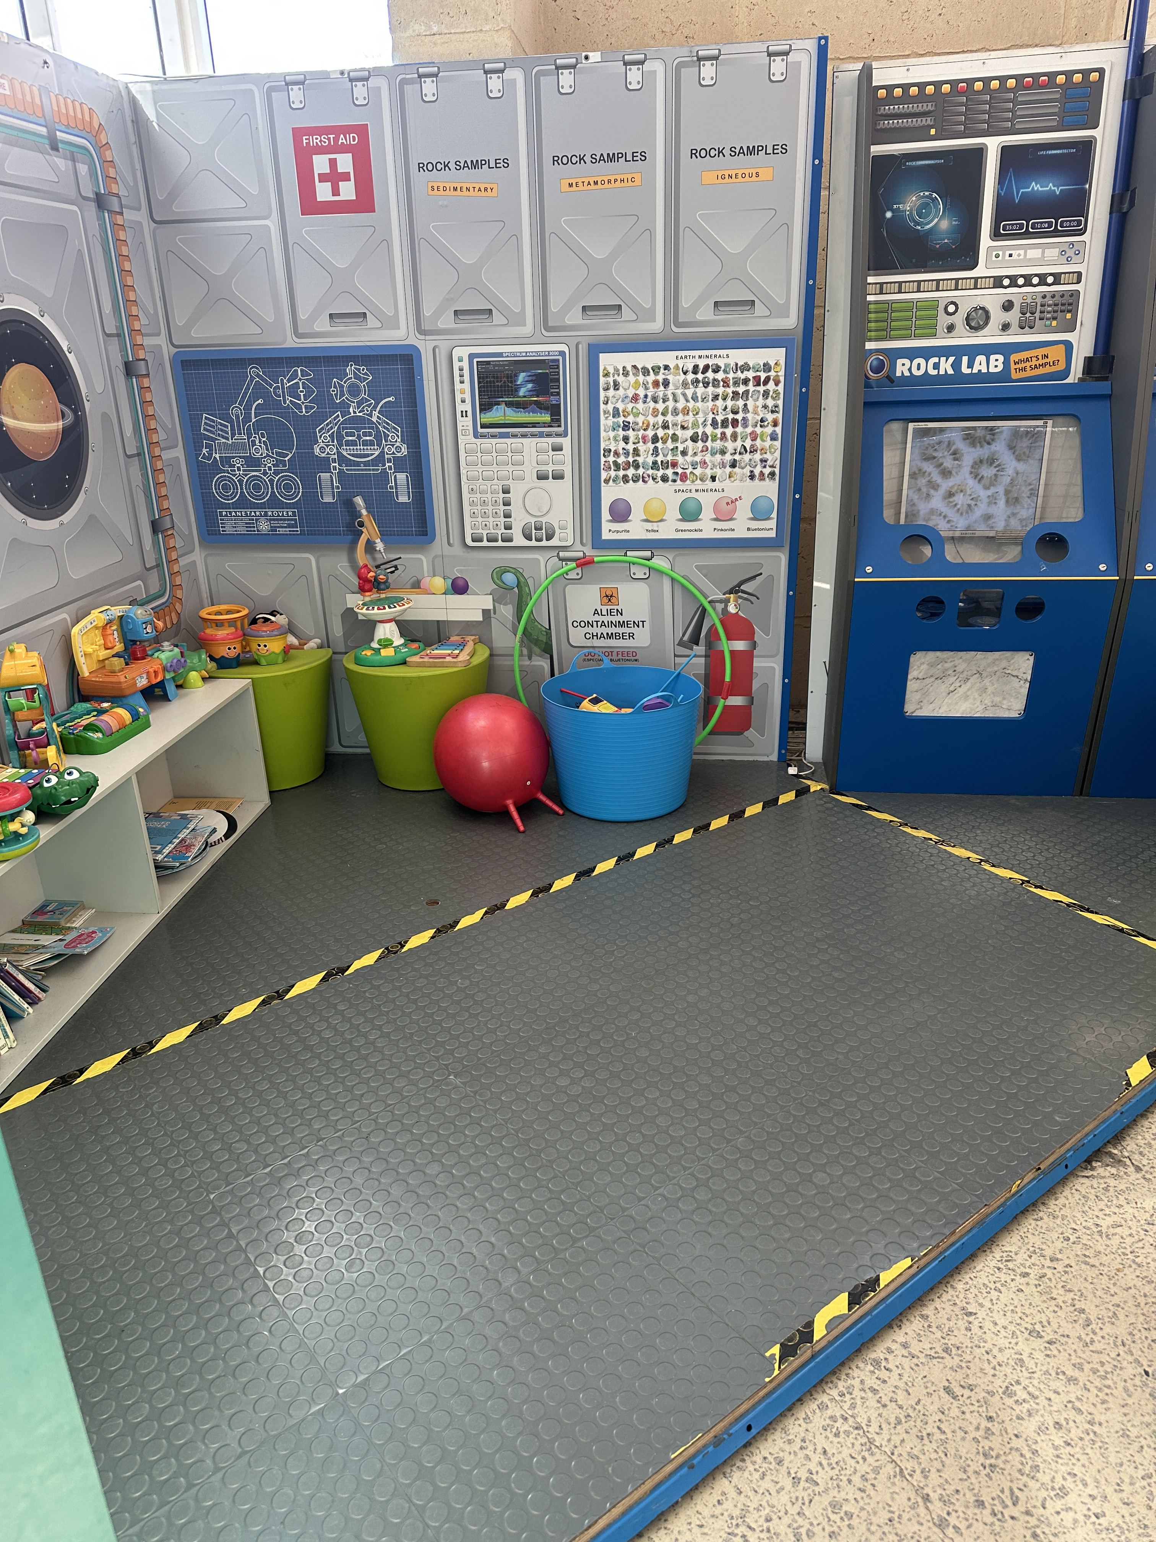
Play area

Parks and gardens
- The following parks and gardens amenities are available
- Direction signage contains distances
- Accessible picnic tables
- Accessible BBQs
- The park contains an observation deck or tower
- The observation deck provides a clear view through the safety railing
  - Parks and Gardens Access/Entry Image(s)
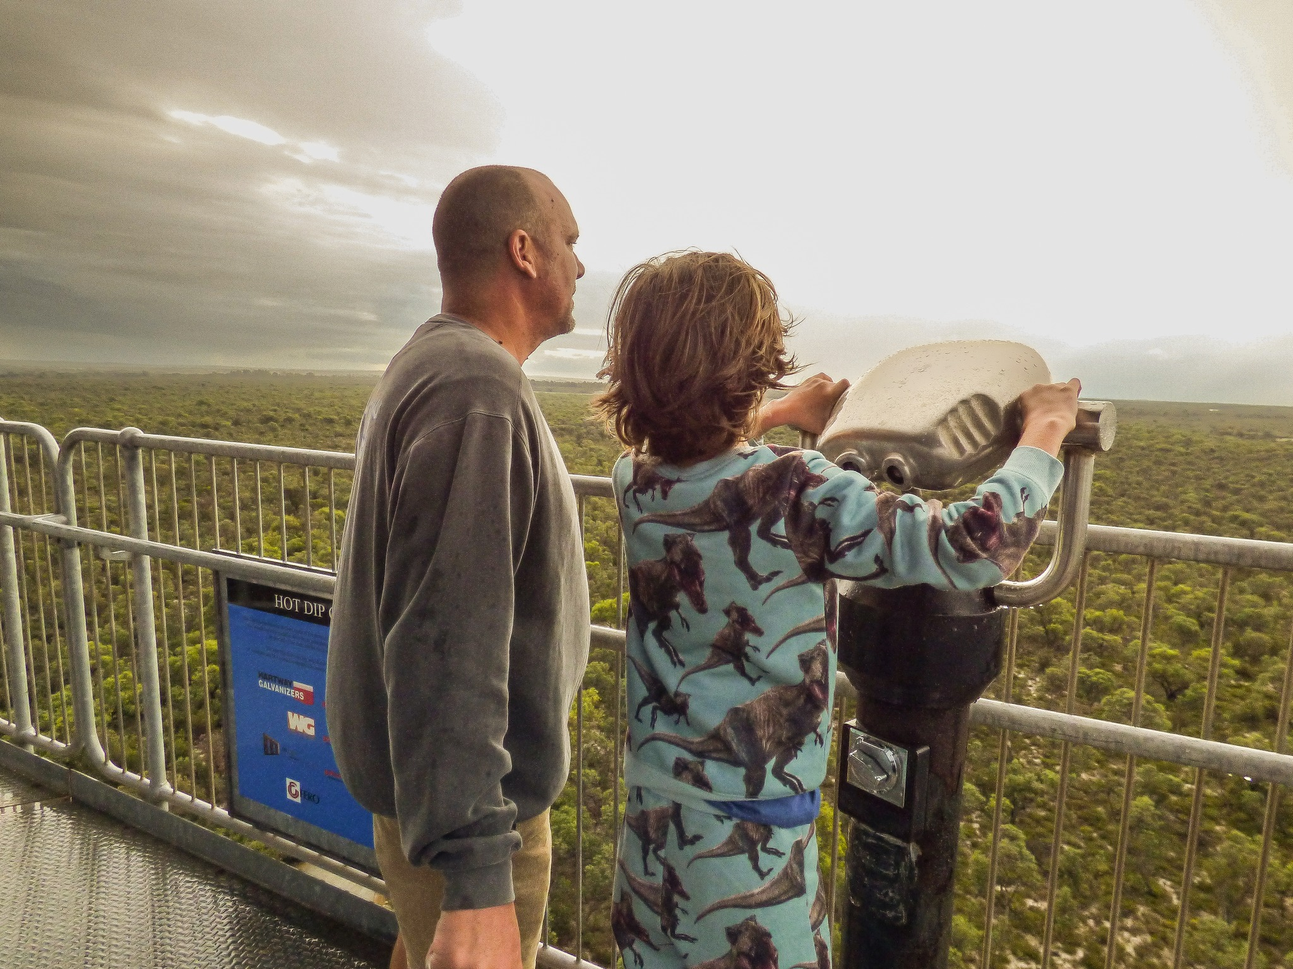
Tower with rails

Report Disclaimer
Please note that this business report, provided as a result of the use of the diagnostic assessment, is for information purposes only.
Australian Tourism Industry Council (ATIC) cannot guarantee the accuracy of respondent’s answers, or that they are fully representative of your business. Therefore, ATIC does not warrant or guarantee any particular outcome in respect of your businesses self-assessment.
This report is intended as guidance only for your business and should not be relied on for future marketing considerations. ATIC recommends that you seek your own independent advice as well as the results from the diagnostic.
Links to external web sites are inserted for convenience and do not constitute endorsement of material at those sites, or any associated organisation, product or service.
ATIC does not:
- Assume any legal liability for the accuracy, completeness, or usefulness of any information from this report or any links provided; or
- Accept responsibility for any loss associated directly or indirectly from the use of this report.

