ATIC Accessibility
To support the accessible community in making informed travel decisions for their individual needs

This report prepared for:
Business name: | BIG4 Launceston Holiday Park
Address: | 94 Glen Dhu Street
Town: | Launceston
Contact for enquiries: | Bronwyn Wild
Contact Number: | (03) 6344 2600
Contact Email: | bron@big4launceston.com.au
Website: | https://big4launceston.com.au/
Date: | 2026-10-20 16:14

ATIC Accessibility
The following pages provides travellers with information on the businesses facilities and amenities which aims to support the traveller to make an informed decision on whether the business is suitable for their individual needs.
OVERVIEW 4
Business Overview 4
Bookings 4
Emergency Management 4
Communications 5
Other Information 5
Guide Dog and Service Animals 5
GENERAL 7
Pre-arrival, arrival and reception 7
Cognitive Impairment Support 9
Car Park and Access amenities 9
Entry 9
Internal Spaces 10
Public areas 11
External Paths 12
Steps 12
Ramps 13
ACCOMMODATION 18
Bedrooms 18
Room Amenities 18
Bathrooms 19
COMMON AREAS 27
Play Spaces 27
Report Disclaimer 33

OVERVIEW

Business Overview

The business has the following products/services available
- Accommodation

Our business caters for the following disability types:
- Blind or low vision
- Deaf or low hearing
- Limited mobility
- Wheelchairs or mobility scooters
- Food allergies or intolerances
- Cognitive or people on the Autism Spectrum

Bookings

The business offers the following methods for bookings and enquiries:
- Phone
- Email
- Webportal
- Our website supports Screen Readers
- Our forms have high contract boxes and submit boxes
- Staff have undergone disability awareness and training

Emergency Management
- The business has an emergency management and evacuation plan for guests with a disability
- Emergency and evacuation procedures are explained on arrival
We ensure exit access is free and clear at all times by: We regularly inspect and maintain the pathways leading to accessible accommodations and designated accessible areas. Our dedicated staff ensures that these pathways are clear of any obstructions, such as equipment, furniture, or other objects that may impede movement or hinder evacuation. Staff Training: Our team members undergo comprehensive training to understand the importance of maintaining accessibility during emergency situations. They are educated on the specific requirements and protocols necessary for assisting guests with disabilities during an evacuation, ensuring their safety and well-being.
- There is an emergency refuge that has an intercommunication system linked and has sufficient fire resistance levels.
- Guests with disabilities are noted in the guest log book for emergency and evacuation purposes

Communications
- An accessibility guide is available on the website
https://big4launceston.com.au/accessible-information/
- Our website meets WCAG 2.0 accessibility standards
- Our business offers the following alternative communication methods
- Plain English
- There is easy to read signage and information (e.g. menus and emergency information)
- There is a Pictorial menu
- There are Picture boards
As well as verbal communication, we also provide guests with text message communication and email communication. At check in, we also provide printed information. The printed documents have maps and information on the local area

Other Information
- For bookings made onsite, the ticket booth/counter/box office is accessible for people using a wheelchair
- The business accepts the companion card

Guide Dog and Service Animals
- The business provides a secure area with shade and water for service animals
- The business provides a toilet area for service animals
- Bowls, bedding, etc. are provided for service animals
The business provides the following services for services animals: BIG4 Launceston Holiday Park caters to the needs of certified service dogs. With accessible accommodation that is suited to these service dogs. Our park features spacious and well-maintained dog-walking areas where service dogs can exercise. Our staff are also on hand to assist guests with service dogs, ensuring a seamless and enjoyable holiday experience throughout their stay.

GENERAL

Pre-arrival, arrival and reception
The business has the following in place to support guests during pre-arrival, arrival and reception
- Booking information and websites are compatible with screen readers
- There is a reception/public entryway.
- Seating available at reception
- A lower counter at reception/ticket office
- A clipboard to allow check-in/ticket purchase whilst seated
- A tablet with text to voice or pen and paper at reception to aid in communication
- Picture Board at reception to aid in communication
- Lighting in the reception area is even and glare free
- Large print information sheets and registration forms
No access via intercom is necessary to gain access to the property. A hearing loop is not currently fitted in the reception area. BIG4 Launceston Holiday Park supports guests who are deaf or have low hearing through alternative communication methods, including email, SMS/text message, written information, printed maps, pen and paper at reception, plain English communication, and staff assistance. Reception lighting is even and glare-free to assist guests who lip read, and guests are encouraged to advise any communication preferences prior to arrival so staff can support their check-in experience.
- Information and maps are available in written form
- A familiarisation tour
- Advertising material, web sites and social media contain information relating to phone numbers available for non-voice communication e: Text, SMS, email and fax
- A key to any accessible facilities that are locked
- Keys are available for each guest
- Luggage assistance
The following steps are in place to ensure that people with fatigue related to their disability are not disadvantaged by long wait times: We aim to provide priority check-in services for guests with disabilities. This allows them to expedite the check-in process and minimise any waiting time at the reception desk, ensuring a smoother and more efficient arrival experience.
- In addition, the following further information can assist guests:
BIG4 Launceston Holiday Park supports guests before arrival, on arrival and during check-in by providing multiple communication options and practical assistance from reception staff.

Guests can contact the park prior to arrival by phone, email or online enquiry to discuss accessibility requirements, accommodation suitability, parking, access routes and communication preferences. Written information and park maps are available, and staff can provide information in plain English or assist with check-in using pen and paper, printed material, SMS/text message or email where required.

A hearing loop is not currently fitted in the reception area. Guests who are deaf or have low hearing are supported through alternative communication methods, including email, SMS/text message, written information, printed maps, pen and paper at reception, plain English communication and staff assistance. Reception lighting is even and glare-free to assist guests who lip read.

No access via intercom is required to enter the property. Guests may access reception directly during opening hours, and staff are available to assist with arrival information, luggage support and check-in where needed.

BIG4 Launceston Holiday Park is located on a naturally steep and elevated site, with accommodation and facilities spread across a large area. Due to the natural contour of the property, some sections of the park are not suitable for guests with limited mobility and may be difficult or unsafe to access without assistance. We do not currently provide a formal step-free map or guide for the entire property, as not all areas of the park can be accessed by a practical step-free route.

Our accessible villas have been strategically positioned in the areas of the park least impacted by the natural slope, with closer access to reception, parking and emergency evacuation areas where practical. Guests with mobility requirements are encouraged to contact reception prior to arrival so we can allocate the most suitable accommodation, explain the most appropriate access routes, and provide guidance based on their individual needs.

To support guests who may experience fatigue or difficulty standing for long periods, seating is available at reception and staff aim to provide priority check-in where practical. Staff can assist with a smoother arrival experience by reducing waiting time, offering seating, providing printed or written information, and giving guidance on nearby rest areas or quieter spaces within the park.

Cognitive Impairment Support
- Documents are available in plain English for people with cognitive impairment (This may include instructions, guides, menus and general information)
- A "social script" guide to your premises or attraction describing the sights, sounds and smells to aid parents/carers prepare visitors in advance
- A space for parents and children on the Autism Spectrum

Car Park and Access amenities
The business has the following Car Park and Access amenities
- A drop off zone
- Designated disabled parking bays
- Level or ramped access from the car park to the entrance
- The accessible entrance is clearly signed from the parking bay
- Kerb ramps are in place where a pavement or walkway needs to be crossed
- In addition, the following further information can assist guests:
Designated accessible parking and drop-off access are available close to reception and the most suitable access areas of the park.

BIG4 Launceston Holiday Park is located on a naturally steep and elevated site, so guests with mobility or access requirements are encouraged to contact reception prior to arrival. This allows our team to provide guidance on the most appropriate parking, drop-off point and access route based on the guest’s individual needs and allocated accommodation.

Where practical, accessible accommodation has been positioned in areas of the park with the most suitable gradient and access to reception, parking and emergency evacuation areas. Staff are available to assist with arrival information and can provide further details about local transport options, taxi access and the most practical arrival arrangements for each guest.

Entry
The business has the following amenities/systems in place for entry
- A drop off point close to the entrance
- A path of access to the building is slip resistance and even
- A path of access to the building is clear of obstruction
- Glass doors are fitted with a visual sighting strip
- Door jams/doors are of a contrasting colour to surrounding walls
- Door handles are of a contrasting colour to the door
- Signage is written in a contrasting colour
- Signage is written in a Sans Serif font and use upper and lower case letters
- The entry door is a minimum of 850mm wide
- The entry door has self opening or a light opening pressure (for manual operations)
- The entrance sill is less than 13mm
- There a clear space of at least 1500mm x 1500mm in front of all doors.
- The entrance door mats have a thickness less than 13mm and a width of 7500mm or greater
- In addition, the following further information can assist guests:
Reception and accessible accommodation areas have been positioned in the most practical section of the park for guest access, with drop-off access available close to reception.

Entry areas are maintained to support safe and comfortable access, including clear pathways, even and slip-resistant surfaces where practical, contrasting signage and door features, and sufficient entry width for guests using mobility aids. Staff regularly monitor entry areas to ensure they remain clear of obstructions.

Due to the naturally elevated layout of the park, guests with mobility, vision or access requirements are encouraged to contact reception prior to arrival so we can provide guidance on the most suitable parking, drop-off and entry points for their stay.
- In addition, the following further information can assist guests:
Lifts are not provided at BIG4 Launceston Holiday Park. The park is spread across a large, naturally elevated site rather than a multi-storey building environment.

To support accessibility, our certified accessible accommodation and reception area are located in the lowest elevated areas of the park where access is most practical. Guests with mobility requirements are encouraged to contact reception prior to booking so we can provide guidance on the most suitable accommodation and access routes for their stay.

Internal Spaces
- Clear and unobstructed routes through and between buildings
- Interior walls are matte or low sheen
- Floors, walls, counters and furniture are of contrasting colours
- Menus are available in large print or Braille
- Tableware/glassware contrast with the table surface or table cloth
- Floor surfaces are hard or short pile carpet
- Seating is available for guests unable to stand for long periods
- Accessible facilities are clearly signed and visible from all areas
- All corridors greater than 900mm
- In addition, the following further information can assist guests:
BIG4 Launceston Holiday Park offers certified accessible accommodation, as well as larger accommodation styles that may suit guests with varying access, mobility, sensory or support needs.

Internal spaces within our accessible accommodation are designed to support safe and comfortable movement, with clear routes where practical, hard flooring, appropriate doorway and corridor widths, contrasting finishes, accessible seating options, and layouts that can be discussed with guests prior to arrival.

Due to the nature of our location, formal quiet periods are not always achievable. The park is located within Tasmania’s second largest city and is positioned near an overhead flight path, a major highway and the general activity of an urban environment. We are transparent about this so guests and carers can make an informed decision before booking.

To help reduce external noise impacts, our accommodation has been designed with sound reduction in mind, including double-glazed windows with 10mm air gaps and 13mm plasterboard rather than standard 10mm plasterboard. These design features assist in improving guest comfort within the accommodation.

Guests with sensory, mobility or accessibility requirements are encouraged to contact reception prior to booking so we can discuss the most suitable accommodation option, explain the layout and facilities, and provide any additional information needed to support their stay.

Public areas
The public areas have the following amenities in place
- Display units, Televisions, Video displays etc. are open captioned
- Even lighting
- Seating

External Paths
External paths of travel
- Surfaces are concrete, asphalt, smooth paving or hard packed fine gravel (max aggregate size 13mm)
- Paths or slopes longer than 15 metres have resting places or seats
- Pathways are wider than 900mm
There are no steps anywhere in the vicinity of the accessible accommodation, the reception building or the emergency evacuation location
- In addition, the following further information can assist guests:
BIG4 Launceston Holiday Park is located on a naturally steep and elevated site, with accommodation and facilities spread across a large area. Pathway surfaces vary across the property and may include concrete, asphalt, hard surfaces and maintained access routes.

There are no steps in the immediate vicinity of the accessible accommodation, reception building or emergency evacuation location. These areas have been selected to provide the most practical access for guests with mobility requirements and are positioned in the areas least impacted by the natural contour of the property.

Due to the steep terrain, not all external paths throughout the park are suitable for guests using wheelchairs, scooters or mobility aids. Guests with access requirements are encouraged to contact reception prior to arrival so we can provide guidance on the most suitable accommodation, parking, drop-off point and access route for their stay.

Steps
Steps
- There are steps.
- Top and bottom steps are easily distinguished through colour contrast or the use of TGSIs (Tactile Ground Surface Indicators)
- All steps or staircases have enclosed risers
- The underside of all staircases are enclosed or protected to a height of at least 2 metres
- Handrails fitted to all open sets of steps
- Handrails extend 300mm beyond the top and bottom step
- In addition, the following further information can assist guests:
BIG4 Launceston Holiday Park is located on a steeply elevated property and there are steps and staircases throughout some general areas of the park.

There are no steps into reception or into the certified accessible accommodation. Our accessible accommodation has been positioned close to the evacuation area and in an area with minimal gradient to support safer and easier movement for guests with access needs.

Due to the natural gradient of the property, some areas of the wider park may not be suitable for all guests with mobility requirements. Guests are encouraged to contact reception before arrival so our team can provide information about the most suitable accommodation location, access routes and parking options for their individual needs.

Ramps
Ramps have the following amenities are in place
- There are ramps.
- All fixed ramps are 1:14 or less
- Hand rails are fitted
- Long ramps (more than 10m) are 1:20 or less
- Ramps have a raised edge of at least 100mm
- In addition, the following further information can assist guests:
BIG4 Launceston Holiday Park is an accommodation-based business and does not operate as a public attraction, visitor centre or public toilet facility.

A public accessible toilet, registered Changing Places facility, adult change table and hoist are not currently provided onsite. Accessible bathroom facilities are provided within our certified accessible accommodation for guests staying at the park.

Guests with accessibility, mobility or personal care requirements are encouraged to contact reception prior to booking so we can provide accurate information about our accessible accommodation, bathroom layout and available facilities, and assist them in determining whether the park is suitable for their individual needs.

ACCOMMODATION

Bedrooms
The bedrooms have the following facilities/amenities in place
- There are 2 rooms available to guests who use a wheelchair
- Bedroom furniture can be re-arranged on request

The following bed types are available in wheelchair accessible rooms
- One double/queen bed/king bed
  - Layout of room Image(s)
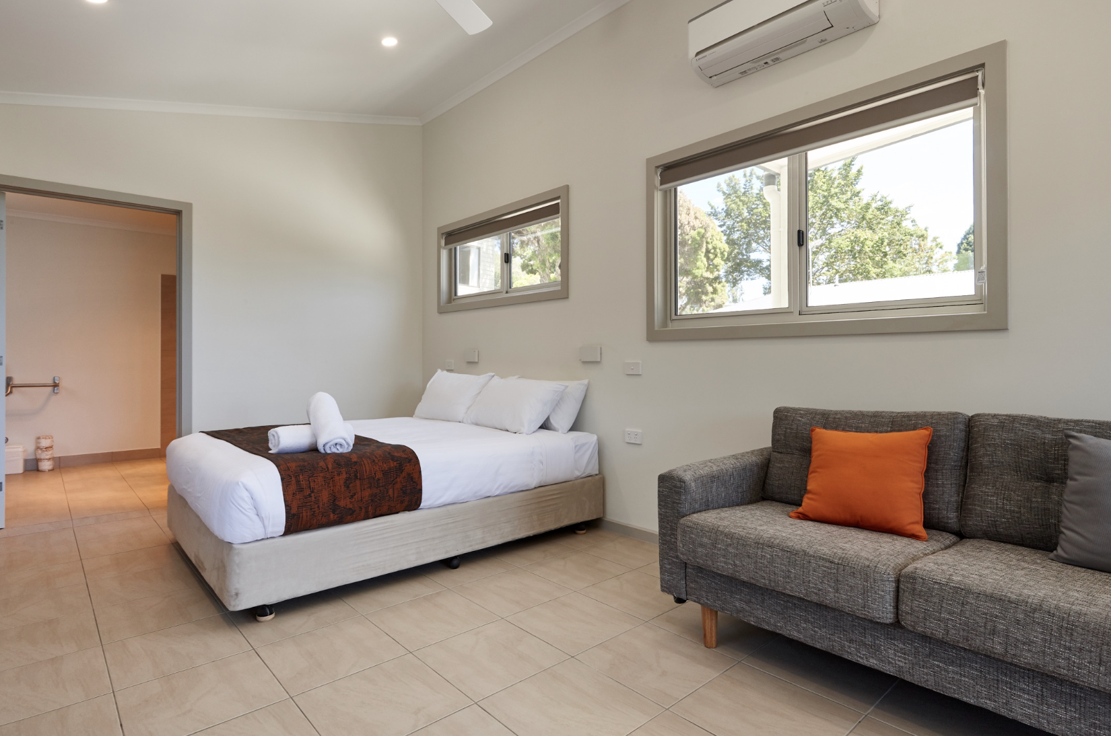
Screenshot 2023-06-03 at 4.05.43 pm

Room Amenities
- Lower hanging rails are in wardrobes
- Visual alarm is fitted to the room
- Televisions are equipped with closed captioning capability
- There is contrast between the walls, skirtings, floor and furniture
- There is a clear path through the room
- The edges of all furniture and fixtures are rounded
- Wardrobe handles are a contrasting colour to the doors and draws
- Housekeeping procedures instruct staff not to reposition furniture that has been moved
- Doors open fully against the adjoining wall
- There is a clear opening at least 850mm wide
- There at least one chair with rigid arms
- Wardrobe and drawer handles are easy to grip
- The bedside lamp switch is easy to reach from the bed
- There is at least 850mm clear space beside the bed
- The bed height is no higher than 680mm from the floor
- There is at least 130mm clearance under the bed
- The business offers a range of non-allergenic bedding
- Non-allergenic cleaning products are used
- In addition, the following further information can assist guests:
BIG4 Launceston Holiday Park provides self-contained holiday park accommodation rather than hotel-style rooms. As such, guest rooms do not include internal room phones, interconnecting phone systems, or direct-dial phone access to reception, restaurants or hotel services. The room phone questions are therefore not applicable to our property.

Guests are able to contact reception during office hours by mobile phone or in person at reception. The park does not operate a 24-hour reception desk, and after-hours and emergency contact information is provided to guests through our standard arrival and guest communication processes.

Our certified accessible accommodation has been designed to support safe and comfortable movement for guests with varying access needs. Features include clear internal pathways, appropriate door openings, contrast between walls, floors and furniture, easy-to-grip handles, rounded furniture edges, accessible chair options, and bedside lighting positioned within reach where practical.

The bathroom facilities in our accessible accommodation include a certified accessible shower with appropriate wall-fixed seating. An additional shower chair can also be arranged for guests if required.

Bathrooms
The bathrooms have the following facilities/amenities in place
- All heating appliances and hot water pipes are protected or insulated
- All shower, bath and basin taps are clearly differentiated between hot and cold
- Fixtures and fittings have rounded edges
- The hot water is thermostatically controlled to 41 degrees
- The door is at least 850mm wide
- There is a minimum of 850mm beside the toilet
- Handrails are fitted
- There is a minimum of 1400mm of clear space in front of the toilet
- The toilet seat is a contrasting colour to the floor
- The toilet seat is 460mm above the floor
- There is a roll-in shower with fold down fixed seat or a shower chair
- A door is fitted to the shower
- A door is fitted to the showers with an outward swing at minimum width of 900 mm
  - Bathroom Image(s)
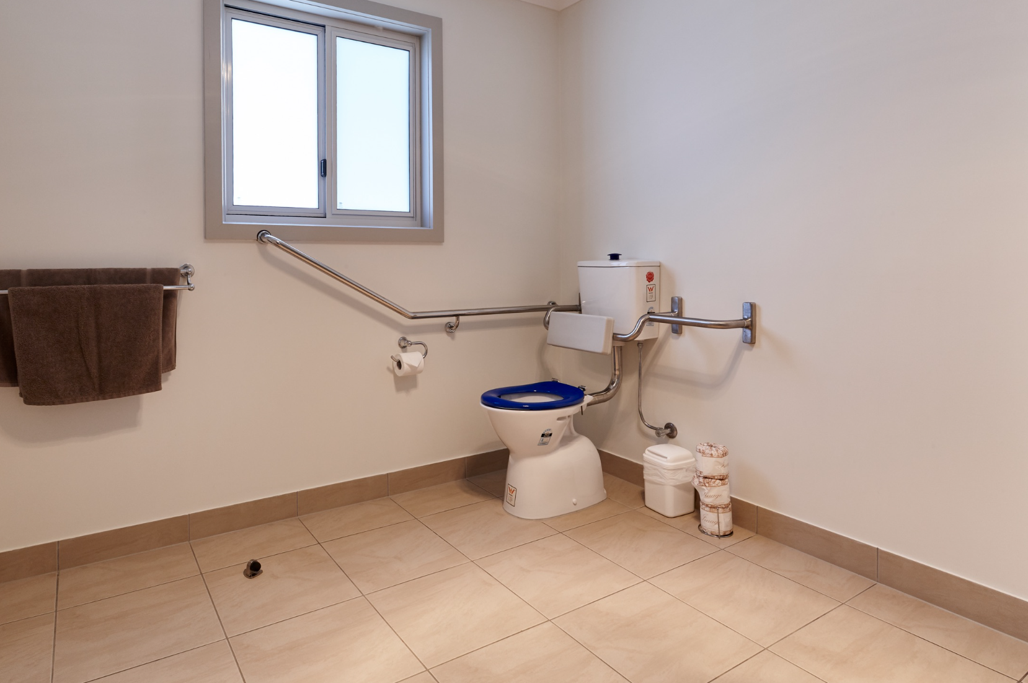
Screenshot 2023-06-03 at 4.03.15 pm
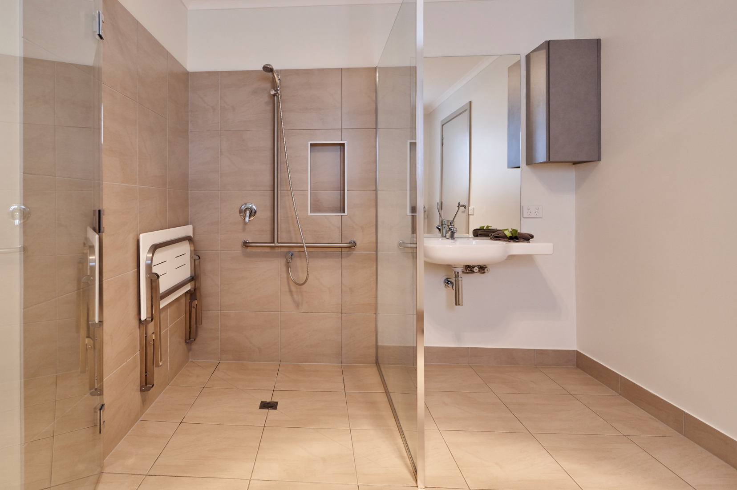
Screenshot 2023-06-03 at 4.03.26 pm
- In addition, the following further information can assist guests:
Bathrooms in our certified accessible accommodation have been designed to support safe and practical use for guests with mobility and access requirements.

Accessible bathroom features include protected or insulated hot water pipes and heating appliances, clearly differentiated hot and cold taps, rounded fixtures and fittings, handrails, suitable circulation space beside and in front of the toilet, a contrasting toilet seat, and a roll-in shower with seating. Bathroom door widths and shower access have been designed to support guests using mobility aids, with clear access where practical.

Portable shower heads on flexible hoses are available in accessible bathrooms, and shower doors are outward opening to support safer access. Guests are encouraged to contact reception prior to booking if they require specific bathroom measurements, photos or further information about the layout, shower seat, handrail placement, toilet clearance or vanity access.

We do not currently offer a specific range of non-allergenic toiletries as standard. Guests with allergies, sensitivities, specific toiletry requirements, or allergies to particular cleaning products are encouraged to contact reception prior to check-in so we can discuss their needs and provide accurate information about the products supplied and used in the accommodation.

COMMON AREAS

Play Spaces
- Level access is provided to play spaces
- Ramps provided are at least 25% of elevated sections of the play space
- There wheelchair accessible activities
- The space contain colour contrasting elements
- Seating is provided in or around the play space
  - Image(s)
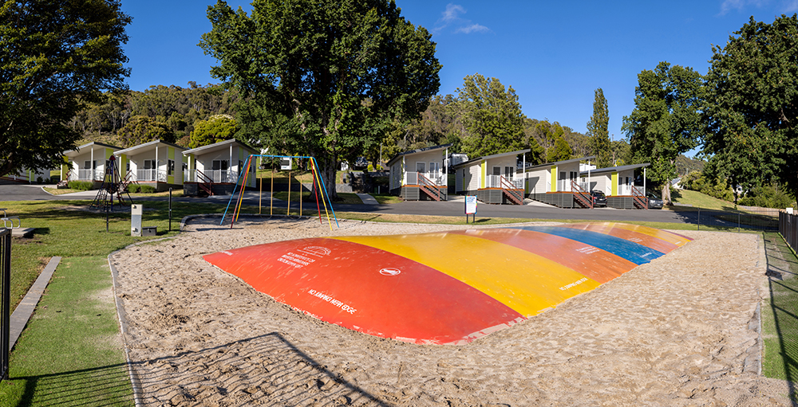
LA--201
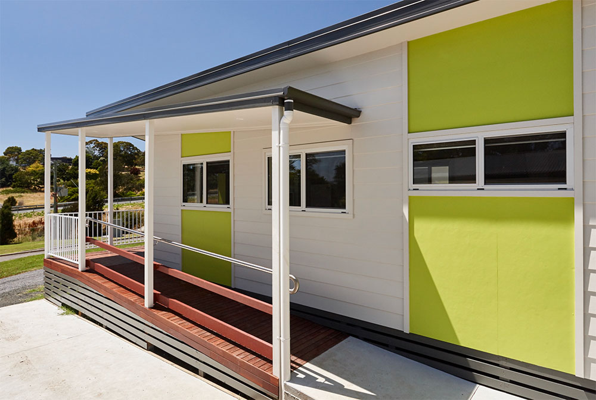
Screenshot-2023-06-03-at-7.42.30-pm
- In addition, the following further information can assist guests:
Our recreational and play area is located in the lower, more accessible section of the park, between reception and our accessible accommodation. This area has been positioned in one of the least steep parts of the property to provide the most practical access for families and guests with varying mobility needs.

The play space includes level access where practical, nearby seating, colour contrasting elements and accessible activities suitable for a range of children and families. While the playground does not currently include a rubberised surface, wheelchair swing, or dedicated cognitive or tactile play panels, the area is close to reception and accessible accommodation, allowing guests and carers to more easily assess suitability for their individual needs.

Guests with specific access, sensory or mobility requirements are encouraged to contact reception prior to arrival so we can provide further information about the play space layout, access paths, nearby seating, parking and surrounding facilities.

Report Disclaimer
Please note that this business report, provided as a result of the use of the diagnostic assessment, is for information purposes only.
Australian Tourism Industry Council (ATIC) cannot guarantee the accuracy of respondent’s answers, or that they are fully representative of your business. Therefore, ATIC does not warrant or guarantee any particular outcome in respect of your businesses self-assessment.
This report is intended as guidance only for your business and should not be relied on for future marketing considerations. ATIC recommends that you seek your own independent advice as well as the results from the diagnostic.
Links to external web sites are inserted for convenience and do not constitute endorsement of material at those sites, or any associated organisation, product or service.
ATIC does not:
- Assume any legal liability for the accuracy, completeness, or usefulness of any information from this report or any links provided; or
- Accept responsibility for any loss associated directly or indirectly from the use of this report.

