ATIC Accessibility
To support the accessible community in making informed travel decisions for their individual needs

This report prepared for:
Business name: | Narrows Escape Rainforest Retreat
Address: | 78 Narrows
Town: | Montville
Contact for enquiries: | Ali Khan and Xochi Lindholm
Contact Number: | 07 5478 5000
Contact Email: | reception@narrowsescape.com.au
Website: | https://www.narrowsescape.com.au/
Date: | 2026-09-09 04:37

ATIC Accessibility
The following pages provides travellers with information on the businesses facilities and amenities which aims to support the traveller to make an informed decision on whether the business is suitable for their individual needs.
OVERVIEW 4
Business Overview 4
Bookings 4
Emergency Management 4
Communications 5
Other Information 6
Guide Dog and Service Animals 6
GENERAL 7
Pre-arrival, arrival and reception 7
Cognitive Impairment Support 7
Car Park and Access amenities 8
Entry 8
Internal Spaces 8
Public areas 9
External Paths 9
Steps 9
Ramps 9
ACCOMMODATION 11
Bedrooms 11
Room Amenities 11
Bathrooms 12
COMMON AREAS 13
Report Disclaimer 15

OVERVIEW

Business Overview

The business has the following products/services available
- Accommodation

Our business caters for the following disability types:
- Blind or low vision
- Deaf or low hearing
- Limited mobility
- Wheelchairs or mobility scooters
- Food allergies or intolerances
- Cognitive or people on the Autism Spectrum

Bookings

The business offers the following methods for bookings and enquiries:
- Phone
- Email
- Webportal
- Our website supports Screen Readers
- Staff have undergone disability awareness and training

Emergency Management
- Emergency and evacuation procedures are explained on arrival
- There are Audible device/s to alert occupants to evacuate with instructions on how to evacuate.
- There are visual device/s to alert occupants to evacuate.
- Exit access is free and clear at all times
We ensure exit access is free and clear at all times by: It is maintained daily
- Exits and access to exists are greater than 900mm
- Exit doors are able to be opened by all occupants
- Exits to the emergency evacuation point does not include stairways
- There is an emergency refuge that has an intercommunication system linked and has sufficient fire resistance levels.
- The evacuation point is clearly marked by a sign
The business identifies guests who need additional assistance should an emergency occur by: Pre-arrival we identify if guests have any assistance needs through our confirmation email.
The procedure for assisting guests who need assisted rescue is: The onsite manager is the safety warden to escort guests in case of emergency
- Guests with disabilities are noted in the guest log book for emergency and evacuation purposes

Communications
- An accessibility guide is available on the website
https://narrowsescape.com.au/accessibility/
- Our website meets WCAG 2.0 accessibility standards
- Our business offers the following alternative communication methods
- Plain English
- Magnifiers
NA
- There is easy to read signage and information (e.g. menus and emergency information)
- There is a Pictorial menu
  - Pictorial Menu Image(s)
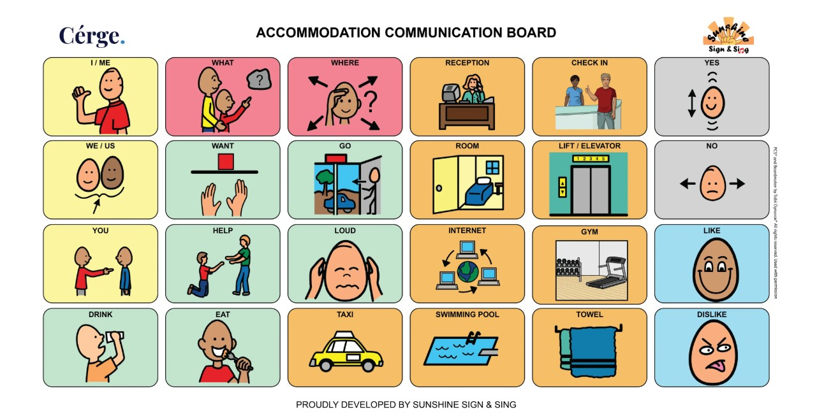
Pictorial Communication Board
- There are Picture boards
  - Picture Boards Image(s)
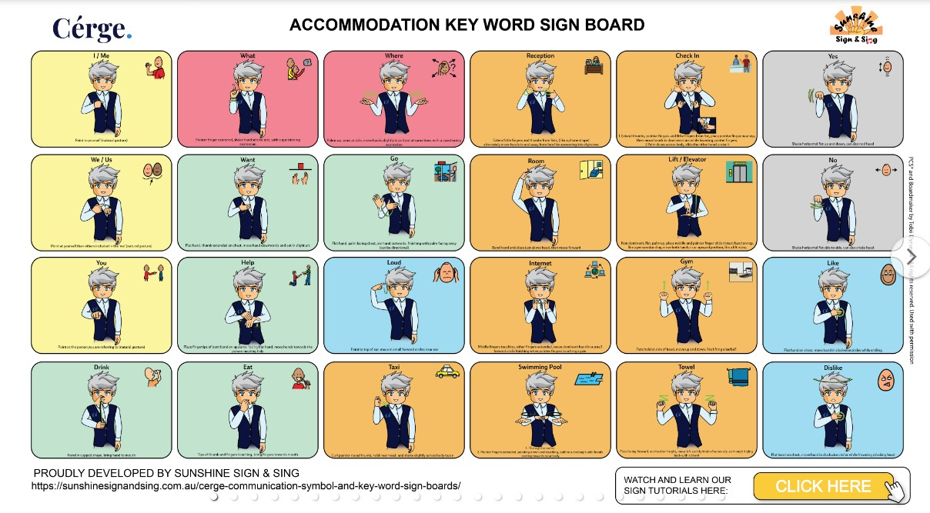
Pictorial menu for accessibility

Other Information
- The business accepts the companion card

Guide Dog and Service Animals
- The business provides a secure area with shade and water for service animals
- The business provides a toilet area for service animals
- Bowls, bedding, etc. are provided for service animals
The business provides the following services for services animals: Service animal are welcome to reside in the cottages

GENERAL

Pre-arrival, arrival and reception
The business has the following in place to support guests during pre-arrival, arrival and reception
- Booking information and websites are compatible with screen readers
- There is a reception/public entryway.
- Seating available at reception
- A lower counter at reception/ticket office
- A clipboard to allow check-in/ticket purchase whilst seated
- A tablet with text to voice or pen and paper at reception to aid in communication
- Picture Board at reception to aid in communication
- Lighting in the reception area is even and glare free
Paperword is completed prior to arrival
- Information and maps are available in written form
- A step free map/guide
- A familiarisation tour
- Keys are available for each guest
- Luggage assistance
The following steps are in place to ensure that people with fatigue related to their disability are not disadvantaged by long wait times: We have pre-arrival check-in and only 8 villas. There are chairs in reception if guests need to wait to be assisted.
- In addition, the following further information can assist guests:
We have partnered with Cerge so there is detailed information about our accessibility available on our website for guests with accessibility needs who are considering booking accommodation.

Cognitive Impairment Support
- Documents are available in plain English for people with cognitive impairment (This may include instructions, guides, menus and general information)
- A "social script" guide to your premises or attraction describing the sights, sounds and smells to aid parents/carers prepare visitors in advance
- The 'social script' is available in word and other editable formats

Car Park and Access amenities
The business has the following Car Park and Access amenities
- A drop off zone
- Designated disabled parking bays
- Level or ramped access from the car park to the entrance
- The accessible entrance is clearly signed from the parking bay
- Kerb ramps are in place where a pavement or walkway needs to be crossed
- In addition, the following further information can assist guests:
The car park doesn't have any barriers

Entry
The business has the following amenities/systems in place for entry
- A drop off point close to the entrance
- A path of access to the building is slip resistance and even
- A path of access to the building is clear of obstruction
- Glass doors are fitted with a visual sighting strip
- Door jams/doors are of a contrasting colour to surrounding walls
- Door handles are of a contrasting colour to the door
- Signage is written in a contrasting colour
- The entry door is a minimum of 850mm wide
- The entry door has self opening or a light opening pressure (for manual operations)
- The entrance sill is less than 13mm
- There a clear space of at least 1500mm x 1500mm in front of all doors.
- The entrance door mats have a thickness less than 13mm and a width of 7500mm or greater

Internal Spaces
- Clear and unobstructed routes through and between buildings
- Interior walls are matte or low sheen
- Floors, walls, counters and furniture are of contrasting colours
- Any protruding or overhanging obstructions are at least 2meters above the floor or are protected
- Menus are available in large print or Braille
- Tableware/glassware contrast with the table surface or table cloth
- Floor surfaces are hard or short pile carpet
- Seating is available for guests unable to stand for long periods
- Accessible facilities are clearly signed and visible from all areas
- All corridors greater than 900mm
- In addition, the following further information can assist guests:
We are adults only so we don't cater for children on the autism spectrum.

Public areas
The public areas have the following amenities in place
- Even lighting
- Seating

External Paths
External paths of travel
- Surfaces are concrete, asphalt, smooth paving or hard packed fine gravel (max aggregate size 13mm)
- Pathways are wider than 900mm
- There 3 successive steps or less on any path or at any doorway
- Any paths having steps are clearly identified as non-wheelchair accessible
- Step free routes clearly signed

Steps
Steps
- There are steps.
- Top and bottom steps are easily distinguished through colour contrast or the use of TGSIs (Tactile Ground Surface Indicators)
- All steps or staircases have enclosed risers
- The underside of all staircases are enclosed or protected to a height of at least 2 metres
- Handrails fitted to all open sets of steps
- Handrails extend 300mm beyond the top and bottom step
- Where steps are present are there three steps or less
- In addition, the following further information can assist guests:
Guests can select our accessible villa or one with no steps if they have accessibility needs

Ramps
Ramps have the following amenities are in place
- There are ramps.
- All fixed ramps are 1:14 or less
- Hand rails are fitted
- Long ramps (more than 10m) are 1:20 or less
- Ramps have a raised edge of at least 100mm

ACCOMMODATION

Bedrooms
The bedrooms have the following facilities/amenities in place
- There are 1 rooms available to guests who use a wheelchair
- Bedroom furniture can be re-arranged on request

The following bed types are available in wheelchair accessible rooms
- One double/queen bed/king bed
- Two single beds
  - Layout of room Image(s)
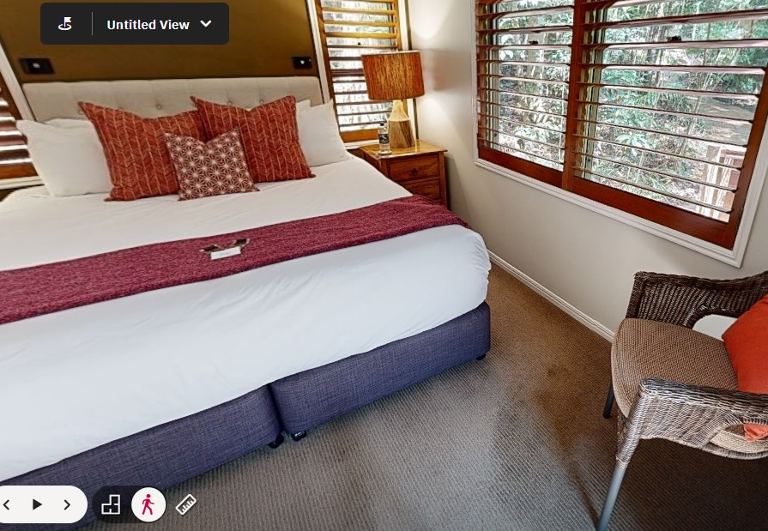
Accesibility photo

Room Amenities
- Visual alarm is fitted to the room
- Televisions are equipped with closed captioning capability
- Vibrating alarm clocks
- There is contrast between the walls, skirtings, floor and furniture
- There is a clear path through the room
- The edges of all furniture and fixtures are rounded
- Housekeeping procedures instruct staff not to reposition furniture that has been moved
- Doors open fully against the adjoining wall
- There is a clear opening at least 850mm wide
- There luggage racks for at least two suitcases
- There at least one chair with rigid arms
- Wardrobe and drawer handles are easy to grip
- The bedside lamp switch is easy to reach from the bed
- There is at least 850mm clear space beside the bed
- The bed height is no higher than 680mm from the floor
- There is at least 130mm clearance under the bed
- The business offers a range of non-allergenic bedding
- Non-allergenic cleaning products are used
- In addition, the following further information can assist guests:
We don't have phones in the villas.

Bathrooms
The bathrooms have the following facilities/amenities in place
- All heating appliances and hot water pipes are protected or insulated
- All shower, bath and basin taps are clearly differentiated between hot and cold
- Fixtures and fittings have rounded edges
- The hot water is thermostatically controlled to 41 degrees
- The door is at least 850mm wide
- There is a minimum of 850mm beside the toilet
- Handrails are fitted
- There is a minimum of 1400mm of clear space in front of the toilet
- The toilet seat is 460mm above the floor
- A range of non-allergenic toiletries are available
- There is a roll-in shower with fold down fixed seat or a shower chair
- There is a portable shower head on flexible hose
  - Bathroom Image(s)
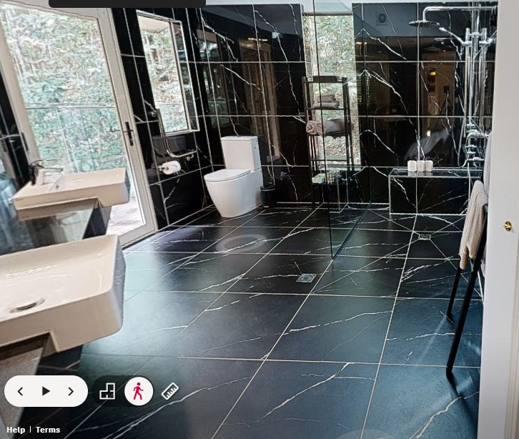
Screenshot 2026-07-09 111921

COMMON AREAS

Report Disclaimer
Please note that this business report, provided as a result of the use of the diagnostic assessment, is for information purposes only.
Australian Tourism Industry Council (ATIC) cannot guarantee the accuracy of respondent’s answers, or that they are fully representative of your business. Therefore, ATIC does not warrant or guarantee any particular outcome in respect of your businesses self-assessment.
This report is intended as guidance only for your business and should not be relied on for future marketing considerations. ATIC recommends that you seek your own independent advice as well as the results from the diagnostic.
Links to external web sites are inserted for convenience and do not constitute endorsement of material at those sites, or any associated organisation, product or service.
ATIC does not:
- Assume any legal liability for the accuracy, completeness, or usefulness of any information from this report or any links provided; or
- Accept responsibility for any loss associated directly or indirectly from the use of this report.

