ATIC Accessibility
To support the accessible community in making informed travel decisions for their individual needs

This report prepared for:
Business name: | Novotel Perth Murray Street
Address: | 388 Murray Street
Town: | Perth
Contact for enquiries: | Carla Jordan
Contact Number: | +61 8 6371 6371
Contact Email: | hb6h3@accor.com
Website: | https://www.novotelperthmurraystreet.com.au/
Date: | 2026-10-28 21:56

ATIC Accessibility
The following pages provides travellers with information on the businesses facilities and amenities which aims to support the traveller to make an informed decision on whether the business is suitable for their individual needs.
OVERVIEW 4
Business Overview 4
Bookings 4
Emergency Management 4
Communications 4
Other Information 5
GENERAL 6
Pre-arrival, arrival and reception 6
Car Park and Access amenities 6
Entry 6
Lifts 7
Internal Spaces 7
Public areas 7
External Paths 7
Public Toilets/Adult change facilities 8
ACCOMMODATION 9
Bedrooms 9
Room Amenities 9
Bathrooms 10
COMMON AREAS 11
Swimming pools, spas and waterparks 11
Report Disclaimer 13

OVERVIEW

Business Overview

The business has the following products/services available
- Accommodation

Our business caters for the following disability types:
- Blind or low vision
- Deaf or low hearing
- Limited mobility
- Wheelchairs or mobility scooters
- Cognitive or people on the Autism Spectrum

Bookings

The business offers the following methods for bookings and enquiries:
- Phone
- Email
- Webportal
- Our website supports Screen Readers
- Our forms have high contract boxes and submit boxes

Emergency Management
- The business has an emergency management and evacuation plan for guests with a disability
- Guests with disabilities are noted in the guest log book for emergency and evacuation purposes

Communications

Other Information
- For bookings made onsite, the ticket booth/counter/box office is accessible for people using a wheelchair

GENERAL

Pre-arrival, arrival and reception
The business has the following in place to support guests during pre-arrival, arrival and reception
- Booking information and websites are compatible with screen readers
- There is a reception/public entryway.
- A tablet with text to voice or pen and paper at reception to aid in communication
- Lighting in the reception area is even and glare free
- Information and maps are available in written form
- A familiarisation tour
- Keys are available for each guest
- Luggage assistance
The following steps are in place to ensure that people with fatigue related to their disability are not disadvantaged by long wait times: Seating is available in the lobby

Car Park and Access amenities
The business has the following Car Park and Access amenities
- A drop off zone
- Designated disabled parking bays
- Level or ramped access from the car park to the entrance
- An intercom system is available at the entrance of car park

Entry
The business has the following amenities/systems in place for entry
- A path of access to the building is slip resistance and even
- A path of access to the building is clear of obstruction
- Self opening entry doors or fitted with a self closer
- Glass doors are fitted with a visual sighting strip
- Door jams/doors are of a contrasting colour to surrounding walls
- Door handles are of a contrasting colour to the door
- Signage is written in a contrasting colour
- Signage is written in a Sans Serif font and use upper and lower case letters
- The entry door is a minimum of 850mm wide
- The entry door has self opening or a light opening pressure (for manual operations)
- There a clear space of at least 1500mm x 1500mm in front of all doors.
- The entrance door mats have a thickness less than 13mm and a width of 7500mm or greater

Lifts
- Premises has lifts

Internal Spaces
- Clear and unobstructed routes through and between buildings
- Interior walls are matte or low sheen
- Floors, walls, counters and furniture are of contrasting colours
- Any protruding or overhanging obstructions are at least 2meters above the floor or are protected
- Tableware/glassware contrast with the table surface or table cloth
- Floor surfaces are hard or short pile carpet
- Accessible facilities are clearly signed and visible from all areas
- All corridors greater than 900mm

Public areas
The public areas have the following amenities in place
- Display units, Televisions, Video displays etc. are open captioned
- Even lighting
- Seating

External Paths
External paths of travel
- Surfaces are concrete, asphalt, smooth paving or hard packed fine gravel (max aggregate size 13mm)
- Pathways are wider than 900mm
We don't have steps
We don't have steps
- Step free routes clearly signed

Public Toilets/Adult change facilities
Public Toilets/Adult change facilities have the following amenities are in place
- There is an accessible toilet for public use
- The door is at least 850mm wide
- There is a minimum of 850mm beside the toilet
- Handrails are fitted
- The toilet seat is 460mm above the floor
- There is 2m mm of clear space in front of the toilet
- The toilet seat of a contrasting colour to the floor
- The toilet seat is460mm above the floor

ACCOMMODATION

Bedrooms
The bedrooms have the following facilities/amenities in place
- There are 18 rooms available to guests who use a wheelchair
- Bedroom furniture can be re-arranged on request

The following bed types are available in wheelchair accessible rooms
- One double/queen bed/king bed
  - Layout of room Image(s)
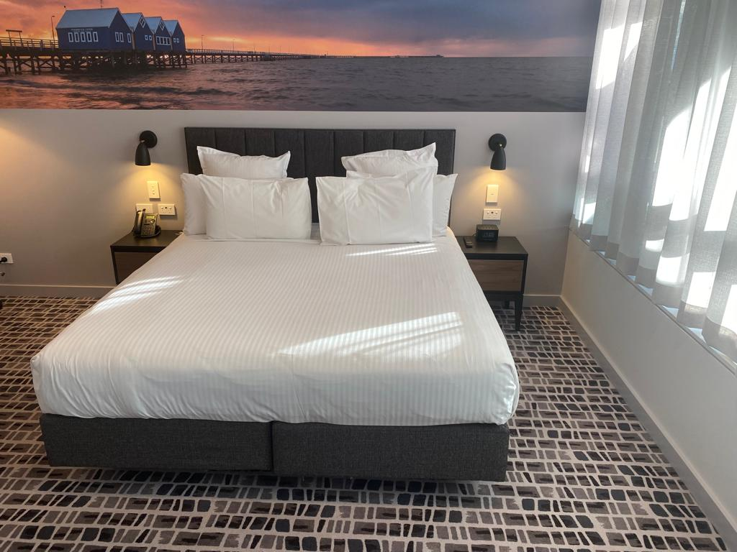
WhatsApp Image 2023-10-31 at 5.08.20 PM (1)

Room Amenities
- Visual alarm is fitted to the room
- Televisions are equipped with closed captioning capability
- Room phones have volume control
- Room phones have a visual ringing indicator
- There is contrast between the walls, skirtings, floor and furniture
- There is a clear path through the room
- The edges of all furniture and fixtures are rounded
- Doors open fully against the adjoining wall
- There is a clear opening at least 850mm wide
- There luggage racks for at least two suitcases
- There at least one chair with rigid arms
- Wardrobe and drawer handles are easy to grip
- The bedside lamp switch is easy to reach from the bed
- There is at least 850mm clear space beside the bed
- The bed height is no higher than 680mm from the floor
- There is at least 130mm clearance under the bed

Bathrooms
The bathrooms have the following facilities/amenities in place
- All heating appliances and hot water pipes are protected or insulated
- All shower, bath and basin taps are clearly differentiated between hot and cold
- Fixtures and fittings have rounded edges
- The hot water is thermostatically controlled to 41 degrees
- The door is at least 850mm wide
- There is a minimum of 850mm beside the toilet
- Handrails are fitted
- There is a minimum of 1400mm of clear space in front of the toilet
- The toilet seat is a contrasting colour to the floor
- The toilet seat is 460mm above the floor
- There is a portable shower head on flexible hose
- A door is fitted to the shower
- A door is fitted to the showers with an outward swing at minimum width of 900 mm
  - Bathroom Image(s)
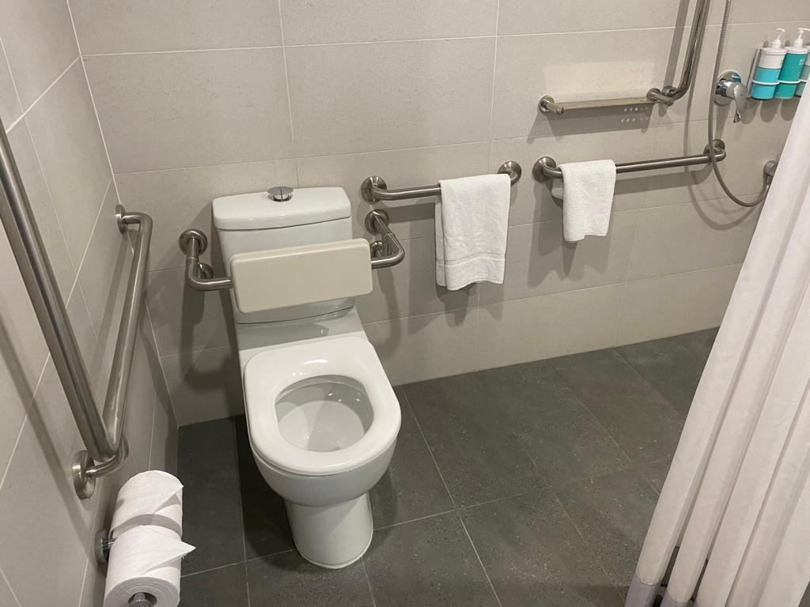
WhatsApp Image 2023-10-31 at 5.08.20 PM

COMMON AREAS

Swimming pools, spas and waterparks
- The following swimming pools, spas and waterparks amenities are available
- Unisex change facilities with an accessible toilet

The following accessible entry methods are available to the pools and spas:
- Accessible pool stairs (hand rails both sides)
  - Pool Access Image(s)
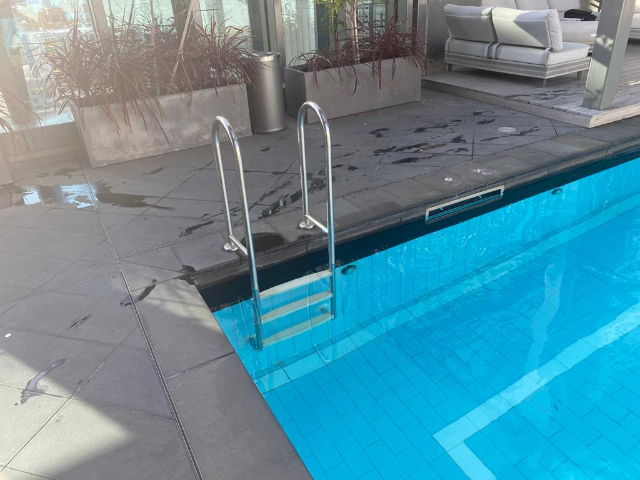
WhatsApp Image 2023-10-31 at 5.23.18 PM

Report Disclaimer
Please note that this business report, provided as a result of the use of the diagnostic assessment, is for information purposes only.
Australian Tourism Industry Council (ATIC) cannot guarantee the accuracy of respondent’s answers, or that they are fully representative of your business. Therefore, ATIC does not warrant or guarantee any particular outcome in respect of your businesses self-assessment.
This report is intended as guidance only for your business and should not be relied on for future marketing considerations. ATIC recommends that you seek your own independent advice as well as the results from the diagnostic.
Links to external web sites are inserted for convenience and do not constitute endorsement of material at those sites, or any associated organisation, product or service.
ATIC does not:
- Assume any legal liability for the accuracy, completeness, or usefulness of any information from this report or any links provided; or
- Accept responsibility for any loss associated directly or indirectly from the use of this report.

