ATIC Accessibility
To support the accessible community in making informed travel decisions for their individual needs

This report prepared for:
Business name: | Pemberton Discovery Tours Pty Ltd
Address: | 12 Brockman St
Town: | Pemberton
Contact for enquiries: | Toni Dearle
Contact Number: | 0897760484
Contact Email: | info@pembertondiscoverytours.com.au
Website: | www.pembertondiscoverytours.com.au
Date: | 2026-10-31 21:41

ATIC Accessibility
The following pages provides travellers with information on the businesses facilities and amenities which aims to support the traveller to make an informed decision on whether the business is suitable for their individual needs.
OVERVIEW 4
Business Overview 4
Bookings 4
Emergency Management 4
Communications 5
Other Information 5
Guide Dog and Service Animals 5
GENERAL 6
Pre-arrival, arrival and reception 6
Cognitive Impairment Support 6
Car Park and Access amenities 6
Entry 7
Internal Spaces 7
Public areas 7
External Paths 8
Steps 8
TOUR OPERATORS 9
Tour/Transport Services 9
Route Planning 9
Guides 9
ADVENTURE ACTIVITIES 11
Adventure activities 11
Report Disclaimer 13

OVERVIEW

Business Overview

The business has the following products/services available
- Tour/Transport
- Adventure

Our business caters for the following disability types:
- Blind or low vision
- Deaf or low hearing
- Limited mobility
- Wheelchairs or mobility scooters
- Food allergies or intolerances
- Cognitive or people on the Autism Spectrum

Bookings

The business offers the following methods for bookings and enquiries:
- Phone
- Email
- Webportal
- Our website supports Screen Readers
- Our forms have high contract boxes and submit boxes
- Staff have undergone disability awareness and training

Emergency Management
- Emergency and evacuation procedures are explained on arrival
- Exit signs are clear and easy to see
- Exit access is free and clear at all times
We ensure exit access is free and clear at all times by: small group tours
- Exits and access to exists are greater than 900mm
- Exit doors are able to be opened by all occupants
- Exits that include stairways have emergency stair travel devices available.
- Exits including stairwells, have bright edges used on the steps.
- The evacuation point is clearly marked by a sign
The business identifies guests who need additional assistance should an emergency occur by: At booking, usually by phone.
The procedure for assisting guests who need assisted rescue is: Usually guests travel with a carer
- Guests with disabilities are noted in the guest log book for emergency and evacuation purposes

Communications
- An accessibility guide is available on the website
https://www.pembertondiscoverytours.com.au/post/accessibility-is-important-to-us
- Our website meets WCAG 2.0 accessibility standards
- Our business offers the following alternative communication methods
- Plain English
Email, Ipad
- There is easy to read signage and information (e.g. menus and emergency information)

Other Information
- The business accepts the companion card

Guide Dog and Service Animals
- The business provides a secure area with shade and water for service animals
- Bowls, bedding, etc. are provided for service animals
The business provides the following services for services animals: There will be room on the floor next to the passenger. Case by Case situation.

GENERAL

Pre-arrival, arrival and reception
The business has the following in place to support guests during pre-arrival, arrival and reception
- Booking information and websites are compatible with screen readers
- Information and maps are available in written form
no locked facilities - our guides are with the guests the whole time
The following steps are in place to ensure that people with fatigue related to their disability are not disadvantaged by long wait times: All accessibility bookings are done case by case - as a small tour operator with a maximum of 13 passengers, the guests are asked prior to arrival to ensure we can cater to any requirements.
- In addition, the following further information can assist guests:
All accessibility bookings are done case by case - as a small tour operator with a maximum of 13 passengers, the guests are asked prior to arrival to ensure we can cater to any requirements.

Cognitive Impairment Support
- Documents are available in plain English for people with cognitive impairment (This may include instructions, guides, menus and general information)
- A "social script" guide to your premises or attraction describing the sights, sounds and smells to aid parents/carers prepare visitors in advance
- Quiet periods or early opening times for people on the Autism Spectrum
- A space for parents and children on the Autism Spectrum

Car Park and Access amenities
The business has the following Car Park and Access amenities
- A drop off zone
- Designated disabled parking bays
- Level or ramped access from the car park to the entrance
- The accessible entrance is clearly signed from the parking bay
- Kerb ramps are in place where a pavement or walkway needs to be crossed
- In addition, the following further information can assist guests:
All accessibility bookings are done case by case - as a small tour operator with a maximum of 13 passengers, the guests are asked prior to arrival to ensure we can cater to any requirements.

Entry
The business has the following amenities/systems in place for entry
- A drop off point close to the entrance
- A path of access to the building is slip resistance and even
- A path of access to the building is clear of obstruction
- Glass doors are fitted with a visual sighting strip
- Door jams/doors are of a contrasting colour to surrounding walls
- Door handles are of a contrasting colour to the door
- Signage is written in a contrasting colour
- Signage is written in a Sans Serif font and use upper and lower case letters
- The entry door is a minimum of 850mm wide
- The entrance sill is less than 13mm
- There a clear space of at least 1500mm x 1500mm in front of all doors.
- The entrance door mats have a thickness less than 13mm and a width of 7500mm or greater
- In addition, the following further information can assist guests:
The information here is for the Crossings Bakery - our meeting spot for our tours

Internal Spaces
- Clear and unobstructed routes through and between buildings
- Interior walls are matte or low sheen
- Floors, walls, counters and furniture are of contrasting colours
- Floor surfaces are hard or short pile carpet
- Seating is available for guests unable to stand for long periods
- Accessible facilities are clearly signed and visible from all areas
- All corridors greater than 900mm
- There is a quiet space for parents and children on the Autism Spectrum
- In addition, the following further information can assist guests:
This is the Crossings Bakery - our meeting spot

Public areas
The public areas have the following amenities in place
- Even lighting
- Seating
- In addition, the following further information can assist guests:
This is for the Crossings Bakery - our meeting spot (not compulsory as you can wait in your vehicle)

External Paths
External paths of travel
- Pathways are wider than 900mm
National Park
National Park - bush trails
- In addition, the following further information can assist guests:
All our walking / outside vehicle activity is considered optional.

Steps
Steps
- There are steps.
- Top and bottom steps are easily distinguished through colour contrast or the use of TGSIs (Tactile Ground Surface Indicators)
- All steps or staircases have enclosed risers
- The underside of all staircases are enclosed or protected to a height of at least 2 metres
- Handrails fitted to all open sets of steps
- Handrails extend 300mm beyond the top and bottom step
- Where steps are present are there three steps or less
- In addition, the following further information can assist guests:
Steps to climb into the vehicles
- In addition, the following further information can assist guests:
There is adult changing facilities just next to our departure point.

TOUR OPERATORS

Tour/Transport Services
The tour/transport services have the following facilities/amenities in place
- Buses/Coaches
- 0 vehicles have wheelchair lifts or ramps
- 0 vehicles have low floors with ramped entry
The maximum wheelchair capacity available in the fleet is: 3
- Commentary is available in written format

Route Planning
- Route Planning
- The tour route includes stops with accessible toilet facilities
- In addition, the following further information can assist guests:
All accessibility bookings are done case by case - as a small tour operator with a maximum of 13 passengers, the guests are asked prior to arrival to ensure we can cater to any requirements.
- Lunch stop venues are accessible
- Sightseeing and photo opportunity stops are step free

Guides
- Use of clear/simple English
- Correct pronunciation for lip readers
- There is a audio description of surroundings
  - Image(s)
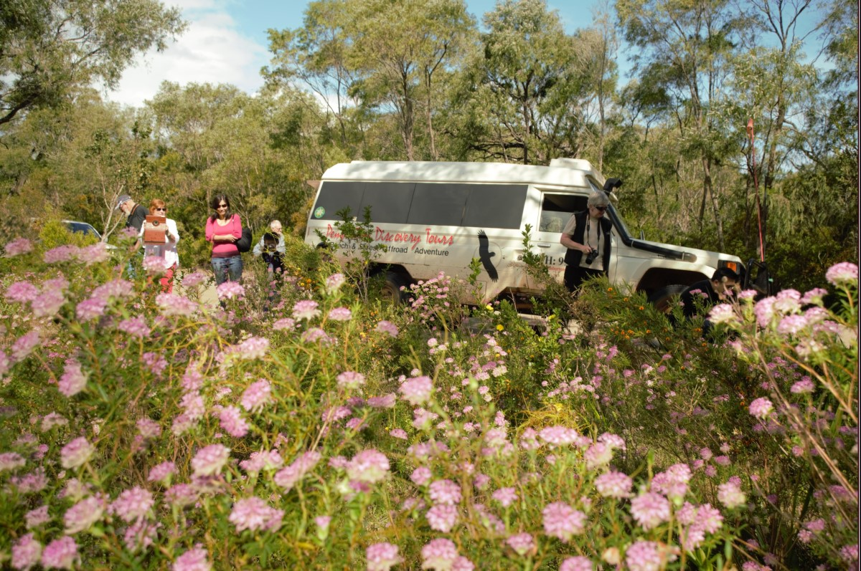
Arkana in flowers2
- In addition, the following further information can assist guests:
All accessibility bookings are done case by case - as a small tour operator with a maximum of 13 passengers, the guests are asked prior to arrival to ensure we can cater to any requirements.

ADVENTURE ACTIVITIES

Adventure activities
The adventure activities have the following facilities/amenities in place
- Our adventure activities cater for people with a disability
The following activities are available to people with a disability: All activities however in a case by case situation - as a small tour operator with a maximum of 13 passengers, the guests are asked prior to arrival to ensure we can cater to any requirements.
The equipment utilised to make the activities available are: Accessible seats - these include the front and side passenger seats with hand rails. Language and photos (visual aid) Time - most of our adventure is offroad so our guests really appreciate a guided journey through the landscapes
The following limitations apply to participation, including those activities that are not available to people with a disability: No wheelchair friendly pathways; so previous guests have enjoyed sitting and enjoying the view. Offroad wheelchairs are able to access these areas however do need to be booked in as an additional vehicle maybe required to carry them.
  - Adventure Activity Image(s)
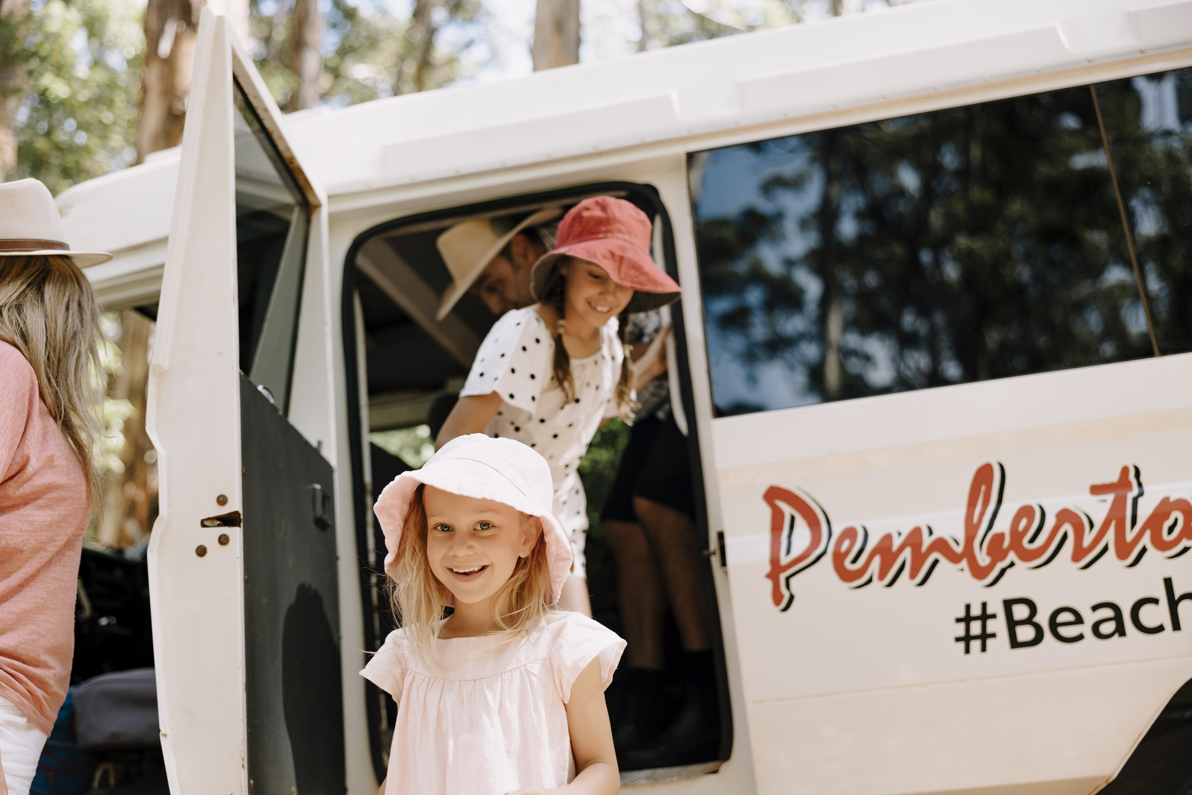
TA_NECI_WA_PembertonDiscovery_240322 SENG6391
- In addition, the following further information can assist guests:
All accessibility bookings are done case by case - as a small tour operator with a maximum of 13 passengers, the guests are asked prior to arrival to ensure we can cater to any requirements.

Report Disclaimer
Please note that this business report, provided as a result of the use of the diagnostic assessment, is for information purposes only.
Australian Tourism Industry Council (ATIC) cannot guarantee the accuracy of respondent’s answers, or that they are fully representative of your business. Therefore, ATIC does not warrant or guarantee any particular outcome in respect of your businesses self-assessment.
This report is intended as guidance only for your business and should not be relied on for future marketing considerations. ATIC recommends that you seek your own independent advice as well as the results from the diagnostic.
Links to external web sites are inserted for convenience and do not constitute endorsement of material at those sites, or any associated organisation, product or service.
ATIC does not:
- Assume any legal liability for the accuracy, completeness, or usefulness of any information from this report or any links provided; or
- Accept responsibility for any loss associated directly or indirectly from the use of this report.

