ATIC Accessibility
To support the accessible community in making informed travel decisions for their individual needs

This report prepared for:
Business name: | Whalesong Cruises
Address: | Shop 2, 17 Buccaneer Dr
Town: | Urangan
Contact for enquiries: | Ben Duffy
Contact Number: | 07 4125 6222
Contact Email: | ben@whalesong.com.au
Website: | www.whalesong.com.au
Date: | 2026-10-25 04:00

ATIC Accessibility
The following pages provides travellers with information on the businesses facilities and amenities which aims to support the traveller to make an informed decision on whether the business is suitable for their individual needs.
OVERVIEW 4
Business Overview 4
Bookings 4
Emergency Management 4
Communications 5
Other Information 7
Guide Dog and Service Animals 7
GENERAL 9
Pre-arrival, arrival and reception 9
Cognitive Impairment Support 9
Car Park and Access amenities 10
Entry 10
Internal Spaces 10
Public areas 11
Displays, exhibits, commentary and live performances 11
External Paths 11
Ramps 11
Public Toilets/Adult change facilities 12
TOUR OPERATORS 13
Tour/Transport Services 13
Route Planning 13
Guides 13
Report Disclaimer 18

OVERVIEW

Business Overview

The business has the following products/services available
- Tour/Transport

Our business caters for the following disability types:
- Blind or low vision
- Deaf or low hearing
- Limited mobility
- Wheelchairs or mobility scooters
- Food allergies or intolerances
- Cognitive or people on the Autism Spectrum

Bookings

The business offers the following methods for bookings and enquiries:
- Phone
- Email
- Webportal
- Our website supports Screen Readers
- Our forms have high contract boxes and submit boxes
- Staff have undergone disability awareness and training

Emergency Management
- The business has an emergency management and evacuation plan for guests with a disability
- Emergency and evacuation procedures are explained on arrival
We ensure exit access is free and clear at all times by: No fixtures near exits. Only passengers can stand near and will be moved in case of an emergency
- Exits that include stairways have emergency stair travel devices available.
- There is an emergency refuge that has an intercommunication system linked and has sufficient fire resistance levels.
- Exits including stairwells, have bright edges used on the steps.
- Guests with disabilities are noted in the guest log book for emergency and evacuation purposes

Communications
- An accessibility guide is available on the website
https://whalesong.com.au/about/accessibility/
- Our website meets WCAG 2.0 accessibility standards
- Our business offers the following alternative communication methods
- Plain English
- Magnifiers
Audio guides (with transcripts) on VacayIt app and our website
- There is easy to read signage and information (e.g. menus and emergency information)
- There is a Pictorial menu
- There are Picture boards
  - Picture Boards Image(s)
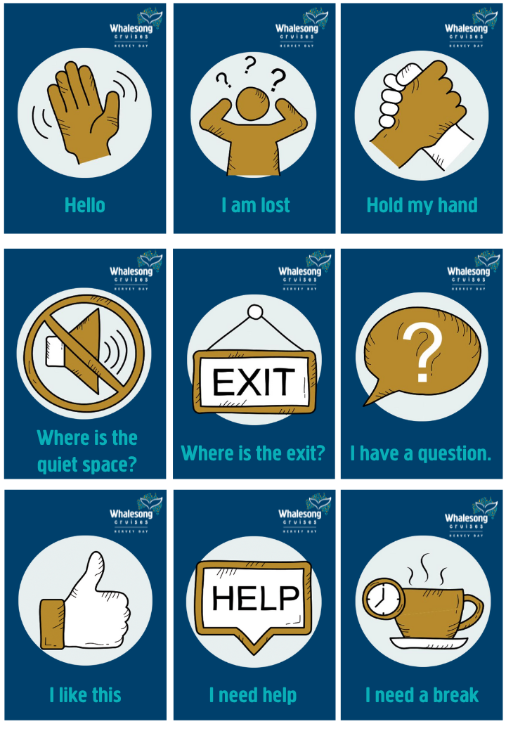
Whalesong Cruises - communciation cards - guest1
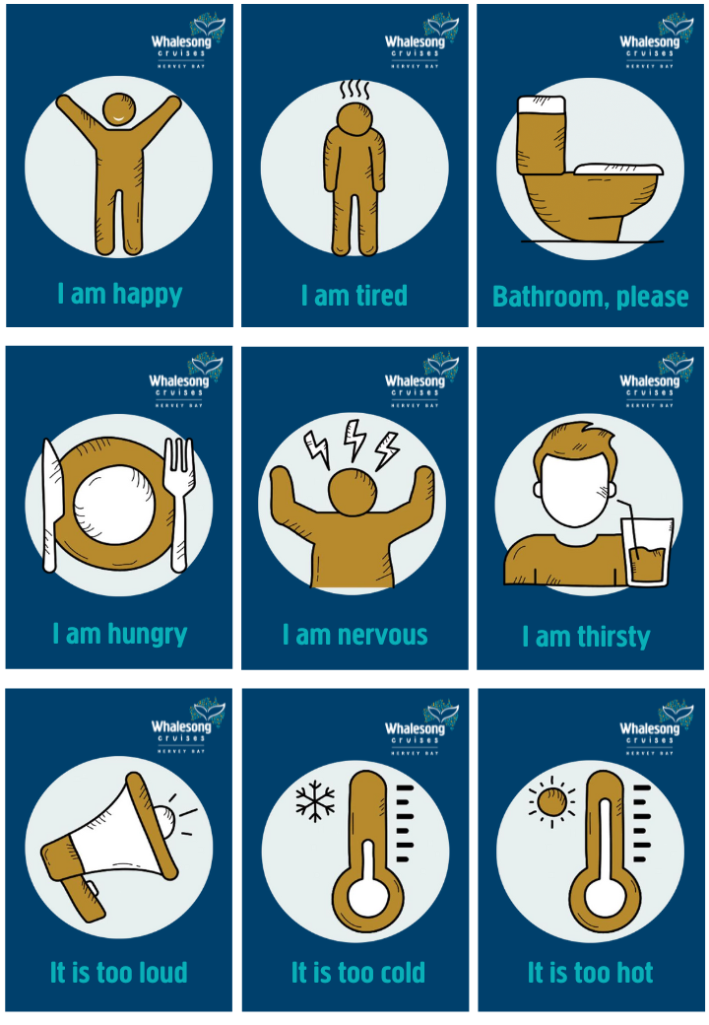
Whalesong Cruises - communciation cards - guest2
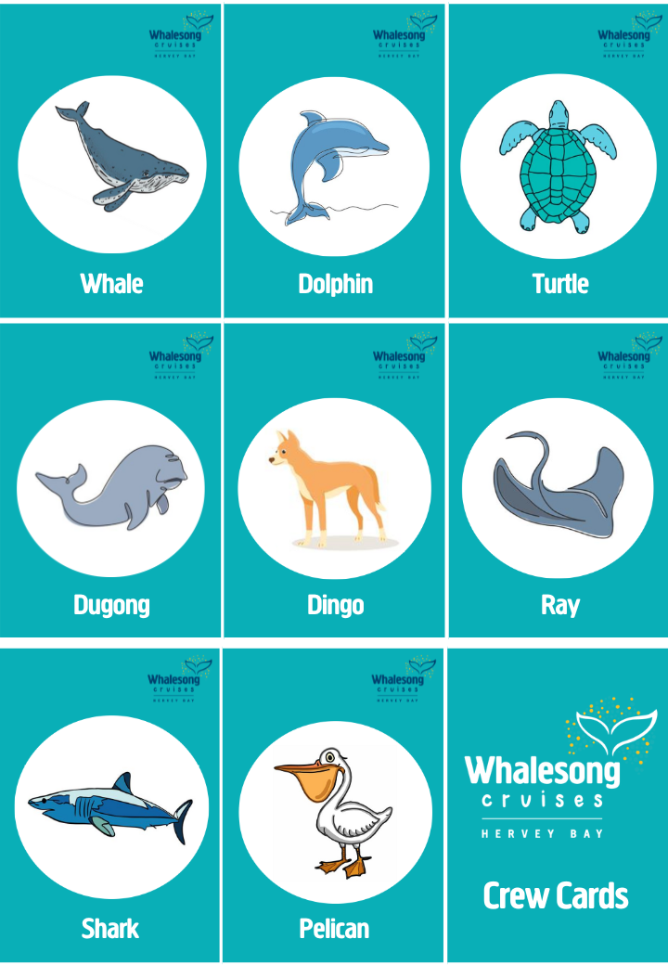
Whalesong Cruises - reminder cards - crew1
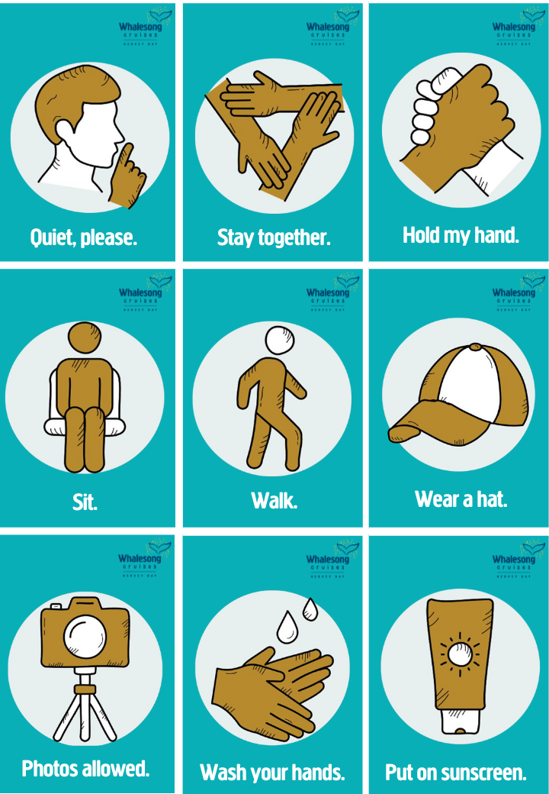
Whalesong Cruises - reminder cards - crew2
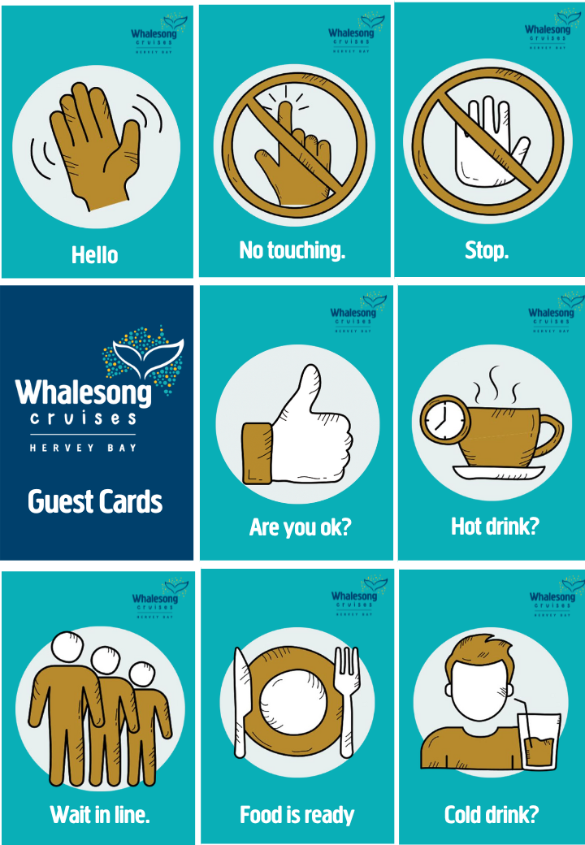
Whalesong Cruises - reminder cards - crew3
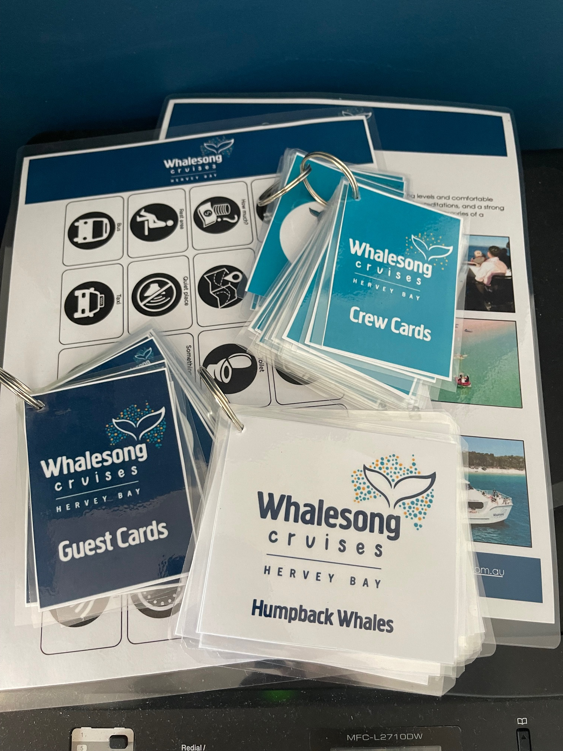
Whalesong Cruises collection of visual tools
information about humpback whale behaviours, showing a picture and words (attached above)

Other Information
- For bookings made onsite, the ticket booth/counter/box office is accessible for people using a wheelchair
- The business accepts the companion card

Guide Dog and Service Animals
- The business provides a secure area with shade and water for service animals
- Bowls, bedding, etc. are provided for service animals
The business provides the following services for services animals: All guests with service animals are given priority boarding to be seated where they (and their service animal) will be most comfortable throughout the cruise. Crew will guide them to their preferred seats and ensure they're comfortable in their position. If service animal is not to have interaction with anyone else, upon boarding, all other guests are respectfully asked to not engage with the animal.

GENERAL

Pre-arrival, arrival and reception
The business has the following in place to support guests during pre-arrival, arrival and reception
- Booking information and websites are compatible with screen readers
- There is a reception/public entryway.
- Seating available at reception
- A lower counter at reception/ticket office
- A clipboard to allow check-in/ticket purchase whilst seated
- A tablet with text to voice or pen and paper at reception to aid in communication
- Picture Board at reception to aid in communication
- Lighting in the reception area is even and glare free
- Large print information sheets and registration forms
We offer visual guides in the office to assist in guest/office communication. Also, we offer a guest lounge and private space for all respectful interactions to occur and for effective communication. The office team have had accessible training for all disabilities, including for guests who are non-verbal, neurodiverse and have low hearing. We have not identified the need for a hearing loop in our reception, as we provide an ideal space for all interactions to occur, as well as all the visual aids we've created to ensure a smooth process.
- Information and maps are available in written form
- A step free map/guide
- A familiarisation tour
- Advertising material, web sites and social media contain information relating to phone numbers available for non-voice communication e: Text, SMS, email and fax
No accessible facilities are locked
The following steps are in place to ensure that people with fatigue related to their disability are not disadvantaged by long wait times: Waiting/sitting room at marina office. Will be taken directly to boat to priority board, and seated immediately.

Cognitive Impairment Support
- Documents are available in plain English for people with cognitive impairment (This may include instructions, guides, menus and general information)
- A "social script" guide to your premises or attraction describing the sights, sounds and smells to aid parents/carers prepare visitors in advance
- The 'social script' is available in word and other editable formats
- Quiet periods or early opening times for people on the Autism Spectrum
- A space for parents and children on the Autism Spectrum

Car Park and Access amenities
The business has the following Car Park and Access amenities
- A drop off zone
- Designated disabled parking bays
- Level or ramped access from the car park to the entrance
- The accessible entrance is clearly signed from the parking bay
- The public transport services available are:
Detailed map and instructions (with distances) provided on the website: https://whalesong.com.au/about/accessibility
- Kerb ramps are in place where a pavement or walkway needs to be crossed

Entry
The business has the following amenities/systems in place for entry
- A drop off point close to the entrance
- A path of access to the building is slip resistance and even
- A path of access to the building is clear of obstruction
- Self opening entry doors or fitted with a self closer
- Glass doors are fitted with a visual sighting strip
- Door jams/doors are of a contrasting colour to surrounding walls
- Door handles are of a contrasting colour to the door
- Signage is written in a contrasting colour
- Signage is written in a Sans Serif font and use upper and lower case letters
- The entry door is a minimum of 850mm wide
- The entrance sill is less than 13mm
- There a clear space of at least 1500mm x 1500mm in front of all doors.
- The entrance door mats have a thickness less than 13mm and a width of 7500mm or greater

Internal Spaces
- Clear and unobstructed routes through and between buildings
- Interior walls are matte or low sheen
- Floors, walls, counters and furniture are of contrasting colours
- Any protruding or overhanging obstructions are at least 2meters above the floor or are protected
- Floor surfaces are hard or short pile carpet
- Seating is available for guests unable to stand for long periods
- Accessible facilities are clearly signed and visible from all areas
- All corridors greater than 900mm
- There is a quiet space for parents and children on the Autism Spectrum

Public areas
The public areas have the following amenities in place
- Even lighting
- Seating

Displays, exhibits, commentary and live performances
For displays, exhibits, commentary and live performances the following amenities are in place
- Seating
- Wheelchair accessible spaces/seating
- A written transcript where audio description is provided i.e. display commentary, tour commentary

External Paths
External paths of travel
- Surfaces are concrete, asphalt, smooth paving or hard packed fine gravel (max aggregate size 13mm)
- Paths or slopes longer than 15 metres have resting places or seats
- Pathways are wider than 900mm
- There 3 successive steps or less on any path or at any doorway
- Any paths having steps are clearly identified as non-wheelchair accessible
- Step free routes clearly signed

Ramps
Ramps have the following amenities are in place
- There are ramps.
- All fixed ramps are 1:14 or less
- Hand rails are fitted
- Long ramps (more than 10m) are 1:20 or less
- Temporary ramps are available
- Temporary ramps are in place for the duration of the guests stay
- Ramps have a raised edge of at least 100mm
- In addition, the following further information can assist guests:
Temporary ramps are only used to access the boat. Once on the boat, the wide decks and ramp into the downstairs saloon, mean access to all areas of the main level.

Public Toilets/Adult change facilities
Public Toilets/Adult change facilities have the following amenities are in place
- There is an accessible toilet for public use
- The door is at least 850mm wide
- There is a minimum of 850mm beside the toilet
- Handrails are fitted
- The toilet seat is 460mm above the floor
- There is 1450 mm of clear space in front of the toilet
- The toilet seat of a contrasting colour to the floor
- The toilet seat is460mm above the floor

TOUR OPERATORS

Tour/Transport Services
The tour/transport services have the following facilities/amenities in place
- Buses/Coaches
- 0 vehicles have wheelchair lifts or ramps
- 0 vehicles have low floors with ramped entry
The maximum wheelchair capacity available in the fleet is: 0
- Commentary is available in written format

Route Planning
- There is an accessible toilet on-board for public use
- The door is at least 850mm wide
- There is a minimum of 850mm beside the toilet
- Handrails are fitted
- The toilet seat is 460mm above the floor
- There is 1450 mm of clear space in front of the toilet
- The toilet seat of a contrasting colour to the floor
- The toilet seat is 460mm above the floor
  - Accessible Toilet Image(s)
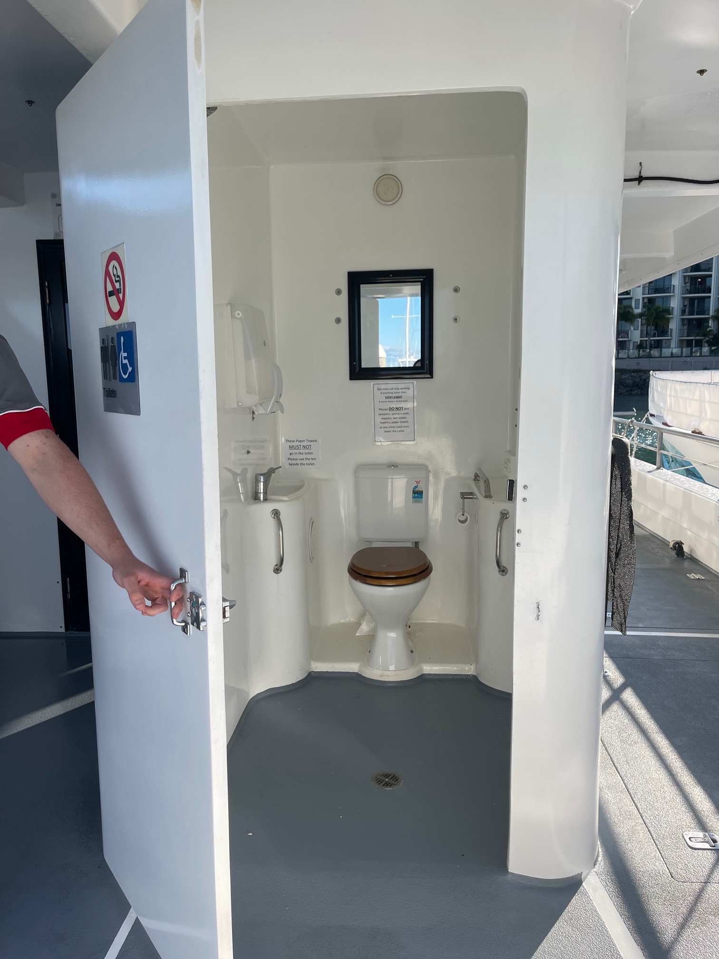
Onboard accessible toilet with clear sign and in braille

Guides
- Use of clear/simple English
- Correct pronunciation for lip readers
- There is a audio description of surroundings
- Marine
- Marine craft are wheelchair accessible
- Length (cm) 130.
- Width (cm) 100.
- Height (cm) 150.
- Weight (kg) 200+.
  - Image(s)
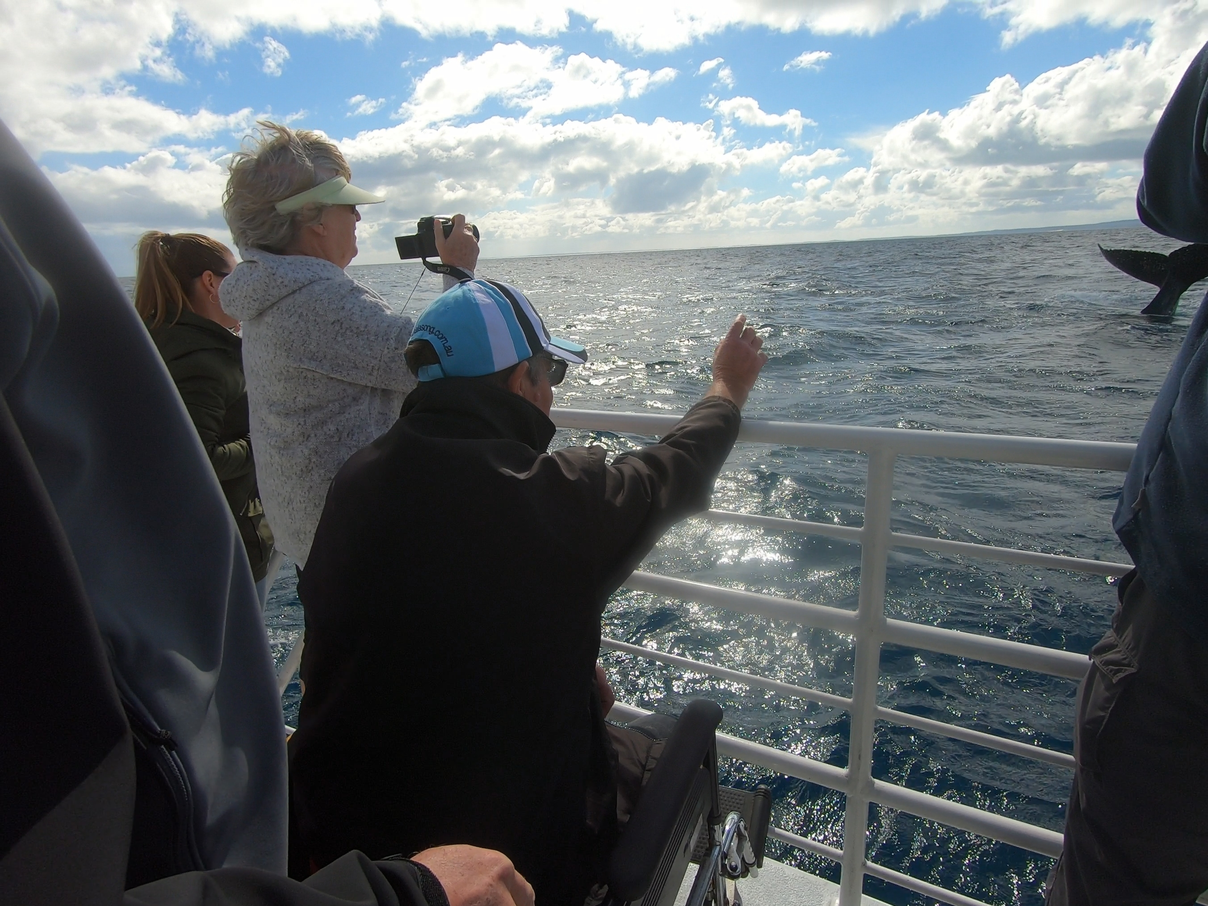
Whalesong Cruises Hervey Bay wheelchair accessible
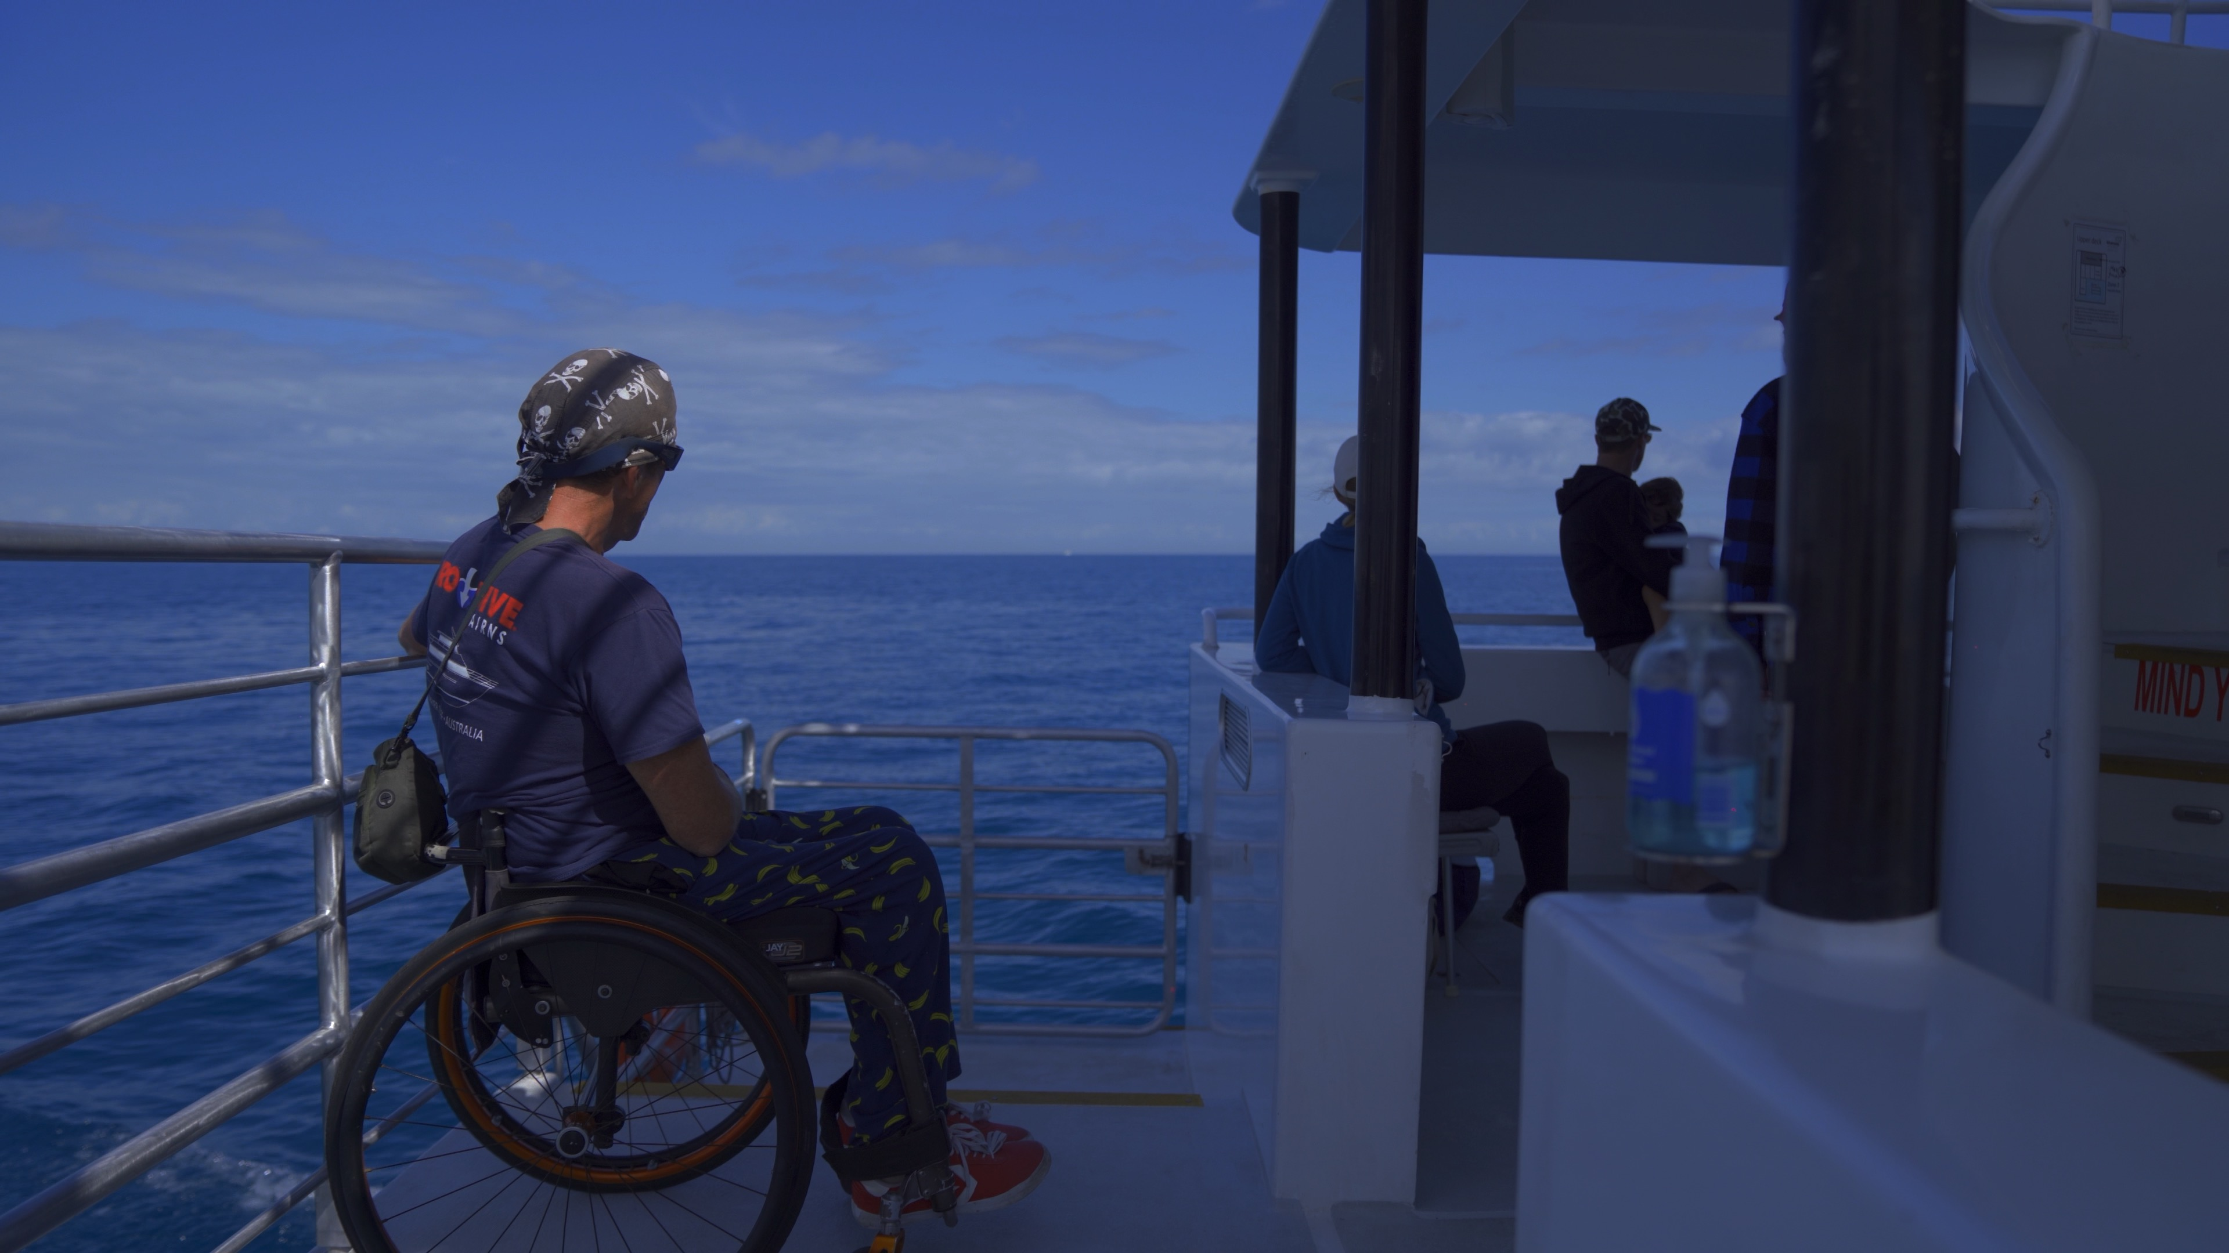
Whalesong Cruises wheelchair on boat
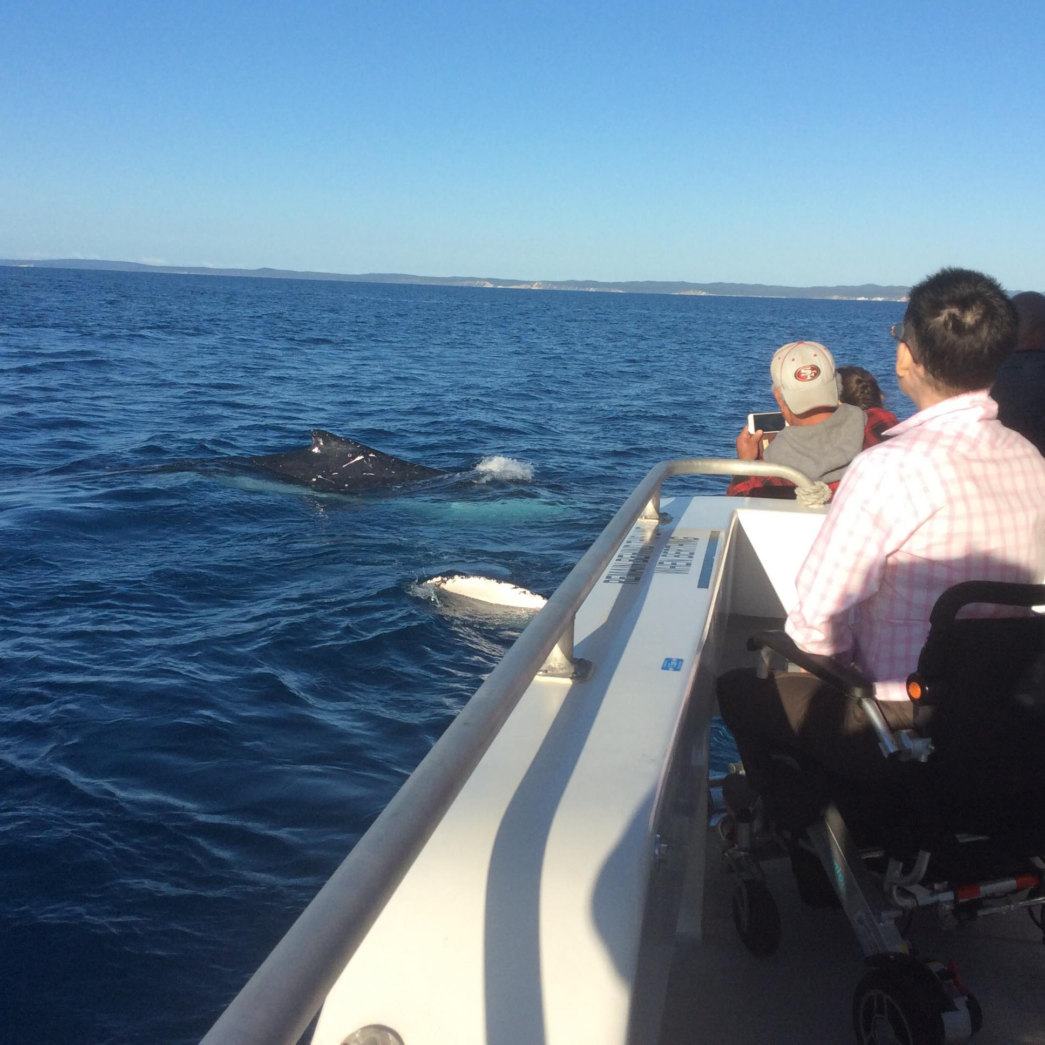
Wheelchair accessible boat - MV Whalesong Hervey Bay
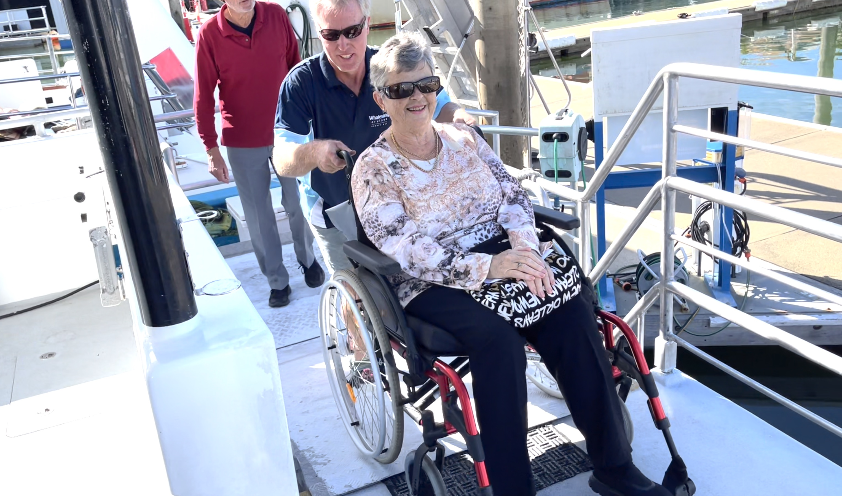
Wheelchair assistance up ramp onto boat
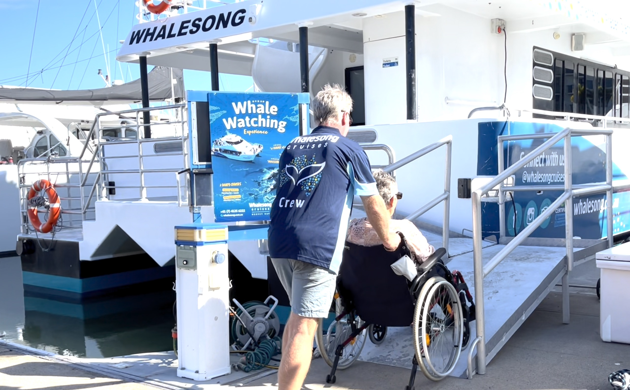
Wheelchair assistance up ramp onto boat1
- In addition, the following further information can assist guests:
More photos of actual access journey to and onto boat are on website.

Report Disclaimer
Please note that this business report, provided as a result of the use of the diagnostic assessment, is for information purposes only.
Australian Tourism Industry Council (ATIC) cannot guarantee the accuracy of respondent’s answers, or that they are fully representative of your business. Therefore, ATIC does not warrant or guarantee any particular outcome in respect of your businesses self-assessment.
This report is intended as guidance only for your business and should not be relied on for future marketing considerations. ATIC recommends that you seek your own independent advice as well as the results from the diagnostic.
Links to external web sites are inserted for convenience and do not constitute endorsement of material at those sites, or any associated organisation, product or service.
ATIC does not:
- Assume any legal liability for the accuracy, completeness, or usefulness of any information from this report or any links provided; or
- Accept responsibility for any loss associated directly or indirectly from the use of this report.

