ATIC Accessibility
To support the accessible community in making informed travel decisions for their individual needs

This report prepared for:
Business name: | Australian Pinnacle Tours
Address: | Shop 1, Old Perth Port, Barrack Street Jetty
Town: | Perth
Contact for enquiries: | Rebekah Nel
Contact Number: | 08 6270 6060
Contact Email: | reservations@pinnacletours.com.au
Website: | https://www.australianpinnacletours.com.au/
Date: | 2026-10-28 16:22

ATIC Accessibility
The following pages provides travellers with information on the businesses facilities and amenities which aims to support the traveller to make an informed decision on whether the business is suitable for their individual needs.
OVERVIEW 4
Business Overview 4
Bookings 4
Emergency Management 4
Communications 5
Other Information 5
GENERAL 6
Pre-arrival, arrival and reception 6
Cognitive Impairment Support 6
Car Park and Access amenities 6
Entry 7
Internal Spaces 7
Public areas 7
Displays, exhibits, commentary and live performances 7
External Paths 7
TOUR OPERATORS 8
Tour/Transport Services 8
Route Planning 8
Guides 8
ACCOMMODATION 10
FOOD AND DRINK 11
Report Disclaimer 13

OVERVIEW

Business Overview

The business has the following products/services available
- Tour/Transport

Our business caters for the following disability types:
- Blind or low vision
- Deaf or low hearing
- Limited mobility
- Food allergies or intolerances
- Cognitive or people on the Autism Spectrum

Bookings

The business offers the following methods for bookings and enquiries:
- Phone
- Email
- Webportal
- Our website supports Screen Readers
- Our forms have high contract boxes and submit boxes

Emergency Management
- Emergency and evacuation procedures are explained on arrival
- There are Audible device/s to alert occupants to evacuate with instructions on how to evacuate.
- Exit signs are clear and easy to see
- Exit access is free and clear at all times
We ensure exit access is free and clear at all times by: customers must be seated unless entering/exiting vehicle
- Exits and access to exists are greater than 900mm
- The evacuation point is clearly marked by a sign
The business identifies guests who need additional assistance should an emergency occur by: the customer will inform the staff
The procedure for assisting guests who need assisted rescue is: NA

Communications
- Our business offers the following alternative communication methods
- Plain English
In Person Communications
- There is easy to read signage and information (e.g. menus and emergency information)

Other Information
- For bookings made onsite, the ticket booth/counter/box office is accessible for people using a wheelchair
- The business accepts the companion card
The business provides the following services for services animals: NA

GENERAL

Pre-arrival, arrival and reception
The business has the following in place to support guests during pre-arrival, arrival and reception
- Booking information and websites are compatible with screen readers
- There is a reception/public entryway.
- Seating available at reception
- A lower counter at reception/ticket office
- A tablet with text to voice or pen and paper at reception to aid in communication
- Lighting in the reception area is even and glare free
customer service fill out bookings and forms not the customer
- Information and maps are available in written form
- Advertising material, web sites and social media contain information relating to phone numbers available for non-voice communication e: Text, SMS, email and fax
The following steps are in place to ensure that people with fatigue related to their disability are not disadvantaged by long wait times: Seating provided for entire duration of travel and transport, most stops/attractions have seating/ramps/rails/etc.

Cognitive Impairment Support
- Documents are available in plain English for people with cognitive impairment (This may include instructions, guides, menus and general information)
- Quiet periods or early opening times for people on the Autism Spectrum

Car Park and Access amenities
The business has the following Car Park and Access amenities
- A drop off zone
- Designated disabled parking bays
- Level or ramped access from the car park to the entrance
- Kerb ramps are in place where a pavement or walkway needs to be crossed

Entry
The business has the following amenities/systems in place for entry
- A drop off point close to the entrance
- A path of access to the building is slip resistance and even
- A path of access to the building is clear of obstruction

Internal Spaces
- Interior walls are matte or low sheen
- Any protruding or overhanging obstructions are at least 2meters above the floor or are protected
- Floor surfaces are hard or short pile carpet
- Seating is available for guests unable to stand for long periods
- All corridors greater than 900mm

Public areas
The public areas have the following amenities in place
- Display units, Televisions, Video displays etc. are open captioned
- Even lighting

Displays, exhibits, commentary and live performances
For displays, exhibits, commentary and live performances the following amenities are in place
- Seating

External Paths
External paths of travel
- Surfaces are concrete, asphalt, smooth paving or hard packed fine gravel (max aggregate size 13mm)
- Pathways are wider than 900mm

TOUR OPERATORS

Tour/Transport Services
The tour/transport services have the following facilities/amenities in place
- Buses/Coaches
- 2 vehicles have wheelchair lifts or ramps
- 2 vehicles have low floors with ramped entry
The maximum wheelchair capacity available in the fleet is: 2
- Audio visual displays are sub titles

Route Planning
- Route Planning
- The tour route includes stops with accessible toilet facilities
- Lunch stop venues are accessible
- Overnight Stops
The total number of wheelchair passengers that can be catered for at overnight stops are: 2
- Walking Tours

Guides

Guides have been trained in the following
- Use of clear/simple English
- Correct pronunciation for lip readers
  - Image(s)
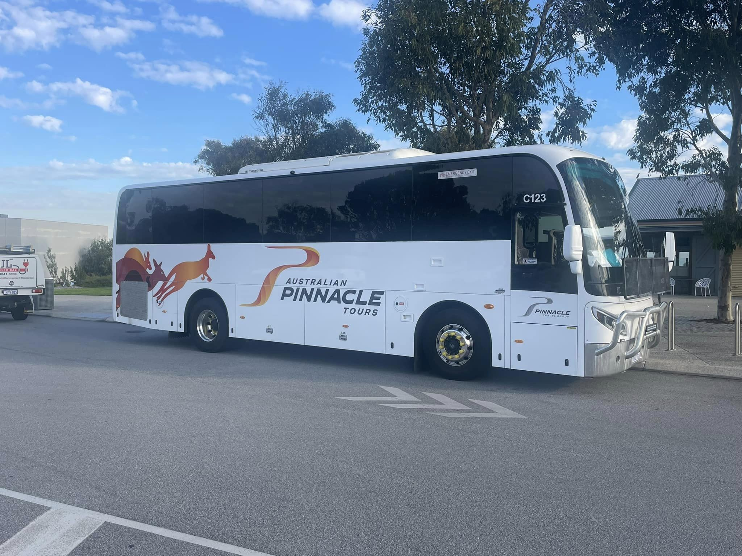
apt bus wrap
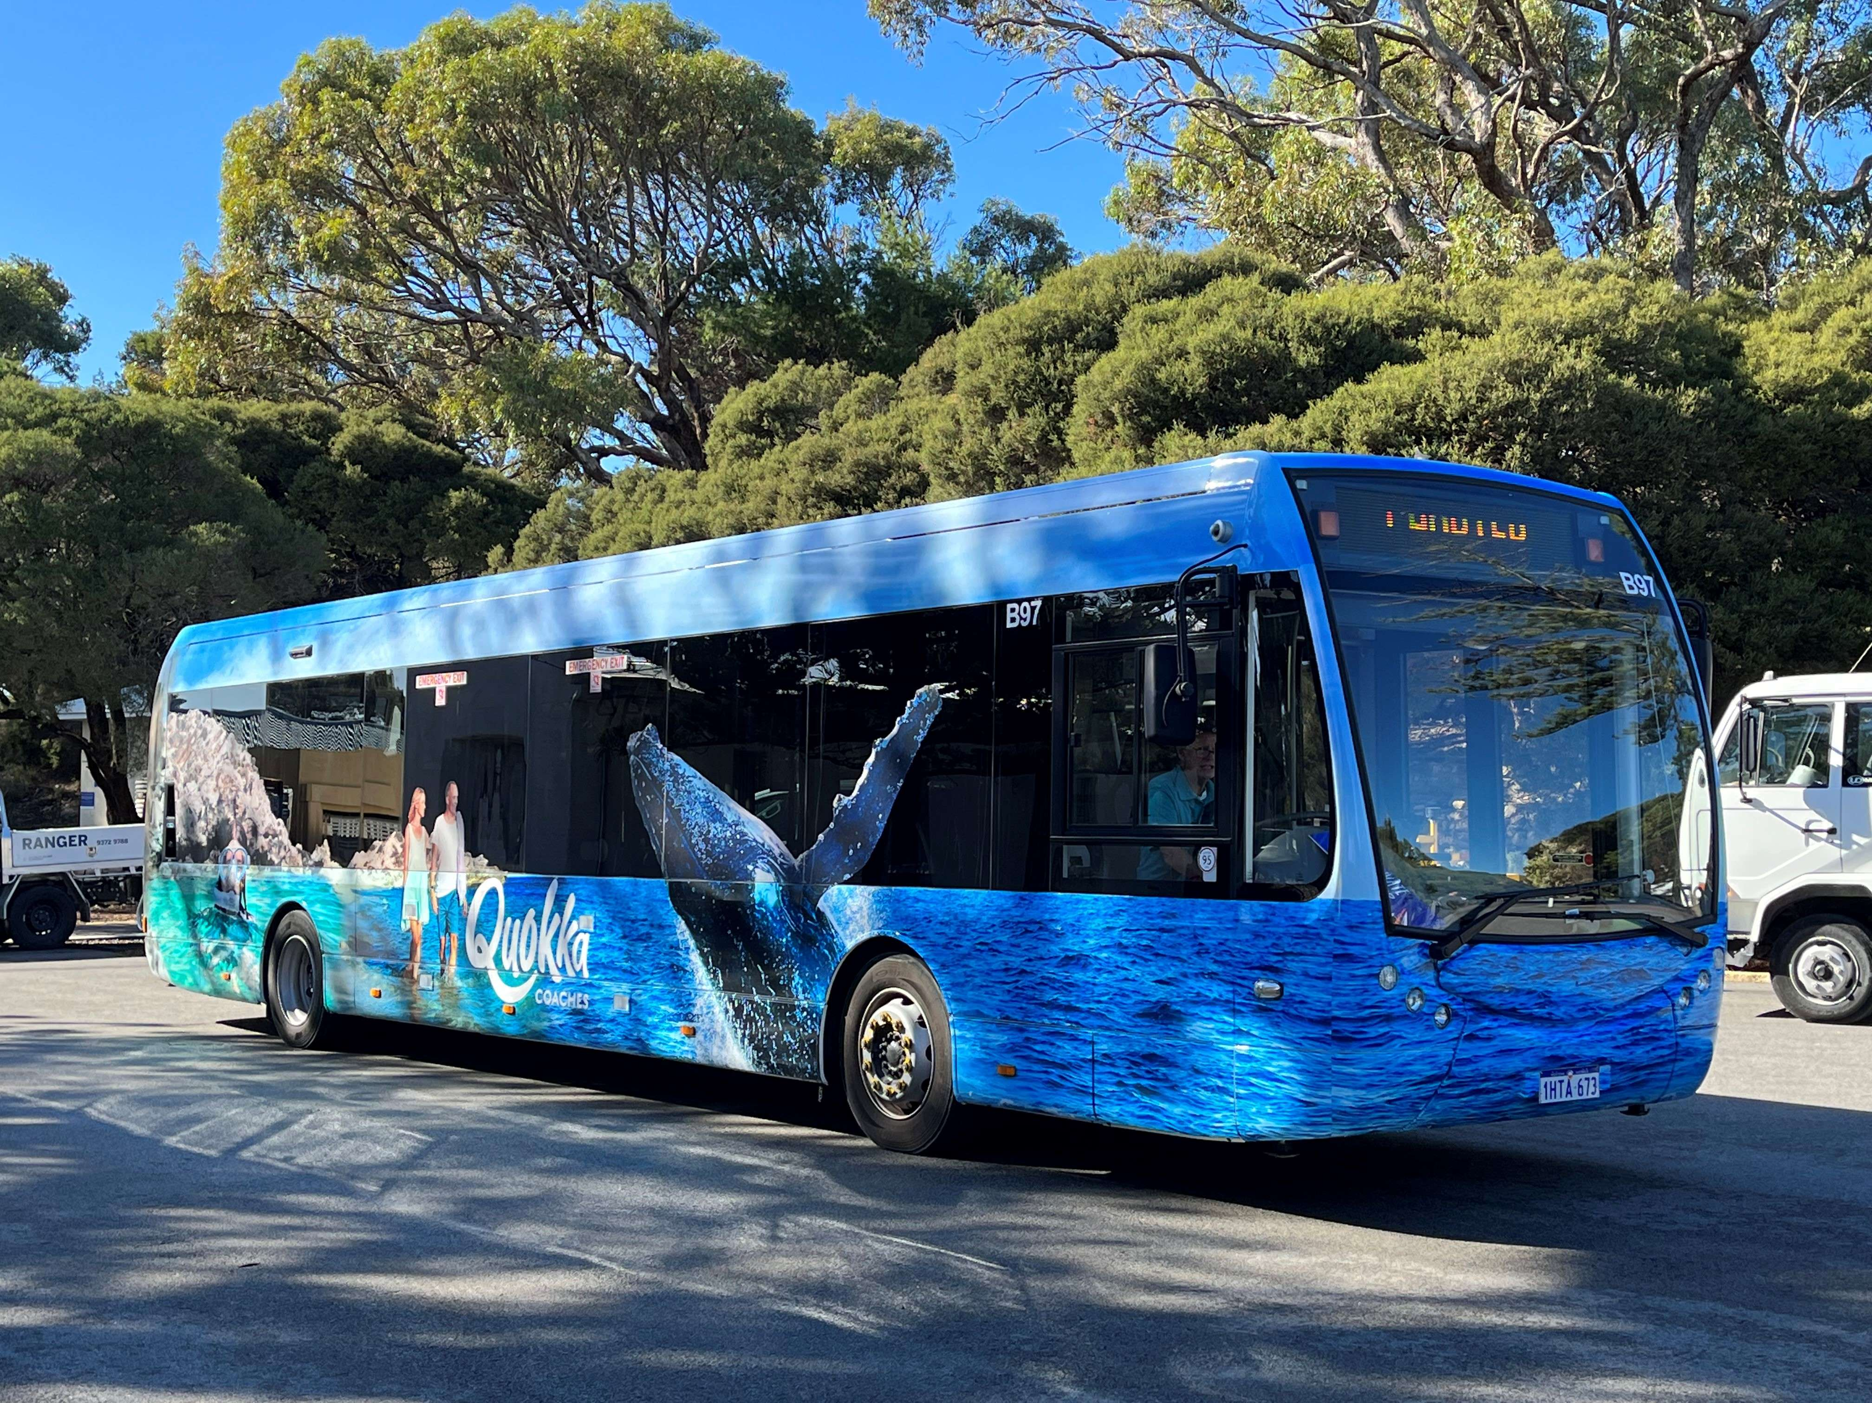
wrap5
- This tour stops at attractions/accommodation/food and beverage/retail spaces that are not operated by this business. For information relating to these individual properties please follow the weblink provided

ACCOMMODATION
- There are 0 rooms available to guests who use a wheelchair
  - Layout of room Image(s)

not applicable

FOOD AND DRINK
- The smallest doorway is NA wide
- There are procedures in place to avoid cross-contamination of food products
  - Food and Beverage Image(s)
not applicable
- In addition, the following further information can assist guests:
Food and drink services are provided by external vendors, cafes and restaurants

Report Disclaimer
Please note that this business report, provided as a result of the use of the diagnostic assessment, is for information purposes only.
Australian Tourism Industry Council (ATIC) cannot guarantee the accuracy of respondent’s answers, or that they are fully representative of your business. Therefore, ATIC does not warrant or guarantee any particular outcome in respect of your businesses self-assessment.
This report is intended as guidance only for your business and should not be relied on for future marketing considerations. ATIC recommends that you seek your own independent advice as well as the results from the diagnostic.
Links to external web sites are inserted for convenience and do not constitute endorsement of material at those sites, or any associated organisation, product or service.
ATIC does not:
- Assume any legal liability for the accuracy, completeness, or usefulness of any information from this report or any links provided; or
- Accept responsibility for any loss associated directly or indirectly from the use of this report.

