ATIC Accessibility
To support the accessible community in making informed travel decisions for their individual needs

This report prepared for:
Business name: | Mt Hart Wilderness Lodge
Address: | Gibb River Road
Town: | Derby
Contact for enquiries: | Natasha Marti
Contact Number: | (08) 9191 4645
Contact Email: | enquiries@mounthart.com.au
Website: | www.mounthart.com.au
Date: | 2026-10-20 14:59

ATIC Accessibility
The following pages provides travellers with information on the businesses facilities and amenities which aims to support the traveller to make an informed decision on whether the business is suitable for their individual needs.
OVERVIEW 4
Business Overview 4
Bookings 4
Emergency Management 4
Communications 5
Other Information 5
Guide Dog and Service Animals 5
GENERAL 6
Pre-arrival, arrival and reception 6
Cognitive Impairment Support 6
Car Park and Access amenities 6
Entry 7
Internal Spaces 7
Public areas 7
External Paths 7
Steps 8
Public Toilets/Adult change facilities 8
ACCOMMODATION 9
Bedrooms 9
Room Amenities 10
Bathrooms 10
COMMON AREAS 13
FOOD AND DRINK 14
Dining Spaces 14
Report Disclaimer 19

OVERVIEW

Business Overview

The business has the following products/services available
- Accommodation
- Food and Drink

Our business caters for the following disability types:
- Deaf or low hearing
- Limited mobility
- Wheelchairs or mobility scooters
- Food allergies or intolerances

Bookings

The business offers the following methods for bookings and enquiries:
- Phone
- Email
- Webportal
- Our forms have high contract boxes and submit boxes

Emergency Management
- Emergency and evacuation procedures are explained on arrival
- Exit signs are clear and easy to see
- Exit access is free and clear at all times
We ensure exit access is free and clear at all times by: Maintenance
- Exits and access to exists are greater than 900mm
- Exit doors are able to be opened by all occupants
- Exits to the emergency evacuation point does not include stairways
The business identifies guests who need additional assistance should an emergency occur by: Guests with a disability are noted in the guest log for emergency evacuation purposes
The procedure for assisting guests who need assisted rescue is: The procedure for assisting guests with disabilities who need assisted rescue at Mt Hart Wilderness Lodge includes ensuring their safety, providing necessary medical attention, and coordinating with emergency services while considering their specific accessibility needs.
- Guests with disabilities are noted in the guest log book for emergency and evacuation purposes

Communications

Other Information
- For bookings made onsite, the ticket booth/counter/box office is accessible for people using a wheelchair

Guide Dog and Service Animals
- The business provides a secure area with shade and water for service animals
- The business provides a toilet area for service animals
- Bowls, bedding, etc. are provided for service animals

GENERAL

Pre-arrival, arrival and reception
The business has the following in place to support guests during pre-arrival, arrival and reception
- There is a reception/public entryway.
- Seating available at reception
- A lower counter at reception/ticket office
- A clipboard to allow check-in/ticket purchase whilst seated
- A tablet with text to voice or pen and paper at reception to aid in communication
- Picture Board at reception to aid in communication
- Hearing loop fitted to the reception area
- Lighting in the reception area is even and glare free
- Large print information sheets and registration forms
- Information and maps are available in written form
- A familiarisation tour
- Advertising material, web sites and social media contain information relating to phone numbers available for non-voice communication e: Text, SMS, email and fax
- Luggage assistance
The following steps are in place to ensure that people with fatigue related to their disability are not disadvantaged by long wait times: Mount Hart Wilderness Lodge has implemented measures to reduce wait times for guests with fatigue-related disabilities, including providing seating, shaded rest areas, and assistance during activities.

Cognitive Impairment Support
- Documents are available in plain English for people with cognitive impairment (This may include instructions, guides, menus and general information)
- A "social script" guide to your premises or attraction describing the sights, sounds and smells to aid parents/carers prepare visitors in advance

Car Park and Access amenities
The business has the following Car Park and Access amenities
- A drop off zone
- Level or ramped access from the car park to the entrance
- The accessible entrance is clearly signed from the parking bay

Entry
The business has the following amenities/systems in place for entry
- A drop off point close to the entrance
- A path of access to the building is slip resistance and even
- A path of access to the building is clear of obstruction
- Door jams/doors are of a contrasting colour to surrounding walls
- Door handles are of a contrasting colour to the door
- Signage is written in a contrasting colour
- The entry door is a minimum of 850mm wide
- The entrance sill is less than 13mm
- There a clear space of at least 1500mm x 1500mm in front of all doors.
- The entrance door mats have a thickness less than 13mm and a width of 7500mm or greater

Internal Spaces
- Clear and unobstructed routes through and between buildings
- Interior walls are matte or low sheen
- Floors, walls, counters and furniture are of contrasting colours
- Any protruding or overhanging obstructions are at least 2meters above the floor or are protected
- Tableware/glassware contrast with the table surface or table cloth
- Seating is available for guests unable to stand for long periods
- Accessible facilities are clearly signed and visible from all areas
- All corridors greater than 900mm
- There is a quiet space for parents and children on the Autism Spectrum

Public areas
The public areas have the following amenities in place
- Display units, Televisions, Video displays etc. are open captioned
- Even lighting
- Seating

External Paths
External paths of travel
- Surfaces are concrete, asphalt, smooth paving or hard packed fine gravel (max aggregate size 13mm)
- Pathways are wider than 900mm

Steps
Steps
- There are steps.
- Top and bottom steps are easily distinguished through colour contrast or the use of TGSIs (Tactile Ground Surface Indicators)
- All steps or staircases have enclosed risers
- The underside of all staircases are enclosed or protected to a height of at least 2 metres
- Where steps are present are there three steps or less

Public Toilets/Adult change facilities
Public Toilets/Adult change facilities have the following amenities are in place
- There is an accessible toilet for public use
- The door is at least 850mm wide
- There is a minimum of 850mm beside the toilet
- Handrails are fitted
- The toilet seat is 460mm above the floor
- There is 1500mm mm of clear space in front of the toilet
- The toilet seat of a contrasting colour to the floor
- The toilet seat is460mm above the floor
- There is a registered changing places facility

ACCOMMODATION

Bedrooms
The bedrooms have the following facilities/amenities in place
- There are 5 rooms available to guests who use a wheelchair
- Bedroom furniture can be re-arranged on request

The following bed types are available in wheelchair accessible rooms
- One double/queen bed/king bed
- One single bed
- Two single beds
- Two double/queen
- One double/queen and one single
  - Layout of room Image(s)
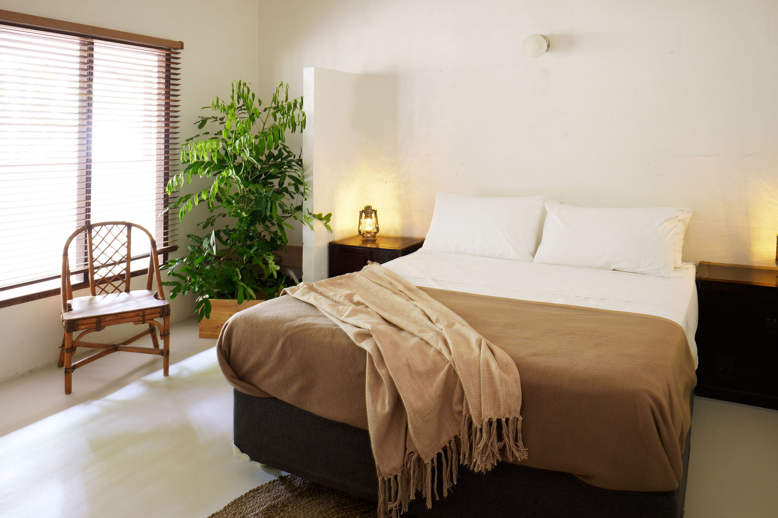
Mount-Hart-Kimberley-Western-Australia (242)
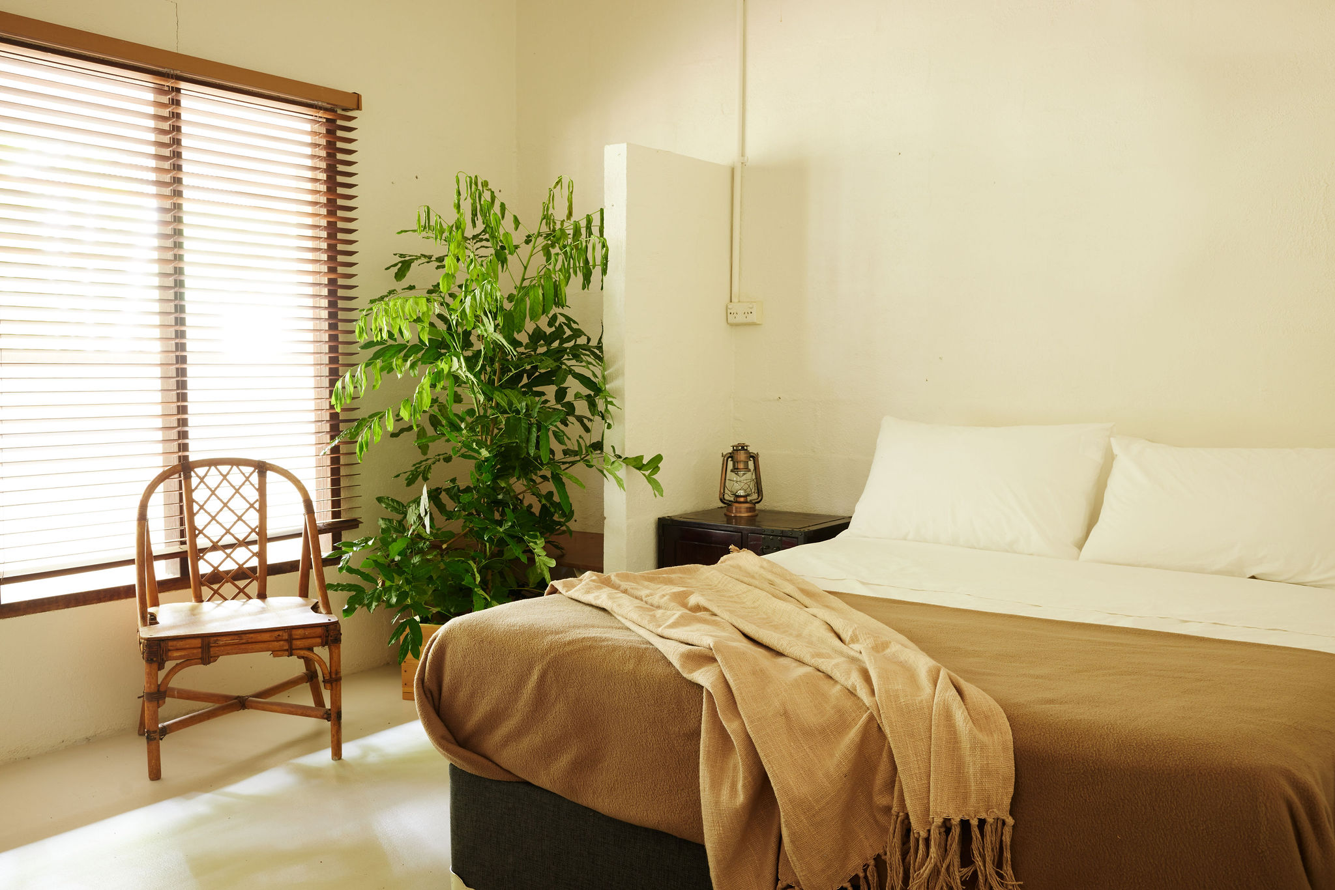
Mount-Hart-Kimberley-Western-Australia (272)
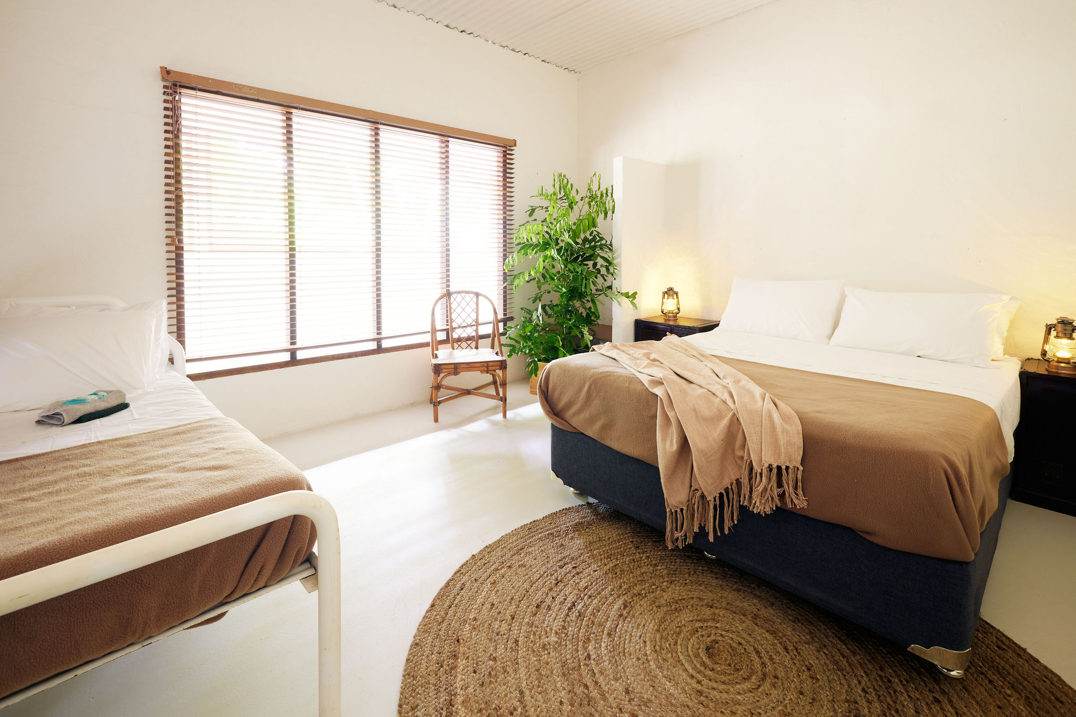
Mount-Hart-Kimberley-Western-Australia (295)

Room Amenities
For guests with a hearing impairment, the following emergency evacuation procedures apply to ensure safe evacuation: To accommodate guests with hearing impairments and ensure their safe evacuation, Mount Hart Wilderness Lodge utilizes written emergency instructions in guest rooms and assigns trained staff specific responsibilities.
- Televisions are equipped with closed captioning capability
- There is a clear path through the room
- Wardrobe handles are a contrasting colour to the doors and draws
- Housekeeping procedures instruct staff not to reposition furniture that has been moved
- Doors open fully against the adjoining wall
- There is a clear opening at least 850mm wide
- There luggage racks for at least two suitcases
- Wardrobe and drawer handles are easy to grip
- The bedside lamp switch is easy to reach from the bed
- There is at least 850mm clear space beside the bed
- The bed height is no higher than 680mm from the floor
- There is at least 130mm clearance under the bed
- Non-allergenic cleaning products are used

Bathrooms
The bathrooms have the following facilities/amenities in place
- All shower, bath and basin taps are clearly differentiated between hot and cold
- Fixtures and fittings have rounded edges
- The hot water is thermostatically controlled to 41 degrees
- The door is at least 850mm wide
- There is a minimum of 850mm beside the toilet
- Handrails are fitted
- There is a minimum of 1400mm of clear space in front of the toilet
- The toilet seat is a contrasting colour to the floor
- The toilet seat is 460mm above the floor
- A range of non-allergenic toiletries are available
  - Bathroom Image(s)
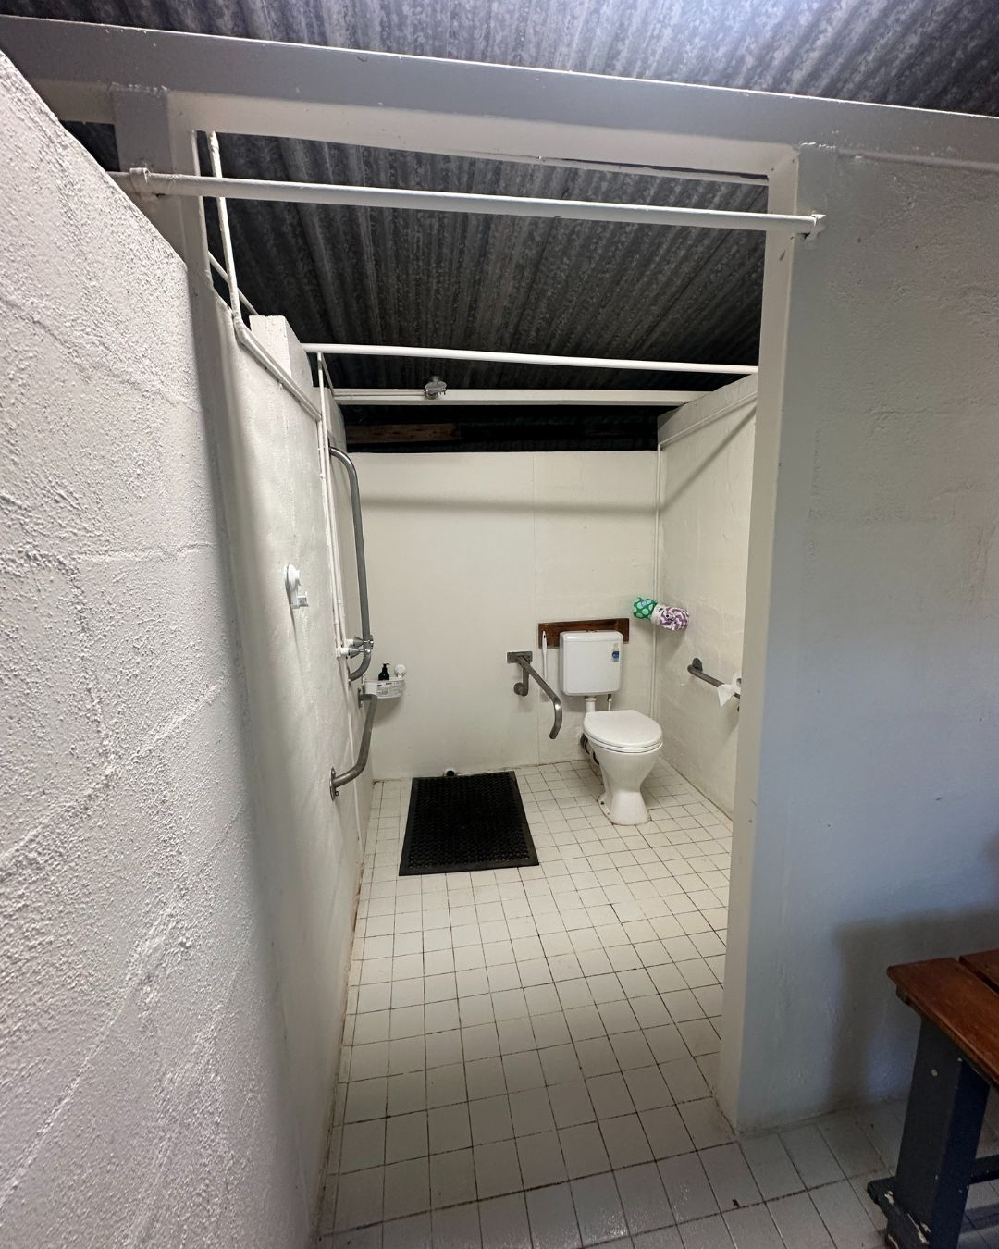
1
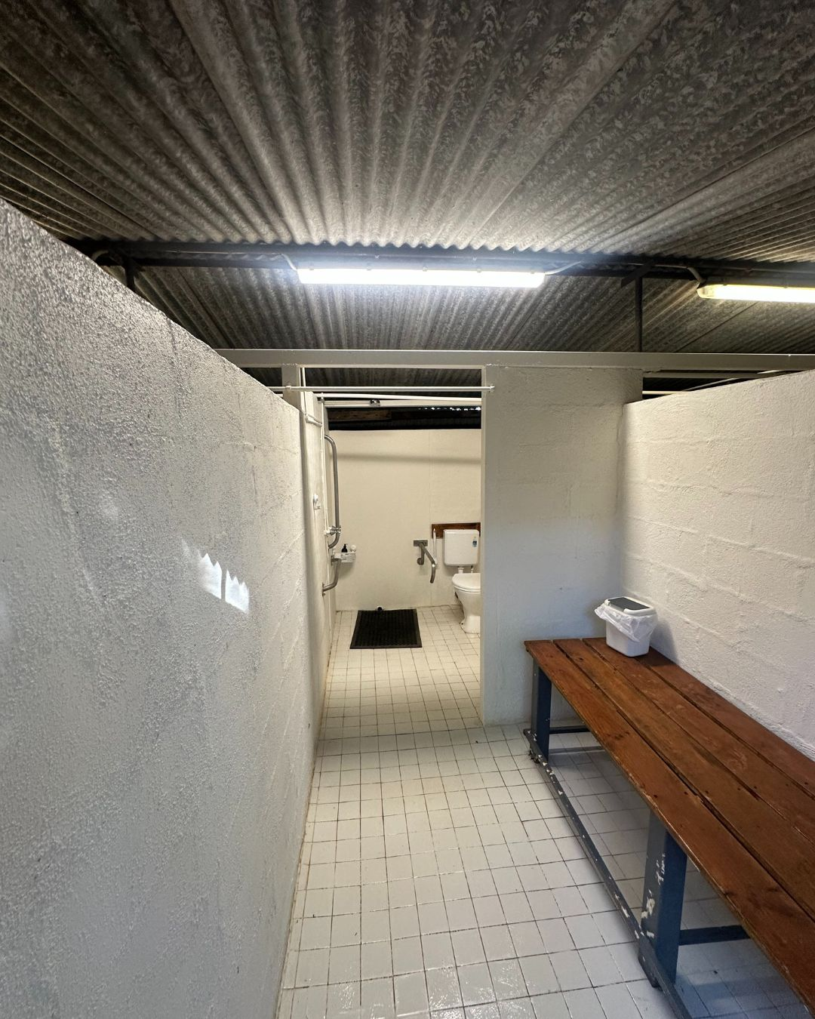
2
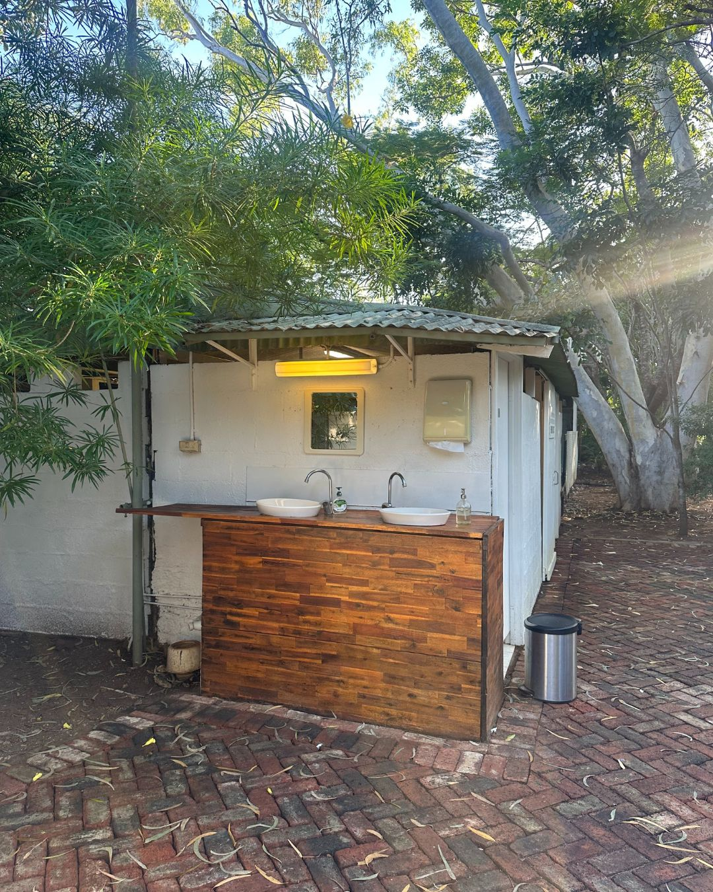
3
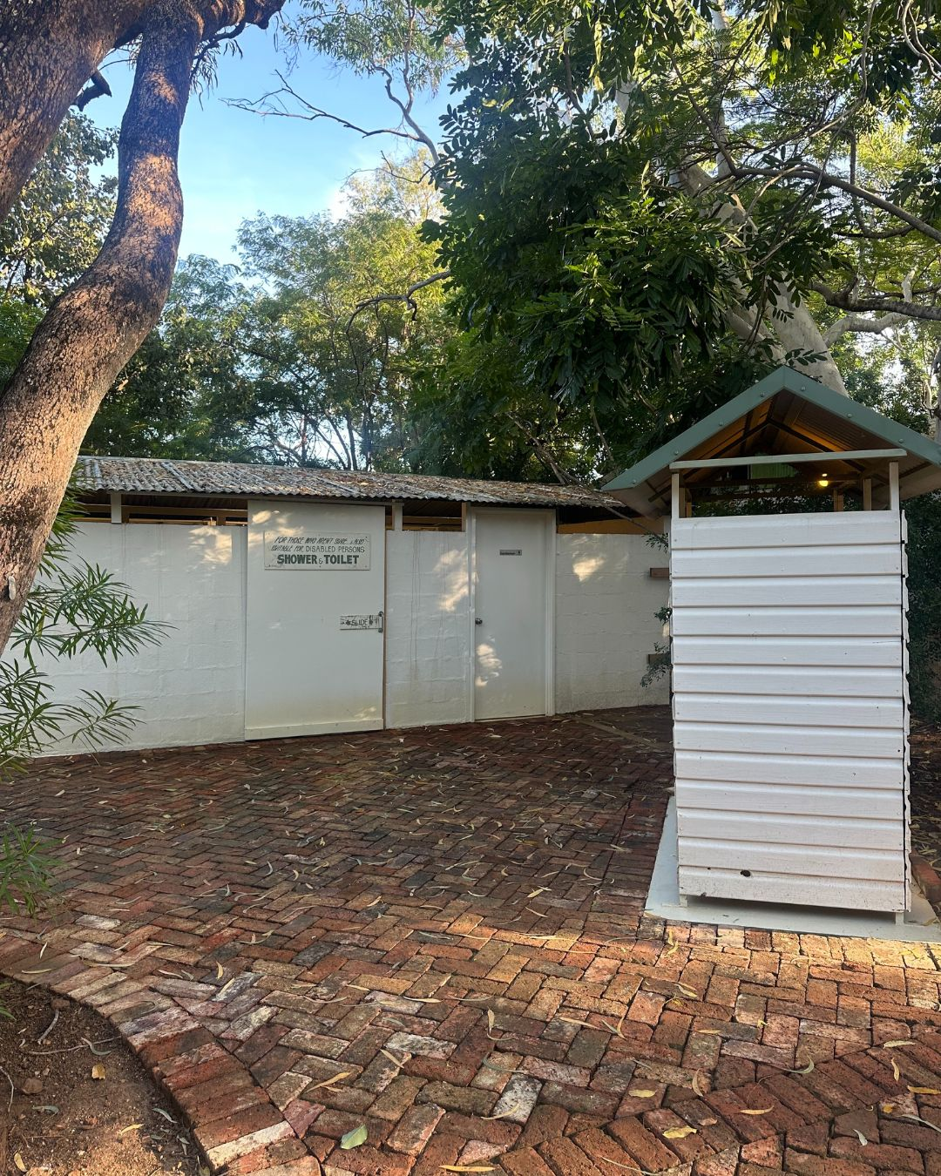
4

COMMON AREAS

FOOD AND DRINK

Dining Spaces
The dining spaces have the following facilities/amenities in place
- The entrance has level access
- The doorway is at least 850mm wide
- There is level access through the dining area
- Chairs are moveable to allow for wheelchairs to be seated at the tables
- There are areas of full lighting
- There are large print menus
- There are Plain English menus
- There is an accessible toilet

Our business caters for the following dietary requirements
- Sugar free (diabetic)
- Gluten free (celiac)
- Lactose free (dairy free)
- Low fat and fibre with no gastric content
- Nut free
- Organic
- Vegetarian
- Vegan
- Kosher
- Halal
- There are procedures in place to avoid cross-contamination of food products
  - Food and Beverage Image(s)
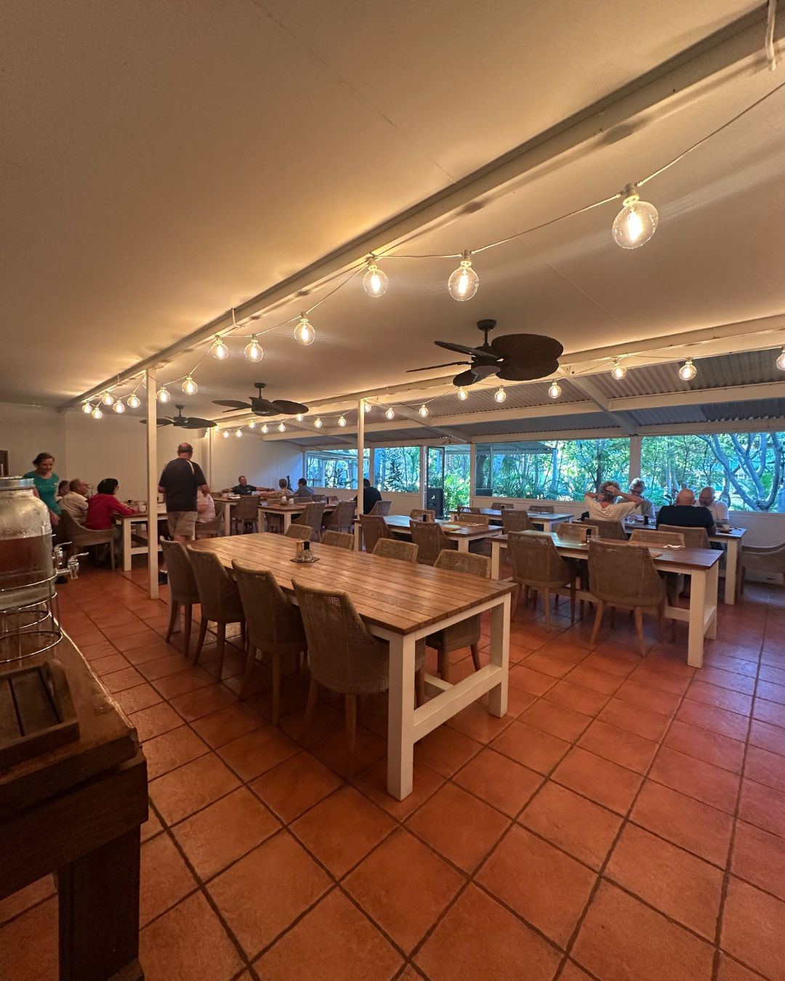
1
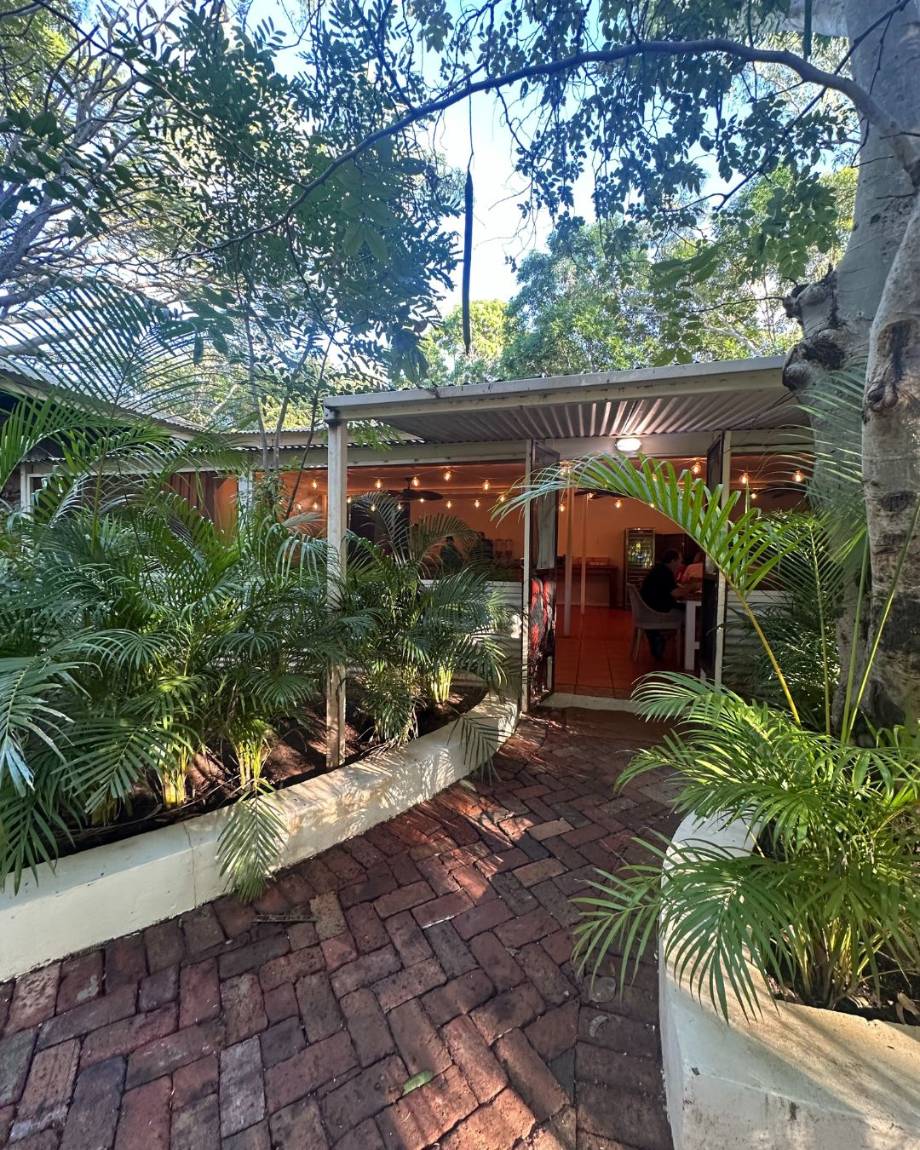
2
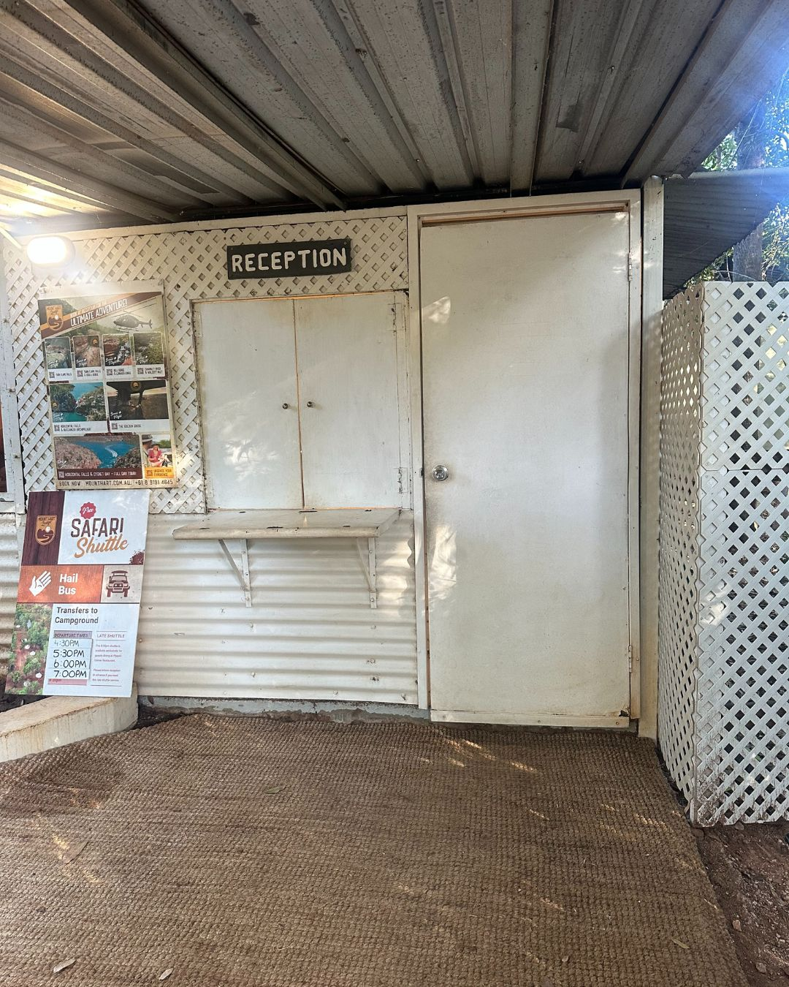
3
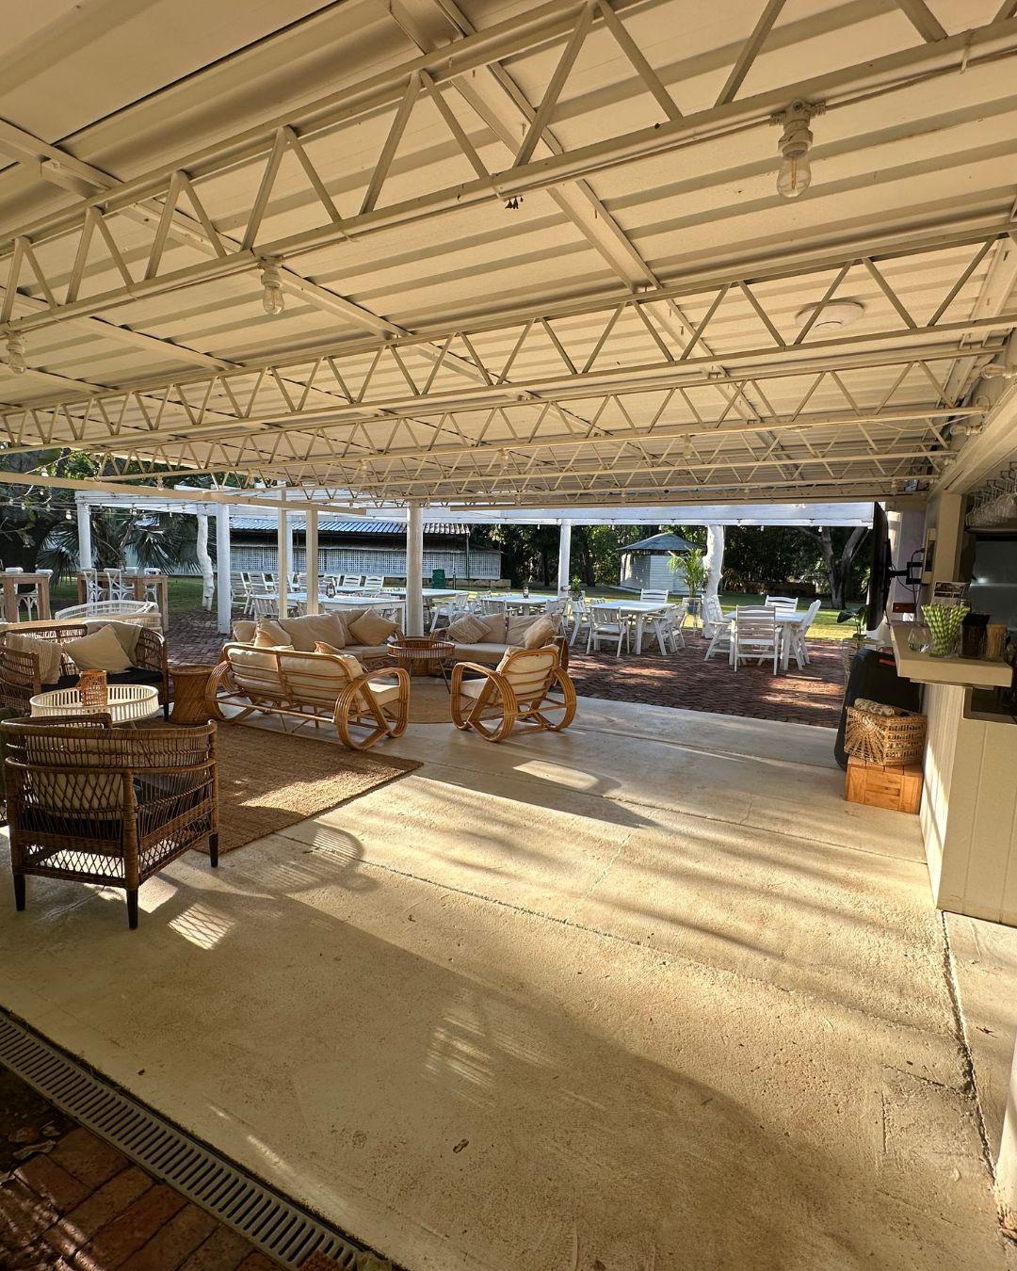
4
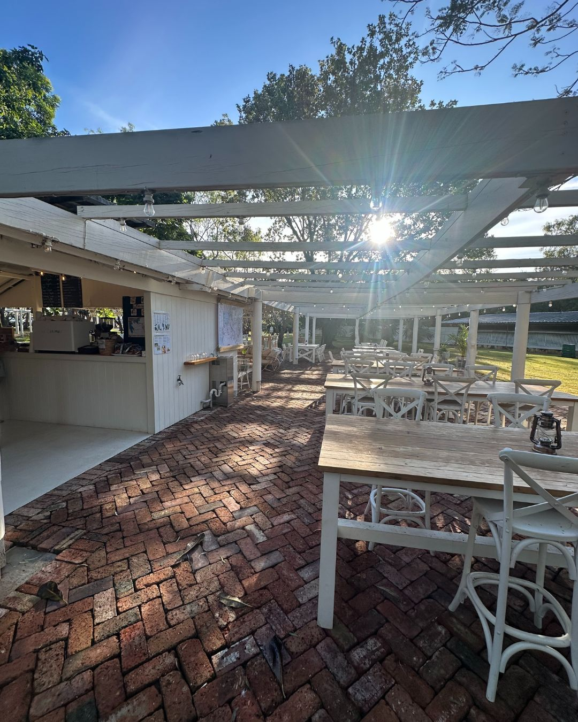
5
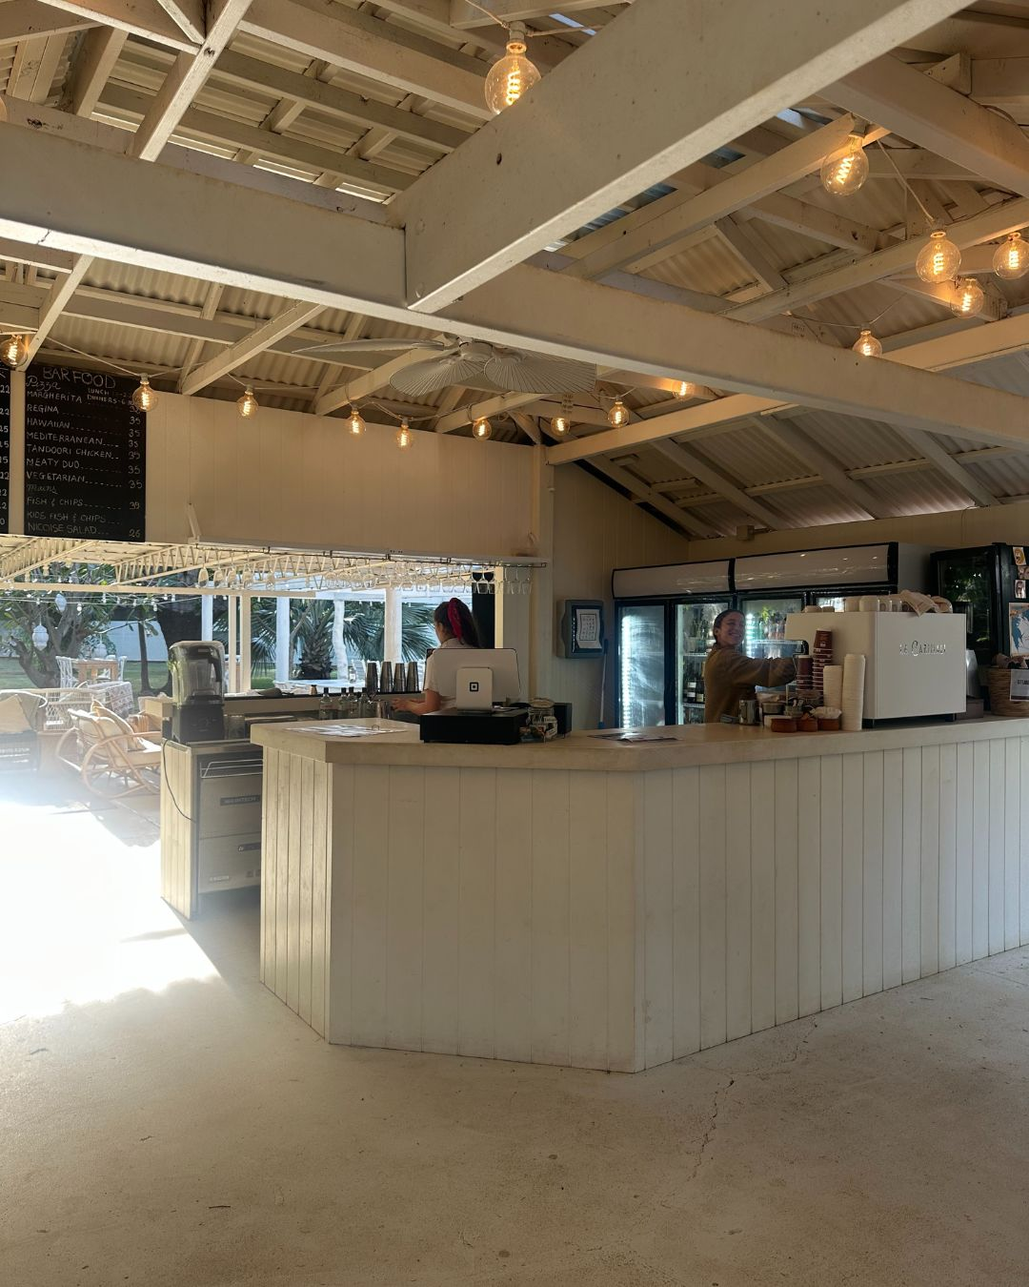
6

Report Disclaimer
Please note that this business report, provided as a result of the use of the diagnostic assessment, is for information purposes only.
Australian Tourism Industry Council (ATIC) cannot guarantee the accuracy of respondent’s answers, or that they are fully representative of your business. Therefore, ATIC does not warrant or guarantee any particular outcome in respect of your businesses self-assessment.
This report is intended as guidance only for your business and should not be relied on for future marketing considerations. ATIC recommends that you seek your own independent advice as well as the results from the diagnostic.
Links to external web sites are inserted for convenience and do not constitute endorsement of material at those sites, or any associated organisation, product or service.
ATIC does not:
- Assume any legal liability for the accuracy, completeness, or usefulness of any information from this report or any links provided; or
- Accept responsibility for any loss associated directly or indirectly from the use of this report.

