ATIC Accessibility
To support the accessible community in making informed travel decisions for their individual needs

This report prepared for:
Business name: | Arirrki Aboriginal corporation
Address: | Arnhem Highway
Town: | Middle Point
Contact for enquiries: | Alexandra Field
Contact Number: | 08 8978 9077
Contact Email: | spectacular@jumpingcrocodile.com.au
Website: | www.jumpingcrocodile.com.au
Date: | 2026-11-07 06:43

ATIC Accessibility
The following pages provides travellers with information on the businesses facilities and amenities which aims to support the traveller to make an informed decision on whether the business is suitable for their individual needs.
OVERVIEW 4
Business Overview 4
Bookings 4
Emergency Management 4
Communications 5
Other Information 5
Guide Dog and Service Animals 5
GENERAL 6
Pre-arrival, arrival and reception 6
Cognitive Impairment Support 6
Car Park and Access amenities 7
Entry 7
Internal Spaces 7
Public areas 8
Displays, exhibits, commentary and live performances 8
External Paths 8
Steps 9
Ramps 9
Public Toilets/Adult change facilities 9
ATTRACTIONS 10
Zoos and Wildlife Parks 10
COMMON AREAS 15
Report Disclaimer 17

OVERVIEW

Business Overview

The business has the following products/services available
- Attraction

Our business caters for the following disability types:
- Blind or low vision
- Deaf or low hearing
- Limited mobility
- Wheelchairs or mobility scooters
- Food allergies or intolerances
- Cognitive or people on the Autism Spectrum

Bookings

The business offers the following methods for bookings and enquiries:
- Phone
- Email
- Webportal
- Our website supports Screen Readers
- Our forms have high contract boxes and submit boxes
- Staff have undergone disability awareness and training

Emergency Management
- The business has an emergency management and evacuation plan for guests with a disability
- Emergency and evacuation procedures are explained on arrival
- There is an emergency refuge that has an intercommunication system linked and has sufficient fire resistance levels.
- Guests with disabilities are noted in the guest log book for emergency and evacuation purposes

Communications
- An accessibility guide is available on the website
https://jumpingcrocodile.com.au/faq/
- Our website meets WCAG 2.0 accessibility standards
- Our business offers the following alternative communication methods
- Plain English
- Braille Displays
- Magnifiers
- There is easy to read signage and information (e.g. menus and emergency information)
Information booklets with pictures, written information, introduction cards

Other Information
- For bookings made onsite, the ticket booth/counter/box office is accessible for people using a wheelchair
- The business accepts the companion card

Guide Dog and Service Animals
- The business provides a secure area with shade and water for service animals
- The business provides a toilet area for service animals
- Bowls, bedding, etc. are provided for service animals
The business provides the following services for services animals: Service animal relief areas freely available, water and shaded areas available

GENERAL

Pre-arrival, arrival and reception
The business has the following in place to support guests during pre-arrival, arrival and reception
- Booking information and websites are compatible with screen readers
- There is a reception/public entryway.
- Seating available at reception
- A lower counter at reception/ticket office
- A clipboard to allow check-in/ticket purchase whilst seated
- A tablet with text to voice or pen and paper at reception to aid in communication
- Picture Board at reception to aid in communication
- Lighting in the reception area is even and glare free
- Large print information sheets and registration forms
Check in/ticket purchase is performed by staff for guests
- Information and maps are available in written form
- A facility map and information is available in Braille
- A step free map/guide
- A familiarisation tour
The following steps are in place to ensure that people with fatigue related to their disability are not disadvantaged by long wait times: Ample seating is available throughout the premises to aid guests with fatigue
- In addition, the following further information can assist guests:
Ample written information and private support are available in lieu of a hearing loop

Cognitive Impairment Support
- Documents are available in plain English for people with cognitive impairment (This may include instructions, guides, menus and general information)
- A "social script" guide to your premises or attraction describing the sights, sounds and smells to aid parents/carers prepare visitors in advance
- The 'social script' is available in word and other editable formats
- Quiet periods or early opening times for people on the Autism Spectrum
- A space for parents and children on the Autism Spectrum
- Access has alternative procedures and clear written instructions with universal access symbols

Car Park and Access amenities
The business has the following Car Park and Access amenities
- A drop off zone
- Designated disabled parking bays
- Level or ramped access from the car park to the entrance
- The accessible entrance is clearly signed from the parking bay
- The public transport services available are:
No public transport nearby available of which guests are informed
- Kerb ramps are in place where a pavement or walkway needs to be crossed

Entry
The business has the following amenities/systems in place for entry
- A drop off point close to the entrance
- A path of access to the building is slip resistance and even
- A path of access to the building is clear of obstruction
- Self opening entry doors or fitted with a self closer
- Glass doors are fitted with a visual sighting strip
- Door jams/doors are of a contrasting colour to surrounding walls
- Door handles are of a contrasting colour to the door
- Signage is written in a contrasting colour
- Signage is written in a Sans Serif font and use upper and lower case letters
- The entry door is a minimum of 850mm wide
- The entry door has self opening or a light opening pressure (for manual operations)
- The entrance sill is less than 13mm
- There a clear space of at least 1500mm x 1500mm in front of all doors.
- The entrance door mats have a thickness less than 13mm and a width of 7500mm or greater

Internal Spaces
- Clear and unobstructed routes through and between buildings
- Interior walls are matte or low sheen
- Floors, walls, counters and furniture are of contrasting colours
- Any protruding or overhanging obstructions are at least 2meters above the floor or are protected
- Floor surfaces are hard or short pile carpet
- Seating is available for guests unable to stand for long periods
- Accessible facilities are clearly signed and visible from all areas
- All corridors greater than 900mm
- There is a quiet space for parents and children on the Autism Spectrum

Public areas
The public areas have the following amenities in place
- Display units, Televisions, Video displays etc. are open captioned
- Even lighting
- Seating
- In addition, the following further information can assist guests:
Ample written information and private support are available in lieu of a hearing loop

Displays, exhibits, commentary and live performances
For displays, exhibits, commentary and live performances the following amenities are in place
- Seating
- Wheelchair accessible spaces/seating
- A written transcript where audio description is provided i.e. display commentary, tour commentary
- In addition, the following further information can assist guests:
Ample written information and private support are available in lieu of a hearing loop

External Paths
External paths of travel
- Surfaces are concrete, asphalt, smooth paving or hard packed fine gravel (max aggregate size 13mm)
- Paths or slopes longer than 15 metres have resting places or seats
- Pathways are wider than 900mm
- There 3 successive steps or less on any path or at any doorway
- Any paths having steps are clearly identified as non-wheelchair accessible
- Step free routes clearly signed

Steps
Steps
- There are steps.
- Top and bottom steps are easily distinguished through colour contrast or the use of TGSIs (Tactile Ground Surface Indicators)
- All steps or staircases have enclosed risers
- The underside of all staircases are enclosed or protected to a height of at least 2 metres
- Handrails fitted to all open sets of steps
- Handrails extend 300mm beyond the top and bottom step
- Where steps are present are there three steps or less

Ramps
Ramps have the following amenities are in place
- There are ramps.
- All fixed ramps are 1:14 or less
- Hand rails are fitted
- Long ramps (more than 10m) are 1:20 or less
- Temporary ramps are available
- Temporary ramps are in place for the duration of the guests stay
- Ramps have a raised edge of at least 100mm

Public Toilets/Adult change facilities
Public Toilets/Adult change facilities have the following amenities are in place
- There is an accessible toilet for public use
- The door is at least 850mm wide
- There is a minimum of 850mm beside the toilet
- Handrails are fitted
- The toilet seat is 460mm above the floor
- There is 172cm x 230cm mm of clear space in front of the toilet
- The toilet seat of a contrasting colour to the floor
- The toilet seat is460mm above the floor

ATTRACTIONS

Zoos and Wildlife Parks
- Guide and service dogs are welcome
Guide and service animals should observe the following rules: Service animals are allowed within our onshore facilities, however, they are not permitted on our vessels due to safety concerns regarding crocodiles
- A secure area with shade and water for service dogs is available
- A guide for patrons who are blind or vision impaired are available
- Displays have glass or mesh viewing panels for children or people seated in wheelchairs
- Signage is positioned between 800mm and 1200mm above the ground
- Signage is in a font larger than 18 point
- Signage and information provide pictorial information
The following alternative information sources are available: Written guides and interpretive signage available onsite and via a booklet given to guests
- Seating is provided at regular intervals
- Aviaries and other enclosures provide level access
- Airlocks provide sufficient room for a wheelchair
- Tour vehicles are available
- Tour vehicles have a wheelchair lift or ramp
- In addition, the following further information can assist guests:
Assistance is available to transfer from wheelchair to seating aboard the vessel
  - Image(s)
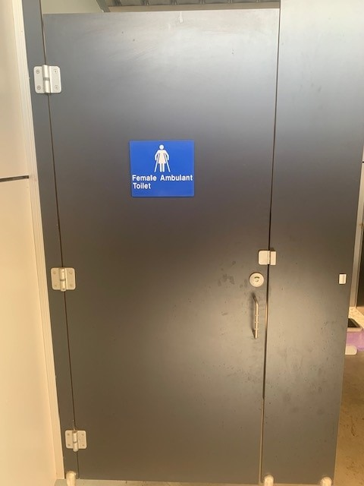
ambulant toilet
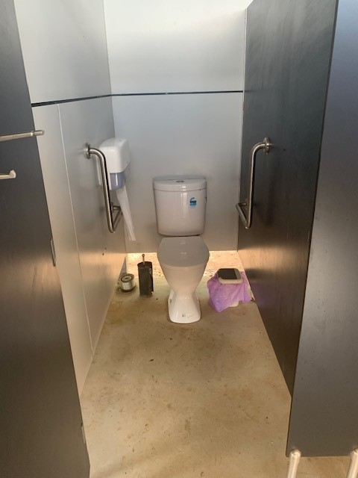
ambulant toilet2
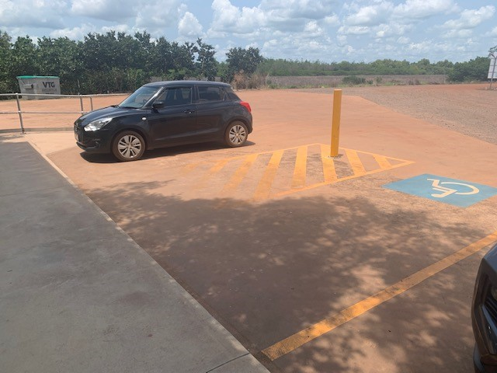
disabled carpark
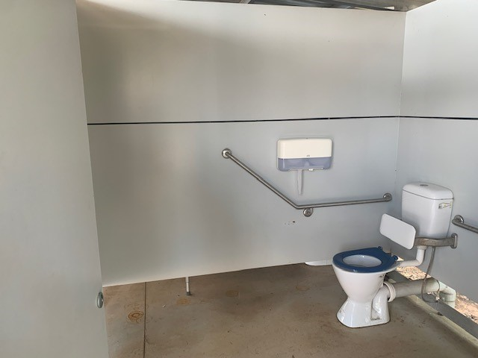
disabled toilet
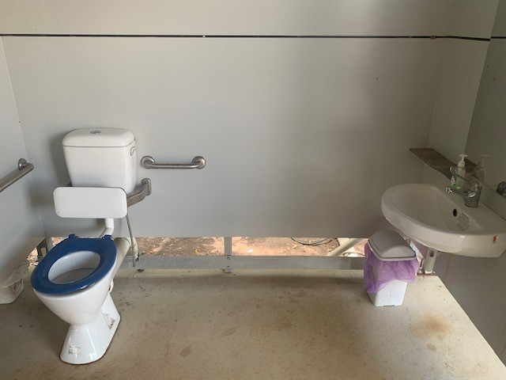
disabled toilet2
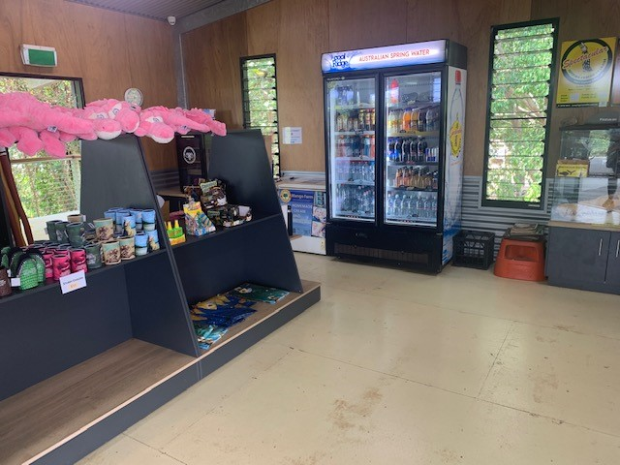
gift shop
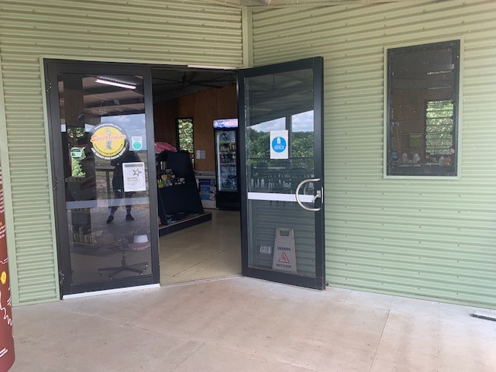
main entrance
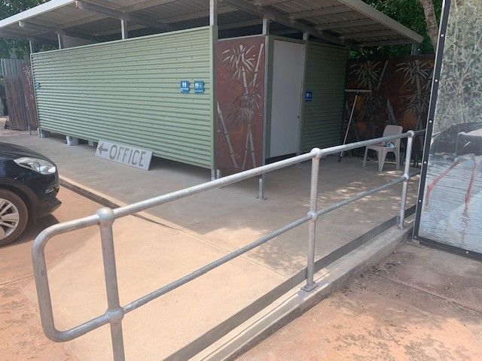
path to disabled toilets
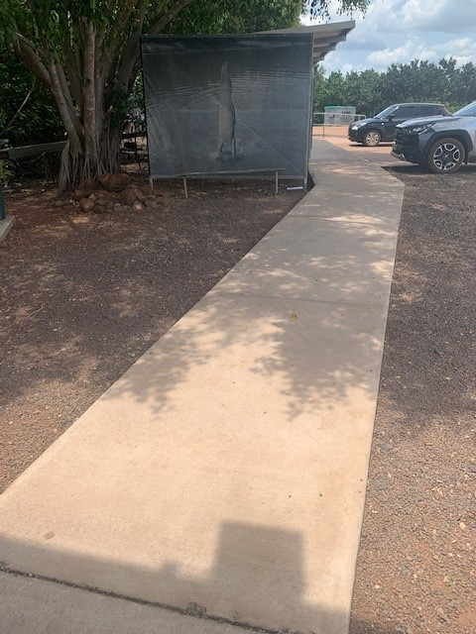
paths
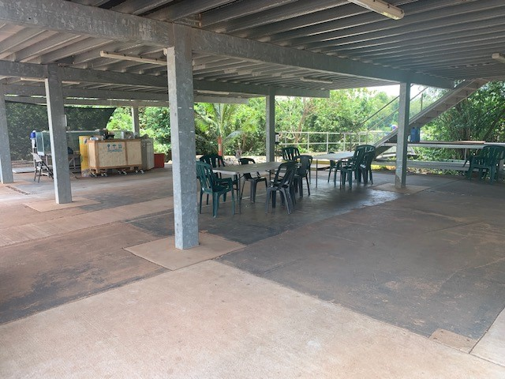
seating
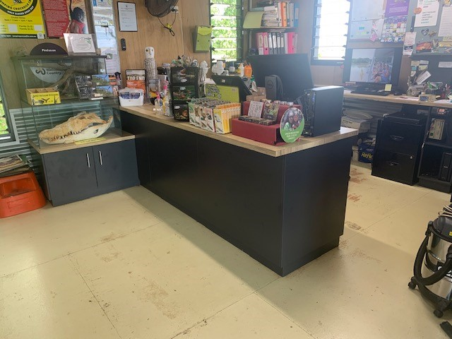
ticket counter
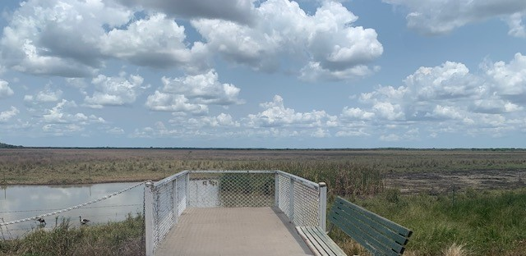
Viewing area
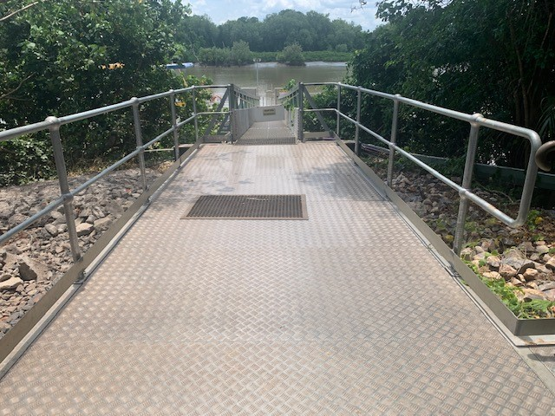
walkway

COMMON AREAS

Report Disclaimer
Please note that this business report, provided as a result of the use of the diagnostic assessment, is for information purposes only.
Australian Tourism Industry Council (ATIC) cannot guarantee the accuracy of respondent’s answers, or that they are fully representative of your business. Therefore, ATIC does not warrant or guarantee any particular outcome in respect of your businesses self-assessment.
This report is intended as guidance only for your business and should not be relied on for future marketing considerations. ATIC recommends that you seek your own independent advice as well as the results from the diagnostic.
Links to external web sites are inserted for convenience and do not constitute endorsement of material at those sites, or any associated organisation, product or service.
ATIC does not:
- Assume any legal liability for the accuracy, completeness, or usefulness of any information from this report or any links provided; or
- Accept responsibility for any loss associated directly or indirectly from the use of this report.

