ATIC Accessibility
To support the accessible community in making informed travel decisions for their individual needs

This report prepared for:
Business name: | Great Southern Outback Tours and Accommodation
Address: | 113 Riverside Drive
Town: | Kalgan
Contact for enquiries: | Wayne Monks
Contact Number: | 0499113193
Contact Email: | wmonks@westnet.com.au
Website: | https://greatsouthernoutback.com.au/
Date: | 2026-10-23 20:47

ATIC Accessibility
The following pages provides travellers with information on the businesses facilities and amenities which aims to support the traveller to make an informed decision on whether the business is suitable for their individual needs.
OVERVIEW 4
Business Overview 4
Bookings 4
Emergency Management 4
Communications 5
GENERAL 6
Pre-arrival, arrival and reception 6
Cognitive Impairment Support 6
Car Park and Access amenities 6
Entry 6
Internal Spaces 7
Public areas 7
External Paths 7
Steps 7
TOUR OPERATORS 8
Tour/Transport Services 8
Route Planning 8
Guides 8
ACCOMMODATION 10
Room Amenities 10
Bathrooms 10
COMMON AREAS 12
Parks and gardens 12
FOOD AND DRINK 14
Dining Spaces 14
Report Disclaimer 17

OVERVIEW

Business Overview

The business has the following products/services available
- Tour/Transport
- Accommodation

Bookings

The business offers the following methods for bookings and enquiries:
- Phone
- Email
- Webportal

Emergency Management
- Emergency and evacuation procedures are explained on arrival
- There are Audible device/s to alert occupants to evacuate with instructions on how to evacuate.
- There are visual device/s to alert occupants to evacuate.
- Exit access is free and clear at all times
We ensure exit access is free and clear at all times by: Farmstay has a number of easy access departure points
- Exits and access to exists are greater than 900mm
- Exit doors are able to be opened by all occupants
- Exits to the emergency evacuation point does not include stairways
The business identifies guests who need additional assistance should an emergency occur by: It doesnt
The procedure for assisting guests who need assisted rescue is: Personal assistance

Communications
The business provides the following services for services animals: No pets but would consider for service animals

GENERAL

Pre-arrival, arrival and reception
The business has the following in place to support guests during pre-arrival, arrival and reception
- Booking information and websites are compatible with screen readers
- A familiarisation tour
The following steps are in place to ensure that people with fatigue related to their disability are not disadvantaged by long wait times: I dont have any - I am a Farmstay and I operate this property by myself - I am present when guests arrive.
- In addition, the following further information can assist guests:
Set of House Rules

Cognitive Impairment Support
- Documents are available in plain English for people with cognitive impairment (This may include instructions, guides, menus and general information)

Car Park and Access amenities
The business has the following Car Park and Access amenities
- Designated disabled parking bays

Entry
The business has the following amenities/systems in place for entry
- A path of access to the building is clear of obstruction
- Door jams/doors are of a contrasting colour to surrounding walls
- The entry door is a minimum of 850mm wide
- There a clear space of at least 1500mm x 1500mm in front of all doors.
- The entrance door mats have a thickness less than 13mm and a width of 7500mm or greater
- In addition, the following further information can assist guests:
Yes slight height as you enter the main entrance >13mm

Internal Spaces
- Clear and unobstructed routes through and between buildings
- Interior walls are matte or low sheen
- Floors, walls, counters and furniture are of contrasting colours
- Tableware/glassware contrast with the table surface or table cloth
- Floor surfaces are hard or short pile carpet
- Seating is available for guests unable to stand for long periods
- All corridors greater than 900mm

Public areas
The public areas have the following amenities in place
- Even lighting
- In addition, the following further information can assist guests:
No public areas - I am not a hotel but a Farmstay and I have plenty of seating arrangements

External Paths
External paths of travel
- Paths or slopes longer than 15 metres have resting places or seats
- Pathways are wider than 900mm
- There 3 successive steps or less on any path or at any doorway
- In addition, the following further information can assist guests:
I have steps leading from the carport to the main door

Steps
Steps
- There are steps.
- Where steps are present are there three steps or less
- In addition, the following further information can assist guests:
I have small steps inside the house but only around 5-10mm
- In addition, the following further information can assist guests:
I a farmstay so not open to the Public at any time

TOUR OPERATORS

Tour/Transport Services
The tour/transport services have the following facilities/amenities in place
- Buses/Coaches
- None vehicles have wheelchair lifts or ramps
- None vehicles have low floors with ramped entry
The maximum wheelchair capacity available in the fleet is: None

Route Planning
- Route Planning
- The tour route includes stops with accessible toilet facilities
- In addition, the following further information can assist guests:
I hire 12 and 25 seater buses and they do not accessible toilets
- Lunch stop venues are accessible
- Overnight Stops
- For overnight stays, wheelchair accessible rooms are available
The total number of wheelchair passengers that can be catered for at overnight stops are: None
- Walking Tours

Guides

Guides have been trained in the following
- Use of clear/simple English
- Correct pronunciation for lip readers
- Marine
  - Image(s)
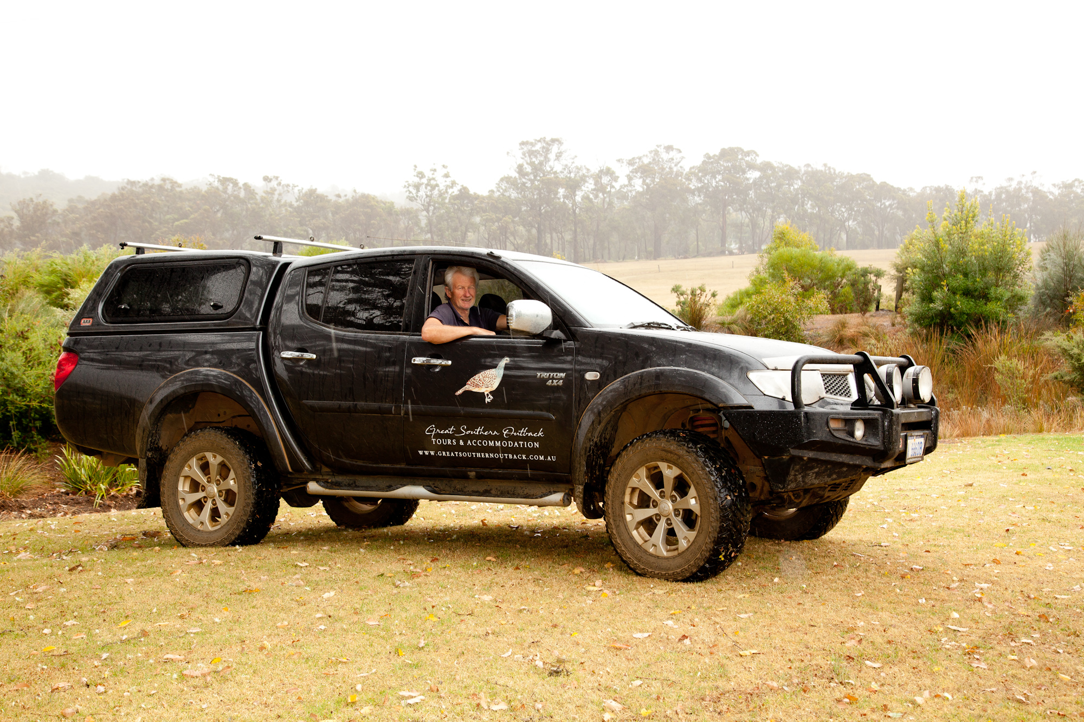
The Grange N - February 2020
- This tour stops at attractions/accommodation/food and beverage/retail spaces that are not operated by this business. For information relating to these individual properties please follow the weblink provided
- In addition, the following further information can assist guests:
I dont have a photo of the hire MV's so have loaded my own 4WDV - which I do not use for tours

ACCOMMODATION

Room Amenities
- Visual alarm is fitted to the room
- There is contrast between the walls, skirtings, floor and furniture
- There is a clear path through the room
- Wardrobe handles are a contrasting colour to the doors and draws
- Doors open fully against the adjoining wall
- There is a clear opening at least 850mm wide
- There luggage racks for at least two suitcases
- There at least one chair with rigid arms
- Wardrobe and drawer handles are easy to grip
- The bedside lamp switch is easy to reach from the bed
- There is at least 850mm clear space beside the bed
- The bed height is no higher than 680mm from the floor
- In addition, the following further information can assist guests:
I use an eco product

Bathrooms
The bathrooms have the following facilities/amenities in place
- All heating appliances and hot water pipes are protected or insulated
- The width of the door is 700mm.
- There is a minimum of 850mm beside the toilet
- There is a minimum of 1400mm of clear space in front of the toilet
- The toilet seat is a contrasting colour to the floor
- The actual height of the toilet seat is 450mm.
- A range of non-allergenic toiletries are available
- There is a portable shower head on flexible hose
- A door is fitted to the shower
  - Bathroom Image(s)
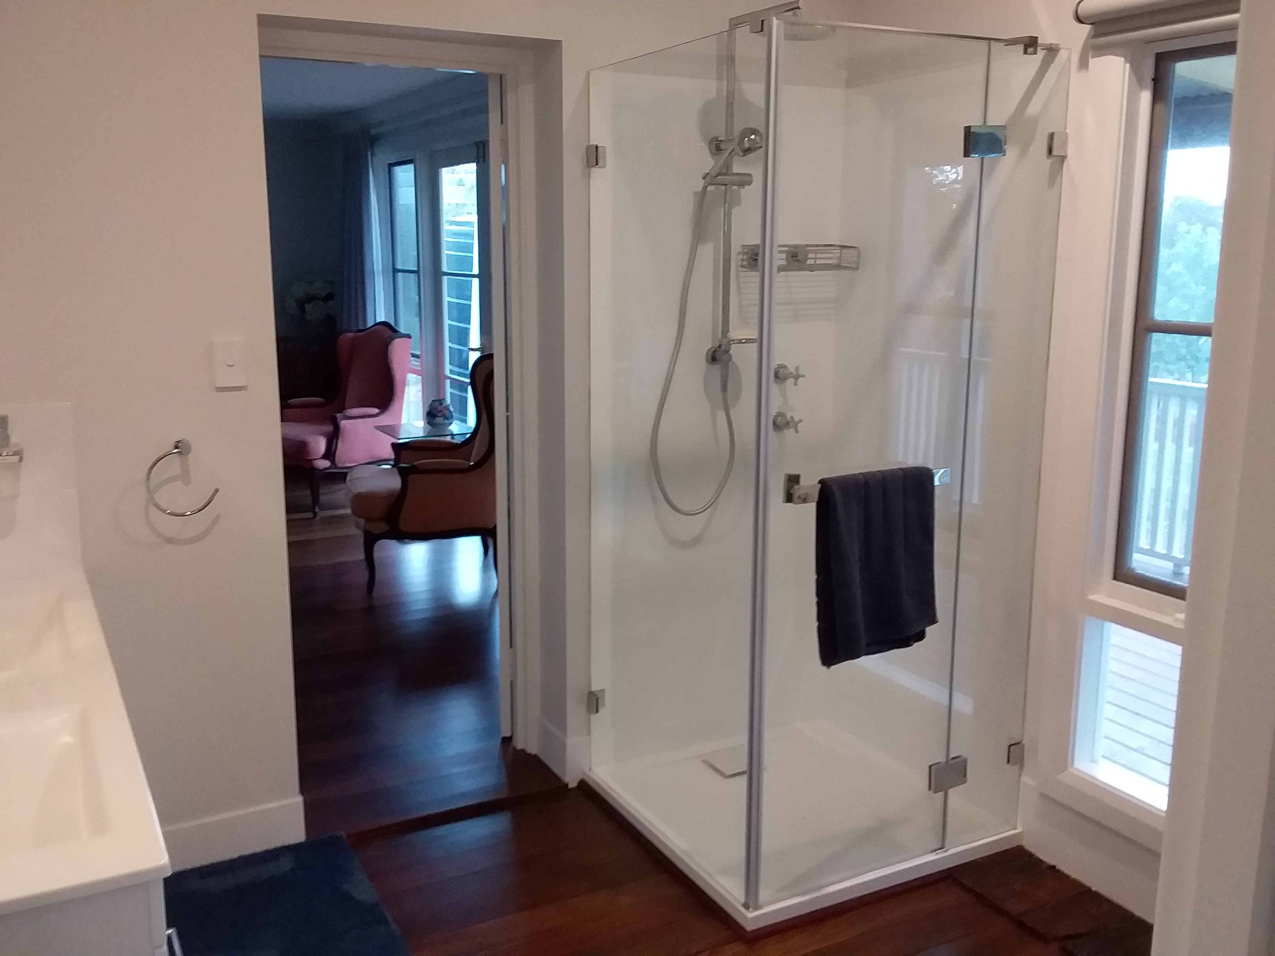
20190318_163912
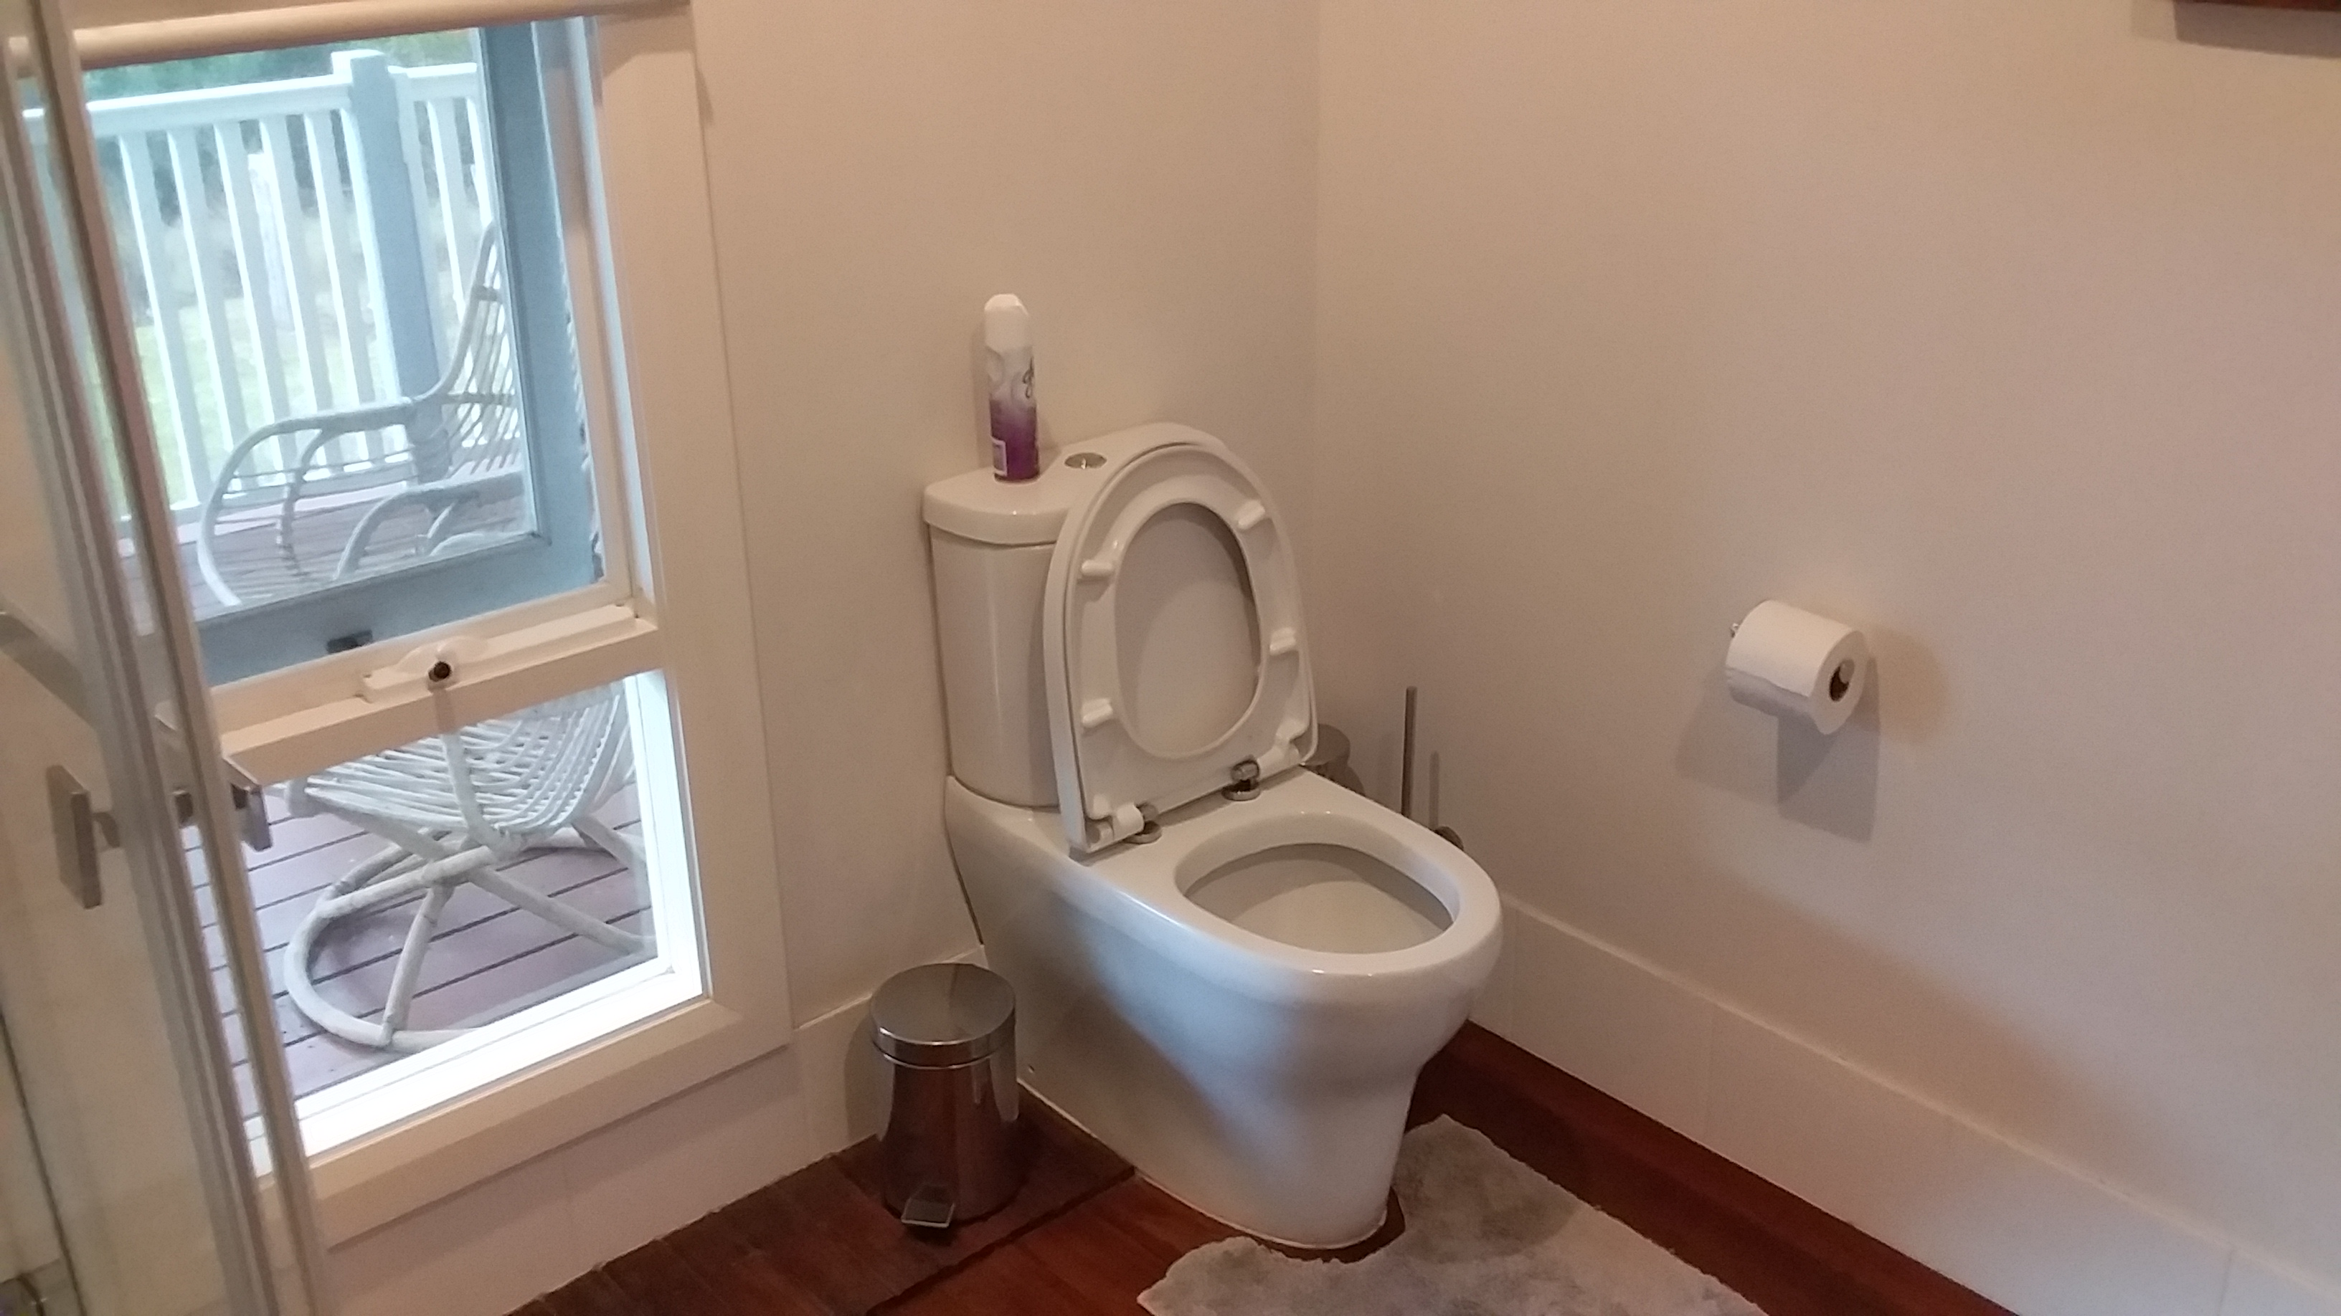
20240626_141836
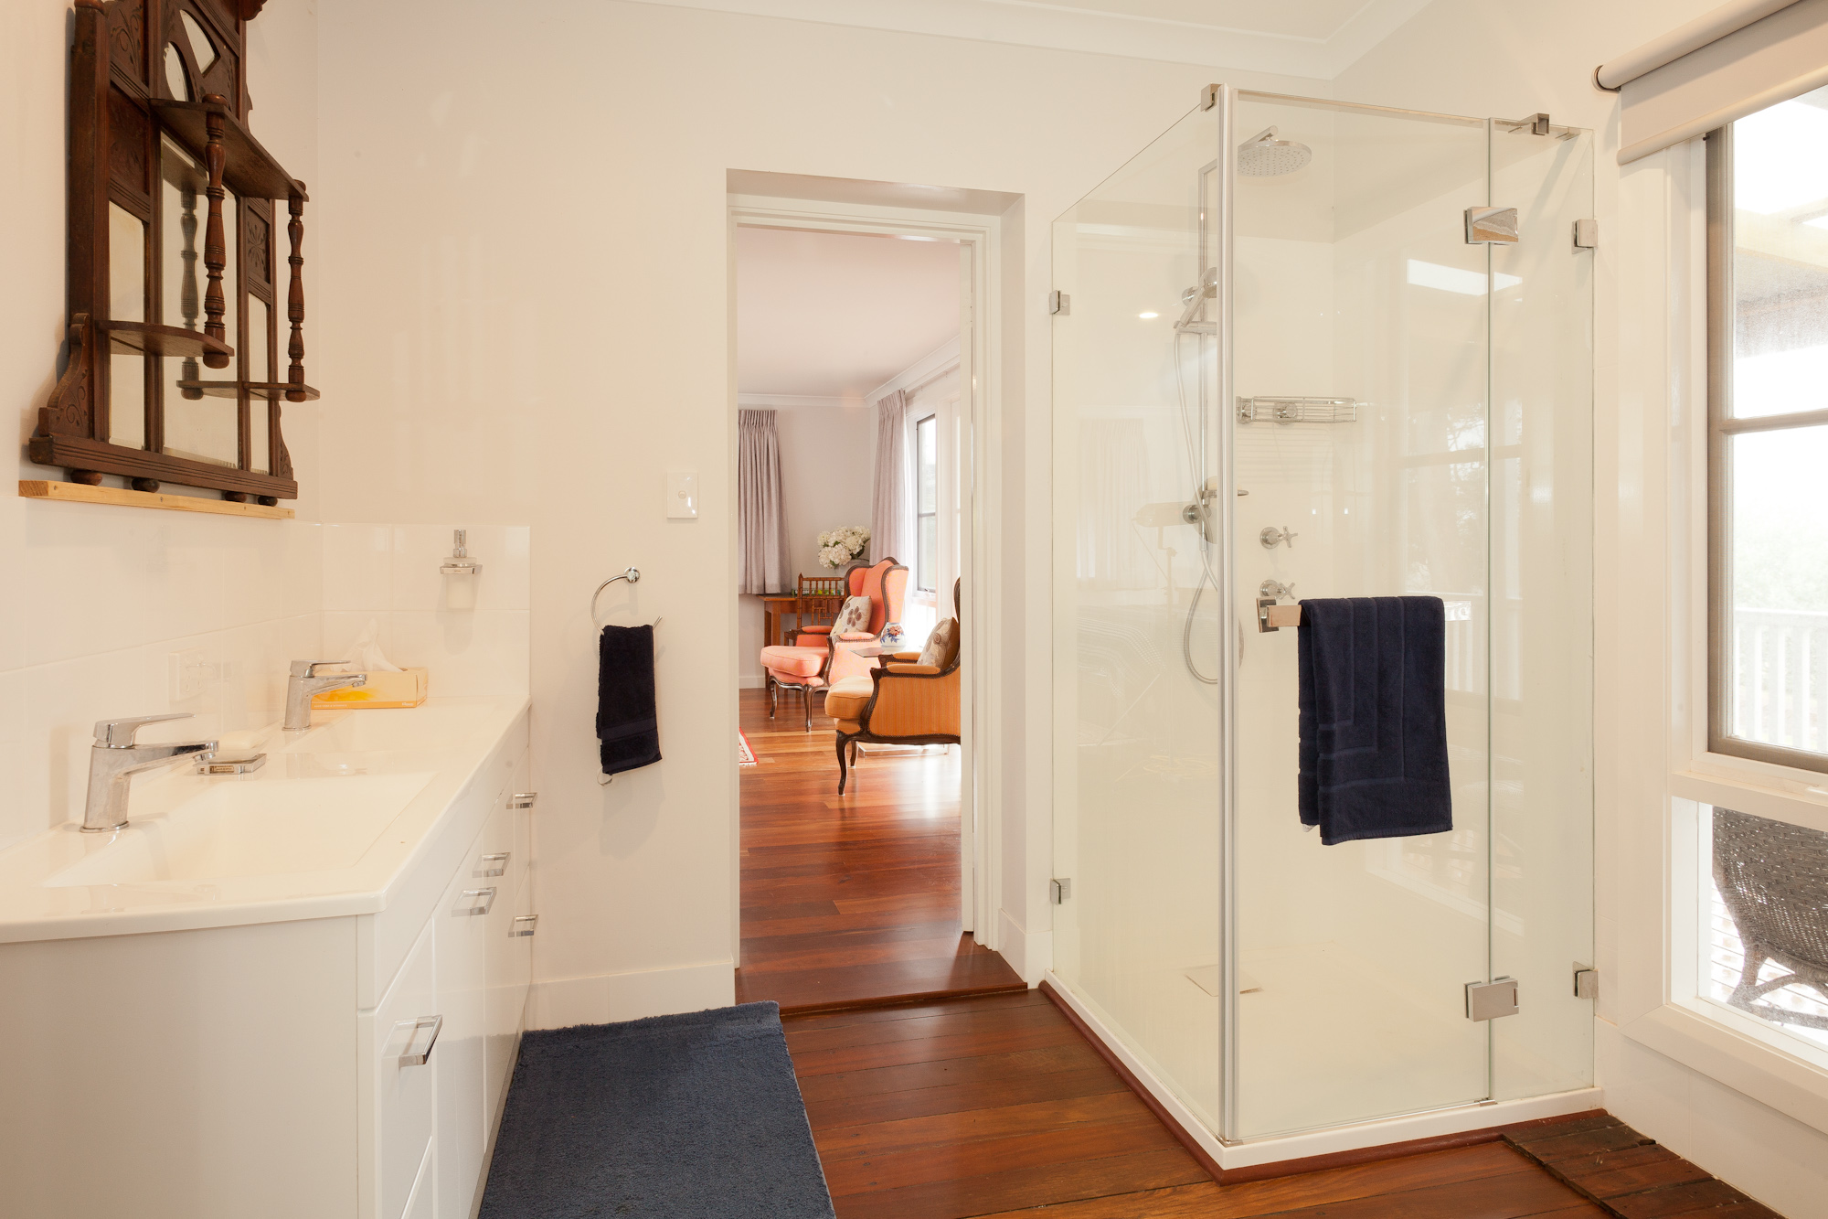
The Grange M - February 2020
- In addition, the following further information can assist guests:
Dont have handrails and dont have a seat in the shower

COMMON AREAS

Parks and gardens
- The following parks and gardens amenities are available
- Seats are provided at regular intervals
- The park or garden contains sensory experiences
  - Parks and Gardens Access/Entry Image(s)
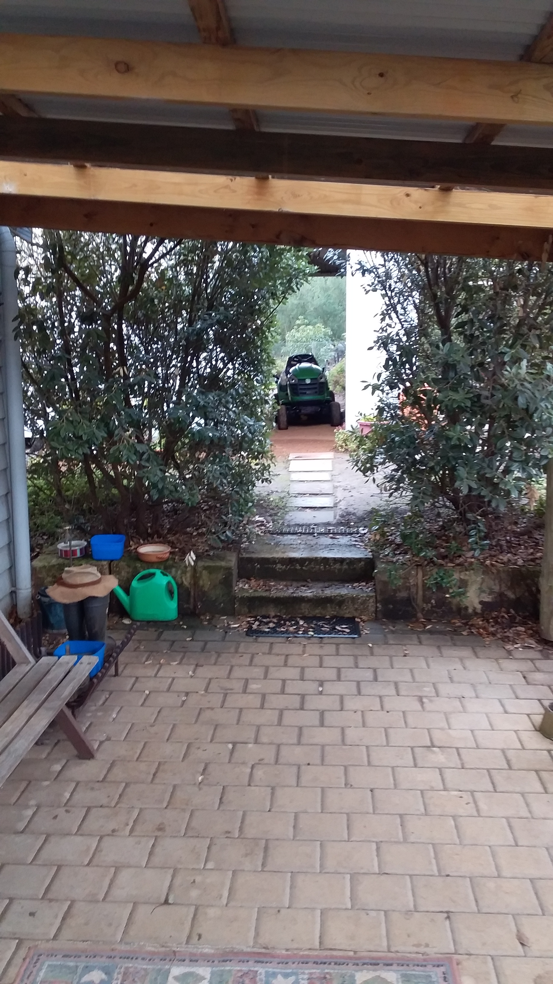
20240626_141916
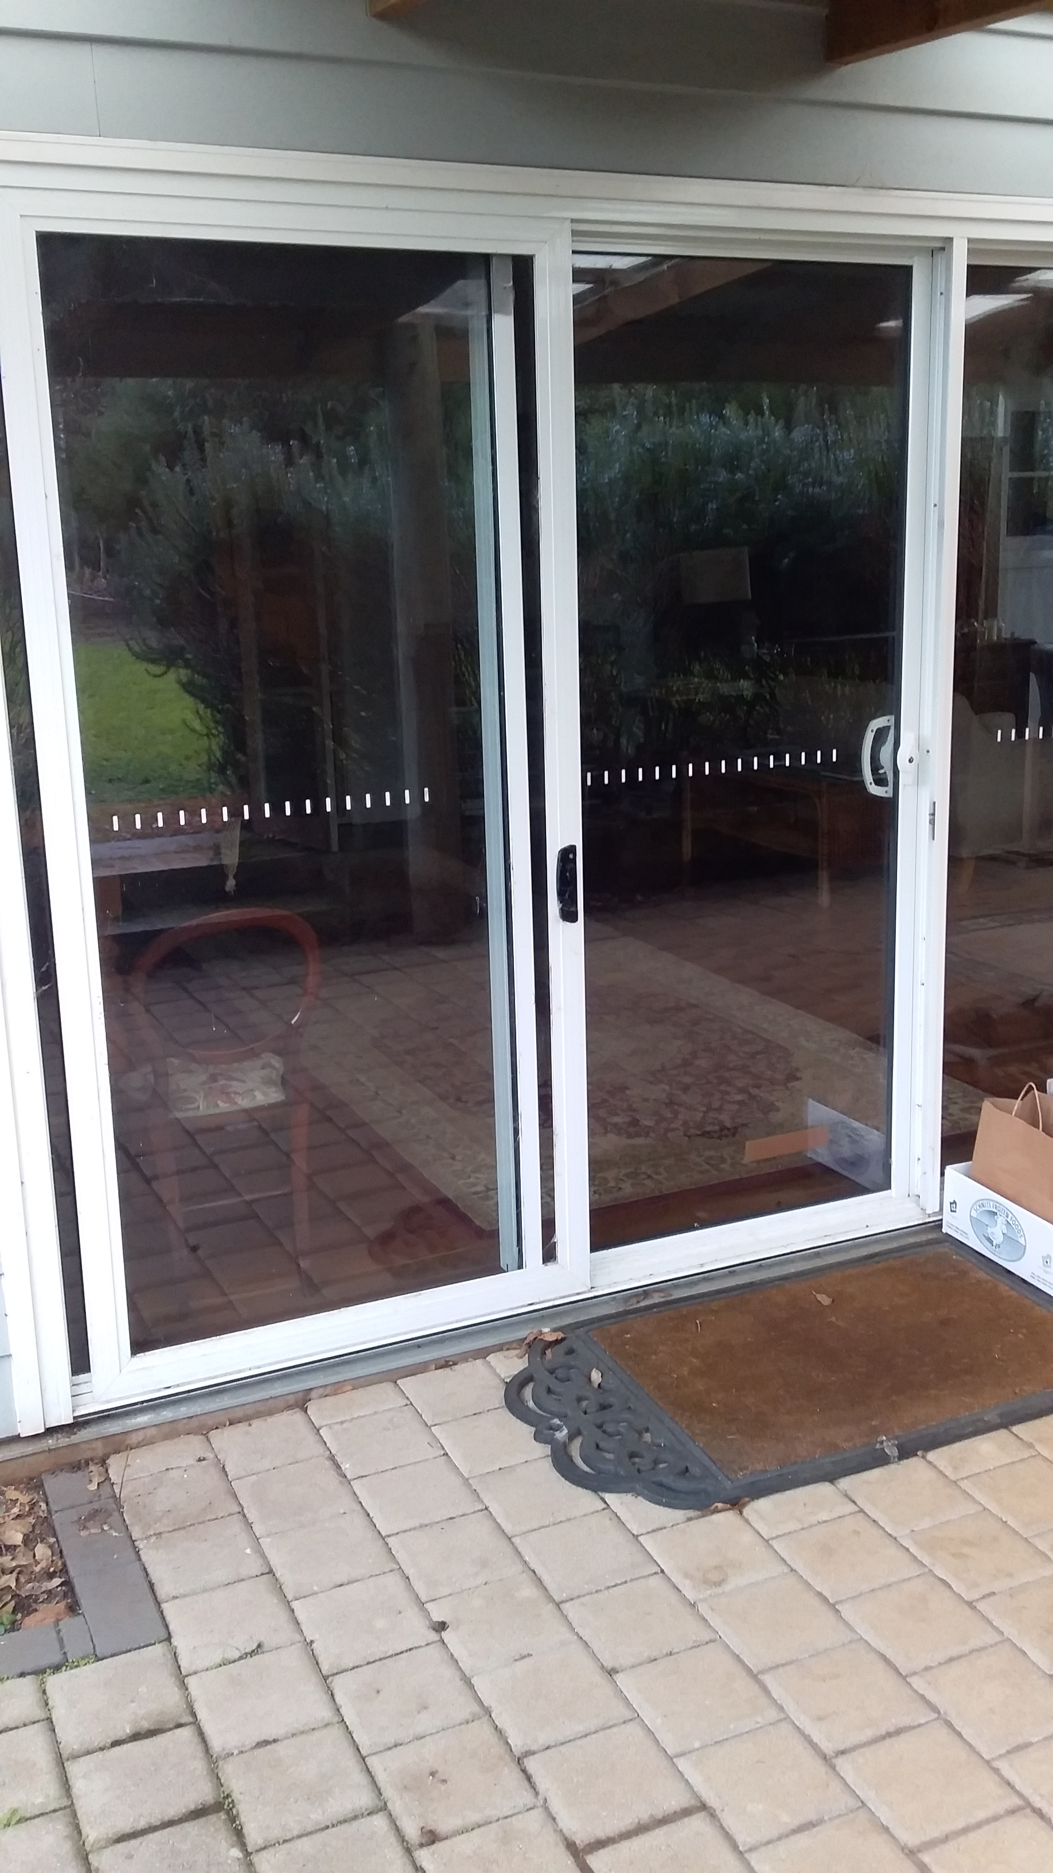
20240626_141927
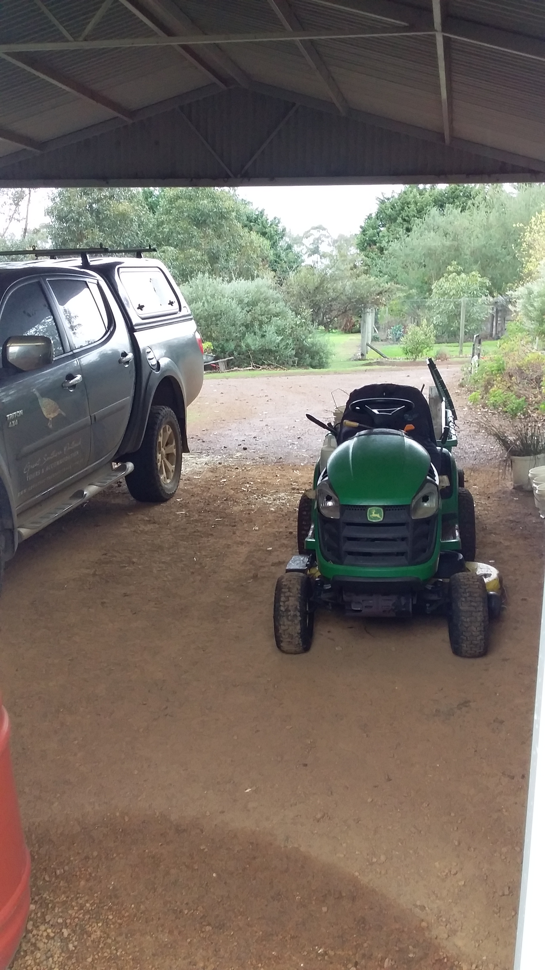
20240626_141947
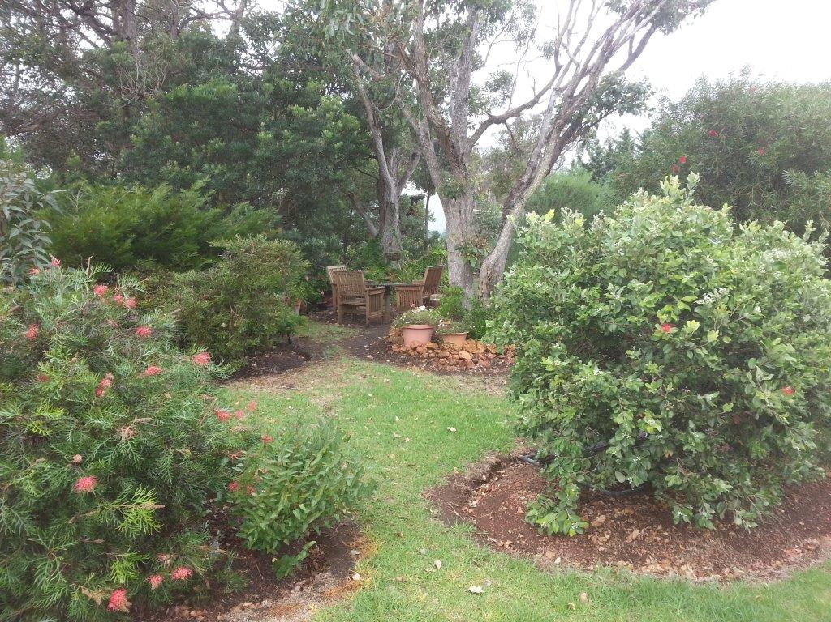
Native garden (3)

FOOD AND DRINK

Dining Spaces
The dining spaces have the following facilities/amenities in place
- The doorway is at least 850mm wide
- There is level access through the dining area
- Chairs are moveable to allow for wheelchairs to be seated at the tables
- There are areas of full lighting

Our business caters for the following dietary requirements
- Organic
- Vegetarian
- There are procedures in place to avoid cross-contamination of food products
- There is a sample menu available online
Sample menu is available here - https://static1.squarespace.com/static/5e00545be7d30700bb8597bd/t/656e7283a830142b9b74f15e/1701737094646/The+Grange+on+Kalgan+-+Breakfast+Menu+November+2023.pdf
  - Food and Beverage Image(s)
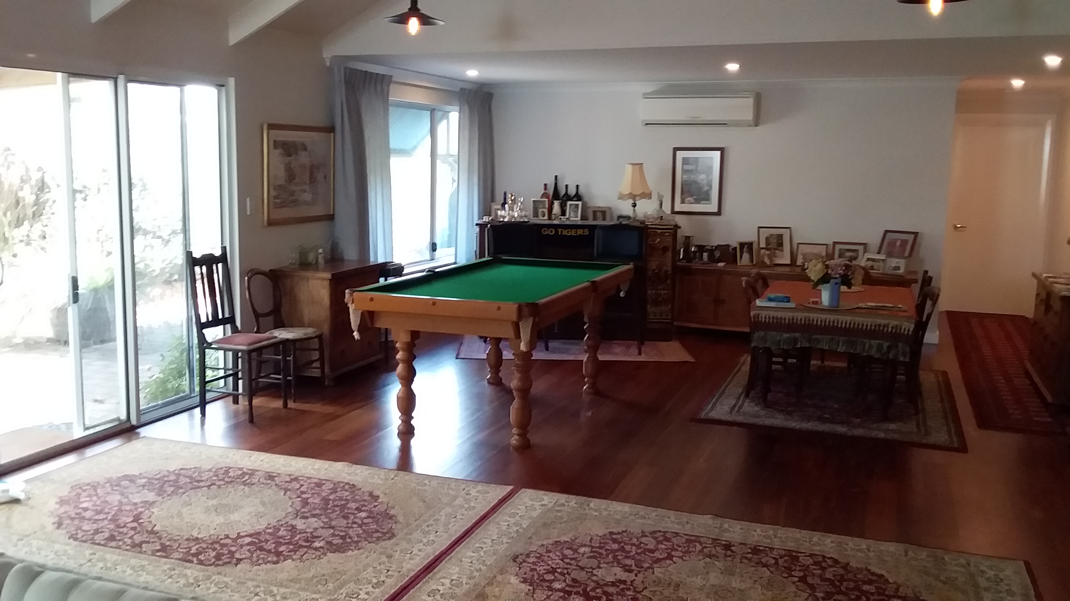
028
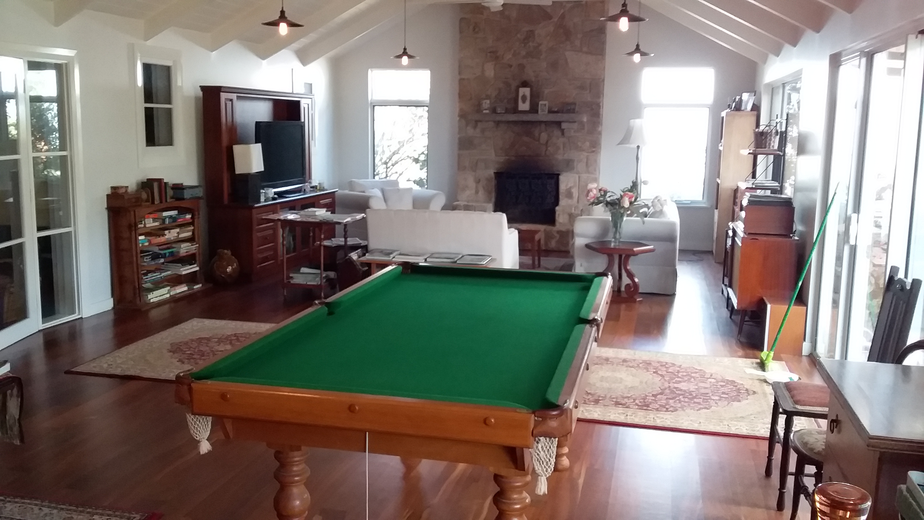
029
- In addition, the following further information can assist guests:
I have a menu for my premium guests but most guests use the large family room in the 2 photos above

Report Disclaimer
Please note that this business report, provided as a result of the use of the diagnostic assessment, is for information purposes only.
Australian Tourism Industry Council (ATIC) cannot guarantee the accuracy of respondent’s answers, or that they are fully representative of your business. Therefore, ATIC does not warrant or guarantee any particular outcome in respect of your businesses self-assessment.
This report is intended as guidance only for your business and should not be relied on for future marketing considerations. ATIC recommends that you seek your own independent advice as well as the results from the diagnostic.
Links to external web sites are inserted for convenience and do not constitute endorsement of material at those sites, or any associated organisation, product or service.
ATIC does not:
- Assume any legal liability for the accuracy, completeness, or usefulness of any information from this report or any links provided; or
- Accept responsibility for any loss associated directly or indirectly from the use of this report.

